Coded CPAT: specification and plan
The full build of the Python model: structure, design choices and plan
2026-10-29
Table of Contents

Status. Planning done (phases 0 and 1 of the plan, 2026-10-29): the design choices of section 10 are decided and coded/NORMS.md states the rules that follow; section 11 is the detailed plan. Companion documents: the equation list (../equations/Equations.qmd, code-name version Equations_codes.qmd), the checklist of the plan (coded/TODO.md).
Section | Contents
1 | The request, cleaned up
2 | Principles
3 | Folder structure
4 | How a run works (box diagrams)
5 | Data: databases
6 | Inputs
7 | Switchable equation forms
8 | Tests and comparisons
9 | Documents and the website
10 | Design choices for the user
11 | The plan
12 | Excel-AI choices to flag

1. The request (user, 2026-10-29), cleaned up

1.1 Goal
Build the full Python model (“Coded CPAT”) that directly replicates the mitigation and distribution modules of Excel-AI (excel_ai/CPAT-AI-Mitigation-Prototype_v<version>.xlsm, CPAT-AI-Distribution-Prototype_v<version>.xlsm). The numbers must match Excel-AI. The overall norm is: always follow Excel-AI. Where an Excel-AI choice looks strange or wrong, report it to the user rather than silently departing; known departures from legacy CPAT are already tracked in the register (bugs L, issues I, departures LD, upgrades U).
The purpose of the code is full human readability: a reader with the methodology in one hand should be able to find each equation in the code in the other.

1.2 Ways the model is run
- From saved scenarios: a table of scenario inputs in the MTInputs form (one row per NameOfParameter, one column per scenario), as legacy CPAT and Excel-AI ScenarioDefinition.
- From a reactive Shiny user interface (later), which populates the same inputs dynamically.
- Both use an advanced inputs file as well: time series and longer-form inputs of different types (the legacy Manual inputs tab).
The code runs many countries and many scenarios in one call (batch, comparisons), and one country with two or more scenarios (the main user interface).

1.3 Data: databases
Python and Excel-AI both run from the same databases. A database holds two or more complete sets of data:
Set | Contents | Where
Full | Every table, including the four proprietary tables | A separate, private repository (never this one)
Public | Every table except the four proprietary tables: energy balances (EnergyCons/Balances), domestic prices (Prices_dom), the GTAP input-output table (IO_GTAP) and the household survey (HHSurvey) | This repository (data/)
This mirrors how Excel-AI and legacy CPAT work (legacy NoPropData workbooks lack the same four tables).

1.4 Testing
- Compare Python with Excel-AI systematically.
- Compare Python or Excel-AI with legacy CPAT.
- In each case first for one country, then for all.
- For these comparisons use a systematic dataset: the public set (full except the four proprietary tables), with the four tables filled the same way in every model.

1.5 Documentation and readability
- The methodology is in docs/01_MainDocumentation/*.qmd. A website will be built from qmd (to HTML), with tabs for Excel-AI and for Python.
- Plan the Python project in a human-readable way too, in qmd (markdown with extras) that can be built into the website and into Word.
- An equation list: an executive summary with the core equations of each part, and appendices with all the adjustments. It uses the Greek letters and index letters of the methodology documentation; indices are shown only where they add clarity (otherwise the text says which indices an equation ranges over).
- A parallel version with code names instead of Greek letters, using the authoritative list of CPAT variable codes (e.g. ener), the codes map in excel_ai/.
- Box diagrams of the modular structure.
- A separate NORMS and TODO for the Python project. Most Excel norms (formatting) do not apply; the overriding norm is to follow Excel-AI.

1.6 Structure
- Decide up front whether the model computes everything for year t (all modules, including air pollution and transport co-benefits) before moving to year t+1.
- Placeholder modules for air pollution and transport co-benefits, with their imports and exports defined now. Transport co-benefits will later be related to the transport (engineer) mitigation model.
- Switchable core equations. The structure must allow later switching between forms of the core equations through one global switch: simple-CPAT (basic CPAT equations for every sector, power included), standard-CPAT (engineering power and transport models on), CPAT partial adjustment, CES partial adjustment (taking the CES-compatible price of the energy service), and CDPM (SISEPUEDE) plus FTT-like. Excel-AI implements its core equations as LAMBDA formulas; the Python forms play the same role. Only the Excel-AI form is built now.
- Keep the existing, clean folder structure of coded/ as the starting point; do not clutter the core folders with working files; prefer a subfolder (with one pointer file at the top) over more than three new files in a folder. Recommend improvements to the structure, then make them.

1.7 Sequence of work
- Plan the folder and code structure for readability (this document, NORMS.md, the diagrams).
- The equation list (Greek letters) and its parallel version with code names.
- Design choices: documented here (section 10) and gone through with the user, question by question.
- The detailed plan (section 11 and coded/TODO.md), then the build.

2. Principles
- Follow Excel-AI. The numbers of Coded CPAT equal Excel-AI’s, code by code, year by year; a difference is a defect of one of the two, found and registered. Through Excel-AI, Coded CPAT inherits the replication rule (never replicate a legacy bug; replicate and track every legacy issue).
- Readable first. One equation, one function, with the equation in the docstring as in the equation list; names from the codes map; no hidden constants; the model order written once (mitigation/chain.py). Speed comes second, and is reached by working on whole arrays of countries and scenarios at once, not by obscure code.
- One model, many front ends. One entry point, cpat_model.run(scenarios, database, settings), used by the command line (scenario files, many countries and scenarios), the Shiny app (one country, two or more scenarios, reactive) and the tests.
- Same inputs, same data, same codes as Excel-AI. Scenario inputs are MTInputs rows by NameOfParameter; advanced inputs are the legacy Manual inputs, Settings and Constants; data come from the same databases; results carry the Excel-AI output codes.
- Structure that allows change. The core demand equations sit behind slots that the scenario input ModelForm can fill with other forms (D4); downstream modules (distribution, air pollution, transport co-benefits) talk to mitigation through declared interfaces.
- Documents from one source. qmd for people, generated Word copies, md for guides; the equation list in one source file for both of its versions.

3. Folder structure

3.1 Principles
- Keep what is clean. The top level of coded/ stays as it is: cpat_model/ (the model), cpat_shiny/ (the app), cpat_testing/ (tests), cpat_documentation/ (documents), and the entry points and configuration files. Only NORMS.md is added at the top.
- The package reads like the model. Inside cpat_model/, one subpackage per block of Excel-AI, named for what it computes, and one file, mitigation/chain.py, that lists the blocks in the order they run. A reader learns the model by reading chain.py, then each block in turn.
- Shared machinery in one place (core/), the switchable equation forms in another (forms/), so model blocks hold only equations.
- Inputs and data at the edge. Only inputs/ reads scenario files and only data/ reads databases; model code receives arrays.
- Documents in cpat_documentation/, one subfolder per kind (project, equations, developer, user), with qmd sources and generated Word copies.
- No working files in the core folders (NORMS 2.2): kept comparison scripts in cpat_testing/compare/, run outputs in coded/outputs/ (git-ignored).

3.2 Target layout
coded/
README.md What Coded CPAT is, how to run it, map of the folders
NORMS.md Python norms (adds to the root NORMS.md)
TODO.md Open work: the plan (section 11)
run_model.py Command line: run a scenario set, write results
app.py Shiny app
config.py, .env Settings: database, paths, model form
environment.yml, requirements*.txt
cpat_model/ THE MODEL
__init__.py run(scenarios, database, settings) -> Results (the one entry point)
settings.py Run settings: database, countries, years, global switches (D16)
core/ Shared machinery
dims.py Index sets: fuels i, sectors j, years t, technologies, deciles (names as the methodology)
variables.py Variable registry: code -> description, unit, dimensions, symbol (from the codes map)
paths.py Policy paths (linear start-target paths), deflators
loop.py The three stages: prepare, year loop, finish
units.py, constants.py
inputs/ Scenario inputs (MTInputs table), advanced inputs, validation, defaults
data/ Database access: full / public / dummy, loaders, reshaping to dims
forms/ Switchable demand equations, chosen by the scenario input ModelForm:
CPAT (Excel-AI), later CPAT and CES partial adjustment, CDPM-FTT
mitigation/ The mitigation module, one subpackage per Excel-AI block
chain.py The order of the blocks in one year (and in prepare / finish)
policies/ prices/ power/ transport/ buildings/ industry/ fuel_use/
revenues/ emissions/ ghg/ air_pollutants/ gdp/ carbon_pricing/ welfare/
air_pollution/ Placeholder module: declared inputs and outputs
transport_cobenefits/ Placeholder module: declared inputs and outputs
distribution/ The distribution module (analysis year, deciles)
results/ Results by Excel-AI output code; indicators; exports (Excel layout)
cpat_shiny/ The app (unchanged structure); calls cpat_model.run
cpat_testing/ Tests mirroring cpat_model/
compare/ Comparisons with Excel-AI and legacy CPAT (scripts and fixtures)
cpat_documentation/
make_docs.py qmd -> Word
project/ Spec.qmd (this document) and its Word copy, figures/
equations/ The equation list: Greek and code-name versions (qmd, Word)
developer/ Developer guide
user/ User pages (read by the Shiny app)

3.3 Changes to the existing structure
Change | Why | When
Add coded/NORMS.md; rewrite coded/TODO.md as the plan | Requested: own norms and TODO for the Python project | Now
Add cpat_documentation/project/ and equations/, make_docs.py | Planning documents and the equation list, in qmd with Word copies, ready for the website | Now
Rename developer/dev_documetation.md to dev_documentation.md (done; the website builder docs/CPAT_ai_documentation_qmd/make_qmd.py updated) | Typo in a file name others link to | Now
Add core/, inputs/, forms/, results/, air_pollution/, transport_cobenefits/ in cpat_model/ | Section 3.2 | Phase 2 (after D1-D7 are decided)
Rebuild mitigation/ in Excel-AI block order; retire mitigation/methan_fee/ (typo), fiscal_revenues/tmp_logic.py, indicators/ into results/, dashboard_inputs.py and distribution_inputs.py into inputs/, data_read/ into data/ | One subpackage per block; no working files; inputs and data at the edge | Phases 3-5, block by block (D7)
cpat_testing/compare/ | Kept comparison scripts out of the model | Phase 2

4. How a run works

4.1 From inputs to results
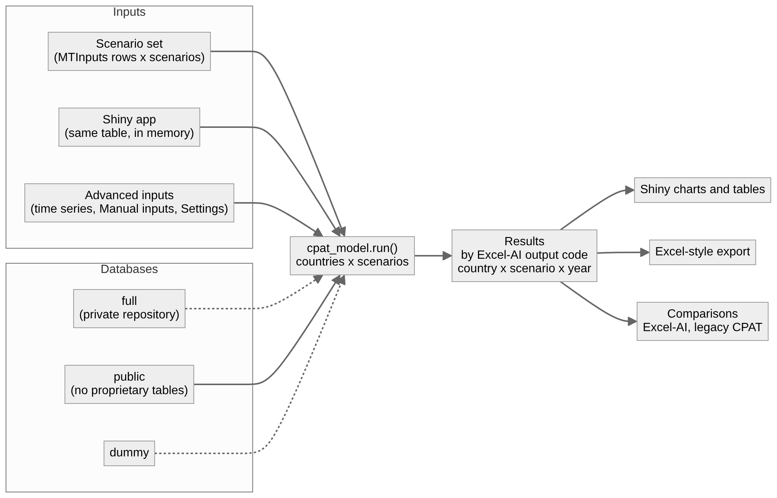

4.2 Two passes, three stages (D1, D15: recommended options)
Excel-AI computes year by year with no circular reference: year t reads year t-1 and earlier (the GDP feedback reaches year t+1; power demand reads last year’s electricity price; capacity, vintages and vehicle stocks are recursions on t-1), and its only look-aheads read exogenous paths (the levelised variable cost of power over [t, 2041], built from prices and policies; next year’s manual capacity input). Policy scenarios also read scenario-1 values: stored ones (sheet BaselineCO2: CO2 by ETS sector, the calibration values in the GHG inventory year) and same-year ones (.ref, which reach the model only through the fiscal space and so GDP of t+1). Coded CPAT therefore runs the baseline first, then each policy scenario in turn (any number of scenarios; D15), each run in three stages:
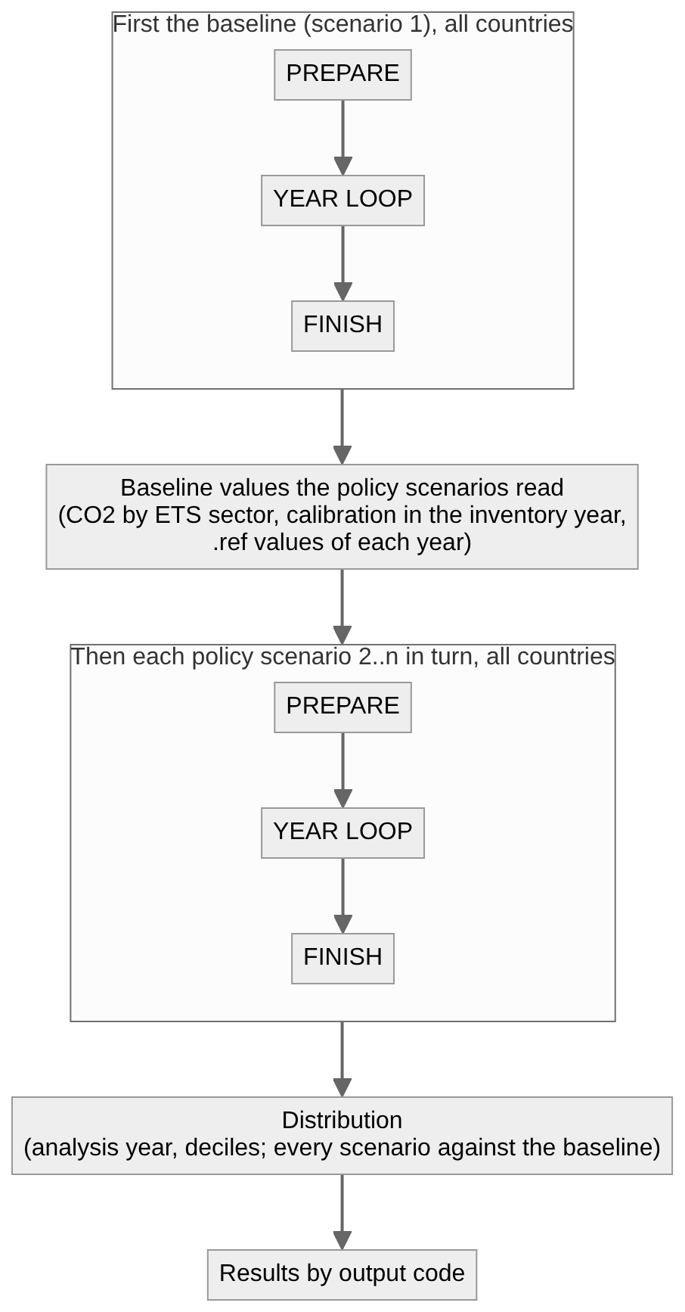
Stage | What | Excel-AI blocks
Prepare (all years at once; nothing here depends on a quantity of the model) | Years, CPI and deflator indices, baseline GDP growth, income factor, shock path; policy paths (carbon tax, ETS, feebates, excises, subsidy reform, methane fee, Pigouvian components from the module values); international prices and the retail-price chain before and after policies; power cost paths incl. the levelised variable cost | 0, 1, 2, power costs of 3
Year loop (t = base year + 1 … last year; each block reads year t and earlier) | GDP level of t (from the effect of t-1); road engineer model; fuel demand by sector and fuel (the core-equation slot); residential leakage and the exempt split; power demand, dispatch, retirement, investment, electricity prices; energy totals; revenues; CO2 (and the ETS check); other GHGs and methane; local air pollutants; air-pollution and transport co-benefit modules for year t; GDP effect of t | 16 (level), 5b, 5-8, 6b, 3 (quantities), 11, 12, 13, 14, 15, modules, 16
Finish (all years) | Carbon-pricing indicators; inputs from the modules (modelled concentration, per-litre externalities); welfare, externalities, subsidies, efficient prices; exports to distribution | 17, 17b, 18, 19
Outside the passes: the ETS goal seek (iterates whole runs until emissions meet the cap; run only on request, root NORMS 5c) and the range-anxiety fit (offline, stored as data), as in Excel-AI.
Every function works on all countries at once (an array dimension); scenarios run one after another, and their results are joined along a scenario dimension.

4.3 One year of the loop (the chain)
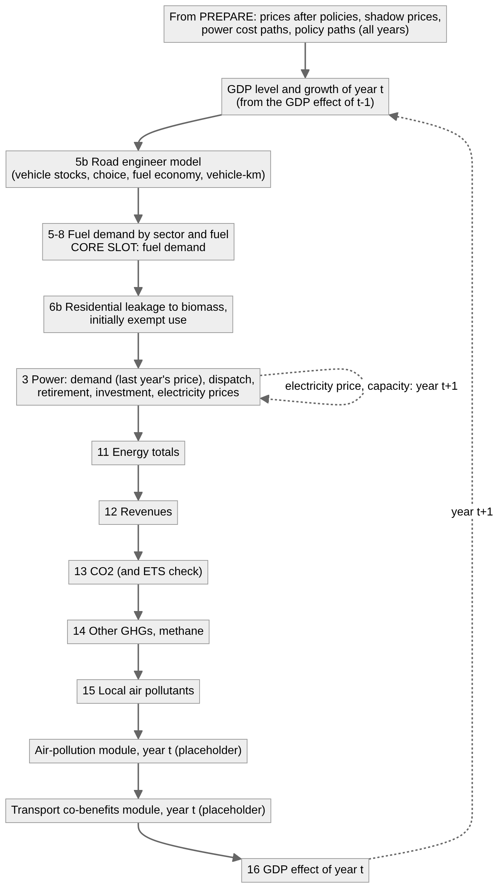
mitigation/chain.py holds exactly this list, so the order is written once.

4.4 Switchable core equations (D4)
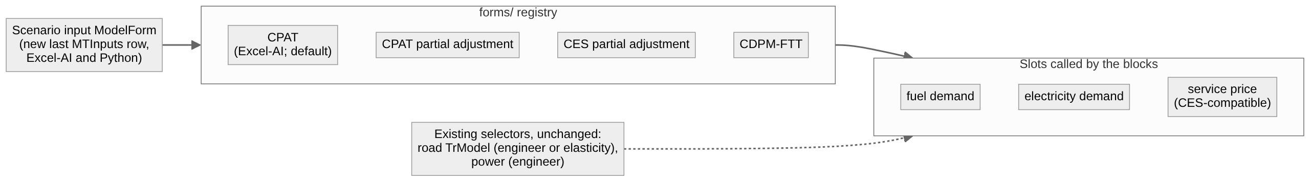
Each form provides a function for every slot with the same signature; a block calls the slot, never a form directly. Only CPAT is built now; the others must not change its numbers (section 7).

4.5 Modules and their interfaces
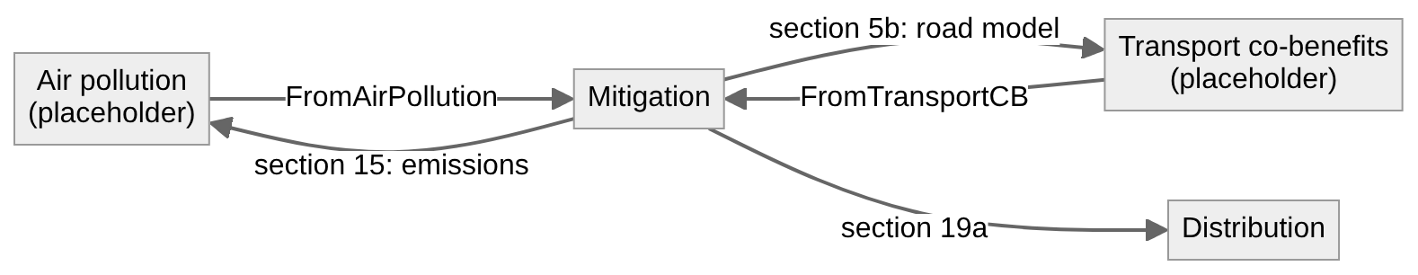
Module | Reads from mitigation | Returns to mitigation | Used in mitigation | Placeholder behaviour now
Distribution | Section 19a (about 29 rows, both scenario groups) | nothing | - | Built (to be moved onto the new structure)
Air pollution | Section 15 (aps.<pollutant>.<module sector>), energy use of power and residential by fuel, CO2, GDP, population | air.vpm (value of averted PM2.5, by year), concentration coefficients by module sector and pollutant | Pigouvian tax (prepare stage: exogenous, I151) and welfare, subsidies, efficient prices (finish) | Returns Excel-AI’s typed values (FromAirPollution: Egypt from the legacy 465 run; 0 elsewhere, I106) in prepare; its year-t step records its inputs and computes nothing
Transport co-benefits | Section 5b (road fuel use by class, fuel economy, vehicle-km by class, road share) | tran.acc.km, tran.con.km, tran.rdm.km (cost per vehicle-km) | Pigouvian tax (prepare) and road welfare (finish) | As air pollution, from FromTransportCB
Why the module values enter in prepare, not in the loop: in Excel-AI the Pigouvian tax uses them, the tax enters the power policy cost and so the forward-looking levelised cost; a damage that depended on this year’s emissions would make the model circular (issue I151). Each placeholder module therefore has two hooks: prepare (exogenous values, used now) and step(t) (the live module, later). If a live module’s damages are to feed back into prices, that needs an outer iteration or a one-year lag: a decision for when the module is built.

5. Data: databases
Database | Contents | Where | Used for
full | Every table, including the four proprietary tables | Private repository, cloned outside this one; path in .env | Real runs (Coded CPAT, Excel-AI and legacy CPAT alike)
public | Every table except the four proprietary tables (real values) | Not yet available (D6); planned for data/ | Everything that may be shared
dummy | Today’s data/dummy/: every table in the real formats, all with dummy values (user 2026-10-29) | data/dummy/ | Development, tests, the shipped Excel files; the comparisons where full is not available
The four proprietary tables, with their Coded CPAT and legacy names:
Table | Coded CPAT file | Legacy tab
Energy balances | energy_consumption.csv | EnergyCons (legacy also reads the IEA flow-level Balances)
Domestic prices | prices_dom.csv | Prices_dom
GTAP input-output | distn_io_gtap.csv | IO_GTAP
Household survey | distn_hh_survey.csv | HHSurvey
- One database, every model. Excel-AI’s data workbook is built from the same database (data/scripts/build_data_workbook.py), and the legacy layout of the four tables from it (export_to_legacy.py), so the three models read identical numbers.
- The systematic dataset for comparisons is the private full database where it is available, with dummy as the option that always works (user 2026-10-29); every model in a comparison reads the same one.
- Storage (D6): CSV folders in the current data/ structure; the model’s input files (scenario sets, advanced inputs) are kept there too (data/inputs/). The code interface (every table, column, key and unit the model reads) is documented for the data person in data/INTERFACE.md (phase 2).
- The loader layer (cpat_model/data/) reads a database into labelled arrays (country, year, fuel, sector, …) once per session and caches it; the Shiny app keeps it in memory.
- The rules of root NORMS.md section 8 stand: only public and dummy data are committed; nothing computed from full is committed either.

6. Inputs
Input | Form | Read by
Scenario set | The rows of legacy MTInputs (465 rows 8-413, then the Excel-AI additions), keyed by NameOfParameter, one column per scenario (column 1 the baseline), plus the countries each scenario runs for. The Excel-AI ScenarioDefinition columns paste into it unchanged | inputs/scenarios.py
Advanced inputs | Time series and longer-form inputs: the legacy Manual inputs blocks Excel-AI reads (manual international prices, fiscal multipliers by lag, manual capacity paths, BEV fuel economy, manual elasticities, ETS override prices, …), and the global switches and constants of Excel-AI Settings and Constants | inputs/advanced.py
Run settings | Database, countries, years, the inputs Excel-AI reads from the baseline column for every scenario (D16), output options | settings.py
- The Shiny app builds the same scenario set in memory (one country, two or more scenarios); run_model.py reads it from a file (many countries, many scenarios). Both call cpat_model.run.
- Defaults are Excel-AI’s (ScenarioDefinition column G, Settings, Constants). Values keep legacy units (percentages typed as whole numbers where legacy does, issue I85).
- Every input is validated once, before the run: unknown names, wrong types, option values that legacy does not have.

7. Switchable equation forms
The behavioural core of CPAT is a small number of equations: fuel demand by sector and fuel, electricity demand, power supply (dispatch and investment) and road transport. Excel-AI implements each as a named LAMBDA (FUELUSE and AEEIFACTOR for fuel demand, DEMANDMULT for electricity, DISPATCH, LOGITW, FIRSTROUND, CHEAPFILL, LEVELISED for power, ROADSWITCH, DEMROAD, OWNDEM, GOMPTGT for road transport).
The switch is a scenario input (D4). A new input ModelForm is added at the end of the MTInputs rows (below the last legacy row, in the block of prototype additions, root NORMS section 4), the same in Excel-AI’s ScenarioDefinition and in Coded CPAT’s scenario sets, one value per scenario. In Excel-AI the LAMBDA of each core equation reads it; in Python the block calls a slot in cpat_model/forms/, and ModelForm decides which implementation fills it.
The existing selectors stay as they are. The engineer-or-elasticity selectors of power and road transport (TrModel, and the power model choice) are unchanged and are not overridden by ModelForm; power always uses the engineer model. ModelForm chooses the form of the demand equations:
ModelForm | Fuel and electricity demand | Status
CPAT (default) | CPAT constant elasticities (Excel-AI FUELUSE, DEMANDMULT) | Built first: replicates Excel-AI
CPAT partial adjustment | Partial adjustment towards the CPAT long-run level (issue I62) | Later
CES partial adjustment | CES demand for energy services with partial adjustment, taking the CES-compatible price of each service | Later
CDPM-FTT | CDPM (SISEPUEDE)-like stock model with FTT-like technology diffusion | Later
“Simple-CPAT” and “standard-CPAT” of the original request are then the CPAT form with the elasticity or engineer selectors of road transport (and, if it is ever built, of power).
Rules: every implementation of a slot has the same signature (year t and t-1 values in, year t values out); a new form never changes the numbers of CPAT; a form that needs new parameters takes them from the advanced inputs, with defaults that leave CPAT unchanged; the row is added to Excel-AI and Python in the same release.

8. Tests and comparisons
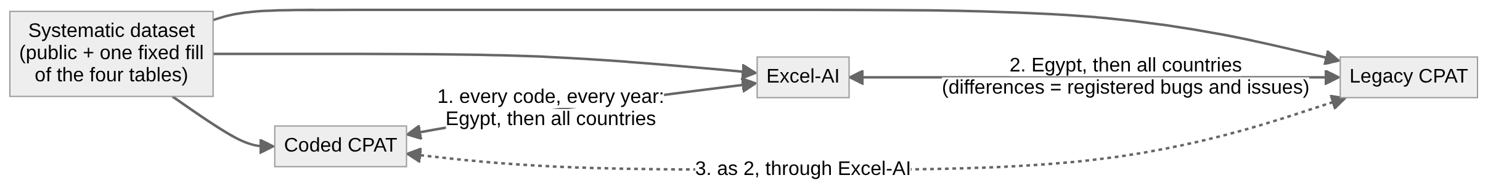
Level | What | Reference | When
Unit | One equation, small hand-checked cases | Hand calculation | Every equation as it is written
Block | One block of mitigation, all its codes, Egypt | First the existing Python recomputations of Excel-AI (check_full.py, power_model_ref.py, transport_model_ref.py, distribution_ref.py; D8), then Excel-AI values by code from the recalculated release workbook | Every block of phase 3
End to end | Every code, both scenario groups, every year | Excel-AI; then legacy CPAT through the LegacyDiff register | Phase 5; at every Excel-AI release
- Tolerance: relative 1e-9 (absolute 1e-9 near zero). A larger difference is a defect in one of the models: found, fixed or registered, never loosened.
- check_full.py does not yet recompute the newest rows of Excel-AI 0.9.0 (sections 17b and 18, the Pigouvian netting, R6, R10, the power memos): for those blocks the comparison uses Excel-AI values directly.
- Every Python-Excel-AI difference report lists codes by block and the first year and largest difference, so the cause is found from the top of the chain.

9. Documents and the website
Document | Source | Generated | Audience
This spec and plan | cpat_documentation/project/Spec.qmd | Spec.docx | People: the team, reviewers
Equation list (methodology notation) | cpat_documentation/equations/equations.yaml | Equations.qmd, Equations.docx | People
Equation list (code names) | the same yaml | Equations_codes.qmd, Equations_codes.docx | People and developers
Norms, open work, layout | coded/NORMS.md, TODO.md, README.md | - | Developers and AI agents
Developer guide | cpat_documentation/developer/ | - | Developers
- qmd or md? A .qmd file is markdown plus a YAML header and optional executable cells; any tool reads it as text, so it is as code-readable as .md. GitHub, however, shows .md formatted and .qmd as plain text, and agents look for NORMS.md, TODO.md, README.md by name. So the guides stay .md and the documents for people are .qmd. Quarto renders both, so all of them can join the website.
- Word copies are generated by cpat_documentation/make_docs.py (pandoc; diagrams pre-rendered to PNG) or by quarto render <file> --to docx; never edited by hand.
- The website (D12): one Quarto site, tabs CPAT methodology (the existing book in docs/01_MainDocumentation/), Excel-AI and Coded CPAT; the Coded CPAT tab lists the qmd files above.

10. Design choices: decided (user 2026-10-29)
The user went through the choices on 2026-10-29. The table gives each decision; the options considered follow it, for the record. coded/NORMS.md states the rules that follow.
# | Choice | Decision (user 2026-10-29)
D1 | Order of computation | Year by year: prepare (quantity-free, all years) → year loop (every mitigation block, then the air-pollution and transport co-benefit modules, then GDP) → finish
D2 | How quantities are held | xarray labelled arrays (country, year, fuel, sector, …)
D3 | Variable names | CPAT code stems (ener, atp, …), with a registry from the codes map
D4 | Switch between equation forms | A new scenario input ModelForm, added at the end of the MTInputs rows, set up the same way in Excel-AI and Python. It does not affect or override the existing engineer-or-elasticity selectors of power and transport (power always uses the engineer model)
D5 | Input files | Scenario set as an MTInputs table (rows by NameOfParameter, a column per scenario, each scenario for a list of countries) plus an advanced-inputs workbook
D6 | Databases | CSV folders in the current data/ structure, augmented by the input files; document the code interface (the tables, columns and keys the model reads, not a user interface) for the data person. Databases: full (private repository; used for comparisons where available) and dummy (data/dummy/, every table dummy)
D7 | Existing code | Rebuild inside coded/, block by block; delete each old part when its replacement passes
D8 | Comparison source | The existing Python recomputations first (excel_ai/mitigation/check_full.py, power_model_ref.py, transport_model_ref.py, distribution_ref.py), then Excel-AI values by code
D9 | Time window | As Excel-AI, as run settings (base year, last year 2041)
D10 | Placeholder modules | Two hooks: prepare (Excel-AI’s typed values, which feed the Pigouvian taxes) and step(t) in the year loop (empty until the module is built)
D11 | Performance | Under 1 second for the user interface (one country, two scenarios)
D12 | Website | One Quarto site at docs/, tabs CPAT methodology, Excel-AI, Coded CPAT
D13 | Equation list source | One source (equations.yaml), both versions generated
D14 | Versioning | Based on Excel-AI: <Excel-AI version>p<Python version>, e.g. 0.9.1p0.1 = Python version 0.1 of the replication of Excel-AI 0.9.1. Excel-AI’s numbering was rebased on 2026-10-29 (mitigation 9.0 is now 0.9.0, distribution 1.3 is 0.1.3), so the first release replicating today’s Excel-AI is 0.9.0p0.1
D15 | Baseline values read by policy scenarios | n scenarios, run scenario by scenario: the baseline pass first, then each policy scenario in turn, reading the baseline values it needs
D16 | Scenario inputs acting as global settings | Run settings, taken from the baseline column, with a check that warns when another scenario column differs

Structure and computation
D1. Order of computation: year by year, or module by module? (decided: see the table)
- A. Year by year, all modules within the year (recommended). Three stages: prepare (all years at once, for everything without feedback: policy paths, international prices, deflators, exogenous drivers, base-year calibration), the year loop (for t = base year + 1 … last year, every block of mitigation, then air pollution and transport co-benefits, for year t; GDP of year t feeds year t+1), finish (all-year results, welfare, indicators; distribution in its analysis year). This is how Excel-AI computes (years across, each year reads the year before; GDP feedback one year later, NORMS 5c), so the numbers match by construction, and later modules with feedback (Pigouvian taxes from air-pollution damages, endogenous transport) fit without restructuring.
- B. Module by module, each over all years at once (vectorised in time). Simpler for blocks without feedback, but the GDP feedback and the lagged price terms force iterations over the whole model until convergence; harder to match Excel-AI exactly.
- C. Hybrid by module: modules without feedback over all years, the rest year by year. Two styles in one code base; less readable.
D2. How quantities are held in the code (decided: see the table)
- A. Labelled arrays, xarray (recommended). Each quantity is an array with named dimensions (country, scenario, year, fuel, sector, …). Equations read like the equation list (ener = ener_prev * (atp / atp_prev) ** eps_u), broadcasting by name; many countries and scenarios cost nothing extra. One added dependency.
- B. pandas DataFrames with a MultiIndex (today’s coded/): familiar, but index alignment and year columns as strings make equations long.
- C. numpy arrays with axis conventions: fastest, least readable.
D3. Variable names in the code (decided: see the table)
- A. CPAT code stems (recommended): ener, atp, ctx, with _prev, _ref, _chg suffixes; a generated variable registry (from the codes map) gives description, unit, dimensions and Greek symbol. Matches Excel-AI and the outputs one to one; the codes are short but documented in every docstring.
- B. Descriptive English names (fuel_use, after_tax_price) with the code as metadata: easier for a newcomer, but two vocabularies to keep aligned.
D4. The switch between equation forms (decided: see the table)
- A. One global setting model_form, mapped to a form for each core-equation slot (recommended). Slots: fuel demand, electricity demand, power supply, road transport, service price (CES-compatible price). Forms: simple_cpat (elasticity equations for every sector, power and road included), standard_cpat (Excel-AI: engineering power and road models on; default), cpat_partial_adjustment, ces_partial_adjustment, cdpm_ftt (SISEPUEDE-like stock model plus FTT-like technology diffusion). Each form is a function with the same signature, registered in cpat_model/forms/, as Excel-AI’s LAMBDAs. Only standard_cpat (and the switches Excel-AI already has, e.g. TrModel) is built now.
- B. As A, plus an override per slot or per sector (e.g. CES in buildings only). Can be added later without changing A.
- Question: should the scenario inputs that already switch models in Excel-AI and legacy (road transport TrModel, power) stay per-scenario inputs, with model_form only setting their defaults? (recommended: yes)
D5. Input files (decided: see the table)
- A. Scenario set: one table (xlsx or CSV), rows = the legacy MTInputs rows in order (NameOfParameter), columns = scenarios, plus a row per scenario for the country (or “all”); Excel-AI’s ScenarioDefinition pastes into it. Advanced inputs: one workbook with one tab per kind (time series by year, tables by fuel and sector, settings), defaults from Excel-AI Settings, Manual inputs and Constants. The Shiny app writes the same structures in memory.
- B. YAML/JSON scenario files (one per scenario). Readable for programmers, but not the MTInputs form people use.
- Question: can one scenario set mix countries (scenario x country pairs), or is a scenario always “these inputs for every listed country”? (recommended: inputs per scenario, applied to a list of countries; country-specific values through the advanced inputs)
D6. Databases (decided: see the table)
- A. A database is a folder of CSV tables plus a manifest (datapackage.json: tables, columns, source, licence class, proprietary or not). public in this repository (data/), full in the private repository (same layout, the four proprietary tables added), dummy as today. The model reads DATA_ENVIRONMENT (public, full, dummy) and the path of the private repository from .env. Excel-AI’s data workbook is built from the same database (data/scripts/build_data_workbook.py), so both models read identical numbers.
- B. A single database file (SQLite or DuckDB) per set. One file to move, fast queries; but binary, not diff-able in git.
- Answered (user 2026-10-29): (i) the four proprietary tables are EnergyCons/Balances, Prices_dom, IO_GTAP and HHSurvey; (ii) the systematic comparisons use the private full database where it is available, and the code must also allow dummy as an option; (iii) every table in data/dummy/ is dummy (not only the four), so a real public set (full minus the four tables) is not yet in this repository. Still open: where the public set lives and whether it is needed beyond full and dummy (see the design questions).
D7. The existing code in coded/ (decided: see the table)
- A. Keep the folders, rebuild the model inside them block by block (recommended). cpat_shiny/, cpat_testing/, cpat_documentation/ and the data loaders stay; cpat_model/mitigation/ is rebuilt in Excel-AI block order on the new structure (D1-D4); each old subpackage is deleted when its replacement passes the Excel-AI comparison. Distribution (validated against Excel, 48 tests) is moved onto the new structure with its tests unchanged.
- B. A new package next to the old one (e.g. cpat/), switch over at the end. Clean start, but two models in the repository for months.
- C. Refactor the existing components in place. Least churn, but the existing design (pandas, component classes, input keys) shapes the new code.
D8. Excel-AI as the comparison source (decided: see the table)
- A. Extract Excel-AI values by code (all codes, both scenario groups, every year) from the recalculated release workbook into a fixture table, one per release and country set, with a script in cpat_testing/compare/ (LibreOffice recalculation, as the Excel checks). Python compares code by code, tolerance 1e-9.
- B. Compare against the existing Python recomputations of excel_ai/mitigation/check_full.py. Faster to start, but it is a second implementation, not Excel-AI itself.
- Question: which countries for “all countries”: every country in the data, or a fixed test set?

Scope and behaviour
D9. The time window and base year (decided: see the table): base year and last year (2041) as settings, the same for all countries in a run.
D10. Placeholders for air pollution and transport co-benefits (decided: see the table)
- A. Each module is a package with declared inputs (the codes it reads from mitigation: section 15 for air pollution, section 5b for transport co-benefits) and outputs (the codes it returns: air.vpm and concentration coefficients; tran.acc.km, tran.con.km, tran.rdm.km), and two hooks: prepare returns Excel-AI’s typed values (FromAirPollution, FromTransportCB), which feed the Pigouvian taxes before the year loop as in Excel-AI (I151); step(t) runs inside the year loop after the local pollutants and computes nothing until the module is built (section 4.5).
- B. Post-processing only, after the run. Simpler, but the Pigouvian taxes need the values before the loop, and a later live module would need restructuring.
- Question for later: when a live module’s damages depend on the scenario’s own emissions, should they feed prices with a one-year lag (acyclic, simple) or through an outer iteration (exact, slower)?
D11. Performance target for the Shiny app (decided: see the table): one country, two scenarios in about 1-2 seconds; all countries, a few scenarios, in minutes. Acceptable?
D12. The website (decided: see the table)
- A. One Quarto website at docs/ with tabs: CPAT methodology (the existing book), Excel-AI (method notes, register), Coded CPAT (spec, equation list, developer guide). The Python pages stay in coded/cpat_documentation/ and the website lists them; Word copies are generated.
- B. A separate website per project.
D13. Equation list source (decided: see the table)
- A. One source, two documents. The equations are written once in equations/equations.yaml (id, part, core or adjustment, Greek form, code form, indices, meaning, methodology reference, Excel-AI reference); a script writes the Greek and the code-name qmd from it, so the two never drift apart, and the tests check that every id has a function.
- B. Two hand-written qmd files.
D14. Release and versioning of Coded CPAT (decided: see the table): version numbers follow the Excel-AI version replicated (e.g. Coded CPAT 9.0 = Excel-AI 9.0), or an own version with the Excel-AI version stated?
D15. Baseline values read by policy scenarios (decided: see the table)
- A. Two passes: run the baseline (scenario 1) for all years first, then every policy scenario together, reading the baseline values they need (CO2 by ETS sector, the calibration values in the GHG inventory year, the same-year .ref values). Numbers equal Excel-AI’s as long as its stored values are current (section 12, item 1); the comparison reports it if not.
- B. Read Excel-AI’s stored values (sheet BaselineCO2) as data. Matches the shipped workbook exactly even when it is stale, but ties Python to a workbook.
- C. One pass, all scenarios together, with stored values from a previous run (as Excel). Fastest, least transparent.
D16. Scenario inputs that act as global settings (decided: see the table): inputs that Excel-AI reads from the scenario-1 column for every scenario (BiomassLeakage, BiomassNormal, cooking exemption, cookstove efficiencies) become run settings (A), checked to agree across the scenario columns; or (B) stay per-scenario inputs with the baseline value used for all, as Excel-AI.

11. The plan
The plan in words; coded/TODO.md is its checklist and the record of status. Each task is a day or less of work and ends with its check, a CAVEATS.md entry and a commit. Phases 0 (planning documents) and 1 (design choices) are done (2026-10-29).

Phase 2: foundations
Task | What | Check
2.1 Data interface | data/INTERFACE.md, for the data person: every table the model reads, its file, columns, keys (codes protocol C9), units, years, which are proprietary, the layout of full and dummy, and where the input files go (data/inputs/) | Every loader reads only what the document lists (a test)
2.2 Package skeleton | cpat_model/ folders of spec section 3.2, run() entry point, settings.py; version constants EXCEL_AI_VERSION and __version__ (<Excel-AI>p<Python>, D14) | Imports; run() returns empty results
2.3 Index sets | core/dims.py from the codes map vocabularies: fuels, sectors and groups, generation types, vehicle classes, pollutants, UNFCCC categories, deciles | Equal to the codes map
2.4 Variable registry | core/variables.py generated from the codes map (stem, template, unit, description) with the symbols of equations.yaml; resolve the 33 names marked † in the equation list | Every code name in the equation list is in the registry
2.5 Loop | core/loop.py: baseline first, then each scenario (D15); prepare, year loop, finish; mitigation/chain.py with empty blocks; core/paths.py (policy paths, CPI and deflator indices) | A run over dummy data gives arrays with the right dimensions; paths equal hand cases
2.6 Data layer | data/: database choice (.env: DATA_ENVIRONMENT = full or dummy, path of the private repository), loaders to labelled arrays, exact float parsing, a cache for the app | Dummy loads; values equal the CSV text
2.7 Inputs | inputs/: scenario-set table (rows from data/mvp_legacy_extracts/mtinputs_465.csv plus the Excel-AI additions and the new ModelForm row; a column per scenario; countries per scenario), the advanced-inputs workbook (Manual inputs blocks, Settings, Constants), validation; global settings with their agreement check (D16) | Excel-AI ScenarioDefinition columns J and K read back unchanged
2.8 Forms | forms/: the registry, the slots (fuel demand, electricity demand, service price), the CPAT form; with Excel-AI, the ModelForm row added to ScenarioDefinition (default CPAT, no value change) | Slot dispatch test; Excel-AI quick check unchanged
2.9 Results | results/: results by Excel-AI output code (country, scenario, year); export in the Excel layout | Round trip code to array to code
2.10 Placeholder modules | air_pollution/, transport_cobenefits/: declared inputs and outputs; prepare returns the FromAirPollution and FromTransportCB values (extracted to data/), step(t) empty (D10) | Values equal the Excel-AI tabs
2.11 Comparison harness | cpat_testing/compare/: reference values by code for Egypt from the existing Python recomputations (D8), later from the recalculated Excel-AI workbook; a report by block, first year and largest difference | Harness runs on one block of reference values
2.12 Equation-id test | Every equation id in equations.yaml has a function citing it, and every cited id exists | Test passes on the skeleton (ids marked pending)

Phase 3: mitigation, block by block (chain order)
For every block: (a) complete its equations in the equation list (appendix A), (b) write the functions, (c) unit tests, (d) compare with the reference for Egypt, (e) register every difference (L, M, I, DOC) and fix it in the model at fault.
Task | Block (Excel-AI section) | Stage
3.1 | Header: years, CPI and deflator indices, baseline GDP growth, income factor, demand shock (0) | Prepare
3.2 | Policies: carbon tax, ETS (coverage, cap, price estimate, override), feebates, excise reform, subsidy and price-control phase-outs, existing carbon pricing, methane fee, exemptions, Pigouvian components (1) | Prepare
3.3 | Prices: international prices, supply cost, taxes and subsidies, VAT, new policies, after-tax and shadow prices (2) | Prepare
3.4 | Power costs: capital cost paths, levelised fixed and variable costs, variable and policy costs (3, cost rows) | Prepare
3.5 | GDP level of the year (16, level rows) | Loop
3.6 | Road engineer model, in three tasks: ownership and stocks; total cost of ownership and choice; fuel economy, vehicle-km, road fuel use (5b) | Loop
3.7 | Fuel demand through the slot, road switch, biofuels (5-8); residential leakage and initially exempt use (6b) | Loop
3.8 | Power quantities, in three tasks: demand; dispatch, VRE and storage; retirement, investment, electricity prices (3) | Loop
3.9 | Energy totals (11) and revenues (12) | Loop
3.10 | CO2 and the ETS check (13); other GHGs and methane (14); local air pollutants (15) | Loop
3.11 | Module steps (placeholders) and GDP effects (16, 16b) | Loop
3.12 | Carbon-pricing indicators (17, 17b); welfare, externalities, subsidies, efficient prices (18); exports to distribution (19a) | Finish

Phase 4: distribution
Task | What | Check
4.1 | The validated distribution package on the new inputs, data and results; it reads the 19a results of the run | Its 48 tests unchanged
4.2 | Fix the open items of the old TODO that the move touches (revenue units, national totals, projected electricity price) | Against distribution_ref.py, then Excel-AI Distribution

Phase 5: systematic comparisons
Task | What
5.1 | Excel-AI values by code (both groups, every year) from the recalculated release workbook; Python against them, Egypt
5.2 | The same for every country (full where available, else dummy)
5.3 | Python or Excel-AI against legacy CPAT: Egypt, then every country, through the LegacyDiff register
5.4 | Speed: profile against the target of under 1 second for one country and two scenarios (D11); cache the data and the baseline run in the app

Phase 6: running the model
Task | What
6.1 | run_model.py: a scenario-set file in, results out (many countries, many scenarios)
6.2 | Shiny: builds the scenario set, calls cpat_model.run, reruns only changed scenarios
6.3 | Retire the replaced code (old mitigation/ subpackages, dashboard_inputs.py, distribution_inputs.py, data_read/, indicators/)
6.4 | Website: the Coded CPAT tab of the Quarto site at docs/ (D12)
6.5 | First release, <Excel-AI version>p0.1

Later
The other demand forms (CPAT partial adjustment, CES partial adjustment, CDPM-FTT), each added to Excel-AI and Python together; the air-pollution and transport co-benefit modules (the transport module linked to the road engineer model).

12. Excel-AI choices to flag
The overriding norm is to replicate Excel-AI. These choices are replicated as they are, but they are unusual enough that the user should know of them before the build; each is already in the register or proposed for it.
- Stored scenario-1 values. Policy scenarios read baseline values stored on sheet BaselineCO2 and refreshed by the build (CO2 by ETS sector for the ETS cap and price estimate; the CO2 calibration factor and the energy-methane calibration in the GHG inventory year, 2024, which is after the base year). In Excel the results therefore depend on values stored by the last build, not on the current inputs. Coded CPAT computes them in its baseline pass (D15); the two agree only while Excel-AI’s stored values are current, which the comparison checks.
- Scenario inputs that act as global settings. Some inputs are read from the scenario-1 column for every scenario (BiomassLeakage, BiomassNormal, the cooking-exemption inputs, cookstove efficiencies). In Coded CPAT they become run settings (D16), with a check that every scenario column agrees.
- The road engineer model runs in every scenario whatever TrModel (issue I100); its outputs feed the transport co-benefit interface even when the elasticity form drives fuel use.
- Module values typed for Egypt only. The air-pollution and transport co-benefit values (FromAirPollution, FromTransportCB) are typed from the legacy 465 run for Egypt; every other country reads 0 (I106), so Pigouvian taxes and those welfare terms are zero outside Egypt.
- Pigouvian taxes by proxy (I151): marginal air-pollution damages use base-year fuel-use weights and typed values, so they do not respond to the scenario; this keeps the model acyclic (the tax enters the forward-looking power cost) and is the reason the placeholder modules feed the model in the prepare stage.
- Fuel demand has no partial adjustment (I62): the full response to a price change happens in the year of the change. The cpat_partial_adjustment form addresses this later.
- Investment need extrapolates required generation as Req(t)²/Req(t−1) instead of reading next year (L67 fix), and the levelised variable cost of power looks forward to 2041: both are exogenous, so they sit in the prepare stage.
- ETS price by goal seek. The ETS permit price is found by an outer iteration over whole runs (run only on request); between runs it is a stored override row per scenario. Coded CPAT keeps the override as an advanced input and offers the iteration as a separate function.

12b. Apparent errors in the methodology documentation
Registered as documentation bugs DOC1-DOC20 (new code DOC, root NORMS section 0; excel_ai/BUGS.md section 3). Found while extracting the notation (full list: ../equations/reference/notation_from_methodology.md section 4). They do not change Coded CPAT, which follows Excel-AI, but the methodology should be corrected:
- No in-model GDP equation: neither the multipliers chapter nor the mitigation chapter gives the GDP feedback; the equation list takes it from Excel-AI.
- Undefined symbols: $ϵ_{G}$ in both power-demand equations (presumably $ϵ_{Y}$); $tex$ in Appendix C.
- Markup sign: $mu^{T}=gnc^{av}+tmc−hrp$ is then added to the price; to reproduce historical prices it must be $hrp−gnc^{av}−tmc$.
- Storage: the derivative of $sst=9v^{2}$ is written $18v^{2}$ (should be $18v$); the long-term storage table does not match its formula.
- Welfare: $ddw$ uses $nc$ for $ncp$, and the text calls half the difference of the taxes their average.
- Supply price: producer subsidies added in Appendix C, subtracted in the main text; base-year window 2019-2021 in one place, 2018-2022 in another.
- Overloaded letters: $g$ (sector group, generation, growth rate, consumption category, PIT gain), $γ$ (six meanings), $E$, $p$/$P$, $j$, $i$; electricity coded ecy in mitigation and ely in distribution. The equation list fixes one meaning per letter within each part (its symbol appendix).

