Documentation Styling Guidelines
Contents
Installing Quarto 2
Navigation 3
Editing Options 4
Source Markdown 4
Visual Editor 5
Styling and Structure 6
Sections 6
Citations 6
Figures 7
Equations 8
Footnotes 9
Rendering and Preview 10

Installing Quarto
The documentation is built using Quarto which is a pandoc based publishing system that is used to render websites/documents. It is highly suggested to install quarto - the installation files for different operating systems can be found here: https://quarto.org/docs/get-started/.
If you’re using the latest version of RStudio (v2022.07.1+ and above), then Quarto is pre-installed and separate installation is not required. Once installed, the options to visually edit the documentation chapters will be visible within RStudio.

Navigation
The documentation can be opened in Rstudio as an RProject (documentation.Rproj). The files are structured as follows:
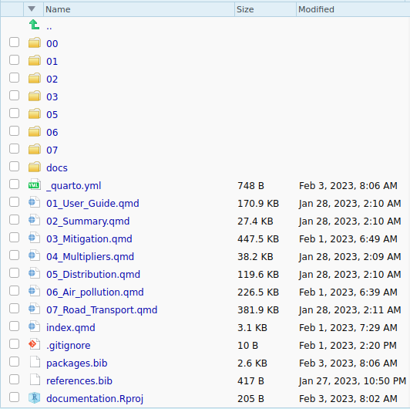

- The .qmd files are markdown versions of different documentation chapters. These can be opened directly in the RStudio editor.
- index.qmd file contains the text from the cover page - 00Cover.docx from the earlier version of the documentation. This will be the landing page for the documentation website.
- The images/plots used in each chapter are stored in the respectively numbered folders (.png format).
- The _quarto.yml file is the YAML file containing settings for rendering of the documentation website.
- The “docs” folder contains the rendered html files for the website. The website can be accessed locally by opening the index.html file in the folder. The folder is named “docs” to allow for publishing using github pages.

Editing Options
Once opened in RStudio, there are two options available for editing the quarto markdown (.qmd) files – directly edit the source files written in markdown or edit the page using the visual editor. These can be toggled at the top of the RStudio Editor.

Source Markdown

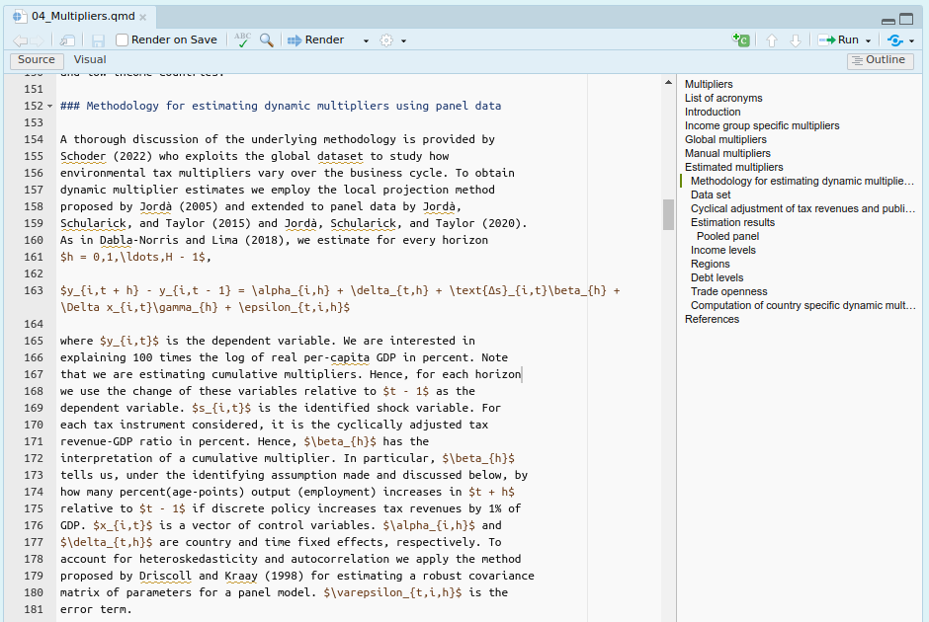
The source option shows the file in the markdown syntax as is (see figure above).
The details of the markdown syntax and the output (headings, lists, tables, figures etc.) can be found here: https://quarto.org/docs/authoring/markdown-basics.html

Visual Editor
The Visual editor shows the visual output of the chapter. Please note that since some documentation chapters are quite large, they might take a few seconds to open in the visual editor. Also note while in most cases the output will look exactly the same as in the visual editor, there might still be minor differences with the final webpage.
In addition to adding text, the editor also provides options to add images, tables, bullet lists and citations directly in the page:
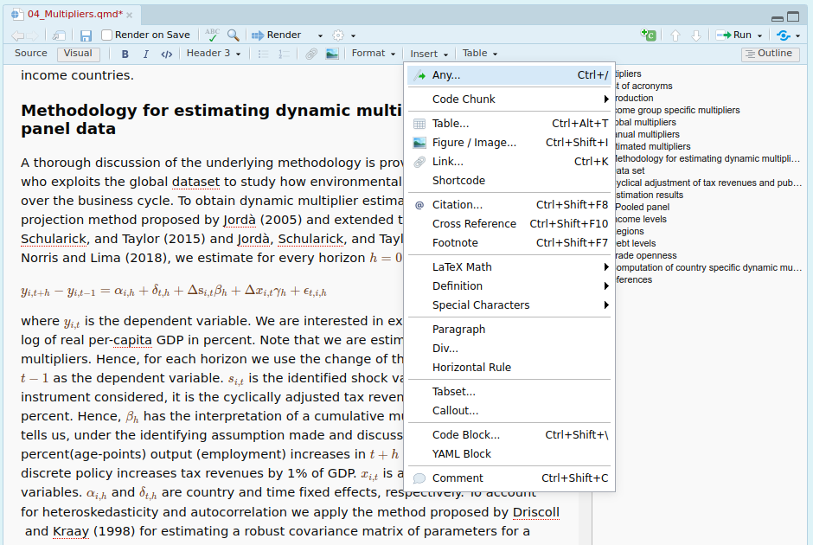
Further information can be found here: https://quarto.org/docs/visual-editor/

Styling and Structure
The following sections discuss the structure of the documentation and styling options:

Sections
The sections in different chapters are structured using the default markdown heading levels. Level 1 heading (#) are chapters (1,2,3 etc), level 2 heading (##) are sections (1.1, 1.2, 1.3 etc). The text references from the original documentation have been kept as is and in general point to the correct sections.
If you want to add new sectional cross references, please use the following syntax and method.
If possible, please add new sections towards the end of the respective higher level as adding new sections in the middle might affect existing hard-coded references that exist within text.
Further details about cross referencing are available here: https://quarto.org/docs/authoring/cross-references.html

Citations
Citations can be added to the documentation chapters using standard bibtex. The bibliography is stored in a file called “references.bib”. It is unpopulated right now. Please add bibtex details of the citation to this file along with a unique identifier. For example:
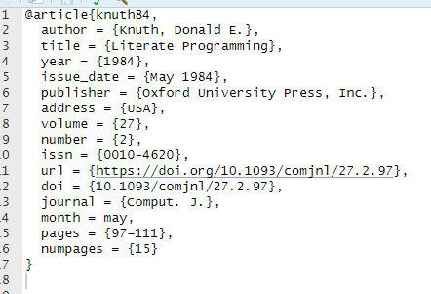
The above article can now be cited anywhere within the documentation using “@knuth84”. For more details about citation syntax, please see: https://quarto.org/docs/authoring/footnotes-and-citations.html#sec-citations

Figures
Figures can be added anywhere in the text using the standard markdown syntax. An example from the documentation:
The first part within “[ ]” is the caption of the figure and the second part within “( )” is the path to the image file.
The figures are displayed using their actual size, with larger figures being constrained to the size of the documentation page. This works well in most cases. However, if you wish to impose a custom size on display of the figures this can be done using the following attribute:
The default units for width and height are pixels. The alignment of the figure can be changed using the attribute: {fig-align:”right”}
It is also possible to automatically number and cross reference figures as well. This works similar to the cross references for sections. Cross references in case of figures can be added using the following:
Further information about adding figures can be found here: https://quarto.org/docs/authoring/figures.html.
Right now, there are few places where double captions exist (with an extra one in the text). Here, we need to pick a consistent numbering system and also change it within the text.
Please note that the visual editor provides an easier option of adding/removing figures directly using GUI

Equations
Latex equations can be directly added within the markdown text. Please enclose latex math in single $ for in-line equations. For example:
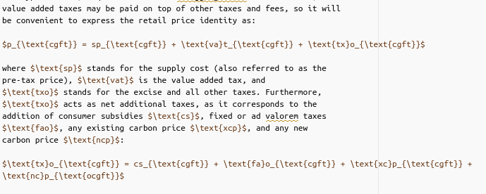
Pasted image 20230203134757.png
These will be rendered as:
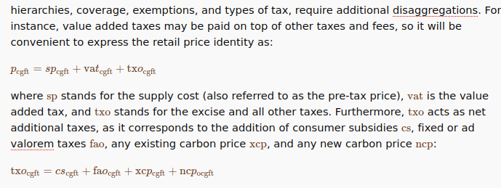
Equations can also be added using the “Insert Anything” option in the visual editor.
Equations can also be labelled in the same way as Figure: {#eq_nameref}

Footnotes
Footnotes can be added within the text using the syntax:
Here, “[^1_3]” points to a footnote which can be added anywhere in the text. Currently, footnotes of each chapter are placed at the end of the chapter. For example:
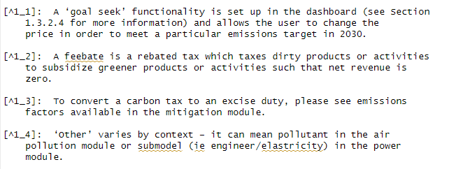
It must be made sure that the footnote numbering/reference is unique. Presently the footnotes have been referred as (1_2, 1_3, 2_4 etc) where the prefix to _ is the chapter number and suffix is the footnote number from the existing documentation.

Rendering and Preview
If you are interested in previewing the changes to the page you are editing, please follow the following steps:
- Save the qmd file you have edited.
- In the terminal tab of RStudio, write the command “quarto preview” and press enter.
This will render the page and open it locally within the browser. Once this page is open any further changes that you make in the “qmd” file will automatically reflect in the preview as soon as the files is saved.
The entire documentation can be built using the command “quarto render” in the terminal within the RStudio IDE. This command will rebuild the entire website and store it within the docs folder. You can open the “index.html” in the folder to check the output. If you are doing edits and want to preview what the changes look like, it is suggested to use “quarto preview”, as it is much faster than rendering the whole website.
Once you are done editing and are satisfied with the changes, use the “quarto render” command to render the whole website and push the changes to the repository. The changes will reflect in the website once the changes you have pushed to private repository are also pushed to the public repo where the website is located.

