Distribution module: how to use it, and the prompt to update it
CPAT-AI · repo github.com/cpmodelai/cpat_ai · prompt file excel_ai/plans/prompts/Distribution_module_prompt.md · 2026-10-29

1. Example queries
Short prompts to type into GitHub Copilot (Current checkout, Claude Opus, Interactive). The long instructions are in Distribution_module_prompt.md; Copilot reads them from the repo, so you never paste them. Send one prompt, read the report, then send the next.

Starter (new session)
Type @ to attach the two files, then:
@AGENTS.md @excel_ai/plans/prompts/Distribution_module_prompt.md Follow these files. Do phase 0 only, then stop and report.

If excel_ai/plans/prompts/ is not in your checkout, double-click SyncRepo.bat first; if it is still missing, paste the whole of Distribution_module_prompt.md instead (Appendix A of the Word guide).

Starter queries
One at a time, after the starter (or in a new session with the two files attached):
- Review what already exists (the module is built)
@AGENTS.md @excel_ai/plans/prompts/Distribution_module_prompt.md The module exists (v0.1.3). Review it against `NORMS.md` section 9 and its README, run `check_distribution.py`, and report what is missing. Do phase 0 only, then stop and report.

- Run a scenario end to end
Change the live carbon price in the mitigation prototype to <x> USD/tCO2 in <year>, update the distribution module from it, and show me the effect by decile and the Gini change against the current values.

- Check it against legacy outputs
Check it against legacy outputs: compare the distribution module's results for Egypt with legacy 465's cached values, decile by decile in the analysis year (overall, urban, rural), and the MTOutputs distribution results. List every difference above 0.1% with its cause: a registered bug fix, a replicated issue, or unexplained (then find the cause).

- Produce a short PowerPoint, following the norms of the other documents
Produce a short PowerPoint (about 6 slides) on the distribution module: what it does, how it links to the other modules, the results for Egypt against legacy, the bugs fixed and issues replicated (codes), open decisions. Follow the norms of the other documents: the CPAT-AI Overview deck (`excel_ai/CPAT-AI_Overview_v<version>.pptx`, builder `excel_ai/mitigation/presentation/build_deck.js`), counts taken from the register, `NORMS.md` 5. Save it as `excel_ai/CPAT-AI_Distribution_Overview_v<version>.pptx`.

- Check that every bug found is in the registers
Check that every bug and issue you found is in the register (`excel_ai/mitigation/issues_register.py`, `make_legacy_fixes.py`), with its code, legacy cells and cross-references; regenerate `excel_ai/BUGS.md`, `excel_ai/ISSUES.md` and the tracker, and list what you added.

- Adjust what you do not like or what is missing
I found I don't like format (x) / you are lacking output (y): please adjust. Change the builder, not the built workbook; rebuild, rerun the check and show me the result.

Next phases
Go ahead with phase 1.

Go ahead with phase 2.

Go ahead with phase 3.

Example follow-ups
Look at one result:
For Egypt, the live scenario, show me the total effect by decile (overall, urban, rural) and the Gini change, next to legacy 465's cached values, with the reason for each difference.

Check a legacy bug in the register:
Show me register item <code>: the legacy cells, what legacy computes, what the module computes and the effect on deciles 1 and 10. Is it a bug or an issue under NORMS.md section 0?

Change a distribution setting (the formula source is excel_ai/mitigation/build.py):
<describe the change>. Change it in excel_ai/mitigation/build.py, rebuild the prototype, rebuild the module, run check_distribution.py and show me the result.

When a check fails:
check_distribution.py fails on <name of the check>. Find the cause, fix the builder (not the check), rebuild and run the check again. Tell me what was wrong.

Before you save:
Show me the changes before you save them. List every file you changed and why.

Resume later in a new session:
@AGENTS.md @excel_ai/plans/prompts/Distribution_module_prompt.md We are at phase <n>. Read the bottom of CAVEATS.md and the last report, then do phase <n> only and stop.

Then save to GitHub: close the workbooks and double-click SyncRepo.bat in the repo folder.

2. What this is
The distribution module already exists: excel_ai/CPAT-AI-Distribution-Prototype_v0.1.3.xlsm, household effects of a mitigation scenario by income decile in one analysis year, replicating the legacy Distribution sheet (bugs fixed and registered; issues replicated and registered). It is cut from the built mitigation prototype, so its formulas have one source (excel_ai/mitigation/build.py), and it reads Mitigation only through its tab FromMitigation (section 19a of the mitigation workbook, defined name ExportDistn).

2b. Using the module (no AI needed)
- Open CPAT-AI-Mitigation-Prototype_latest.xlsm (in excel_ai/permalink_countryeditable/), define the scenario, click Recalculate now, and save it (or leave it open).
- Open CPAT-AI-Distribution-Prototype_latest.xlsm from the same folder and enable macros.
- On Cover, click Update from Mitigation: it copies section 19a of the mitigation workbook into FromMitigation and recalculates. Cover shows the file used and its time.
- Read the results on Distribution (one column group per scenario, deciles across).
- Distribution settings of a scenario (analysis year, revenue recycling, targeting): ScenarioDefinition, then Recalculate now.
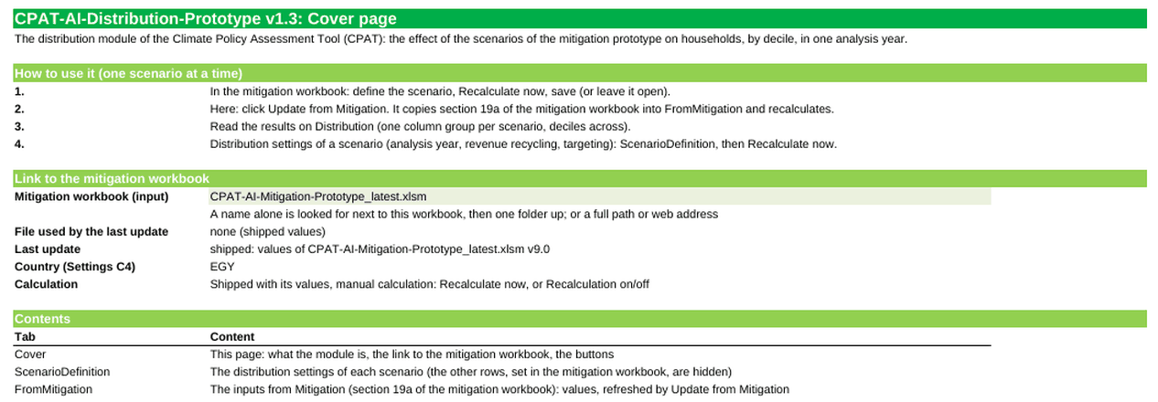
The Cover of the distribution module v0.1.3 (rendered from the file; the buttons are not shown)

2c. What the prompt does
It does not rebuild the module. It (1) makes the macro look for the mitigation workbook in permalink_countryeditable/ first, as the module rules of NORMS.md section 9 require (today it looks in permalink/); (2) checks the module against legacy 465 decile by decile and registers anything new; (3) fixes the Cover version table and releases v0.1.4. Phase 0 is a review only.

3. Before you start
- The Setup guide (other/SetupGuide.docx) Parts 1 and 3 are done: Git, the GitHub Copilot app signed in, the repo in C:\Users\WB<PID>\Repos\CPAT-AI.
- The repo is up to date: double-click SyncRepo.bat once before you start (section 5).
- The prompt file excel_ai/plans/prompts/Distribution_module_prompt.md is in your checkout after you sync (it is on main); if not, use Appendix A (the same text).
- Time and credits: each phase is a long task. Send one phase, read the report, then the next. Type /context to see the credits used.
- Victor and Faustyna: you do not need Copilot to use the module (section 2b). The prompt is for changes to it.
Optional (not needed to start): Copilot runs the builders and checks with Python and recalculates the workbooks in LibreOffice. If either is missing on your desktop, the prompt tells Copilot to say so, install nothing without your OK, and list what it could not run; you then review the workbook in Excel 365.

4. Step by step in GitHub Copilot (local mode)
"Local mode" means Copilot works on the CPAT-AI folder on your laptop (workspace Current checkout), not in a cloud copy. Everything it builds lands in C:\Users\WB<PID>\Repos\CPAT-AI, where you can open it in Excel, and you save it to GitHub yourself at the end (section 5).

Step 1. Open the repo folder (first time only)
In the Copilot app sidebar, click + next to Projects, then Open folder, and pick C:\Users\WB<PID>\Repos\CPAT-AI. It stays in the sidebar.
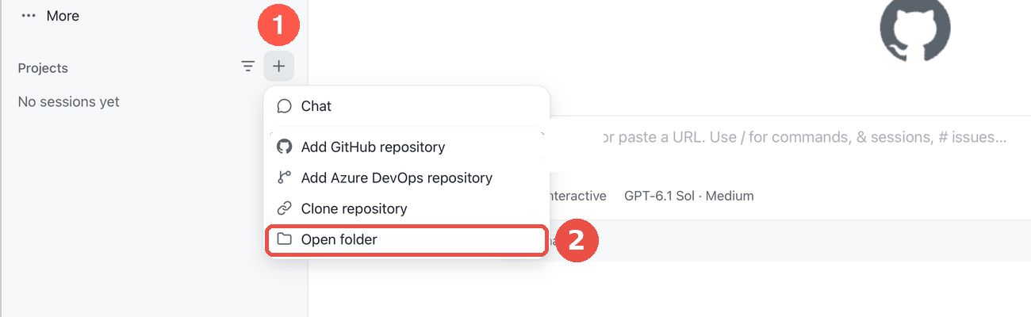
Projects: + then Open folder

Step 2. Start a session in local mode
Point at CPAT-AI in the sidebar and click the + next to it. Under the prompt box, open the workspace selector and choose Current checkout ("Work in the existing checkout"). Do not choose New worktree or Cloud.
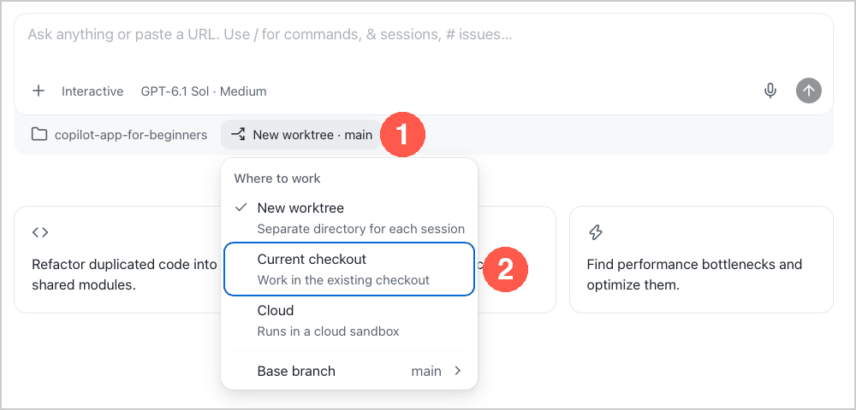
Workspace selector: Current checkout = local mode

Step 3. Pick the model
Click the model chip under the prompt box, switch Auto off, then pick Claude Opus (the strongest model: this is a long, careful task). Effort: High if offered.
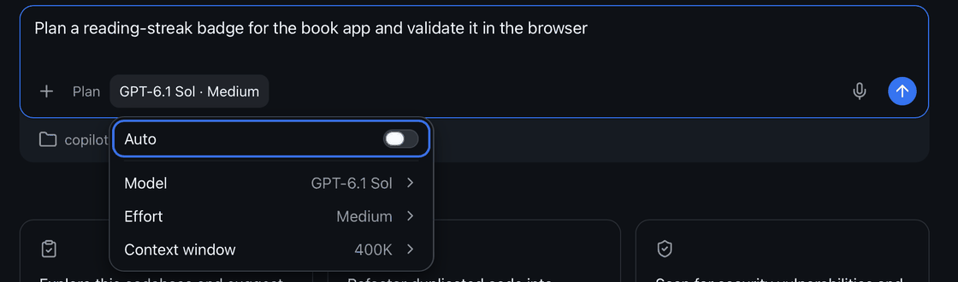
Model chip: Auto off, then Model

Step 4. Pick the mode
Click the mode chip and pick Interactive: Copilot asks before it runs commands or edits files, and you approve each step. Do not use Autopilot for this task.
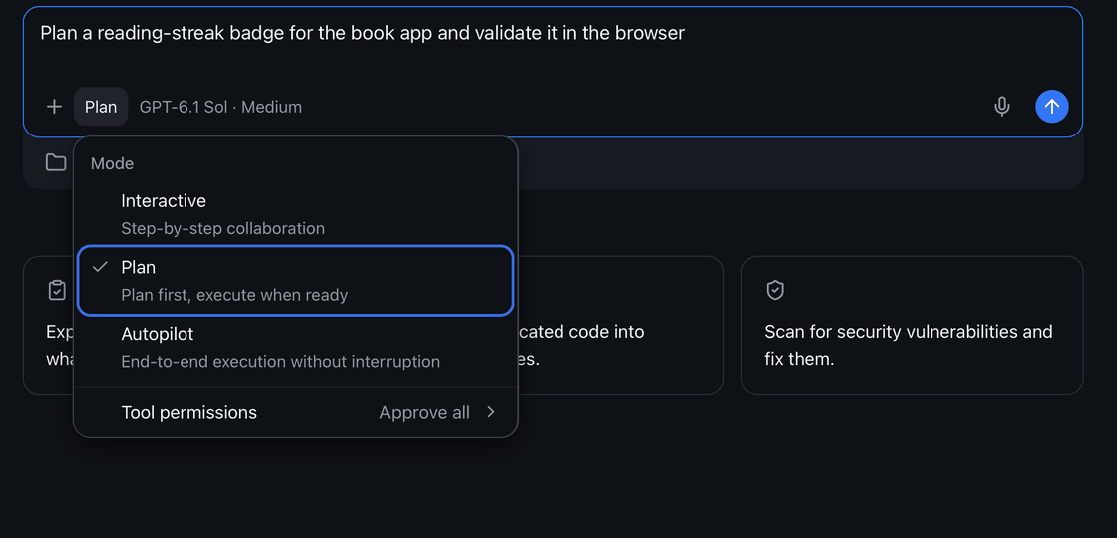
Mode chip: pick Interactive

Step 5. Give it the prompt
You only type a short starter prompt. The long instructions are a file in the repo (excel_ai/plans/prompts/Distribution_module_prompt.md) that Copilot reads itself; the starter and the follow-up prompts are in excel_ai/plans/prompts/Distribution_starter_prompts.md and in section 1.
Option A (the prompt file is in your checkout): type @, pick AGENTS.md, type @ again, pick excel_ai/plans/prompts/Distribution_module_prompt.md, then add the words below and press Enter.
@AGENTS.md @excel_ai/plans/prompts/Distribution_module_prompt.md Follow these files. Do phase 0 only, then stop and report.

Option B (the file is not in your checkout yet, or you prefer to paste): copy the whole text of Appendix A into the prompt box, after @AGENTS.md , and press Enter.
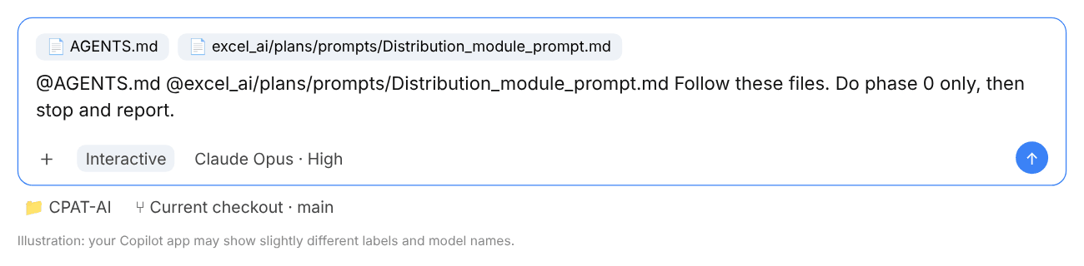
The prompt box with both files attached (illustration)

Step 6. Let it work, approve each step, read the report
Copilot reads the documents, runs commands and asks for approval. Approve reading files and running Python; refuse anything that would delete files, change excel_ai/legacy/ or push to GitHub. When it stops, it reports what it did, the bugs and issues it registered, and the decisions it needs from you. Answer the decisions in plain words before going on.
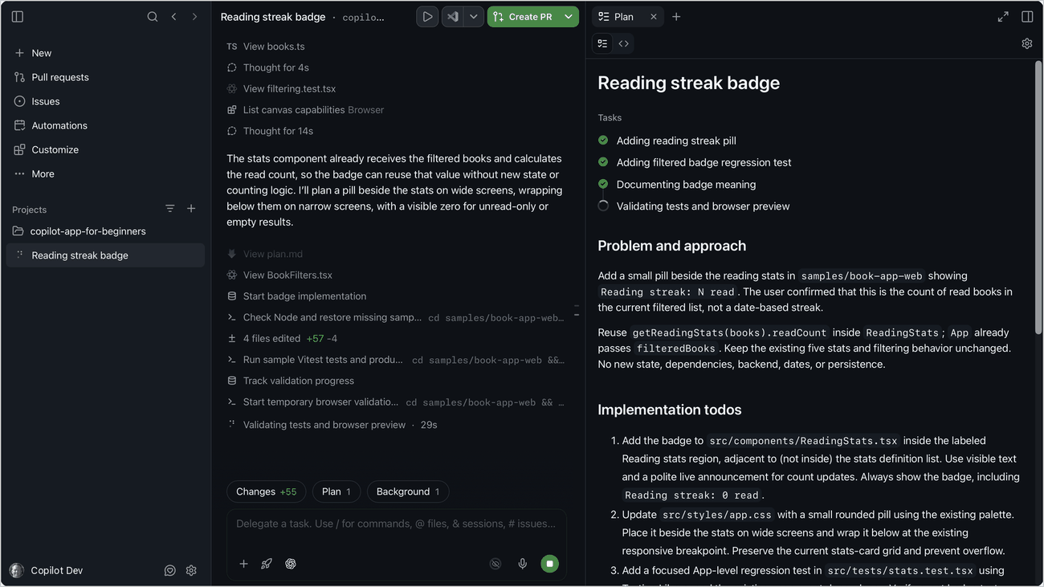
A session at work: the steps on the left, the plan on the right

Step 7. The next phases, one message each
Send these one at a time. Read each report and check it (the third column) before sending the next.
Send | What it does | Check before going on
Go ahead with phase 1. | The macro looks for the mitigation workbook in permalink_countryeditable/ first; Cover shows the file used | The macro test and the VBA name scan pass
Go ahead with phase 2. | Legacy check on 465, decile by decile, through distribution_ref.py | Every difference explained by a registered bug or issue
Go ahead with phase 3. | Release v0.1.4: rebuild, check_distribution.py, publish, README, CAVEATS, TODO | PASS; _latest in both permalink folders

More example follow-ups (answering its decisions, asking for an explanation, a failing check, stopping and resuming in a new session): section 1.

Step 8. Look at the changes
Type Show me the changes before you save them. or open Changes under the prompt box: every edited file as a diff. Open the new workbook in Excel 365 (enable macros) and look at it. Do not edit a built workbook by hand: ask Copilot to change the builder and rebuild.
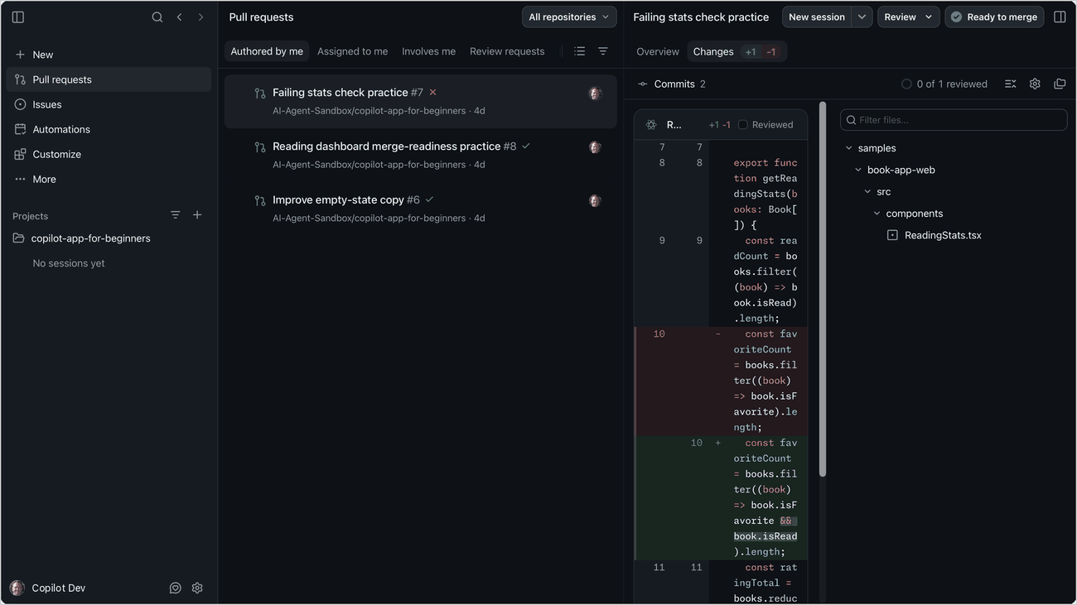
The Changes view: every edit as a diff before you keep it

5. When done: save to GitHub with SyncRepo.bat
Copilot does not commit unless you ask (AGENTS.md). When the last phase is done and you are happy with the result, save everything to GitHub with the sync script in the repo folder.
- Close every workbook of the repo in Excel (an open file cannot be committed cleanly).
- In File Explorer, go to C:\Users\WB<PID>\Repos\CPAT-AI and double-click `SyncRepo.bat`.
- It switches to main, pulls everyone else's changes, and lists the files you changed. Read the list: no workbook or export with real (proprietary) data may be in it (only dummy or public data are committed).
- Type a short commit message, for example Distribution module v0.1.4: permalink_countryeditable link, legacy 465 check, and press Enter.
- It commits, pushes to main and shows Pushed. Press any key to close the window.
- Check on github.com/cpmodelai/cpat_ai that your commit is the latest one.
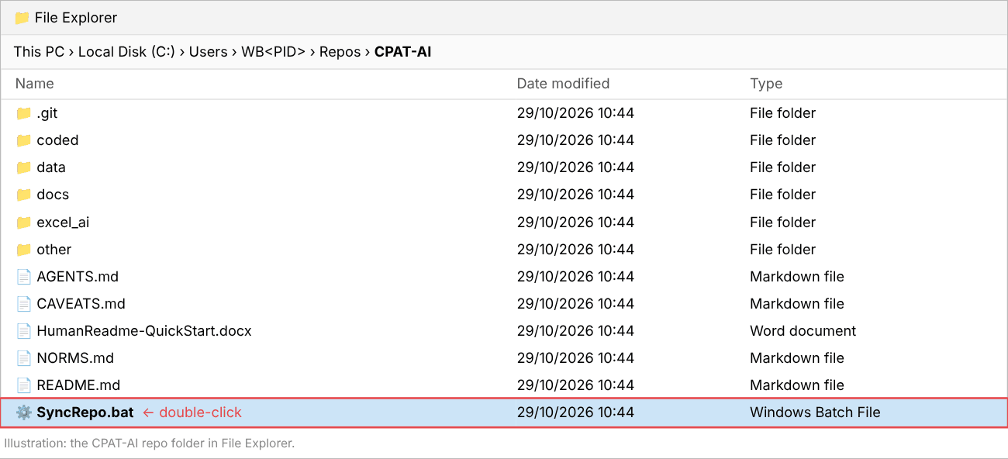
The CPAT-AI folder: double-click SyncRepo.bat (illustration)
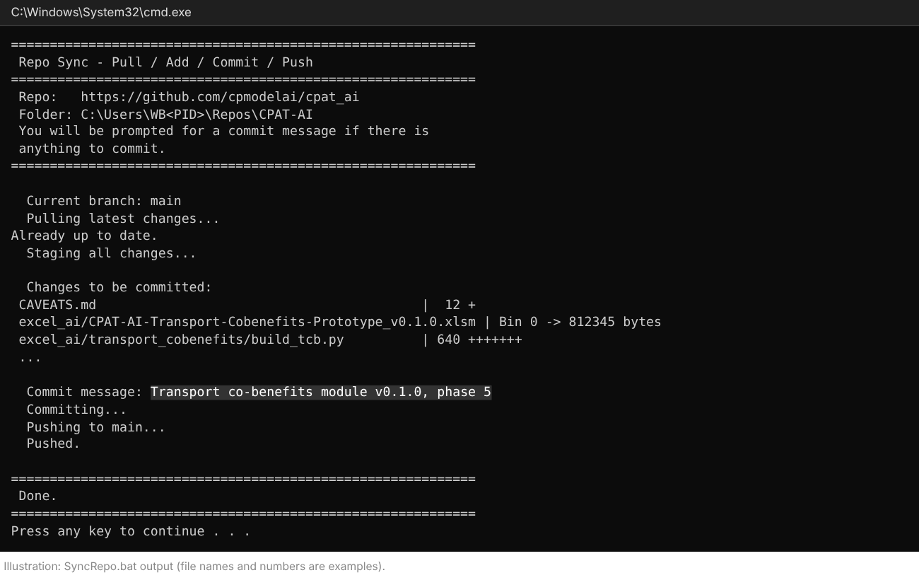
SyncRepo.bat at work: pull, list of changes, your message, push (illustration)
Other ways: from a terminal in the repo folder, SyncRepo.bat "your message" skips the question; SyncAllRepos.bat in the Repos folder syncs every repo; or tell Copilot Commit and push with a clear message.
If it stops with [ERROR] Could not switch to main, Copilot left work on another branch: ask Copilot "Merge this branch into main locally and switch to main", then run SyncRepo.bat again. If it stops with a merge conflict or a failed push, use GitHub Desktop (Setup guide, Part 4) or ask Copilot to resolve the merge; for a binary file (Excel, Word) keep one whole version.

6. The repo in brief (github.com/cpmodelai/cpat_ai)
Four documents to know:
- README.md: start here; what is where and who reads what.
- AGENTS.md: the instructions every AI follows; attach it to every prompt.
- NORMS.md: the rules. Section 0: never replicate a legacy bug; always replicate a legacy issue, and register both. Section 9: how the modules work. Section 1: the column layout.
- CAVEATS.md: the log of every finished task (newest at the bottom); read it before building on earlier work.
Also useful: excel_ai/BUGS.md and excel_ai/ISSUES.md (the legacy bugs and issues found so far), HumanReadme-QuickStart.docx (a short orientation for people), excel_ai/plans/prompts/ (these prompts).

Appendix A. The prompt (exact text)
The full content of excel_ai/plans/prompts/Distribution_module_prompt.md. Paste all of it (Step 5, option B).
# Prompt: bring the distribution module up to the module norms (v0.1.4)

The distribution module already exists (`excel_ai/CPAT-AI-Distribution-Prototype_v0.1.3.xlsm`, sources in `excel_ai/distribution/`). This prompt does not rebuild it: it links it through `permalink_countryeditable/`, checks it against legacy, and closes the open items of the module norms. Paste this whole file into GitHub Copilot (Current checkout, Interactive, Claude Opus), with `@AGENTS.md` attached, or attach this file and type "Follow this file. Do phase 0 only, then stop and report." Work one phase per message. Human guide: `CPAT-AI_HowTo_Distribution.docx` in this folder.

---

You are working in the CPAT-AI repository on the local checkout. Follow `AGENTS.md` and every document it points to, above all `NORMS.md` section 0 (bugs and issues), section 1.1b (the distribution layout) and **section 9 (how modules work)**. Read before you start: `excel_ai/distribution/README.md`, `build_distribution.py`, `CPATDistribution.bas`, `check_distribution.py` and its last report; `excel_ai/plans/Modules.md` (M3, M6); the distribution items of the register (`excel_ai/mitigation/issues_register.py`, Module = Distribution; former codes D1-D31, DI1-DI4) and of `excel_ai/BUGS.md` and `excel_ai/ISSUES.md`; `other/distribution/LESSONS_LEARNED.md`; `excel_ai/mitigation/distribution_ref.py`; the bottom of `CAVEATS.md`.

## Rules (do not break them)

1. **Legacy first** (the legacy `Distribution` sheet of `excel_ai/legacy/workbooks/CPAT 1.0pre_465_NoPropData.xlsb`, read-only). Never replicate a legacy bug: fix it and register it (`L`, with cells and a cell-level fix plan). Always replicate a legacy issue and register it (`I`). When unsure, treat it as an issue, replicate it, and ask me. Next free codes from `register.py`; one register, no list of your own.
2. **The distribution formulas have one source**: `excel_ai/mitigation/build.py`. The module is cut from the built prototype. Change a formula there, rebuild the prototype, then rebuild the module; never edit the module workbook by hand.
3. **Column norms**: the distribution layout of `NORMS.md` 1.1b (A-J descriptors as Mitigation; per group a code column, basket, deciles 1-10, spacer; group *n* reads Mitigation group *n*); `FromMitigation` keeps the Mitigation column layout (1.1, 9.2).
4. **Encapsulated**: the `Distribution` sheet reads only `FromMitigation`, `ScenarioDefinition`, its data tabs and Settings constants (NORMS 9.2); its results stay on the `Distribution` sheet under the LiveOutputs codes `<iso>.distn.*`, because no other workbook reads them yet (an output tab of plain copies, NORMS 9.2, is added only if I agree).
5. Excel rules as `NORMS.md` 3, 3b, 3d, 3g, 3h. If Python, openpyxl or LibreOffice is missing on this computer, say so before you start: install nothing without my OK; where LibreOffice is missing, skip the recalculation steps and list what was not run (I review in Excel 365). Never commit real data. Do not commit or push unless I ask.

## Phases (one per message; stop after each and report)

**Phase 0. Review (no change).** Build nothing. Report: (a) how the module meets `NORMS.md` section 9, item by item, and what is missing; (b) the macro's file search (it looks for the mitigation workbook next to the module, in `permalink\`, one folder up, then in `permalink\` one folder up: it does **not** look in `permalink_countryeditable\` yet, NORMS 5a and 9.3); (c) the distribution bugs and issues in the register on 465 (any legacy 465 change to the `Distribution` sheet since 456: rows moved, bugs the CPAT team fixed); (d) the date and result of the last `check_distribution.py`; (e) the Cover: its title and version log still use the old numbering (v1.3 for 0.1.3) and not the version-table columns of NORMS 5b (Version, Date, Description, Max abs regression diff).

**Phase 1. Link through `permalink_countryeditable/`.** In `CPATDistribution.bas` (`MitPath`): look first in `permalink_countryeditable\` (next to the module, then one folder up), then the current places; Cover says which file was used (link table: path, saved time, scenario names). Same change in the builder's Cover text and README. Test the search order with a Python emulation of the macro and the VBA name scan of `check_distribution.py`.

**Phase 2. Legacy check on 465.** Compare the module (Egypt, the scenario of the prototype) with legacy 465's cached `Distribution` values and `MTOutputs` distribution results, decile by decile, through `distribution_ref.py`; every difference explained by a registered bug fix or issue, or reported as new. Register what is new.

**Phase 3. Release.** Bump `VERSION` to 0.1.4, rebuild (`python excel_ai/distribution/build_distribution.py`), run `python excel_ai/distribution/check_distribution.py` (PASS), lint, publish with `release.py` `publish(link=True)` to `excel_ai/`, `releases/`, `permalink/` and `permalink_countryeditable/`. Cover title and version table in the 0.1.x numbering and the NORMS 5b columns, with a row naming the mitigation version used. Update `excel_ai/distribution/README.md`, `excel_ai/plans/TODO.md` (M6: distribution done), the register lists, and add the entry at the bottom of `CAVEATS.md`.

## Report after each phase

What you did; files changed; check results (PASS/FAIL with numbers); bugs and issues (codes); open questions for me. Do not go to the next phase until I say so.

Appendix B. Getting set up with AI in the Climate-Fiscal Team
The text of the team's setup guide (other/SetupGuide.docx; written to setup_guide.md by make_quick_guides.py).
This guide has four parts. Part 1, Setup: new users, once. Part 2, Update: if you set up before the repos moved to github.com/cpmodelai, once. Part 3, Tools: how to use the three tools. Part 4, Git in brief: what git does and how to fix a clash.

Part 1. Setup (new users)
Action A: Please create a GitHub ID (using a work or personal email address).
1. Go to https://github.com and click Sign up.
2. Enter your email address and a password.
3. Type the username you want. GitHub will tell you right away if it’s taken.
4. Complete the verification puzzle, then enter the code GitHub emails you.
Action B: Please get Git for Windows from the WB Software Center, and GitHub Copilot from the Microsoft Store. GitHub Desktop (also in the Software Center, or desktop.github.com) is recommended too: it shows your changes and helps resolve merge issues (Part 4).
Action C: Go to C:\Users\WB<PID> (go to C:\Users and find your folder: WB followed by your PID). Download Repos.zip (https://worldbankgroup.sharepoint.com/:u:/s/WKPEFFiles/IQDg6DHLPk2BSKjexUoCSQE6AWxZvE7l9KfLJjHP9XBj3K8?e=hDP9IL) (or get it from github.com/cpmodelai/repo-tools) and extract it there, then go to C:\Users\WB<PID>\Repos. Click CloneRepos.bat to clone the selected repos. Then click SyncAllRepos.bat for any changes later.
Action D: Add your GitHub ID (and get an Enterprise account).
- Once you have your ID, ask Kacper (klukaszewicz@worldbank.org) to add you to cpmodelai, where our repos are. Copy in Paulina and Stephen for information.
- Ask for your user ID to be added to the WB GitHub organisation: http://githubmemberrequest/
- Get a GitHub Enterprise account by emailing GitHub_Enterprise_Admin@worldbankgroup.org with your GitHub ID.

Optional: linking Claude to the repos
1. Create a Claude account. Go to claude.ai (or get the Claude app) and click Sign up, with an email address or a Google account. If you used email, click the sign-in link Claude sends you, then enter your name. You are on the free plan; you can upgrade later from Settings.
2. Connect GitHub. A “repo” (repository) is a folder of files stored on GitHub. In Claude, go to Settings → Connectors, find GitHub and click Connect; GitHub asks you to approve access (support.claude.com, “Use the GitHub integration”).
3. Add a repo. Open a chat (or a Project), click + next to the message box, choose “Add from GitHub”, then search or paste the repo URL. Claude can now read its files; you can add several repos.

Part 2. Update to the new repos (existing users)
The repos have moved from github.com/cpmodel to github.com/cpmodelai, and some default folder names have changed. If you set up before this, do these steps once. The new RepoDirectory.csv in Repos.zip lists the new addresses.
Repo · Old address · New address (RepoName) · Default folder (FolderName)
Climate-fiscal AI tools · github.com/cpmodel/new-ai-tools · github.com/cpmodelai/climate-fiscal-ai-tools · climate-fiscal-ai-tools (was new-ai-tools)
CPAT-AI · github.com/cpmodel/CPAT-AI · github.com/cpmodelai/cpat_ai · CPAT-AI
Repo tools · (new) · github.com/cpmodelai/repo-tools · repo-tools
1. Save your work first. Double-click SyncAllRepos.bat (or see Part 3, Step 3) so nothing is lost. If a push fails, copy the files you changed somewhere safe.
2. Get the new files. Download Repos.zip (Action C) and extract it into C:\Users\WB<PID>\Repos. Let it replace RepoDirectory.csv, SyncAllRepos.bat and CloneRepos.bat.
3. Check the addresses. Open RepoDirectory.csv in Notepad. Every RepoName must start with https://github.com/cpmodelai/ (not cpmodel).
4. Check the folder names. FolderName is the folder inside Repos for each repo, and it must match exactly. The defaults have changed (table above): use the default (and move the old folder aside, step 5), or change FolderName to the name you want.
5. Move the old folders aside. Rename each old folder, for example new-ai-tools to new-ai-tools_old and CPAT-AI to CPAT-AI_old. They still point to the old addresses.
6. Download the new repos. Double-click CloneRepos.bat. It downloads every repo in RepoDirectory.csv whose folder is missing, and warns about any folder that points to another address. Sign in to GitHub if asked; your ID must be in cpmodelai (Action D).
7. Copy across and check. Copy any unsaved files from the _old folders into the new ones. Double-click SyncAllRepos.bat: every repo shows Pulling, none shows [SKIP] Folder not found. Then delete the _old folders.
8. Update the Copilot app. Add the new folders in the sidebar (Part 3, Step 1) and remove the old ones.
Check: CloneRepos.bat shows [OK] for every repo. In each repo folder, git remote -v shows https://github.com/cpmodelai/...
Download fresh rather than re-pointing the old folders: the new repos do not share all of the old history, so pulls into an old folder can fail.

Part 3. Tools (GitHub Copilot app)
AI tools quick start: three tools, each in its own repo. The repo address is at the start of each tool.
We assume you already have
- The repo for your tool downloaded on your laptop (C:\Users\WB<PID>\Repos\folder>, Part 1 or 2) and up to date.
- The GitHub Copilot app installed (Microsoft Store) and signed in with your GitHub account.
- Part 1 done (and Part 2 if you set up before the move). Not there yet? See Presentations/GitHub_Copilot_AI_User_Guide.pptx.
Steps 1-2 set up a session. Then do Tool 1, 2 or 3. Step 3 saves your work.

Step 1. Open the repo and start a session (once per task)
1. Add the repo (first time only). In the sidebar, click + next to Projects, then Open folder. Pick the tool’s repo folder, for example Repos\climate-fiscal-ai-tools. It stays in the sidebar.
2. Start a session. Point at the repo in the sidebar and click the + next to it.
3. Work in your folder. Under the prompt box, open the workspace selector and choose Current checkout. Copilot then edits the repo folder on your laptop.

Step 2. Pick the model and the mode (every session)
1. Model. Click the model chip under the prompt box. Switch Auto off, then pick Claude Sonnet for everyday work, Claude Opus for the excise research.
2. Mode. Click the mode chip and pick Interactive: Copilot asks before it acts.
3. Credits. Type /context at any time to see the AI credits the session has used.

Tool 1. Excise diagnostic for Indonesia (Claude Opus · Interactive)
Repo: https://github.com/cpmodelai/climate-fiscal-ai-tools · Folder: Repos\climate-fiscal-ai-tools
⚠ Deep research uses a lot of credits. Send one prompt, read the answer, then send the next. Check /context as you go. Stop and fix anything wrong before going on.
Attach the instructions: type @ and pick user_guide/excise_diagnostic_process.md (or drag the file onto the prompt box).
Paste: @user_guide/excise_diagnostic_process.md Follow this file. Run stage A1 for Indonesia, 2020 to 2026-09-30. Search the web for the laws. Stop after A1.
Then, one at a time: Run stage A2. · Run stage A3. · Run stage A4. · Run stage A5. · Run stage A6. Save the Word report and Excel workbook in ExciseDiagnostic/country_results/Indonesia/.
Check: every rate quoted with its date and a source link; missing data says data_gap.

Tool 2. Add tax indicators to the dashboard (Claude Sonnet · Interactive)
Repo: https://github.com/cpmodelai/climate-fiscal-ai-tools · Folder: Repos\climate-fiscal-ai-tools
Paste: Add VAT, personal income tax, corporate income tax and excises (% of GDP) to the dashboard, under Tax revenue, from the IMF WoRLD file already in raw_data. Follow TaxMacroFiscalDashboard/build/README.md. Do not change anything else. Then rebuild and show me Indonesia.
Then: Commit and push with a clear message.
Check: Indonesia, % of GDP: tax 10.08 · VAT 3.52 · corporate 2.65 · personal 1.79 · excises 1.11

Tool 3. Make an update to CPAT-AI (Claude Opus · Interactive)
Repo: https://github.com/cpmodelai/cpat_ai · Folder: Repos\CPAT-AI
Attach the rules: type @ and pick AGENTS.md (or drag the file onto the prompt box). It points Copilot to NORMS.md, CAVEATS.md and the to-do lists, so it follows the repo’s rules.
Paste (fill in your change): @AGENTS.md Follow this file and the documents it points to. In the mitigation prototype, <describe your change>. Never replicate a legacy bug; replicate legacy issues and register them. Rebuild, run excel_ai/mitigation/check_quick.py and show me the result. Then add the entry at the bottom of CAVEATS.md and update excel_ai/plans/TODO.md.
Then, one at a time: Show me the changes before you save them. · Commit and push with a clear message.
Rules the repo sets (AGENTS.md):
- Never edit a released workbook: the build writes a new version.
- All data go in data/, with the script that converts them.
- Every finished task ends with an entry at the bottom of CAVEATS.md.
- Copilot does not commit unless you ask.
- The checks need Python 3, openpyxl and LibreOffice. Use Claude Sonnet for text-only edits.
Check: check_quick.py says PASS; a new entry at the bottom of CAVEATS.md; the change shows on github.com/cpmodelai/cpat_ai.

Step 3. Save your work to GitHub
1. Ask Copilot. Type: Commit and push with a clear message. Approve what it shows.
2. Or use the script. Double-click SyncAllRepos.bat in your Repos folder (all repos at once), or SyncRepo.bat in the repo folder where there is one.
3. Check. On github.com/cpmodelai/climate-fiscal-ai-tools (Tools 1-2) or github.com/cpmodelai/cpat_ai (Tool 3), your change shows as the latest commit.
With Claude instead: on claude.ai make a Project, add excise_diagnostic_process.md, switch on Research, and paste the same prompts.

Part 4. Git in brief
Git keeps every version of every file in a repo. Your Repos folder holds a local copy of each repo; GitHub holds the shared copy. The scripts in repo-tools (CloneRepos.bat, SyncRepo.bat, SyncAllRepos.bat) do the usual steps for you.
Word · What it means
clone · Download a repo to your laptop, once (CloneRepos.bat).
pull · Get everyone else’s changes from GitHub.
commit · Save a snapshot of your changes, with a one-line message.
push · Send your commits to GitHub so others get them.
branch · A parallel line of work. main is the shared one; AI sessions often work on their own branch.
pull request (PR) · A request to merge a branch into main, reviewed on github.com.
merge conflict · You and someone else changed the same lines; git asks which version to keep.
Every day: double-click SyncAllRepos.bat (or SyncRepo.bat in one repo). It switches to main, pulls, then commits and pushes your changes with the message you type.
If the sync stops with a conflict or a failed push, use GitHub Desktop. File → Add local repository, pick the repo folder. It lists the files in conflict; for each one choose Open in editor (or “Use mine” / “Use theirs”), keep the right text, then click Continue merge, then Push origin. For a binary file (Excel, Word) pick one whole version and copy your changes into it by hand. If in doubt, copy your changed files somewhere safe first, or ask an AI session to resolve the merge.
Never commit real data. Before every sync, check the list of changed files: no CPAT workbook or export holding proprietary data (see the CPAT-AI quick start, section 4).

