Air pollution module: the prompt and how to run it
CPAT-AI · repo github.com/cpmodelai/cpat_ai · prompt file excel_ai/plans/prompts/AP_module_prompt.md · 2026-10-29

1. Example queries
Short prompts to type into GitHub Copilot (Current checkout, Claude Opus, Interactive). The long instructions are in AP_module_prompt.md; Copilot reads them from the repo, so you never paste them. Send one prompt, read the report, then send the next.

Starter (new session)
Type @ to attach the two files, then:
@AGENTS.md @excel_ai/plans/prompts/AP_module_prompt.md Follow these files. Do phase 0 only, then stop and report.

If excel_ai/plans/prompts/ is not in your checkout, double-click SyncRepo.bat first; if it is still missing, paste the whole of AP_module_prompt.md instead (Appendix A of the Word guide).

Starter queries
One at a time, after the starter (or in a new session with the two files attached):
- Build it, starting from what already exists
@AGENTS.md @excel_ai/plans/prompts/AP_module_prompt.md Build the module, starting from what already exists: the v0.3 scaffold in `excel_ai/air_pollution/`, the extracts in `data/air_pollution/legacy_459/`, `Equations_v1_0.md`, the plan `excel_ai/plans/Air_pollution.md` and the distribution module's patterns. Do phase 0 only, then stop and report.

- Check it against legacy outputs
Check it against legacy outputs: compare the air pollution module's results for Egypt with legacy 465's cached values, year by year, both scenarios. List every difference above 0.1% with its cause: a registered bug fix, a replicated issue, or unexplained (then find the cause).

- Produce a short PowerPoint, following the norms of the other documents
Produce a short PowerPoint (about 6 slides) on the air pollution module: what it does, how it links to the other modules, the results for Egypt against legacy, the bugs fixed and issues replicated (codes), open decisions. Follow the norms of the other documents: the CPAT-AI Overview deck (`excel_ai/CPAT-AI_Overview_v<version>.pptx`, builder `excel_ai/mitigation/presentation/build_deck.js`), counts taken from the register, `NORMS.md` 5. Save it as `excel_ai/CPAT-AI_AirPollution_Overview_v<version>.pptx`.

- Check that every bug found is in the registers
Check that every bug and issue you found is in the register (`excel_ai/mitigation/issues_register.py`, `make_legacy_fixes.py`), with its code, legacy cells and cross-references; regenerate `excel_ai/BUGS.md`, `excel_ai/ISSUES.md` and the tracker, and list what you added.

- Adjust what you do not like or what is missing
I found I don't like format (x) / you are lacking output (y): please adjust. Change the builder, not the built workbook; rebuild, rerun the check and show me the result.

Next phases
Go ahead with phase 1.

Go ahead with phase 2.

Go ahead with phase 3.

Go ahead with phase 4.

Go ahead with phase 5.

Example follow-ups
Answer the decisions it asks for (example only: use your own decisions):
Decisions: B1 replicate as an issue for now and show me the effect of the fix on Egypt deaths and wel.air; B14 remove the "Transfer from OECD" option; I-d replicate as an issue. Unit damages from scenario 1 as legacy; compute 2041. Record these in the register, then go ahead with phase 1.

Check the units at the boundary:
Show me, for Egypt 2022, the emissions read from Mitigation section 15 in kt and the tonnes the module uses, pollutant by pollutant, next to the legacy 465 values.

Ask for an explanation:
Explain in plain words, with the Egypt numbers for 2030, how emissions become deaths and then the value of averted deaths in this module.

When a check fails:
check_ap.py fails on <name of the check>. Find the cause, fix the builder (not the check), rebuild and run the check again. Tell me what was wrong.

Before you save:
Show me the changes before you save them. List every file you changed and why.

Stop for the day, and resume later in a new session:
Stop here. Add the CAVEATS.md entry and the TODO items for what is left, and tell me which phase is next.

@AGENTS.md @excel_ai/plans/prompts/AP_module_prompt.md We are at phase <n>. Read the bottom of CAVEATS.md and the last report, then do phase <n> only and stop.

Then save to GitHub: close the workbooks and double-click SyncRepo.bat in the repo folder.

2. What this does
Finishes the air pollution module that was started (the recovered v0.3 scaffold in excel_ai/air_pollution/: Cover, inputs from Mitigation and nine legacy data tables, no calculations yet). The result is a free-standing workbook, CPAT-AI-Air-Pollution-Prototype_v0.1.0.xlsm, that reproduces the legacy Air pollution sheet (concentrations, exposure, health burden, valuation, unit externalities per fuel) of CPAT 1.0pre_465.
It follows NORMS.md section 9: inputs only through FromMitigation (Mitigation section 15: emissions by pollutant and sector, in kt, converted to tonnes once), outputs only through ToMitigation (the rows of Mitigation's tab FromAirPollution) and ToTransportCB (VSL and daily earnings for the transport co-benefits module); the same column layout as the Mitigation sheet; links through excel_ai/permalink_countryeditable/ (then permalink/).
Legacy rule (NORMS.md section 0): bugs fixed and registered (L), issues replicated and registered (I). The scaffold was written on legacy 459; phase 0 reconciles it with 465, the latest legacy file. Bugs that need your decision (B1 adult-disease incidence, B14 "Transfer from OECD", I-d manual VSL units) are replicated as issues and listed for you.

3. Before you start
- The Setup guide (other/SetupGuide.docx) Parts 1 and 3 are done: Git, the GitHub Copilot app signed in, the repo in C:\Users\WB<PID>\Repos\CPAT-AI.
- The repo is up to date: double-click SyncRepo.bat once before you start (section 5).
- The prompt file excel_ai/plans/prompts/AP_module_prompt.md is in your checkout after you sync (it is on main); if not, use Appendix A (the same text).
- Time and credits: each phase is a long task. Send one phase, read the report, then the next. Type /context to see the credits used.
- Read excel_ai/plans/Air_pollution.md section 7 (decisions, above all B1): Copilot will ask you about them.
Optional (not needed to start): Copilot runs the builders and checks with Python and recalculates the workbooks in LibreOffice. If either is missing on your desktop, the prompt tells Copilot to say so, install nothing without your OK, and list what it could not run; you then review the workbook in Excel 365.

4. Step by step in GitHub Copilot (local mode)
"Local mode" means Copilot works on the CPAT-AI folder on your laptop (workspace Current checkout), not in a cloud copy. Everything it builds lands in C:\Users\WB<PID>\Repos\CPAT-AI, where you can open it in Excel, and you save it to GitHub yourself at the end (section 5).

Step 1. Open the repo folder (first time only)
In the Copilot app sidebar, click + next to Projects, then Open folder, and pick C:\Users\WB<PID>\Repos\CPAT-AI. It stays in the sidebar.
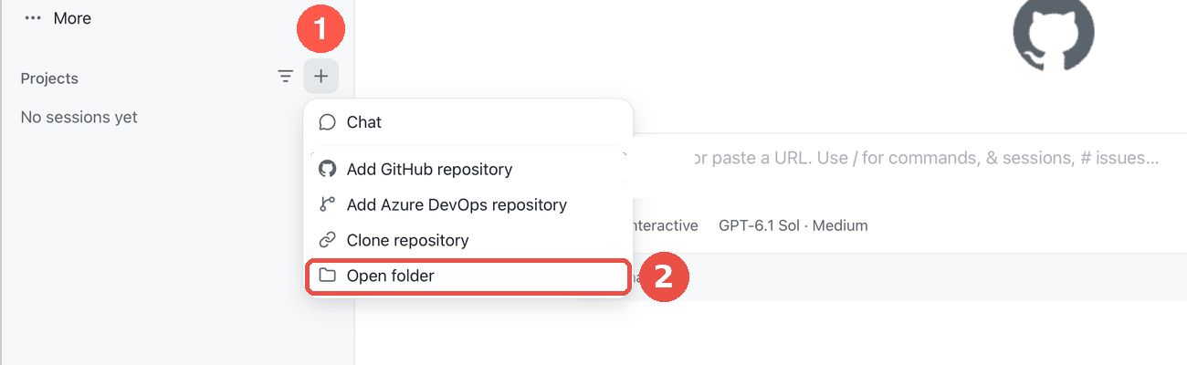
Projects: + then Open folder

Step 2. Start a session in local mode
Point at CPAT-AI in the sidebar and click the + next to it. Under the prompt box, open the workspace selector and choose Current checkout ("Work in the existing checkout"). Do not choose New worktree or Cloud.
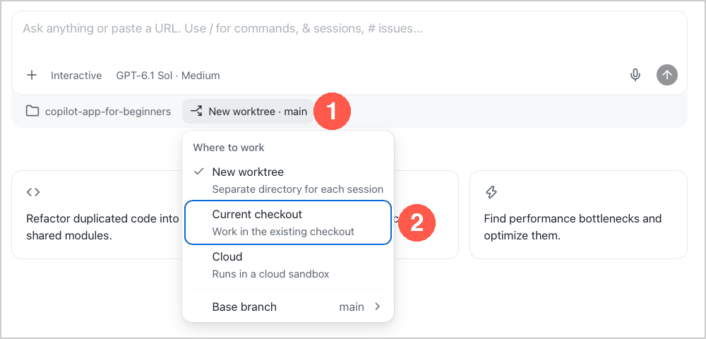
Workspace selector: Current checkout = local mode

Step 3. Pick the model
Click the model chip under the prompt box, switch Auto off, then pick Claude Opus (the strongest model: this is a long, careful task). Effort: High if offered.
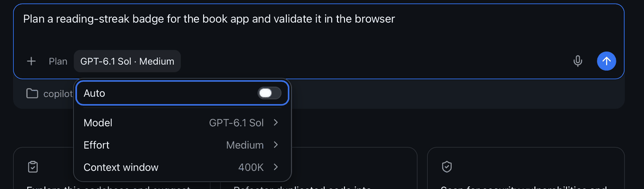
Model chip: Auto off, then Model

Step 4. Pick the mode
Click the mode chip and pick Interactive: Copilot asks before it runs commands or edits files, and you approve each step. Do not use Autopilot for this task.
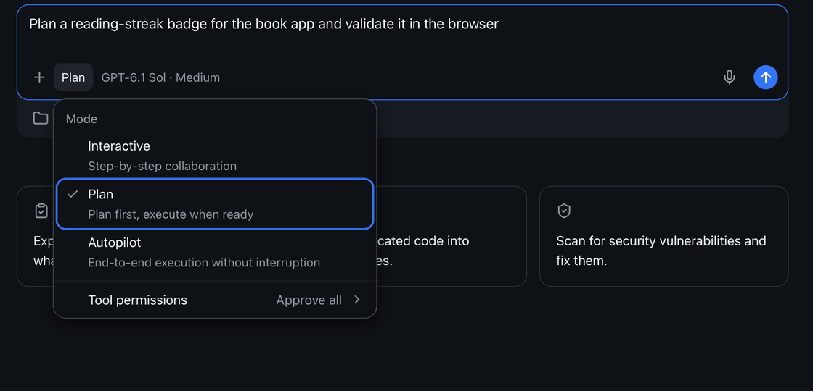
Mode chip: pick Interactive

Step 5. Give it the prompt
You only type a short starter prompt. The long instructions are a file in the repo (excel_ai/plans/prompts/AP_module_prompt.md) that Copilot reads itself; the starter and the follow-up prompts are in excel_ai/plans/prompts/AP_starter_prompts.md and in section 1.
Option A (the prompt file is in your checkout): type @, pick AGENTS.md, type @ again, pick excel_ai/plans/prompts/AP_module_prompt.md, then add the words below and press Enter.
@AGENTS.md @excel_ai/plans/prompts/AP_module_prompt.md Follow these files. Do phase 0 only, then stop and report.

Option B (the file is not in your checkout yet, or you prefer to paste): copy the whole text of Appendix A into the prompt box, after @AGENTS.md , and press Enter.
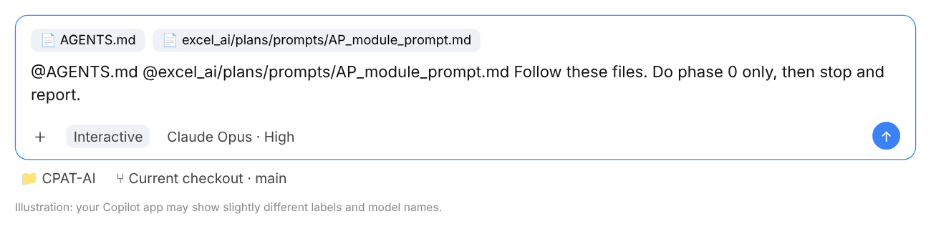
The prompt box with both files attached (illustration)

Step 6. Let it work, approve each step, read the report
Copilot reads the documents, runs commands and asks for approval. Approve reading files and running Python; refuse anything that would delete files, change excel_ai/legacy/ or push to GitHub. When it stops, it reports what it did, the bugs and issues it registered, and the decisions it needs from you. Answer the decisions in plain words before going on.
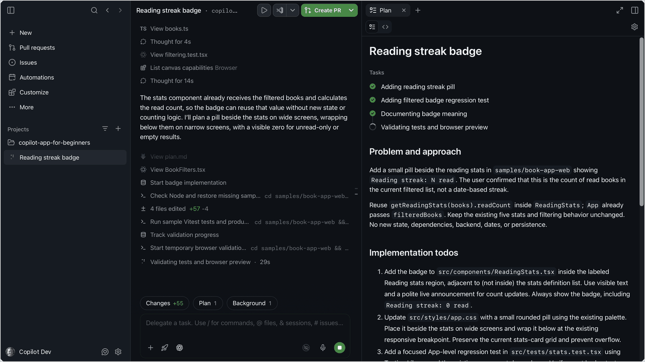
A session at work: the steps on the left, the plan on the right

Step 7. The next phases, one message each
Send these one at a time. Read each report and check it (the third column) before sending the next.
Send | What it does | Check before going on
Go ahead with phase 1. | Python reference ap_ref.py: the legacy chain from emissions to valuation and unit costs | Fixes off reproduces the cached legacy values; the effect of each fix is listed
Go ahead with phase 2. | Data step: data tabs in legacy layout, country and method selection | All-country clone test passes; no proprietary data
Go ahead with phase 3. | The calculation sheet, ToMitigation and ToTransportCB, the builder and macro | Opens in Excel without a repair prompt; Mitigation column layout; kt converted to t once
Go ahead with phase 4. | check_ap.py and its report, with the option sweep | PASS; differences from Mitigation's typed FromAirPollution values explained
Go ahead with phase 5. | Release, README, method, CAVEATS, TODO, register | _latest in both permalink folders; the old Standalone copy removed

More example follow-ups (answering its decisions, asking for an explanation, a failing check, stopping and resuming in a new session): section 1.

Step 8. Look at the changes
Type Show me the changes before you save them. or open Changes under the prompt box: every edited file as a diff. Open the new workbook in Excel 365 (enable macros) and look at it. Do not edit a built workbook by hand: ask Copilot to change the builder and rebuild.
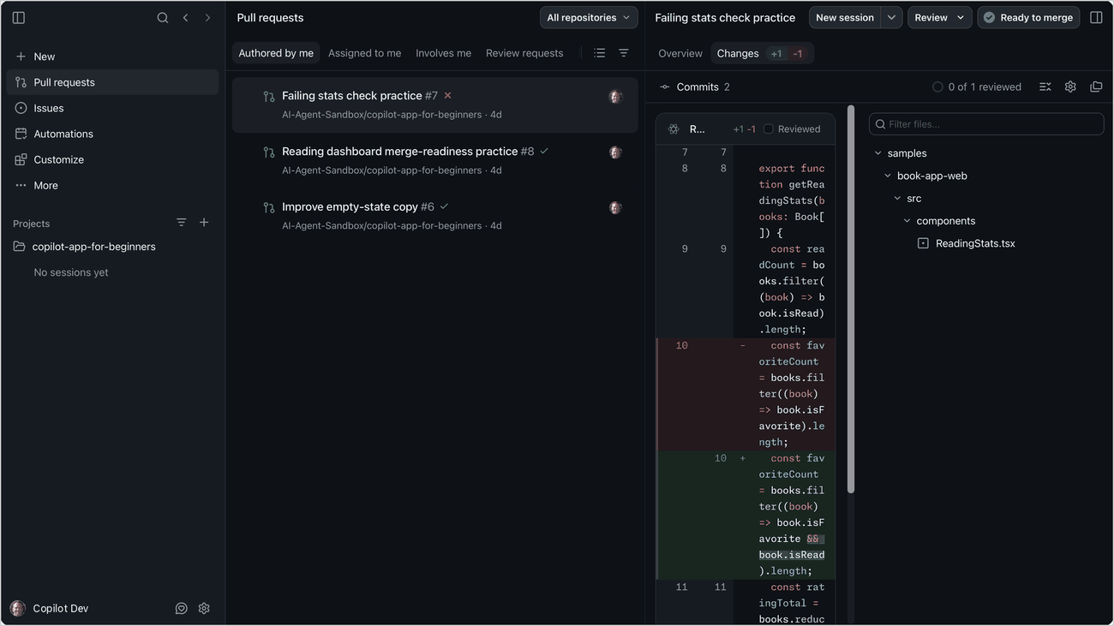
The Changes view: every edit as a diff before you keep it

5. When done: save to GitHub with SyncRepo.bat
Copilot does not commit unless you ask (AGENTS.md). When the last phase is done and you are happy with the result, save everything to GitHub with the sync script in the repo folder.
- Close every workbook of the repo in Excel (an open file cannot be committed cleanly).
- In File Explorer, go to C:\Users\WB<PID>\Repos\CPAT-AI and double-click `SyncRepo.bat`.
- It switches to main, pulls everyone else's changes, and lists the files you changed. Read the list: no workbook or export with real (proprietary) data may be in it (only dummy or public data are committed).
- Type a short commit message, for example Air pollution module v0.1.0, and press Enter.
- It commits, pushes to main and shows Pushed. Press any key to close the window.
- Check on github.com/cpmodelai/cpat_ai that your commit is the latest one.
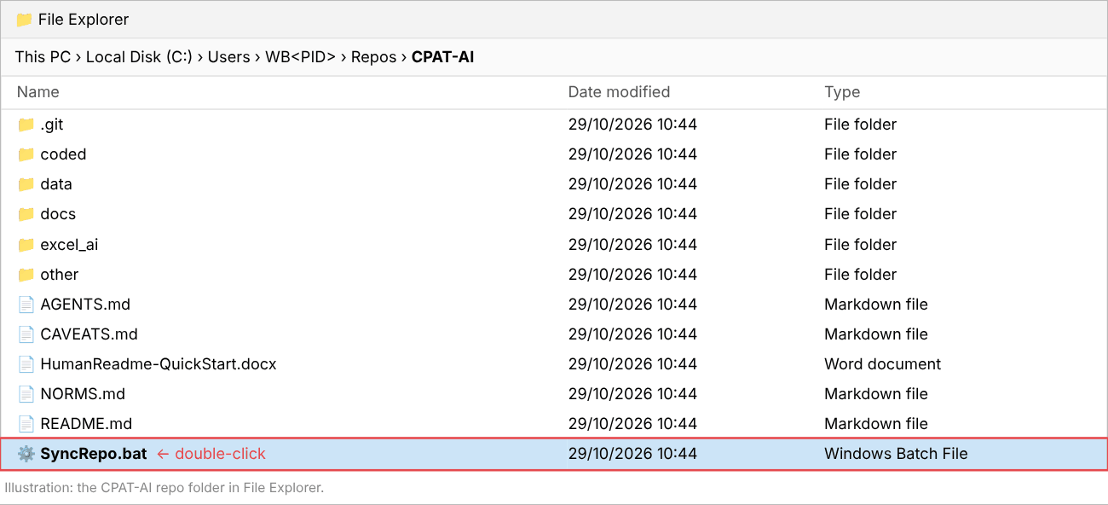
The CPAT-AI folder: double-click SyncRepo.bat (illustration)
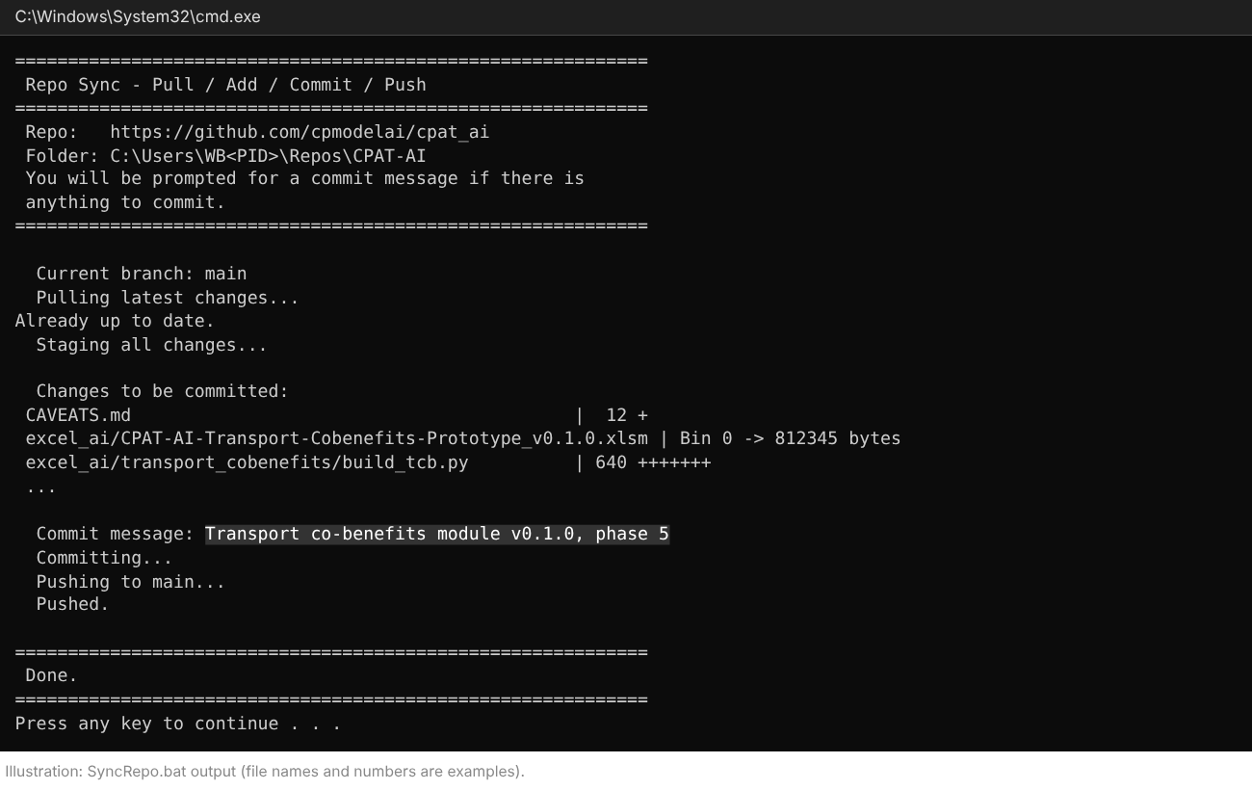
SyncRepo.bat at work: pull, list of changes, your message, push (illustration)
Other ways: from a terminal in the repo folder, SyncRepo.bat "your message" skips the question; SyncAllRepos.bat in the Repos folder syncs every repo; or tell Copilot Commit and push with a clear message.
If it stops with [ERROR] Could not switch to main, Copilot left work on another branch: ask Copilot "Merge this branch into main locally and switch to main", then run SyncRepo.bat again. If it stops with a merge conflict or a failed push, use GitHub Desktop (Setup guide, Part 4) or ask Copilot to resolve the merge; for a binary file (Excel, Word) keep one whole version.

6. The repo in brief (github.com/cpmodelai/cpat_ai)
Four documents to know:
- README.md: start here; what is where and who reads what.
- AGENTS.md: the instructions every AI follows; attach it to every prompt.
- NORMS.md: the rules. Section 0: never replicate a legacy bug; always replicate a legacy issue, and register both. Section 9: how the modules work. Section 1: the column layout.
- CAVEATS.md: the log of every finished task (newest at the bottom); read it before building on earlier work.
Also useful: excel_ai/BUGS.md and excel_ai/ISSUES.md (the legacy bugs and issues found so far), HumanReadme-QuickStart.docx (a short orientation for people), excel_ai/plans/prompts/ (these prompts).

Appendix A. The prompt (exact text)
The full content of excel_ai/plans/prompts/AP_module_prompt.md. Paste all of it (Step 5, option B).
# Prompt: finish the air pollution module (AP), v0.1.0 (from the v0.3 scaffold)

Paste this whole file into GitHub Copilot (Current checkout, Interactive, Claude Opus), with `@AGENTS.md` attached, or attach this file and type "Follow this file. Do phase 0 only, then stop and report." Work one phase per message. Human guide: `CPAT-AI_Prompt_AirPollution.docx` in this folder.

---

You are working in the CPAT-AI repository on the local checkout. Follow `AGENTS.md` and every document it points to, above all `NORMS.md` section 0 (bugs and issues) and **section 9 (how modules work)**. The module is already started: read `excel_ai/air_pollution/README.md`, `Equations_v1_0.md`, `Python_Comparison_v0_2.md`, `Recovery_2026_10_27.md`, `build_workbook.py` (the v0.3 scaffold: Cover, Data Sources, Mitigation Inputs, nine data tabs), `data/air_pollution/legacy_459/` and its extractor `data/scripts/extract_air_pollution_legacy.py`; then `excel_ai/plans/Air_pollution.md` (legacy map, equations, cached Egypt values, bugs B1-B14, issues I-a to I-o, decisions), `excel_ai/plans/Modules.md`, `excel_ai/plans/Remaining_functionality.md` sections 7-8, `excel_ai/distribution/README.md` (the module already built this way: copy its patterns), `excel_ai/mitigation/build.py` (section 15 and the tab `FromAirPollution`: `AP_TYPED`, `AP_MEMO`, `COB_KAPPA`), and the bottom of `CAVEATS.md`.

## Goal

Turn the v0.3 scaffold into a working, free-standing module `excel_ai/CPAT-AI-Air-Pollution-Prototype_v0.1.0.xlsm` that reproduces the legacy `Air pollution` sheet (concentrations, exposure, health burden, valuation, unit externalities), with its inputs and outputs encapsulated and its links through the permalink folders. Keep the scaffold's work (data extracts, crosswalk, Cover); do not overwrite `CPAT-AI-Air-Pollution-Standalone-v0.3.xlsx` (it stays as the recovered release).

## Rules (do not break them)

1. **Legacy first, and the legacy file is 465.** `NORMS.md` section 8: `excel_ai/legacy/workbooks/CPAT 1.0pre_465_NoPropData.xlsb` is the latest legacy workbook (read-only; never save or recalculate it). The scaffold and the plan were written on 459 and 456: re-check every row, table and value you use on 465 and report the differences. **Never replicate a legacy bug**: fix it and register it (`L`, with cells and a cell-level fix plan). **Always replicate a legacy issue** and register it (`I`). When unsure, treat it as an issue, replicate it, and ask me. Next free codes from `excel_ai/mitigation/register.py`; never reuse one; one register for every module (Module = Air pollution), no list of your own. From the plan: B2-B13 are bugs (fix); **B1 (adult incidence on the 25+ population), B14 ("Transfer from OECD") and I-d (manual VSL units) need my decision: replicate them as issues for now, note them, and list them for me.**
2. **The same column norms as Mitigation** (`NORMS.md` 1.1 and 9.2): A section, B fuel or pollutant, C sector, D description, E unit, F source, G input code, H output code, I note, J helper; K the code column of scenario group 1; L..AE the years 2022..2041 (L = base year; legacy AP stops at 2040: compute 2041, which fixes B4); AF spacer; groups of 22 columns, group 2 from AG (the LAMBDA group), capacity groups 1-7; years in row 1, title band row 2, scenario name row 4, scenario number row 5; differences against scenario 1 by `.ref` rows (3e). One group = legacy block C (baseline) or D (policy). The `FromMitigation`, `ToMitigation` and `ToTransportCB` tabs use the same columns. Visual style: `NORMS.md` section 2.
3. **Encapsulated, free-standing** (`NORMS.md` 9.1-9.2). Rename the scaffold's "Mitigation Inputs" tab to `FromMitigation`. The calculation sheet `Air pollution` (legacy name) reads only `FromMitigation`, `ScenarioDefinition`, the data tabs (legacy tables unchanged, `DATA_AIR_POLL->>`, NORMS 1.5) and constants (the RR grid, VSL groups, betas, TMRELs, disability weights, lag shares: typed legacy tables with their legacy cells as source). No formula reads another workbook; no number typed into a calculation cell.
4. **Links through the permalink folders** (`NORMS.md` 9.3), as `excel_ai/distribution/CPATDistribution.bas` does: macro `UpdateFromMitigation` reads Mitigation section 15 ("15. Local air pollutants: outputs to the air pollution module": emissions `aps.<pol>.<sec>` in kt, residential coal and biomass use, CO2 and GWP, plus GDP, population, deflator, PPP GDP per capita) from `CPAT-AI-Mitigation-Prototype_latest.xlsm`, searching `permalink_countryeditable/` first, then `permalink/` (next to the workbook, one folder up), else the path on Cover; copy values **by code**; check the variables; write the link table on Cover. **Convert kt to tonnes once, in the scale column of `FromMitigation`** (legacy works in t; `NORMS.md` 3 money and units rule), never inside a formula body.
5. **Outputs** leave only through two tabs of plain copies: `ToMitigation` (defined name `OutAP`; the rows and codes of Mitigation's tab `FromAirPollution`: value of averted PM2.5 `air.vpm`, concentration coefficients by sector and pollutant, unit costs `airpol.cost.<sec>.<fuel>`; then `wel.air.usd`, `wel.air.pct` and the LiveOutputs `air.*` codes of the plan, section 6.5) and `ToTransportCB` (defined name `OutAPtoTCB`: VSL in constant USD and daily earnings, legacy rows 741 and 855, codes `air.vsl`, `air.earn.d`), which the transport co-benefits module reads.
6. One scenario at a time, no batch; the module never runs Mitigation's macros. AP settings global, as legacy (ScenarioDefinition rows 321-338 of 465, green where used, grey and noted where inert: I-g).
7. Excel rules: short formulas (LAMBDAs for longer logic), names (3b, 3d), no volatile functions, exact `INDEX/MATCH` on keys (the duplicate keys of GBD, IF PP, ConcMat, Air_Data: first match, as legacy, issue I-n), lint every file, write with openpyxl and recalculate in LibreOffice. VBA: `NORMS.md` 3h. If Python, openpyxl or LibreOffice is missing on this computer, say so before you start: install nothing without my OK; where LibreOffice is missing, skip the recalculation steps and list what was not run (I review in Excel 365).
8. Do not change the mitigation prototype in this task. If section 15 lacks a row the module needs, stop and tell me; list the change in `excel_ai/plans/TODO.md`.
9. Never commit real data. Do not commit or push unless I ask.

## Phases (one per message; stop after each and report)

**Phase 0. Reconcile the scaffold with legacy 465 and register (no new workbook yet).**
- Compare the nine extracted tables (`data/air_pollution/legacy_459/`) with the 465 tabs; re-extract to `data/air_pollution/legacy_465/` if anything differs (same script, a version argument; tests in `data/tests/`). Report row counts and differences.
- Map the legacy `Air pollution` sheet of 465 (blocks A-H, plan section 1) and the Mitigation hand-off rows (E3) on 465; report rows that moved or changed.
- Check the code crosswalk (`country.mit.em.<pol>.<sec>.<scen>` in t against `aps.<pol>.<sec>` in kt), years and units.
- Say which country legacy 465 caches (Egypt or Senegal) and plan the numerical regression on it; Egypt is the end-to-end case with the mitigation prototype.
- Re-check B1-B14 and I-a to I-o on 465 and add them to the register; regenerate `excel_ai/BUGS.md` and `excel_ai/ISSUES.md`.
- Report: bugs (fixed) and issues (replicated) with codes, decisions I owe you (plan section 7 list), contradictions with the plan.

**Phase 1. Python reference.** `excel_ai/air_pollution/ap_ref.py`: one scenario group plus its scenario-1 reference, the chain of plan section 1 (concentrations, HAP, RR, exposed population, burden OAP/HAP/O3/depression, multi-risk, valuation, productivity, unit externalities), `fixes=True|False`. `legacy_test()` with `fixes=False` must reproduce the cached legacy values (plan section 4, re-read on 465) to print precision; print the effect of each fix. Reconcile with `Python_Comparison_v0_2.md`; legacy wins any disagreement.

**Phase 2. Data step.** Data tabs in legacy layout with keys to the right and named ranges sized for all countries (NORMS 1.5); country and method selection as a block of formulas (Inputs_air: GBD exposure, age structure, incidence, ConcMat coefficients of the selected method, ExposureCoefs, IF PP, WB, IHME, ILO, Air_Data). All-country clone test as `check_allcountry.py` does.

**Phase 3. Calculation sheet.** `Air pollution` with Mitigation's geometry: concentrations and HAP, RR, exposed population, burden chains, valuation and averted values against scenario 1, unit externalities per fuel and sector (from scenario 1, issue I-b). Group 1 plain, group 2 LAMBDAs. `ToMitigation`, `ToTransportCB`, `Check`. Builder `excel_ai/air_pollution/build_ap.py` (keep `build_workbook.py` for the v0.3 scaffold or fold it in; say which), VBA `CPATAirPollution.bas` (UpdateFromMitigation, RecalculateNow). Fill `FromMitigation` from `excel_ai/permalink/CPAT-AI-Mitigation-Prototype_latest.xlsm` by the macro's mapping (Python emulation).

**Phase 4. Checks.** `excel_ai/air_pollution/check_ap.py` (NORMS 9.6): lint; no formula outside the allowed tabs; no external links; `FromMitigation` equals section 15 through the mapping; `ToMitigation` matches Mitigation's `FromAirPollution` row for row (and, for Egypt, the typed values there, within the effect of the fixed bugs: explain every difference); group 2 against `ap_ref.py` fed with the sheet's own inputs (1e-9); option sweep (PM2.5 methods, O3 methods, VSL methods, discount options, lag, GBD factor); paste test of groups 3-6; end to end with a changed Mitigation scenario. Report `check_ap_report.md`.

**Phase 5. Release and documents.** Publish with `excel_ai/shared/release.py` `publish(link=True)`: the versioned file at the top of `excel_ai/`, `CPAT-AI-Air-Pollution-Prototype_latest.xlsm` in `permalink/` and `permalink_countryeditable/`; remove the old `CPAT-AI-Air-Pollution-Standalone_latest.xlsx` from both (nothing links to it; say so in CAVEATS). Version table naming the mitigation version used. Update `excel_ai/air_pollution/README.md` (how it works, how to update, build and check), `Equations_v1_0.md` as the method (current method only: NORMS 7), `excel_ai/README.md`, `excel_ai/plans/TODO.md` (M4, M6, the "Air Pollution recovery" items; Mitigation to read `OutAP` instead of its typed `FromAirPollution` values as a new item), the register lists, and add the entry at the bottom of `CAVEATS.md`.

## Report after each phase

What you did; files changed; check results (PASS/FAIL with numbers); bugs fixed and issues replicated (codes); open questions for me. Do not go to the next phase until I say so.

Appendix B. Getting set up with AI in the Climate-Fiscal Team
The text of the team's setup guide (other/SetupGuide.docx; written to setup_guide.md by make_quick_guides.py).
This guide has four parts. Part 1, Setup: new users, once. Part 2, Update: if you set up before the repos moved to github.com/cpmodelai, once. Part 3, Tools: how to use the three tools. Part 4, Git in brief: what git does and how to fix a clash.

Part 1. Setup (new users)
Action A: Please create a GitHub ID (using a work or personal email address).
1. Go to https://github.com and click Sign up.
2. Enter your email address and a password.
3. Type the username you want. GitHub will tell you right away if it’s taken.
4. Complete the verification puzzle, then enter the code GitHub emails you.
Action B: Please get Git for Windows from the WB Software Center, and GitHub Copilot from the Microsoft Store. GitHub Desktop (also in the Software Center, or desktop.github.com) is recommended too: it shows your changes and helps resolve merge issues (Part 4).
Action C: Go to C:\Users\WB<PID> (go to C:\Users and find your folder: WB followed by your PID). Download Repos.zip (https://worldbankgroup.sharepoint.com/:u:/s/WKPEFFiles/IQDg6DHLPk2BSKjexUoCSQE6AWxZvE7l9KfLJjHP9XBj3K8?e=hDP9IL) (or get it from github.com/cpmodelai/repo-tools) and extract it there, then go to C:\Users\WB<PID>\Repos. Click CloneRepos.bat to clone the selected repos. Then click SyncAllRepos.bat for any changes later.
Action D: Add your GitHub ID (and get an Enterprise account).
- Once you have your ID, ask Kacper (klukaszewicz@worldbank.org) to add you to cpmodelai, where our repos are. Copy in Paulina and Stephen for information.
- Ask for your user ID to be added to the WB GitHub organisation: http://githubmemberrequest/
- Get a GitHub Enterprise account by emailing GitHub_Enterprise_Admin@worldbankgroup.org with your GitHub ID.

Optional: linking Claude to the repos
1. Create a Claude account. Go to claude.ai (or get the Claude app) and click Sign up, with an email address or a Google account. If you used email, click the sign-in link Claude sends you, then enter your name. You are on the free plan; you can upgrade later from Settings.
2. Connect GitHub. A “repo” (repository) is a folder of files stored on GitHub. In Claude, go to Settings → Connectors, find GitHub and click Connect; GitHub asks you to approve access (support.claude.com, “Use the GitHub integration”).
3. Add a repo. Open a chat (or a Project), click + next to the message box, choose “Add from GitHub”, then search or paste the repo URL. Claude can now read its files; you can add several repos.

Part 2. Update to the new repos (existing users)
The repos have moved from github.com/cpmodel to github.com/cpmodelai, and some default folder names have changed. If you set up before this, do these steps once. The new RepoDirectory.csv in Repos.zip lists the new addresses.
Repo · Old address · New address (RepoName) · Default folder (FolderName)
Climate-fiscal AI tools · github.com/cpmodel/new-ai-tools · github.com/cpmodelai/climate-fiscal-ai-tools · climate-fiscal-ai-tools (was new-ai-tools)
CPAT-AI · github.com/cpmodel/CPAT-AI · github.com/cpmodelai/cpat_ai · CPAT-AI
Repo tools · (new) · github.com/cpmodelai/repo-tools · repo-tools
1. Save your work first. Double-click SyncAllRepos.bat (or see Part 3, Step 3) so nothing is lost. If a push fails, copy the files you changed somewhere safe.
2. Get the new files. Download Repos.zip (Action C) and extract it into C:\Users\WB<PID>\Repos. Let it replace RepoDirectory.csv, SyncAllRepos.bat and CloneRepos.bat.
3. Check the addresses. Open RepoDirectory.csv in Notepad. Every RepoName must start with https://github.com/cpmodelai/ (not cpmodel).
4. Check the folder names. FolderName is the folder inside Repos for each repo, and it must match exactly. The defaults have changed (table above): use the default (and move the old folder aside, step 5), or change FolderName to the name you want.
5. Move the old folders aside. Rename each old folder, for example new-ai-tools to new-ai-tools_old and CPAT-AI to CPAT-AI_old. They still point to the old addresses.
6. Download the new repos. Double-click CloneRepos.bat. It downloads every repo in RepoDirectory.csv whose folder is missing, and warns about any folder that points to another address. Sign in to GitHub if asked; your ID must be in cpmodelai (Action D).
7. Copy across and check. Copy any unsaved files from the _old folders into the new ones. Double-click SyncAllRepos.bat: every repo shows Pulling, none shows [SKIP] Folder not found. Then delete the _old folders.
8. Update the Copilot app. Add the new folders in the sidebar (Part 3, Step 1) and remove the old ones.
Check: CloneRepos.bat shows [OK] for every repo. In each repo folder, git remote -v shows https://github.com/cpmodelai/...
Download fresh rather than re-pointing the old folders: the new repos do not share all of the old history, so pulls into an old folder can fail.

Part 3. Tools (GitHub Copilot app)
AI tools quick start: three tools, each in its own repo. The repo address is at the start of each tool.
We assume you already have
- The repo for your tool downloaded on your laptop (C:\Users\WB<PID>\Repos\folder>, Part 1 or 2) and up to date.
- The GitHub Copilot app installed (Microsoft Store) and signed in with your GitHub account.
- Part 1 done (and Part 2 if you set up before the move). Not there yet? See Presentations/GitHub_Copilot_AI_User_Guide.pptx.
Steps 1-2 set up a session. Then do Tool 1, 2 or 3. Step 3 saves your work.

Step 1. Open the repo and start a session (once per task)
1. Add the repo (first time only). In the sidebar, click + next to Projects, then Open folder. Pick the tool’s repo folder, for example Repos\climate-fiscal-ai-tools. It stays in the sidebar.
2. Start a session. Point at the repo in the sidebar and click the + next to it.
3. Work in your folder. Under the prompt box, open the workspace selector and choose Current checkout. Copilot then edits the repo folder on your laptop.

Step 2. Pick the model and the mode (every session)
1. Model. Click the model chip under the prompt box. Switch Auto off, then pick Claude Sonnet for everyday work, Claude Opus for the excise research.
2. Mode. Click the mode chip and pick Interactive: Copilot asks before it acts.
3. Credits. Type /context at any time to see the AI credits the session has used.

Tool 1. Excise diagnostic for Indonesia (Claude Opus · Interactive)
Repo: https://github.com/cpmodelai/climate-fiscal-ai-tools · Folder: Repos\climate-fiscal-ai-tools
⚠ Deep research uses a lot of credits. Send one prompt, read the answer, then send the next. Check /context as you go. Stop and fix anything wrong before going on.
Attach the instructions: type @ and pick user_guide/excise_diagnostic_process.md (or drag the file onto the prompt box).
Paste: @user_guide/excise_diagnostic_process.md Follow this file. Run stage A1 for Indonesia, 2020 to 2026-09-30. Search the web for the laws. Stop after A1.
Then, one at a time: Run stage A2. · Run stage A3. · Run stage A4. · Run stage A5. · Run stage A6. Save the Word report and Excel workbook in ExciseDiagnostic/country_results/Indonesia/.
Check: every rate quoted with its date and a source link; missing data says data_gap.

Tool 2. Add tax indicators to the dashboard (Claude Sonnet · Interactive)
Repo: https://github.com/cpmodelai/climate-fiscal-ai-tools · Folder: Repos\climate-fiscal-ai-tools
Paste: Add VAT, personal income tax, corporate income tax and excises (% of GDP) to the dashboard, under Tax revenue, from the IMF WoRLD file already in raw_data. Follow TaxMacroFiscalDashboard/build/README.md. Do not change anything else. Then rebuild and show me Indonesia.
Then: Commit and push with a clear message.
Check: Indonesia, % of GDP: tax 10.08 · VAT 3.52 · corporate 2.65 · personal 1.79 · excises 1.11

Tool 3. Make an update to CPAT-AI (Claude Opus · Interactive)
Repo: https://github.com/cpmodelai/cpat_ai · Folder: Repos\CPAT-AI
Attach the rules: type @ and pick AGENTS.md (or drag the file onto the prompt box). It points Copilot to NORMS.md, CAVEATS.md and the to-do lists, so it follows the repo’s rules.
Paste (fill in your change): @AGENTS.md Follow this file and the documents it points to. In the mitigation prototype, <describe your change>. Never replicate a legacy bug; replicate legacy issues and register them. Rebuild, run excel_ai/mitigation/check_quick.py and show me the result. Then add the entry at the bottom of CAVEATS.md and update excel_ai/plans/TODO.md.
Then, one at a time: Show me the changes before you save them. · Commit and push with a clear message.
Rules the repo sets (AGENTS.md):
- Never edit a released workbook: the build writes a new version.
- All data go in data/, with the script that converts them.
- Every finished task ends with an entry at the bottom of CAVEATS.md.
- Copilot does not commit unless you ask.
- The checks need Python 3, openpyxl and LibreOffice. Use Claude Sonnet for text-only edits.
Check: check_quick.py says PASS; a new entry at the bottom of CAVEATS.md; the change shows on github.com/cpmodelai/cpat_ai.

Step 3. Save your work to GitHub
1. Ask Copilot. Type: Commit and push with a clear message. Approve what it shows.
2. Or use the script. Double-click SyncAllRepos.bat in your Repos folder (all repos at once), or SyncRepo.bat in the repo folder where there is one.
3. Check. On github.com/cpmodelai/climate-fiscal-ai-tools (Tools 1-2) or github.com/cpmodelai/cpat_ai (Tool 3), your change shows as the latest commit.
With Claude instead: on claude.ai make a Project, add excise_diagnostic_process.md, switch on Research, and paste the same prompts.

Part 4. Git in brief
Git keeps every version of every file in a repo. Your Repos folder holds a local copy of each repo; GitHub holds the shared copy. The scripts in repo-tools (CloneRepos.bat, SyncRepo.bat, SyncAllRepos.bat) do the usual steps for you.
Word · What it means
clone · Download a repo to your laptop, once (CloneRepos.bat).
pull · Get everyone else’s changes from GitHub.
commit · Save a snapshot of your changes, with a one-line message.
push · Send your commits to GitHub so others get them.
branch · A parallel line of work. main is the shared one; AI sessions often work on their own branch.
pull request (PR) · A request to merge a branch into main, reviewed on github.com.
merge conflict · You and someone else changed the same lines; git asks which version to keep.
Every day: double-click SyncAllRepos.bat (or SyncRepo.bat in one repo). It switches to main, pulls, then commits and pushes your changes with the message you type.
If the sync stops with a conflict or a failed push, use GitHub Desktop. File → Add local repository, pick the repo folder. It lists the files in conflict; for each one choose Open in editor (or “Use mine” / “Use theirs”), keep the right text, then click Continue merge, then Push origin. For a binary file (Excel, Word) pick one whole version and copy your changes into it by hand. If in doubt, copy your changed files somewhere safe first, or ask an AI session to resolve the merge.
Never commit real data. Before every sync, check the list of changed files: no CPAT workbook or export holding proprietary data (see the CPAT-AI quick start, section 4).

