Distribution module: how to use it, and the prompt to update it
CPAT-AI · repo github.com/cpmodelai/cpat_ai · prompt file excel_ai/plans/prompts/Distribution_module_prompt.md · 2026-10-29

1. What this is
The distribution module already exists: excel_ai/CPAT-AI-Distribution-Prototype_v0.1.3.xlsm, household effects of a mitigation scenario by income decile in one analysis year, replicating the legacy Distribution sheet (bugs fixed and registered; issues replicated and registered). It is cut from the built mitigation prototype, so its formulas have one source (excel_ai/mitigation/build.py), and it reads Mitigation only through its tab FromMitigation (section 19a of the mitigation workbook, defined name ExportDistn).

1b. Using the module (no AI needed)
- Open CPAT-AI-Mitigation-Prototype_latest.xlsm (in excel_ai/permalink_countryeditable/), define the scenario, click Recalculate now, and save it (or leave it open).
- Open CPAT-AI-Distribution-Prototype_latest.xlsm from the same folder and enable macros.
- On Cover, click Update from Mitigation: it copies section 19a of the mitigation workbook into FromMitigation and recalculates. Cover shows the file used and its time.
- Read the results on Distribution (one column group per scenario, deciles across).
- Distribution settings of a scenario (analysis year, revenue recycling, targeting): ScenarioDefinition, then Recalculate now.
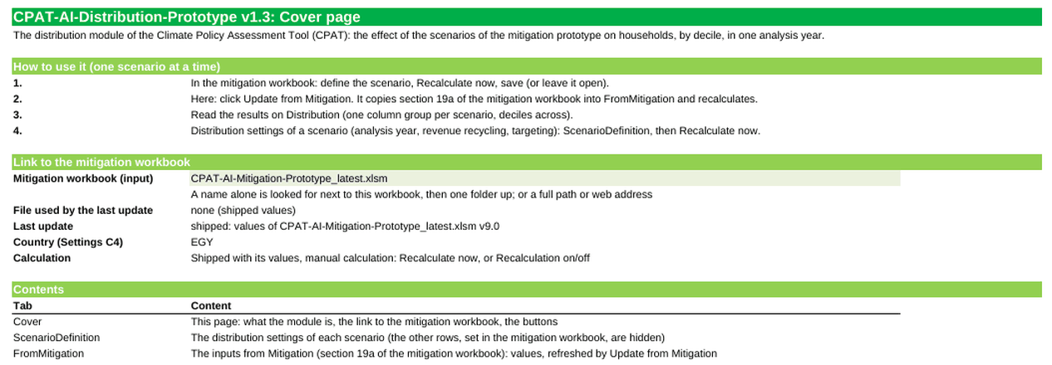
The Cover of the distribution module v0.1.3 (rendered from the file; the buttons are not shown)

1c. What the prompt does
It does not rebuild the module. It (1) makes the macro look for the mitigation workbook in permalink_countryeditable/ first, as the module rules of NORMS.md section 9 require (today it looks in permalink/); (2) checks the module against legacy 465 decile by decile and registers anything new; (3) fixes the Cover version table and releases v0.1.4. Phase 0 is a review only.

2. Before you start
- The Setup guide (other/SetupGuide.docx) Parts 1 and 3 are done: Git, the GitHub Copilot app signed in, the repo in C:\Users\WB<PID>\Repos\CPAT-AI.
- The repo is up to date: double-click SyncRepo.bat once before you start (section 4).
- The prompt file excel_ai/plans/prompts/Distribution_module_prompt.md is in your checkout once the CPAT-AI branch that adds it is merged into main and you have synced; until then use Appendix A (the same text).
- Time and credits: each phase is a long task. Send one phase, read the report, then the next. Type /context to see the credits used.
- Victor and Faustyna: you do not need Copilot to use the module (section 1b). The prompt is for changes to it.
Optional (not needed to start): Copilot runs the builders and checks with Python and recalculates the workbooks in LibreOffice. If either is missing on your desktop, the prompt tells Copilot to say so, install nothing without your OK, and list what it could not run; you then review the workbook in Excel 365.

3. Step by step in GitHub Copilot (local mode)
"Local mode" means Copilot works on the CPAT-AI folder on your laptop (workspace Current checkout), not in a cloud copy. Everything it builds lands in C:\Users\WB<PID>\Repos\CPAT-AI, where you can open it in Excel, and you save it to GitHub yourself at the end (section 4).

Step 1. Open the repo folder (first time only)
In the Copilot app sidebar, click + next to Projects, then Open folder, and pick C:\Users\WB<PID>\Repos\CPAT-AI. It stays in the sidebar.
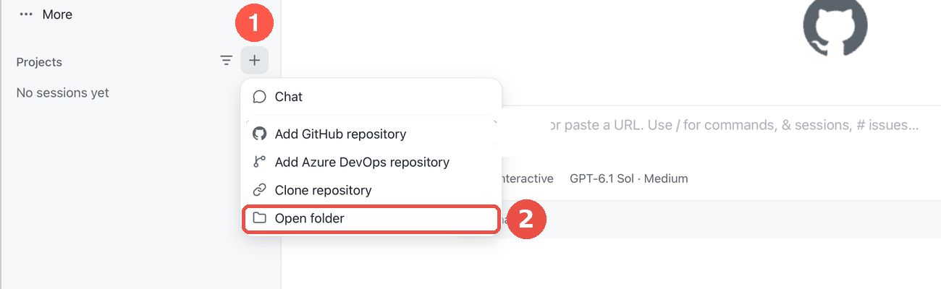
Projects: + then Open folder

Step 2. Start a session in local mode
Point at CPAT-AI in the sidebar and click the + next to it. Under the prompt box, open the workspace selector and choose Current checkout ("Work in the existing checkout"). Do not choose New worktree or Cloud.
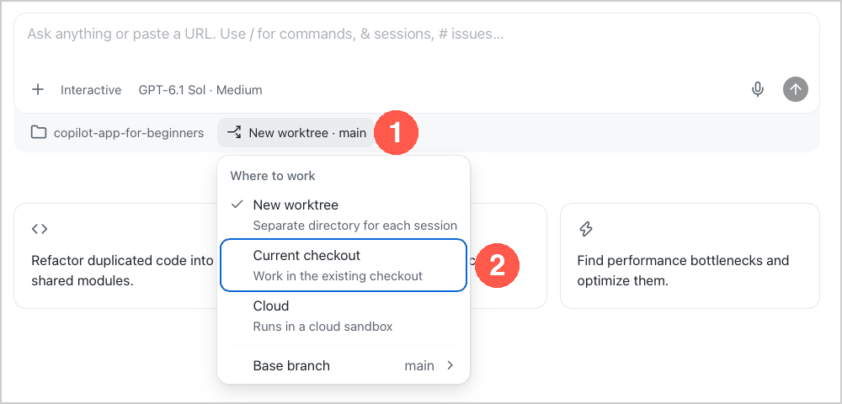
Workspace selector: Current checkout = local mode

Step 3. Pick the model
Click the model chip under the prompt box, switch Auto off, then pick Claude Opus (the strongest model: this is a long, careful task). Effort: High if offered.
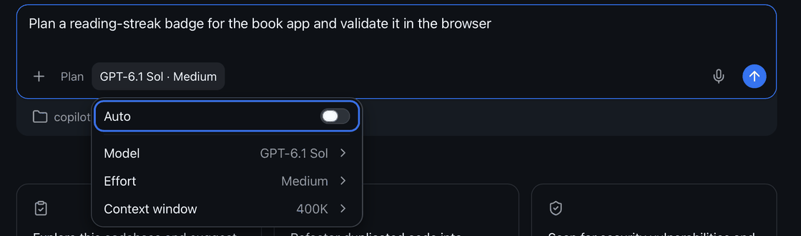
Model chip: Auto off, then Model

Step 4. Pick the mode
Click the mode chip and pick Interactive: Copilot asks before it runs commands or edits files, and you approve each step. Do not use Autopilot for this task.
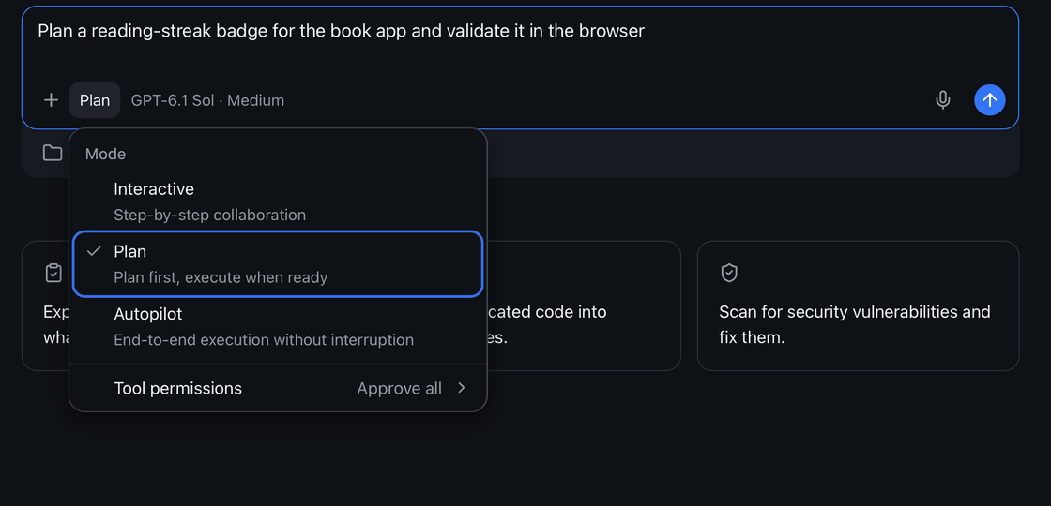
Mode chip: pick Interactive

Step 5. Give it the prompt
You only type a short starter prompt. The long instructions are a file in the repo (excel_ai/plans/prompts/Distribution_module_prompt.md) that Copilot reads itself; the starter and the follow-up prompts are in excel_ai/plans/prompts/Distribution_starter_prompts.md and in Appendix B.
Option A (the prompt file is in your checkout): type @, pick AGENTS.md, type @ again, pick excel_ai/plans/prompts/Distribution_module_prompt.md, then add the words below and press Enter.
@AGENTS.md @excel_ai/plans/prompts/Distribution_module_prompt.md Follow these files. Do phase 0 only, then stop and report.

Option B (the file is not in your checkout yet, or you prefer to paste): copy the whole text of Appendix A into the prompt box, after @AGENTS.md , and press Enter.
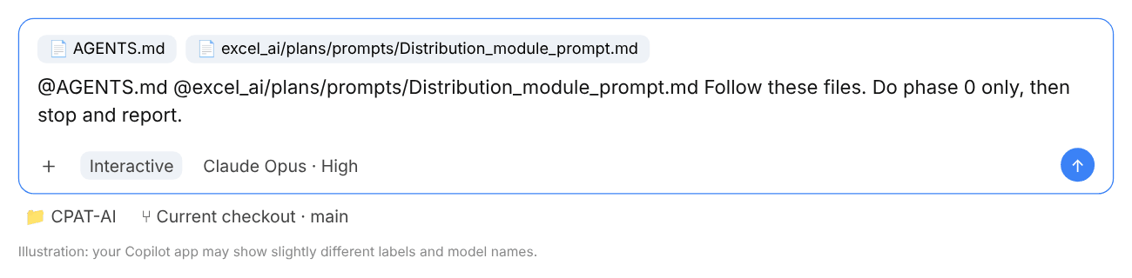
The prompt box with both files attached (illustration)

Step 6. Let it work, approve each step, read the report
Copilot reads the documents, runs commands and asks for approval. Approve reading files and running Python; refuse anything that would delete files, change excel_ai/legacy/ or push to GitHub. When it stops, it reports what it did, the bugs and issues it registered, and the decisions it needs from you. Answer the decisions in plain words before going on.
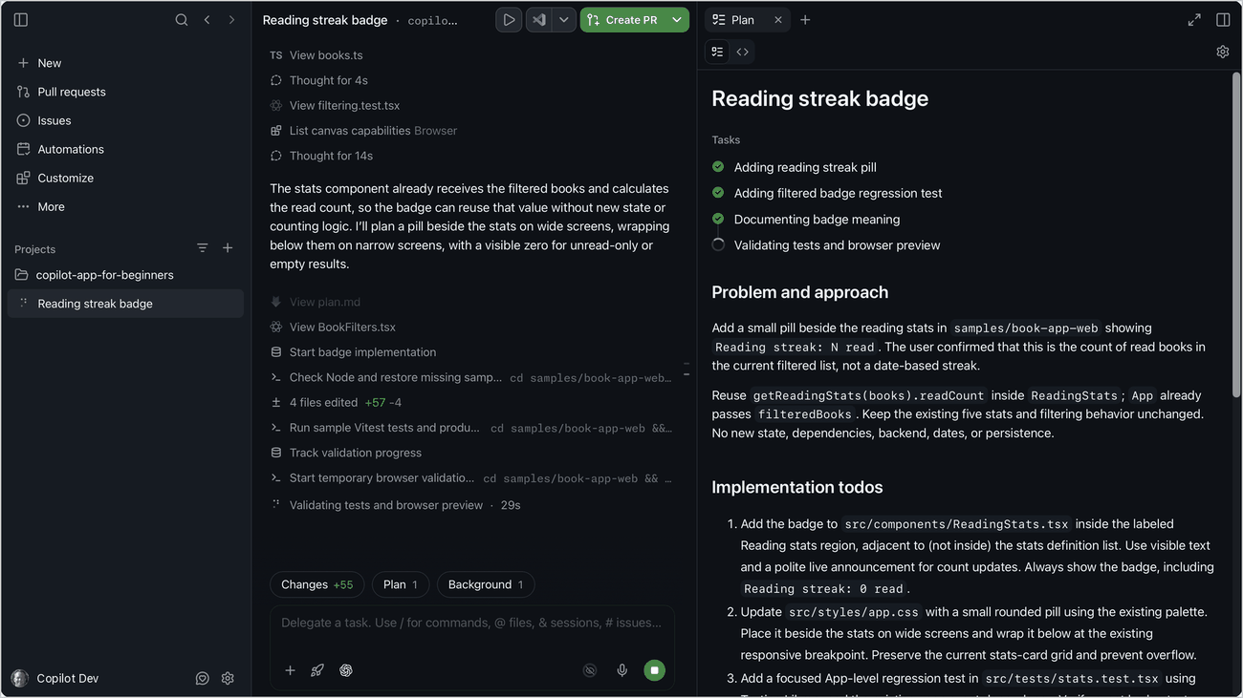
A session at work: the steps on the left, the plan on the right

Step 7. The next phases, one message each
Send these one at a time. Read each report and check it (the third column) before sending the next.
Send | What it does | Check before going on
Go ahead with phase 1. | The macro looks for the mitigation workbook in permalink_countryeditable/ first; Cover shows the file used | The macro test and the VBA name scan pass
Go ahead with phase 2. | Legacy check on 465, decile by decile, through distribution_ref.py | Every difference explained by a registered bug or issue
Go ahead with phase 3. | Release v0.1.4: rebuild, check_distribution.py, publish, README, CAVEATS, TODO | PASS; _latest in both permalink folders

More example follow-ups (answering its decisions, asking for an explanation, a failing check, stopping and resuming in a new session): Appendix B.

Step 8. Look at the changes
Type Show me the changes before you save them. or open Changes under the prompt box: every edited file as a diff. Open the new workbook in Excel 365 (enable macros) and look at it. Do not edit a built workbook by hand: ask Copilot to change the builder and rebuild.
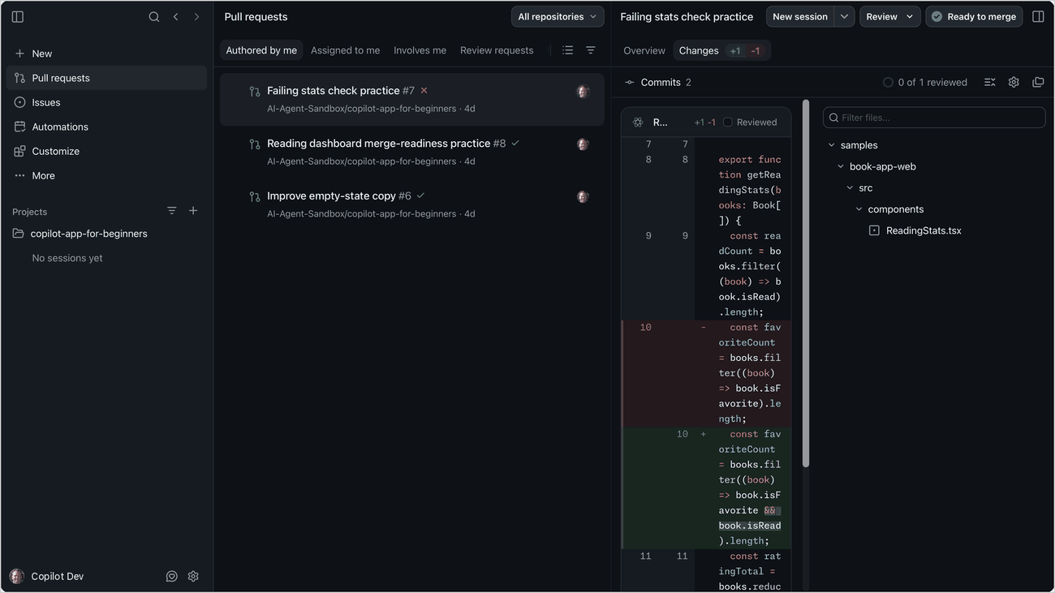
The Changes view: every edit as a diff before you keep it

4. When done: save to GitHub with SyncRepo.bat
Copilot does not commit unless you ask (AGENTS.md). When the last phase is done and you are happy with the result, save everything to GitHub with the sync script in the repo folder.
- Close every workbook of the repo in Excel (an open file cannot be committed cleanly).
- In File Explorer, go to C:\Users\WB<PID>\Repos\CPAT-AI and double-click `SyncRepo.bat`.
- It switches to main, pulls everyone else's changes, and lists the files you changed. Read the list: no workbook or export with real (proprietary) data may be in it (only dummy or public data are committed).
- Type a short commit message, for example Distribution module v0.1.4: permalink_countryeditable link, legacy 465 check, and press Enter.
- It commits, pushes to main and shows Pushed. Press any key to close the window.
- Check on github.com/cpmodelai/cpat_ai that your commit is the latest one.
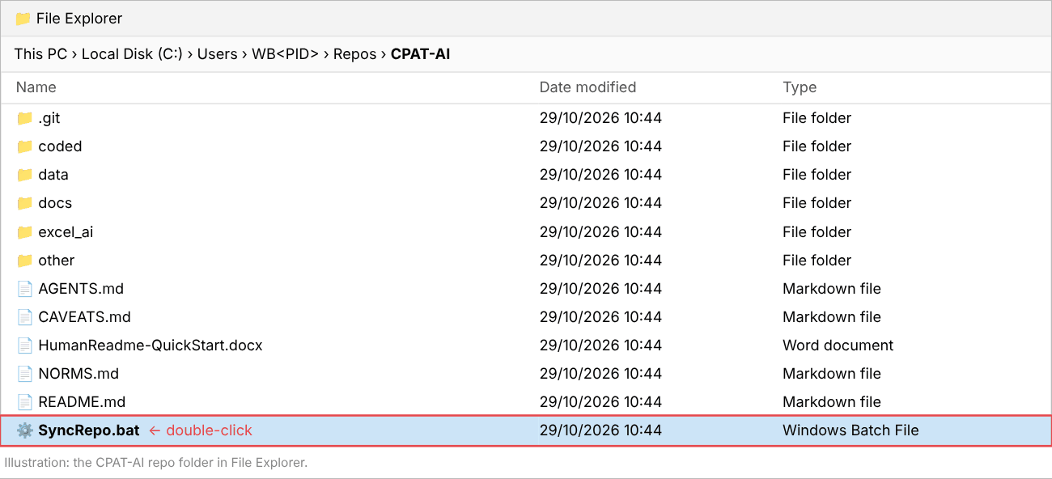
The CPAT-AI folder: double-click SyncRepo.bat (illustration)
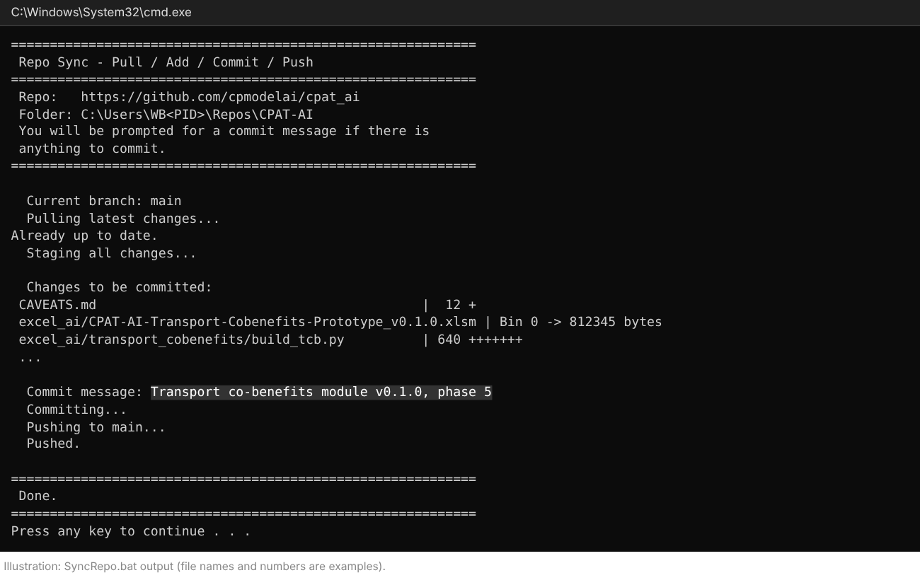
SyncRepo.bat at work: pull, list of changes, your message, push (illustration)
Other ways: from a terminal in the repo folder, SyncRepo.bat "your message" skips the question; SyncAllRepos.bat in the Repos folder syncs every repo; or tell Copilot Commit and push with a clear message.
If it stops with [ERROR] Could not switch to main, Copilot left work on another branch: ask Copilot "Merge this branch into main locally and switch to main", then run SyncRepo.bat again. If it stops with a merge conflict or a failed push, use GitHub Desktop (Setup guide, Part 4) or ask Copilot to resolve the merge; for a binary file (Excel, Word) keep one whole version.

Appendix A. The prompt (exact text)
The full content of excel_ai/plans/prompts/Distribution_module_prompt.md. Paste all of it (Step 5, option B).
# Prompt: bring the distribution module up to the module norms (v0.1.4)

The distribution module already exists (`excel_ai/CPAT-AI-Distribution-Prototype_v0.1.3.xlsm`, sources in `excel_ai/distribution/`). This prompt does not rebuild it: it links it through `permalink_countryeditable/`, checks it against legacy, and closes the open items of the module norms. Paste this whole file into GitHub Copilot (Current checkout, Interactive, Claude Opus), with `@AGENTS.md` attached, or attach this file and type "Follow this file. Do phase 0 only, then stop and report." Work one phase per message. Human guide: `CPAT-AI_HowTo_Distribution.docx` in this folder.

---

You are working in the CPAT-AI repository on the local checkout. Follow `AGENTS.md` and every document it points to, above all `NORMS.md` section 0 (bugs and issues), section 1.1b (the distribution layout) and **section 9 (how modules work)**. Read before you start: `excel_ai/distribution/README.md`, `build_distribution.py`, `CPATDistribution.bas`, `check_distribution.py` and its last report; `excel_ai/plans/Modules.md` (M3, M6); the distribution items of the register (`excel_ai/mitigation/issues_register.py`, Module = Distribution; former codes D1-D31, DI1-DI4) and of `excel_ai/BUGS.md` and `excel_ai/ISSUES.md`; `other/distribution/LESSONS_LEARNED.md`; `excel_ai/mitigation/distribution_ref.py`; the bottom of `CAVEATS.md`.

## Rules (do not break them)

1. **Legacy first** (the legacy `Distribution` sheet of `excel_ai/legacy/workbooks/CPAT 1.0pre_465_NoPropData.xlsb`, read-only). Never replicate a legacy bug: fix it and register it (`L`, with cells and a cell-level fix plan). Always replicate a legacy issue and register it (`I`). When unsure, treat it as an issue, replicate it, and ask me. Next free codes from `register.py`; one register, no list of your own.
2. **The distribution formulas have one source**: `excel_ai/mitigation/build.py`. The module is cut from the built prototype. Change a formula there, rebuild the prototype, then rebuild the module; never edit the module workbook by hand.
3. **Column norms**: the distribution layout of `NORMS.md` 1.1b (A-J descriptors as Mitigation; per group a code column, basket, deciles 1-10, spacer; group *n* reads Mitigation group *n*); `FromMitigation` keeps the Mitigation column layout (1.1, 9.2).
4. **Encapsulated**: the `Distribution` sheet reads only `FromMitigation`, `ScenarioDefinition`, its data tabs and Settings constants (NORMS 9.2); its results stay on the `Distribution` sheet under the LiveOutputs codes `<iso>.distn.*`, because no other workbook reads them yet (an output tab of plain copies, NORMS 9.2, is added only if I agree).
5. Excel rules as `NORMS.md` 3, 3b, 3d, 3g, 3h. If Python, openpyxl or LibreOffice is missing on this computer, say so before you start: install nothing without my OK; where LibreOffice is missing, skip the recalculation steps and list what was not run (I review in Excel 365). Never commit real data. Do not commit or push unless I ask.

## Phases (one per message; stop after each and report)

**Phase 0. Review (no change).** Build nothing. Report: (a) how the module meets `NORMS.md` section 9, item by item, and what is missing; (b) the macro's file search (it looks for the mitigation workbook next to the module, in `permalink\`, one folder up, then in `permalink\` one folder up: it does **not** look in `permalink_countryeditable\` yet, NORMS 5a and 9.3); (c) the distribution bugs and issues in the register on 465 (any legacy 465 change to the `Distribution` sheet since 456: rows moved, bugs the CPAT team fixed); (d) the date and result of the last `check_distribution.py`; (e) the Cover: its title and version log still use the old numbering (v1.3 for 0.1.3) and not the version-table columns of NORMS 5b (Version, Date, Description, Max abs regression diff).

**Phase 1. Link through `permalink_countryeditable/`.** In `CPATDistribution.bas` (`MitPath`): look first in `permalink_countryeditable\` (next to the module, then one folder up), then the current places; Cover says which file was used (link table: path, saved time, scenario names). Same change in the builder's Cover text and README. Test the search order with a Python emulation of the macro and the VBA name scan of `check_distribution.py`.

**Phase 2. Legacy check on 465.** Compare the module (Egypt, the scenario of the prototype) with legacy 465's cached `Distribution` values and `MTOutputs` distribution results, decile by decile, through `distribution_ref.py`; every difference explained by a registered bug fix or issue, or reported as new. Register what is new.

**Phase 3. Release.** Bump `VERSION` to 0.1.4, rebuild (`python excel_ai/distribution/build_distribution.py`), run `python excel_ai/distribution/check_distribution.py` (PASS), lint, publish with `release.py` `publish(link=True)` to `excel_ai/`, `releases/`, `permalink/` and `permalink_countryeditable/`. Cover title and version table in the 0.1.x numbering and the NORMS 5b columns, with a row naming the mitigation version used. Update `excel_ai/distribution/README.md`, `excel_ai/plans/TODO.md` (M6: distribution done), the register lists, and add the entry at the bottom of `CAVEATS.md`.

## Report after each phase

What you did; files changed; check results (PASS/FAIL with numbers); bugs and issues (codes); open questions for me. Do not go to the next phase until I say so.

Appendix B. Starter and follow-up prompts
The content of excel_ai/plans/prompts/Distribution_starter_prompts.md. Type or paste one box at a time.
Short prompts to type into GitHub Copilot (Current checkout, Claude Opus, Interactive). The long instructions are in Distribution_module_prompt.md; Copilot reads them from the repo, so you never paste them. Send one prompt, read the report, then send the next.

Starter (new session)
Type @ to attach the two files, then:
@AGENTS.md @excel_ai/plans/prompts/Distribution_module_prompt.md Follow these files. Do phase 0 only, then stop and report.

If excel_ai/plans/prompts/ is not in your checkout yet (the branch is not merged), sync first; if it is still missing, paste the whole of Distribution_module_prompt.md instead (Appendix A of the Word guide).

Next phases
Go ahead with phase 1.

Go ahead with phase 2.

Go ahead with phase 3.

Example follow-ups
Look at one result:
For Egypt, the live scenario, show me the total effect by decile (overall, urban, rural) and the Gini change, next to legacy 465's cached values, with the reason for each difference.

Check a legacy bug in the register:
Show me register item <code>: the legacy cells, what legacy computes, what the module computes and the effect on deciles 1 and 10. Is it a bug or an issue under NORMS.md section 0?

Change a distribution setting (the formula source is excel_ai/mitigation/build.py):
<describe the change>. Change it in excel_ai/mitigation/build.py, rebuild the prototype, rebuild the module, run check_distribution.py and show me the result.

When a check fails:
check_distribution.py fails on <name of the check>. Find the cause, fix the builder (not the check), rebuild and run the check again. Tell me what was wrong.

Before you save:
Show me the changes before you save them. List every file you changed and why.

Resume later in a new session:
@AGENTS.md @excel_ai/plans/prompts/Distribution_module_prompt.md We are at phase <n>. Read the bottom of CAVEATS.md and the last report, then do phase <n> only and stop.

Then save to GitHub: close the workbooks and double-click SyncRepo.bat in the repo folder.

