CPAT-AI: Quick Start for People
A short, human-readable orientation to the cpat_ai repository, mostly about the Excel prototype. Written 2026-10-29 for prototype v0.8.5, updated for the first full release, v1.0.0. The detail lives in the documents listed in section 1; this guide only points to them.

1. Key documents (start here)
Paths are relative to the repository root. Files named _v<version> carry the current version (today v1.0.0); older versions are in excel_ai/releases/.

Human-readable documents
Document | What it is for
HumanReadme-QuickStart.docx | This guide (root folder), with the setup guide as Appendix A.
excel_ai/mitigation/CPAT-AI-Mitigation_Documentation.docx | Short documentation of the mitigation prototype: what it is, quick start, how it works, limits.
excel_ai/mitigation/CPAT-AI-Mitigation_Methods.docx | Methods volume: one chapter per block, with equations.
excel_ai/Tracking_Legacy_Bugs_v<version>.xlsx | The master list of bugs and issues, every module, with the CPAT team’s own tabs.
excel_ai/Legacy_CPAT_Bugs_v<version>.docx | Every legacy bug found, with its cell-level fix plan for legacy CPAT.
excel_ai/CPAT-AI_CodesMap_v<version>.xlsx | Codes, variables and every input (legacy row, name, Python key).
other/SetupGuide.docx | Getting set up: GitHub, the repos, the AI tools, git in brief (same as Appendix A).

Key PowerPoints
Deck | What it is for
excel_ai/CPAT-AI_Overview_v<version>.pptx | The CPAT-AI deck: status, how to use the prototype, results. The quickest overview.
other/presentations/AIClimate-FiscalTools_v2.6.pptx | The overarching deck on the team’s AI climate-fiscal tools, CPAT-AI among them.

Computer-readable files
Plain-text (Markdown) files that the AI and the scripts read; GitHub shows them formatted, so people can read them too.
File | What it is for
README.md, excel_ai/README.md | Front page of the repo and of the Excel prototypes: who reads what, folder map. Each module folder has its own README.
AGENTS.md (and CLAUDE.md) | The entry point for any AI working in the repo.
NORMS.md | The rules for every task (people and AI alike).
CAVEATS.md | Log of every finished task and its caveats (newest at the bottom).
excel_ai/BUGS.md, excel_ai/ISSUES.md | Short lists of bugs and issues (generated from the register).
excel_ai/plans/TODO.md | The single list of open work; one file per open plan alongside.
data/README.md | Every data table, the converters and the tests.

2. What the Excel prototype is, and the plan
The World Bank/IMF Climate Policy Assessment Tool (CPAT) models the fiscal, economic, energy, emissions and distributional effects of carbon pricing and related policies. The legacy CPAT is a very large single workbook (excel_ai/legacy/workbooks/CPAT 1.0pre_465_NoPropData.xlsb, read-only).
CPAT-AI rebuilds it, with AI help, as readable modular Excel workbooks. The mitigation prototype answers: what do carbon taxes, ETSs, feebates, excises, subsidy reform and a methane fee do to prices, energy use, emissions, revenue and GDP, year by year to 2041, for one country at a time?

The plan
- Replicate CPAT-legacy in Excel. Match legacy results, but without its bugs (every bug is fixed). Issues are replicated as legacy has them, not yet upgraded: improvements are proposed and tracked, then decided later.
- Make Python replicate the Excel prototype (coded/, the Coded CPAT and its Shiny app), using the same codes and input names, so the two can be compared number for number.

Key improvements over legacy
- Every known legacy bug fixed, and documented with a fix plan the CPAT team can apply to legacy.
- Readable: each formula is at most 100 characters and one formula serves a whole block; sections follow legacy’s section numbers.
- Any country: formulas contain no country numbers; all country data come from the data tabs, chosen by the country code on Settings.
- Linked data: the data tables refresh from a data workbook (Power Query) instead of being pasted in.
- Scenarios: a dashboard (ScenarioCompare) compares up to 10 stored scenarios; every output has a code shared with Python (e.g. egy.mit.co2.tot.tot.2).
- Modular: separate Distribution and Air Pollution files (Transport Co-benefits to follow).
- Checked: an independent Python recalculation, a quick check after every change, and a full check at milestones.

3. The modules and who is responsible
Module | File (in excel_ai/) | Responsible
Mitigation | CPAT-AI-Mitigation-Prototype_v<version>.xlsm; sources in mitigation/ | Stephen (others joining soon)
Distribution | CPAT-AI-Distribution-Prototype_v<version>.xlsm; sources in distribution/ | Faustyna (Victor joining soon)
Air Pollution (AP) | air_pollution/CPAT-AI-Air-Pollution-Standalone-v0.3.xlsx | Paulina
Transport Co-benefits | Planned (plans/Transport_cobenefits.md) | Alexandra

Permalink folders
excel_ai/permalink/ holds fixed-name copies (<Name>_latest.<ext>) that other files link to, so links do not break when the version number changes. It holds every module: today CPAT-AI-Mitigation-Prototype_latest.xlsm, CPAT-AI-Distribution-Prototype_latest.xlsm and CPAT-AI-Air-Pollution-Standalone_latest.xlsx (Transport Co-benefits when it exists). The builders publish to it.
New: `excel_ai/permalink_countryeditable/` is a copy of permalink/ with the same modules, and the builders refresh both. Open and edit the copies here to run, say, mitigation for a particular country on your local drive; the modules keep reading each other through the fixed names. Keep copies holding real data local: never commit them.

How the modules connect and how data flow
- Mitigation is the hub. Its section 19 “Exports to modules” holds one named export block per module, keyed by output codes.
- Each other module reads that block from the mitigation file in the permalink folder: Distribution today with the Update from Mitigation button on its Cover; next, a Power Query to the copy in permalink_countryeditable/ (TODO M6), so a country edit made locally flows straight into Distribution, AP and Transport Co-benefits.
- Data tables flow the same way: from the data workbook in data/workbooks/ (or SharePoint) into the prototype’s data tabs by Power Query.

4. Data and information security
- The repo has a data store in data/: the CPAT data tables in Python and CPAT layouts, with the scripts that convert them. Coded CPAT reads data/tidy/: the public legacy tables plus the Egypt rows of the proprietary tables that the public legacy file contains. Every table in data/dummy/ is dummy (fake values in the real formats), not only the four proprietary ones.
- The four proprietary tables: EnergyCons (energy consumption), Prices_dom (domestic energy prices), HHSurvey (household survey) and IO_GTAP (input-output table). Dummy versions: data/legacy_dummy/ and data/dummy/.
- The four main files for information security are the core human-readable files at the top of excel_ai/: the bugs document, the tracker, the codes map and the deck. They are shared beyond the team, so they must hold no proprietary data or values derived from it.
- Never upload any form of CPAT containing real data to the repo (a workbook, an export, a CSV or a screenshot). That breaks information security. Real data stay on the restricted SharePoint site or your local drive (REAL_DATA_PATH); real-data files are git-ignored, but check before every commit.

Loading data into the mitigation module
On ScenarioCompare choose the data source, then click Update data tables (status shown on Cover):
Source | What it does
Embedded (default) | Uses the data shipped inside the workbook; no update.
Dummy - local file | Reads data/workbooks/CPAT_Data_dummy_python.xlsx from your local clone (or a path you type in the source table).
Dummy - SharePoint | Reads the same dummy workbook from the team SharePoint site.
Real data (local path) | Type the path of a real data workbook kept outside the repo; the file you then save holds real data and must not be committed.

5. Bugs, issues and how they are tracked
The rule (`NORMS.md` section 0): never replicate a legacy bug; always replicate a legacy issue, and track it.
 | Bug | Issue
Meaning | Legacy does not do what it means to: a wrong row, a term applied twice, a sign error. | Legacy does what it means to, but the choice is open to question: old data, a simplification, a missing feature.
We | Fix it. Never replicated. | Replicate it exactly; depart only by explicit user decision.
Example | L1: services electricity demand grows with the industrial multiple after 2023. | I89: price data end in 2022, as legacy (accepted).
Codes: L legacy bug, M prototype bug, I issue (data problems are issues), LD departure from legacy, U upgrade. One register for every module (excel_ai/mitigation/issues_register.py) generates the tracker, the bugs document, BUGS.md and ISSUES.md at every release.

Where things stand (v1.0.0)
Count | Status
228 legacy bugs (L) | Fixed in the prototype, except 26 in parts not built (R4, R5, R12 deferred and a few display rows). In legacy 465 (CPAT team): 52 fixed, 9 fixed with caveats, 2 marked fixed but not fixed, 164 outstanding.
22 prototype bugs (M) | All fixed (1 withdrawn: not a bug); M15-M22 were found by Coded CPAT.
135 issues (I), 14 of them data problems | 90 accepted, 19 open, 18 resolved, 4 dropped, 4 closed (the open ones include the open data problems).
35 departures (LD), 9 upgrades (U) | Each one a recorded user decision or proposal.

Major open issues
- I98 (Extremely high): combustion emission factors use only the GAINS base and final factors; the year-by-year paths are needed.
- I97 (Very high): blank VAT cells in the IMF price dataset (legacy fix L170 is in the prototype).
- I90: the proprietary tables are Egypt only, so other countries need data.
- I148 (Extremely high): the current-account data are typed for Egypt only (other countries need the WEO data).
- R4 CBAM process emissions, R5 green public investment and R12 industrial emissions intensity are deferred (legacy work in progress; design notes on branch wip-r4-r5-r12). I1: the prototype has not yet had a full run in Excel 365 by the team (it is built and checked in LibreOffice).
To raise a bug or issue: add it to the tracker (or ask the AI to register it). It must appear in BUGS.md or ISSUES.md the same day.

6. Key norms, with examples
NORMS.md holds all of them. The ones to know first:
- Bugs vs issues (section 0): as above. When in doubt, treat it as an issue, replicate it and ask.
- Never improve legacy silently: newer data or a better method is an upgrade (U) for the team to decide, e.g. a new population source.
- Versions (section 5): never edit a released workbook; build the next version. Main files are <Name>_v<version>, e.g. CPAT-AI-Mitigation-Prototype_v1.0.0.xlsm; older ones go to releases/.
- Permalink: only files others link to get a _latest copy; permalink_countryeditable/ mirrors permalink/ (section 5a).
- Inputs (section 4): use legacy MTInputs names, e.g. CPLevelTarget for the carbon price in the target year, the same in Excel and Python.
- Style (sections 1-2): fixed column layout and CPAT colours, e.g. input cells light green, code cells light blue, calculation cells unfilled; every formula at most 100 characters.
- Data (section 8): all data live in data/; only dummy or public data are committed.
- Every finished task is logged in CAVEATS.md (section 6); methodology and version notes are separate documents (section 7).

7. How the AI works here
Any AI tool (Claude, Codex, Copilot, ...) starts from AGENTS.md (Claude’s CLAUDE.md just points to it). AGENTS.md routes the AI to README.md, NORMS.md, BUGS.md, ISSUES.md, the TODO list and CAVEATS.md, so it follows the same rules as people and logs what it did. To change how the AI behaves, change NORMS.md, not the AI’s own file.

Queries you can ask
- “Which legacy bugs are still open in legacy 465, and which affect revenue?”
- “Explain how the retail price of diesel is built up, with the cells in the prototype.”
- “Is this difference from legacy a bug or an issue? Register it.”
- “What changed between v0.9.2 and v1.0.0?” (it reads CAVEATS.md and the version log)
- “Where does the Distribution module get its fuel price changes from?”
- “Run the quick check and tell me if anything broke.”

8. The repos and git
All three repos sit under the GitHub organisation cpmodelai:
Repo | Purpose
cpat_ai (private) | This repo: the CPAT Excel prototypes, the Python model, data and documents.
climate-fiscal-ai-tools (public) | The wider set of AI climate-fiscal tools beyond CPAT (e.g. the excise diagnostic, the tax dashboard). Public, so never put CPAT data or internal material there.
repo-tools (public) | The helper scripts that make git easy: CloneRepos.bat, SyncRepo.bat, SyncAllRepos.bat, RepoDirectory.csv (in Repos.zip).
Getting set up and a short guide to git are in Appendix A (also other/SetupGuide.docx). In short: double-click SyncAllRepos.bat to pull and push every repo; if it stops with a merge conflict, GitHub Desktop shows the clashing files and helps you resolve them.

9. Further information
- Folder map: README.md (root) and excel_ai/README.md; each module folder has its own README.
- How-to guides: the setup and tools guide other/SetupGuide.docx (Appendix A); the quick start in the mitigation Documentation; linking data in data/README.md; regenerating the distribution data in other/distribution/REGENERATING_THE_DISTRIBUTIONAL_WORKBOOK.md.
- Supporting material in other/: research papers, decks (other/presentations/), the distribution pseudocode and earlier prototypes.
- Plans: excel_ai/plans/ (e.g. Modules.md for the modular design).
- Python model (Coded CPAT 1.0.0p1.0, equal to the prototype code by code): coded/README.md, its deck coded/cpat_documentation/Coded-CPAT_Overview_v<version>.pptx and the Coded CPAT tab of the website.
- Personal working folders: users/.

Appendix A. Getting set up with AI in the Climate-Fiscal team
This guide has four parts. Part 1, Setup: new users, once. Part 2, Update: if you set up before the repos moved to github.com/cpmodelai, once. Part 3, Tools: how to use the three tools. Part 4, Git in brief: what git does and how to fix a clash.

Part 1. Setup (new users)
Action A: Please create a GitHub ID (using a work or personal email address).
- Go to https://github.com and click Sign up.
- Enter your email address and a password.
- Type the username you want. GitHub will tell you right away if it’s taken.
- Complete the verification puzzle, then enter the code GitHub emails you.
Action B: Please get Git for Windows from the WB Software Center, and GitHub Copilot from the Microsoft Store. GitHub Desktop (also in the Software Center, or desktop.github.com) is recommended too: it shows your changes and helps resolve merge issues (Part 4).
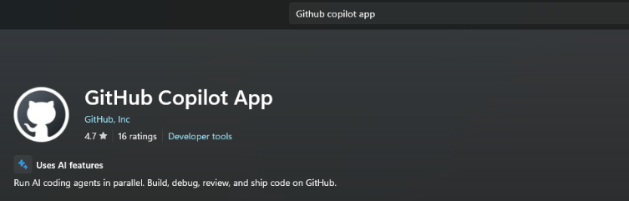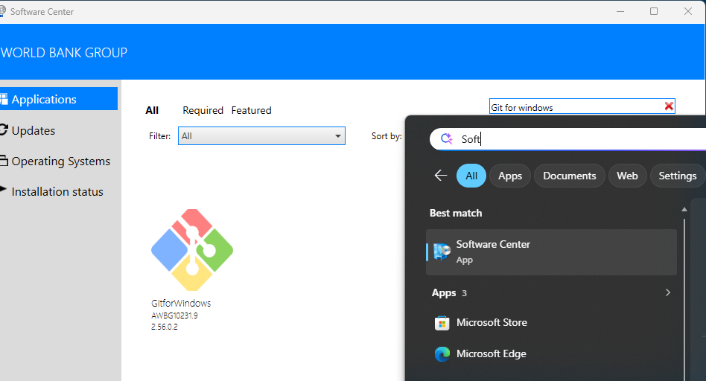
Action C: Go to C:\Users\WB<PID> (go to C:\Users and find your folder: WB followed by your PID). Download Repos.zip (or get it from github.com/cpmodelai/repo-tools) and extract it there, then go to C:\Users\WB<PID>\Repos. Click CloneRepos.bat to clone the selected repos. Then click SyncAllRepos.bat for any changes later.
Action D: Add your GitHub ID (and get an Enterprise account).
- Once you have your ID, ask Kacper (klukaszewicz@worldbank.org) to add you to cpmodelai, where our repos are. Copy in Paulina and Stephen for information.
- Ask for your user ID to be added to the WB GitHub organisation: http://githubmemberrequest/
- Get a GitHub Enterprise account by emailing GitHub_Enterprise_Admin@worldbankgroup.org with your GitHub ID.

Optional: linking Claude to the repos
1. Create a Claude account. Go to claude.ai (or get the Claude app) and click Sign up, with an email address or a Google account. If you used email, click the sign-in link Claude sends you, then enter your name. You are on the free plan; you can upgrade later from Settings.
2. Connect GitHub. A “repo” (repository) is a folder of files stored on GitHub. In Claude, go to Settings → Connectors, find GitHub and click Connect; GitHub asks you to approve access (support.claude.com, “Use the GitHub integration”).
3. Add a repo. Open a chat (or a Project), click + next to the message box, choose “Add from GitHub”, then search or paste the repo URL. Claude can now read its files; you can add several repos.

Part 2. Update to the new repos (existing users)
The repos have moved from github.com/cpmodel to github.com/cpmodelai, and some default folder names have changed. If you set up before this, do these steps once. The new RepoDirectory.csv in Repos.zip lists the new addresses.
Repo | Old address | New address (RepoName) | Default folder (FolderName)
Climate-fiscal AI tools | github.com/cpmodel/new-ai-tools | github.com/cpmodelai/climate-fiscal-ai-tools | climate-fiscal-ai-tools (was new-ai-tools)
CPAT-AI | github.com/cpmodel/CPAT-AI | github.com/cpmodelai/cpat_ai | CPAT-AI
Repo tools | (new) | github.com/cpmodelai/repo-tools | repo-tools
1. Save your work first. Double-click SyncAllRepos.bat (or see Part 3, Step 3) so nothing is lost. If a push fails, copy the files you changed somewhere safe.
2. Get the new files. Download Repos.zip (Action C) and extract it into C:\Users\WB<PID>\Repos. Let it replace RepoDirectory.csv, SyncAllRepos.bat and CloneRepos.bat.
3. Check the addresses. Open RepoDirectory.csv in Notepad. Every RepoName must start with https://github.com/cpmodelai/ (not cpmodel).
4. Check the folder names. FolderName is the folder inside Repos for each repo, and it must match exactly. The defaults have changed (table above): use the default (and move the old folder aside, step 5), or change FolderName to the name you want.
5. Move the old folders aside. Rename each old folder, for example new-ai-tools to new-ai-tools_old and CPAT-AI to CPAT-AI_old. They still point to the old addresses.
6. Download the new repos. Double-click CloneRepos.bat. It downloads every repo in RepoDirectory.csv whose folder is missing, and warns about any folder that points to another address. Sign in to GitHub if asked; your ID must be in cpmodelai (Action D).
7. Copy across and check. Copy any unsaved files from the _old folders into the new ones. Double-click SyncAllRepos.bat: every repo shows Pulling, none shows [SKIP] Folder not found. Then delete the _old folders.
8. Update the Copilot app. Add the new folders in the sidebar (Part 3, Step 1) and remove the old ones.
Check: CloneRepos.bat shows [OK] for every repo. In each repo folder, git remote -v shows https://github.com/cpmodelai/...
Download fresh rather than re-pointing the old folders: the new repos do not share all of the old history, so pulls into an old folder can fail.

Part 3. Tools (GitHub Copilot app)
AI tools quick start: three tools, each in its own repo. The repo address is at the start of each tool.

We assume you already have
- The repo for your tool downloaded on your laptop (C:\Users\WB<PID>\Repos\<folder>, Part 1 or 2) and up to date.
- The GitHub Copilot app installed (Microsoft Store) and signed in with your GitHub account.
- Part 1 done (and Part 2 if you set up before the move). Not there yet? See Presentations/GitHub_Copilot_AI_User_Guide.pptx.
Steps 1-2 set up a session. Then do Tool 1, 2 or 3. Step 3 saves your work.

Step 1. Open the repo and start a session (once per task)
1. Add the repo (first time only). In the sidebar, click + next to Projects, then Open folder. Pick the tool’s repo folder, for example Repos\climate-fiscal-ai-tools. It stays in the sidebar.
2. Start a session. Point at the repo in the sidebar and click the + next to it.
3. Work in your folder. Under the prompt box, open the workspace selector and choose Current checkout. Copilot then edits the repo folder on your laptop.
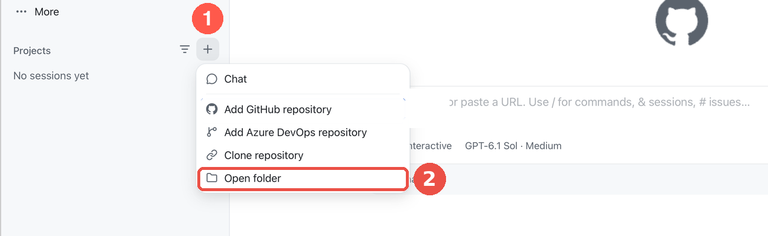
+ next to Projects, then Open folder
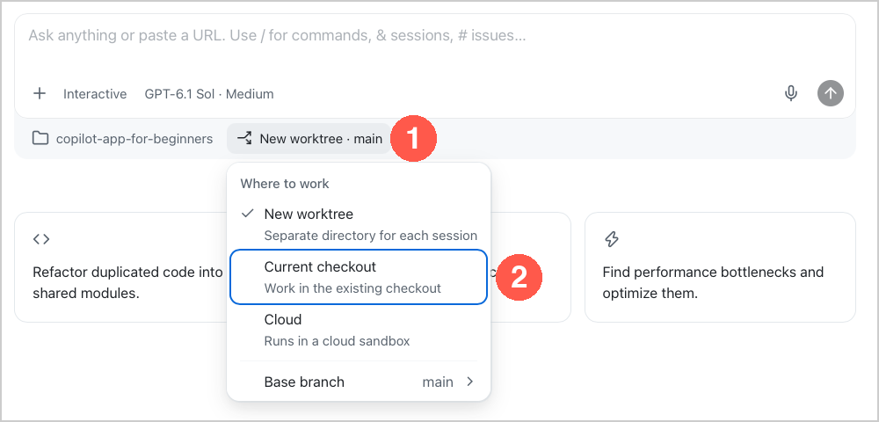
Workspace selector, then Current checkout

Step 2. Pick the model and the mode (every session)
1. Model. Click the model chip under the prompt box. Switch Auto off, then pick Claude Sonnet for everyday work, Claude Opus for the excise research.
2. Mode. Click the mode chip and pick Interactive: Copilot asks before it acts.
3. Credits. Type /context at any time to see the AI credits the session has used.
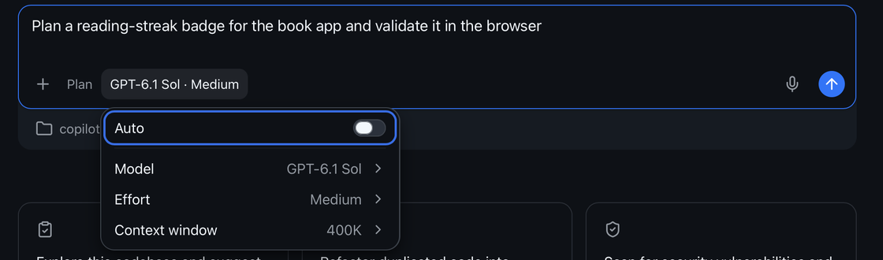
Model chip: Auto off, then Model
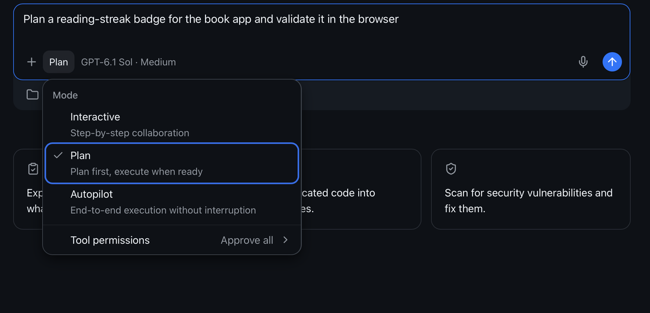
Mode chip: pick Interactive

Tool 1. Excise diagnostic for Indonesia (Claude Opus · Interactive)
Repo: https://github.com/cpmodelai/climate-fiscal-ai-tools · Folder: Repos\climate-fiscal-ai-tools
⚠ Deep research uses a lot of credits. Send one prompt, read the answer, then send the next. Check /context as you go. Stop and fix anything wrong before going on.
Attach the instructions: type @ and pick user_guide/excise_diagnostic_process.md (or drag the file onto the prompt box).
Paste: @user_guide/excise_diagnostic_process.md Follow this file. Run stage A1 for Indonesia, 2020 to 2026-09-30. Search the web for the laws. Stop after A1.
Then, one at a time: Run stage A2. · Run stage A3. · Run stage A4. · Run stage A5. · Run stage A6. Save the Word report and Excel workbook in ExciseDiagnostic/country_results/Indonesia/.
Check: every rate quoted with its date and a source link; missing data says data_gap.
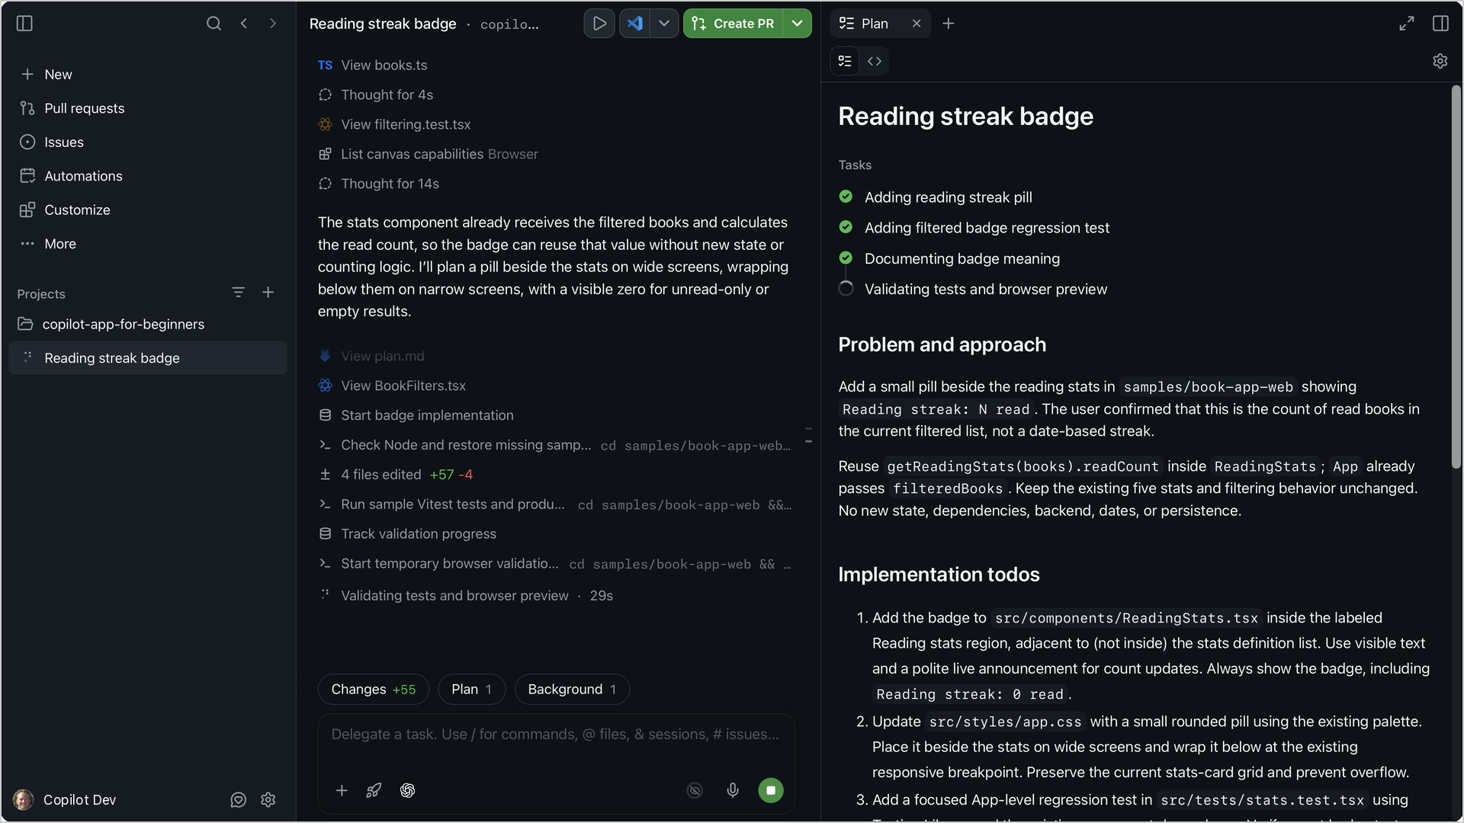
A session at work: the steps on the left, the plan on the right

Tool 2. Add tax indicators to the dashboard (Claude Sonnet · Interactive)
Repo: https://github.com/cpmodelai/climate-fiscal-ai-tools · Folder: Repos\climate-fiscal-ai-tools
Paste: Add VAT, personal income tax, corporate income tax and excises (% of GDP) to the dashboard, under Tax revenue, from the IMF WoRLD file already in raw_data. Follow TaxMacroFiscalDashboard/build/README.md. Do not change anything else. Then rebuild and show me Indonesia.
Then: Commit and push with a clear message.
Check: Indonesia, % of GDP: tax 10.08 · VAT 3.52 · corporate 2.65 · personal 1.79 · excises 1.11
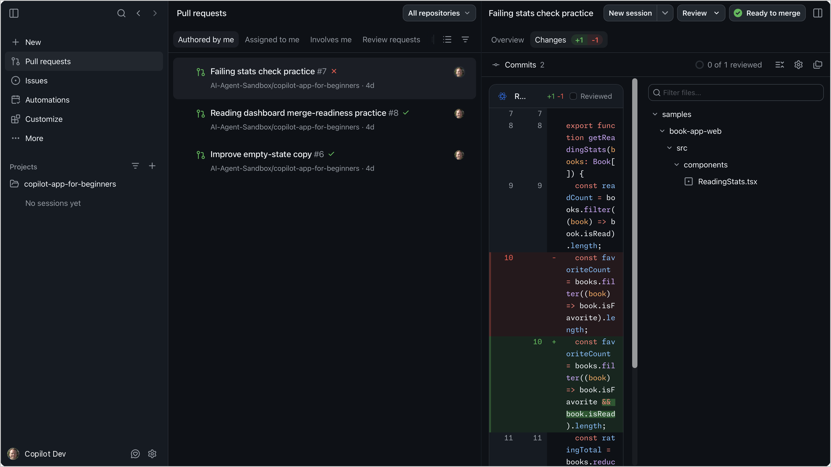
The Changes view: every edit as a diff before you keep it

Tool 3. Make an update to CPAT-AI (Claude Opus · Interactive)
Repo: https://github.com/cpmodelai/cpat_ai · Folder: Repos\CPAT-AI
Attach the rules: type @ and pick AGENTS.md (or drag the file onto the prompt box). It points Copilot to NORMS.md, CAVEATS.md and the to-do lists, so it follows the repo’s rules.
Paste (fill in your change): @AGENTS.md Follow this file and the documents it points to. In the mitigation prototype, <describe your change>. Never replicate a legacy bug; replicate legacy issues and register them. Rebuild, run excel_ai/mitigation/check_quick.py and show me the result. Then add the entry at the bottom of CAVEATS.md and update excel_ai/plans/TODO.md.
Then, one at a time: Show me the changes before you save them. · Commit and push with a clear message.
Rules the repo sets (AGENTS.md):
- Never edit a released workbook: the build writes a new version.
- All data go in data/, with the script that converts them.
- Every finished task ends with an entry at the bottom of CAVEATS.md.
- Copilot does not commit unless you ask.
- The checks need Python 3, openpyxl and LibreOffice. Use Claude Sonnet for text-only edits.
Check: check_quick.py says PASS; a new entry at the bottom of CAVEATS.md; the change shows on github.com/cpmodelai/cpat_ai.

Step 3. Save your work to GitHub
1. Ask Copilot. Type: Commit and push with a clear message. Approve what it shows.
2. Or use the script. Double-click SyncAllRepos.bat in your Repos folder (all repos at once), or SyncRepo.bat in the repo folder where there is one.
3. Check. On github.com/cpmodelai/climate-fiscal-ai-tools (Tools 1-2) or github.com/cpmodelai/cpat_ai (Tool 3), your change shows as the latest commit.
With Claude instead: on claude.ai make a Project, add excise_diagnostic_process.md, switch on Research, and paste the same prompts.

Part 4. Git in brief
Git keeps every version of every file in a repo. Your Repos folder holds a local copy of each repo; GitHub holds the shared copy. The scripts in repo-tools (CloneRepos.bat, SyncRepo.bat, SyncAllRepos.bat) do the usual steps for you.
Word | What it means
clone | Download a repo to your laptop, once (CloneRepos.bat).
pull | Get everyone else’s changes from GitHub.
commit | Save a snapshot of your changes, with a one-line message.
push | Send your commits to GitHub so others get them.
branch | A parallel line of work. main is the shared one; AI sessions often work on their own branch.
pull request (PR) | A request to merge a branch into main, reviewed on github.com.
merge conflict | You and someone else changed the same lines; git asks which version to keep.
Every day: double-click SyncAllRepos.bat (or SyncRepo.bat in one repo). It switches to main, pulls, then commits and pushes your changes with the message you type.
If the sync stops with a conflict or a failed push, use GitHub Desktop. File → Add local repository, pick the repo folder. It lists the files in conflict; for each one choose Open in editor (or “Use mine” / “Use theirs”), keep the right text, then click Continue merge, then Push origin. For a binary file (Excel, Word) pick one whole version and copy your changes into it by hand. If in doubt, copy your changed files somewhere safe first, or ask an AI session to resolve the merge.
Never commit real data. Before every sync, check the list of changed files: no CPAT workbook or export holding proprietary data (see the CPAT-AI quick start, section 4).

