Getting Set Up with AI in the Climate-Fiscal Team
This guide has four parts. Part 1, Setup: new users, once. Part 2, Update: if you set up before the repos moved to github.com/cpmodelai, once. Part 3, Tools: how to use the three tools. Part 4, Git in brief: what git does and how to fix a clash.

Part 1. Setup (new users)
Action A: Please create a GitHub ID (using a work or personal email address).
- Go to https://github.com and click Sign up.
- Enter your email address and a password.
- Type the username you want. GitHub will tell you right away if it’s taken.
- Complete the verification puzzle, then enter the code GitHub emails you.
Action B: Please get Git for Windows from the WB Software Center, and GitHub Copilot from the Microsoft Store. GitHub Desktop (also in the Software Center, or desktop.github.com) is recommended too: it shows your changes and helps resolve merge issues (Part 4).
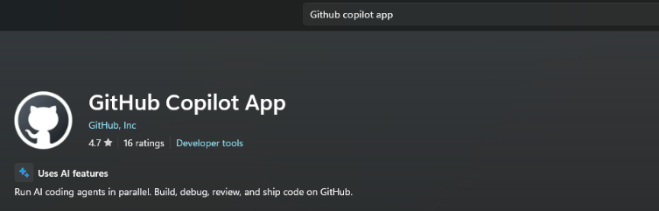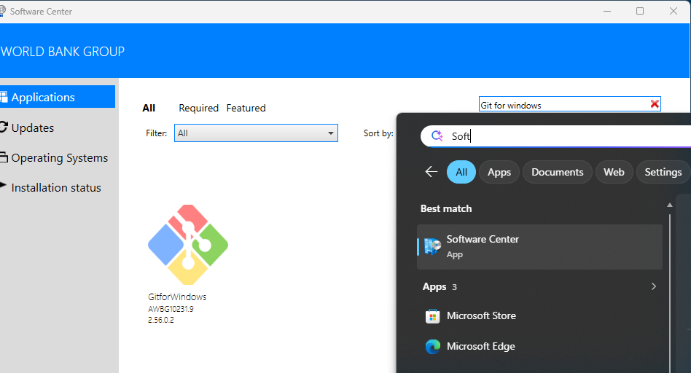
Action C: Go to C:\Users\WB<PID> (go to C:\Users and find your folder: WB followed by your PID). Download Repos.zip (or get it from github.com/cpmodelai/repo-tools) and extract it there, then go to C:\Users\WB<PID>\Repos. Click CloneRepos.bat to clone the selected repos. Then click SyncAllRepos.bat for any changes later.
Action D: Add your GitHub ID (and get an Enterprise account).
- Once you have your ID, ask Kacper (klukaszewicz@worldbank.org) to add you to cpmodelai, where our repos are. Copy in Paulina and Stephen for information.
- Ask for your user ID to be added to the WB GitHub organisation: http://githubmemberrequest/
- Get a GitHub Enterprise account by emailing GitHub_Enterprise_Admin@worldbankgroup.org with your GitHub ID.

Optional: linking Claude to the repos
1. Create a Claude account. Go to claude.ai (or get the Claude app) and click Sign up, with an email address or a Google account. If you used email, click the sign-in link Claude sends you, then enter your name. You are on the free plan; you can upgrade later from Settings.
2. Connect GitHub. A “repo” (repository) is a folder of files stored on GitHub. In Claude, go to Settings → Connectors, find GitHub and click Connect; GitHub asks you to approve access (support.claude.com, “Use the GitHub integration”).
3. Add a repo. Open a chat (or a Project), click + next to the message box, choose “Add from GitHub”, then search or paste the repo URL. Claude can now read its files; you can add several repos.

Part 2. Update to the new repos (existing users)
The repos have moved from github.com/cpmodel to github.com/cpmodelai, and some default folder names have changed. If you set up before this, do these steps once. The new RepoDirectory.csv in Repos.zip lists the new addresses.
Repo | Old address | New address (RepoName) | Default folder (FolderName)
Climate-fiscal AI tools | github.com/cpmodel/new-ai-tools | github.com/cpmodelai/climate-fiscal-ai-tools | climate-fiscal-ai-tools (was new-ai-tools)
CPAT-AI | github.com/cpmodel/CPAT-AI | github.com/cpmodelai/cpat_ai | CPAT-AI
Repo tools | (new) | github.com/cpmodelai/repo-tools | repo-tools
1. Save your work first. Double-click SyncAllRepos.bat (or see Part 3, Step 3) so nothing is lost. If a push fails, copy the files you changed somewhere safe.
2. Get the new files. Download Repos.zip (Action C) and extract it into C:\Users\WB<PID>\Repos. Let it replace RepoDirectory.csv, SyncAllRepos.bat and CloneRepos.bat.
3. Check the addresses. Open RepoDirectory.csv in Notepad. Every RepoName must start with https://github.com/cpmodelai/ (not cpmodel).
4. Check the folder names. FolderName is the folder inside Repos for each repo, and it must match exactly. The defaults have changed (table above): use the default (and move the old folder aside, step 5), or change FolderName to the name you want.
5. Move the old folders aside. Rename each old folder, for example new-ai-tools to new-ai-tools_old and CPAT-AI to CPAT-AI_old. They still point to the old addresses.
6. Download the new repos. Double-click CloneRepos.bat. It downloads every repo in RepoDirectory.csv whose folder is missing, and warns about any folder that points to another address. Sign in to GitHub if asked; your ID must be in cpmodelai (Action D).
7. Copy across and check. Copy any unsaved files from the _old folders into the new ones. Double-click SyncAllRepos.bat: every repo shows Pulling, none shows [SKIP] Folder not found. Then delete the _old folders.
8. Update the Copilot app. Add the new folders in the sidebar (Part 3, Step 1) and remove the old ones.
Check: CloneRepos.bat shows [OK] for every repo. In each repo folder, git remote -v shows https://github.com/cpmodelai/...
Download fresh rather than re-pointing the old folders: the new repos do not share all of the old history, so pulls into an old folder can fail.

Part 3. Tools (GitHub Copilot app)
AI tools quick start: three tools, each in its own repo. The repo address is at the start of each tool.

We assume you already have
- The repo for your tool downloaded on your laptop (C:\Users\WB<PID>\Repos\<folder>, Part 1 or 2) and up to date.
- The GitHub Copilot app installed (Microsoft Store) and signed in with your GitHub account.
- Part 1 done (and Part 2 if you set up before the move). Not there yet? See Presentations/GitHub_Copilot_AI_User_Guide.pptx.
Steps 1-2 set up a session. Then do Tool 1, 2 or 3. Step 3 saves your work.

Step 1. Open the repo and start a session (once per task)
1. Add the repo (first time only). In the sidebar, click + next to Projects, then Open folder. Pick the tool’s repo folder, for example Repos\climate-fiscal-ai-tools. It stays in the sidebar.
2. Start a session. Point at the repo in the sidebar and click the + next to it.
3. Work in your folder. Under the prompt box, open the workspace selector and choose Current checkout. Copilot then edits the repo folder on your laptop.
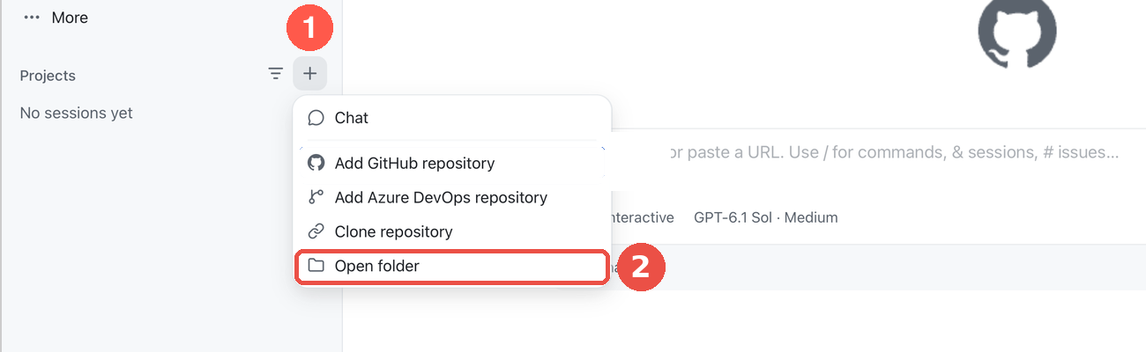
+ next to Projects, then Open folder
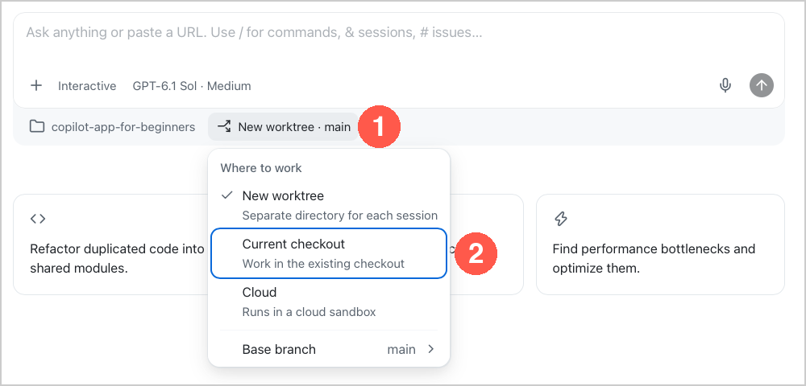
Workspace selector, then Current checkout

Step 2. Pick the model and the mode (every session)
1. Model. Click the model chip under the prompt box. Switch Auto off, then pick Claude Sonnet for everyday work, Claude Opus for the excise research.
2. Mode. Click the mode chip and pick Interactive: Copilot asks before it acts.
3. Credits. Type /context at any time to see the AI credits the session has used.
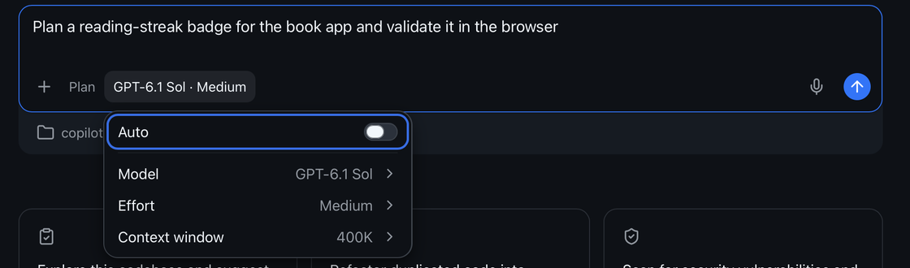
Model chip: Auto off, then Model
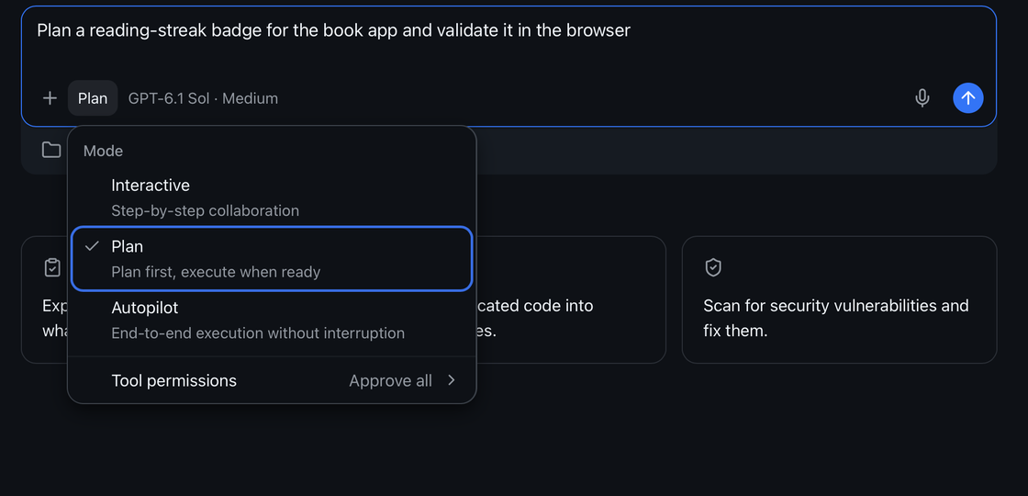
Mode chip: pick Interactive

Tool 1. Excise diagnostic for Indonesia (Claude Opus · Interactive)
Repo: https://github.com/cpmodelai/climate-fiscal-ai-tools · Folder: Repos\climate-fiscal-ai-tools
⚠ Deep research uses a lot of credits. Send one prompt, read the answer, then send the next. Check /context as you go. Stop and fix anything wrong before going on.
Attach the instructions: type @ and pick user_guide/excise_diagnostic_process.md (or drag the file onto the prompt box).
Paste: @user_guide/excise_diagnostic_process.md Follow this file. Run stage A1 for Indonesia, 2020 to 2026-09-30. Search the web for the laws. Stop after A1.
Then, one at a time: Run stage A2. · Run stage A3. · Run stage A4. · Run stage A5. · Run stage A6. Save the Word report and Excel workbook in ExciseDiagnostic/country_results/Indonesia/.
Check: every rate quoted with its date and a source link; missing data says data_gap.
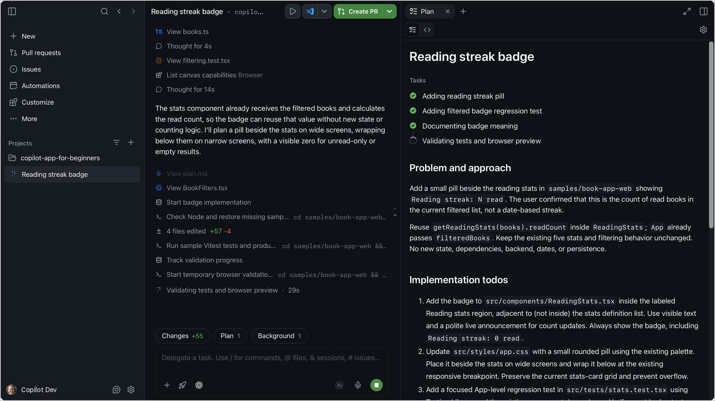
A session at work: the steps on the left, the plan on the right

Tool 2. Add tax indicators to the dashboard (Claude Sonnet · Interactive)
Repo: https://github.com/cpmodelai/climate-fiscal-ai-tools · Folder: Repos\climate-fiscal-ai-tools
Paste: Add VAT, personal income tax, corporate income tax and excises (% of GDP) to the dashboard, under Tax revenue, from the IMF WoRLD file already in raw_data. Follow TaxMacroFiscalDashboard/build/README.md. Do not change anything else. Then rebuild and show me Indonesia.
Then: Commit and push with a clear message.
Check: Indonesia, % of GDP: tax 10.08 · VAT 3.52 · corporate 2.65 · personal 1.79 · excises 1.11
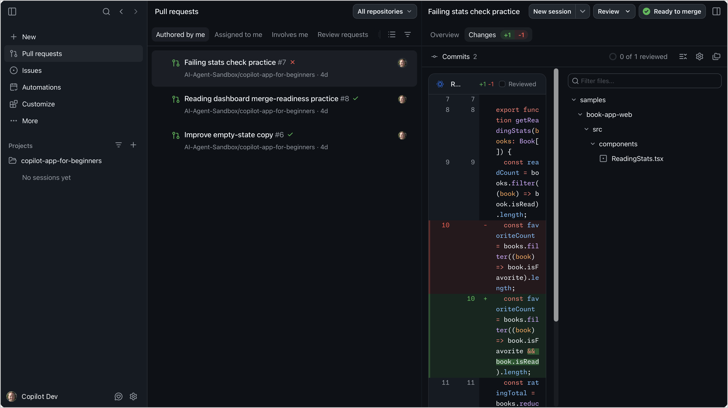
The Changes view: every edit as a diff before you keep it

Tool 3. Make an update to CPAT-AI (Claude Opus · Interactive)
Repo: https://github.com/cpmodelai/cpat_ai · Folder: Repos\CPAT-AI
Attach the rules: type @ and pick AGENTS.md (or drag the file onto the prompt box). It points Copilot to NORMS.md, CAVEATS.md and the to-do lists, so it follows the repo’s rules.
Paste (fill in your change): @AGENTS.md Follow this file and the documents it points to. In the mitigation prototype, <describe your change>. Never replicate a legacy bug; replicate legacy issues and register them. Rebuild, run excel_ai/mitigation/checks/check_quick.py and show me the result. Then add the entry at the bottom of excel_ai/core/CAVEATS.md and update excel_ai/core/TODO.md.
Then, one at a time: Show me the changes before you save them. · Commit and push with a clear message.
Rules the repo sets (AGENTS.md):
- Never edit a released workbook: the build writes a new version.
- All data go in data/, with the script that converts them.
- Every finished task ends with an entry at the bottom of CAVEATS.md.
- Copilot does not commit unless you ask.
- The checks need Python 3, openpyxl and LibreOffice. Use Claude Sonnet for text-only edits.
Check: check_quick.py says PASS; a new entry at the bottom of CAVEATS.md; the change shows on github.com/cpmodelai/cpat_ai.

Step 3. Save your work to GitHub
1. Ask Copilot. Type: Commit and push with a clear message. Approve what it shows.
2. Or use the script. Double-click SyncAllRepos.bat in your Repos folder (all repos at once), or SyncRepo.bat in the repo folder where there is one.
3. Check. On github.com/cpmodelai/climate-fiscal-ai-tools (Tools 1-2) or github.com/cpmodelai/cpat_ai (Tool 3), your change shows as the latest commit.
With Claude instead: on claude.ai make a Project, add excise_diagnostic_process.md, switch on Research, and paste the same prompts.

Part 4. Git in brief
Git keeps every version of every file in a repo. Your Repos folder holds a local copy of each repo; GitHub holds the shared copy. The scripts in repo-tools (CloneRepos.bat, SyncRepo.bat, SyncAllRepos.bat) do the usual steps for you.
Word | What it means
clone | Download a repo to your laptop, once (CloneRepos.bat).
pull | Get everyone else’s changes from GitHub.
commit | Save a snapshot of your changes, with a one-line message.
push | Send your commits to GitHub so others get them.
branch | A parallel line of work. main is the shared one; AI sessions often work on their own branch.
pull request (PR) | A request to merge a branch into main, reviewed on github.com.
merge conflict | You and someone else changed the same lines; git asks which version to keep.
Every day: double-click SyncAllRepos.bat (or SyncRepo.bat in one repo). It switches to main, pulls, then commits and pushes your changes with the message you type.
If the sync stops with a conflict or a failed push, use GitHub Desktop. File → Add local repository, pick the repo folder. It lists the files in conflict; for each one choose Open in editor (or “Use mine” / “Use theirs”), keep the right text, then click Continue merge, then Push origin. For a binary file (Excel, Word) pick one whole version and copy your changes into it by hand. If in doubt, copy your changed files somewhere safe first, or ask an AI session to resolve the merge.
Never commit real data. Before every sync, check the list of changed files: no CPAT workbook or export holding proprietary data (see the CPAT-AI quick start, section 4).

