Getting Set Up with AI in Climate-Fiscal Team
Action A: Please create a github ID (using work or personal email address),
- Go to https://github.com and click Sign up.
- Enter your email address and a password.
- Type the username you want. GitHub will tell you right away if it’s taken.
- Complete the verification puzzle, then enter the code GitHub emails you.
Action B: Please get git for windows from the WB Software Center
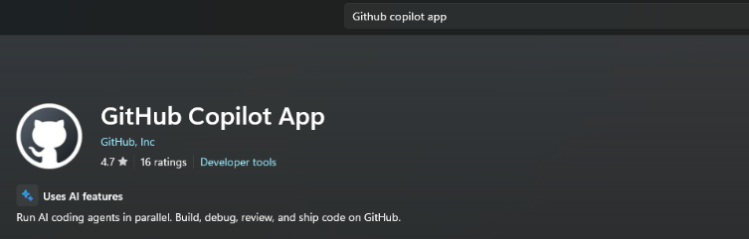
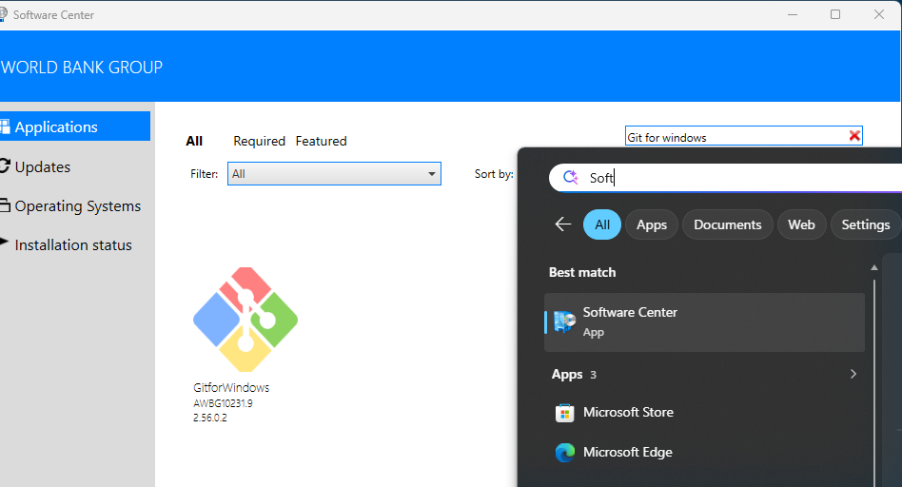
Please get github copilot from the Microsoft store.
Action C: Go to C:\Users\ WBpid (just go to C:\Users and find your folder which will be WB followed by your PID). Download Repos.zip and extract it. Got to C:\Users\WB<PID>\Repos
Click CloneRepos.bat to clone selected repos. Then click SyncAllRepos.bat for any changes later.
Action D: Add your GitHub ID (including Instructions to get Enterprise account)
- Once you have your ID ask Kacper klukaszewicz@worldbank.org to be added to cpmodelsai, where our repos are. Copy in Paulina and me for information.
- Please ask for your user ID to be added to the WB github organisation. http://githubmemberrequest/
- Please get a GitHub Enterprise account by emailing this address with your github ID. <GitHub_Enterprise_Admin@worldbankgroup.org>

Optional: Linking Claude Code to Repos.
Part 1: Create a Claude account
- Go to claude.ai in your browser (or download the Claude app on your phone or computer).
- Click Sign up. You can use an email address or a Google account.
- If you used email, check your inbox and click the sign-in link Claude sends you.
- Enter your name and confirm your details. That’s it — you’re in, on the free plan.
- Optional: if you want more usage or features, you can upgrade to a paid plan later from Settings.
Part 2: Get a GitHub account (if you don’t have one)
A “repo” (repository) is a folder of files stored on GitHub. To add one to Claude, you first need it on GitHub. Sign up free at github.com, then create or open the repo you want.
Part 3: Connect GitHub and add a repo to Claude
- First, turn on the GitHub connector. For more information on enabling GitHub within your account, see Use connectors to extend Claude’s capabilities. In short: go to Settings → Connectors, find GitHub, and click Connect. GitHub will ask you to approve access. claude
- Open a chat (or a Project) and click the + button next to the message box.
- Select “Add from GitHub” from the drop-down. claude
- Search through your accessible repositories, or paste a repository URL. claude
- Pick the repo. Claude can now read its files and help you with them. You can add multiple repositories if needed. claude

AI Tools Quick Start
Two examples with the GitHub Copilot app.

We assume you already have
✓ The new-ai-tools repo downloaded on your laptop (C:\Users\<you>\Repos\climate-fiscal-ai-tools) and up to date.
✓ The GitHub Copilot app installed (Microsoft Store) and signed in with your GitHub account.
✓ Other steps above
Not there yet? See Presentations/GitHub_Copilot_AI_User_Guide.pptx.
Steps 1-2 set up a session. Then do Example 1 or Example 2. Step 3 saves your work.

Step 1. Open the repo and start a session (once per task)
1. Add the repo (first time only). In the sidebar, click + next to Projects, then Open folder. Pick Repos\new-ai-tools. It stays in the sidebar.
2. Start a session. Point at new-ai-tools in the sidebar and click the + next to it.
3. Work in your folder. Under the prompt box, open the workspace selector and choose Current checkout. Copilot then edits the repo folder on your laptop.
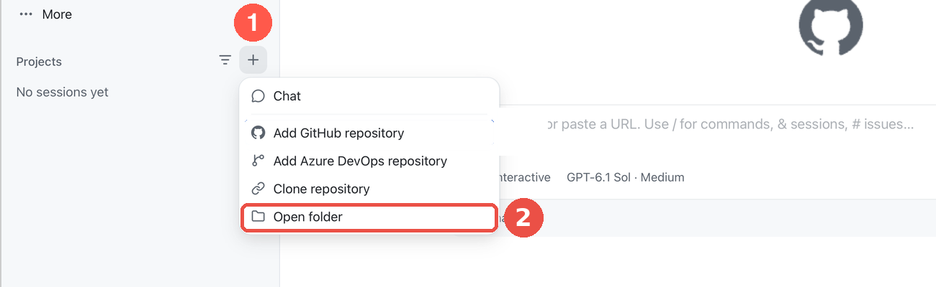
+ next to Projects, then Open folder
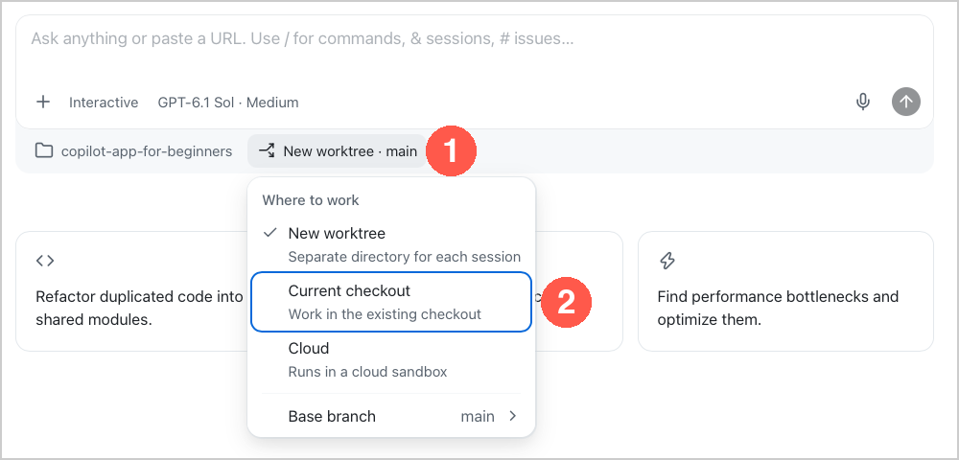
Workspace selector, then Current checkout

Step 2. Pick the model and the mode (every session)
1. Model. Click the model chip under the prompt box. Switch Auto off, then pick Model: Claude Sonnet for everyday work, Claude Opus for the excise research.
2. Mode. Click the mode chip and pick Interactive: Copilot asks before it acts.
3. Credits. Type /context at any time to see the AI credits the session has used.
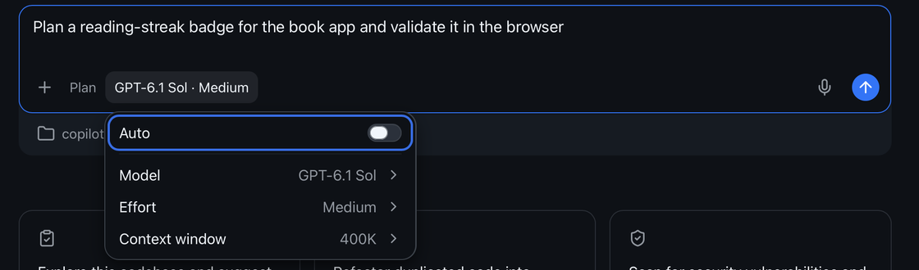
Model chip: Auto off, then Model
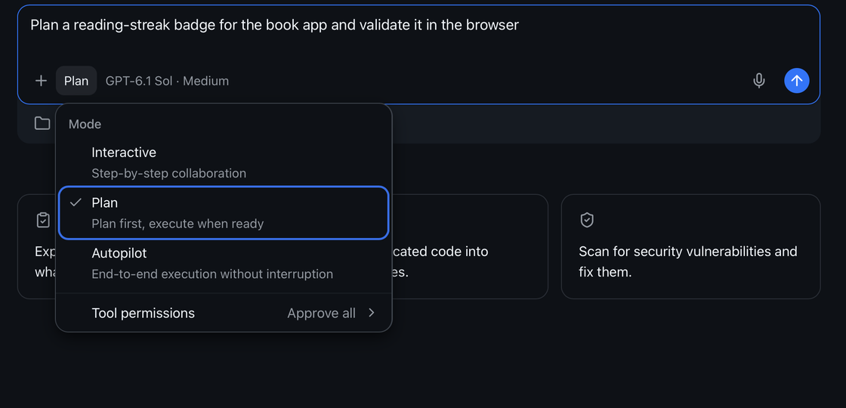
Mode chip: pick Interactive

Excise diagnostic for Indonesia (Claude Opus · Interactive)
⚠ Deep research uses a lot of credits. Send one prompt, read the answer, then send the next. Check /context as you go. Stop and fix anything wrong before going on.
Attach the instructions: type @ and pick user_guide/excise_diagnostic_process.md (or drag the file onto the prompt box).
Paste:
@user_guide/excise_diagnostic_process.md Follow this file. Run stage A1 for Indonesia, 2020 to 2026-09-30. Search the web for the laws. Stop after A1.
Then, one at a time:
Run stage A2.
Run stage A3.
Run stage A4.
Run stage A5.
Run stage A6. Save the Word report and Excel workbook in ExciseDiagnostic/country_results/Indonesia/.
Check: Every rate quoted with its date and a source link; missing data says data_gap.
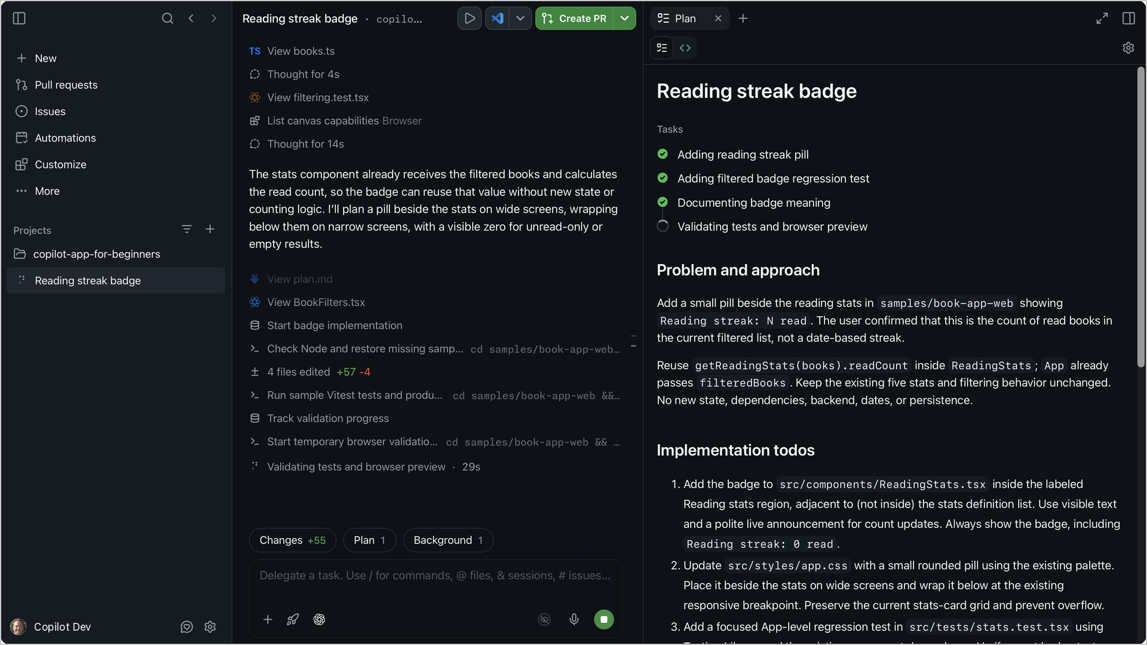
A session at work: the steps on the left, the plan on the right

Add tax indicators to the dashboard (Claude Sonnet · Interactive)
Paste:
Add VAT, personal income tax, corporate income tax and excises (% of GDP) to the dashboard, under Tax revenue, from the IMF WoRLD file already in raw_data. Follow TaxMacroFiscalDashboard/build/README.md. Do not change anything else. Then rebuild and show me Indonesia.
Then:
Commit and push with a clear message.
Check: Indonesia, % of GDP: tax 10.08 · VAT 3.52 · corporate 2.65 · personal 1.79 · excises 1.11
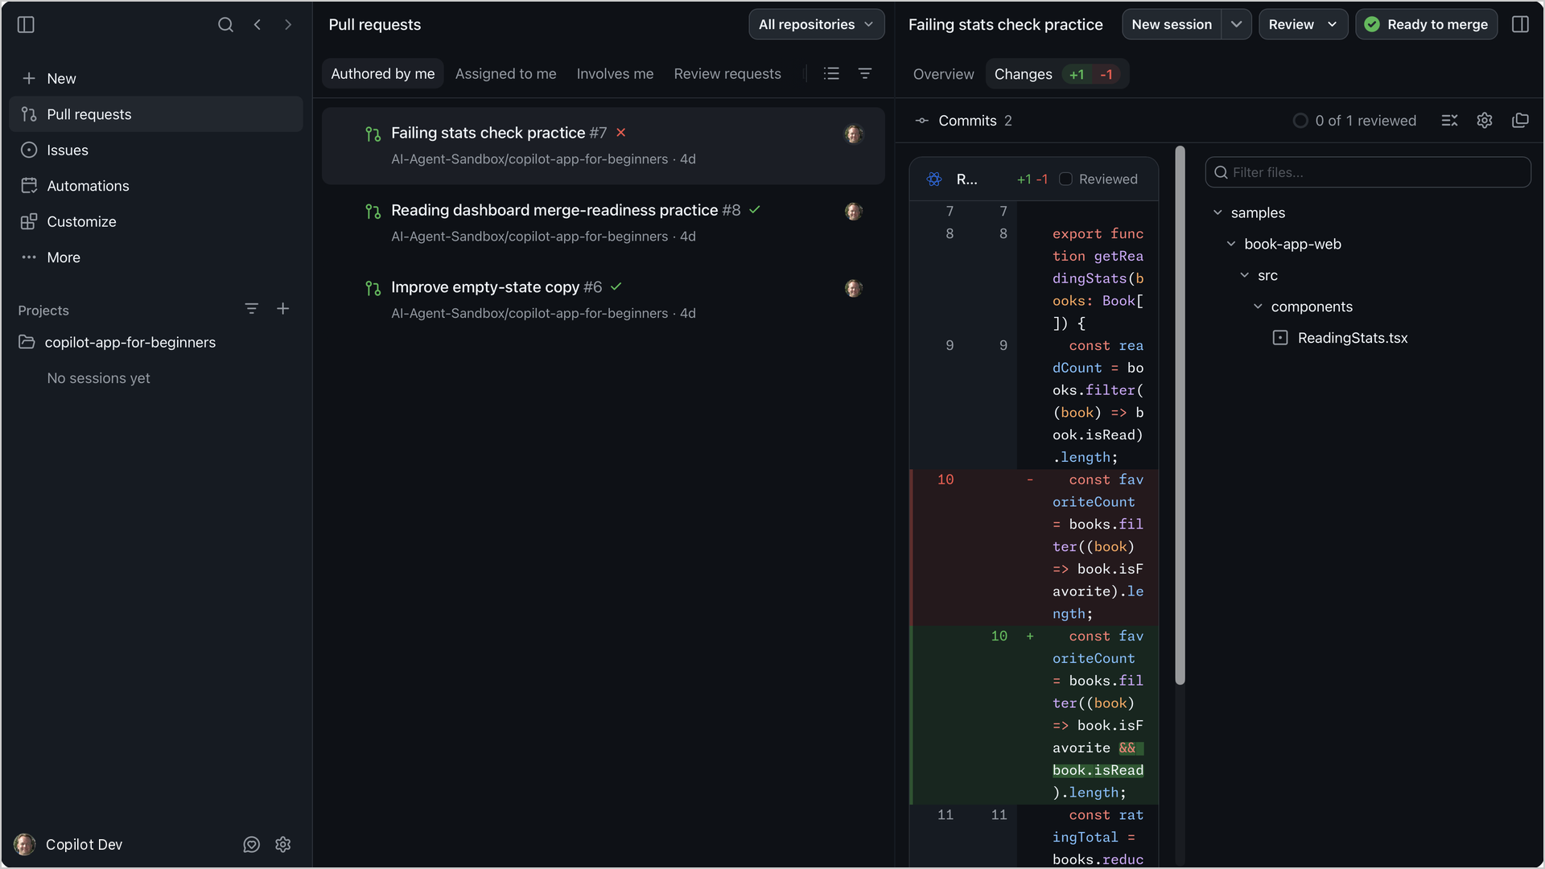
The Changes view: every edit as a diff before you keep it

Step 3. Save your work to GitHub
1. Ask Copilot. Type: Commit and push with a clear message. Approve what it shows.
2. Or use the script. Double-click SyncRepo.bat in the repo folder.

Appendix
With Claude instead: on claude.ai make a Project, add excise_diagnostic_process.md, switch on Research, and paste the same prompts.

