Fall 2017 COMP 3511 Homework Assignment #1
Handout Date: September 14, 2017 Due Date: September 28, 2017
Name: SHI Zhenmei ID: 20329335 E-Mail: zshiad@connect.ust.hk
Notice: This is the latest version which covers the old version. （2）

Please read the following instructions carefully before answering the questions:
- You should finish the homework assignment individually.
- There are a total of 4 questions.
- When you write your answers, please try to be precise and concise.
- Fill in your name, student ID, email at the top of this page.
- Please fill in your answers in the space provided, or you can type your answers in the Microsoft Word file.

- Homework Collection: the hardcopy is required and the homework is collected in collection box #1. The collection boxes locate outside Room 4210, near lift 21 (there are labels attached on the boxes).

- (20 points) Multiple choices.
D
- After setting up______ for the I/O device, the device controller transfers an entire block of data directly to or from its own buffer storage to memory, with no intervention by the CPU.
A) buffers
B) pointers
C) counters
D) all of the above
A
- Which of following is NOT true about asymmetric multiprocessing?
A) Each processor performs all tasks within the operating system.
B) Asymmetric multiprocessing defines a boss-worker relationship.
C) Some processors have predefined tasks.
D) A boss processor controls the system
B
- Which of the following is NOT true about loadable kernel modules?
A) Kernel provides core services while other services are implemented dynamically, as the kernel is running.
B) Each kernel section has defined, protected interfaces, but a single module cannot call another module.
C) The primary module has only core functions and knowledge pf how to load and communicate with other modules.
D) Modules do not need to invoke message passing in order to communicate.
D
- Which one in the following uses inter-process communication (IPC) system?
A) POSIX Shared Memory
B) Mach
C) Windows
D) All of the above
D
- Which is include in PCB when context switch occurs?
A) the value of CPU registers
B) the process state
C) memory-management information
D) all of the above
D
- Which is the method for passing parameters to the OS?
A) passing in registers
B) OS gets parameters’ address from block or table in memory
C) Parameters are placed, or pushed, onto the stack by the program, and popped off the stack by the OS.
D) All of the above

A
- A zombie process is ______.
A) a process that has terminated, but whose parent has not yet called wait()
B) a process whose parent terminates without first calling wait()
C) a process that periodically calls wait(), which allows any resources allocated to terminated processes to be reclaimed by the operating system
D) a process that terminates the execution of its children processes
B
- Two important design issues for cache memory are ____.
A) speed and volatility
B) size and replacement policy
C) power consumption and reusability
D) size and access privileges
B
- _____ provide(s) an interface to the services provided by an operating system.
A) Shared memory
B) System calls
C) Simulators
D) Communication
D
- When a child process is created, which of the following is a possibility in terms of the execution or address space of the child process?
A) The child process runs concurrently with the parent.
B) The child process has a new program loaded into it.
C) The child is a duplicate of the parent.
D) All of the above

- (25 points) Simple questions on fork().
  - Consider the following code segments, what is the total number of processes (including the initial process)? Please elaborate. (10 points)
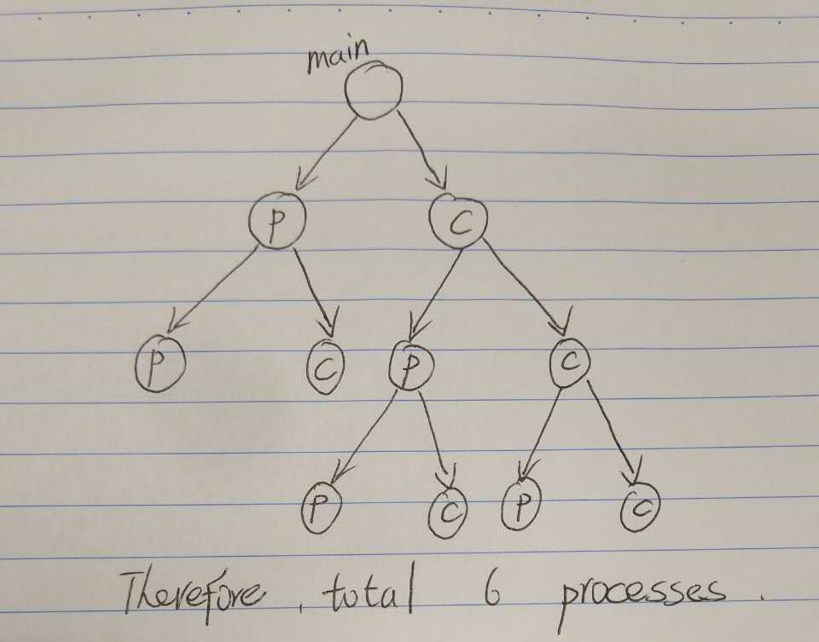
#include <stdlib.h>
#include <stdio.h>
#include <unistd.h>

int main() {
if (fork() == 0) {
fork();
fork();
}
else
fork();
return 0;
}
Ans:
Showed in figure, there will be 6 processes in total.
Consider the following code segments, what is the output of this segment? Please elaborate (10 points)
int var1 = -5;
int main()
{
int var2=5;

if (fork() == 0) {
var1++;
var2++;
printf(" var1 = %d, var2 = %d\n", var1, var2);
}
else {
var1++;
var2--;
printf("var1 = %d, var2 = %d\n", var1, var2);
wait(NULL);
}
return 0;
}
Ans:
The order of print of parent process and child process are random. The variable of child will deep copy from its parent, including global variable. Therefore, the output will be:
var1 = -4, var2 = 6
var1 = -4, var2 = 4
OR:
var1 = -4, var2 = 4
var1 = -4, var2 = 6

  - Both of the parent process and the child process continue execution at the instruction after the fork (). What’s the different value between the parent and the child? (5 points)
Ans:
PID, Running time, Running state, Return values from fork(): 0 for child process, PID of child for parent process

- (30 points) Please answer the following questions in 3-4 sentences.
  - (5 points) Which of the following instructions should be privileged?
a. Set value of timer.
b. Read the clock.
c. Clear memory.
d. Issue a trap instruction.
e. Turn off interrupts.
f. Modify entries in device-status table.
g. Switch from user to kernel mode.
h. Access I/O device.
Ans:
a, c, e, f, h

  - (5 points) Distinguish between the client – server and peer-to-peer models of distributed systems.
Ans:
In client-server model, the roles of the client and server are strictly different. Under this model, the client requests services that are provided by the server.
In peer-to-peer model, the system are considered peers and thus may act as either clients or servers - or both. A node may request a service from another peer, or the node may in fact provide such a service to other peers in the system.

  - (5 points) What are the three major activities of an operating system with regard to memory management?
Ans:
Keep track of which parts of memory are currently being used and by whom
Decide which processes are to be loaded into memory when memory space becomes available
Allocate and deallocate memory space as needed

  - (5 points) What is the main advantage of the layered approach to system design? What are the disadvantages of using the layered approach?
Ans:
Advantage: Simple for construction and debugging due to information hiding from lower-level layers.
Disadvantages: Difficulty of proper definition of the various layers and their functionality. Less efficient as each layer adds certain overhead.

  - (5 points) Why does Java provide the ability to call from a Java program native methods that are written in, say, C or C++? Provide an example of a situation in which a native method is useful.
Ans:
Java programs are intended to be platform I/O independent. Therefore, Java does not provide access to most specific system resources such as reading from I/O devices or ports. To perform a system I/O specific operation, it is needed to call methods that are written in C/C++, which has the ability to access the I/O system.

- (30 points) Process.
  - (6 points) When a process creates a new process using the fork() operation, which of the following state is shared between the parent process and the child process?
a. Stack
b. Heap
c. Shared memory segments
Ans:
c.
Stack and Heap are duplicated when called fork().

  - (6 points) Please briefly explain the five process states, and give a diagram to illustrate the transition between them.
Ans:
New: The process is being created – resources being allocated such as memory
Running: Instructions are being executed on a CPU
Waiting: The process is waiting for some event(s) to occur (such as I/O completion)
Ready: The process is waiting to be assigned to a processor (CPU)
Terminated: The process has finished execution – to release resources
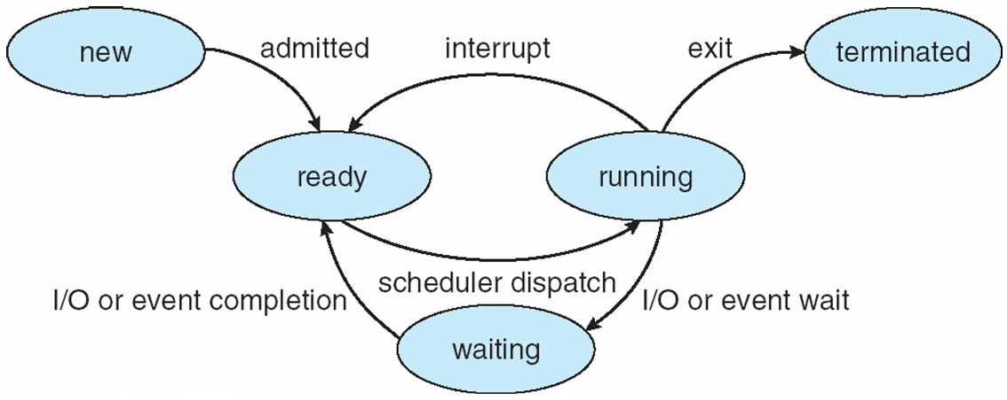

  - (6 points) Please describe the key actions taken by the kernel during context switch.
Ans:
When switching context, the kernel saves the state i.e. value of the CPU registers, PCB, of the old process and loaded the saved state for the new process.

  - (6 points) Describe the differences among short-term, medium-term, and long- term scheduling.
Ans:
Short-term scheduling (CPU scheduling): Selects which process from the ready queue should be executed next and allocates CPU to run.
Medium-term scheduling: Perform swapping of process. Which is removing a process from the memory and store to the disk, or bringing back and continuing execution of a process from the disk. It can be added if degree of multiple programming needs to be reduced.
Long-term scheduling (job scheduling): Selects which processes should be brought into the ready queue or/and memory (after resource allocation such as memory, file and etc.).

  - (6 points) Consider the situation where a process reads a log and many processes writes to the same log. Is it appropriate to use an ordinary pipe as inter-process communication mechanism? If YES, give the reason. If NO, give the reason and a suitable communication mechanism.
Ans:
NO. Ordinary pipe only allows one to one communication. Since there might be multiple process to writing to the pipe at the same time, the log might be messed up. A better IPC mechanism is to use Named pipes.

