First dowload your transactions

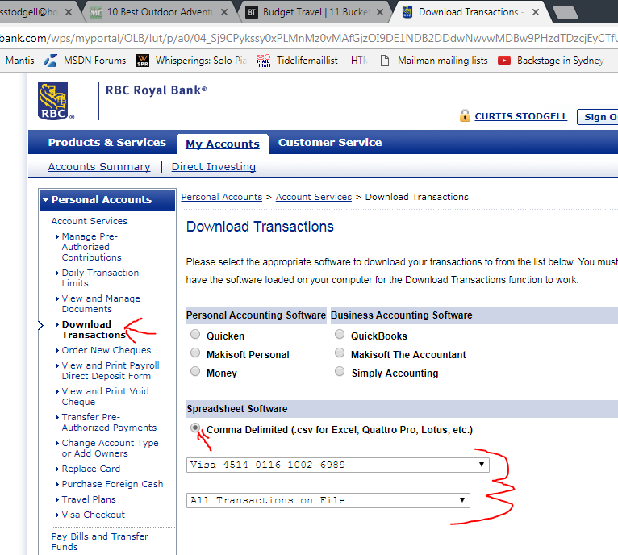

Save it to here:

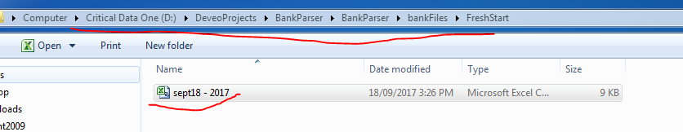

NEXT go to BMO and download transaction since the 28th

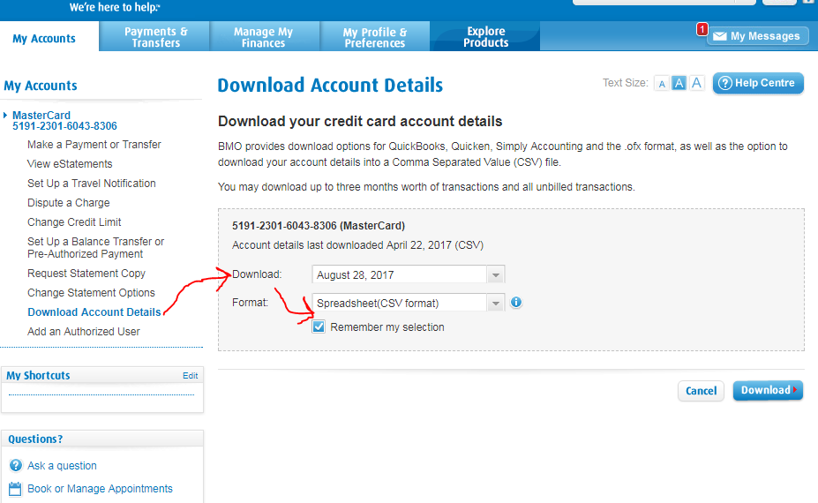

Next remove all the spaces in the csv:

