WAGE_VISCOSITY = 0.03

PRICE_VISCOSITY = 0.06

INIT_POPULATION = [50, 0, 10]

INIT_SAVINGS = [2, 5, 10]

INIT_FIRMS = [10, 0]

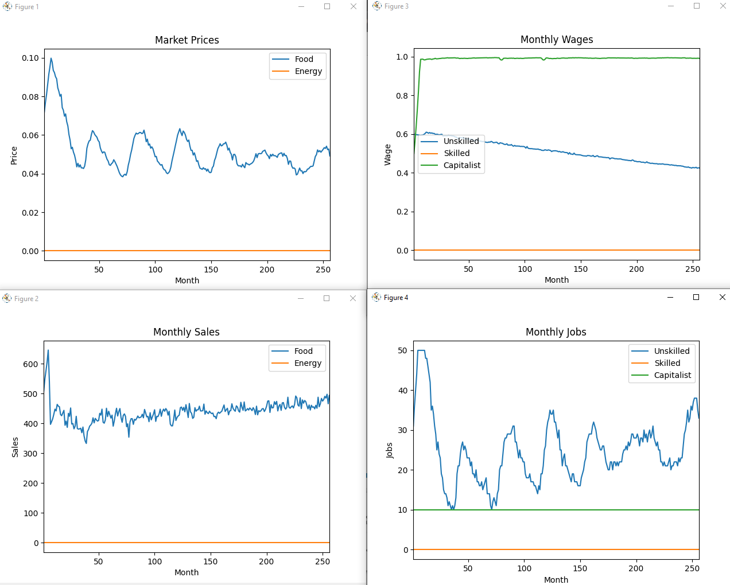

WAGE_VISCOSITY = 0.03

PRICE_VISCOSITY = 0.04

INIT_POPULATION = [50, 0, 10]

INIT_SAVINGS = [2, 5, 10]

INIT_FIRMS = [10, 0]

