Update Progress 11 September 2026

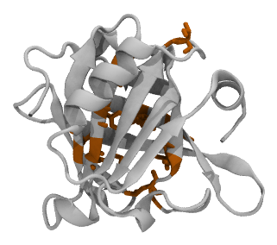 | 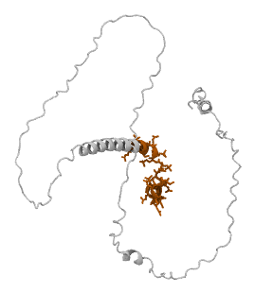
(a) BLG: compact fold, calyx patch (orange) | (b) CASEIN: extended chain, N-term (orange)

Figure 1: Structural contrast between the two proteins (VMD renders): BLG's compact, mostly-buried calyx vs. CASEIN's extended, disordered chain with its N-terminal region already surface-exposed even in the starting structure.

1. BLG Results
Headline numbers (unchanged, PBC-corrected, computed across all 4 replicas): 613 total contact events (97 in CENTER, 516 near-interface across replicas); 6 long contact events (≥10 ns); calyx SASA range 24–37 nm² (mean 28.95 nm²); Pearson correlation between SASA and orientation angle r = +0.006 (block-bootstrap 95% CI [−0.09, +0.11]) – no coupling detected within these limits. These support the paper's current framing: BLG's calyx remains accessible throughout, but the protein does not commit to a bound, reoriented state within the simulated timescale.
Replica | Rg (nm)* | RMSD bb (nm) | RMSD patch (nm) | Calyx SASA (nm²) | γ (mN/m)*
CENTER (1000 ns) | 1.504 ± 0.022 | 0.229 | 0.198 | 3.81 ± 0.46 | 51.9 ± 38.5
R1 | 1.497 ± 0.009 | 0.237 | 0.347 | 3.15 ± 0.34 | 52.7 ± 38.7
R2 | 1.493 ± 0.008 | 0.206 | 0.254 | 3.59 ± 0.32 | 52.0 ± 39.0
R3 | 1.499 ± 0.012 | 0.268 | 0.276 | 3.36 ± 0.48 | 52.6 ± 39.4
Table 1: BLG per-replica structural summary. *For R1/R2/R3, only Rg and γ (surface tension) currently reflect the first 500 of 1000 ns each replica actually ran – a fix to include the remaining trajectory segments for these two analyses is in progress. RMSD and calyx SASA for R1/R2/R3 already cover the full 1000 ns (their analysis scripts already include the extension trajectory segments).

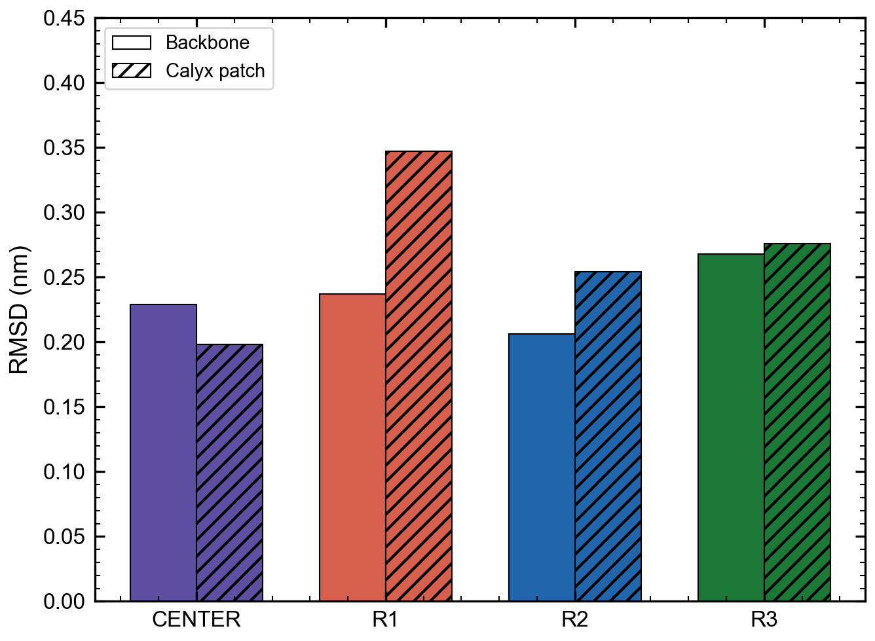

Figure 2: BLG RMSD by region, all 4 replicas: whole-backbone (solid) vs. calyx patch (hatched). R1's patch RMSD is visibly elevated relative to the other replicas – traced to a long (≥10 ns) contact event unique to R1, not a bug.
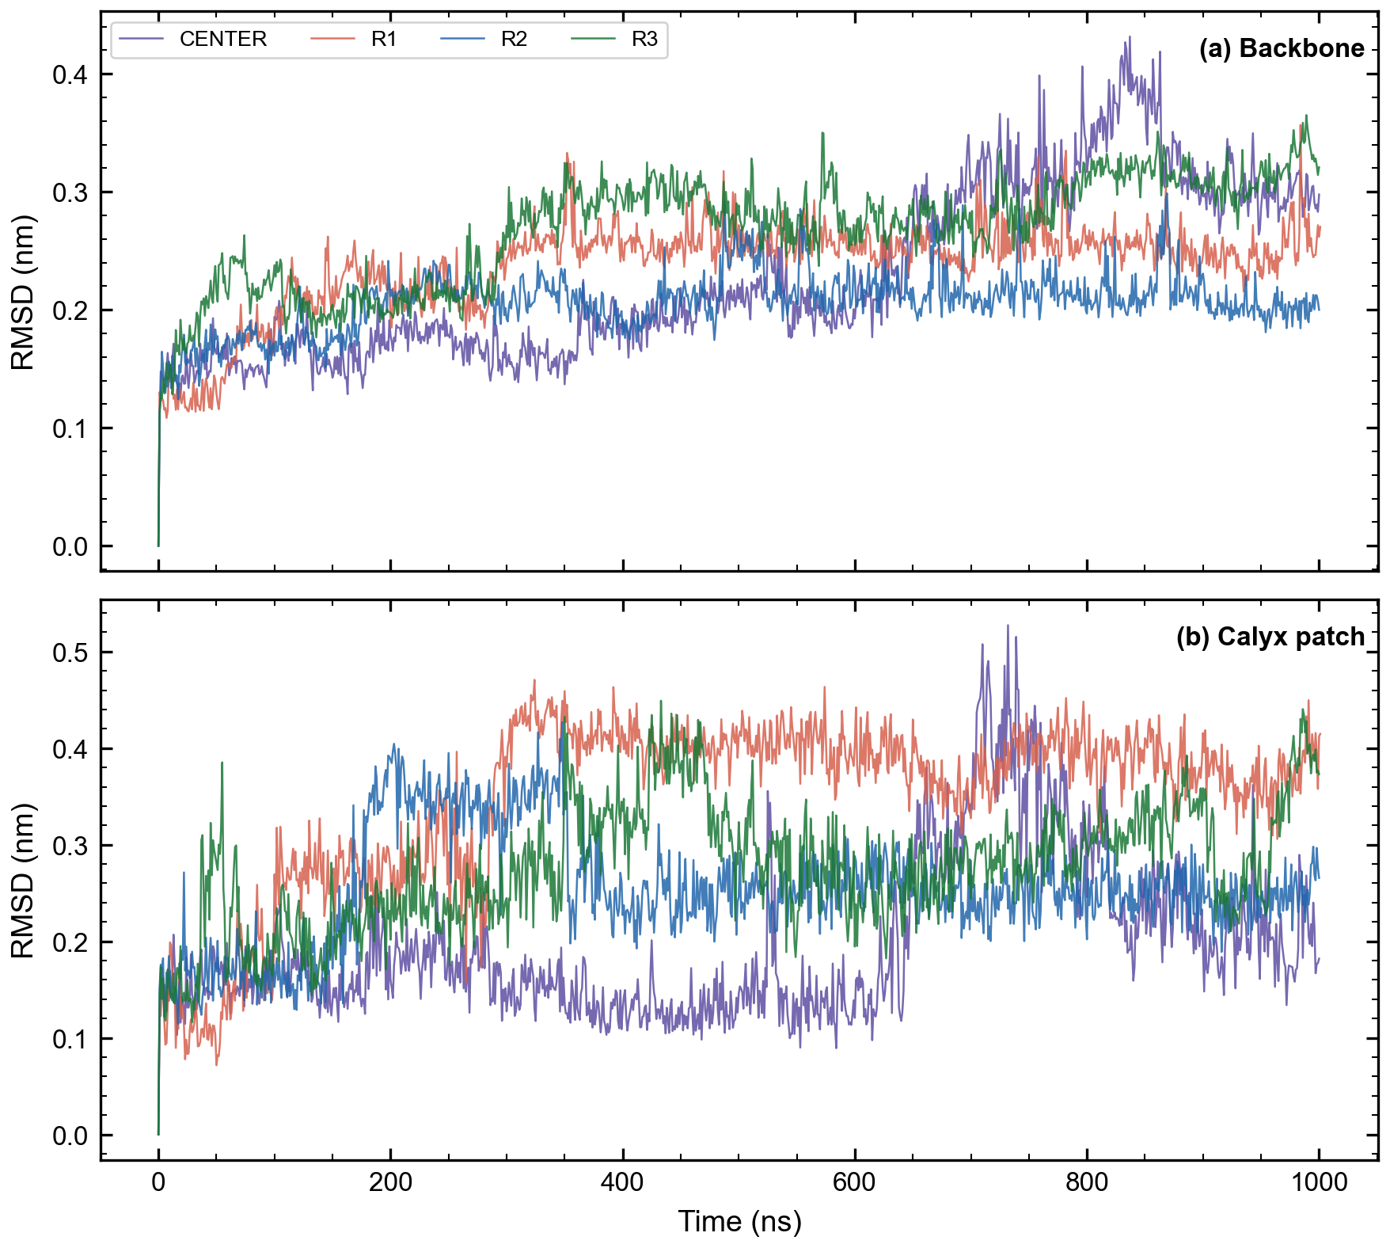

Figure 2b: BLG RMSD vs. time, all 4 replicas (backbone and calyx patch). The trend view: R1's patch RMSD (orange, panel b) visibly steps up around 350 ns and never returns to baseline – the moment of its long contact event – while CENTER's patch RMSD (purple) stays lowest and flattest throughout.
Secondary structure content (DSSP) is stable across all 4 replicas: Helix 10.5–12.4%, Sheet 36.0–36.8%, Coil 50.8–52.9%. Hydrogen-bonding (CENTER only so far): protein-protein 107.3 ± 5.6, protein-water 393.2 ± 13.2, interface water-water 9539.6 ± 328.4 (mean counts per frame).

2. CASEIN (β-casein) Results
First comparative result with real replication (n=2): N-terminal region (residues 1–25) solvent accessibility – the CASEIN analogue of BLG's calyx SASA – is 24.77 ± 1.40 nm² in R1 vs. 25.41 ± 1.97 nm² in CENTER. The two independent 1000 ns runs agree closely, which is good evidence this is a real, reproducible property of the protein rather than an artifact of one starting structure.
Replica | N-term SASA (nm²) | Contact | γ (mN/m) | Hbonds prot-prot | Hbonds prot-water
CENTER (1000 ns) | 25.41 ± 1.97 | 99.5% | 51.4 ± 34.2 | 97.8 ± 9.7 | 565.5 ± 25.1
R1 (1000 ns) | 24.77 ± 1.40 | 99.5% | 52.4 ± 34.6 | 92.0 ± 8.3 | 575.9 ± 24.0
Table 2: CASEIN per-replica summary. Both replicas now have all 7 planned analyses complete. “Contact” is the fraction of frames with a protein-water minimum distance ≤0.3 nm; R1 shows 1 sustained contact event across the full 1000 ns run.

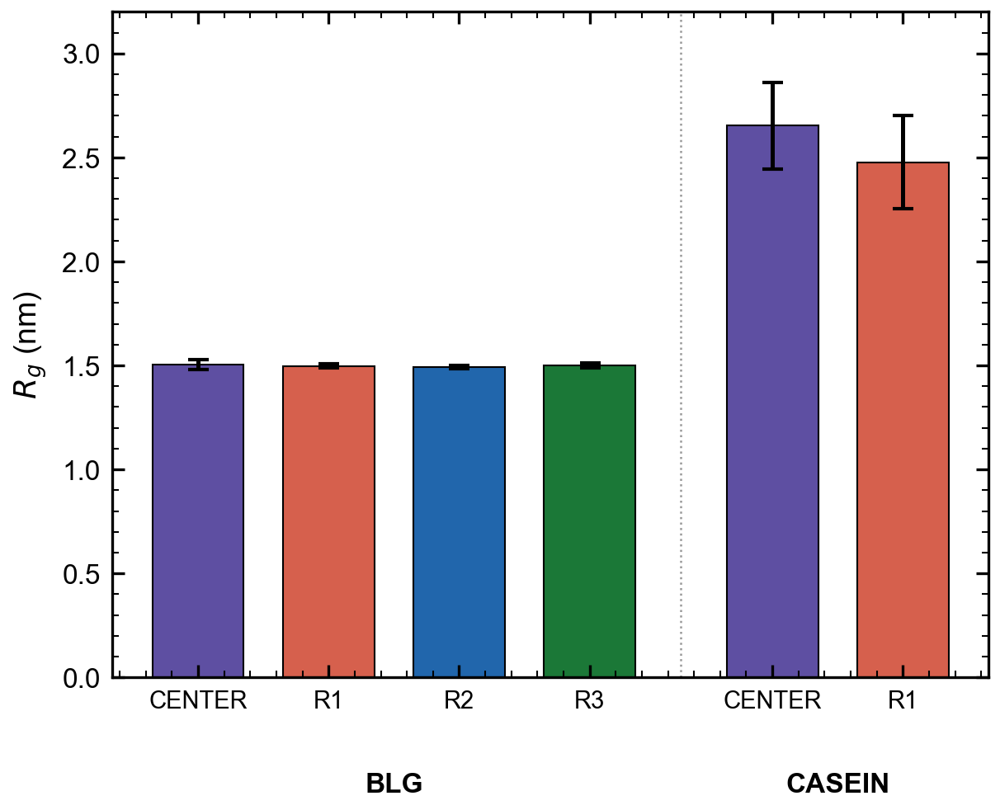

Figure 3: Radius of gyration, BLG vs. CASEIN, all replicas. BLG stays tightly compact (~1.5 nm, all 4 replicas) while CASEIN settles to a larger, still stable range (~2.5–2.7 nm) after its initial relaxation from an extended starting structure.
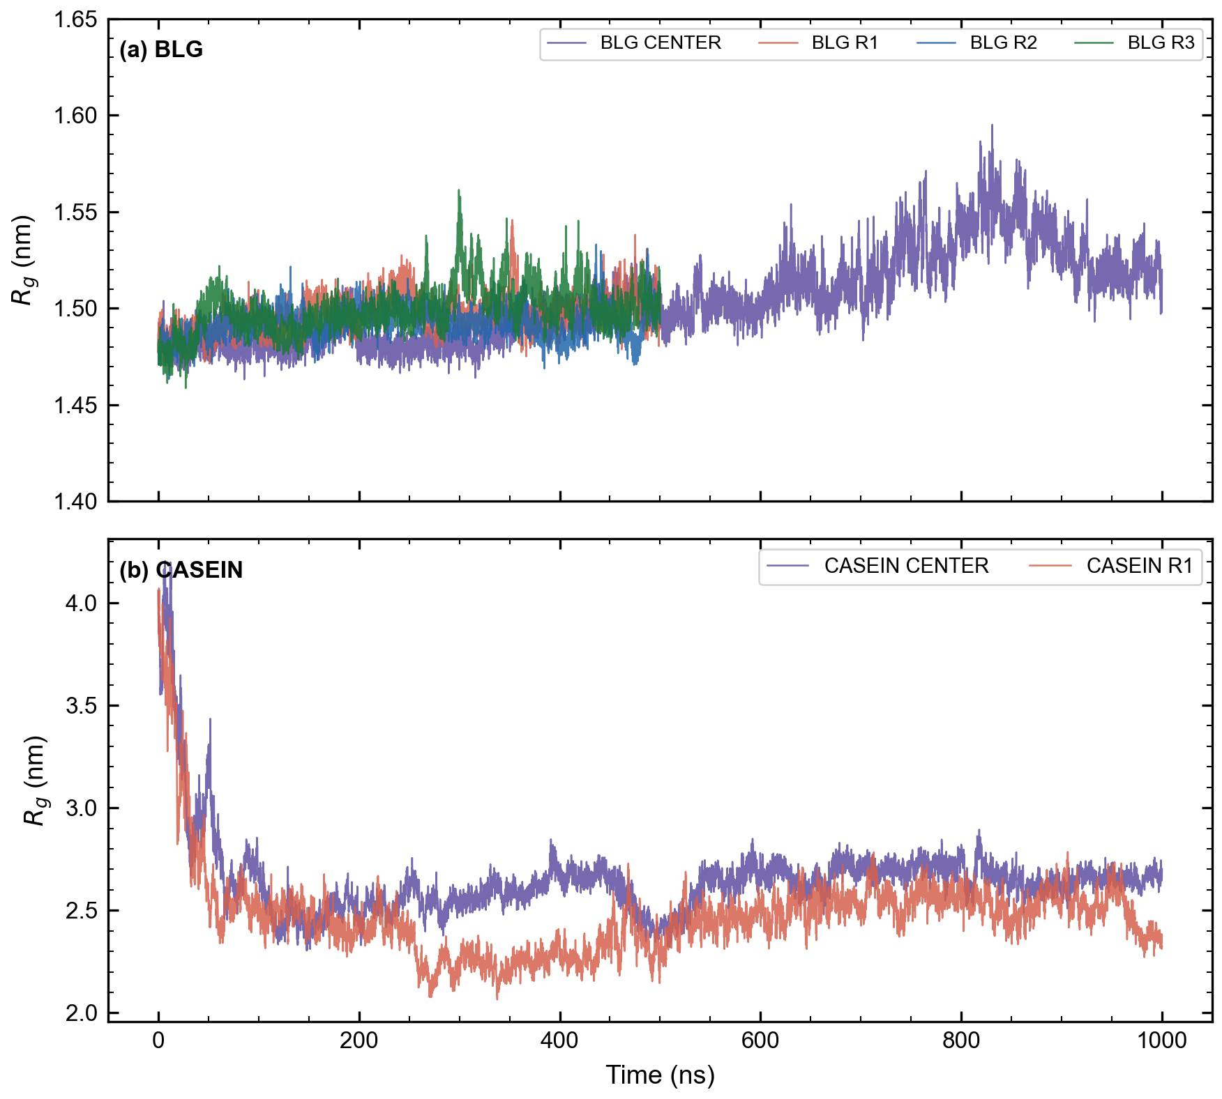

Figure 3b: Rg vs. time. BLG (panel a) is flat and tightly clustered around 1.5 nm from t=0 – no relaxation needed, it started compact. CASEIN (panel b) starts extended (~4 nm, its AlphaFold starting structure) and visibly relaxes down to ~2.5 nm within the first ~100 ns, then stays there – the relaxation transient is directly visible here, not just summarized as a mean.
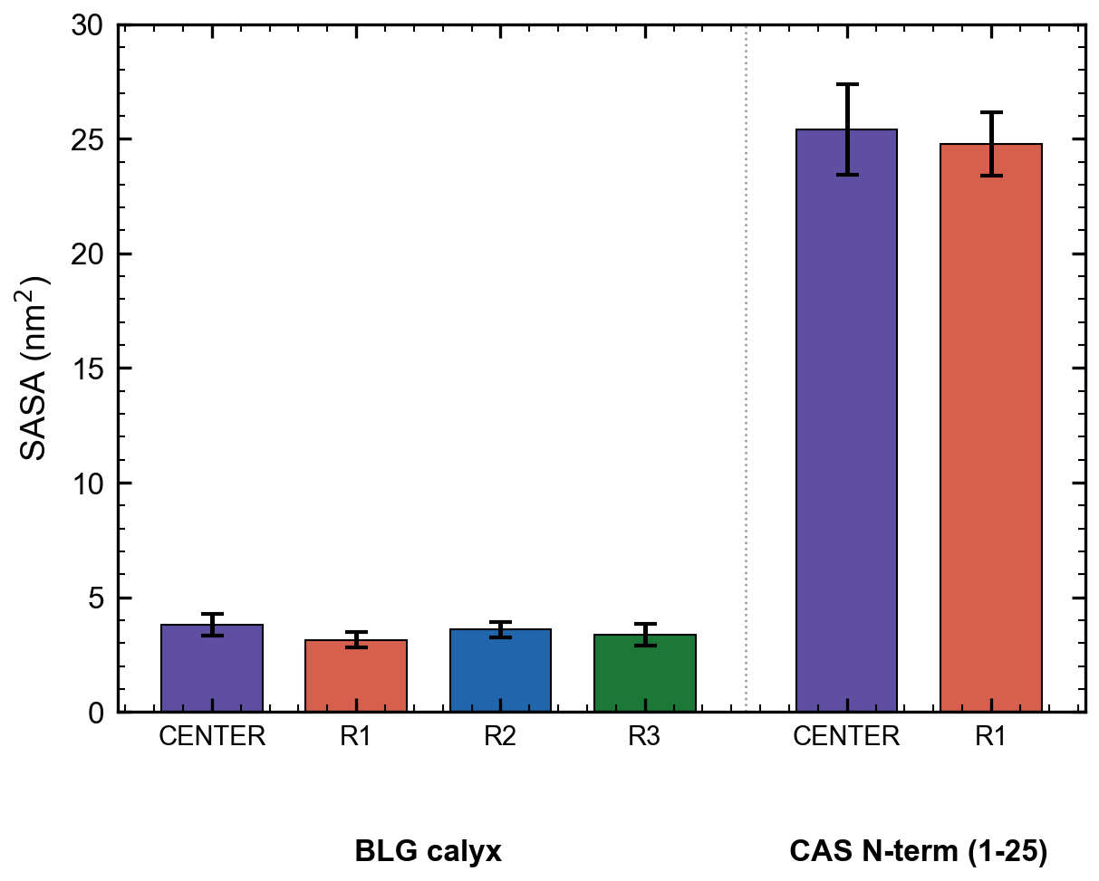

Figure 4: Accessible surface area, BLG calyx vs. CASEIN N-terminal region (residues 1–25), all replicas. The ~7-fold size difference is consistent across every replica of both proteins – not an artifact of any single run.
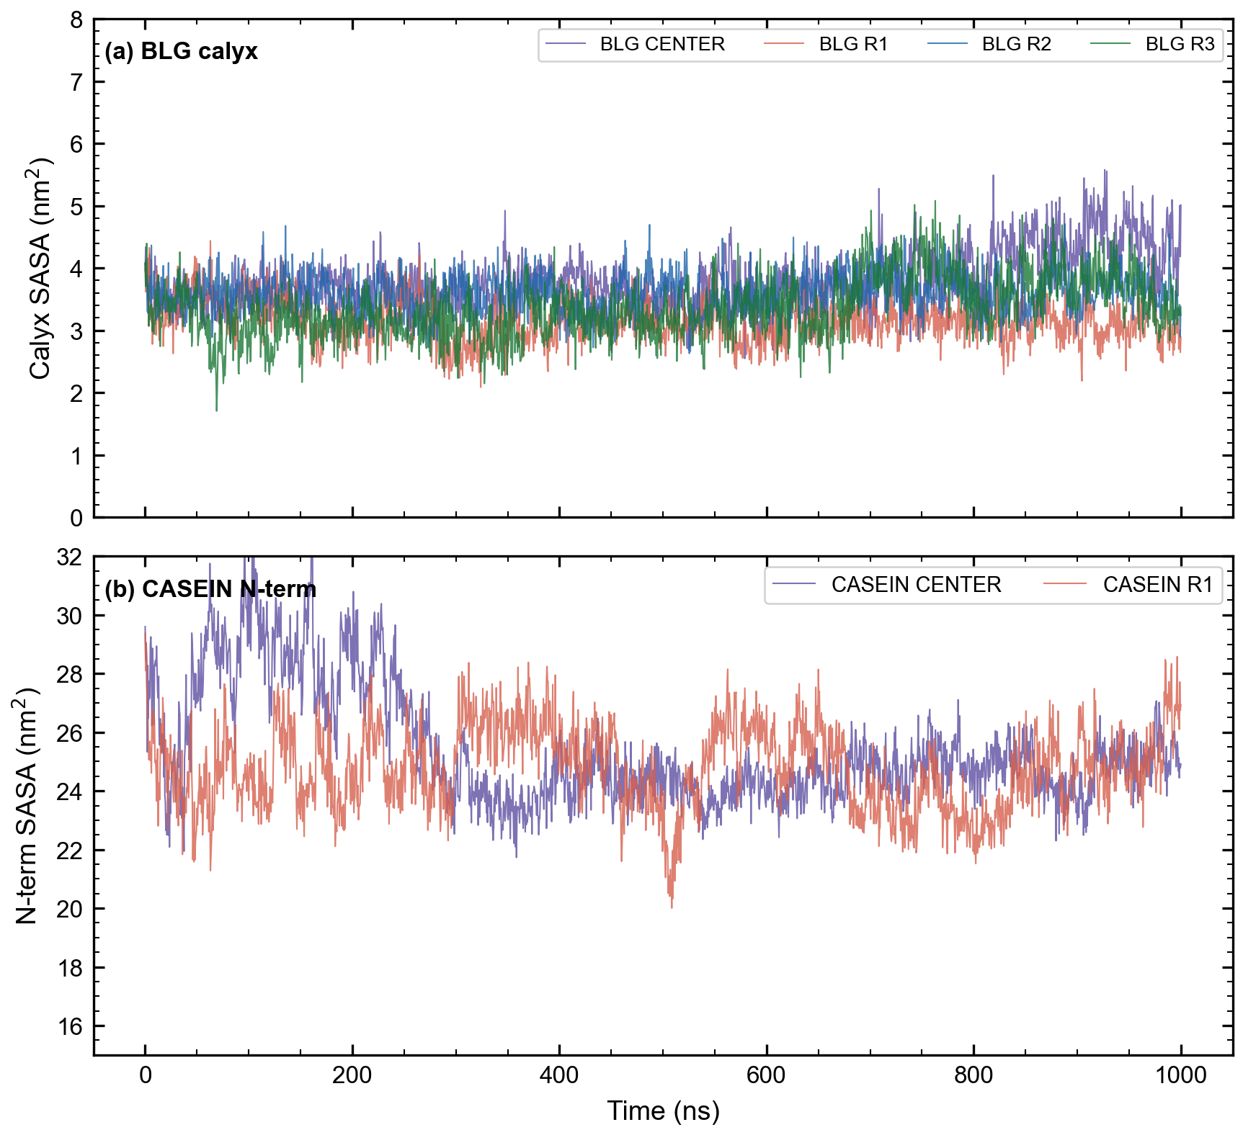

Figure 4b: SASA vs. time. BLG's calyx (panel a) fluctuates in a narrow band (~2–5.5 nm²) throughout, all 4 replicas overlapping closely. CASEIN's N-terminus (panel b) fluctuates far more broadly (roughly 20–32 nm²) but never drops anywhere near BLG's range – the size gap holds at every single timepoint, not just on average.
CASEIN's near-constant interfacial contact (99.5% of frames in both CENTER and R1, versus BLG's much more selective, intermittent contact pattern across 4µs) is a clear structural contrast that directly supports the comparative title: BLG presents a small, selectively-accessible calyx, while CASEIN's disordered chain stays persistently near the interface with its N-terminal region continuously exposed. Rg for R1 confirms the same relaxation pattern already seen in CENTER: an initial compaction from the extended AlphaFold starting structure (~2.85 nm in the first 100 ns) settling to a stable range (~2.5 nm) for the remainder of the trajectory – reassuring that this is a real, reproducible relaxation, not a one-off artifact of the CENTER run's starting conformation. Hydrogen-bonding is also now complete for both replicas and agrees closely (protein-protein 92.0–97.8, protein-water 565.5–575.9, interface water-water 12015.6–12750.5 mean counts per frame) – another independent confirmation that CENTER's behavior was not a one-off.
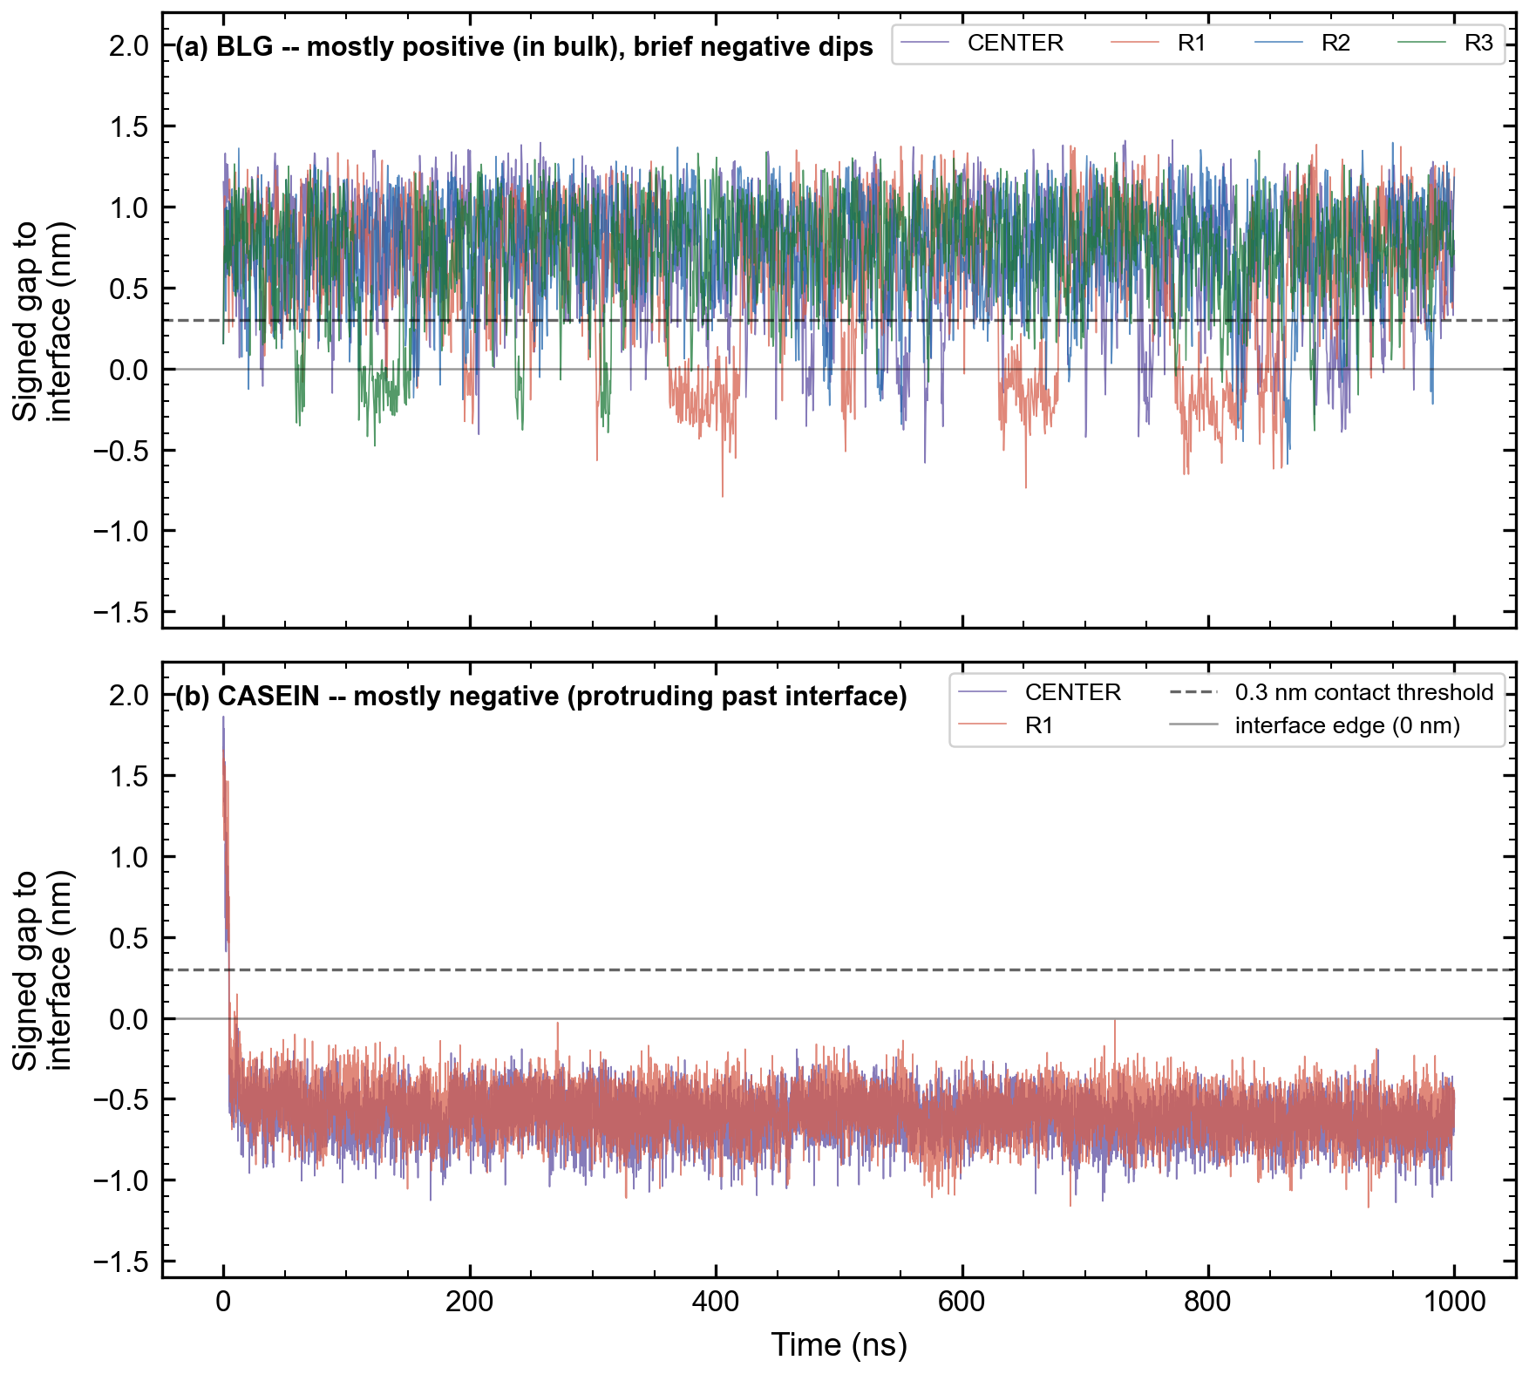

Figure 5: Signed protein-to-interface gap vs. time (positive = inside the water bulk, negative = protruding past the water's statistical edge, into the interfacial/vacuum region). BLG (panel a) sits mostly positive with brief, distinct negative excursions – these are its 613 discrete contact events. CASEIN (panel b) sits almost entirely negative throughout both replicas, averaging around -0.6 nm – it does not just touch the interface, it persistently protrudes past it for virtually the whole trajectory.

