Paper 1 Progress Update: BLG vs. β-Casein at the Air–Water Interface
Chalakon Pornjariyawatch — COMFHA Lab, Kasetsart University
September 25, 2026
Prepared for: Prapasiri Pongprayoon (P.P.)

Executive Summary
Changes since the last update (September 11, 2026):
- The BLG data-completeness gap flagged in the last update is half closed. Rg for R1/R2/R3 now covers the full 1000 ns per replica (fixed today — blg_rg.py's trajectory-extension gap is closed). Surface tension for those same three replicas still reflects only the first 500 ns; the extension segments' .edr energy files exist on the cluster but have not yet been synced locally, so that fix is still pending.
- Structural renders (Figure 1) rebuilt at full publication resolution. The previous report's calyx/N-term renders were a stale 512×512 px placeholder (headless VMD's default framebuffer size); regenerated today at 3008×2400 px, and the figure now also includes the simulation box geometry panel.
- No change to the core scientific picture: BLG remains stable and compact across all 4 replicas, and CASEIN's two-replica comparative result (open, persistently surface-exposed N-terminus vs. BLG's small, selectively-accessible calyx) — reported in full in the September 11 update — still holds with no new data since.
- 5 open questions remain for P.P., unchanged since the June 9 meeting — none carry a hard deadline, but two now block downstream figure/writing decisions.

Structural Overview
Figure 1 re-renders both proteins' key accessible feature at full publication resolution (VMD structural renders regenerated today at 3008×2400 px, up from a stale 512×512 px render — headless VMD's default framebuffer size, fixed via the -size launch flag rather than an in-script resize, which crashes in text-mode VMD) alongside the simulation box geometry for each species.
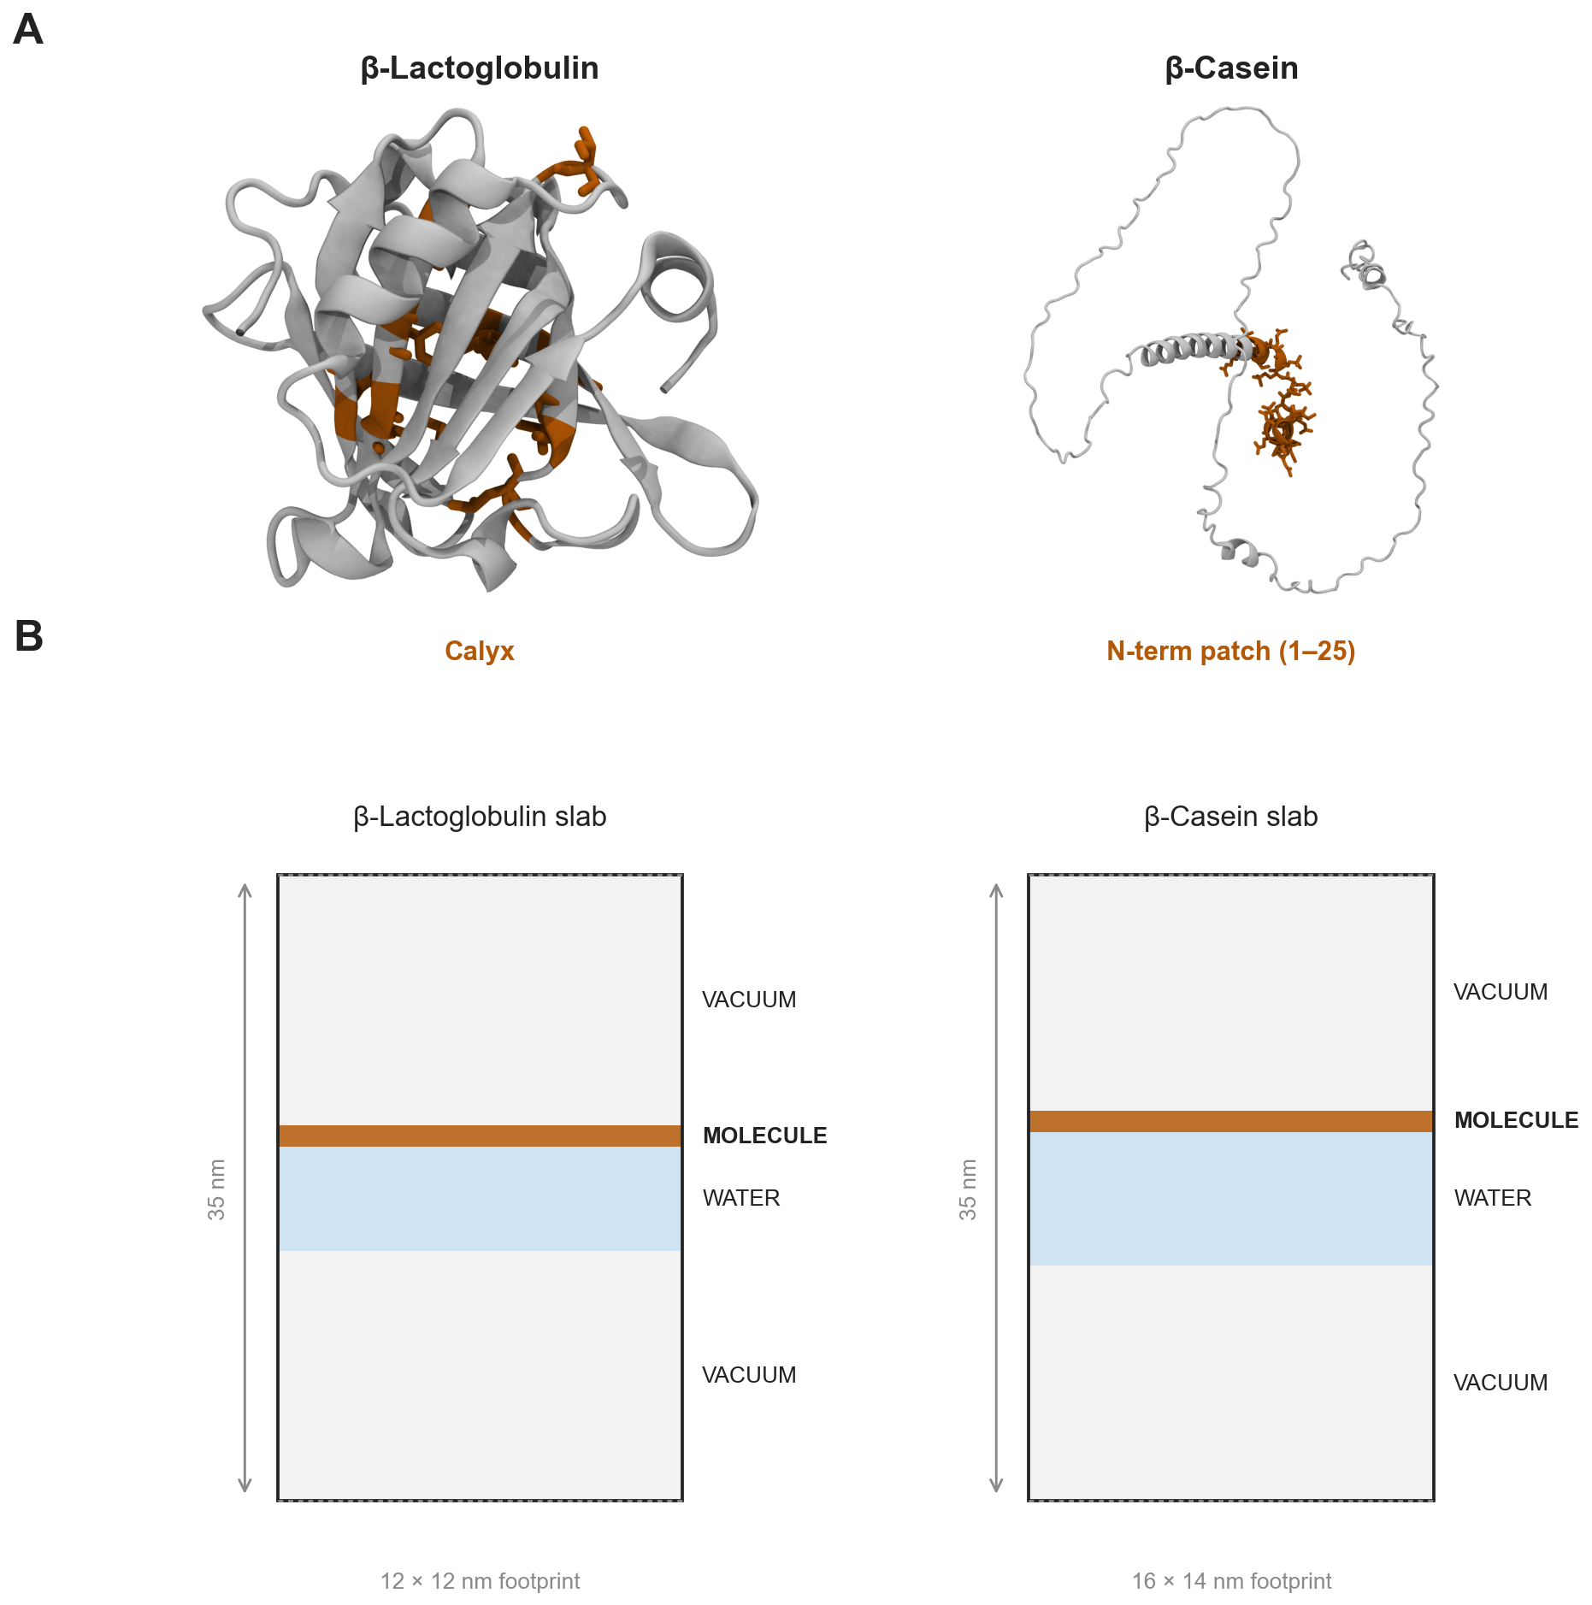
Figure 1: (A) BLG's calyx (9 lining residues, amber) versus CAS's N-terminal accessible patch (residues 1-25, amber), both rendered at the same visual convention (NewCartoon, ambient occlusion, orthographic). (B) Slab simulation box geometry for each species, drawn to the real locked box dimensions.

BLG Results
BLG's headline numbers are unchanged from the last update and remain fully validated across all 4 replicas (CENTER + R1/R2/R3, 4.00 µs total unbiased MD).
Replica | Calyx SASA (nm²) | Rg (nm) | γ (mN/m) | Patch RMSD (nm)
CENTER (1000 ns) | 3.81 ± 0.46 | 1.504 ± 0.022 | 51.9 ± 38.5 | 0.198 ± 0.081
R1 | 3.15 ± 0.34 | 1.497 ± 0.009 | 52.7 ± 38.7* | 0.347 ± 0.088
R2 | 3.59 ± 0.32 | 1.494 ± 0.009 | 52.0 ± 39.0* | 0.254 ± 0.059
R3 | 3.36 ± 0.48 | 1.507 ± 0.014 | 52.6 ± 39.4* | 0.276 ± 0.064
Table 1: BLG per-replica summary. Rg for R1/R2/R3 now covers the full 1000 ns (blg_rg.py's trajectory-extension gap was closed today, 2026-09-25). *γ for R1/R2/R3 is still computed from the first 500 of 1000 ns per replica — blg_surface_tension.py needs the extension segments' .edr energy files, which exist on the cluster but have not yet been synced locally. Not expected to change the qualitative picture, but not yet closed out.

The calyx stays compact and accessible in every replica (no collapse), Rg confirms a globally stable fold, and 613 discrete contact events occur across the full dataset with zero sustained (“gate-open”) adsorption events — the basis for the paper's scope claim (pre-commitment characterisation, not a completed-adsorption mechanism). R1's elevated patch RMSD (0.347 nm vs. 0.20-0.28 nm in the other three) is a real, traced effect: R1 contains 4 of the project's 6 total long (≥10 ns) contact events, and the patch RMSD steps up permanently after its longest event (362-419.5 ns) without ever returning to baseline — a genuine local conformational response to sustained contact, not noise.
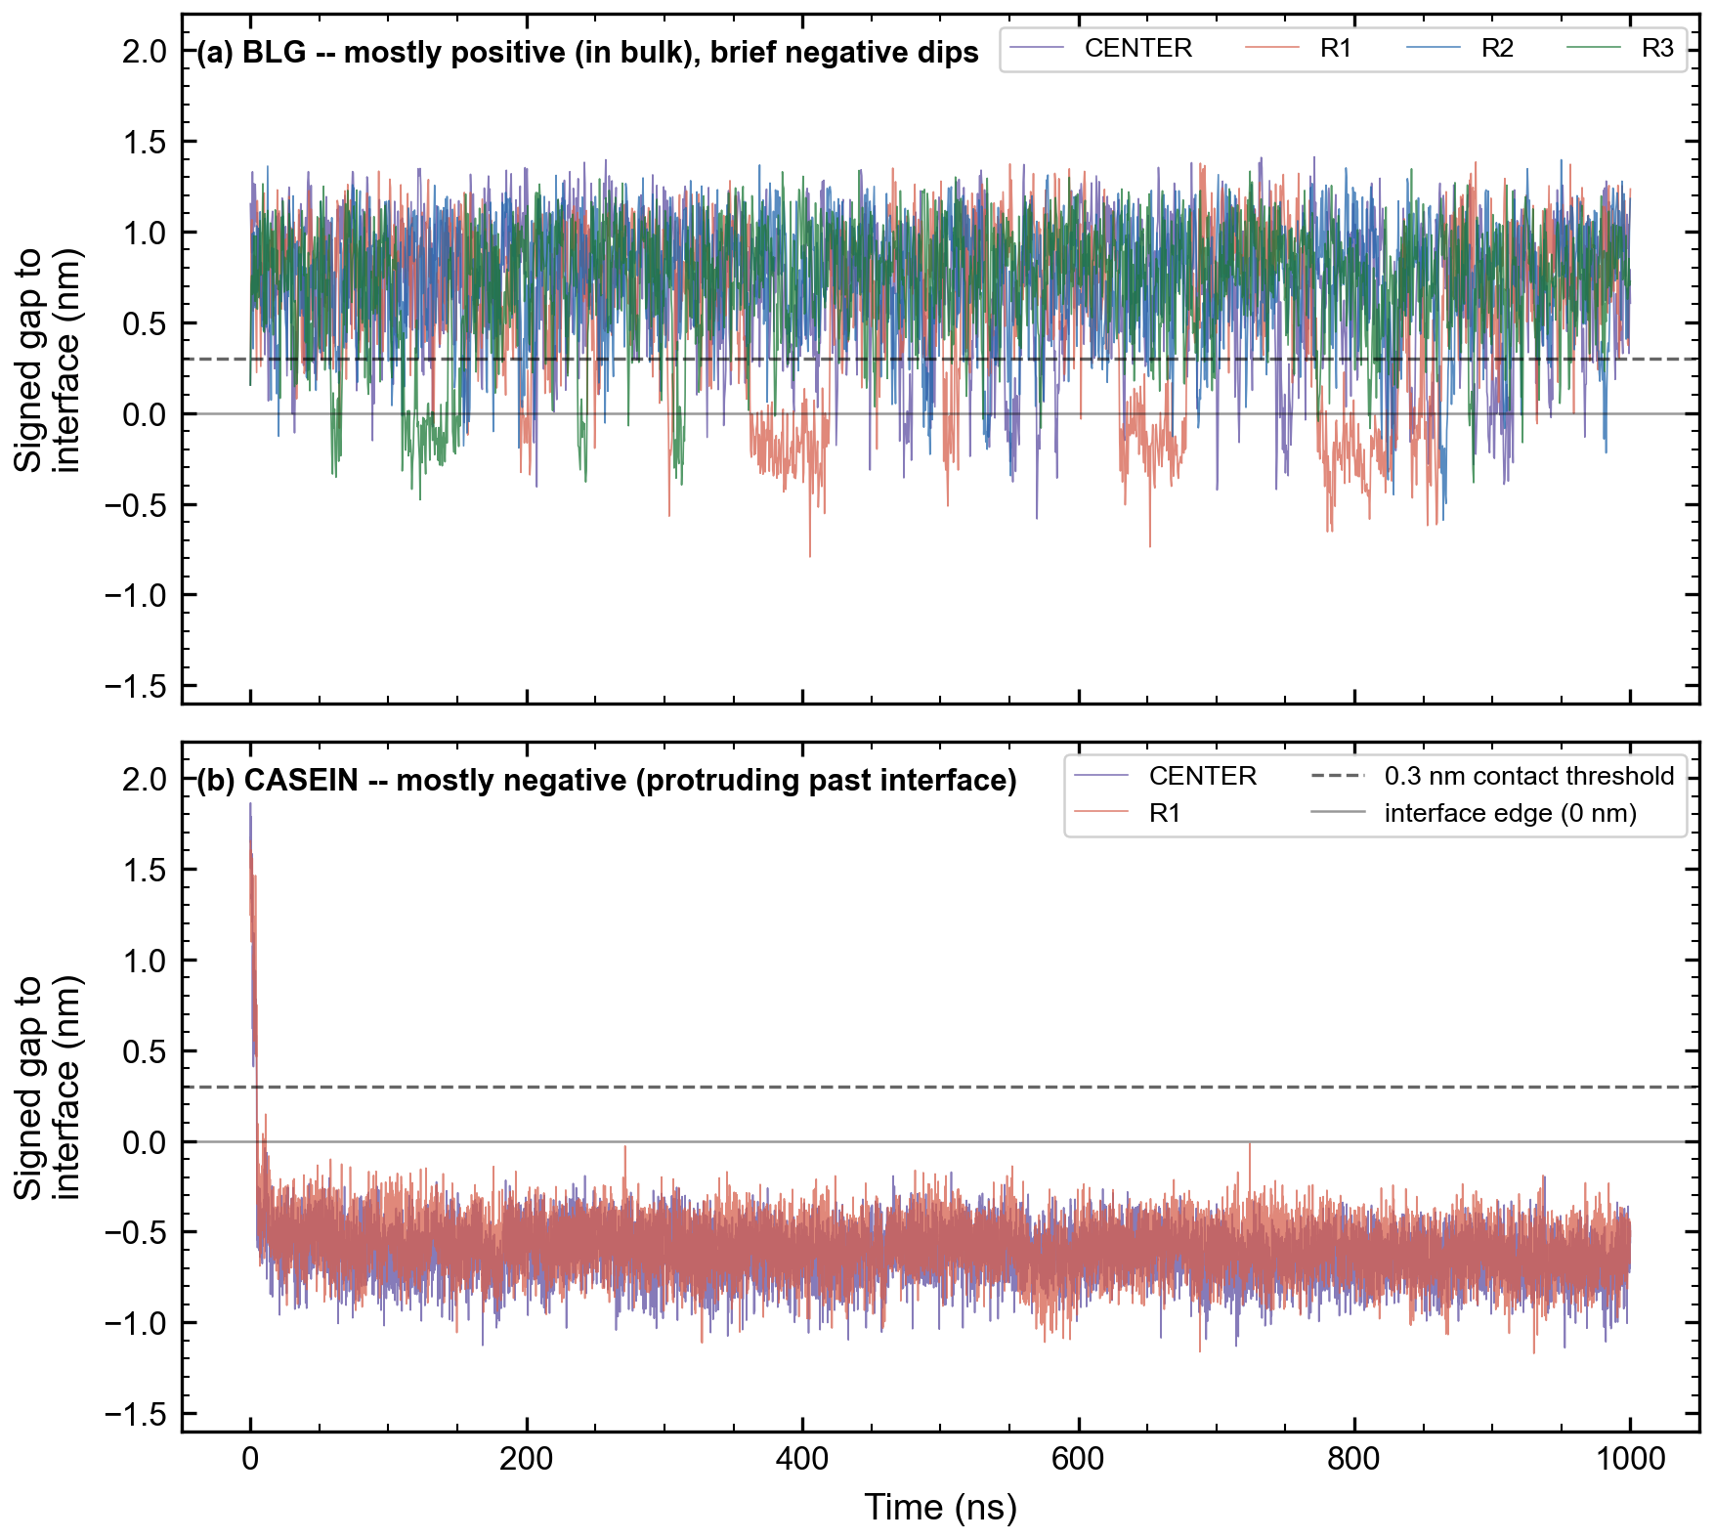
Signed protein-to-interface gap vs. time (positive = inside the water bulk, negative = protruding past the interface). BLG sits mostly positive with brief, distinct negative excursions — its 613 contact events.

β-Casein (CAS) Results
7 of 7 planned analyses complete, now for both CENTER and R1 — the first time every CAS headline metric has independent-replica confirmation rather than a single run.
Replica | N-term SASA (nm²) | Contact | γ (mN/m) | H-bonds prot-prot | H-bonds prot-water
CENTER (1000 ns) | 25.41 ± 1.97 | 99.5% | 51.4 ± 34.2 | 97.8 ± 9.7 | 565.5 ± 25.1
R1 (1000 ns) | 24.77 ± 1.40 | 99.5% | 52.4 ± 34.6 | 92.0 ± 8.3 | 575.9 ± 24.0
Table 2: CAS per-replica summary. “Contact” is the fraction of frames with a protein-water minimum distance ≤0.3 nm; each replica shows 1 sustained contact event across the full 1000 ns run.

CAS's N-terminal region (residues 1-25, the analogue of BLG's calyx) stays large and accessible in both replicas — a ~7-fold size difference from BLG's calyx that holds at every timepoint, not just on average. Rg confirms the same relaxation pattern in both replicas: an initial compaction from the extended AlphaFold starting structure (~2.85 nm, first ~100 ns) settling to a stable range (~2.5-2.7 nm) for the remainder of the trajectory. Hydrogen-bonding agrees closely between replicas (protein-protein 92.0-97.8, protein-water 565.5-575.9, interface water-water 12015.6-12750.5 mean counts per frame).
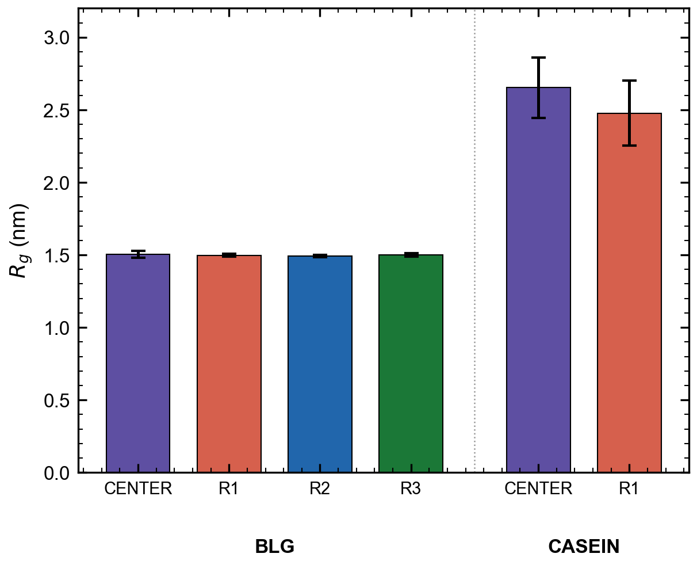
Radius of gyration, BLG vs. CAS, all replicas. BLG stays tightly compact (~1.5 nm) while CAS settles to a larger, stable range (~2.5-2.7 nm) after its initial relaxation.

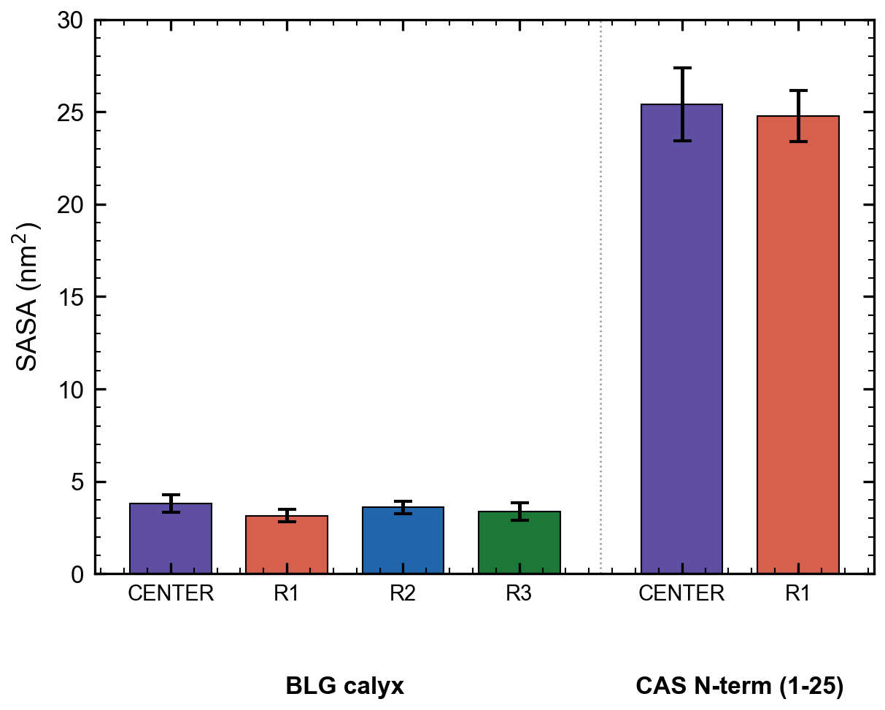
Accessible surface area, BLG calyx vs. CAS N-terminal region, all replicas. The ~7-fold size difference is consistent across every replica of both proteins.

CAS's near-constant interfacial contact (99.5% of frames, both replicas) versus BLG's selective, intermittent contact pattern is the clear structural contrast that directly supports the comparative title: BLG presents a small, selectively-accessible calyx, while CAS's disordered chain stays persistently near the interface with its N-terminal region continuously exposed.

Questions for P.P.
Full detail for all items below is tracked in docs/PP_FEEDBACK_LOG.md. No item carries a near-term (<30 day) deadline; the list is unchanged since the June 9 meeting.
- Secondary-SASA definition. Your note “secondary dasa” from the June 9 meeting is ambiguous. Our best reading: absolute SASA computed per secondary-structure element (DSSP region × SASA) — computable now. A ΔSASA-on-adsorption reading is not computable, since no completed adsorption event exists in either dataset. Please confirm which you meant.
- Which lab experiments to correlate against? Your note said “correlation with lab experiment expected.” We see no in-house tensiometry/Langmuir-trough data in the repo, so we've assumed you mean published literature (already surveyed: Cornec 1999, Ulaganathan 2017a for BLG kinetics; Mackie 1999 for CAS rheology; Atkinson 1995 for CAS N-terminal neutron reflectivity). Please confirm this reading.
- How prescriptive should the “modify to adsorb” claim be? Our data show only the pre-commitment ensemble (no completed adsorption event in either dataset), so a strong causal claim isn't supported. Proposed framing: “intrinsic disorder and surface-exposed hydrophobic patches lower the kinetic barrier to adsorption” — a design-principle statement, not a prescription. Please confirm this is the level of specificity you want.
- Figure-plan sub-decisions. Several small figure choices from your June 9 note remain unconfirmed (Fig 1B: shared or separate boxes; Fig 2: BLG/CAS overlaid or separate subpanels; Fig 4: table or heatmap; exact calyx-clustering residue definition). Low urgency — needed before final figure build, not before analysis.
- Co-author review of the (paused) BLG-only draft. Still a hard blocker alongside the Zenodo DOI for the original main.tex submission checklist, even though it's not urgent while the comparative expansion is in progress.

Note: all numbers above are PBC-corrected and read live from results/analysis/*.npz as of this report's generation date (September 25, 2026). They are not to be treated as frozen if analysis is rerun later — see the R1/R2/R3 Rg/γ caveat in Table 1.

