tab页签切换效果
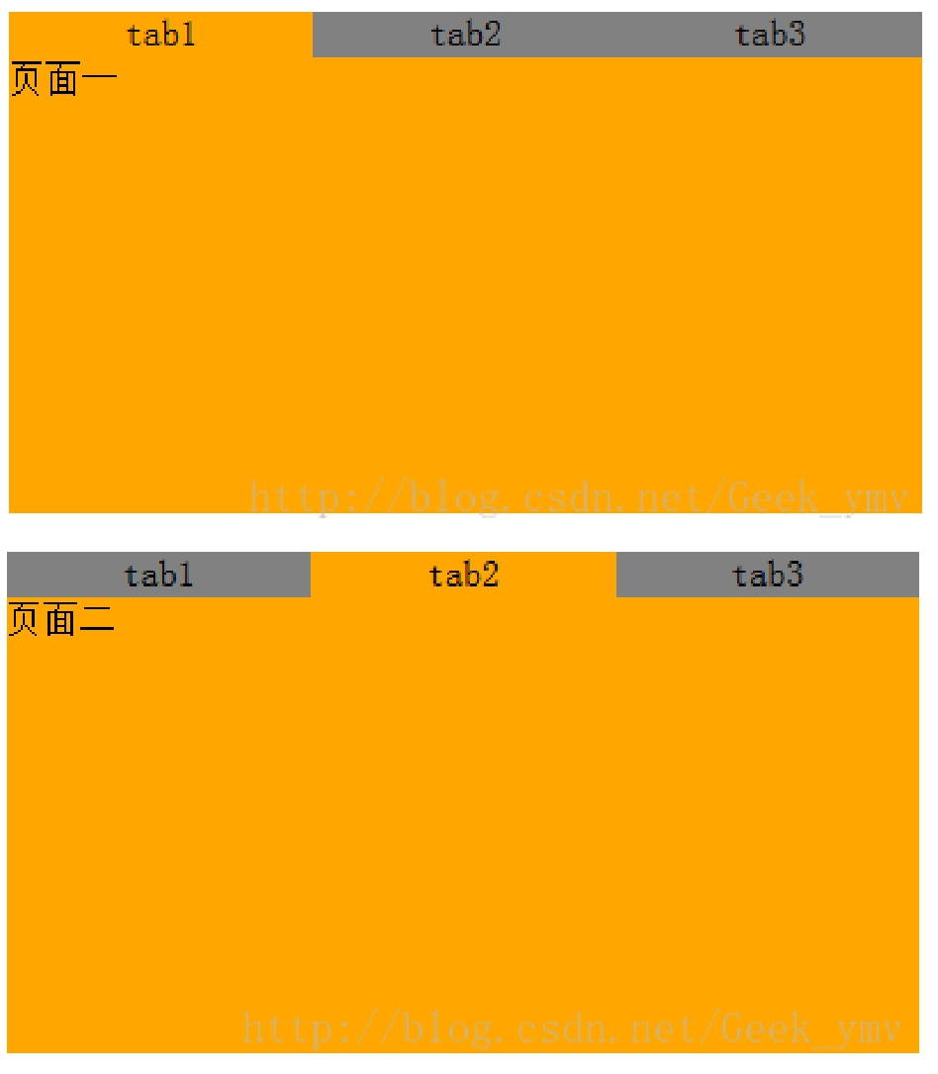

- <!DOCTYPE HTML PUBLIC "-//W3C//DTD HTML 4.01 Transitional//EN"

- "http://www.w3.org/TR/html4/loose.dtd">

- <html xmlns="http://www.w3.org/1999/xhtml">

- <head>

- <meta http-equiv="Content-Type" content="text/html; charset=utf-8" />

- <title>New Web Project</title>

- <style type="text/css">

- #content {
9. |  | width: 400px;
10. |  | height: 200px;
11. | }
12.

- #tab_bar {

14. | width: 400px;
15. | height: 20px;
16. | float: left;

- }

- #tab_bar ul {
19. |  | padding: 0px;
20. |  | margin: 0px;
21. |  | height: 20px;
22. |  | text-align: center;
23. | }
24.

- #tab_bar li {

26. | list-style-type: none;
27. | float: left;
28. | width: 133.3px;
29. | height: 20px;
30. | background-color: gray;

31. | }
32.
33. | .tab_css {
34. |  | width: 400px;
35. |  | height: 200px;
36. |  | background-color: orange;
37. |  | display: none;
38. |  | float: left;
39. | }
40.

- </style>

- <scripttype="text/javascript">

- var myclick = function(v) {

44. |  | var |  | llis | = | document |  |  | .getElementsByTagName("li");
45. |  | for(var |  |  | i = 0; i < llis.length; i++) {
46. |  |  | var |  | lli | = | llis | [i];
47. |  |  | if(lli == document.getElementById("tab" + v)) {
48. |  |  |  |  | lli.style.backgroundColor |  |  |  |  |  |  |  | = |  | "orange" |  |  |  | ;
49. |  |  | } else {
50. |  |  |  |  | lli.style.backgroundColor |  |  |  |  |  |  |  | = |  | "gray" |  |  | ;
51. | }
52. | }
53.
54. |  | var |  | divs | = | document |  |  | .getElementsByClassName("tab_css");
55. |  | for(var |  |  | i = 0; i < divs.length; i++) {
56.
57. |  |  | var |  | divv = divs[i];
58.
59. |  |  | if(divv == document.getElementById("tab" + v + "_content")) {
60. |  |  |  |  | divv.style.display |  |  |  |  |  | = | "block" |  |  | ;
61. |  |  | } else {
62. |  |  |  |  | divv.style.display |  |  |  |  |  | = | "none" |  | ;
63. | }
64. | }
65.

- }

- </script>

- </head>

- <body>

- <divid="content">

- <div id="tab_bar">

- <ul>

73. | <li id="tab1" onclick="myclick(1)" style="background-color: orange">
74. |  | tab1
75. | </li>
76. | <li | id | = | "tab2" |  |  |  | onclick | = | "myclick(2)" | >
77. |  | tab2
78. | </li>
79. | <li id="tab3" onclick="myclick(3)">
80. |  | tab3
81. | </li>
82. | </ul>

- </div>

84. | <div | class |  | = | "tab_css" | id | = | "tab1_content" | style | = | "display: block" | >
85. | <div>页面一</div>
86. | </div>

87. <div class="tab_css" id="tab2_content">

88. <div>页面二</div>

- </div>

90. <divclass="tab_css"id="tab3_content">

91. <div>页面三</div>

92. </div>

- </div>

- </body>

- </html>

