1、在Android.mk里面添加Log模块



2、添加头文件



3、打印



__android_log_print(ANDROID_LOG_INFO,"initStudent","age");

**注意** __android是两根下划线

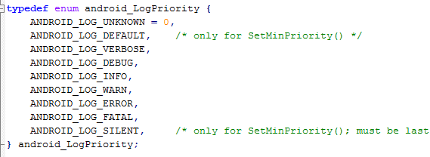

或者

__android_log_print(ANDROID_LOG_INFO,"initStudent","age=%d",1100);

对其格式化