Hacknight 1.0: DarkKNIGHTS

Members: Gourav Patel, Pooja Vasudev Sabnani, Prateek Xaxa

Holistic View:

Our model achieved an accuracy of 83%. To explore the data and exploit them with the model, we have the following UI that supports user entry, realtime prediction, search result for particular employee record and dashboard with analysis of all the data.

The user interface consists of the following views:  
  
1. User Entry

A user can enter their details in the form to get live prediction if treatment is required or not.

The form consists of 2 parts:   
**a) Mandatory User Details** – contains the fields to be compulsorily filed by the user to get the prediction. Helps user get the prediction on the basis of top contributing features.

**b) Additional User Details** – contains optional parameters to be filled by the user to get the score. It helps improvise the accuracy of the prediction.  
  
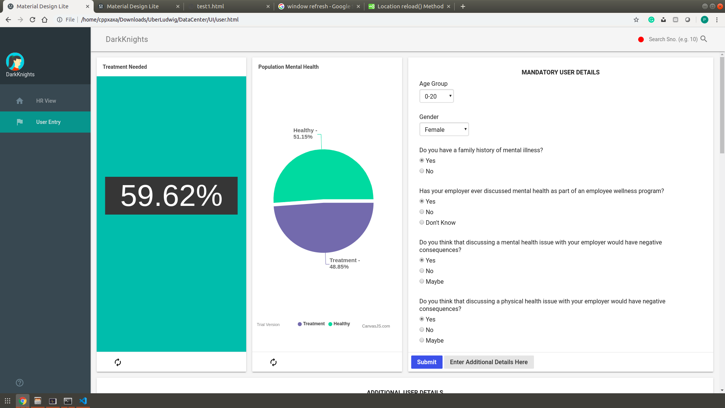

Fig 1. User Entry: Mandatory User Details form

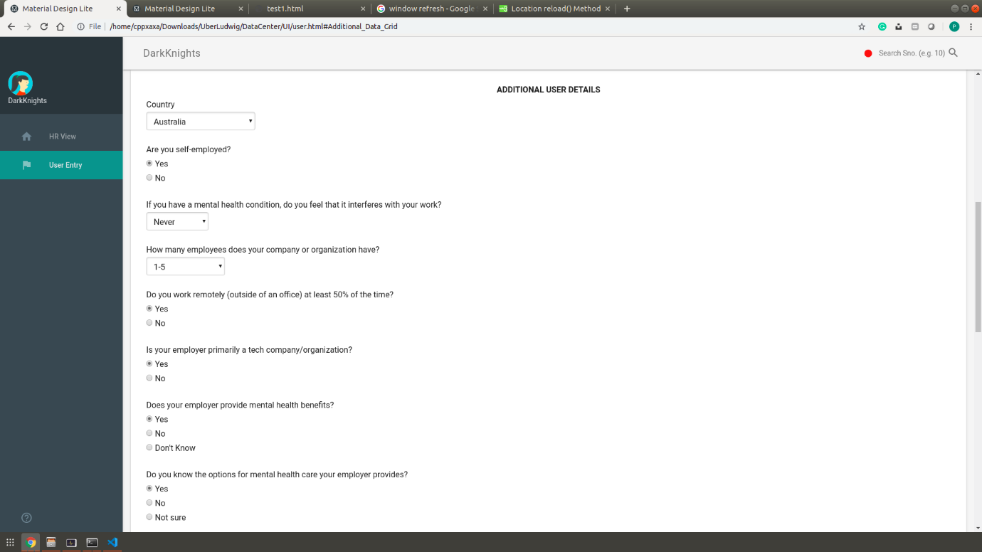

Fig 2.1: User Entry: Additional User Details Form

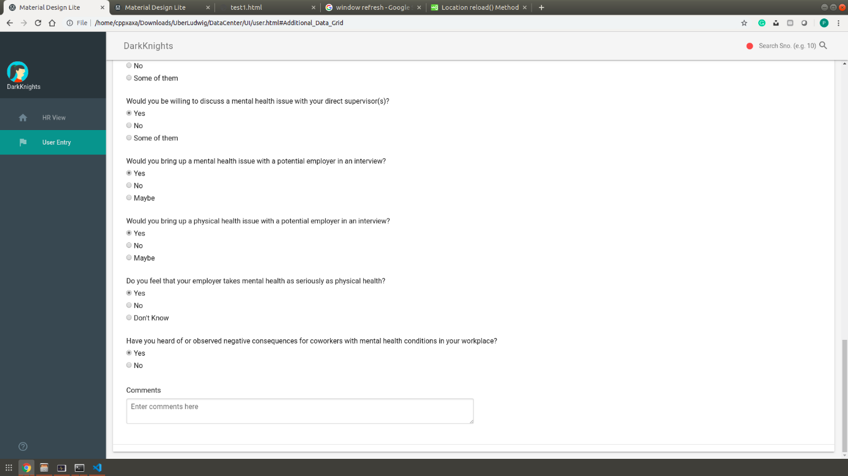

Fig 2.2: User Entry: Additional User Details Form

Live output of the prediction from User entered details in the form. CanvasJS is used to plot the charts.  
  
The output consists of 2 parts:   
a) Whether the user needs treatment  
b) The confidence percentage of the prediction for the model

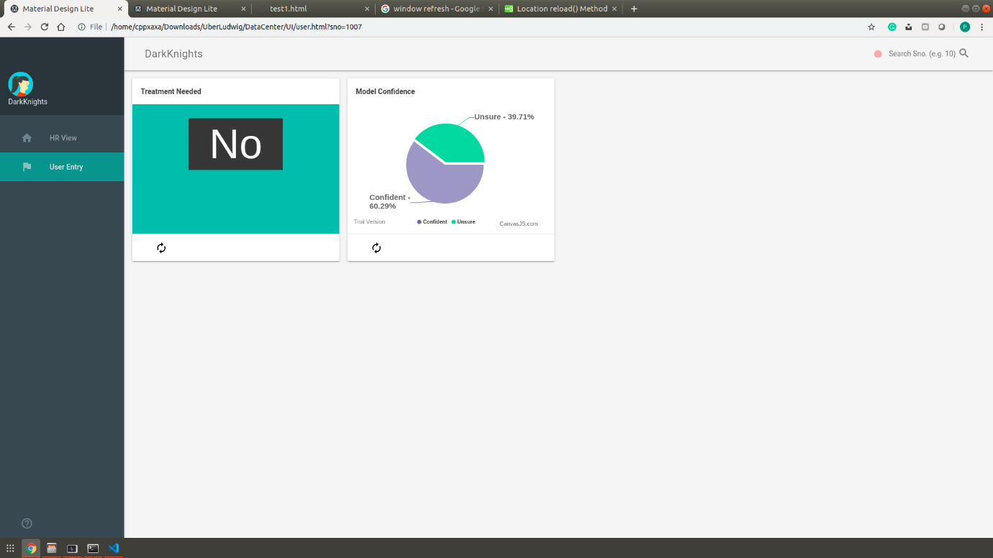

Fig 3: Output of the user entered data

# 2. HR View

The HR view consists of the following components:

* **Search Bar:** The HR can search for a specific user’s record based on S.No. The search bar is hinted with a blinking alert red dot.
* **Average Mental Health Index:** Consists of the Average Mental Health Index derived from the calculation of all the mental health indices of the records.
* **Population Mental Health:** Consists of the division of the healthy population and those who are advised for treatment.
* **Willingness/Openness:** Consists of the user’s willingness to open up about mental and physical health issues.
* **Support from Employer:** Consists of the various ways in which the employers support employees for mental health.
* **Loaded Model Health ( 83.0116 )**: Consists of the accuracy of the model used for prediction.

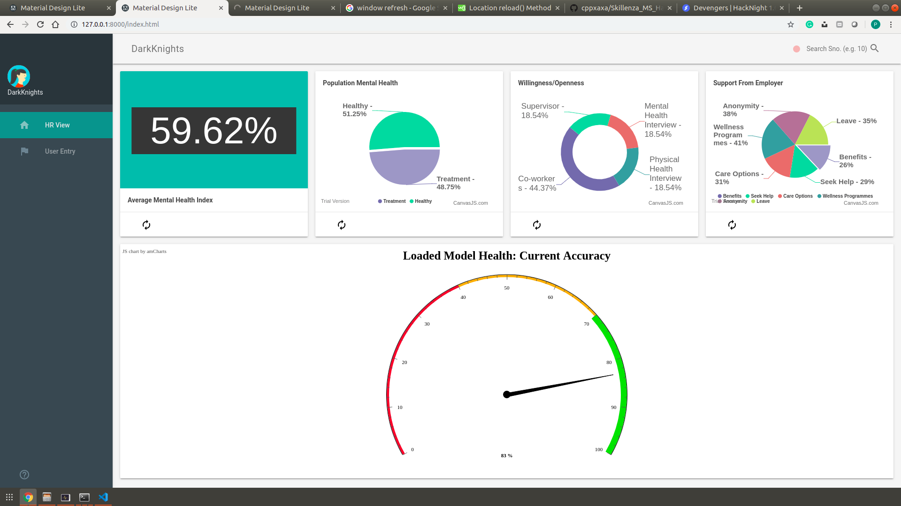

Fig 4: HR View: Consists of Searching option and analytics