Family RPG Game Project
A Collaborative Game Development Summary

The Vision
Two families building an RPG game together. One family handles the technical/coding side, the other brings artistic direction and design. Both families' kids contribute ideas, testing, and feedback. This is a hobby project — evenings and weekends, vibe coding with AI assistance for the programming, learning as we go.

Team & Constraints

What We Have
- Family 1: Technical background, some Roblox Studio experience, will handle coding
- Family 2: Artist/designer background, will direct visual style and create assets
- Kids from both families for ideas and playtesting
- AI tools (Claude) for coding assistance

Realistic Constraints
- Both families have day jobs — this is evenings/weekends only
- Neither person is a professional game developer
- Prefer free tools, willing to pay small amounts if justified
- Want to work on the project simultaneously when possible

Game Engine Options
We have three main options. Here's an honest comparison:

Option 1: RPG Maker MV/MZ (2D Top-Down)
Best for: Getting a playable RPG feeling fastest
Pros:
- All RPG systems built in (dialogue, inventory, combat, menus, saving)
- Visual event system — minimal coding required
- Huge community with tutorials and free assets
- Kids can learn the event system easily
- Claude can write JavaScript plugins when custom features are needed
Cons:
- No multiplayer gameplay (single-player only)
- No real-time collaborative editing
- Games tend to look like "RPG Maker games"
- Art must fit specific tile/sprite format constraints
Cost: $25-40 (Steam sales drop prices significantly)

Option 2: Godot 4 (2D Top-Down)
Best for: Learning real game development, maximum creative freedom
Pros:
- 100% free, no licensing restrictions
- Excellent 2D tooling built specifically for this type of game
- Complete creative freedom over art style and mechanics
- Skills transfer to other projects and engines
- Export to PC, web, mobile from same project
Cons:
- You build EVERYTHING from scratch (movement, dialogue, inventory, combat, menus, saving)
- Steeper learning curve
- No real-time collaborative editing (need Git workflow)
- Months before you have something that "feels like an RPG"
Cost: Free

Option 3: Roblox Studio (3D)
Best for: Real-time collaboration, kids directly involved in building, multiplayer gameplay
Important: Choosing Roblox means shifting to a 3D game, not 2D top-down. This is a fundamentally different visual style and gameplay feel.
Pros:
- Live collaborative editing — everyone works on the same project simultaneously
- Built-in multiplayer for free
- Easy sharing (just send a Roblox link)
- Kids likely already familiar with the platform
- Huge asset library and community resources
Cons:
- No longer a 2D game — completely different art direction needed
- Platform lock-in (game only exists on Roblox)
- Roblox takes ~75% of any revenue
- Art style constrained to Roblox's aesthetic
Cost: Free

Quick Comparison
Factor | RPG Maker | Godot | Roblox
Game Style | 2D Top-Down | 2D Top-Down | 3D
Time to playable RPG | Fastest | Slowest | Medium
Art style freedom | Limited (tile-based) | Full freedom | Roblox aesthetic
Real-time collaboration | No | No | Yes (built-in)
Multiplayer gameplay | No | Possible (hard) | Yes (built-in)
Learning curve | Easiest | Steepest | Medium
Cost | $25-40 | Free | Free
Claude coding support | Yes (JavaScript) | Yes (GDScript) | Yes (Lua)

File Collaboration & Tools by Engine
How we share files and work together depends heavily on which engine we choose. Here's what each option requires:

If We Choose: RPG Maker
File Sharing Method: Google Drive or Dropbox
RPG Maker projects are self-contained folders. We sync the entire project folder through cloud storage. The key rule: only one person edits at a time, then syncs before the other person starts.
Required Tools:
- RPG Maker MV or MZ ($25-40 each, both families need a copy)
- Google Drive or Dropbox (free)
- Aseprite or Piskel for custom sprites (free to $20)
- Shared Google Doc for task tracking and notes (free)
Workflow:
- Before starting work, sync/download the latest project folder
- Message the other family that you're working on it
- Make your changes
- Sync/upload the updated folder
- Message that you're done
Total Cost: ~$50-80 (RPG Maker licenses) + optional art tools

If We Choose: Godot
File Sharing Method: GitHub with GitHub Desktop
Godot projects work well with Git version control. GitHub Desktop provides a visual interface so no command-line knowledge is needed. This allows both families to work on different parts simultaneously without overwriting each other's work.
Required Tools:
- Godot 4.3+ (free)
- GitHub account (free)
- GitHub Desktop app (free)
- Git LFS for large art files (free up to 1GB, then $5/month)
- Aseprite or Krita for 2D art (free to $20)
Workflow:
- Pull latest changes before starting work
- Artist works in the assets/sprites folders
- Programmer works in the scripts/scenes folders
- Commit and push changes when done
- Avoid editing the same files — claim files in a shared doc if needed
Total Cost: $0-25 (optional art tools)

If We Choose: Roblox Studio
File Sharing Method: Built-in Team Create (real-time)
Roblox has real-time collaboration built in. Multiple people can be in the same project at the same time, like Google Docs. No external file sharing needed — everything syncs automatically through Roblox's servers.
Required Tools:
- Roblox Studio (free)
- Roblox account for each person (free)
- Blender for custom 3D models (free)
- Optional: Roblox asset packs from the marketplace (varies)
Workflow:
- Owner enables Team Create and invites collaborators
- Everyone opens the project in Roblox Studio
- Work simultaneously — changes sync in real-time
- Communicate via voice chat or Discord while working
- Publish when ready to test
Total Cost: $0 (everything is free)

Communication Tools (All Engines)
Regardless of engine, we'll need ways to communicate and track progress:
- Group Chat: iMessage, WhatsApp, or Discord for quick coordination
- Design Doc: Shared Google Doc for game ideas, story, character designs, and decisions
- Task Tracking: Simple checklist in Google Doc, or Notion if we want something fancier
- Sync Calls: Weekly or bi-weekly video call to review progress and plan next steps

Artist Tools by Engine
RPG Maker | Godot | Roblox
Aseprite  Pixel art sprites & tiles  $20 or free (compile) | Aseprite or Krita  Any 2D art style  Free to $20 | Blender  3D models & environments  Free
Piskel  Browser-based pixel art  Free | Photoshop/Procreate  If already owned  Varies | Roblox Marketplace  Pre-made 3D assets  Free to paid

First Map Concept
The game starts on a school bus. Players can walk up and down the aisle and interact with students sitting in seats. This is a contained first environment that lets us test movement, collision, and dialogue before building larger areas. The visual style and implementation will depend on which engine we choose.
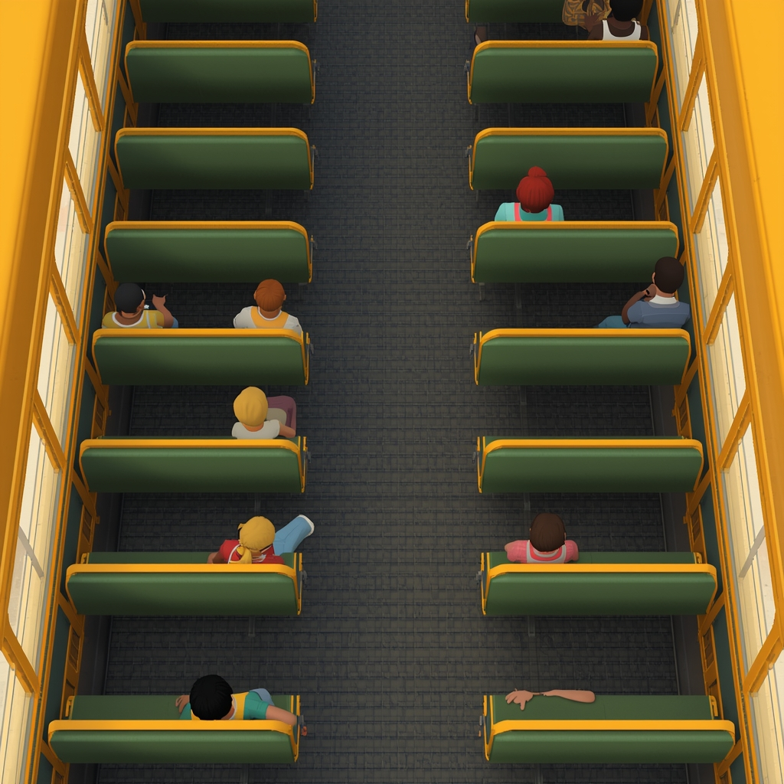

Questions We Need to Answer Together
Before picking an engine, let's align on priorities:
- 2D or 3D? Is the 2D top-down style important, or are we open to making a 3D game?
If 2D matters → RPG Maker or Godot. If 3D is fine → Roblox becomes viable.
- Do we need multiplayer gameplay (players playing together)?
If yes → Roblox is the only realistic option. If no → RPG Maker or Godot.
- What matters more: a "finished feeling" RPG quickly, or learning game dev skills?
If speed → RPG Maker. If learning → Godot or Roblox.
- How involved do we want the kids in actual building (not just testing)?
If very involved → RPG Maker's event system or Roblox. If mostly adults building → any engine.
- Is simultaneous editing (both families working at the exact same time) important?
If yes → only Roblox does this well. If we can take turns → RPG Maker or Godot work fine.

Current Recommendation
If we want a 2D top-down RPG and multiplayer gameplay isn't required, RPG Maker MZ is probably the best fit. It gives us a working RPG feeling fastest, the event system is accessible to everyone, and Claude can write JavaScript plugins when we need custom features. The ~$40 cost per license is worth it for what you get out of the box.
If we want multiplayer gameplay or real-time collaboration is a must-have, Roblox Studio is the right choice — but we should embrace making a 3D game rather than fighting the engine to make it 2D.

Proposed Next Steps
- Review this document together
- Answer the five questions above
- Pick an engine
- Both families install the chosen tool and any required collaboration software
- Schedule a kickoff call to align on art style and first milestone
- Start building!
Questions? Open a conversation with Claude and ask anything — happy to help with all three engines.

