Analytics Capstone Project (ANCP): Project Charter (D1)
Group M | Module M1: Problem Framing | Marketing | Analytics team for Westside (Trent Ltd)
Team member | Roll no.
Ambarish Sengupta | BA05007
Arpan Shah | BA05009
C Prashanth | BA05015
1. Business context
Client: Westside (Trent Ltd). Trent is a Tata enterprise that began in 1952 as Lakme and moved into apparel retail in 1998 [1]. Westside is its lead fashion format and sells more than 22 labels, all designed in-house [1]. As of March 2026 Westside ran 300 stores across 97 cities, and online sales were only about 6% of its revenue, so the store is where almost all selling happens [2]. Its paid loyalty programme, WestStyleClub, has 11.85 million active members, and over 90% of Westside revenue comes from them [2]. This means Westside already knows who most of its buyers are and what they bought.
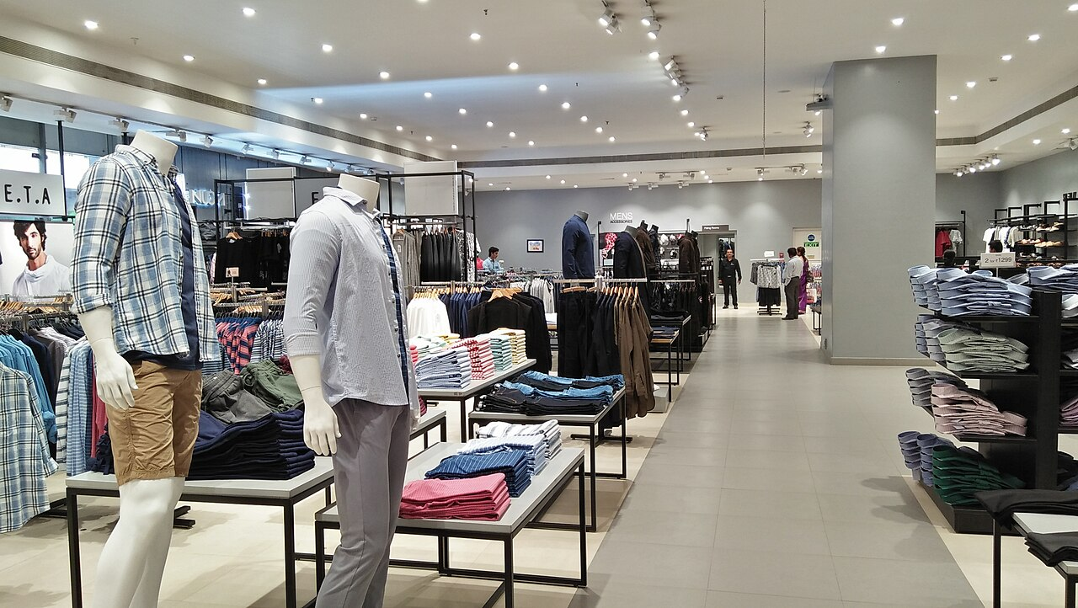
Figure 1. Menswear floor of a Westside store, Mani Square Mall, Kolkata. Photo: Biswarup Ganguly, Wikimedia Commons, CC BY-SA 4.0.
Why now. Trent's standalone revenue grew 19% to Rs 5,666 crore in Q1 FY27, but like-for-like growth of the fashion portfolio was only in the low single digits [3]. Growth is coming from new stores, not from existing ones. Trent also says it is deploying AI tools and analytical models across design, logistics and store operations [3]. We found no public record of a customer-facing styling tool at Westside.
Operations and inventory. Westside controls its own design, sourcing, logistics and selling, buys over 80% of its merchandise within India, and puts new fashion into stores every week [2]. Trent turned its inventory about 5.1 times in FY26 (5.16 the year before) and says RFID and automation have improved supply-chain and in-store productivity and helped to optimise employee cost [2]. A 2023 trade-press feature on Westside lists RFID, PLM, HANA and TMS in its technology stack and does not mention mirrors or AI styling [31]. Elsewhere in Indian apparel, a vendor case study says Style Union cut stock audit time from 7 days to under 24 hours with RFID from supplier to store [30]; that is the vendor's claim and shows the stock-data layer, not a customer-facing use. What this system cannot see is demand that did not end in a sale: the till records what was bought, not what a shopper wanted in a size that was missing, or tried and put back. Rebecca Minkoff reported that its mirrors showed one item being taken into fitting rooms 60 times in a week and sold once, which pointed to a fit problem the sales data alone would have hidden [22]. This is the company's own account.
Industry. Trent values the Indian fashion and lifestyle market at about Rs 12 lakh crore in FY26 and expects about Rs 19 lakh crore by FY30, a growth rate of roughly 12% a year [2].
Technology landscape. Retailers have piloted smart mirrors since 2014. Rebecca Minkoff's fitting-room mirrors and the mirrors H&M Group tested at COS in 2022 read the garment's RFID tag; they do not recognise the shopper [4][5]. Reported gains, such as Rebecca Minkoff selling three times the clothing it expected, are the company's own claims [4]. The only independent, controlled evidence we found is for online fit tools, which raised conversion and order value [6]. Some formats failed: Amazon closed both Amazon Style stores in November 2023 [7]. We found no independent measurement of sales, returns or inventory savings for any smart mirror, so every uplift figure in this charter is a hypothesis to test, not a result.
Prior art. Each part of our idea has been built before; we have not found the combination. In 2014 Rebecca Minkoff and eBay linked RFID fitting rooms to a loyalty account, showed other sizes and colours in stock and suggested outfits, using app check-in and no cameras [23]. In 2015 Neiman Marcus installed MemoMi's MemoryMirror, a camera-fed screen that records outfits so they can be compared [24]. By August 2015 it was in three Neiman Marcus stores; it used an Intel RealSense camera plus three others, and the report said the video was not good enough to show fabric texture [32]. MemoMi's marketing now describes reading body, face shape and complexion, but we found no accuracy or fairness data for it. In India, Reliance Retail's AZORTE store in Navi Mumbai (reported November 2022) uses RFID-enabled screens as virtual style assistants and smart trial rooms alongside in-store consultants; the report gives no results and no sign of face recognition, purchase history or body or skin-tone reading [29].
Patents. Two patent documents are closest. US20240169414A1 covers a smart-mirror stylist that builds a body mask and swaps items until the shopper's expression turns positive; it is shown as abandoned [25]. Its description covers face recognition to identify the user, body-type categories, and skin tone matched against a complexion database, but the words "purchase history" and "RFID" do not appear in it; it does say the mirror may be coupled to the vendor's clothing inventory to build outfits [25]. It also cites four earlier US documents, including IBM's "Providing a personalized fitting room experience" (US20180032818A1) and Fulcrum's "System and method for generating clothing recommendations via a smart mirror" (US20210100375A1); we have not read these in full and a patent search must check them [25]. US10052026B1 is a health-focused mirror, now expired, whose description also mentions outfit suggestions trained on purchase history [26]. We found no product that combines face recognition of a returning shopper, purchase history, body and skin-tone reading and stock-aware outfit advice, but our search was limited. Linking a mirror to a vendor's inventory is therefore already disclosed. What this project would add is the combination with purchase history and live stock by size, demand forecasting from viewing data, and a fairness check on public data. We have not obtained a freedom-to-operate opinion and our patent search was not complete, so Westside would need patent counsel before any deployment.
Scenario note: this is an academic scenario. We found no public record of Westside or Trent running this project, and Westside's customer, purchase and image data is not available to us, so we use public proxy datasets and a small group of consenting volunteers.
2. Business problem and problem statement
A shopper in a Westside store sees thousands of items but gets little help in putting them together. Good styling advice depends on a trained person who knows what suits the shopper's build, colouring and existing wardrobe, and no store can staff that for every customer. Many shoppers therefore buy a single item and leave, even though Westside already holds their purchase history through WestStyleClub and could suggest what goes with it.
Target group. The main users are urban shoppers who do not want to spend time or effort on choosing clothes, are not confident in their own dressing sense, and rely on a suggestion from someone else before they buy. They are the shoppers most likely to pick one safe item and leave, and the ones who gain most from being shown a complete outfit. Confident, fashion-led shoppers are a secondary group. This is our working assumption about who will use the mirror; we found no published figures on the size of this group among Westside's customers, so we will check it with a short shopper survey in M3.
There is a second, less visible cost. Because the store only learns from what is sold, stock is allocated on past sales. Some stores run out of a popular size while others hold the same item until it is marked down or moved by truck to another store. Staff time also goes into fetching sizes and checking whether an item is available. A mirror that knows the store's live stock and records what each shopper looked at can do two things at once: suggest only what is on the shelf in the right size, and tell the planning team what was wanted but not bought.
Problem statement. Westside's sales in existing stores are growing slowly, and most shoppers choose outfits without personal advice. Urban shoppers who put little effort into dressing and depend on suggestions are served worst. We will design and prototype a "stylist mirror": a life-size screen in the store that recognises an enrolled member by face (or by a loyalty QR code), reads their past purchases, estimates their body proportions from the camera, and shows complete outfit combinations of shirts, T-shirts, trousers and accessories from Westside's range. Skin tone is optional: the shopper can allow the camera to estimate it, or simply pick the colours they like, and the mirror works either way. We will then test, on public data and with volunteers, whether its suggestions are better than simply showing best-sellers, whether it works equally well for all skin tones, and whether it could raise the number of items bought per visit. We will also test whether the mirror's record of what shoppers viewed and tried improves the demand forecast for each item, size and store, and whether stock-aware suggestions could lower stock-outs, markdowns, store-to-store transfers and staff time in a simulation.
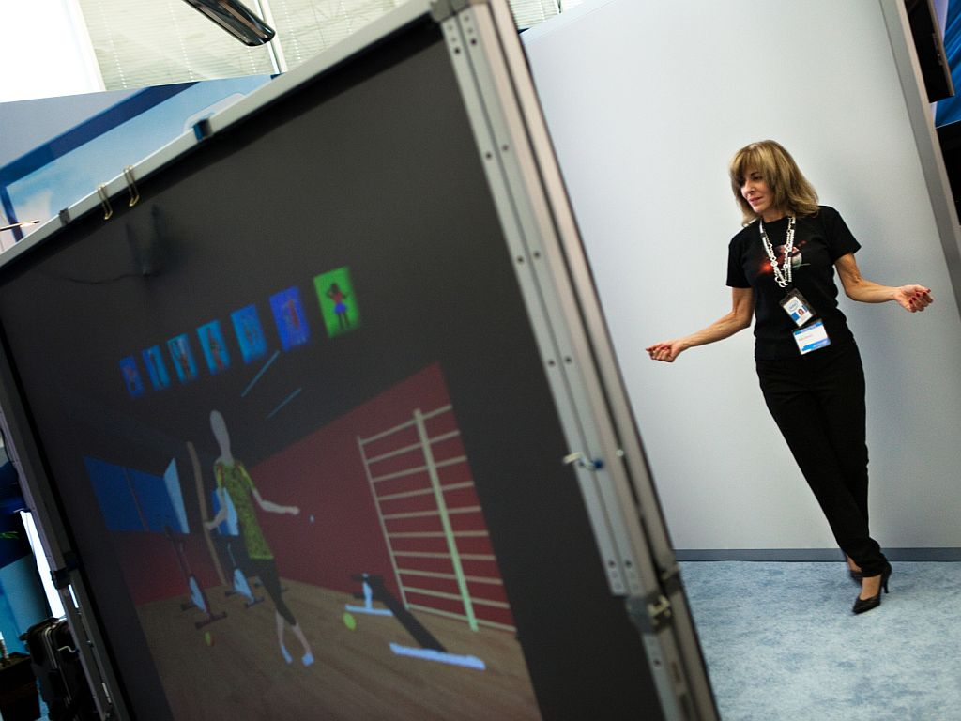  Figure 2. The idea in use: a shopper stands in front of a large screen that shows clothes on an on-screen figure. Intel Labs augmented-reality dressing room demo. Photo: Intel Free Press, Wikimedia Commons, CC BY-SA 2.0. | 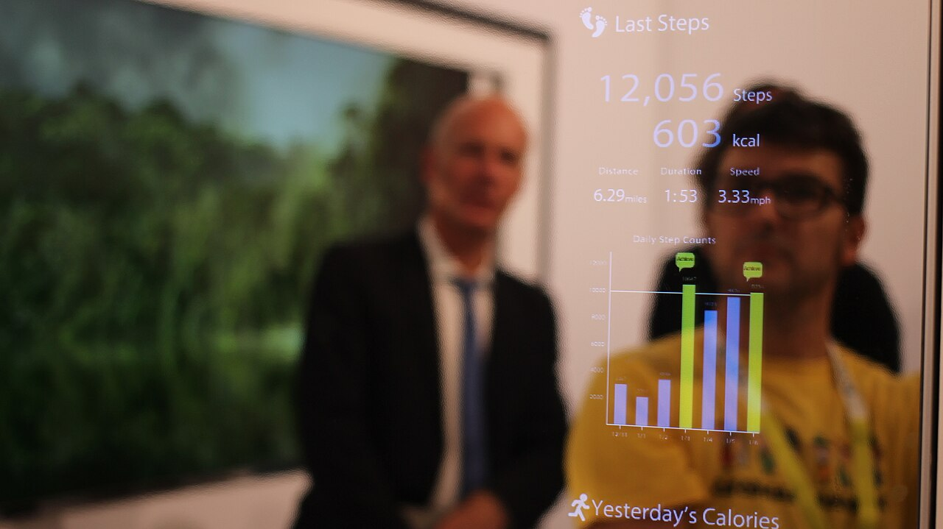  Figure 3. The display: a smart mirror shows information over the viewer's reflection. Our mirror would show outfit suggestions in the same way. Toshiba smart mirror demo. Photo: Maurizio Pesce, Wikimedia Commons, CC BY 2.0.
Figures 2 and 3 show similar technology built by others. They are not the Westside product, which does not exist yet.
3. Project charter
3.1 Success metrics
Targets are proposals and will be confirmed after the data audit (M2). Reference scores come from published work; the targets themselves are our own judgement.
- Recommendation quality: MAP@12 on the final held-out week is at least three times a best-seller baseline. On the full H&M data a top-12 best-seller list scores about 0.006 and the competition winner scored 0.038 [8][9].
- Outfit matching: fill-in-the-blank accuracy and AUC on the disjoint Polyvore test set beat the published Siamese reference of 51.8% and 0.81 [10].
- Face login: no member is ever matched to another member in the volunteer test, and the share of genuine members who are not recognised is reported. A failed match falls back to the QR code.
- Skin tone and body reading: skin-tone estimation is optional and used only when the shopper opts in. When used, the estimate is compared with a measured reference, such as a colour card in the frame or a colorimeter reading, and not only with human raters, because published ratings were biased by the race of the person pictured and the same faces differed by about 22 lightness units (L*) between two cameras [27]. A single image also cannot separate skin colour from lighting without extra information, and existing estimation methods have been shown to favour light skin tones [35]. It must also stay stable when store lighting changes. Body measurements are reported as error in millimetres against the BodyM benchmark [14]. We do not claim a "body type accuracy", because body-shape categories are not reliable (see 3.2).
- Fairness: error rates and the number of outfits offered are compared across skin-tone groups and gender at one fixed setting, as NIST recommends [16], and the gap stays within a limit we set in M5. Outfit quality with shopper-chosen colours is also compared with quality using the estimated skin tone, to test whether the estimate adds anything.
- Fit to target group: in the volunteer study, people who describe themselves as low-effort, low-confidence dressers rate the suggested outfits as something they would wear and buy, and reach a choice in fewer steps than without the mirror.
- Business value: a simulation shows more items per bill with mirror suggestions than with no advice. The uplift assumptions are our own and will be stated clearly; the result is a hypothesis to test, not an expected outcome.
- Stock-aware suggestions: in the simulation every suggested item is in stock in that store in the shopper's size, and slow-moving items get a fair share of suggestions without lowering recommendation quality.
- Demand forecast: the weekly forecast for each item has a lower error (WAPE) when it uses browsing and try-on signals than when it uses past sales alone.
- Operations cost: a simulation compares stock-outs, stock left for markdown, store-to-store transfers and staff minutes per fitting-room visit with and without the mirror. We found no published, independent measurement of these savings for any smart mirror, so the cost assumptions are our own and the result is a hypothesis for a store pilot to test.
- Validity: purchase data is split by date, outfits by item and people by person, never by row, and a leakage checklist is passed.
- Explainability: each suggestion carries a plain-language reason, such as "goes with the navy chinos you bought in June".
3.2 Data plan
- Purchase history: H&M Personalized Fashion Recommendations (Kaggle), about 31.8 million transactions from September 2018 to September 2020 with customer and article details. Use is limited to non-commercial academic work [8].
- Outfit combinations: Polyvore Outfits, disjoint version: 32,140 outfits built from 175,485 items [10]. Catalogue images and attributes: Fashion Product Images (Kaggle), about 44,000 products [11].
- Demand and inventory: the same H&M transactions, which carry the date, article, price and sales channel of every purchase, are added up into weekly demand for each article [8]. No retailer publishes store stock levels or try-on logs, so stock positions and mirror viewing events are simulated from stated rules.
- Skin tone: Meta's Casual Conversations v2, which includes participants from India, is used for testing only [12]. Google's MST-E set may not be used to train a model, so it is used only to train our own raters on the Monk scale [13].
- Body proportions: BodyM, silhouettes of 2,505 people with 14 body measurements [14].
- Face recognition: a pre-trained open model (ArcFace) tested on photos of consenting volunteers [15]. No face dataset is downloaded.
- Preparation: start with a customer sample of the H&M data; audit for missing values, duplicates and returns; build top-and-bottom pairs from Polyvore; keep raw files untouched and save cleaned, versioned copies in the team repository.
- Documentation: a datasheet for each dataset recording the source link, download date, licence and citation.
- Ethics and privacy: a face is personal data. The DPDP Rules were notified on 14 November 2025 with an eighteen-month phased compliance period, so the main consent and security duties apply from May 2027, and penalties can reach Rs 250 crore [17][18]. Until then the 2011 rules treat biometric information as sensitive [19]. Our design is therefore opt-in only: separate consent for face login, with the loyalty QR code as an equal alternative; a second, default-off consent for skin-tone estimation, with shopper-chosen colours as the alternative; no capture of people who have not enrolled; no one under 18; a stored face template, not a photo; and deletion on request. Colour advice is worded as what goes well together, never as a ranking of light and dark skin, and no body-type label or size is shown on the public screen. No Indian law specifically regulates face recognition. A Delhi lawyer's analysis notes that the DPDP Act says consent cannot be sought for what a service does not need, yet lets a business deny service if consent is withheld, so whether a store can make a face scan a condition of entry is unsettled [36]; this is why the QR code is an equal alternative. The EU AI Act, in force for its prohibited practices since 2 February 2025, bans biometric categorisation that infers race, political opinions, trade-union membership, religious beliefs, sex life or sexual orientation [37]. Skin tone is not on that list and the Act does not apply to India-only stores, but we avoid any wording that could suggest race.
- Known limitations: the proxy data is European and Western in style, not Westside's range or Indian wear, and no dataset links a person's face, skin tone, body and purchases. Each part is tested separately and the full experience only with a small volunteer study. Face-recognition error differs between demographic groups by factors of 10 to 100 in NIST tests [16], a US retailer was banned from using it for surveillance for five years after the FTC alleged it never tested accuracy and that false matches were more likely in plurality-Black and Asian communities [20], and one study found the same body placed in a different shape category in up to 40% of cases [21]. A body-shape-aware outfit model fell to an AUC of 54.4 for dresses and 61.9 for tops on people it had not seen in training [28]. That model's body-shape data are 28,000 computer-generated bodies, and the paper reports no test on photographs of real people [28]. Surveys of the field report that try-on results tend to slim the body and force loose garments to standard length [33], that body shape has been barely explored in fashion recommendation because of privacy concerns, and that no satisfactory benchmark dataset exists for any fashion-recommendation task [34]. Skin tone cannot be read cleanly from a camera, because human ratings were biased and the same face differed greatly between cameras [27]. We found no independent evidence that any smart mirror raises sales, so our targets are hypotheses. The inventory and cost results rest on simulated stock and simulated mirror use, not on Westside's records. Results are a proof of concept and must be re-validated on Westside's own data.
3.3 Process flow
M1 Problem framing → M2 Data acquisition and preparation → M3 Exploratory analysis → M4 Modelling → M5 Evaluation → M6 Deployment and monitoring → M7 Communication.
If M5 results are weak or unfair across groups, we return to M4 or M3. Each stage produces one deliverable that the next stage builds on.
3.4 Timeline and named owners
Exact submission dates are announced at the start of each module. We will finish each deliverable 2 days before its module deadline to leave time for review. Each member leads at least two deliverables.
Stage | Key activities | Deliverable (weight) | Lead owner
M1 Problem framing | Problem, metrics, data plan, owners | D1 Project charter (8%) | Ambarish Sengupta
M2 Data acquisition and preparation | Download, audit, clean, version; volunteer consent form | D2 Data audit report, datasheets, cleaned datasets (10%) | Arpan Shah
M3 Exploratory analysis | Buying patterns, items bought together, colour and category mix, weekly demand by item, target-group survey | D3 EDA notebook and two-page insight summary (7%) | C Prashanth
M4 Modelling | Best-seller baseline, recommender, outfit matcher, camera modules, demand forecast, experiment log | D4 Baseline, candidate models, experiment log (10%) | Arpan Shah
M5 Evaluation | Date-wise validation, leakage checklist, fairness across skin tones, colour-choice comparison, forecast error, volunteer study | D5 Evaluation memo (10%) | Ambarish Sengupta
M6 Deployment and monitoring | Mirror design and consent flow, link to store stock, pilot store plan, inventory and cost simulation, monitoring and stop rules | D6 Deployment and monitoring plan (5%) | C Prashanth
M7 Communication | Report, model card, dry-run presentation | D7 Draft report, model card, presentation (10%) | Ambarish Sengupta
The modelling approach for M4 will be confirmed after the data audit and exploratory analysis.
4. References
- Trent Limited, "About us". https://trentlimited.com/pages/about-us
- Trent Limited, Management Discussion and Analysis FY2025-26, as reproduced by India Infoline. https://www.indiainfoline.com/company/trent-ltd/management-discussions
- Trent Limited, "Investor Presentation Q1 FY27", NSE filing, 6 August 2026. https://nsearchives.nseindia.com/corporate/TRENT_06082026134112_InvestorPresentation06082026Q1FY27.pdf
- Digiday, "Inside Rebecca Minkoff's digital store". https://digiday.com/marketing/rebecca-minkoff-digital-store/
- Retail Dive, "H&M tests smart mirrors at COS stores". https://www.retaildive.com/news/hm-tests-smart-mirrors-at-cos-stores-in-a-bid-for-a-more-personalized-expe/625014/
- Gallino, S. and Moreno, A., "The value of fit information in online retail", Manufacturing & Service Operations Management, 2018. https://pubsonline.informs.org/doi/fpi/10.1287/msom.2017.0686
- GeekWire, "Amazon closing its Style physical clothing stores", November 2023. https://www.geekwire.com/2023/amazon-closing-its-style-physical-clothing-stores-will-continue-investing-in-grocery/
- Kaggle, "H&M Personalized Fashion Recommendations" (data, rules and leaderboard). https://www.kaggle.com/competitions/h-and-m-personalized-fashion-recommendations/data
- hallsptcd (GitHub), "H&M Recommender System" (best-seller baseline write-up). https://github.com/hallsptcd/HandM-Recommender-System
- Vasileva, M. et al., "Learning Type-Aware Embeddings for Fashion Compatibility", ECCV 2018 (Polyvore Outfits). https://arxiv.org/abs/1803.09196
- Kaggle, "Fashion Product Images Dataset" (P. Aggarwal). https://www.kaggle.com/datasets/paramaggarwal/fashion-product-images-dataset
- Meta AI, "Casual Conversations v2 dataset". https://ai.meta.com/datasets/casual-conversations-v2-dataset/
- Google, "Monk Skin Tone Examples (MST-E) dataset". https://skintone.google/mste-dataset
- Ruiz, N. et al., "Human Body Measurement Estimation with Adversarial Augmentation" (BodyM dataset), 2022. https://arxiv.org/abs/2210.05667
- Deng, J. et al., "ArcFace: Additive Angular Margin Loss for Deep Face Recognition". https://arxiv.org/pdf/1801.07698
- Grother, P. et al., "Face Recognition Vendor Test Part 3: Demographic Effects", NISTIR 8280, 2019. https://nvlpubs.nist.gov/nistpubs/ir/2019/NIST.IR.8280.pdf
- Press Information Bureau, Government of India, "DPDP Rules, 2025 notified", 17 November 2025. https://static.pib.gov.in/WriteReadData/specificdocs/documents/2025/nov/doc20251117695301.pdf
- AZB & Partners, "India's Digital Personal Data Protection Act: phased rollout and key compliance milestones". https://www.azbpartners.com/bank/indias-digital-personal-data-protection-act-phased-rollout-and-key-compliance-milestones/
- DLA Piper, "Data Protection Laws of the World: India". https://www.dlapiperdataprotection.com/index.html?t=law&c=IN
- US Federal Trade Commission, "Rite Aid banned from using AI facial recognition", December 2023. https://www.ftc.gov/news-events/news/press-releases/2023/12/rite-aid-banned-using-ai-facial-recognition-after-ftc-says-retailer-deployed-technology-without
- Parker, C. J. et al., body-shape classification study using the FFIT system, Manchester Metropolitan University repository, 2021. https://e-space.mmu.ac.uk/627583
- RFID Journal, report on Rebecca Minkoff's RFID-enabled fitting rooms. https://www.rfidjournal.com/?p=72117
- eBay Inc., press release on the Rebecca Minkoff connected store, 12 November 2014. https://www.ebayinc.com/stories/news/ebay-inc-rebecca-minkoff-deliver-next-generation-shopping/
- FashionUnited, report on Neiman Marcus installing the MemoMi MemoryMirror, January 2015. https://fashionunited.com/news/retail/neiman-marcus-debuts-digital-memorymirror/201501145747
- Google Patents, US20240169414A1, "Smart mirror styling system and method", published 23 May 2024. https://patents.google.com/patent/US20240169414A1/en
- Google Patents, US10052026B1, "Smart mirror", granted 21 August 2018. https://patents.google.com/patent/US10052026B1/en
- Cook et al., study of skin-tone rating bias and a colorimetric skin tone scale, arXiv 2410.21005, October 2024. https://arxiv.org/pdf/2410.21005v1
- Pang et al., "Learning Visual Body-Shape-Aware Embeddings for Fashion Compatibility", WACV 2024. https://openaccess.thecvf.com/content/WACV2024/papers/Pang_Learning_Visual_Body-Shape-Aware_Embeddings_for_Fashion_Compatibility_WACV_2024_paper.pdf
- Apparel Resources, report on Reliance Retail's AZORTE store in Navi Mumbai, 14 November 2022. https://apparelresources.com/business-news/retail/reliance-retail-brings-tech-enabled-store-azorte-navi-mumbai/
- Avery Dennison, "Style Union" RFID case study (vendor-published), July 2026. https://rfid.averydennison.com/content/rfid/na/en/home/news-insights/case-studies/rfid-case-study-apparel-style-union.html
- Indian Retailer, "Westside: Crafting Fashion Experiences Since 1998", 21 November 2023. https://www.indianretailer.com/article/retail-business/store/stores-future-westside-crafting-fashion-experiences-1998-retail
- VentureBeat, Sullivan, M., "Memomi's MemoryMirror lets you try on clothes without actually putting them on", 19 August 2015. https://venturebeat.com/ai/memomis-memorymirror-lets-you-try-on-clothes-without-actually-putting-them-on
- Song, D. et al., "Image-Based Virtual Try-On: A Survey", arXiv 2311.04811. https://arxiv.org/abs/2311.04811
- Ding, Y., Lai, Z., Mok, P. Y. and Chua, T.-S., "Computational Technologies for Fashion Recommendation: A Survey", arXiv 2306.03395. https://arxiv.org/abs/2306.03395
- Feng, H. et al., "Towards Racially Unbiased Skin Tone Estimation via Scene Disambiguation", ECCV 2022. https://arxiv.org/abs/2205.03962
- Tankha, R., "Facial recognition technology has come to India but a law to regulate it has not", The Wire, 2 July 2026. https://thewire.in/rights/facial-recognition-technology-has-come-to-india-but-a-law-to-regulate-it-has-not
- EU Artificial Intelligence Act, Article 5, "Prohibited AI practices" (text as published at artificialintelligenceact.eu). https://artificialintelligenceact.eu/article/5/

