Nama: Nur Cahyo Ihsan Prastyawan
Kelas: 2 D4 TK B
NRP: 2210181048

WORKSHOP GRAFIKA KOMPUTER

PRIMITVE DRAWING

1. Program 1
Code:

#include <GL/glew.h>
#include <GLFW/glfw3.h>
#include <stdio.h>

int main() {
GLFWwindow* window;

float points[] = {
0.0f, 0.5f, 0.0f,
0.5f, -0.5f, 0.0f,
-0.5f, -0.5f, 0.0f
};

if (!glfwInit()) return -1;

window = glfwCreateWindow(640, 480, "Primitive Drawing", NULL, NULL);

if (!window) {
glfwTerminate();
return -1;
}

glfwMakeContextCurrent(window);

glewExperimental = GL_TRUE;
glewInit();

const GLubyte* renderer = glGetString(GL_RENDERER);
const GLubyte* version = glGetString(GL_VERSION);

printf("Renderer : %s\n", renderer);
printf("OpenGL version supported %s\n", version);

glEnable(GL_DEPTH_TEST);
glDepthFunc(GL_LESS);

GLuint vbo;
glGenBuffers(1, &vbo);

glBindBuffer(GL_ARRAY_BUFFER, vbo);
glBufferData(GL_ARRAY_BUFFER, sizeof(points), points, GL_STATIC_DRAW);

GLuint vao = 0;
glGenVertexArrays(1, &vao);
glBindVertexArray(vao);
glEnableVertexAttribArray(0);
glBindBuffer(GL_ARRAY_BUFFER, vbo);
glVertexAttribPointer(0, 3, GL_FLOAT, GL_FALSE, 0, NULL);

const char* vertex_shader = "#version 400\n"
"in vec3 vp;"
"void main(){"
" gl_Position = vec4(vp, 1.0);"
"}";

const char* fragment_shader =
"#version 400\n"
"out vec4 frag_colour;"
"void main(){"
" frag_colour = vec4(0.5, 0.25, 0.1, 1);"
"}";

GLuint vs = glCreateShader(GL_VERTEX_SHADER);
glShaderSource(vs, 1, &vertex_shader, NULL);
glCompileShader(vs);
GLuint fs = glCreateShader(GL_FRAGMENT_SHADER);
glShaderSource(fs, 1, &fragment_shader, NULL);
glCompileShader(fs);

GLuint shader_programme = glCreateProgram();
glAttachShader(shader_programme, fs);
glAttachShader(shader_programme, vs);
glLinkProgram(shader_programme);

while (!glfwWindowShouldClose(window)) {
glClear(GL_COLOR_BUFFER_BIT | GL_DEPTH_BUFFER_BIT);
glUseProgram(shader_programme);
glBindVertexArray(vao);
glDrawArrays(GL_TRIANGLES, 0, 3);
glPointSize(20.0);
glfwPollEvents();
glfwSwapBuffers(window);
}
glfwTerminate();
}

Hasil:
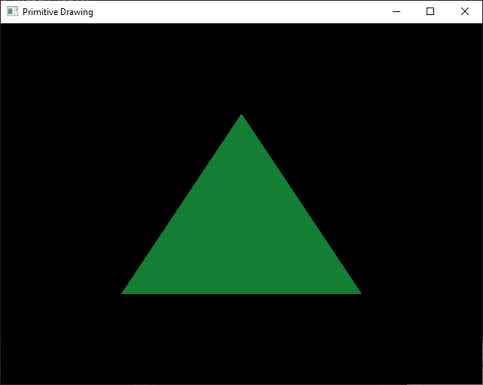

2. Program 2
Code:

#include <GL/glew.h>
#include <GLFW/glfw3.h>
#include <stdio.h>

int main() {
GLFWwindow* window;

float points[] = {
0.0f, 0.5f, 0.0f,
0.5f, -0.5f, 0.0f,
-0.5f, -0.5f, 0.0f
};

if (!glfwInit()) {
fprintf(stderr, "ERROR: could not start GLFW3\n");
return -1;
}

window = glfwCreateWindow(640, 480, "Primitive Drawing", NULL, NULL);

if (!window) {
fprintf(stderr, "ERROR: could not open window with GLFW3\n");
glfwTerminate();
return -1;
}

glfwMakeContextCurrent(window);

glewExperimental = GL_TRUE;
glewInit();

const GLubyte* renderer = glGetString(GL_RENDERER);
const GLubyte* version = glGetString(GL_VERSION);

printf("Renderer : %s\n", renderer);
printf("OpenGL version supported %s\n", version);

glEnable(GL_DEPTH_TEST);
glDepthFunc(GL_LESS);

GLuint vbo;
glGenBuffers(1, &vbo);

glBindBuffer(GL_ARRAY_BUFFER, vbo);
glBufferData(GL_ARRAY_BUFFER, sizeof(points), points, GL_STATIC_DRAW);

GLuint vao = 0;
glGenVertexArrays(1, &vao);
glBindVertexArray(vao);
glEnableVertexAttribArray(0);
glBindBuffer(GL_ARRAY_BUFFER, vbo);
glVertexAttribPointer(0, 3, GL_FLOAT, GL_FALSE, 0, NULL);

const char* vertex_shader = "#version 400\n"
"in vec3 vp;"
"void main(){"
" gl_Position = vec4(vp, 1.0);"
"}";

const char* fragment_shader =
"#version 400\n"
"out vec4 frag_colour;"
"void main(){"
" frag_colour = vec4(161, 155, 0, 1);"
"}";

GLuint vs = glCreateShader(GL_VERTEX_SHADER);
glShaderSource(vs, 1, &vertex_shader, NULL);
glCompileShader(vs);
GLuint fs = glCreateShader(GL_FRAGMENT_SHADER);
glShaderSource(fs, 1, &fragment_shader, NULL);
glCompileShader(fs);

GLuint shader_programme = glCreateProgram();
glAttachShader(shader_programme, fs);
glAttachShader(shader_programme, vs);
glLinkProgram(shader_programme);

while (!glfwWindowShouldClose(window)) {
glClear(GL_COLOR_BUFFER_BIT | GL_DEPTH_BUFFER_BIT);
glUseProgram(shader_programme);
glBindVertexArray(vao);
glDrawArrays(GL_POINTS, 0, 3);
glPointSize(15.0);
glfwPollEvents();
glfwSwapBuffers(window);
}
glfwTerminate();
}

Hasil

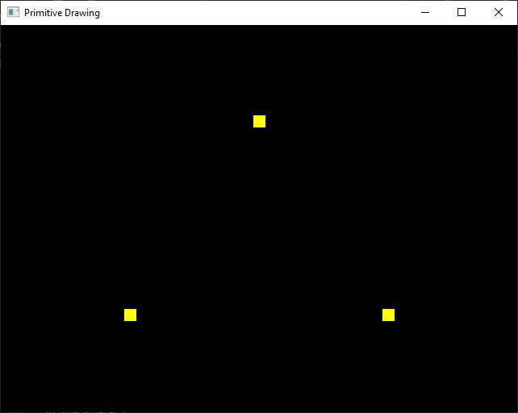

3. Program 3
Code:

#include <GL/glew.h>
#include <GLFW/glfw3.h>
#include <stdio.h>

int main() {
GLFWwindow* window;

float points[] = {
0.5f, 0.5f, 0.0f,
0.5f, -0.5f, 0.0f,
-0.5f, -0.5f, 0.0f,
-0.5f, 0.5f, 0.0f,
0.5f, 0.5f, 0.0f,
-0.5f, 0.5f, 0.0f,
0.5f, -0.5f, 0.0f,
-0.5f, -0.5f, 0.0f
};

if (!glfwInit()) return -1;

window = glfwCreateWindow(640, 480, "Primitive Drawing", NULL, NULL);

if (!window) {
glfwTerminate();
return -1;
}

glfwMakeContextCurrent(window);

glewExperimental = GL_TRUE;
glewInit();

const GLubyte* renderer = glGetString(GL_RENDERER);
const GLubyte* version = glGetString(GL_VERSION);

printf("Renderer : %s\n", renderer);
printf("OpenGL version supported %s\n", version);

glEnable(GL_DEPTH_TEST);
glDepthFunc(GL_LESS);

GLuint vbo;
glGenBuffers(1, &vbo);

glBindBuffer(GL_ARRAY_BUFFER, vbo);
glBufferData(GL_ARRAY_BUFFER, sizeof(points), points, GL_STATIC_DRAW);

GLuint vao = 0;
glGenVertexArrays(1, &vao);
glBindVertexArray(vao);
glEnableVertexAttribArray(0);
glBindBuffer(GL_ARRAY_BUFFER, vbo);
glVertexAttribPointer(0, 3, GL_FLOAT, GL_FALSE, 0, NULL);

const char* vertex_shader = "#version 400\n"
"in vec3 vp;"
"void main(){"
" gl_Position = vec4(vp, 1.0);"
"}";

const char* fragment_shader =
"#version 400\n"
"out vec4 frag_colour;"
"void main(){"
" frag_colour = vec4(0.5, 0.25, 0.1, 1);"
"}";

GLuint vs = glCreateShader(GL_VERTEX_SHADER);
glShaderSource(vs, 1, &vertex_shader, NULL);
glCompileShader(vs);
GLuint fs = glCreateShader(GL_FRAGMENT_SHADER);
glShaderSource(fs, 1, &fragment_shader, NULL);
glCompileShader(fs);

GLuint shader_programme = glCreateProgram();
glAttachShader(shader_programme, fs);
glAttachShader(shader_programme, vs);
glLinkProgram(shader_programme);

while (!glfwWindowShouldClose(window)) {
glClear(GL_COLOR_BUFFER_BIT | GL_DEPTH_BUFFER_BIT);
glUseProgram(shader_programme);
glBindVertexArray(vao);
glDrawArrays(GL_LINE, 0, 4);
glfwPollEvents();
glfwSwapBuffers(window);
}
glfwTerminate();
}

Hasil

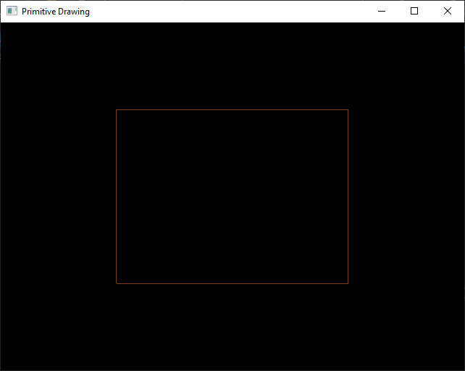

4. Program 4
Code:

#include <GL/glew.h>
#include <GLFW/glfw3.h>
#include <stdio.h>

int main() {
GLFWwindow* window;

float points[] = {
0.5f, 0.5f, 0.0f,
0.5f, -0.5f, 0.0f,
-0.5f, -0.5f, 0.0f,
-0.5f, 0.5f, 0.0f,
0.5f, 0.5f, 0.0f,
-0.5f, 0.5f, 0.0f,
0.5f, -0.5f, 0.0f,
-0.5f, -0.5f, 0.0f
};

if (!glfwInit()) return -1;

window = glfwCreateWindow(640, 480, "Primitive Drawing", NULL, NULL);

if (!window) {
glfwTerminate();
return -1;
}

glfwMakeContextCurrent(window);

glewExperimental = GL_TRUE;
glewInit();

const GLubyte* renderer = glGetString(GL_RENDERER);
const GLubyte* version = glGetString(GL_VERSION);

printf("Renderer : %s\n", renderer);
printf("OpenGL version supported %s\n", version);

glEnable(GL_DEPTH_TEST);
glDepthFunc(GL_LESS);

GLuint vbo;
glGenBuffers(1, &vbo);

glBindBuffer(GL_ARRAY_BUFFER, vbo);
glBufferData(GL_ARRAY_BUFFER, sizeof(points), points, GL_STATIC_DRAW);

GLuint vao = 0;
glGenVertexArrays(1, &vao);
glBindVertexArray(vao);
glEnableVertexAttribArray(0);
glBindBuffer(GL_ARRAY_BUFFER, vbo);
glVertexAttribPointer(0, 3, GL_FLOAT, GL_FALSE, 0, NULL);

const char* vertex_shader = "#version 400\n"
"in vec3 vp;"
"void main(){"
" gl_Position = vec4(vp, 1.0);"
"}";

const char* fragment_shader =
"#version 400\n"
"out vec4 frag_colour;"
"void main(){"
" frag_colour = vec4(0.5, 0.25, 0.1, 1);"
"}";

GLuint vs = glCreateShader(GL_VERTEX_SHADER);
glShaderSource(vs, 1, &vertex_shader, NULL);
glCompileShader(vs);
GLuint fs = glCreateShader(GL_FRAGMENT_SHADER);
glShaderSource(fs, 1, &fragment_shader, NULL);
glCompileShader(fs);

GLuint shader_programme = glCreateProgram();
glAttachShader(shader_programme, fs);
glAttachShader(shader_programme, vs);
glLinkProgram(shader_programme);

while (!glfwWindowShouldClose(window)) {
glClear(GL_COLOR_BUFFER_BIT | GL_DEPTH_BUFFER_BIT);
glUseProgram(shader_programme);
glBindVertexArray(vao);
glDrawArrays(GL_LINE_LOOP, 0, 4);
glfwPollEvents();
glfwSwapBuffers(window);
}
glfwTerminate();
}

