Decision Document: MCP Tools Implementation Strategy
Template for United States of America
Fixed-Price Standalone SOW

July 7, 2025

Presented By:

AI Development Team
Technical Architecture Lead

[Office Address]
[Office Phone Number]
[Email]

Revision Table
Revision | Date | Description of Change
1.0 | XXXXX | Initial Release

Confidentiality Statement
This document contains information that is privileged, confidential, and otherwise protected from disclosure to anyone other than intended recipient(s). As a result, this information should not be disclosed, duplicated or used for any other purpose than to evaluate Actalent. On signing the contract as a result of the process initialized by submission of this document, any right to disclose, duplicate or use the data contained within this document will be to the extent provided in the resulting agreement

Table of Contents
No table of contents entries found.
Table of Exhibits
Exhibit A – Change Order 27

Decision Document: MCP Tools Implementation and AI-Assisted Content Generation Strategy

Title and Metadata
Attribute | Details
Decision ID | MCP-AI-001
Date | July 7, 2025
Status | In Review
Department | AI Research & Development
Proposed By | AI Development Team
Stakeholders | Technical Architecture Team, Management, Client Services
Tags | AI, MCP Tools, Document Generation, Technical Infrastructure

Background/Context
Our organization has been evaluating the implementation of AI-powered document generation capabilities using MCP (Model Context Protocol) tools specifically designed for Word document creation. This decision comes at a critical juncture where we need to determine the optimal deployment strategy and technical architecture for our AI-assisted content generation system.
The current development status shows that we have completed approximately 60% of the major work on MCP tools for Word document generation over a 4-week development cycle. These tools are specifically built to support Actalent formatting requirements and demonstrate significant capabilities in automated document creation. The remaining 30% represents unidentified work that will be addressed when the backlog reaches 10 issues, with code currently frozen at the 60% completion mark.
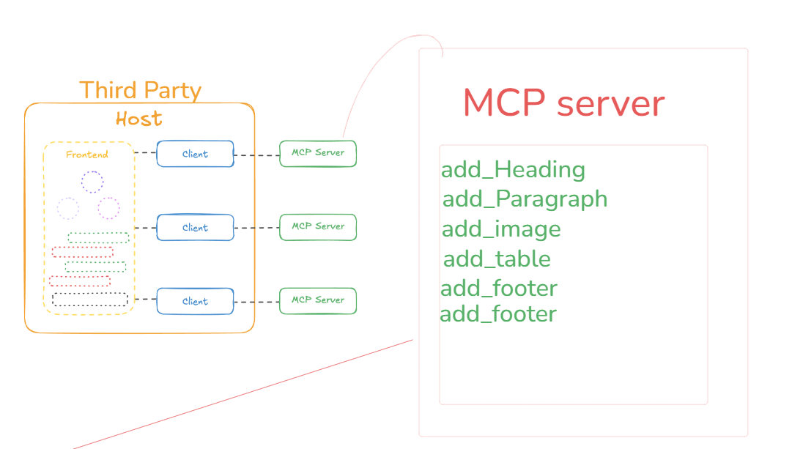
Figure: Current MCP Server Prototype Architecture

Alternatives Considered

Alternative 1: Local Deployment
Local deployment involves running MCP tools on organizational hardware with Python dependencies. This approach offers complete data control and zero operational costs but requires Python environment setup and maintenance.
Pros:
- No operational costs
- Complete data sovereignty
- No external API dependencies
- Enhanced security through isolation
- Docker containerization for cyber attack protection
Cons:
- Requires Python environment management
- Limited to GitHub Copilot interface
- Hardware resource constraints
- Maintenance overhead for local infrastructure

Alternative 2: Cloud Server Deployment
Cloud deployment requires understanding of SSE (Server-Sent Events) and streamable HTTP protocols, enabling custom interfaces beyond GitHub Copilot but introducing operational costs and complexity.
Pros:
- Custom interface capabilities
- Scalable infrastructure
- Advanced streaming protocols support
- Flexible deployment options
- Enhanced accessibility from multiple locations
Cons:
- Ongoing operational costs
- Requires specialized knowledge (SSE, HTTP streaming)
- Data transmission outside organization
- Potential NDA compliance concerns with clients
- Additional complexity in deployment and maintenance

Alternative 3: Hybrid LLM Model Strategy
Implementing a combination of closed-source models (Claude Sonnet) for long-form documents and open-source models (LLama 4) for short-form content, with consideration for fine-tuning capabilities.
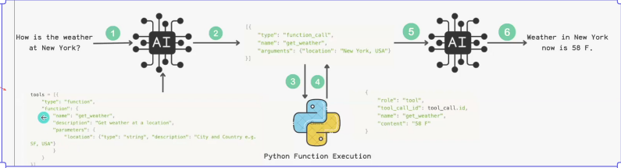
Figure: Generic Example of How LLM Interacts with Tools

The Decision
After careful evaluation of all alternatives, we have decided to implement a phased approach combining local deployment with strategic model selection:
- Phase 1: Local Deployment with Docker Containerization - Implement MCP tools locally using Docker instances with mounted folder access for enhanced security
- Phase 2: Model Strategy Implementation - Deploy Claude Sonnet for long-form document generation and evaluate open-source alternatives for short-form content
- Phase 3: Code Freeze and Monitoring - Maintain current 60% completion status while monitoring for issues to reach the 10-issue threshold before resuming development
- Phase 4: Performance Optimization - Implement accuracy improvement techniques including fine-tuning, in-context learning, and prompt engineering strategies
This decision prioritizes security, cost-effectiveness, and incremental implementation while maintaining flexibility for future enhancements. The choice of local deployment addresses immediate security concerns and eliminates operational costs, while the phased approach allows for learning and optimization.

Impact Analysis

Positive Impacts
- Significant productivity gains: Content generation time reduced by 75% (from 60 to 15 minutes)
- Overall workflow efficiency: 37.5% total time savings despite increased validation requirements
- Enhanced security through Docker containerization
- Zero operational costs for the initial implementation
- Improved document consistency and formatting quality
- Scalable foundation for future AI integrations

Trade-offs and Challenges
- Increased validation time: 75% more time required for review and refinement (20 to 35 minutes)
- Technical debt: 30% unidentified work remaining in the codebase
- Learning curve: Staff training required for new AI-assisted workflows
- Potential system limitations: Interface restricted to GitHub Copilot in Phase 1
- Dependency management: Python environment and Docker maintenance requirements

KPI Metrics and Success Criteria
Metric | Current Performance | Success Criteria
Content Generation Efficiency | 4.0x faster | Target: >3.0x improvement
Overall Workflow Productivity | 1.6x faster | Target: >1.5x improvement
Time Savings Percentage | 37.5% | Target: >30% overall savings
Security Incidents | 0 incidents | Target: Zero security breaches
Validation Quality Score | TBD | Target: >95% accuracy post-validation

Technical Considerations and Optimization Strategies

Addressing System Optimization Issues
Issue 1: System Hallucinations
Solution: Implement AI Agent Response Evaluation (AI Judge) systems and establish validation protocols with project members who have previous project experience.
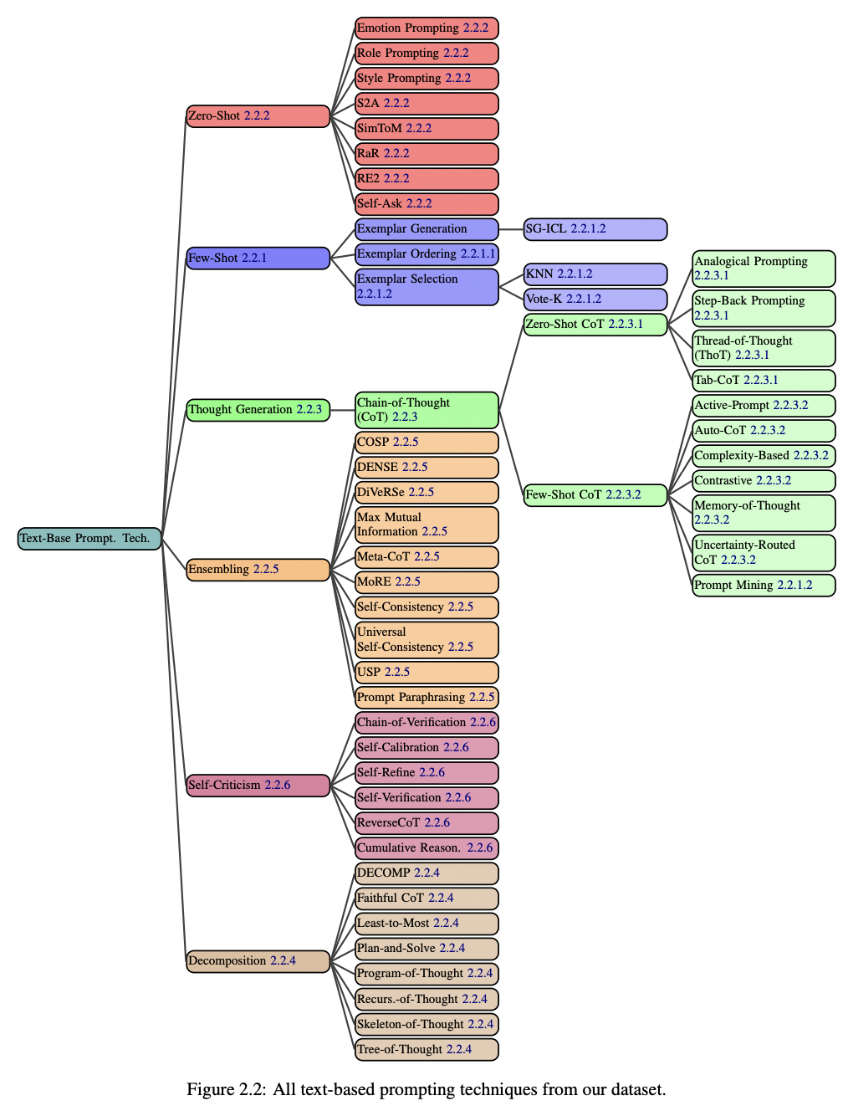
Figure: Prompting Techniques to Improve Accuracy

Issue 2: Unreliable Tool Usage
Solutions include improving tool definitions with better annotations, implementing tool transformations for legacy MCP tools, and considering multi-agent systems for complex tool orchestration.
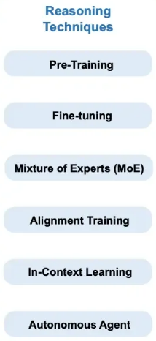
Figure: Reasoning Techniques to Increase Accuracy - In-Context Learning

Context Engineering and Prompt Optimization
Implementing sophisticated prompting strategies including Chain-of-Thought reasoning, Active-Prompt techniques, and proper role separation (System, User, Assistant) to enhance accuracy and reduce ambiguity.
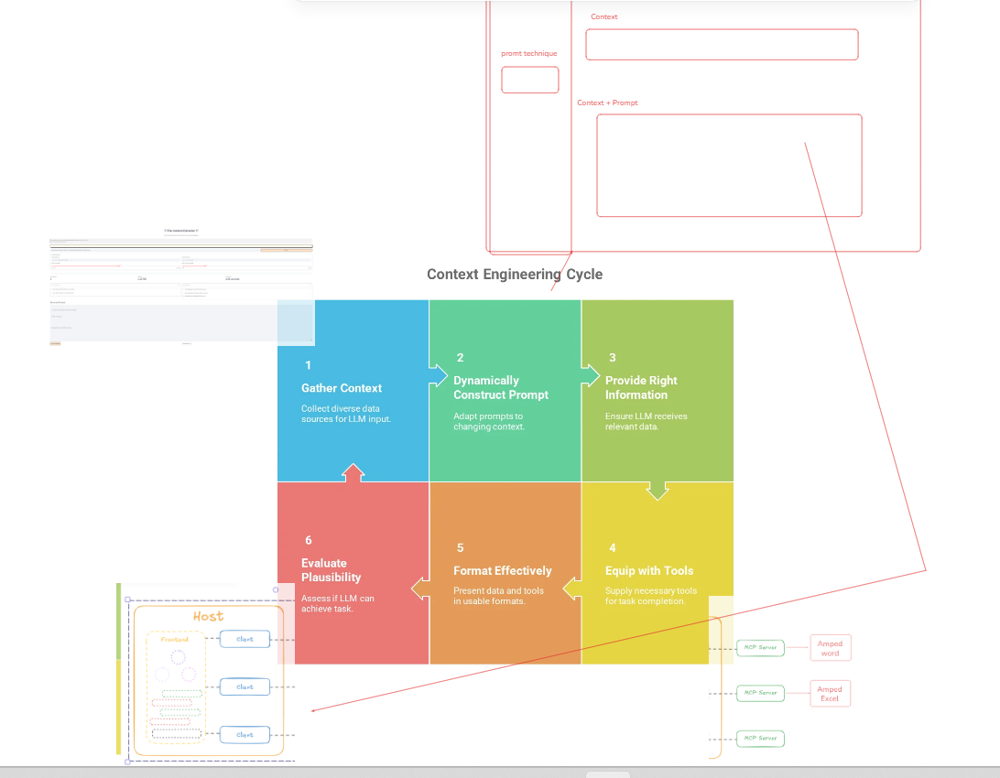
Figure: In-Context Context Engineering

Cost Analysis and Token Management
LLM operations are fundamentally token-based, with costs approximately $0.01 per million tokens. Understanding token economics is crucial for budget planning and optimization.
Component | Description | Details
Input Tokens | Prompts + Context + History | Variable based on document complexity
Output Tokens | Generated content | Typically 3-4x input tokens
Context Window | Claude Sonnet: 120k tokens | Supports comprehensive document context
Cost Structure | $0.01 per 1M tokens | Covers both input and output tokens
Example Calculation | 100 input + 400 output = 500 tokens | Cost: $0.000005 per operation

References
- MCP Tools Development Documentation - Internal development logs and progress reports
- Security Best Practices for AI Systems - Docker containerization guidelines
- LLM Performance Benchmarks - Comparative analysis of Claude Sonnet vs. open-source alternatives
- Cost-Benefit Analysis Framework - Token economics and pricing models
- Prompt Engineering Research - Qiao et al. (2023) reasoning enhancement strategies
- Client NDA Requirements - Data sovereignty and security compliance documentation
- Technical Architecture Specifications - Current prototype and deployment requirements

Next Steps and Action Items
- Immediate (Week 1-2): Set up Docker containerization for MCP tools with security isolation
- Short-term (Month 1): Begin monitoring and documentation of the remaining 30% unidentified work
- Medium-term (Month 2-3): Implement AI Agent Response Evaluation system for quality assurance
- Long-term (Month 4-6): Evaluate open-source LLM alternatives and potential fine-tuning opportunities
- Ongoing: Maintain issue tracking system with 10-issue threshold for development resumption
- Quarterly Review: Assess KPI metrics and adjust strategy based on performance data

