MCP POC Decision Document

[08/07/2025]

Presented By:

Development Team(Nikhil,Akash,PremChand)

Revision Table
Revision | Date | Description of Change
1.0 | XXXXX | Initial Release

Table of Contents
1 📌 MCP Tools Deployment Strategy Decision 2
1.1 📖 Background / Context 2
1.2 🔍 Alternatives Considered 3
1.3 ✅ The Decision 4
1.4 📈 Impact 4
1.5 📚 References 7
1.6 📌 Maintenance Guidance 9
1.7 🧭 Organizational Reminder 9

Table of Exhibits
Exhibit A – Change Order 27

📌 MCP Tools Deployment Strategy Decision
Decision Metadata
- ID: DEC-2025-07-001
- Status: Accepted
- Date of Decision: July 8, 2025
- Author: PremChand
- Stakeholders: Development Team(Nikhil, Akash), Management(Praveen)
- Tags: MCP Tools, Deployment Strategy, AI Infrastructure

📖 Background / Context
The Development Team has developed MCP (Model Context Protocol) tools for Word document generation, achieving 60% completion of major functionality after 4 weeks of development. The system demonstrates significant efficiency gains, with AI-assisted workflows showing 37.5% overall time savings compared to manual processes, despite requiring 75% more validation time.
Current testing with Claude Sonnet AI models through GitHub Copilot extension shows excellent performance for long-form document generation, while GPT models perform well for short-form content. The remaining 30% of unidentified work and potential bugs require strategic decision-making for deployment approach and ongoing maintenance.
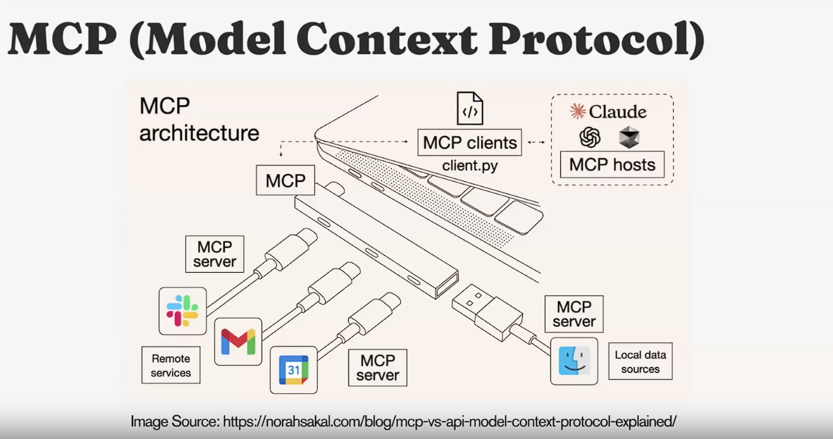
Figure: MCP Overview - Model Context Protocol Architecture

🔍 Alternatives Considered
Option 1: Local Deployment (Docker Instance)
Deploy MCP tools locally using Docker containerization with mounted folder access for security isolation.
Pros: No operational costs, enhanced security through containerization, requires Python environment, complete data control
Cons: Requires local hardware resources, Python dependency management, limited scalability
Option 2: Cloud Server Deployment
Deploy MCP tools on cloud infrastructure with custom interface replacing GitHub Copilot integration.
Pros: High scalability, professional deployment, SSE and streamable HTTP capabilities
Cons: Operational costs, requires custom interface development, additional complexity in SSE/HTTP streaming
Option 3: Hybrid Approach with Phased Deployment
Start with local Docker deployment for immediate use while developing cloud infrastructure for future scaling.
Pros: Immediate deployment capability, risk mitigation, gradual scaling opportunity
Cons: Requires maintaining two deployment strategies, potential duplicate effort
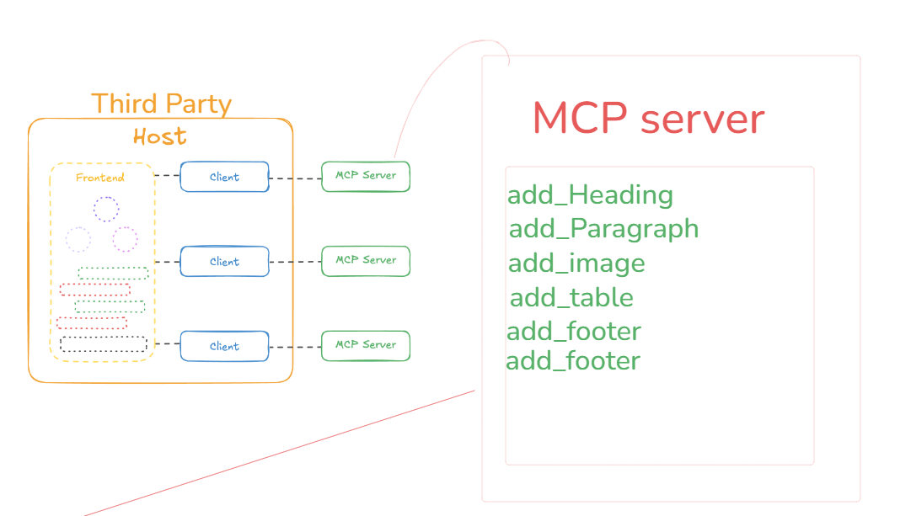
Figure: Current MCP Server Prototype Architecture

✅ The Decision
Decision Made: Implement Local Docker Deployment with Security Containerization (Option 1) as the immediate deployment strategy, while freezing development at 60% completion until backlog reaches 10 identified issues.
Key Rationale:
- Cost Effectiveness: Zero operational costs while maintaining functionality
- Security Priority: Docker containerization provides robust security isolation against cyber attacks
- Immediate Value: 37.5% time savings demonstrated in current testing phase
- Risk Management: Freezing development prevents over-engineering while collecting real-world usage data
- Proven Performance: Claude Sonnet integration showing excellent results for long-form document generation
Approval: This decision was endorsed by the development team and approved by management based on demonstrated efficiency gains and security requirements.

📈 Impact
Expected Benefits:
- Business: 37.5% overall time savings in document generation workflows
- Technical: 4x faster content generation phase, enhanced security through containerization
- User Experience: Seamless integration with existing GitHub Copilot workflows
- Cost: Zero operational expenses for deployment and maintenance
Trade-offs and Drawbacks:
- 75% increase in validation time requirements
- 30% of functionality remains unidentified and unimplemented
- Limited scalability compared to cloud deployment
- Dependency on local hardware resources and Python environment
Risks and Mitigation Strategies:
Risk | Impact | Mitigation Strategy
System Hallucinations | High | Implement AI Judge evaluation and project member validation
Unreliable Tool Use | Medium | Improve tool definitions with annotations and parameter descriptions
Unidentified Bugs | Medium | Monitor usage until 10-issue backlog threshold for development resumption
Security Vulnerabilities | High | Docker containerization with mounted folder restrictions
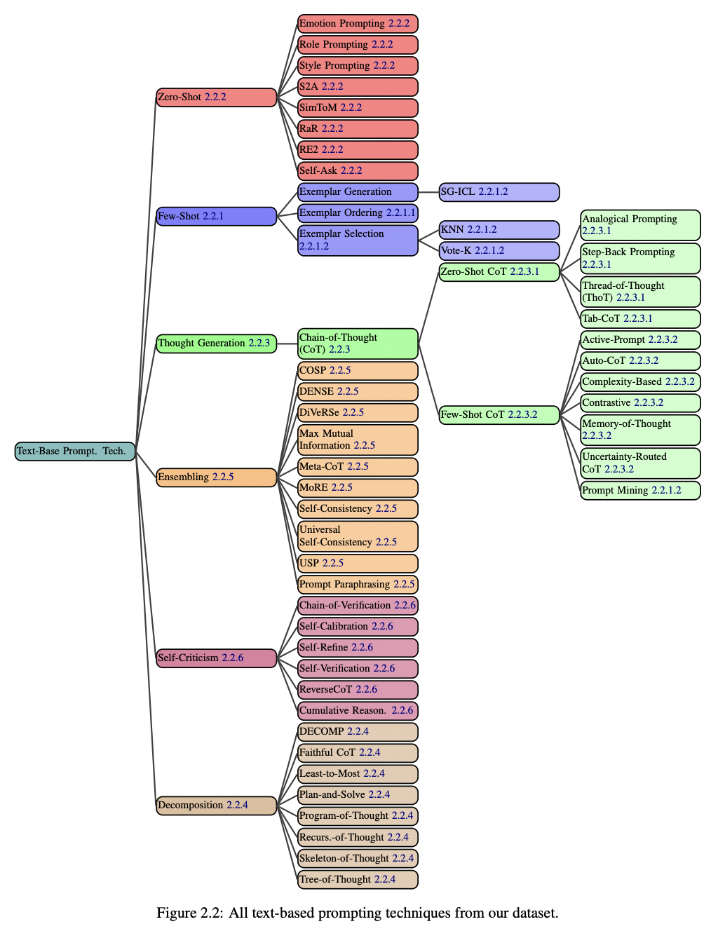
Figure: Prompting Techniques to Improve AI Accuracy

📚 References
Technical Documentation:
- MCP Tools Development Progress Report
- Security Assessment for Docker Containerization
- Performance Benchmarking: Manual vs AI-Assisted Workflows
- Cost Analysis: Local vs Cloud Deployment Options
Supporting Data Sources:
- KPI Analysis: Time Savings Calculations
- Claude Sonnet API Performance Metrics
- Token Cost Analysis and Billing Projections
- Hardware Requirements Assessment (NVIDIA DGX H200 System: Rs 5,00,000)
Visual References:
- MCP Overview Architecture Diagram
- Current MCP Server Prototype Architecture
- Prompting Techniques for Accuracy Improvement
- Reasoning Techniques for Enhanced LLM Performance
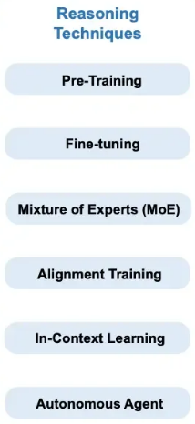
Figure: Reasoning Techniques to Increase Accuracy - In-Context Learning

📌 Maintenance Guidance
This decision document should be reviewed quarterly or when the 10-issue backlog threshold is reached, whichever comes first. The development team will monitor system performance and collect user feedback to inform future iterations.
Version Control: Any changes to deployment strategy or resumption of development work must be documented in a new decision document (DEC-2025-07-002) that references this decision and provides updated rationale.

🧭 Organizational Reminder
Regular review cycles should be established, and all team members should reference this document when making related technical decisions. The success of this deployment strategy depends on consistent monitoring and feedback collection from end users.
This document serves as the foundation for transparent decision-making and provides clear traceability for future strategic planning regarding MCP tools deployment and AI integration initiatives.
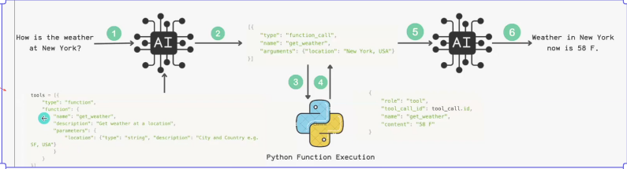
Figure: LLM Interaction with Tools - Generic Example

Next Steps

Ongoing: Implement AI Agent Response Evaluation system for quality assurance or use prompt tuning and context Engineering.
Ongoing: Maintain issue tracking system with 10-issue threshold for development resumption
Long-term: Evaluate open-source LLM alternatives and potential fine-tuning opportunities

