Pixlab
Foundations of Computer Science, 2023-2024

Background & Explanation
We have learned basic components of Java graphics & GUIs. Next, we’re going to see a complex example of these elements interacting in a well-designed class hierarchy and add some features while we’re there.
As you work through this assignment and do the individual challenges you also want to make sure that you understand how all of the architecture fits together. Your final project is likely to be about as complex as this is!

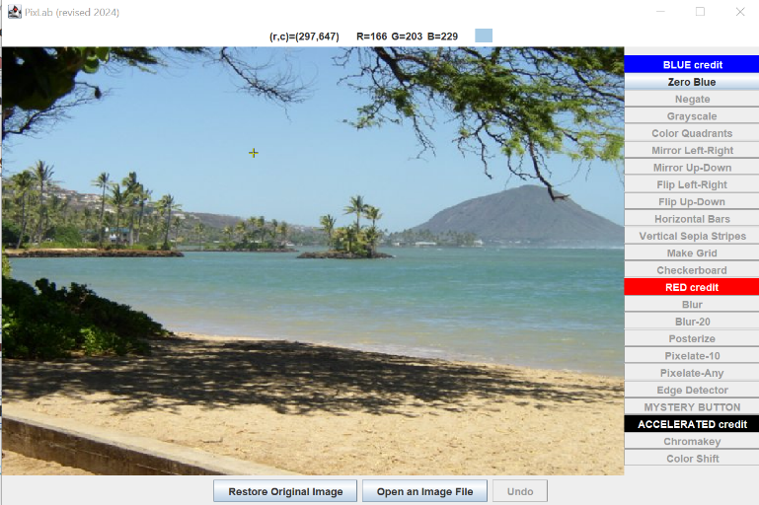
Introducing Pixlab
Download the .zip file from the course website, extract it, and compile / run DriverPix.java. Play around with the program’s current features. Be sure to:
- Click on the image and see the RGB values for that pixel’s color at the top of the screen. (Do you remember how to specify a color using RGB values from Java Art earlier in this unit?)
- Click Zero Blue. What happens to the image?
- Click Restore Original Image.
- Open a different image and repeat the above steps.
A lot of this should be familiar – you’ve written buttons, you’ve made subpanels – but let’s dive in and see how it works.
- Notice that DriverPix has a subpanel PanelPix object.
- Notice that PanelPix has two subpanels (in addition to the standard JPanels that hold buttons) – a ScoreboardPix object and a DisplayPix object.
- Notice that DisplayPix constructs a PixelOperations object.

The “UML Diagram” (Unified Modeling Language) below shows all of the classes involved in this architecture. Dotted lines show “hasa” relationships. For example, DriverPix “hasa” PanelPix object inside it. Thick lines show “isa” relationships. For example, PanelPix “isa” JPanel because PanelPix extends JPanel.
JPanel
DisplayPix
PanelPix
DriverPix

BufferedImage
Scoreboard

Color
2-D array

PixelOperations
ActionListeners
KeyListeners
MouseListeners

Note that, of the many buttons on the right panel, only Zero Blue is a working button. Let's look at all of the code that is needed to set the blue values to zero in each and every RGB pixel.
First, PanelPix has the buttons and listeners. Most of the buttons are disabled and don’t have a listener attached, but on Zero Blue, you can see that the button has a matching action listener…
29 JButton zero = new JButton("Zero Blue");
30 zero.addActionListener(new Listener_zeroBlue());
31 east.add(zero);
. . .
134 private class Listener_zeroBlue implements ActionListener
135 {
136 public void actionPerformed(ActionEvent e)
137 {
138 display.zeroBlue();
139 update( display.getXval() , display.getYval() );
140 }
141 }

…which sends a command to a method in the DisplayPix object, display. The zeroBlue method gets the array of pixels, calls another method in a different object that actually changes the colors, and sets the new image, like this:
57 public void zeroBlue()
58 {
59 Color[][] tmp = pix.getArray( img );
60 pix.zeroBlue( tmp );
61 pix.setImage( img , tmp );
62 }

So, where are the colors actually being changed? Inside the PixelOperations object pix. methods. Each color-manipulating method in pix uses nested for-loops to access each pixel in every row and column:

49 public void zeroBlue(Color[][] arr)
50 {
51 for(int j = 0; j < arr.length; j++)
52 {
53 for(int k = 0; k < arr[0].length; k++)
54 {
55 Color tmp = arr[j][k];
56 arr[j][k] = new Color( tmp.getRed(), tmp.getGreen(), 0 );
57 }
58 }
59 }

To summarize:
- PanelPix's ZeroBlue button has a Listener which calls a zeroBlue method on the DisplayPix object.
- The DisplayPix's zeroBlue method calls methods on a PixelOperations object pix:
  - getArray converts the image to an array of Color objects
  - zeroBlue takes the Color array and changes it
    - Make sure you are clear on the difference between the zeroBlue method in PanelPix, which takes no arguments, and the zeroBlue method in PixelOperations, which takes a 2-D array of Color objects!
  - setImage puts the Color array back in the image

When a button in PanelPix is clicked, it triggers an ActionListener which triggers a method in DisplayPix which triggers several methods in PixelOperations. Make sure this chain of code makes sense before you move on.

Color objects
Finally, we also want to make sure you understand how Color objects work. Here is some partial documentation for Java.awt.Color, which is used to encapsulate colors in either the default sRGB color space or in arbitrary color spaces:

Constructor Summary
Color(int rgb)
Creates an opaque sRGB color with the specified combined RGB value consisting of the red component in bits 16-23, the green component in bits 8-15, and the blue component in bits 0-7.
int black = 0;
int blue = 255; // 2^8-1
int green = 65280; //(2^8-1)*2^8
int red = 16711680; //(2^8-1)*2^16
int white = 16777215; // 2^24-1
black | 0 | 0 | 0 | 0 | 0 | 0 | 0 | 0 | 0 | 0 | 0 | 0 | 0 | 0 | 0 | 0 | 0 | 0 | 0 | 0 | 0 | 0 | 0 | 0
blue | 0 | 0 | 0 | 0 | 0 | 0 | 0 | 0 | 0 | 0 | 0 | 0 | 0 | 0 | 0 | 0 | 1 | 1 | 1 | 1 | 1 | 1 | 1 | 1
green | 0 | 0 | 0 | 0 | 0 | 0 | 0 | 0 | 1 | 1 | 1 | 1 | 1 | 1 | 1 | 1 | 0 | 0 | 0 | 0 | 0 | 0 | 0 | 0
red | 1 | 1 | 1 | 1 | 1 | 1 | 1 | 1 | 0 | 0 | 0 | 0 | 0 | 0 | 0 | 0 | 0 | 0 | 0 | 0 | 0 | 0 | 0 | 0
white | 1 | 1 | 1 | 1 | 1 | 1 | 1 | 1 | 1 | 1 | 1 | 1 | 1 | 1 | 1 | 1 | 1 | 1 | 1 | 1 | 1 | 1 | 1 | 1

Color(int r, int g, int b)
Creates an opaque sRGB color with the specified red, green, and blue, each in the range (0 - 255).

Method Summary
boolean | equals(Object obj)  Determines whether another object is equal to this Color.
int | getBlue()  Returns the blue component in the range 0-255 in the default sRGB space.
int | getGreen()  Returns the green component in the range 0-255 in the default sRGB space.
int | getRed()  Returns the red component in the range 0-255 in the default sRGB space.
int | getRGB()  Returns the RGB value representing the color in the default sRGB ColorModel.  int black = 0;  int blue = 255; // 2^8-1  int green = 65280; //(2^8-1)*2^8  int red = 16711680; //(2^8-1)*2^16  int white = 16777215; // 2^24-1
String | toString()  Returns a string representation of this Color.

An important question: where are setBlue, setGreen, and setRed?

If you aren't allowed to modify a color, how do you do these labs? (You may need to look back at the zeroBlue code to answer this question!)
After the architecture, array structure, and Color objects make sense, you’re ready to get started!

Your Assignment
Your goal will be to implement the other buttons on the panel. Specifically:

Basic Buttons: BLUE Credit

Zero Blue
Sets the blue value to zero for every pixel.

Negate
Negates all the pixels in a picture by setting each color’s value to 255 minus the current value.

Grayscale
Turns picture into shades of gray by setting the red, green, and blue values of each pixel to a mixture of the current red, green, and blue value of the pixel. Some people do a straight average of the three R, G, B values. Others use: 30% red + 59% green + 11% blue. Beware: the Color constructor does not accept double values.

Color Quadrants
You’ve done zeroBlue across the whole image. Now, do zeroRed in the top left quadrant of the image, zeroGreen in the top right quadrant, zeroBlue in the bottom left quadrant, and grayscale in the bottom right.

Mirror L/R
Mirrors the left side of the picture onto the right side of the picture. Get a pixel from the left side of the picture and copy it onto a pixel on the right side of the picture that is on the same row and the same distance from the right end that the left pixel is from the left end.

Mirror U/D
Mirrors the upper half of the picture onto the bottom of the picture.

Flip L/R
Flips the whole image around a vertical axis, producing a left-right mirror image of the whole picture. Algorithm: get a pixel from the left side of the picture and exchange (or swap) it with a pixel on the right side of the picture that is on the same row and the same distance from the right end that the left pixel is from the left end. Notice that there is no need to modify any RGB values.

Flip U/D
Flips the whole image top-to-bottom, producing an upside-down image of the whole picture.

Horizontal Bars
Partially cover the image with 10-pixel-tall black bars spaced at y = 50, y = 150, y = 250, etc. (In other words, the color black should replace every pixel with a y coordinate of 50, 51, 52, 53, 54, 55, 56, 57, 58 or 59… then again starting at y = 150… etc.)

Vertical Sepia Stripes
Sepia-toned pictures have a yellowish tint that we associate with older pictures. Microsoft’s recommended algorithm is:
- Set a pixel’s red value to the sum of .393 of its red value, .769 of its green value, and .189 of its blue value
- Set a pixel’s green value to the sum of .349 of its red value, .686 of its green value, and .168 of its blue value
- Set a pixel’s blue value to the sum of .272 of its red value, .534 of its green value, and .131 of its blue value
- Don't let any RGB value exceed 255.
This button should convert vertical stripes of the original image, 10 pixels wide, spaced at x = 50, x = 150, x = 250, etc, into sepia tone.

Make Grid
Add a grid over top of the image. Grid lines should be a color that stands out – say, bright red or bright blue – and should appear every 25 pixels, vertically and horizontally.

Checkerboard
Draw black squares, 50x50, in a checkerboard pattern over the picture.

Advanced Buttons: RED Credit

Blur
 | *
* | X | *
 | *
Get the colors of the four pixels to the left, right, bottom, and top of the current pixel. Set the current pixel’s color to the average of the colors of the current pixel and its four neighboring pixels. (You might have to click several times to see its effects. Alternatively, just blur the left half of the picture.) Be careful at the edges of the screen!

Blur-20
Clicking this button should have exactly the same effect as clicking the Blur button 20 times in a row. (You may literally call the same function that Blur called, just 20 consecutive times.)

Posterize
A bunch of different colors gets set to just a few colors. For a range of colors, map them to a single color. For instance, if red is between 63 and 128, set red to 95. This requires a bunch of if-statements.

Pixelate-10
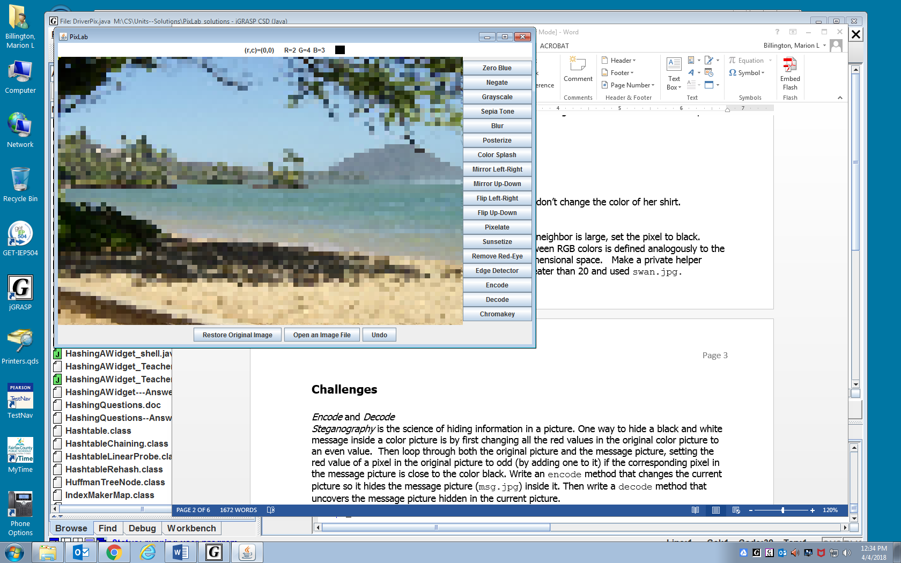
Imagine splitting the image into 10x10 squares. Let the color of the top left corner pixel replace the colors in the rest of the square. (So, for example, the color at 0,0 would replace all the colors in the pixels where the x and y coordinates go from 0 to 9, inclusive. See the example at right.) Be careful at the edges of the screen!

Pixelate-Any
For a greater challenge, first prompt the user to enter the size of the new square. In order to get this to work, you’ll need to add a JTextField to the panel where a user can type the size they wish to use. The JTextField has not been provided for you – where should it go? How will you access it?

Edge Detector
If the "distance" between the colors of a pixel and its neighbor is large, set the pixel to black. Otherwise, set the pixel to white. The "distance" between RGB colors is defined analogously to the Pythagorean distance between two points in three-dimensional space. Make a private helper method colorDistance. I looked for distances greater than 20 and used swan.jpg.

Challenges: ACCELERATED Credit

Chromakey
You may hard-code the foreground picture (blue_mark.jpg) Replace the current pixel color with the color from the other picture (moon-surface.jpg) at the same row and column when the current pixel color is close to a specified color. (This technique is used in many movies today.)
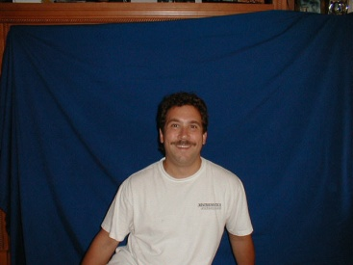 blue_mark.jpg | 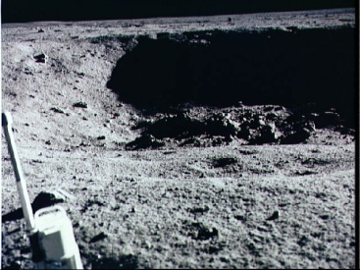  moon-surface.jpg | 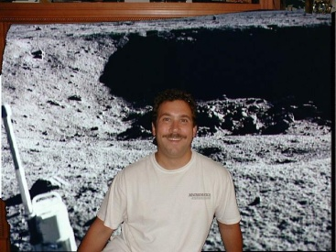  mark on the moon

Color Shift
Add two JTextFields – percentageLeft and percentageRight – and a set of three radio buttons (google “Java Swing radio buttons” if you aren’t sure how to do this) that allow the user to select RED, GREEN, or BLUE. So, you’ll be getting two numbers and a choice of color from the user.
The idea here is that on the left side of the image, all the values of that color will be multiplied by percentageLeft, and on the right, they will be multiplied by percentageRight. Through the middle of the image, left to right, you’ll smoothly transition from one percentage to the other.
So, for example, if someone wrote “200” for percentageLeft, “0” for percentageRight, and selected GREEN, then the GREEN values of the pixels on the far left would all be doubled (200% value), of course with a cap at 255, and on the far right all the GREEN values of the pixels would be 0, with a smooth transition through the middle. (For instance, ¼ of the way from left to right, pixels would have 1.5x their green value. ½ of the way, they’d keep their original green value. ¾ of the way, they’d have 50% or half of their original green value. Etc.)

Undo (2 points)
There is a disabled undo button at the bottom of the window. Make this button work. Every method needs to push the old image onto a data structure that can keep growing as more images are generated. The undo button will pop them off in reverse order, so as you keep clicking it, you go back further and further in the changes you’ve made.

