NAME: _______________________ PERIOD: _____________________

May 2021 SAMPLE
ON LINE PROGRAMMING SAMPLE for the FINAL EXAMINATION

General Instructions

1. This is an open book test. You may access any of your programs and your text or packets or notes.
2. Sit at assigned computer and work on the assigned problem.
3. Do NOT talk. Raise your hand if you have a question.
4 You may not have help from any other person.

Specific Instructions

1. Solve problem. Write classes to implement the Yard interface shown below. Your implementing classes should be named CustomerSmallYard, CustomerMediumYard, and CustomerLargeYard. In addition, you will need a class called DriverSampleYard. You may need additional classes named PanelSampleYard and DisplaySampleYard. The Customer classes must manipulate customer information. The Panel and Display classes must store customer information and contain the GUI. You may write additional classes if you need them. For a penalty, you may omit the GUI.

2. Add program code to your Panel class to read data from a file. Read data from file

G:\My Drive\textFiles\greenGrow.txt

For a penalty, you may either read the data from the keyboard or use JOptionPane.

3. Store all data in objects and put the objects in an array. For a penalty, you may omit this step.

4. Alphabetize the objects in the array by last name. For a penalty, you may omit this step.

5. Add program code, in the form of a method, to Panel, to accomplish data calculations.

6. Add program code to Panel to keep track of a running total of individual calculations.

7. Add program code to Display to output to your data.

8. Use a JOptionPane to prompt the user to enter the file name.

---------------------------------------------------------------------------------------------------------------------------------------

public interface Yard
{
public abstract double getCost();
public abstract String getFirstName();
public abstract String getLastName();
public abstract int compareTo(Yard y);
public abstract String toString();
public abstract int getSize();
}
CS ON-LINE EXAMINATION NAME: ______________________
PROBLEM NUMBER SAMPLE

The Green and Grow Lawn Mowing Company charges its customers based on their total yard to be mowed. Those with a yard or 10,000 square feet or smaller are charged $0.005 per square foot, those with yards larger than 10,000 square feet but not more than 20,000 square feet are charged $0.004 per square foot, and those with yards larger than 20,000 square feet are charged $0.003 per square foot.

Declare classes that implement Yard including a customer's name and yard size. Your before and after GUIs look like the following:

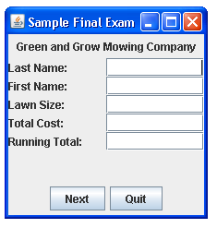
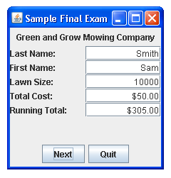

The Running Total for the five customers in the file below will total $305.00.

To assist you, the file on

G:\My Drive\Foundations of CS--students\greenGrow.txt

has the information written one item per line

5
Jeffers
Tom
5000
Smith
Sam
10000
Nevar
Tina
15000
Kim
Lisa
20000
Black
Kim
30000 sample1718.doc

