Transport Planner — an agentically enhanced job
Christian Prior-Mamulyan

Transport Planner — an agentically enhanced job
This is an onboarding example for a logistics company that uses software workers to support selected responsibilities in an existing job.
The job does not disappear. The planner still understands the customer’s needs, weighs competing priorities, and takes responsibility for the operational decision. Some of the research and preparation around that decision is carried out by specialist company services.

Meet the Transport Planner
A Transport Planner plans, tenders, and routes daily shipments. They are expected to:
- create routes that fit distance, time, traffic, and customer requirements;
- identify suitable cost and transport-mode options;
- monitor shipments and adjust plans when conditions change;
- communicate with carriers and drivers; and
- analyze carrier trends and service issues.
This is a broad job. The company does not treat every responsibility as a candidate for automation. It selects a few activities where software can gather evidence and prepare useful work for the planner.

The organization behind the role
The directory data can be presented as a conventional organization chart. This is the human structure in which the Transport Planner works; it is not an agent architecture diagram.
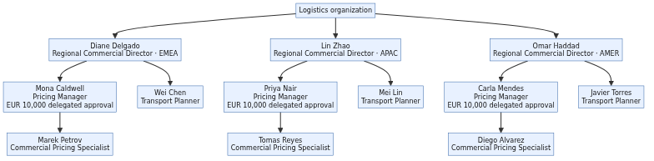

The planner’s immediate team
The Transport Planner works within a small team. The planner’s direct manager is the Regional Commercial Director. Pricing colleagues work alongside the planner when a route recommendation affects a quotation or a commercial decision.
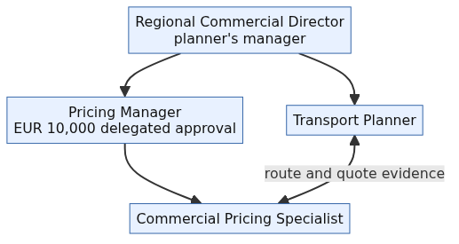
The roles have different responsibilities:
- Transport Planner evaluates executable routes and prepares operational recommendations.
- Commercial Pricing Specialist prepares quotations and compares commercial inputs.
- Pricing Manager governs pricing and approves commercial decisions within the delegated limit.
- Regional Commercial Director manages the planner and is the escalation point above that limit.
In the current showcase, the policy engine explicitly demonstrates a EUR 10,000 approval limit for the commercial management group. The wider organization may have more regions and departments, but this example stays with the planner’s immediate working context.

A business interruption occurs
Imagine that a quote has already been prepared for freight from Shanghai to Munich. The customer has been given a price and service expectation, and the transport plan is based on a particular route and carrier-rate picture.
Then the business world changes:
- the exchange rate moves significantly; or
- a route becomes unavailable because capacity, infrastructure, or an operating condition has changed.
The original quote may no longer be commercially or operationally reliable. This is not a workflow step waiting for someone to click a button. It is a business interruption that requires the company to reassess an existing commitment.
The Transport Planner now needs to understand the impact, find credible route alternatives, and check whether they still meet the customer’s service promise. The Pricing Manager may need to review a commercial deviation or revised quote. The team needs evidence, options, and a clear indication of where human approval is required before the company changes its commitment.

How the planner performs the work here
During onboarding, the new planner is shown the company’s way of performing each responsibility. The following is the next-level version of the job description:
The diagram below gives the whole flow before the individual subtasks are explained. Rounded shapes are events, rectangles are work, diamonds are decisions, and document-shaped nodes represent business information supplied by or written to a supporting system.

1. Understand the shipment need
Diagram path:
- Review the customer requirements, service commitments, and shipment constraints.
- Confirm the origin, destination, equipment, timing, and required mode.
- Identify anything that requires clarification from Commercial, the customer, or a carrier.
The planner owns this understanding. No system can infer an important customer commitment that has not been recorded or explained.

2. Find feasible transport options
Diagram path:
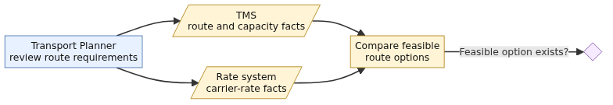
- Review the available routes and route constraints in the TMS.
- Check whether the relevant routes have capacity.
- Check the applicable carrier-rate information.
- Compare the resulting options and the evidence behind them.
The planner gathers and compares the evidence, then remains responsible for deciding whether the options make sense in the real operating context.

3. Prepare a route recommendation
Diagram path:
- Compare the options against cost and service requirements.
- Prepare a route recommendation with alternatives and assumptions.
- Review the recommendation, exceptions, and operational consequences.
- Accept the recommendation, revise the plan, or escalate the exception.
The recommendation is prepared by the planner; operational judgment remains with the planner and the authorized human decision-makers.

4. Consider cost and mode together
Diagram path:
- Compare carrier rates using the same commercial assumptions.
- Balance price with service quality, reliability, transit time, and customer commitments.
- Avoid selecting a nominally cheap option that cannot be executed.
- Explain the recommendation when handing it to Pricing or Commercial.

5. Monitor and adjust the shipment
Diagram path:
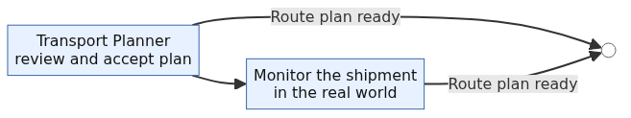
- Monitor the shipment in the real world.
- Respond to delays, capacity changes, and carrier issues.
- Communicate with drivers, carriers, customers, and colleagues.
- Re-plan when the situation changes.
These activities remain part of the Transport Planner’s job throughout the process. They are the responsibilities the company will later examine for carefully bounded support.

The agents are specialist colleagues
The company does not use one all-purpose transport agent. It uses separate specialists with clear responsibilities:
- The Lane Evaluation Agent builds and compares route alternatives. It does not approve deviations.
- The Route Decision Agent prepares a route recommendation. It does not approve the recommendation.
- The Commercial Normalization Agent belongs to the related pricing flow. It makes route costs commercially comparable and prepares quote work, but it does not replace the Pricing Manager’s approval authority.
When one specialist asks another specialist for help, the interaction is a business hand-off: “Please check capacity for this route.” The specialists do not need to know how the other one is implemented.

How the company’s systems are used
The agents do not own the company’s facts. The existing systems remain the authorities:
- the TMS remains authoritative for routes and transport capacity;
- the rate system remains authoritative for carrier rates;
- the quotation system remains authoritative for quote and approval state.
An agent asks a controlled company service for the information it needs. That service uses the existing system interface and returns the result to the agent. The existing system is not replaced, and the agent does not create a hidden copy of its data.
In the technical architecture, the hand-off between agents is called A2A. The controlled service used to access a company system is exposed through MCP, and the service uses the system’s existing API underneath. The business sequence is still simple:
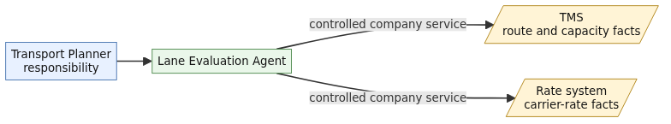
The agents and controlled services have separate machine identities. They do not inherit a planner’s human group membership. This distinction matters: a software worker should not gain human approval rights simply because it supports a human job.

The policy engine protects business actions
In a company, a policy is a clear business rule about who may do what, under which circumstances. It turns responsibilities and approval limits into rules that can be applied consistently—for example, “this role may approve a route deviation up to EUR 10,000,” or “this service may read carrier rates.”
Policies are especially important when software workers act on behalf of the business. In this showcase, policies explicitly govern the agents. They decide which agent may evaluate a lane, check capacity, read rates, or pass work to another approved agent. They also make clear which actions remain reserved for people.
When an agent requests a business action, the request passes through the control-panel Policy Enforcement Point before it can affect a company system. The control panel asks the policy engine whether that particular agent may perform that particular action in that situation. The showcase therefore demonstrates policies for both agent actions and human approval actions:
Policy | Business meaning
agent-may-evaluate-lane | An active agent may evaluate lane options.
agent-may-check-capacity | Only an active company service in the trusted internal environment may check route capacity.
agent-may-read-carrier-rate | Only an active company service in the trusted internal environment may read carrier rates.
agent-may-connect-same-trust-domain | A service may connect only to an active company service in the same trusted environment.
agent-may-delegate-per-catalog | An agent may hand work only to an approved specialist listed in its service catalog.
recommend-noncontracted-lane | A non-contracted route may be recommended, but an additional review is required.
recommend-high-cost-variance | A recommendation more than 8% above baseline requires cost review.
recommend-slower-transit | A recommendation adding more than three transit days requires operations review.
forbid-inactive | An inactive identity cannot perform a controlled action.
This gives the process a simple business boundary:
- agents may gather evidence and prepare recommendations within their assigned responsibilities;
- the policy engine can refuse an agent action even when the agent is technically able to request it; and
- a human approval remains a human approval, with the organization and delegated limit checked explicitly.

Example: an agent checks route capacity
The Lane Evaluation Agent requests a route-capacity check as part of its agentic route evaluation. The showcase includes a policy governing that request. The rule has this shape:
permit(
principal,
action == Agentic::Action::"capacity.check",
resource
) when {
principal.active == true &&
principal has trust_domain &&
principal.trust_domain == "internal"
};
In business terms, the company is saying:
Only an active company service operating inside the trusted logistics environment may check whether a route has capacity. Inactive services and callers from outside that environment are refused.

Example: an agent prepares a route deviation for human approval
The Route Decision Agent may prepare the route-deviation recommendation and its supporting evidence. It cannot approve the deviation. The showcase includes a separate policy for the approval action. Route recommendation and route approval are different responsibilities; the approval rule is reserved for the human commercial management group:
permit(
principal in Agentic::Group::"rfq-commercial-emea",
action == Agentic::Action::"route-deviation.approve",
resource
) when {
context.quote_value_eur_cents <= 1000000
};
In business terms, the company is saying:
A member of the EMEA commercial management group may approve a route deviation up to EUR 10,000. The route agents may prepare evidence and recommendations, but they cannot perform the approval action.
The agent catalog makes the same boundary explicit by listing route-deviation.approve as prohibited for both the Lane Evaluation Agent and the Route Decision Agent. The agent may help prepare a business decision; it may not turn that preparation into an unauthorized commitment.

Human-in-the-loop approvals
Some decisions are deliberately kept with people because they change the company’s commercial commitment. The agents can investigate the situation, compare alternatives, and prepare a recommendation, but they do not silently turn that recommendation into an approved quote or route deviation.
The approval boundary works as follows:
- An agent prepares the recommendation and the evidence behind it.
- The control panel checks whether the requested approval is allowed for the person, group, business action, and amount involved.
- An authorized human reviews the recommendation and accepts, changes, or rejects it.
- The approval and its outcome are recorded in the quotation system.
For this showcase, the Pricing Manager may approve a route deviation up to the delegated EUR 10,000 limit. A request above that limit is escalated to the Regional Commercial Director. The agent remains involved as a source of evidence and preparation, but the accountable human decision stays visible.

What remains with the Transport Planner
The Transport Planner still:
- decides how recommendations fit customer commitments and service priorities;
- validates whether a recommendation is realistic;
- monitors real-world execution;
- communicates with carriers and drivers;
- handles exceptions outside the current capabilities; and
- accepts, revises, or escalates a recommendation.
The agent is a bounded colleague for selected analytical and preparatory work. It is not a digital replacement for the complete job.

Appendix

Source projection
This example is based on the generated projection:
- workload-to-jobs.yaml
- job-titles.yaml
- job-workload-mappings.yaml
- agents/catalog.yaml
- policies

How the planner performs the work with agents
The human process in the main story remains the reference process. This appendix shows the agent-supported variation in more detail. Each diagram makes the policy boundary visible: an agent requests a business action, the control panel asks the policy engine whether that action is permitted, and only then can the agent use a controlled company service or hand work to another agent.
The agents support selected responsibilities. They do not own the shipment, change the systems of record, or receive the planner’s human approval rights. In the diagrams, blue nodes are the human-in-the-loop: the planner reviews the agent’s work, and authorized commercial managers approve changes to the company’s commitment.

1. Confirm the shipment need
The Transport Planner confirms the customer’s requirements and resolves anything unclear. The planner then asks the Lane Evaluation Agent to investigate feasible options. The policy agent-may-evaluate-lane limits that request to an active, approved agent.

2. Find feasible transport options
The Lane Evaluation Agent checks route alternatives and capacity through controlled company services. The policies agent-may-check-capacity and agent-may-read-carrier-rate limit which agent requests may reach the TMS and rate system. MCP provides the controlled access; the existing system APIs remain underneath.

3. Prepare a route recommendation
The Lane Evaluation Agent hands the route options to the Route Decision Agent. The policy agent-may-delegate-per-catalog limits that A2A hand-off to an approved specialist. The Route Decision Agent prepares a recommendation; it does not approve the recommendation.

4. Consider cost and mode together
The Commercial Normalization Agent makes route costs comparable across modes, currencies, and carrier-rate inputs. Its access is limited by the same controlled-service policies. If the result crosses a business threshold, the policies recommend-high-cost-variance or recommend-slower-transit require additional review rather than automatic acceptance.

5. Respond when the situation changes
When an exchange rate moves, a route becomes unavailable, or capacity changes, the process requests fresh analysis. The policy forbid-inactive ensures that an inactive agent cannot restart the work. The planner remains responsible for deciding how the updated recommendation affects the customer commitment.
The agents shorten the path from interruption to useful evidence. The policy engine limits what each agent can do, the systems of record remain authoritative, and the planner remains accountable for the business decision.

