This Year in RPA
#1

Agenda
Hello,

I would like to invite you to the premiere of a RPA YouTube content creator meeting series. The goal is to start with valuable content right from the beginning, and put questions at the center. To be time efficient the duration will be 30 min short, but with a separate „After Hours“ meeting for those who like to join.

👉Please prepare a short introduction in 3-5 sentences for an introduction round.
👉I highly suggest to participate with video camera switched on.
👉When joining the Zoom meeting please chose a name where we can recognize each other.

Here is the planned agenda:

  - Introduction
    - Welcome and introductions & expectations
    - Explanation of the purpose and goals of the meeting
    - Suggested meeting structure for the first 1-3 meetings
    - handling of questions
  - Focus on: Content Trends 2022-Q4 and 2023 to date
    - 3-5min impulse talk
    - 10min initial discussion
  - Focus on: What YouTube does to the audio track of videos
    - 3-5min impulse talk
    - 10min initial discussion
  - Closing Remarks
    - Recap of key takeaways
    - Next steps: Where to take the initial discussion(s)
    - Thank you and closing of the structured part of the meeting.
- After Hours
    - unstructured part of the meeting

Here is a Google Form with ideas for future focus topics: https://forms.gle/v69emDchoFYeaeKX8
- Please vote for 3-5 topics
- Please add your own ideas.

Thomas Janssen will be the Co-Host, which means (amongst others) that he will also have Zoom permissions.
The Zoom meeting will have a waiting room to enter through.

The meeting will not be recorded. Materials of the impulse talks will be shared.

BR
Christian

ID | Duration | Start CET | End CET | Text | Audio | Video | Sketch
preshow | 10min | 11:50 | 12:00
Get-together | 10min | 12:00 | 12:10
Impulse A | 5min | 12:10 | 12:15
Discussion A | 10min | 12:15 | 12:25
Impulse B | 5min | 12:25 | 12:30
Discussion B | 10min | 12:30 | 12:40
Preview | 5min | 12:40 | 12:45
After Show | 45min | 12:45 | 13:30

Deliverables
Metric | Value
Duration | 45min
Platform | Zoom
Date | 2023-03-25
Time | 12:00 CET
Host; Co-Host | Christian Prior-Mamulyan; Thomas Janssen
Focus Topics | - Content Trends 2022-Q4 and 2023 so far  - YouTube and Audio

.

.

Page# | Story Slug | Segment Type | Talent | Camera | Effect | Graphic | Playback | Source | File | Est. Duration | Actual Duration | Total
 | Tease 1
 | Tease 2
 | Tease 3
 | Show Open
 |  | Intro
 |  | Open
 |  | e.g. Live
 |  | e.g. Package
 |  | e.g. VO
 |  | Tag
.

Fokus on…

…Content Trends 2022-Q4 (and 2023 so far)

Script v1
My personal hobby project „thelastweek.in/rpa“ evolved in 2022 to include not just automatic collection of YouTube (meta)data but also a backend with a tagging feature and various output formats in the frontend.
The tags are used to make a distinction between
- RPA and
- Low-Code
I do not actively publish the Low-Code variant -- yet.
But since September 2022 I actively put 2-6 tags on each video. This happens during the week, the latest on Monday for all videos of the previous week.
The tagging feature is also the basis of the distinction between RPA and Low-Code: If I do not tag a video at all then i would not appear in the weekly output! So it is safe to say that each video goes past a human editor before it appears in any of the (currently) three output channels. The decisions which tags to use is based on title, the description, sometimes the content and maybe watching parts of the video. The hardest decisions are between „Power Automate“ and „Power Automate Desktop“ where unfortunately the shorter version gets incorrectly used for the former Softomotive product.
With the tagging feature being based on a database it is possible to generate all kinds of statistics
- hours per year per vendor
- number of videos per tag per month
For the RPA YouTube creators I here present for the first time a report on…
…
In the future I would like to enhance the tagging by a target persona. While the RPA Developer persona might get the most attention content aimed at the Business Analyst are almost nonexistant, and there is little content for a Lead Developer, Solution Architect or Head of Center of Excellence.
I propose to align within the group of RPA YouTube creators to do some market research which content to target. I will gladly adopt my tags to make it measurable.
And I also propose to align within the group of RPA TouTube creators on a methodology to request feedback from viewers. This could be done under the ‚brand‘ of thelastweek.in and the results shared with all members.

Storyboard

ID | Duration | Text | Audio | Video | Sketch
 |  |  | My personal hobby project „thelastweek.in/rpa“ | 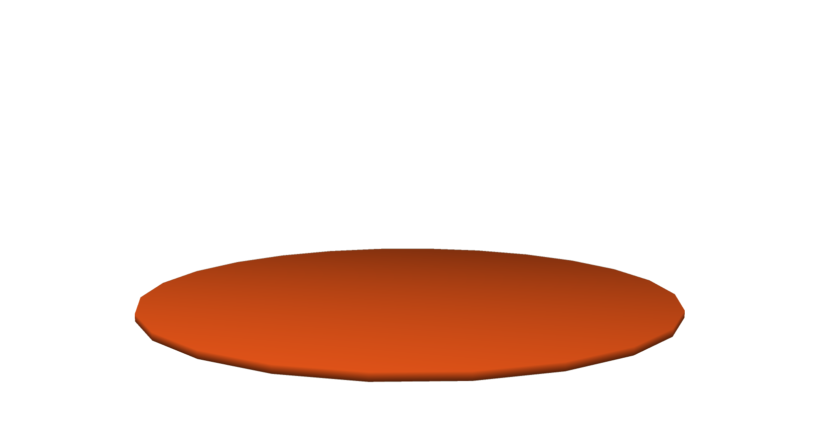
 |  | Metadata appears | evolved in 2022 to include not just automatic collection of YouTube (meta)data | 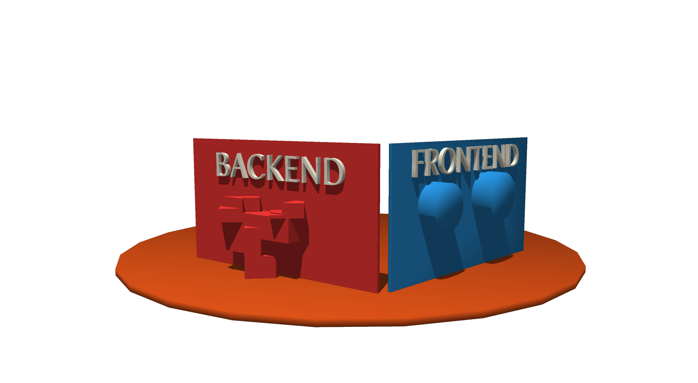
 |  | Tag names appear | but also a backend with a tagging feature
 |  |  | and various output formats in the frontend.
 |  | RPA  Low-Code | The tags are used to make a distinction between  - RPA and  - Low-Code | 
 |  | Tag LowCode disappears | I do not actively publish the Low-Code variant -- yet. | 
 |  |  | If I do not tag a video at all then i would not appear in the weekly output! | 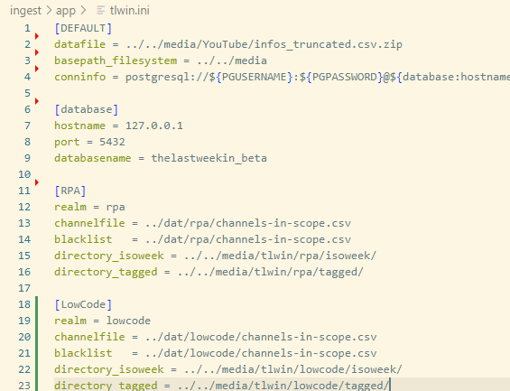
 |  |  | Since September 2022 I actively put 2-6 tags on each video. This happens during the week, the latest on Monday for all videos of the previous week. | 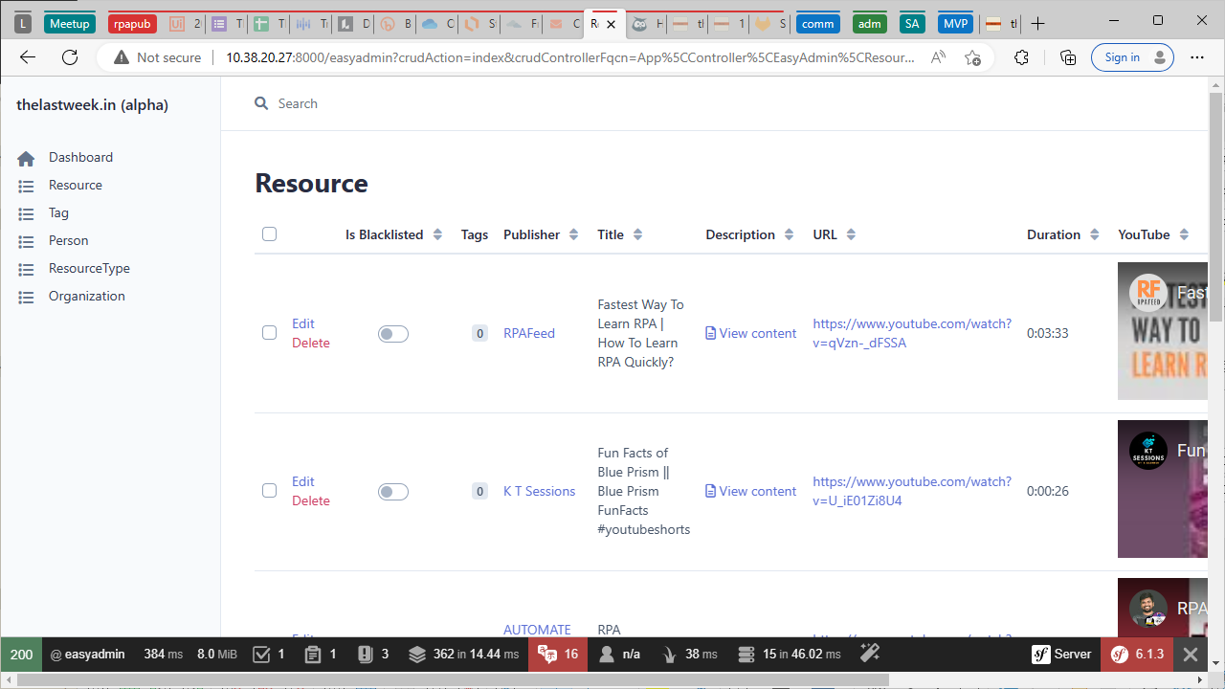
 |  |  | So it is safe to say that each video goes past a human editor before it appears in any of the (currently) three output channels:
 |  |  | The decisions which tags to use is based on title, the description, sometimes the content and maybe watching parts of the video.
 |  | select SUM(duration)  from thelastweek_resources('rpa')  WHERE tags ILIKE '%rpa%' | Now, with the tagging feature being based on a database | 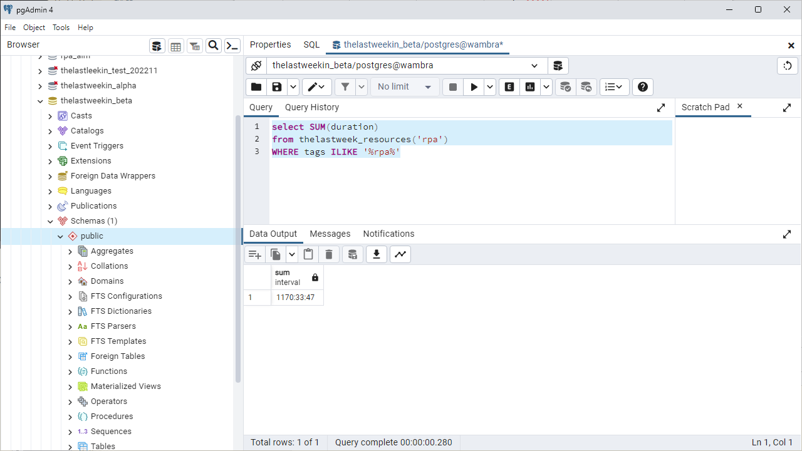
 |  |  | it is possible to generate all kinds of statistics | 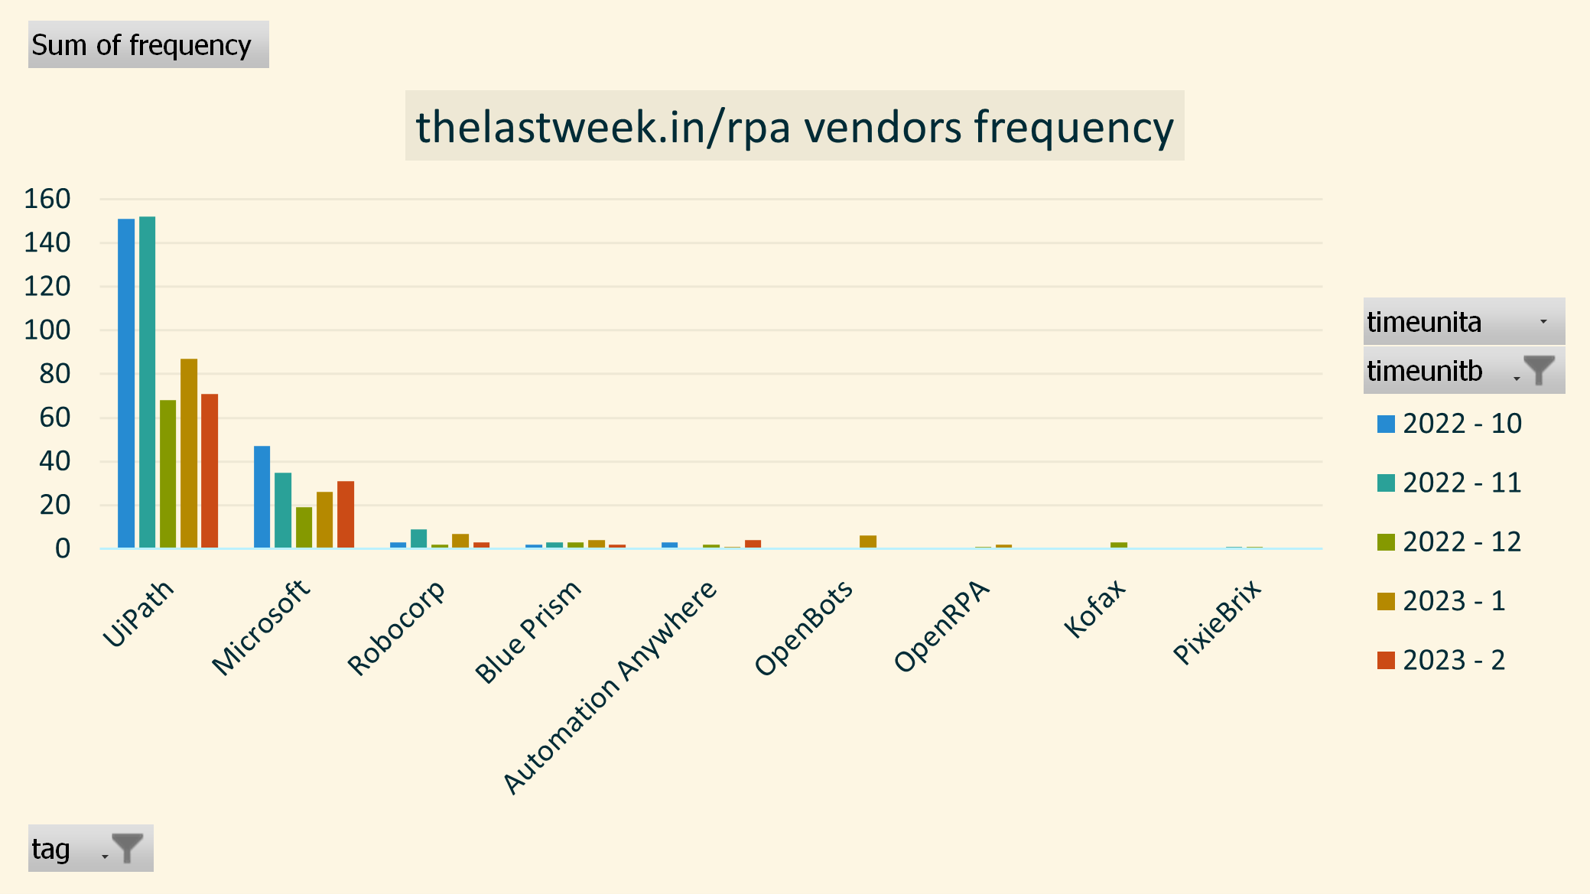
 |  |  | currently based on frequency and duration, like | 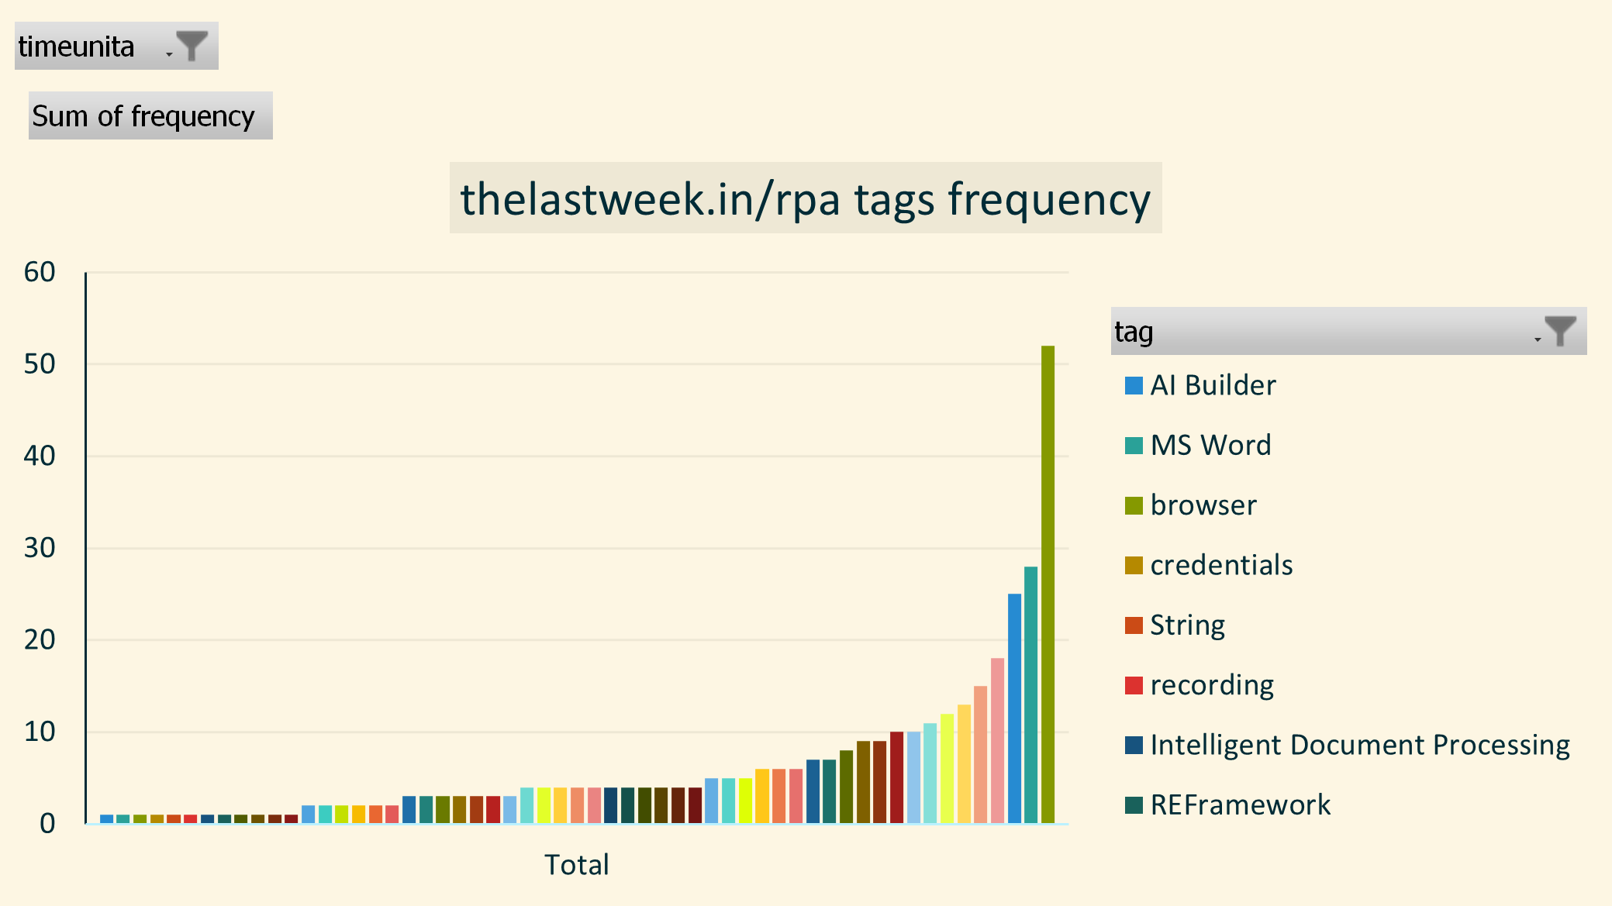
 |  |  | - hours per month per vendor | 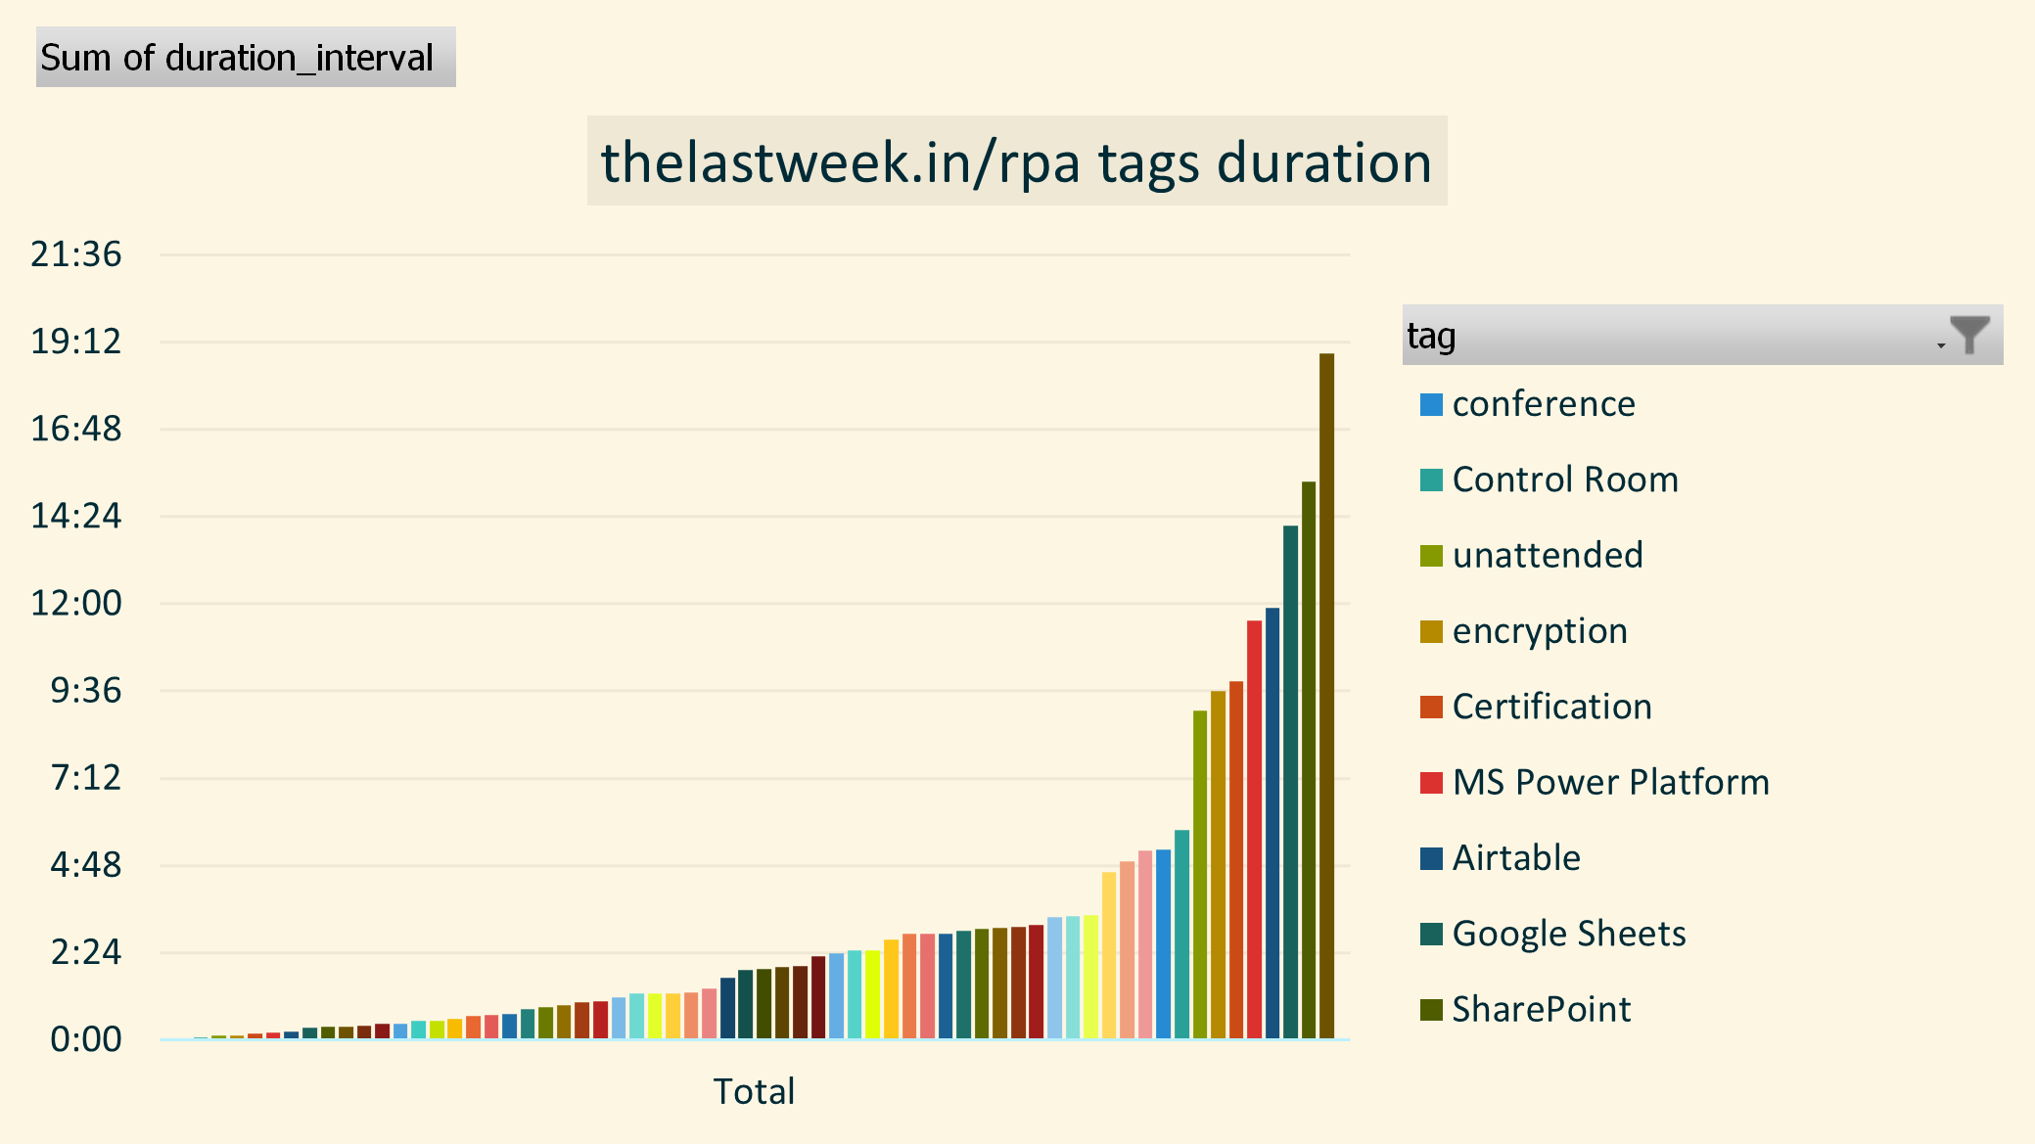
 |  |  | - duration of videos per tag per week
 |  | bit.ly URL | And I can hereby reveal the exclusive access for YouTube RPA creators to the raw data: | 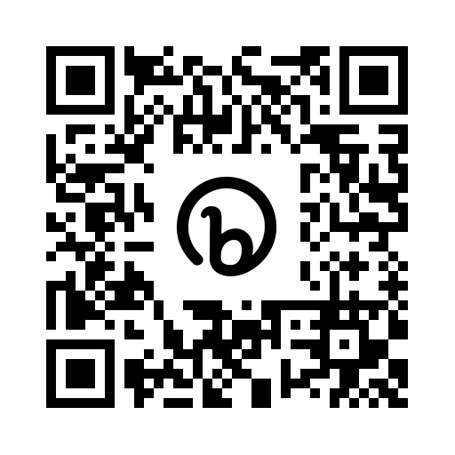
 |  |  | The xlsx file contains the raw data for the current and previous quarter, and some initial Pivot tables and graphs. | 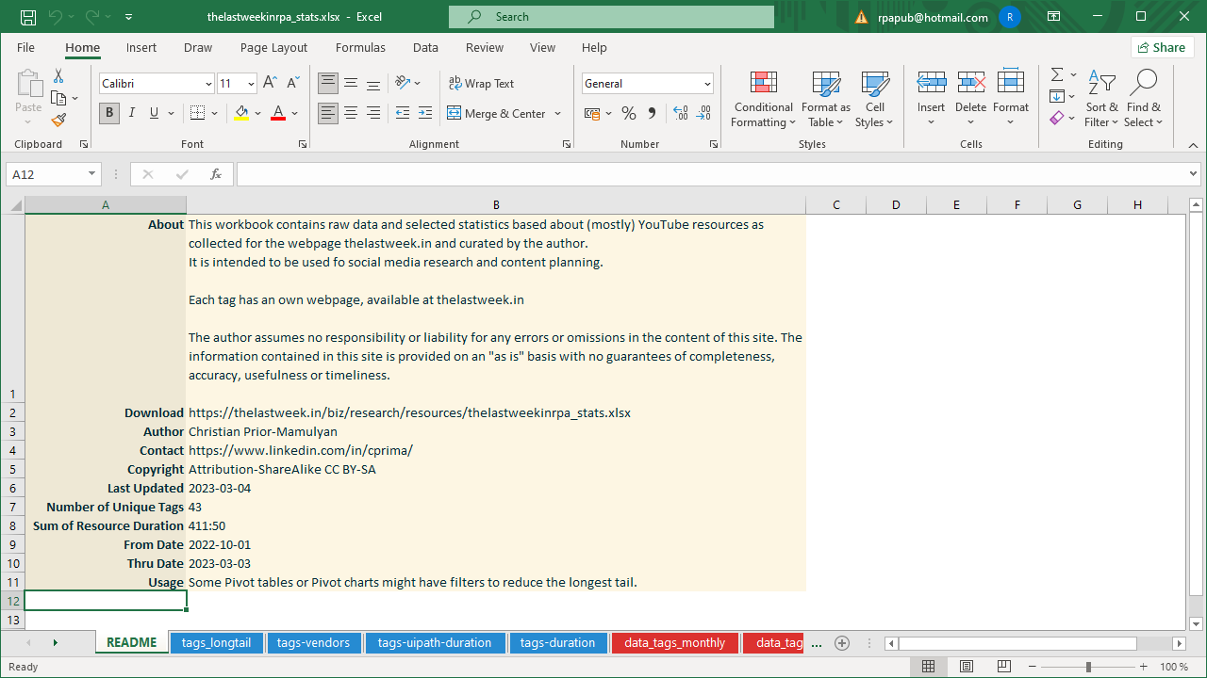
 |  | BUT | BUT
 |  |  | In the future I would like to enhance the tagging by a target persona. | 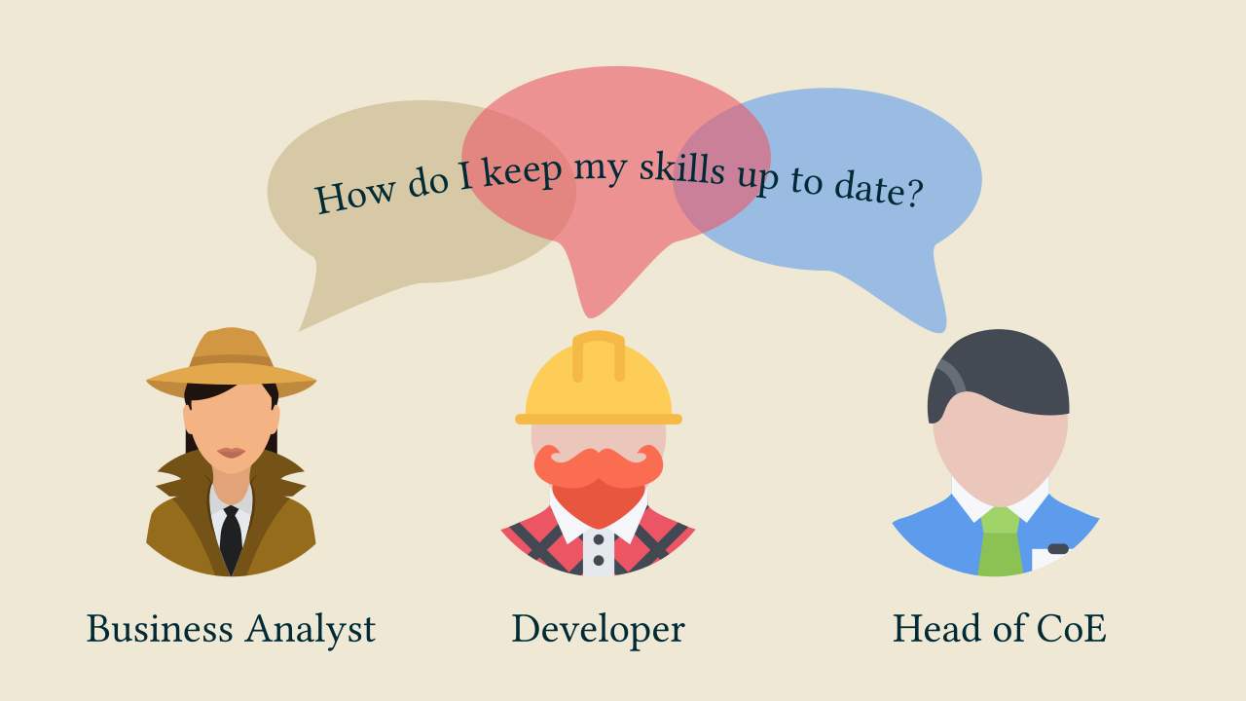
 |  |  | While the RPA Developer persona might get the most attention
 |  |  | content aimed at the Business Analyst are almost nonexistant,
 |  |  | and there is little content for a Lead Developer, Solution Architect or Head of Center of Excellence.
 |  | LET’S ALIGN | In addition to tagging target personas I would gladly use tags that are aligned within the group of RPA YouTube creators. | 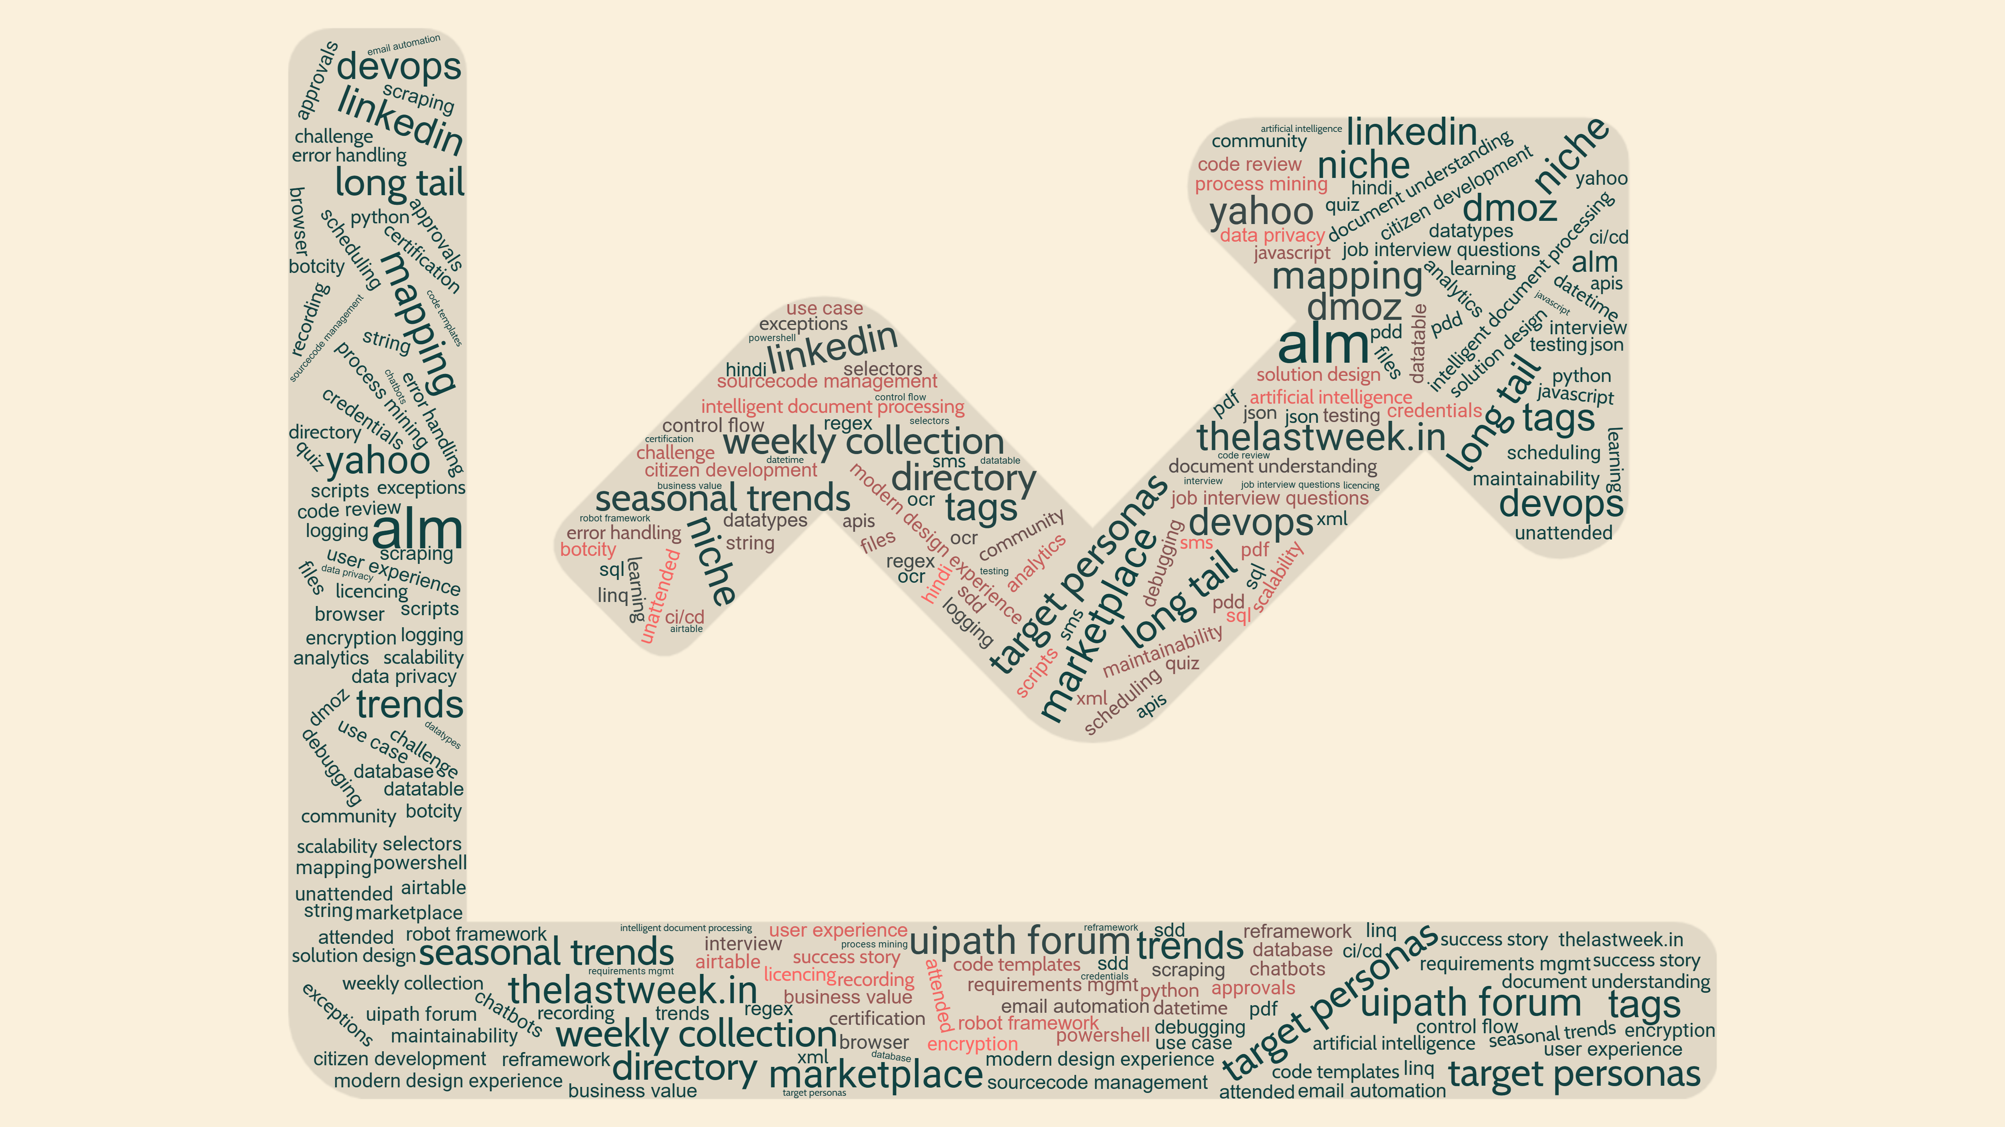
 |  | Market Research | I propose to do some market research which content to target. | 
 |  | measurable | I will gladly adopt my tags to make it measurable. | 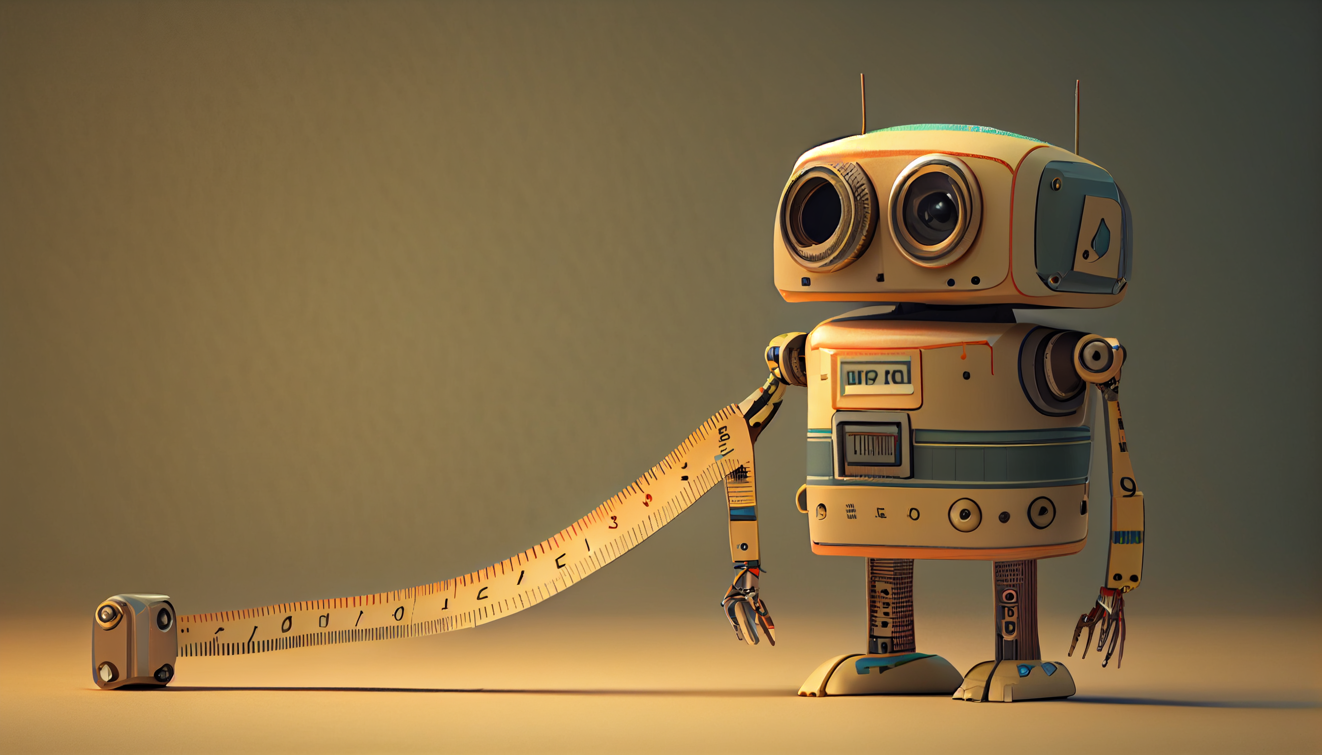
 |  | Questions? | And with that I am happy to open the call for questions! | 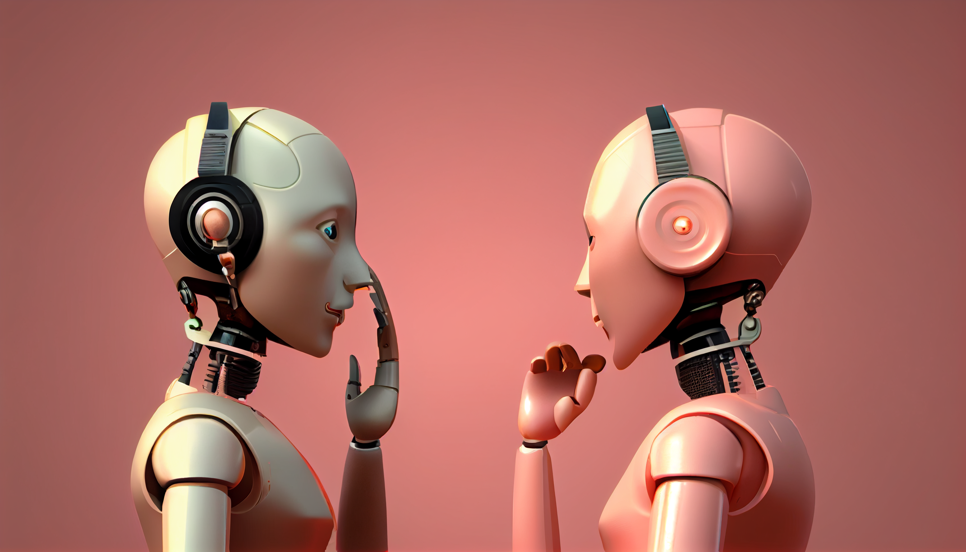

Researching your audience is crucial for any YouTube channel, especially one focused on software technology. Here are some steps to help you conduct audience research for your YouTube channel:

Determine your target audience: Before you can research your audience, you need to have a clear understanding of who your target audience is. Who do you want to reach with your content? Is it software developers, tech enthusiasts, or beginners interested in learning more about software technology?

Conduct keyword research: Use tools like Google AdWords Keyword Planner or Ahrefs to identify the most commonly searched keywords related to your channel's focus. This will help you understand what people are searching for and what kind of content they might be interested in.

Analyze your competitors: Look at other YouTube channels that cover similar topics to yours and analyze their content. Look at their engagement rates, the topics they cover, and the language they use in their videos.

Create a survey: Create a survey using tools like SurveyMonkey or Google Forms and share it with your audience. Ask questions about their interests, preferences, and pain points related to software technology.

Monitor comments and feedback: Pay attention to the comments on your videos and any feedback you receive on social media. This can give you valuable insights into what your audience likes and dislikes about your content.

Use analytics tools: Use YouTube's built-in analytics tools to track your viewers' demographic information, watch time, and engagement rates. This can help you identify patterns and trends in your viewership.

By using these methods, you can gain a better understanding of your audience's interests, preferences, and pain points. This will allow you to create content that is more engaging, relevant, and valuable to your viewers.

------------
Content creation for a YouTube channel focused on software technology can be a fun and engaging process. Here are some steps to consider when creating content for such a channel:

Choose your niche: Software technology is a broad topic, so it's important to narrow down your niche. Consider focusing on a specific area of software technology, such as programming languages, software development methodologies, or software applications.

Research your audience: Knowing your audience is key to creating content that resonates with them. Research the demographic of people who are interested in software technology and their specific interests and pain points.

Plan your content: Create a content calendar that outlines your video ideas, the topics you will cover, and the frequency of your uploads. This will help you stay organized and consistent with your content.

Create engaging content: Your videos should be informative, educational, and entertaining. Use visuals, animations, and other multimedia elements to engage your viewers and make your content visually appealing.

Optimize your videos for search: Use keywords in your video titles, descriptions, and tags to help your videos show up in search results. This will make it easier for people to find your videos and increase your views and subscribers.

Promote your channel: Use social media, email marketing, and other digital marketing tactics to promote your channel and your videos. This will help you reach a wider audience and increase your subscribers and engagement.

Engage with your audience: Respond to comments, answer questions, and engage with your viewers to build a community around your channel. This will help you build a loyal audience and establish yourself as an authority in your niche.

Overall, creating content for a YouTube channel focused on software technology requires planning, research, and creativity. By following these steps, you can create engaging videos that inform, educate, and entertain your audience.
---------------

Audio and YouTube

Big picture:
too loud: YouTube does its thing
too low: competitive disadvantage

ID | Duration | Text | Audio | Video | Sketch
Opening: Viewers are tired, competition is strong
 |  |  | The pandemic brought many changes, one of them is described as „Zoom fatigue“, a tiredness from overuse of videotelephony. | 
 |  | harder to understand  harder to engage | And bad audio quality can contribute to zoom fatigue in several ways: When the audio quality is poor,  - it can be harder to understand what is being said, which requires more cognitive effort to process the information.  - it can be harder to engage with the content, which can lead to disengagement and reduced viewer engagement
 |  |  | The competition became stronger:  During the pandemic many content creators invested in improved setup and workflows, raising the quality level in regards to video, audio, lighting and presentation. | 
State your purpose
 |  |  | This is about viewer retention by improving the audio quality explicitly for the YouTube platform.
 |  | LUFS  True Peak | We will get to know two benchmarks:  −14 dB LUFS  −1dB True Peak
 |  |  | YouTube uses loudness normalization and true peak limiting to standardize the audio levels across all the videos uploaded to their platform.
Use stories and examples
 |  |  | Imagine you are on a train and listening with headphones to a playlist of YouTube videos. Chances are high that at the beginning of each new video you have to reach for your smartphone an adjust the volume: | 
 |  |  | The video might not be loud enough to understand it in the noisy train!
 |  |  | Thankfully YouTube does protect you against the opposite: Too loud videos are automatically reduced in their loudness.
 |  |  | In this context „loudness“ means the perceived level of sound as perceived by hte human ear. This is in contract to the purely electronic measurement of volume as measured in Decibel scales.
 |  |  | Ever since approx. 2010 the so-called loudness wars in TV advertisement and music production were were regulated based on a new measurement called „loudness“.
 |  | Relative to −14 dB LUFS integrated | And it is a loudness algorithm that YouTube implements to lower the audio level to its standard −14 dB LUFS integrated. | 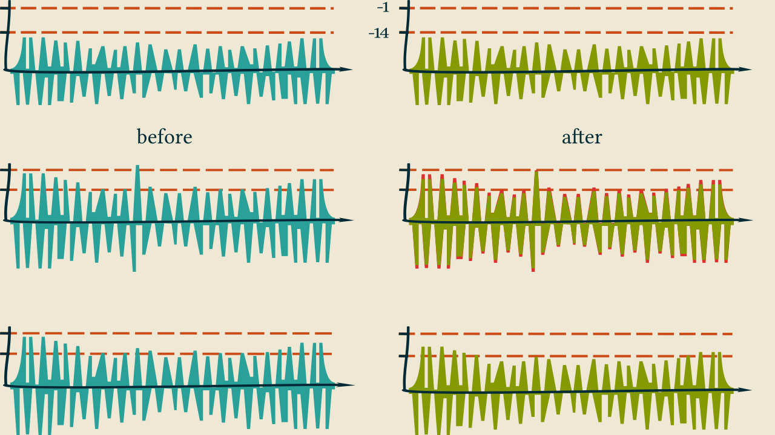
 |  |  | Now this is important: YouTube will do these adjustments over the whole duration of the video, and not fix intermediate parts that might be the culprit.
 |  |  | On the other hand, YouTube does not raise the level of your audio!
Offer solutions
 |  | stats for nerds | The adjustments by YouTube can be seen in each video by right clicking the player and clicking „stats for nerds“.
 |  |  | These stats are not for nerds only but absolutely essential for each creator. They should be the first thing to look at after a video uploaded, and be taken into consideration from the very beginning.
 |  |  |  | 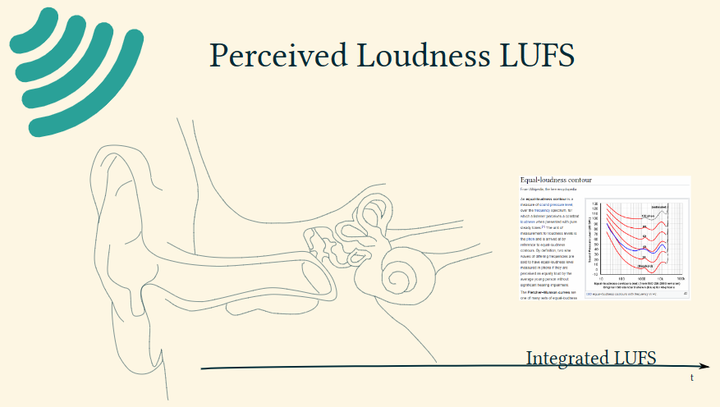
 |  |  | Before diving deeper into loudness the 2nd important measurement needs introduction, one that is not seen in the stats for nerds:
 |  | True Peak | True Peak. Often very short in duration, this are the highest peaks in a loudness diagram, and where at around 0dB potentially „clipping“ occurs. | 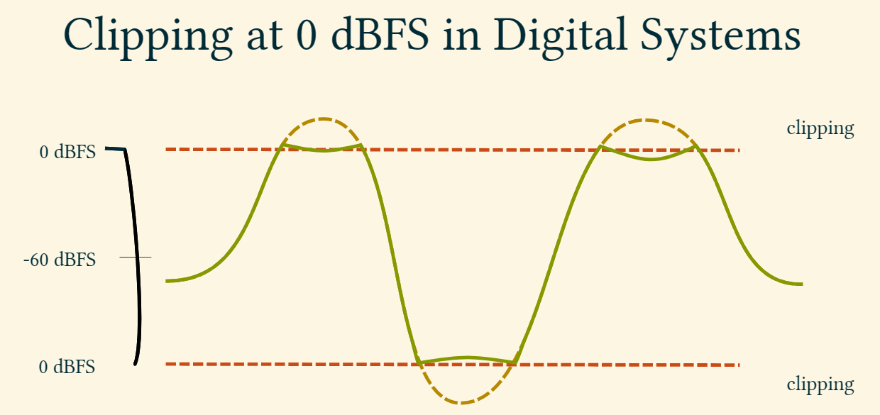
 |  |  | From the recording with a microphone until YouTube there are many stages where the levels may be adjusted, and the way digital audio works is that short peaks at around 0dB will get distorted.
 |  |  | To prevent such distortion in the digital domain from happening YouTube also checks for True Peak.
 |  | −1dB True Peak | If the value is above −1dB YouTube will lower the video’s level. Again, over the whole duration of the video.
 |  |  | But again, no upward correction will be applied if the value is below.
 |  |  |  | 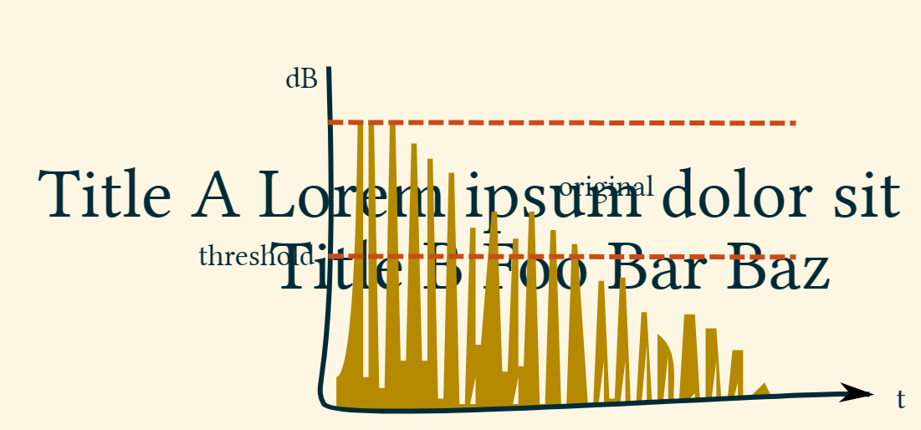
 |  |  | With YouTube „doing it’s thing“ to the content you created the way to go is obviously to tightly watch out for these factors during production.
 |  |  | This is especially important because content not loud enough will not be fixed by YouTube. And end up in a playlist in between properly produced videos.
 |  |  | Here is a practical approach to what will happen to an uploaded video, before it is ready for viewers:
 |  |  | A widely used tool to evaluate these aspects is Youlean Loudness Meter, available as a standalone GUI for free as in beer.
 |  |  | YLM, as it is often appreviated, will give you the measurements for a particular file that YouTube is acting upon, and momentary readings in a graph that make problematic parts identifiable.
 |  |  | Hands-On
 |  |  | So what is the best first step to use YLM, to open the recording as soon as the file is available?
 |  |  | The usefulness of YLM starts even earlier: Before recording, have YLM evaluating your microphone settings and move your levels to be close to the YouTube standard.
 |  |  | By the way, this can be done not just by adjusting sliders but also by getting closer to the microphone.

----------

Start with a strong opening statement
State your purpose
Use stories and examples
Offer solutions
End with a strong call to action

-----------------------

YouTube uses loudness normalization and true peak limiting to standardize the audio levels across all the videos uploaded to their platform.

Loudness normalization is a process that ensures that all audio on YouTube is played back at a consistent volume level. It analyzes the audio and adjusts it so that the loudness level is consistent, regardless of the video's original volume. This means that if you watch several videos in a row, you won't have to keep adjusting the volume.

True peak limiting, on the other hand, is a process that ensures that the audio does not exceed a certain peak level. This is important because audio that exceeds the maximum level can cause distortion and damage to speakers and headphones. By limiting the audio to a specific peak level, YouTube ensures that the audio quality is consistent and doesn't cause any damage to the listener's equipment.

Both of these processes help to ensure that audio on YouTube is consistent and enjoyable to listen to. They also help to protect the listener's equipment and prevent any damage that might be caused by audio that is too loud or exceeds the maximum peak level. Overall, YouTube's use of loudness normalization and true peak limiting helps to improve the audio quality and listening experience for users on their platform.

