Hi there!

Many thanks for answering my initial questionnaire regarding an
> infrequent peer group meetings with other RPA content creators

Today I would like to share the results with you:

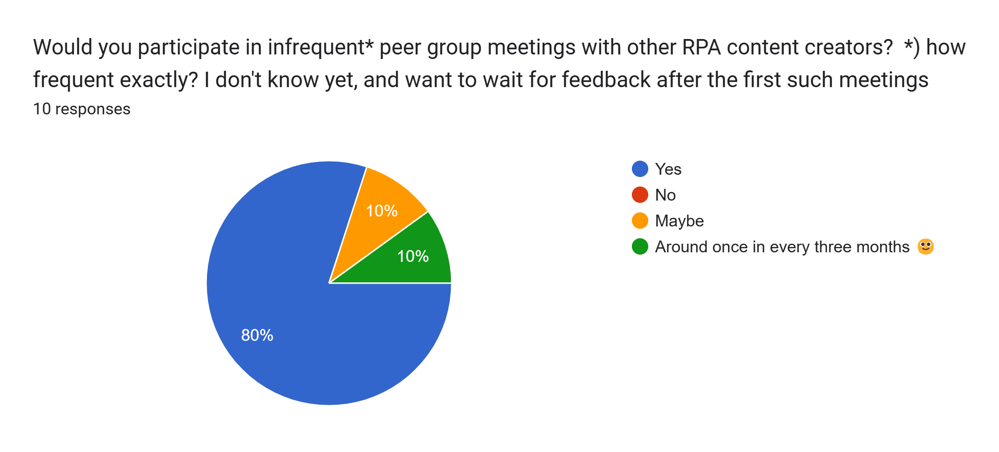

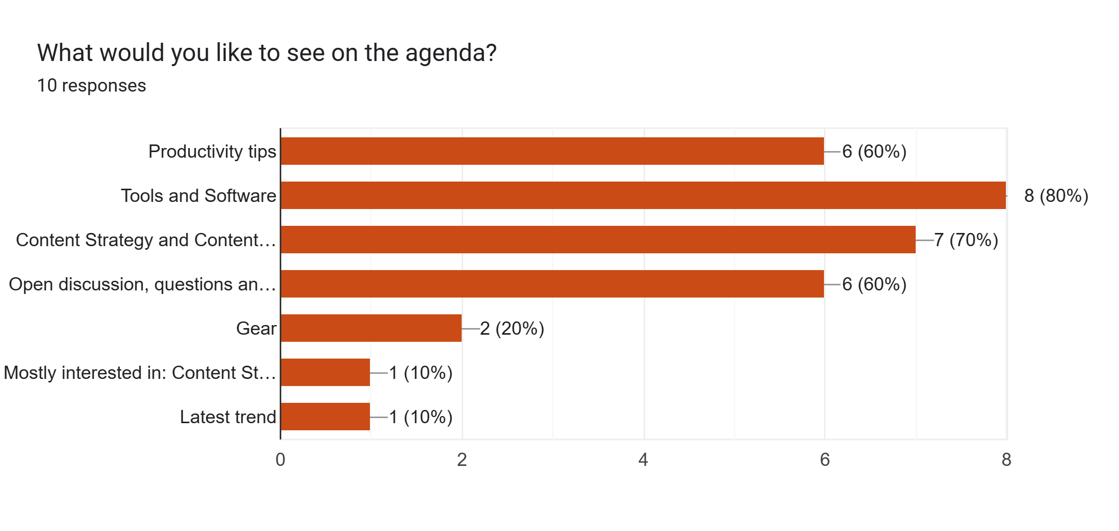

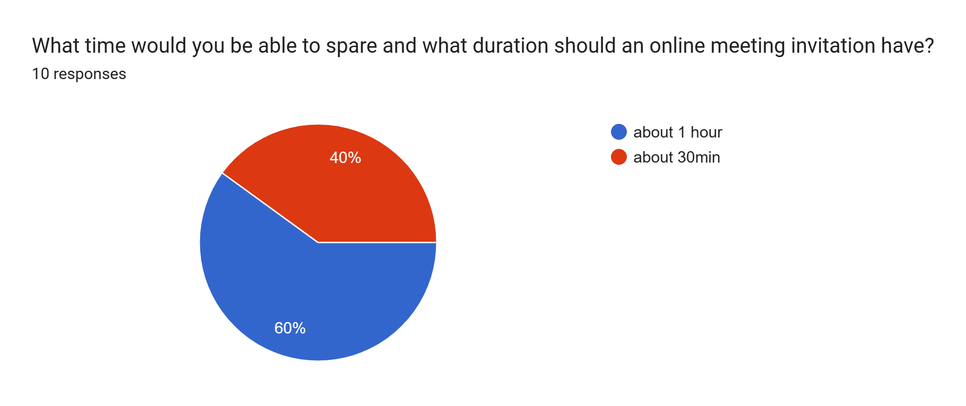

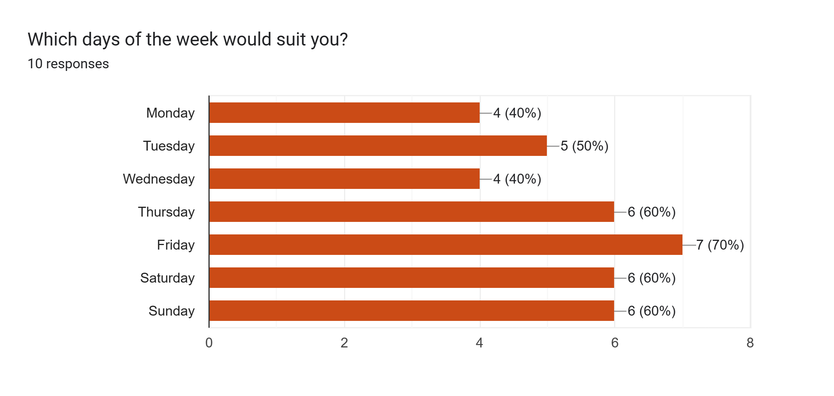

I plan to invite for a Zoom meeting (will be sent out in the next days)
- Saturday, 25th of March
- around 13:00 UTC
- which would be around 17:30 IST
(final time to be determined, plus/minus an hour)

The initial agenda will cater to both:
- ~30min of agenda
- another 30min "after hours" without a set agenda

The idea is to
- have a quick introduction round (I plan to keep the first meetings rather small with 5-10 participants)
- 2 blocks where I give 5min of impulse talks, followed by 10min for questions

I aligned with Thomas Janssen on some topic ideas.
I have easily 25 potential topics related to
- Productivity tips
- Tools and Software
- Content Strategy and Content Creation

This hopefully gives questions and knowledge exchange a wide room, while keeping somewhat of a focus.
I plan to (pre-)record or otherwise publish the 5min impulse part, if participants can't make it.
Other than that I plan to not record or otherwise make accessible the meeting, as I believe this will improve the knowledge exchange.

Please keep in mind that in all things video-audio-production I am self-taught over the last years,
therefore without professional experience; but also without any commercial interest.

Looking forward to the meeting series over the course of the next months!

BR
Christian

