 | MINISTRY OF EDUCATION AND TRAINING

FPT UNIVERSITY
Capstone Project Document
Gas selling support system
Embedded System Design Document
GSS Team
Group Member | Nguyễn Xuân Quyết – 00818  Nguyễn Đức Vượng - 01067  Đinh Nho Hào - 00985  Nguyễn Huy Tuấn - 00986  Lê Thế Đại Dương - 01098
Supervisor | Mr. Phan Duy Hùng
Capstone Project code | GSS_v1.0

- Hanoi, May 16th 2012 -

The Table of Contents
1. Introduction 3
2. Hardware Description 4
2.1 Caller ID Board 4
2.2 Caller ID board’s schematic: 5
2.3 Caller ID board’s PCB (Printed circuit board) 6
3. Software Description 7
3.1. Data flow Diagram 7
3.2. State Diagram 8
3.3. Description of Functions 9
3.3.1. Hardware uart module 9
3.3.2 Software uart module 9
3.3.3 Processing module 10

Introduction
In this System Design Document, we will be presenting more about Embedded System (ES) of our Gas selling support system (GSS). The document includes design of Caller ID Board which helps decode phone number from phone signal and send to PC. The document also provides an explanation of different functions, procedures and variables.

Hardware Description

Caller ID Board

Caller ID Board is the main part of our project, this board will get data stream from telephone line and decode to phone number by SM8223A and PIC16F876A. The board runs at 9V voltage. After decode to phone number, the board will push it to computer by serial communication port (RS232 protocol).

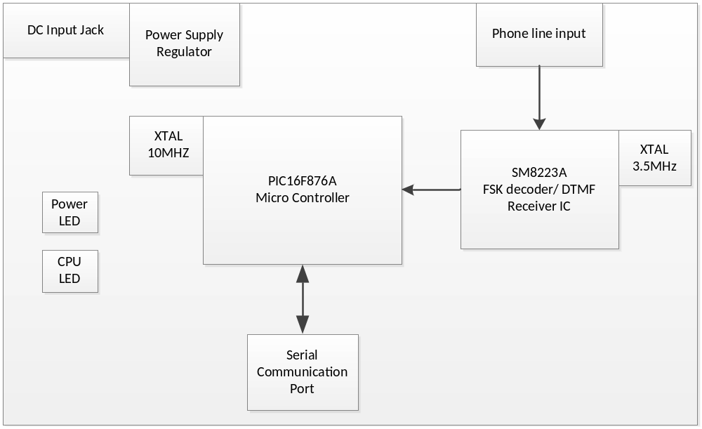

Figure 1: Caller ID board

Caller ID board’s schematic:
This is schematic of Caller ID board, it include components we are using and details about the wire between the components. The viewer will have an overview about our Caller ID board, it has been split to many parts, we can understand role of each part in the board.

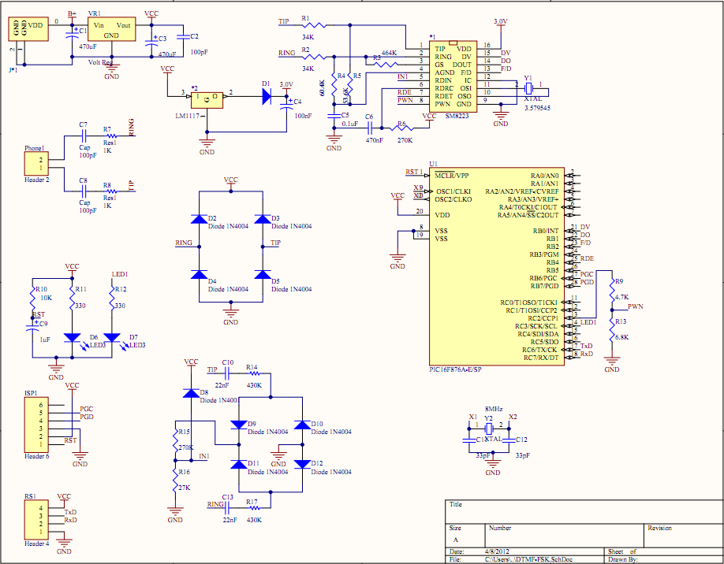

Figure 2: Caller ID board’s schematic

Caller ID board’s PCB (Printed circuit board)

The PCB includes electric components which we had been drawn in schematic and the wires used for connect components. In PCB, we can know exactly the size of the board for each component through pin map. After arranging position of components and wires, we can make real device with the size has been calculate before.

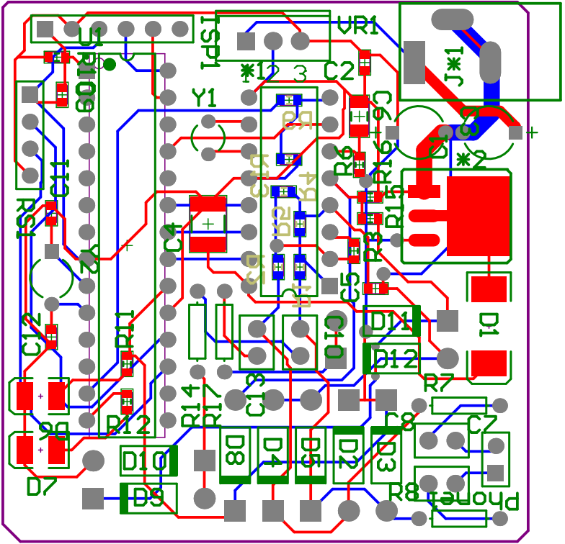

Figure 3: Caller ID board’s PCB

Software Description

Data flow Diagram

To begin, the power supply is turned on. After initializing components, the board will automatic enter standby mode and waiting for ring signal in telephone line. When there is no signal detected, the board will remain standby mode. SM8223A IC has an trigger pin, it will change the status from low to high each time ring signal detected, this pin can wake up PIC16F876A µC. The board goes to normal mode.

The board is kept in normal mode and wait for data from telephone line. SM8223A will demodulate incoming data and transfer to PIC16F876A µC (both FSK and DTMF encoded signal). In PIC16F876A, it will be decoded to phone number and transfer to PC via RS232 protocol. Finally, the board returns to standby mode to save power and wait for other ring signal.

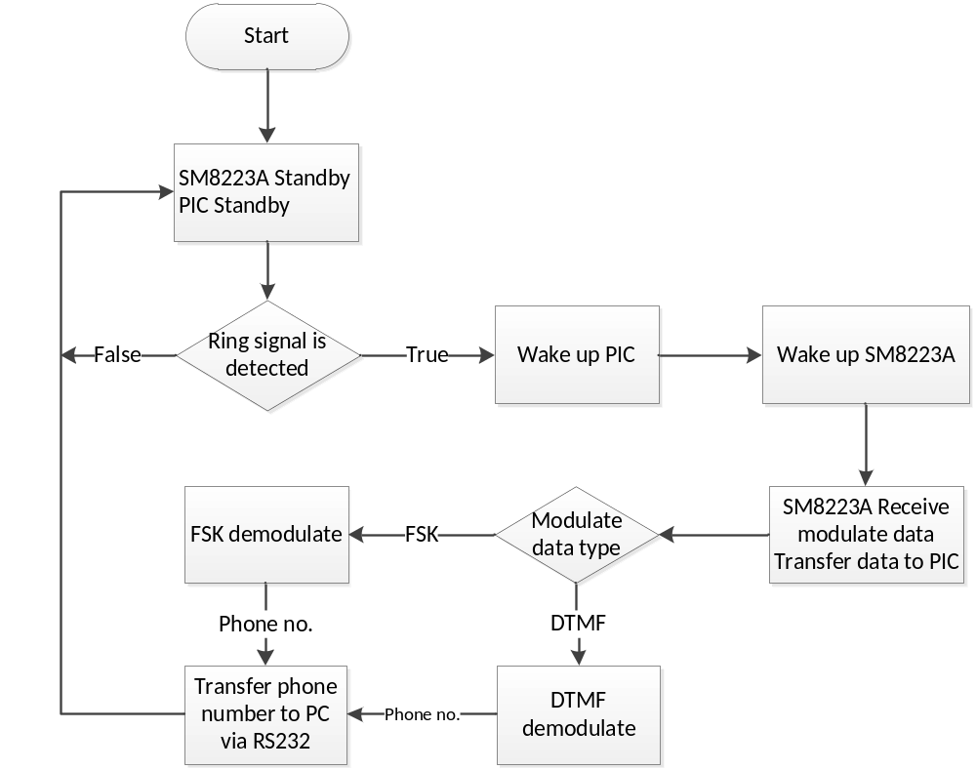

Figure 4: Dataflow diagram

State Diagram

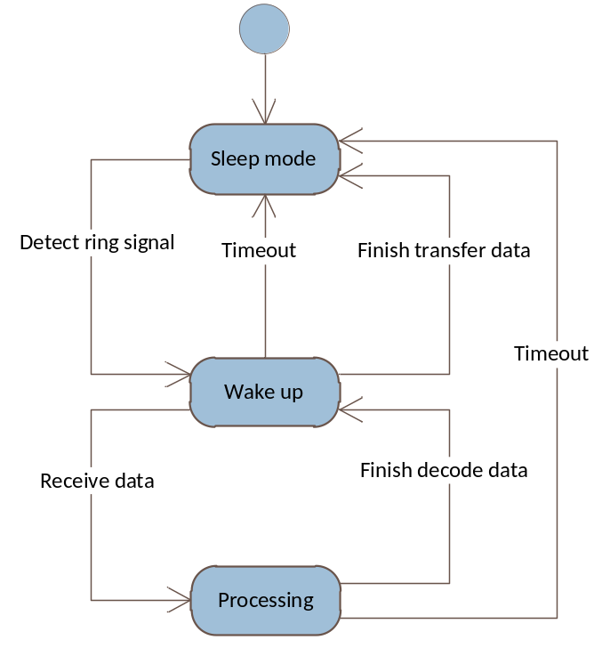

Figure 5: State diagram

Description of Functions

Hardware uart module

No. | Function Name | Parameter | Output | Description
1 | huart_init | N/A | N/A | This function makes initialize value for registers of uart protocol.
2 | huart_getc | N/A | char | This function will get a character from data stream input and return this char to program.
3 | huart_gets | char* str_in | N/A | This function will get a serial of characters (string) from data stream input and set to str_in variable.
4 | huart_putc | char char_out | N/A | This function will send char_out character to PC through RS232 cable.
5 | huart_puts | const char* str_out | N/A | This function will push str_out string to PC through RS232 cable.
6 | huart_data_ready | N/A | N/A | This function get status of data stream has data or not.

Software uart module

No. | Prototype | Input | Output | Description
7 | suart_init | N/A | N/A | This function will initialize all variables; enable interrupt before chips go to power down mode.
8 | suart_putc | char char_out | N/A | This function will send char_out character to data stream.
9 | suart_getc | N/A | char | This function will get a character from data stream input and return this char to program.

Processing module
No. | Prototype | Input | Output | Description
10 | init_all | N/A | N/A | This function will initialize all variables; enable interrupt before chips go to power down mode.
11 | process | N/A | N/A | This function is used for receiving raw data from SM8223A and decode to customer’s phone number.
12 | interrupt isr | N/A | N/A | This function will manage actions each time PIC has an interrupt.
13 | turn_led | bit led_status | N/A | Turn on led when start receive data and turn off when decoded data is sent.

