**Overview:**

The nonprofit foundation Alphabet Soup wants a tool to help it select applicants for funding with the best chance of success in their ventures. With knowledge of machine learning and neural networks, features in the provided dataset were used to create a binary classifier to predict applicant success if funded by Alphabet Soup.

**Review:**

Initially filtered out any extraneous information, thus EIN and NAME were removed; NAME was re-inserted for the second test. The model’s target variable is “IS_SUCCESSFUL” and verified by values; 1 is yes and 0 is no. Also analyzed was “APPLICATION” data; “CLASSIFICATION” used for binning.

**Compiling, Training, and Evaluation:**

After applying Neural Networks, three total layers exist for each model. Hidden nodes were dictated by the respective features.

A three-layer training model created 477 parameters. The initial attempt (73% accuracy) fell slightly short of the desired 75%.

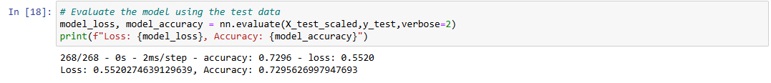

**Optimization:**

By including the “Name” column in the dataset, nearly 79% accuracy was achieved, surpassing the desired 75% threshold with 3,298 parameters.

