Battlefleet Gothic XR - Companion
Unified rules-and-roster companion: core rules, then the faction sections (rules, ships, fleet lists), then scenarios and the reference appendix.
Contents

Core Rules 2
1. Leadership (incl. Faction Tables) 2
2. Fleet Commanders 2
3. Command Checks & Modifiers 2
4. Special Orders 3
5. Squadrons 5
6. Ship Orientation & Fire Arcs 7
7. Movement 7
8. Moving Through Blast Markers 7
9. Ramming 8
10. Direct Fire & Gunnery 8
11. Nova Cannon 9
12. Torpedoes 10
13. Mines 11
14. Fighters 11
15. Bombers 12
16. Resilient Attack Craft 12
17. Multi-Role Attack Craft 13
18. Waves of Attack Craft 13
19. Combat Air Patrol (CAP) 13
20. Turret Suppression 14
21. Defense Turrets 16
22. Massed Turrets 15
23. Shooting at Ordnance 15
24. Hit-and-Run Raids 16
25. Boarding Actions 16
26. Damage & Critical Hits 17
27. Catastrophic Damage 18
28. Crippled Ships 19
29. Damage Control & Blast Removal 19
30. Disengaging 19
31. Victory Points 20
32. Terrain & Celestial Phenomena 20
33. Celestial: Sun, Solar Flares & Radiation 23
34. Orbit & Atmosphere 23
Imperial Navy 25
Adeptus Mechanicus 34
Space Marines 40
Inquisition & Grey Knights 47
Rogue Traders 51
Support Assets 59
Chaos 63
Orks 74
Tau & Allies 83
Scenarios 90
Campaigns 134
3. Promotions and Demotions 138
4. Ship Experience 137
5. Repairs & Withdrawals 137
6. Appeals 137
Appendix 1 - Campaign Tables 146
Appendix 2 - Refits and Crew Skills 148
Appendix 3 - Special Damage Tables 153
Appendix 4 - Leadership Tables 155
Appendix 5 - Default Damage Tables 156
Appendix 6 - Special Orders 157
Appendix 7 - Gunnery Table 158

Core Rules

1. Leadership (incl. Faction Tables)
In Battlefleet Gothic, the expertise of a captain and his (or her) crew is shown by the ship's leadership value: the higher it is, the better the captain and crew. Leadership is very important, because ships must test against this value if they wish to use special orders.
As mentioned earlier, in one-off games you roll a D6 to determine each ship's leadership value before the start of the game. Look up the result of the dice roll on the table below to see what Leadership value the ship has. Escorts roll once per squadron, with the whole squadron sharing the value rolled. Each capital ship rolls individually for leadership, even if it is part of a squadron.
Starting Leadership by faction: see Appendix 4, p.155.

Leadership Modifiers
During a game, various modifiers may be applied to your ships that may increase or decrease their leadership value. However, under no circumstances can a ship's leadership be modified higher than 10 after taking all bonuses and penalties into account. In effect, a leadership check roll of 11 or 12 always fails unless specifically stated otherwise.
If a ship is reduced to leadership 1 or less, it cannot voluntarily attempt special orders or leadership tests of any kind unless some combination of effects brings it to leadership 2 or greater. If forced to take a leadership test with leadership 1 or less, the ship automatically fails. Note that a ship's leadership value cannot be reduced below zero.
Source: BFG:XR Rulebook, "Introduction - Leadership", p.7

Faction-Specific Leadership Tables
Some factions do not use the default Starting Leadership table; their fleet lists replace it. All of them are unified into one table in the Appendix: see Appendix 4, p.155. Factions not listed there use the Default column.
Source: BFG:XR faction fleet lists / codex documents

2. Fleet Commanders
Your fleet may be led by a commander, such as an Imperial Admiral, Chaos Warmaster, Eldar Dragon Prince or Ork Warboss. A fleet commander is a unique type of unit that is not represented by a separate model. Instead, a commander must embark upon a ship in your fleet, which will usually be a flagship of some sort. That ship will then act as the game piece for your fleet commander (in addition to its normal rules).
Fleet commanders often come with special rules that will benefit their own ship or those around it. In addition, they will often have a fixed leadership value (shown in brackets). A fleet commander's leadership always supersedes that of the vessel he or she is assigned to, even if it is lower!
Lastly, most fleet commanders may purchase special upgrades for themselves or their ship, including re-rolls for your fleet's command checks. The cost of a fleet commander (and any of his or her re-rolls and upgrades) is added to that of the assigned ship - if it is lost or crippled, that cost will count against the vessel's victory point value (see the Scenarios section for details).
A fleet with a total points value of more than 750 points must be led by a fleet commander.
Fleet Commander Re-rolls: Most commanders have a number of command check re-rolls available to them, as indicated in the Fleet Commander or Secondary Commander section of the fleet list. Each of these re-rolls can only be used once. Any re-rolls from an embarked commander are lost for the remainder of the battle (if the flagship is destroyed).
Note also: during a radiation burst, Fleet Commanders may only use their re-rolls on command checks for their own ship or squadron.
Source: BFG:XR Rulebook, "Assembling the Fleet - Fleet Commanders", p.57

3. Command Checks & Modifiers
In the midst of battle a captain may order his ships to perform special maneuvers or direct more of his ship's power to weapons or engines. However, a vessel's crew is never perfect; miscommunication, mistakes, and slow response can prevent a ship from enacting its captain's orders exactly as instructed. To represent this uncertainty, a vessel undertaking special orders must first pass a Command check.
A command check is resolved by rolling 2D6 and comparing the result to the ship's leadership (Ld). If the roll is equal to or less than the ship's Ld value, it has passed the check and goes onto special orders. Other than Brace for Impact, all special orders last until the start of the vessel's next turn.
If the roll is higher than the ship's Ld value, it fails the check and may not go onto special orders. Furthermore, once you have failed a command check for one ship in your fleet, you may not make any further command checks to use special orders in the same turn. It can be imagined that the delays and confusion in trying to get that particular ship to perform special orders means that the opportunity has passed for any further orders to be issued.
With all special orders except Brace for Impact you must attempt the command check in the movement phase, before moving. Remember that a ship must then resolve any required movement immediately, and no ship may be on multiple special orders at the same time unless specifically stated in its rules.

Command Check Modifiers
Some circumstances will make it easier or harder for a vessel to use special orders. To represent this, there are two modifiers that can apply to command checks, one positive and one negative. Remember that these modifiers cannot increase a vessel's Ld value above 10 or below zero.
Under Fire (-1 Ld): If a ship has blast markers in contact with its base, it is under fire and suffers a -1 penalty to its leadership value when attempting command checks.
Enemy Contacts (+1 Ld): Enemy ships operating under special orders create a variety of anomalous energy readings and sensor echoes. This makes it much easier for enemy ships to detect them and react. A vessel gains a +1 bonus to its leadership value when attempting command checks if any enemy ships are on special orders.
Source: BFG:XR Rulebook, "Introduction - Special Orders / Command Checks", p.8-9

4. Special Orders
There are six different special orders that a ship may use, each one allowing the vessel to perform better at something, such as gunnery or navigation, during its turn. A ship or squadron may only ever be on one special order at a time, unless specifically stated otherwise in its special rules.
Special orders are declared during the movement phase by choosing a vessel or squadron, declaring the order, resolving the associated command check, then moving the ship or squadron. You must resolve this process completely, including any movement, before continuing with the next ship or squadron.
All Ahead Full: A ship going All Ahead Full directs more power to its engines to produce an extra burst of speed, gaining additional movement distance (allowing it to either escape or close with the enemy) at the cost of its weapons' effectiveness.
Come to New Heading: The ship diverts power to its directional control thrusters in order to change course more sharply, allowing the vessel to turn twice during its movement phase, at the cost of its weapons' effectiveness.
Burn Retros: The ship directs additional energy into its retro thrusters in order to kill some of its forward momentum and hold position. Again, this impairs the vessel's ability to bring its weapons to bear against enemy targets.
Lock On: The ship maintains a steady course and draws additional energy from its engines to fire its weapons in multiple salvos. A vessel that is locked on cannot turn, but improves its shooting effectiveness dramatically.
Reload Ordnance: Each time a ship deploys ordnance, it must 'reload' its launch bays, torpedo tubes, and so on before it can deploy another wave or salvo. To do this, a vessel must successfully use the Reload Ordnance special order. As this does not drain weapon or engine power, the ship's movement and shooting effectiveness remains unchanged.
Brace for Impact! This order is unique in that it can only be used during the ordnance phase or during an opponent's turn (usually when a particularly deadly salvo is about to strike the ship), and may be used even if the ship is already on special orders. Power from systems is redirected to shields, blast doors, and other defenses, while the crew hunkers down at their stations. The vessel gains a saving throw against incoming hits at the cost of reducing its combat effectiveness and preventing it from using any other special orders for a full turn.
Further Brace for Impact notes: If the ship passes its command check, it is placed on Brace For Impact special orders until the end of its next turn, replacing any special orders it is on currently. A braced ship gains a saving throw against any hits it suffers (but not hits against its shields or other defenses). Roll a D6 for each hit: on a score of 4+, the hit is ignored. A ship on Brace For Impact orders may not use special orders at all during its next turn. The ship also halves the firepower of its gunnery weapons and the strength of both its lances and ordnance armaments (rounding up).
Declaring Brace For Impact Orders: Brace For Impact orders may be declared at any point before damage is rolled, including during the ordnance phase or the opponent's turn. A ship may brace against each attacker separately (for instance, a ship may brace against an attacker's lances after choosing not to do so against its gunnery weapons). However, a ship may only attempt to brace once per attacker per turn. If the command check is failed, the ship cannot attempt to go on Brace For Impact special orders again until the ship, squadron, or ordnance marker currently attacking has completed all of its attacks.
Other Special Orders: Any changes to a ship's movement resulting from previous special orders remain in effect even after bracing (such as from All Ahead Full or Burn Retros orders). Similarly, a vessel that is braced while on Reload Ordnance orders is still reloaded normally.
Bonus Damage: Brace For Impact special orders do not protect against any critical damage inflicted by unsaved hits. However, against any weapons which inflict multiple damage points with each hit (such as some Ork and Eldar weapons), a braced ship rolls one save per damage point inflicted past its shields and other defenses.
Boarding & Hit-and-Run Raids: Braced ships may save against any hit-and-run raids directed at them, just like other types of attack. (The target chooses whether to brace before the attack is rolled; if it passes the command check, it saves against each raid on a 4+.) However, Brace For Impact special orders offer no protection whatsoever against any damage (critical or otherwise) inflicted during a boarding action.
Source: BFG:XR Rulebook, "The Shooting Phase - Brace For Impact", p.21 (summary box p.9)

Command Checks
A vessel undertaking special orders must first pass a Command check. A command check is resolved by rolling 2D6 and comparing the result to the ship's leadership (Ld). If the roll is equal to or less than the ship's Ld value, it has passed the check and goes onto special orders. Other than Brace for Impact, all special orders last until the start of the vessel's next turn.
If the roll is higher than the ship's Ld value, it fails the check and may not go onto special orders. Furthermore, once you have failed a command check for one ship in your fleet, you many not make any further command checks to use special orders in the same turn.
With all special orders except Brace for Impact you must attempt the command check in the movement phase, before moving. There is no restriction on how many ships and/or squadrons in your fleet may be on special orders at one time.
If your fleet has access to special rules that grant the ability to automatically pass a command check, such abilities may only be used before a command check is failed unless specifically stated otherwise.
Command Check Modifiers: Under Fire (-1Ld): If a ship has blast markers in contact with its base, it is under fire and suffers a -1 penalty to its leadership value when attempting command checks.
Enemy Contacts (+1Ld): A vessel gains a +1 bonus to its leadership value when attempting command checks if any enemy ships are on special orders.
(These modifiers cannot increase a vessel's Ld value above 10 or below zero. The Under Fire and Enemy Contacts modifiers apply to command checks only, not to other leadership tests.)
A summary of all six special orders is given in Appendix 6, p.157.

5. Squadrons
Small ships, such as escorts, stand little chance of damaging larger ships on their own, so they are normally grouped into squadrons. A squadron will maneuver closely together and mass its weaponry to attack more effectively. Although cruisers and battleships normally operate alone, they can also be grouped into squadrons for a major battle, where their awesome firepower can be put to good effect. Squadrons may have all sorts of different names, such as formations, flotillas, packs, patrol groups or forces, but they all work in the same way.

Forming Squadrons
In general, a fleet's largest vessels will not always fight as squadrons, except in the fiercest of battles. However, most races' escort-class ships function almost exclusively in groups. As such, squadrons are formed a little differently depending on the type of ships involved.
Capital Ships: Squadrons of capital ships will be formed at the beginning of a game, before any ships are deployed for battle. See the 'Forming up the Fleet' section on page 56 for further details regarding capital ship squadrons.
Escorts: Squadrons of escorts, on the other hand, are selected as such from your fleet list at the time players pick their forces. Usually, escort squadrons will have no more than six ships, although some fleet lists may be different (again, see page 56 for more details).
In general, squadrons may include ships of different classes, as long as they are all the same type (and no more than four are 2-hit escorts). For example, you could form an escort squadron of three Cobra class destroyers and three Firestorm class frigates. In practice, it is often easier to form squadrons of a single class, but this is ultimately a matter of taste.

Squadron Leadership
Using squadrons enables the Admiral of the Fleet to give orders to groups of ships at the same time, instead of having to relay orders to each ship in his fleet individually. Furthermore, squadrons of ships are often experienced at fighting together, and thus will be less prone to miscommunication and errors. These advantages are represented by the following special rules:
Capital Ship Squadrons: Each capital ship in a squadron rolls for leadership individually, as normal. However, if a capital ship squadron contains ships with different leadership values, the squadron will always use the highest leadership value among its remaining members.
Escort Squadrons: Before the start of the game, each escort squadron only makes a single roll to determine the leadership value for the entire squadron as a whole.
Command Checks & Other Rolls: All squadrons have the highly desirable advantage of only needing to attempt a single command check to place the entire squadron on special orders. However, squadrons under fire suffer -1 Ld to their command checks if any one member is in contact with blast markers. All other leadership modifiers apply to ships in the squadron normally. As is true for individual vessels, squadrons may only undergo one special order per turn (including Brace For Impact, which replaces any current special orders for the entire squadron).
Any other rolls that ships would be required to make are also resolved once for the whole squadron, such as for bonus speed while on All Ahead Full special orders, leadership tests, target priority checks, and so forth, unless otherwise specified.

Squadron Coherency
To remain part of a squadron, each member must be no more than 15cm away from another ship in the squadron, so that they form a continuous chain with 'links' of up to 15cm between each ship.
If a ship is forced to break formation, it no longer counts as part of the squadron until it moves back to within 15cm of another member. If a squadron breaks into multiple groups, simply designate one as the 'main body' of the squadron that the others must rejoin, and treat the rest as out of formation. Any ships out of formation must move to restore squadron coherency as soon as possible, and cannot benefit from the squadron's special orders until they have done so.
Source: BFG:XR Rulebook, "Advanced Rules - Squadrons", p.43

Maneuvering Squadrons
Individual ships in a squadron move freely using the standard movement rules, as long as they stay in formation at the end of their move. If any ship in an escort squadron moves off the table edge, the entire squadron must immediately, and in later turns, only attempt to disengage. Capital ships disengage individually as normal.

Shooting at Squadrons
Target aspect: ships in a targeted squadron may present different aspects to the attacker (for example, some closing and some abeam). The attacker chooses which aspect to fire at, but cannot score hits on any ship that is harder to target than that category. Against two closing and two abeam ships, firing at them as closing targets can only hit the two closing ships.
Allocating hits: hits go to the nearest eligible ship in the squadron until it is destroyed (including any critical damage), then the next nearest eligible ship takes the remaining hits, and so on. Ships out of the attacker's range or fire arc cannot be hit, and a Leadership test cannot be used to pick out an individual ship in a squadron.
This does not apply to ordnance, which still attacks the first ship it contacts as normal. Likewise, boarding actions, teleport attacks and so forth may pick out individual targets as per their rules, and a nova cannon only damages ships actually under the template.
Critical damage before destruction: a ship in a squadron that is fired on until destroyed must roll for and apply all its critical damage before it counts as destroyed, so a squadron cannot 'hide' extra damage on a wrecked ship. The easiest way is to roll for critical hits one damage point at a time, recording any extra damage as you go.
For example, a squadron of three Dauntless light cruisers (6 hits and 1 shield total) is fired upon and takes a total of 13 hits. All critical damage rolls must be made for the first Dauntless before declaring it destroyed: if, while applying hits one at a time, it rolls Thrusters Damaged (+1 damage) and Engine Room Damaged (+1 damage) as it is destroyed, eight hits remain to be applied to the next closest Dauntless.
This matters most for squadrons of ships that do not roll critical damage normally, such as escorts, small defences and other unique ships that take a point of damage when they suffer a critical hit.
Source: BFG:XR Rulebook, "Advanced Rules - Squadrons", p.44
Forming Squadrons (from "Assembling the Fleet - Building Your List", p.58)
When forming your ships into squadrons, your fleet must obey the following restrictions, except where your faction's fleet list states otherwise:
All escort ships must be formed into squadrons of between two and six ships each, at the time they are chosen for your fleet. The escorts in a squadron do not have to all be of the same class, but you may not have more than four 2-hit escorts in one squadron.
A single escort may be taken in a fleet as long as there are no other escorts included. However, you cannot ignore any other restrictions, such as fleets which require a minimum number of escorts, and so forth. In addition, if a fleet has at least two escorts, they must be divided so that no escort is operating without at least one other in a squadron (except those that are normally allowed to operate alone, such as transports or Tau Messenger ships).
Cruisers, battlecruisers, heavy cruisers and light cruisers may be formed into squadrons of two to four ships each, at the time they are deployed, and may be mixed in the same squadron.
Grand cruisers and battleships may be formed into squadrons of two to three ships at the time they are deployed, but you may not mix battleships and grand cruisers in a squadron.
Note that the distinctions between different types of cruisers will be found in the fleet list itself - as far as profiles go, they are all cruisers (also note that some fleets will use different names for their cruisers - look for the terms grand, heavy, light, etc). If a fleet does not differentiate its cruisers, they will use the preceding rules for normal cruisers.
Source: BFG:XR Rulebook, "Assembling the Fleet - Building Your List", p.58

6. Ship Orientation & Fire Arcs

The Bearing Compass
A vital instrument in the game is the bearing compass, a circular card template with a hole punched through the middle. It is used for two purposes. Firstly, to check the fire arcs of your own ships to see which weapons they can bring to bear against the enemy. Doing so is simple: place the template over your ship so that the hole in the center is above the center of the flying stand and the two arrows are pointing along the length of the ship. This places the 90 degree quadrants so that one is in front, one is behind, and one is to each side of the ship.
Secondly, it is used to find out what aspect a target is presenting to a ship firing at it. In this case the bearing compass is placed over the target in the same way as described previously.

Fire Arcs
Weapons have a limited field of fire depending on where they are mounted on the vessel. The different fire arcs are: front, left, right and rear. Some weapons can shoot in more than one fire arc. For example, most dorsal weaponry can be fired left, front, or right. Some weapons can even fire all round. Other weapons may have an area-of-effect that is not directed at a particular target, instead affecting everything around the firing vessel. If the line of fire is between two arcs, the attacking player gets to choose which arc to use for that phase. This applies to both shooting and target orientation.
Standard naval terms are used frequently within this book and the main BFG sourcebooks. The meaning of each term is below.
Prow = front; Stern (aft) = rear; Port = left side; Starboard = right side; Dorsal = the top/spine of the hull (dorsal weapons usually fire left/front/right).
Source: BFG:XR Rulebook, "Bearing Compass" p.4; "Fire Arcs" (The Shooting Phase) p.16

7. Movement
Moving ships: move your ships one at a time, in any order; each moves up to its speed before you choose the next. Ships never move simultaneously, even in a squadron.
Move distance: a ship moves up to its Speed (the Spd value on its profile). All Ahead Full increases this and Burn Retros reduces it (see Special Orders); damage and blast markers can also slow a ship.
Minimum move: a ship must move at least half its speed unless it is on Burn Retros. If it can't (due to damage, blast markers and so forth), it moves the maximum distance it can instead. A ship that moves less than 5cm, for any reason, counts as Defenses on the Gunnery Table.
Turning: ships move straight ahead and may make one turn during their move, unless special orders say otherwise. A turn can be up to the ship's Turn value (45° or 90°). Before turning, a ship must move straight ahead: a battleship 15cm, a cruiser 10cm; an escort can turn at any point in its move. Only forward movement made in the current movement phase counts toward this distance.
Source: BFG:XR Rulebook, "The Movement Phase - Basic Moves", p.13

8. Moving Through Blast Markers
If a vessel moves through any blast markers, it reduces its speed that phase by 5cm, regardless of the number of markers actually moved through. A vessel is considered to be moving through blast markers even if it is moving away from markers it is in contact with at the beginning of the movement phase. If a ship cannot elect to slow down (such as those on All Ahead Full special orders), and comes into contact with a blast marker within the last 5cm of its movement, it must instead stop no farther than the point it comes into contact with the marker (and not before).
If a ship is not equipped with shields, or its shields have been permanently disabled (rather than simply depleted) and it moves through at least one blast marker, roll a D6. On a result of 6, it suffers 1 point of damage. Likewise, when an ordnance marker moves through any blast markers, it is destroyed on a D6 roll of 6. These tests only need to be made once per move, no matter how many blast markers a unit encounters along its path.
Source: BFG:XR Rulebook, "The Shooting Phase - Blast Markers", p.22

9. Ramming
A ship on All Ahead Full special orders may try to ram a single enemy vessel as it moves. It can never ram more than one enemy in a single move.
Declaring: declare the target after passing the command check for All Ahead Full, but before rolling for its speed bonus. Once declared, the ram cannot be abandoned or switched to another target, even if the ship ends its move in contact with several enemies or never reaches its target. Target priority does not apply: any enemy vessel may be nominated.
Check course: when the ram is declared, the ship takes a Leadership test: on 3D6 if the target is a smaller type of ship than the rammer, on 1D6 if it is a larger type, otherwise on 2D6. If it fails, the ship misses and completes its move normally without ramming (still on All Ahead Full).
Movement: the rammer still follows All Ahead Full: it cannot turn, and it must complete its full move if it survives the ram, even as a wrecked hulk. After resolving the ram it may still shoot, board, launch ordnance and so on, if it meets the usual requirements.
Damage to the target: the ram succeeds if any part of the rammer's base touches any part of the target's base during its move. Roll 1D6 for each point of the rammer's starting damage capacity. Each die that equals or beats the target's Armour on the facing struck inflicts 1 point of damage.
Damage to the rammer: if the ships meet front-to-front, or the target is a defence, the rammer rolls dice equal to the target's starting damage capacity; otherwise half that, rounding up. Each die that equals or beats the rammer's front Armour inflicts 1 point of damage.
Shields do not deflect ramming damage on either side. Damage is resolved immediately on contact: if either ship explodes, resolve hits from the explosion before the rammer finishes its move, and if the rammed ship explodes, its blast markers slow the rammer. Once the ram is resolved, the rammer continues its move (unless it exploded).
Faction ramming rules: Orks, Hull Krusha (one automatic hit on a successful ram; Xenos p.55) and the Goffs clan (always pass the Leadership test to ram; Xenos p.57). Space hulks count as defences for ramming (Chaos Space Hulk, Imperium p.44-45; Ork Space Hulk, Xenos p.69-70).
Source: BFG:XR Rulebook, "Movement Phase - All Ahead Full: Ramming Speed!", p.37

10. Direct Fire & Gunnery
Direct firing uses a ship's macrobatteries, lances and nova cannon. In order to make direct fire attacks, the firing ship must have at least some weapons within range and fire arc of the enemy.

Range
Measure the range from the firing ship to the target vessel. Any weapons which are out of range may not fire. Because ships vary immensely in size and shape, we use the stems of the models' bases as a pair of convenient center points for checking range.

Fire Arcs
Weapons have a limited field of fire depending on where they are mounted on the vessel. The different fire arcs are: front, left, right and rear. Some weapons can shoot in more than one fire arc. If the line of fire is between two arcs, the attacking player gets to choose which arc to use for that phase. This applies to both shooting and target orientation.

Target Priority
Normally, each weapon that a ship chooses to fire must target the nearest enemy within its firing arc. However, if the ship passes a leadership test (also called a target priority test), its weapons may be fired at any targets within range and firing arc. A vessel firing at enemy ships and defenses may ignore enemy ordnance markers when determining the nearest enemy and vice versa for ships firing at enemy ordnance.
Lances (direct firing): If a lance weapon system is within range and fire arc of the target simply roll 1D6 per point of lance strength. Any dice which score a 4, 5 or 6 hit the target regardless of the target's Armor value and cause 1 damage point. Ships that pass a target priority test may split the strength of their lance weapons between multiple targets in a given fire arc. Naturally, a ship must have lance strength of 2 or greater (after any modifiers) in order to split fire this way.
Weapons batteries (/Macrobatteries) (direct firing): If a ship's macrobattery is within range and fire arc of the target, look up the battery's firepower on the ship's data sheet. Then look up the target's type and orientation on the Gunnery table. If a ship is firing multiple macrobatteries at the same target, total up the firepower of all the macrobatteries the firing ship is shooting at the target before consulting the Gunnery table. First find your total firepower on the column on the left of the table. Next look across the top of the table to find the target type you are shooting at.
Which way the target is traveling is important for gunnery purposes as it is much harder to hit a target moving across your sights (abeam) than one closing or moving away from you. By cross referencing the total firepower of the attack with the target type and orientation you will find out how many dice to roll to hit. Each dice roll which equals or beats the target's Armor value scores a hit and inflicts 1 point of damage.
Mixing Different Gunnery Weapons: If a ship or squadron has multiple distinct weapons that rely on the gunnery table (like a Space Marine strike cruiser), all of its gunnery weapons may be treated as firing simultaneously. In this case, resolve all rolls to-hit from each different gunnery weapon firing on the target first, then apply the results in the order the weapons were fired (each unique weapon type must still calculate its dice separately). Doing this prevents any column-shift penalties that would result from firing the weapons individually, but also commits all the chosen weapons to the attack, even if the first weapon ends up destroying the target.
Firepower Greater Than 20: If a combination of ships or weapons has a firepower value greater than 20, look up 20 and the remaining firepower separately and add the resulting numbers of dice together. For example, a squadron of two Carnages with a firepower 32 salvo against an abeam capital ship would roll 7+4 dice for its attack (firepower 20+12).
Gunnery Modifiers: Modifiers are applied in the form of column shifts. A good modifier means that you move across the Gunnery table one column to the left when you work out how many Hit dice to roll. A bad modifier means you move across one column to the right. No target aspect or modifier can adjust shooting beyond the far left or right columns on the gunnery table. The gunnery modifiers are summarized as follows:
- Target within 15cm: Left-shift.
- Target more than 30cm away: Right-shift.
- Firing through blast markers: Right-shift.
Splitting Fire: Ships that pass a target priority test may split the firepower of their gunnery weapons between multiple targets in a given fire arc. Naturally, a ship must have firepower of 2 or greater (after any modifiers, which must be applied before working out target orientation on the Gunnery table) in order to split fire this way.
Gunnery Table: see Appendix 7, p.158.

Stationary Targets
A ship that does not move at least 5cm, for any reason, counts as Defenses on the Gunnery Table (see section 7, Movement).
Source: BFG:XR Rulebook (current), "The Shooting Phase - Direct Fire", p.16-18; minimum-movement / stationary rule from "Movement", p.13

11. Nova Cannon
A nova cannon is a massive weapon, normally mounted in the prow of a ship so that the recoil it generates can be compensated for by the vessel's engines. It fires a projectile at incredible velocity, using graviometric impellers to accelerate it to close to light speed. The projectile implodes at a preset distance after firing, unleashing a force more potent than a dozen plasma bombs.
Nova Cannon Rules: To fire a nova cannon, place the template so that the entire outer edge is anywhere between 30cm and 150cm from the firing ship and within the correct firing arc (usually the front). It does not have to be centered on a single enemy vessel and can be placed so that it touches more than one ship. However, a target priority test must be made if the closest target more than 30cm away is not at least partially under the template, and the template must not touch any friendly ships.
When the template is placed, check the range. If the target is within 45cm, roll a scatter die and 1D6. Roll 2D6 if the range is between 45cm to 60cm, and 3D6 if the range is between 60cm and 150cm. If the scatter die rolls a "Hit," the template remains where it is placed. If it is a miss, the template moves the distance rolled (in cm) in the direction shown by the miss arrow. Any ships attempting to use Brace for Impact orders against a nova cannon must do so before this roll is made.
Any vessel whose base touches the template takes one automatic hit. Any vessel whose base touches the hole at the template's center takes D6 hits, regardless of its Armor value. Any ordnance touching the template is automatically removed. If no ships were hit by the nova cannon place a single blast marker under the center of the template.
Note that nova cannon are not affected in any way by Lock On and Reload Ordnance special orders. A vessel on any other special orders may not fire its nova cannon at all.
Obstacles: The nova cannon is a line of sight weapon and cannot fire through any obstacles or celestial phenomena that act as normal line of sight obstructions, such as planets, moons, asteroid fields, etc. However, such obstacles may be fired upon if desired. If a direct hit is scored on the scatter dice, place D6 blast markers in contact with the obstacle or field's edge.
Template: A nova cannon template is a circle with a 5cm outer diameter and a 1.2cm diameter hole in the center. In a pinch, the Games Workshop small blast template may be used for this purpose.
Source: BFG:XR Rulebook, "The Shooting Phase - Nova Cannon", p.19

12. Torpedoes
The term 'torpedo' has always been used to describe any long-range missile carried by a spaceship. A typical anti-ship torpedo is over 200 feet long and powered by a plasma reactor, which also acts as a sizable portion of its warhead, turning it into a devastating plasma bomb. The area of a ship given over to the torpedo tubes is a massive space criss-crossed by lifts, hoists and gantry cranes for moving the huge missiles from the armored magazine silos where they are stored to the launch tubes.
Once a torpedo has been launched, the plasma drive propels it forward at high speed, whilst beginning an energy build-up that culminates in its detonation. Torpedoes have a limited ability to detect a target and will alter course to intercept if they pass within a few thousand kilometers of a vessel.
Torpedo Rules: Torpedoes are launched by ships with torpedo tubes, which are typically fitted to the prow of a ship. In-game, torpedo salvos have a strength value and a speed value, which are shown on a vessel's profile. The higher the strength, the more torpedoes there are in a salvo; the higher the speed, the faster they move across the battlefield. All torpedo salvos are represented by 2.5cm x 2cm markers. In older editions, this is equivalent to a 'Strength-3' torpedo token. Place dice next to each marker showing the actual strength of the salvo.
Torpedoes launch in a straight line from the firing ship's stem towards any point within the weapon's firing arc, moving a distance equal to their speed and continuing in this direction in each subsequent ordnance phase (unless specifically able to change heading) until they run out of strength or leave the battlefield. Torpedo salvos must always move their full speed, keeping the marker's center on the same point along the line of fire at all times.
If a torpedo marker contacts a ship's base (friend or foe) it attacks. Roll a D6 for every point of strength in the torpedo salvo. Each dice result which equals or beats the ship's Armor value scores one hit, applying the appropriate effect for the torpedo's type, as described in its special rules. The torpedo salvo continues moving after the attack but its strength is reduced by 1 for every hit it inflicted. Torpedoes that re-roll missed attacks must do so, even if the target is already destroyed.
On the turn it is launched, a torpedo salvo cannot attack a target that is not actually in its firing arc, no matter how close it is or whether the marker contacts the target's base. Also, torpedoes may never attack a single target more than once per full turn, even if they are already in contact with it at the start of the movement or ordnance phase. For example, a torpedo marker that ends its movement overlapping the base of a vessel will attack it upon contact, but will not attack that same ship again at the beginning of that ship's movement phase. Vessels in such a situation may assume the torpedoes have flown off behind them and move off of the torpedo marker.
Premature Detonation: A salvo of torpedoes can be triggered prematurely (removing it from play) by any of the following:
- On a D6 roll of 6 while moving through any blast markers.
- If the salvo is fired on by direct fire weapons and any hits are scored.
- If the salvo hits another torpedo marker.
Source: BFG:XR Rulebook (current), "The Ordnance Phase - Types of Ordnance", p.27

13. Mines
Space-borne mines almost always follow similar designs, regardless of which race constructs them. Although little more than self-guided explosives, mines are quite dangerous to enemy warships, and pose a substantial threat in large numbers.
Space Mine Rules: Each mine launcher on a vessel may launch one mine per turn (the number of mine launchers a ship has is often called its mine launcher strength). Mines are represented by 20mm square markers, like attack craft, but may never be grouped into waves or salvos. Once launched, a mine activates and will continue to function until it is destroyed. Mines must move exactly 10cm directly towards the nearest enemy vessel in every ordnance phase. If a mine contacts an enemy vessel it attacks it immediately, rolling 8D6 against the target's Armor value to hit. Like other ordnance, mines ignore shields. If a ship with mine launchers suffers critical damage to the launchers' location, it suffers an extra D3 damage as some mines explode!
Note: some printings of the rulebook read that damage from mines may be blocked by shields. This is an error: mines ignore shields, as above.
Do not confuse this with minefields. A minefield (p.67) is treated as an asteroid field, and failing the Leadership test to navigate one inflicts asteroid-impact damage, against which shields DO apply normally (see Asteroid Fields, p.24). A ship inside a minefield can suffer both: asteroid-impact damage (shields apply) and, on a 5+ detection, a mine attack (shields ignored). Two separate damage sources; they stack.
Mines follow all the regular rules for ordnance regarding moving through blast markers, shooting, and so forth. Except for fighters (which will remove mines just like any other ordnance), mines are not affected by, and do not affect, any other ordnance markers on the battlefield.
Source: BFG:XR Rulebook, "The Ordnance Phase - Types of Ordnance", p.27

14. Fighters
Fighters are small, fast and extremely agile. They are only armed with weapons suitable for destroying torpedoes, mines, and other attack craft. In combat, the fighter's job is to intercept enemy ordnance and protect the vulnerable bombers and assault craft on their way to and from their target.
Fighter Rules: Fighter attacks have the following effects when they come into contact:
Vs Ordnance Markers. The defenders are scattered or destroyed during the dogfighting. The victorious fighters return to their mother ship for rearming and refueling. Remove both the defending and attacking markers from play. Note that this is a compulsory attack; fighters must always intercept enemy attack craft and mines they encounter, as well as any torpedoes (friend or foe) that they contact.
Vs Ships. The puny fighters cannot hope to damage the much larger vessel, so they will simply hold position out of harm's way. Leave the squadron marker in play (do not roll any turret attacks). Fighters in base contact with friendly ships may move with them to screen against enemy ordnance in a process called combat air patrol, which is explained further in the Advanced Rules section.
Source: BFG:XR Rulebook, "Attack Craft Special Rules", p.31

15. Bombers
Bombers are slower, heavier craft with destructive anti-ship weapons. Though vulnerable to enemy fighters, bombers can be a serious threat to ships.
Bomber Rules: Bomber attacks have the following effects when they move into contact:
Vs Ordnance Markers. Enemy fighters will remove bombers normally, as described in their rules. Any other ordnance will simply be avoided - leave both markers in play (no attacks are resolved).
Vs Ships. The bombers make an attack run on the ship. Make D6 rolls to hit against the ship's lowest Armor value for each attacking bomber squadron. The number of attacks the squadron makes reduces by one for each turret on the ship (minimum zero). Note that this does not include any bonuses from vessels massing turrets, but still applies even if the defending ship fired its turrets at torpedoes or mines in the same phase. Remove the squadron markers from play once the attack has been completed.
Source: BFG:XR Rulebook, "Attack Craft Special Rules", p.31

16. Resilient Attack Craft
Some attack craft are so large and heavily armored that interception by enemy fighters may not always guarantee victory. Likewise, some fighters have expanded fuel reserves and armaments, allowing them to operate away from their mother ship for extended periods of time. This is represented by a 'resilient' save noted in an attack craft's description.
Attack craft that are resilient have a save (usually 4+) against other ordnance. When a squadron of resilient attack craft intercept or are intercepted by another ordnance marker, roll a D6 - if the result is equal or better than the squadron's save value, it remains in play rather than being removed.
Resilient attack craft can only attempt this save once per phase, regardless of whether they are attacking or being attacked. Furthermore, if they pass their save and remain in play, they must immediately stop where the interaction took place and cannot move any further in the same phase (although fighters on combat air patrol will still move with their parent ship). In all cases, resilient attack craft that fail to make their save are immediately removed.
Resilient saves do not work against blast markers, turrets, enemy shooting attacks, or after attacking an enemy ship. In these cases, a squadron cannot use its resilient save to avoid being removed. Resilient multi-role attack craft that can behave as fighters must do so when in contact with ordnance, but any surviving markers may attack enemy ships in base contact after resolving other ordnance interactions.
Fighters and Multiple Attacks: If a resilient fighter squadron is still in contact with enemy ordnance markers when it passes its save, it will automatically intercept again and subsequently be removed as normal, since it cannot use its save twice in the same phase. See the following example:
A wave of 2 resilient Space Marine Thunderhawks (which can behave as fighters) moves into contact with a wave of 2 Chaos Swiftdeath fighters:
The lead squadrons interact first, intercepting each other. The Thunderhawk squadron passes its save, remaining the lead squadron of its wave, while the lead Swiftdeath squadron is removed normally.
The two waves are still in contact, so their lead markers interact again (the first Thunderhawk and the second Swiftdeath), removing both squadrons this time as the Thunderhawk cannot use its save again that phase, leaving the second Thunderhawk marker alone as the only survivor.
Note that the resolution process is the same even if both squadrons are resilient. That is, if a squadron of resilient fighters intercepts a squadron of resilient attack craft and both squadrons pass their saves, the two markers must continue to interact and thus both will be removed as normal.
Splitting Resilient Waves: If a wave containing resilient attack craft intercepts or is intercepted by ordnance before the wave has moved, any markers which use their resilient save (and must stop moving) may be split from the wave (following the rules on page 32) after resolving the interaction, thus allowing the other squadrons in the wave to move as normal. If they are not split off, the wave cannot move.
Source: BFG:XR Rulebook (current), "Advanced Rules - Ordnance Phase", p.39

17. Multi-Role Attack Craft
Certain fleets throughout the 41st Millennium make use of attack craft that are not restricted to just one type of mission profile, instead employing versatile multi-role attack craft.
Multi-role attack craft combine the abilities of two or more types of standard attack craft. In general, they are subject to all of the normal rules for each of their types, with the following clarifications:
Multi-role Fighters: Since fighters are required to intercept all torpedoes, enemy attack craft, and hostile mines they contact, multi-role squadrons that can behave as fighters are also subject to this restriction. This means that they cannot choose to act as some other type of attack craft in order to avoid interacting or being removed.
Bombers & Assault Boats: Likewise, multi-role squadrons that can function as bombers or assault boats are required to attack any enemy ships they contact; they cannot choose to act as fighters or torpedo bombers to avoid making an attack run.
When attacking in a wave, all multi-role attack craft that can function as both bombers and assault boats must attack in the same way - either as bombers or as assault boats, not a mix of the two. Choose after the defending ship fires its turrets.
Source: BFG:XR Rulebook (current), "Advanced Rules - Ordnance Phase", p.39

18. Waves of Attack Craft
When a ship launches its attack craft, it may choose to combine any number of them into a wave, which will move and attack together. To show attack craft deployed as a wave, place the markers so they're in one of the two formations below:
- Close: A wave of attack craft in close formation are represented by a vertical stack of markers arranged with the lead marker on top and the rest in order below it. Fighters must be placed ahead of other attack craft (i.e. as close to the lead as possible).
- Loose: A wave in loose formation are arranged as a block of adjacent markers with the smallest perimeter possible (such as 3 x 2). In this case, the wave is ordered left-to-right, front-to-back, starting with the front-left marker. As above, fighters must be placed ahead of other attack craft.
The order of the markers (and which one is the lead marker) is important for resolving interactions with ships and other ordnance. For this purpose, any multi-role attack craft that function as fighters must be placed between pure fighters and other craft.
Source: BFG:XR Rulebook, "The Ordnance Phase - Waves of Attack Craft", p.32

19. Combat Air Patrol (CAP)
Due to the danger posed by enemy bombers, assault boats, and torpedoes, fleets will often employ fighter escorts to supplement the turret defenses of their light and medium cruisers (although particularly important battleships will sometimes receive a few squadrons as well). This practice is called combat air patrol, or CAP.
Joining / Leaving CAP: Any fighters or attack craft that behave as fighters may, at any point during their normal movement, be placed on CAP for a friendly ship in base contact. Squadrons on CAP move with the parent vessel during its movement phase, remaining in contact rather than moving independently in their ordnance phase (in other words, no double moves).
A fighter squadron which moves further than its normal speed as a result of escorting a faster ship, such as a Thunderhawk (Speed: 20cm) escorting a Cobra (Speed: 30cm), also forfeits its move in the opposing player's ordnance phase, though it is still capable of defending the ship they are currently escorting.
A fighter squadron will usually stay on CAP until it is removed by ordnance or its parent vessel is destroyed. However, it may voluntarily leave CAP at the start of the owning player's movement phase or during the owning player's part of the enemy ordnance phase. In both cases, it will immediately return to the regular rules for moving and attacking.
CAP Special Rules: Fighters on CAP will always intercept any enemy ordnance the escorted ship encounters, regardless of where the ordnance actually makes contact. This is the only instance where ordnance may interact without actually being in physical contact. In all other respects they will intercept enemies normally.
Multiple Fighters on CAP: More than one fighter squadron on CAP for a single ship function as independent markers in all respects and are never a wave, even if markers were part of one when placed on CAP. (Any non-fighters that are part of a wave when the fighters are placed on CAP will automatically split off).
As a result, if the ship encounters blast markers or is subsequently destroyed, the fighter squadrons must roll separately against any effects. Any fighters that survive the destruction of their parent vessel will thereafter act as independent ordnance markers and may move again in the subsequent ordnance phase.
Multi-role / Other Attack Craft: Other attack craft which do not behave as fighters cannot be placed on a ship's CAP for any reason. For example, a bomber squadron cannot be placed on CAP in order to attack enemy ships that the escorted vessel encounters during its movement.
However, multi-role ordnance markers that can act as fighters may still be placed on CAP normally. In this case, such squadrons are capable of attacking enemy ships they encounter, but may only do so during the ordnance phase or if an enemy vessel moves into contact during the enemy's movement phase. They may not otherwise attack a ship unless they leave CAP first. See the examples below:
An Ork Terror Ship with two Ork fighta-bommas on CAP decides to ram an Imperial cruiser. Despite contacting the enemy, the fighta-bommas dragged along with the Terror Ship do not automatically attack the Imperial cruiser. Instead, they must wait until the ordnance phase and may only attack if the escorted ship actually ended its movement in base contact with the target vessel.
On the other hand, if the Imperial cruiser moves into contact with the Terror Ship for any reason, the fighta-bommas will attack it immediately (if the contact is from ramming, the cruiser's ram attacks are resolved first, however).
Note that because the markers on CAP are not in a wave, if an enemy ship is destroyed by multi-role attack craft on CAP, only remove the markers that actually attacked.
CAP vs. Friendly Ordnance
It is possible (though difficult) to defend friendly attack craft by moving them within the perimeter of a ship's base that has fighters on CAP, since enemy ordnance which contacts the escorted ship will be intercepted by the fighters on CAP first.
Furthermore, fighters on CAP will not intercept torpedoes or mines while they are being launched from the parent ship or from friendly ships in base contact, including massed torpedo salvos launched by a squadron. However, they will defend against torpedoes and enemy mines in any other instance.
Resilient Attack Craft vs. CAP
Resilient bombers and assault boats that end their movement in base contact with a ship escorted by CAP may attack it normally, even if stopped after using their save (provided that they do not need to move any further and that they survive the vessel's turret attacks).
Source: BFG:XR Rulebook, "Advanced Rules - Ordnance Phase", p.40

20. Turret Suppression
Waves containing both fighters and bombers gain an additional bonus, as the fighters may temporarily neutralize enemy turrets before the bombers make their attack run. This is resolved as follows:
For each surviving fighter in the wave, you may treat one squadron of bombers as making exactly 3 attacks (instead of rolling randomly), regardless of the target's Turrets value. Bombers able to re-roll their number of attacks add +1 extra attack in this case (for a total of 4 instead of 3).
For example: A wave of 3 fighters and 3 bombers attacks a ship with 4 turrets, losing two squadrons before attacking. This removes the two front-most fighter markers, leaving the wave with 1 fighter and 3 bombers. One bomber may then make 3 attacks, while the other two make D6-4 each.
Multi-role squadrons that function as both fighters and bombers may either suppress turrets or perform attacks (choose before the defender fires its turrets). At least one squadron must attack the ship however, and all the squadrons suppressing turrets must be as close to the front of the wave as possible (meaning they will be the first to be removed by turret fire).
Source: BFG:XR Rulebook (current), "The Ordnance Phase - Launching Waves of Attack Craft", p.32

21. Defense Turrets
Most warships mount numerous point-defense systems and automatic turrets for shooting down enemy ordnance during their final attack run. A ship's main armament is simply too huge and slow to track ordnance at such close ranges. However, turrets may be fired immediately whenever enemy ordnance touches the ship's base. This always takes effect before resolving any ordnance attacks. To fire turrets, roll a D6 for each point of the ship's Turrets value, and apply the relevant effect below:
Vs Torpedoes: Each die that scores a 4, 5, or 6 reduces the salvo's strength by 1.
Vs Mines: If at least one die scores a 4, 5, or 6, the attacking marker rolls 4D6 to hit instead of 8D6.
Vs Attack Craft: Each die that scores a 4, 5, or 6 removes 1 attacking marker. While this makes ships nearly impervious to individual squadrons, attack craft usually come in waves (as described on page 32).
Due to the greater difficulty tracking attack craft as opposed to torpedoes and/or mines, a ship that uses its turrets to defend against attack craft may not use them against any other type of ordnance in the same phase, and vice versa. Otherwise, a ship may always fire its turrets when attacked by ordnance.
Massed Turrets: Ships in base contact with a vessel under attack by ordnance may 'mass' their turrets with it. For each ship contributing its turrets, add +1 to the turret strength of the defending ship (limit +3). Ships that mass turrets are subject to the same restrictions as the defending ship regarding attack craft and other ordnance. Ships that are crippled or have no turrets may not contribute to this bonus, but may benefit from allied ships' turrets normally. As ships move individually, it is not usually possible to mass turrets during a vessel's move unless it contacts ordnance while moving through an allied ship's base.
Source: BFG:XR Rulebook (current), "The Ordnance Phase - Defense Turrets", p.28

22. Massed Turrets
Ships in base contact with a vessel under attack by ordnance may 'mass' their turrets with it. For each ship contributing its turrets, add +1 to the turret strength of the defending ship (limit +3). Ships that mass turrets are subject to the same restrictions as the defending ship regarding attack craft and other ordnance. Ships that are crippled or have no turrets may not contribute to this bonus, but may benefit from allied ships' turrets normally. As ships move individually, it is not usually possible to mass turrets during a vessel's move unless it contacts ordnance while moving through an allied ship's base.
Source: BFG:XR Rulebook, "The Ordnance Phase - Defense Turrets / Massed Turrets", p.28

23. Shooting at Ordnance
Ordnance may be fired at in the shooting phase with direct fire weapons. Ordnance is subject to the normal rules for target priority, but remember that ships firing at ordnance only count other enemy ordnance markers for the purposes of determining the nearest enemy.
Unless otherwise specified, rolls to-hit from direct fire weapons will only hit ordnance on a score of 6+, because they are such difficult targets. If an ordnance marker or wave is hit by enemy shooting it is removed from play.
Note that gunnery weapons firing at ordnance use the 'Ordnance' column on the Gunnery table. This is because ordnance targets are relatively small and fast moving.
Source: BFG:XR Rulebook, "The Ordnance Phase - Shooting at Ordnance", p.26

24. Hit-and-Run Raids
A hit-and-run raid is a small boarding party sent to sabotage an enemy ship. Raids come from boarding torps (one raid per hit), assault boats (one raid per squadron that reaches the target) and teleport attacks.
Order of play:
1. Boarding torps and assault boats must first survive the target's turrets.
2. The target may Brace for Impact before the raids are rolled.
3. Roll each raid (below).
4. A braced target saves against each successful raid on a 4+.
Vs. capital ships (and other targets that can suffer critical damage): roll a single D6, not 2D6, and immediately apply that result from the Critical Hits table (Appendix 5). A final result of 1 or less has no effect. Modifiers apply first, so a raid with a +1 bonus (e.g. Space Marines) always causes damage.
Vs. escorts and small targets (that don't use the Critical Hits table): 1 point of damage on a 4+, applying modifiers as normal. This damage cannot cause a critical hit.
Bonuses: any bonus to a ship's hit-and-run raids (faction, refit, upgrade or crew) also applies to ordnance it launches, unless stated otherwise.
Teleport attacks: in its end phase, a ship may make one teleport attack against a single enemy ship within 10cm, resolved as a hit-and-run raid. The target's shields must be down, and it may not have more remaining hits than the attacker. Crippled ships, ships on special orders other than Lock On or Reload Ordnance, and escorts and defences with fewer than 3 starting hits cannot teleport. Teleport attacks are resolved before damage control and blast marker removal; if both players have teleport attacks or boarding actions to resolve, the player whose turn it is chooses the order.
Faction teleport rules: Space Marines, Teleport Assault (Imperium p.134); Inquisition & Grey Knights, Ordo honour guards (Imperium p.100); Chaos, Champions of the Dark Gods and Chaos Terminators (Imperium p.20); Orks, Soopa Tellyporta (Xenos p.56); Ramilies Star Fort and Fortress-Monastery quadrants (Imperium p.87, p.146). Tau and Nicassar vessels cannot teleport (Xenos p.78, p.95).
Source: BFG:XR Rulebook, "Attack Craft Special Rules - Assault Boats", p.31; "Hit-and-Run Attacks", p.33; "Teleport Attacks", p.42

25. Boarding Actions
Moving in: move the attacking vessel into base contact with the target and declare the boarding action. A ship that boards may not fire its weapons or launch ordnance in the same turn.
Troop rating: equal to the ship's remaining damage points. The defending ship also adds its turrets (after any other modifiers, and not counting massed turrets). The side with the higher troop rating gains a bonus to its boarding roll; apply only the highest:
Your troop rating vs. the enemy's | Bonus
Higher | +1
Double or greater | +2
Triple or greater | +3
Quadruple or greater | +4

Crew damage bonus: some factions add a crew damage bonus to their boarding roll (see below). Only the largest applicable bonus applies, unless stated otherwise.
Resolving: all boarding actions are resolved in the attacking player's end phase, before damage control and blast marker removal. The target must still be in base contact; the attacker cannot board a different enemy in contact instead. Both players roll a D6 and add:
- Enemy ship has blast markers in contact: +1
- Enemy ship is on special orders: +1
- Enemy ship is crippled: +2
- Higher troop rating: +1 to +4
- Crew damage bonus: varies
Results: the higher total wins. The loser suffers damage equal to the difference in scores; shields do not absorb it and Brace for Impact does not save it. Boarding damage does not cause critical hits in the usual way. Instead, find the difference on the table below, then roll a D6 for each ship involved (winner and loser) against its requirement; on a success that ship suffers a critical hit, resolved as normal.
Difference | Result | Critical hit on (winner / loser)
1 | Stalemate | 5+ / 5+
2 | Heavy Fighting | 5+ / 4+
3 | Driven Back | 6+ / 3+
4 | Stormed | 6+ / 2+
5+ | Overwhelmed | None / Auto

Reduced to 0 by boarding: do not roll for catastrophic damage; the ship becomes a drifting hulk. Excess damage still counts towards the result, and the critical hit roll is still made. A ship reduced to 0 by the critical damage itself rolls on the Catastrophic Damage table as normal. Ships that survive may move off normally in their next movement phase.
Drawn combats: if the totals are equal, the ships grapple and fight again in each end phase (between the original participants) until one side is destroyed. While locked together they may not move, shoot, launch ordnance or disengage, and do not add turrets to their troop rating; otherwise they act normally (defending against ordnance, using special orders, making teleport attacks, etc.). Once the combat is resolved, surviving ships may move off in their next turn.
Several attackers: several ships may combine to board one enemy, making a single roll and adding their troop ratings together. The defender gains each bonus that applies to any of the attackers (crippled, on special orders, etc.), even if the others do not qualify. If the attacking group loses, its owner divides the damage among the attacking ships, and the critical hit roll applies to each ship involved. Attackers may instead board separately, resolving each fight on its own.
Escorts: escorts may board like any other ship. Critical hits against escorts always inflict 1 point of damage instead of rolling on the table, so an escort can win a boarding action and still be destroyed.
Faction boarding rules: crew damage bonuses: Space Marines +2 (Imperium p.132), Chaos +1 (Imperium p.19), Orks +1 (Xenos p.54), Inquisition Battle Sister detachments (Imperium p.100). Troop rating: Chaos Mark of Khorne doubles it (Imperium p.19); an Ork Warboss doubles it (Xenos p.56) and Goffs add turrets when attacking (Xenos p.57); Tau Kor'vattra and Nicassar vessels halve it (Xenos p.78, p.95), and Nicassar never initiate boarding. Re-rolls: attackers re-roll against Adeptus Mechanicus ships (Imperium p.4); an Inquisitorial retinue forces the attacker to re-roll (Imperium p.99). Chaos Space Marine crews use the Space Marine rules (Champions of the Dark Gods, Imperium p.20). Ork Grabbin' Klaws (Xenos p.55). Individual ships and commanders with their own boarding rules (e.g. Lord Admiral Rath, Abaddon, the Slaverer, star forts) are covered in their entries.
Source: BFG:XR Rulebook, "End Phase - Boarding Actions", pp.41-42

26. Damage & Critical Hits

Taking Hits
When a ship is damaged, note the number of hits it has taken on your fleet roster. Once a ship has lost half its damage points (rounding up) it is crippled. When a ship has lost all its hits, it is out of action and a roll needs to be made on the Catastrophic Damage table to see if it explodes in a spectacular fashion or simply drifts helplessly.
Crippled Ships: A ship which loses half its damage points is crippled. Crippled ships halve their lance strength, ordnance strength, gunnery firepower, turrets, and shields values (rounding up) and reduce their speed by 5cm. Crippled vessels may not fire their nova cannon, if they have one. When a crippled ship is on Brace For Impact special orders, the firepower of its gunnery weapons and strength of its lances and ordnance are halved again.
For example, a standard Lunar class cruiser has 8 hits and is therefore crippled when it has suffered 4 points of damage.

Critical Hits
The weapons used in space are so destructive that when a ship is hit there is a chance that a vital location will be critically damaged. Critical hits can temporarily knock out a ship's weapons and engines, start fires or even breach its hull.
Roll a D6 for each hit scored on a ship (but not against its shields). On a roll of 1-5 the hit causes no extra effects. On a roll of 6 the hit causes critical damage. Roll 2D6 on the table below to see what effect it has. Do not roll for further critical hits for any damage caused by a critical hit. Note that a check for critical damage must be made for every point of damage scored on a ship, regardless of its source (unless otherwise specified).
Critical Hits on Small Targets: Escorts and defenses with less than 3 starting hits suffer one point of damage whenever they suffer a critical hit, instead of rolling on the table.
Critical Hits Table: see Appendix 5, p.156.

27. Catastrophic Damage
A ship with no hits left is effectively out of action. There may still be some crew left alive, trapped in compartments that have yet to be breached, and there may still be power available in some sections of the ship, but the vessel can no longer fight. When a ship is reduced to zero damage, do the following based on their type:
Capital Ships: For mighty capital ships, there is a chance that the vessel will spectacularly explode as its reactors overload or its warp-drive malfunctions. Roll 2D6 on the Catastrophic Damage table below to see what happens.
Escorts: When escort ships are reduced to zero damage remove them from play and replace them with a blast marker, to represent the expanding cloud of debris left by their passing. Note that because a normal blast marker token is smaller than the diameter of a 32mm flying base, this blast marker cannot take down the shields of any ships in base contact unless they are actually overlapping the destroyed escort's base.
Defenses: Any defenses with 3 or more hits are treated as capital ships and may explode as normal. All other defenses are replaced by a blast marker, like escorts.
Catastrophic Damage Table: see Appendix 5, p.156.

28. Crippled Ships
A ship which loses half its damage points (rounding up) is crippled.
Crippled ships halve their lance strength, ordnance strength, gunnery firepower, turrets, and shields values (rounding up) and reduce their speed by 5cm. Crippled vessels may not fire their nova cannon, if they have one. When a crippled ship is on Brace For Impact special orders, the effectiveness of its armaments is halved again.
For example, a standard Lunar class cruiser has 8 hits and is therefore crippled when it has suffered 4 points of damage.
Source: BFG:XR Rulebook, "The Shooting Phase - Damage / Crippled Ships", p.20

29. Damage Control & Blast Removal
Both players can attempt to repair critical damage during the end phase. Repair crews will be working continuously of course, welding up hull breaches, re-routing power conduits, putting out fires and generally trying to keep the ship functioning.
In each player's end phase, every capital ship with repairable critical damage rolls 1D6 per hit point it has remaining. Each result of '6' enables a ship to repair one critically damaged system. However, due to interference from debris and shield impacts, ships in contact with blast markers only roll half as many dice (rounding up). If both players need to make repair rolls, the player whose turn it is rolls for his or her ships first.

Blast Marker Removal
With time, the debris and shock waves represented by blast markers will dissipate sufficiently to be of no further impediment to ships or their weapons. To represent this, the player whose turn it is rolls a D6 and removes that many blast markers from the table. Blast markers in contact with ships' bases may not be removed, but otherwise the player is free to choose which ones will go.
In addition, the player must also roll a D6 for each stationary defense (if any) and remove that many blast markers from its base. This only applies to immobile defenses, not those whose movement has simply been reduced to 0cm.
Source: BFG:XR Rulebook, "The End Phase - Damage Control / Blast Marker Removal", p.35

30. Disengaging
Sometimes it is better to run away and live to fight another day. A ship may be crippled with no hope of defeating its attackers, or just outnumbered so heavily that its captain decides that it's hopeless to fight on. The classic approach to disengaging is to make a sudden course alteration and then cut all power so that the ship cannot be detected by its energy emissions. With luck the vessel will simply drift out of the immediate battle area and can set course for home once it is clear of the fighting. This strategy is far from guaranteed to succeed however, and may leave the ship vulnerable if it fails.
A ship may disengage from battle in one of two ways: first, any vessel that moves off of the table edge during play for any reason counts as being disengaged (whether it intended to or not)! Second, a ship or escort squadron may take a leadership test at the end of its movement phase with the following modifiers:
- Each blast marker within 5cm: +1 Ld
- Celestial phenomena within 15cm*: +3 Ld
- Each enemy within 15cm: -1 Ld
*This is for a tabletop feature such as an asteroid field, gas cloud, or planet. If a tabletop effect such as a radiation burst or solar flare is taking place this bonus applies anywhere on the tabletop. Only apply this bonus once, regardless of the number of celestial phenomena within range.
If the test is passed, the disengaging ship is removed from the tabletop and may not return during the game. If the test is failed the ship remains in play and may not fire, launch ordnance or attempt to use special orders (except Brace for Impact) during the rest of its turn. Note that both enemy ships and ordnance markers count against a vessel's leadership when it attempts to disengage. Furthermore, remember that a ship or squadron's leadership value cannot exceed 10 for any reason.
Forced Disengagement: Any ship or squadron that through any combination of effects is reduced to Leadership 1 or less must attempt to disengage or move off of the closest table edge (if possible).
Source: BFG:XR Rulebook, "Advanced Rules - Disengaging from Combat", p.38

31. Victory Points
In many scenarios, the winner will be the player who scores the most victory points. Victory points are a measure of how much damage a fleet has inflicted on its enemy and are won by crippling and destroying enemy ships. Additional victory points can also be scored by achieving certain objectives, as detailed in the Victory Conditions section of the scenario, such as escaping an attack or attacking an enemy base. Victory points are earned as follows:
Enemies Destroyed: Each capital ship, escort squadron, and defense installation that is completely destroyed at the end of the game awards the opposing player a number of victory points equal to that unit/squadron's total points value, including the cost of any commanders or other upgrades on board. Note that capital ships and planetary defenses (even those that behave like escorts) are always calculated separately for victory point purposes, even if part of a squadron.
Enemies Crippled: Each capital ship, escort squadron, and defense installation that is crippled at the end of the game awards the opposing player a number of victory points equal to 25% of that unit/squadron's total points value, including the cost of any commanders, upgrades (and so on) as normal. An escort squadron is considered to be crippled for this purpose if at least half its ships (rounding up) are destroyed. In a campaign game, units that start crippled must suffer at least one damage to count for this condition.
Enemies Scattered: Each non-crippled capital ship, escort squadron, and defense installation that has disengaged before the end of the game awards the opposing player a number of victory points equal to 10% of that unit/squadron's total points value, including the cost of any commanders, upgrades (and so on) as normal.
Holding the Field: At the end of the battle, the fleet that holds the field earns victory points for the number of hulks it captures. Your fleet holds the field at the end of the battle if there are no enemy vessels remaining (all have either disengaged or been destroyed) and your fleet has at least one operational ship on the table. If a fleet holds the field, the controlling player earns victory points equal to 50% of the total points value of each hulk on the table, both friendly and enemy. Note that this is in addition to any victory points awarded for actually destroying those ships.
Source: BFG:XR Rulebook, "Scenarios - Victory Points", p.79

32. Terrain & Celestial Phenomena

Planets
Placement & Composition: Planets are placed anywhere on the table or as described in the scenario being played. In addition, planets may have moons and/or rings. A medium planet usually has D3-1 moons, while a large planet usually has D6-2 moons. A large planet will also have D3 rings on a D6 roll of 5 or 6. The rules for moons and rings are described below.
Typical Template Sizes
Size | Diameter | Gravity
Small | 0-15cm | 0-10cm
Medium | 16-25cm | 0-15cm
Large | 26-50cm | 0-30cm

Gravity well is measured from the template edge. Roughly: small = Mercury, Pluto or Mars; medium = Venus or Earth; large = Saturn or Jupiter.
Effects: Planets are represented by a template or model placed on the tabletop. The template blocks line of sight for direct fire weapons, and any torpedoes that strike it are detonated. Hulks which drift into a planet are also destroyed. Ships may move 'through' a planet (passing over or under it). However, line of sight is not blocked to any such ships that are on or touching a planetary template, and torpedoes fired from within the template are removed when they reach the edge.
Gravity Wells: Furthermore, every planet is surrounded by an area of space where its gravitational pull is strong enough to affect shipping. This area is referred to as its gravity well. The gravity well extends out a set distance from the edge of the planet template and affects a ship's maneuvering. Gravity well radius by planet size is given in the Typical Template Sizes table above.
High Orbit: A ship within a planet's gravity well is normally in high orbit. While in high orbit, ships do not need to move, but remember that stationary vessels use the defenses column on the Gunnery chart.
In addition, a ship may make a free turn when it begins and/or ends its move in high orbit. These free turns must be made towards the center of the planetary template, or up to 45 degrees in that direction (by the shortest possible angle), whichever is less. Turns made this way do not require any minimum movement distance. They can even be made when a ship cannot normally turn, such as when under All Ahead Full or Lock On special orders. Finally, they can also be combined with Come To New Heading special orders.
Low Orbit: Alternatively, ships within a planet's gravity well at the start of their turn may choose to enter low orbit. A ship that does so is removed from play and placed on a separate low orbit table. Ships which return to high orbit are placed touching the outer edge of the planet template.
Fighting in Low Orbit (planetary assault scenarios): In certain scenarios, ships can enter low orbit to attack a planet. Achieving low orbit is essential to any such attack, since a drop ship's range is very limited and any attempt to bombard ground forces from a greater distance is purely up to chance.
You will need a separate table (or section at one end of the main table) to represent low orbit. This does not need to be very large: 45-60cm wide by 90-135cm long should be sufficient. Nominate one long table edge as the 'planet' edge, representing the surface of the planet itself.
Low Orbit Special Rules: Ships in low orbit do not have to move and capital ships do not require a minimum distance before they can turn. To represent interference from the planet's gravity and the outer edges of its atmosphere, all gunnery weapons in low orbit suffer one column shift to the right. Furthermore, lances and nova cannons require a 4+ roll to fire, and torpedoes and mines may not be launched at all.
Ships that move within 45cm of the planet edge are gripped in the heart of the gravity well and must use their engines to keep them aloft. At the start of each player's turn, all ships within 45cm of the planet table edge fall directly towards the planet (without changing facing in any way). The distance that they move depends upon the size of the planet:
- Small: 5cm
- Medium: 8cm
- Large: 10cm
Any ship that moves off of the planet table edge in this way is totally destroyed. Escorts and transports which voluntarily move off the planet edge are said to have landed and count as disengaging. However, capital ships cannot land. If a ship in low orbit moves off from any other edge, it returns to high orbit. However, a ship may not enter and leave low orbit in the same turn, and any ordnance launched on the low orbit table cannot leave it at all.
Moons: Most planets have many small moons around them and most of these are no larger than generously sized asteroids. These rules are confined to dealing with larger moons several thousand kilometers in diameter.
Placement: Moons use templates up to 5cm in diameter. Each moon is placed 2D6x10cm from the planet's edge, in a direction determined by a scatter die (pointing from the center of the template). Note that moons do not move during the course of the game, as the time-scale for their orbit is much longer than that of a typical battle.
Effects: Moons are counted as small planets in all respects, including the effects of gravity wells and so forth. However, we recommend that players do not use the low orbit rules for moons unless fleets are very large and there is ample table space available.
Ringed Planets: Occasionally large planets will have rings made up of gas, dust and asteroids.
Placement: Each ring is D6cm wide and begins D6x5cm away from the planet's edge. Note that some may end up merging into one another, but that's fine. Use any materials or templates you prefer to represent them. If you have pieces with fixed sizes and materials, feel free to use those instead, rather than generating the size and type of rings randomly (this can speed up the setup process).
Effects: Roll a D6 to determine the type of each ring: a score of 1-4 generates a gas/dust ring, while a score of 5-6 generates an asteroid ring. These use the rules for gas/dust clouds and asteroid fields, respectively. Alternatively, you may simply assign a type to each ring instead, to fit with your available models.

Asteroid Fields
Asteroid fields orbit most stars at varying distances. They are generally thought to be debris fragments left over from collisions between planets during the formation of a star system. Asteroid fields may also be left over after the destruction of a planet or moon, or represent an area of wreckage resulting from a space battle.
Placement: Each asteroid field is D3x5cm wide and D3x5cm long. Use rocks or gravel to represent them on the table, with the long direction running parallel to the sunward table edge.
Effects: Asteroid fields block line of sight for direct fire attacks such as lances, gunnery weapons, and nova cannon, and any torpedoes that strike one will automatically detonate. Hulks which drift into an asteroid field are also destroyed. Attack craft squadrons which move through an asteroid field are destroyed on a D6 roll of 6, just like for blast markers. Opposing vessels in an asteroid field may fire upon each other with battery-type weapons and lances, but at no more than 10cm range, and all weapons do so at half strength/firepower (and no column-shifts for close range). Crippled or braced ships in an asteroid field may not fire at all.
Furthermore, ships moving through an asteroid field, or coming into base contact with the edge of one, must first pass a leadership test to navigate it successfully. Ships on All Ahead Full special orders must test on 3D6 instead of 2D6. Due to their size, escorts may re-roll the result if they fail, but the second roll stands. A ship that fails this test suffers D6 damage from asteroid impacts (shields blocking damage normally). Note that blast markers are not placed when asteroid impacts overload shields, but the ship will still be slowed down by 5cm.
Squadrons test once for the whole group, just like any other leadership check. When a squadron of capital ships fails the test, each member that comes in base contact with the asteroid field in any way suffers D6 damage. On the other hand, when an escort squadron fails this test (even after re-rolling it), D6 damage must be distributed evenly among the escorts that actually contacted the asteroid field, in the order that the ships were moved.
Note that asteroid fields do not block damage from exploding ships for any reason - resolve explosions as though the field were not there.
Firing on Asteroid Fields: In rare instances, players may wish to fire upon an asteroid field. To do so, a ship or squadron must first pass a leadership test (regardless of range, and even if it is the only possible target). Shooting at an asteroid field is resolved normally, counting the field as ordnance. For each hit inflicted, place a blast marker in contact with the edge of the field, as close as possible to the direction of shooting (without overlapping other markers).

Gas and Dust Clouds
Gas and dust clouds represent areas of space with a notably greater density of (mostly) hydrogen gas or tiny particles of matter. These clouds may be fragments left over from the formation of stars and planets, the outer fringes of nebulae or protostars, or even gasses ejected by solar flares. They represent a moderate navigational hazard to shipping: basic shielding is sufficient to prevent damage but ships must reduce speed to pass through them. Gas and dust clouds impair targeting by macrobatteries and may destroy ordnance however, making them useful areas to exploit in ship-to-ship combat.
Placement: Each gas/dust cloud is D6x2cm wide and D6x5cm long. Use flock or cotton wool to represent them on the table, with the long direction running parallel to the sunward table edge.
Effects: To ships in base contact, gas and dust clouds have the same effect as a single blast marker in all respects (such as for shooting, movement, shields, etc). Note that if a ship with no shields whatsoever (not those whose shields are just overloaded) takes damage from a gas or dust cloud and explodes, the explosion is resolved at the point where the ship made contact with the feature.
Source: BFG:XR Rulebook, "Celestial Phenomena - Tabletop Features", p.52-54

33. Celestial: Sun, Solar Flares & Radiation

Sunward Table Edge
Tabletop features are generally placed in relation to the nearest star. This is because nearly everything caught in the inconceivably gross gravitational pull of a star will be in some kind of orbit around it. When placing tabletop features, always start by determining which table edge is closest to the nearest star, described as 'sunward' in Battlefleet Gothic. To do so, roll a D6 and compare the result to the diagram in the book. Once you have established which way is sunward, you can start to place celestial phenomena.
Fighting Sunward (Tabletop Effects): In close proximity, an opposing ship with the sun behind it is easier to pick out and track using reflection surveyors and image capture devices.
Effects: In the outer parts of a solar system, the light from the distant star has no effect on combat. In battles taking place from the Flare Region to the Inner Biosphere, the intense light from the sun provides the following effects: Any gunnery weapons fired towards the sunward table edge double the normal number of column shifts for long and short range. To determine if you are shooting sunward, place the bearing compass over the firing ship with the arrows parallel to the sunward table edge. If the target is within the abeam arc on the sunward side, the vessel is firing sunward.
For example, a cruiser firing its macrobatteries at a sunward target 40cm away would suffer two column shifts to the right instead of one. Likewise, a ship firing at point blank range (within 15cm) gains two column shifts left rather than only one.

Solar Flares
Most stars periodically release explosive bursts of energy over small areas of their surface. Of course small, in solar terms, means areas hundreds of millions of kilometers across! These huge flares of energy rush outward at tremendous speeds, flooding the vicinity with highly charged particles and magnetic shock waves. A shielded vessel can find its protection virtually overwhelmed by these events and a vessel without shields is sure to suffer damage.
Effects: At the start of each turn, roll a D6 per solar flare generated on the celestial phenomena table. If any dice score a 6, a solar flare occurs. Note that a solar flare may only occur once per game - afterwards, no further rolls are made in subsequent turns. When a solar flare occurs, each ship on the table has one blast marker placed in contact with its base, as close as possible to the sunward table edge. Any vessel without shields (whether overloaded, collapsed, etc) suffers one automatic hit and will take critical damage on a roll of 4+ (rather than 6). Finally, roll a D6 for each ordnance marker on the table - on a score of 4 or more it is removed from play.

Radiation Bursts
As well as solar flares and often in conjunction with them, a sun will frequently emit bursts of radiation, including electromagnetic and radio waves. These temporarily scramble any communications traffic between ships and even disrupt ship-board comm-nets. Commanding a ship under these conditions is extremely difficult, and for this reason most captains assiduously avoid the flare region and mercurial zone of the local star.
Effects: At the start of each turn, roll a D6 per radiation burst generated on the celestial phenomena table. If any dice score a 5 or more, a radiation burst occurs (limit one per turn). If this happens, roll a D6 to see what the interference level will be. All ships on the table reduce their Leadership value by that value for the duration of the turn. For example, if a radiation burst occurs and a 3 is rolled for the interference level, all ships suffer -3 to their leadership. In addition to the reduced leadership value for the interference, Fleet Commanders may only use their re-rolls on command checks for their own ship or squadron during radiation bursts.
Source: BFG:XR Rulebook, "Tabletop Features / Tabletop Effects" - Sunward p.52; Fighting Sunward, Solar Flares & Radiation Bursts p.55

34. Orbit & Atmosphere

High Orbit
A ship within a planet's gravity well is normally in high orbit. While in high orbit, ships do not need to move, but remember that stationary vessels use the defenses column on the Gunnery chart. In addition, a ship may make a free turn when it begins and/or ends its move in high orbit. These free turns must be made towards the center of the planetary template, or up to 45 degrees in that direction (by the shortest possible angle), whichever is less. Turns made this way do not require any minimum movement distance. They can even be made when a ship cannot normally turn, such as when under All Ahead Full or Lock On special orders. Finally, they can also be combined with Come to New Heading special orders.

Fighting in Low Orbit
In certain scenarios, ships can enter low orbit to attack a planet. Achieving low orbit is essential to any such attack, since a drop ship's range is very limited and any attempt to bombard ground forces from a greater distance is purely up to chance.
You will need a separate table (or section at one end of the main table) to represent low orbit. This does not need to be very large: 45-60cm wide by 90-135cm long should be sufficient. Nominate one long table edge as the 'planet' edge, representing the surface of the planet itself.
Low Orbit Special Rules: Ships in low orbit do not have to move and capital ships do not require a minimum distance before they can turn. To represent interference from the planet's gravity and the outer edges of its atmosphere, all gunnery weapons in low orbit suffer one column shift to the right. Furthermore, lances and nova cannons require a 4+ roll to fire, and torpedoes and mines may not be launched at all.
Ships that move within 45cm of the planet edge are gripped in the heart of the gravity well and must use their engines to keep them aloft. At the start of each player's turn, all ships within 45cm of the planet table edge fall directly towards the planet (without changing facing in any way). The distance that they move depends upon the size of the planet: Small 5cm, Medium 8cm, Large 10cm. Any ship that moves off of the planet table edge in this way is totally destroyed. Escorts and transports which voluntarily move off the planet edge are said to have landed and count as disengaging; however, capital ships cannot land. If a ship in low orbit moves off from any other edge, it returns to high orbit.
(For reference: a planet's gravity well, which affects high-orbit maneuvering, extends Small 10cm / Medium 15cm / Large 30cm from the template edge. Planet sizes by diameter are Small up to 15cm, Medium 16-25cm, Large 26-50cm. See the Terrain excerpt for the full planet rules.)
Source: BFG:XR Rulebook, "Tabletop Features - High Orbit / Fighting in Low Orbit", p.54-55

Imperial Navy Imperium p.63-88
Imperial Navy carriers launch Fury Fighters (ASF, 30cm) and Starhawk Bombers (BMR, 20cm); Shark assault boats (AB, 30cm) and Marauder torpedo bombers (TB, 20cm) are attack-craft options.
Arcs: each bracket is one weapon mount at the listed FP or S. (L), (R) = two mounts, one per side, firing separately. (L/F/R) = one mount that can fire into any of those arcs, at one target.

Battleships
Class | Pts | Hits | Base | Spd | Turn | Sh | Armr | Tur | Armament | Notes
Emperor Battleship | 365 | 12 | 60mm | 15cm | 45° | 4 | 5+ | 5 | Macrobatteries 60cm FP6 (L), (R); Launch Bays port S4 + stbd S4 (ASF 30cm, BMR 20cm); Dorsal Macrobatteries 60cm FP5 (L/F/R); Prow Macrobatteries 60cm FP5 (L/F/R) | Ponderous (no Come to New Heading). Sensors +1 Ld at all times (max 10). Attack craft: AB 30cm +5pts, TB 20cm +80pts
Apocalypse Battleship | 365 | 12 | 60mm | 15cm | 45° | 4 | 6+P / 5+ | 4 | Lances 60cm FP6 (L), (R); Dorsal Macrobatteries 60cm FP9 (L/F/R); Prow Nova Cannon 30-150cm Template (F) | Ponderous. Underpowered lances: if it fires lances beyond 30cm during its turn, place a blast marker in contact with its rear arc
Oberon Battleship | 355 | 12 | 60mm | 15cm | 45° | 4 | 5+ | 5 | Launch Bays port S2 + stbd S2 (ASF 30cm, BMR 20cm); Macrobatteries 60cm FP6 (L), (R); Lances 60cm FP2 (L), (R); Dorsal Macrobatteries 60cm FP5 (L/F/R); Prow Macrobatteries 60cm FP5 (L/F/R) | Ponderous. Sensors +1 Ld at all times (max 10). Attack craft: AB 30cm +5pts, TB 20cm +80pts
Retribution Battleship | 355 | 12 | 60mm | 20cm | 45° | 4 | 6+P / 5+ | 4 | Macrobatteries 45cm FP18 (L), (R); Dorsal Lances 60cm FP3 (L/F/R); Prow Torps 30cm S9 (F) | Ponderous
Victory Battleship | 355 | 12 | 60mm | 20cm | 45° | 4 | 6+P / 5+ | 4 | Lances 60cm FP4 (L), (R); Dorsal Macrobatteries 60cm FP9 (L/F/R); Prow Nova Cannon 30-150cm Template (F) | Ponderous. Refit: swap prow nova cannon for prow torpedoes (30cm S9 F), -10pts
The Vae Victis (unique)  Battleship | 330 | 12 | 60mm | 20cm | 45° | 4 | 6+P / 5+ | 5 | Lances 45cm FP4 (L), (R); Macrobatteries 60cm FP6 (L), (R); Prow Torps 30cm S6 (F) | Ponderous

Grand Cruisers
Class | Pts | Hits | Base | Spd | Turn | Sh | Armr | Tur | Armament | Notes
Exorcist Grand Cruiser | 260 | 10 | 60mm | 20cm | 45° | 3 | 5+ | 3 | Launch Bays port S3 + stbd S3 (ASF 30cm, BMR 20cm); Macrobatteries 45cm FP8 (L), (R) | Ablative Prow Armour (ignores Prow Armament Damaged crits; lost if prow torpedoes taken). Attack craft: AB 30cm +5pts, TB 20cm +60pts. Refits: Prow Torps 30cm S6 (F) +25pts; Comms Uplink +1 Ld +20pts; Improved Thrusters +1D6cm to All Ahead Full roll +5pts
Vengeance Grand Cruiser | 230 | 10 | 60mm | 20cm | 45° | 3 | 5+ | 3 | Lances 45cm FP2 (L), (R); Macrobatteries 60cm FP10 (L), (R) | Ablative Prow Armour. Refits: Prow Torps 30cm S6 (F) +25pts; Comms Uplink +1 Ld +20pts; Improved Thrusters +5pts
Avenger Grand Cruiser | 200 | 10 | 60mm | 20cm | 45° | 3 | 5+ | 3 | Macrobatteries 30cm FP20 (L), (R) | Ablative Prow Armour. Refits: Prow Torps 30cm S6 (F) +25pts; Comms Uplink +1 Ld +20pts; Improved Thrusters +5pts

Battlecruisers
Class | Pts | Hits | Base | Spd | Turn | Sh | Armr | Tur | Armament | Notes
Mars Battlecruiser | 260 | 8 | 32mm | 20cm | 45° | 2 | 6+P / 5+ | 2 | Macrobatteries 45cm FP6 (L), (R); Launch Bays port S2 + stbd S2 (ASF 30cm, BMR 20cm); Dorsal Lances 60cm FP2 (L/F/R); Prow Nova Cannon 30-150cm Template (F) | Refits: Targeting Matrix (Macrobatteries get +1 left column-shift) +15pts; Extra Turrets 2→3 +10pts. Attack craft: TB 20cm +40pts
Dominion Battlecruiser | 260 | 8 | 32mm | 20cm | 45° | 2 | 6+P / 5+ | 3 | Launch Bays port S2 + stbd S2 (ASF 30cm, BMR 20cm); Lances 45cm FP2 (L), (R); Dorsal Lances 60cm FP2 (L/F/R); Prow Torps 30cm S6 (F) | Attack craft: TB 20cm +40pts
Mercury Battlecruiser | 255 | 8 | 32mm | 25cm | 45° | 2 | 6+P / 5+ | 3 | Macrobatteries 60cm FP6 (L), (R); Macrobatteries 45cm FP4 (L), (R); Dorsal Lances 60cm FP2 (L/F/R); Prow Nova Cannon 30-150cm Template (F) | Refits: 45cm Macrobatteries to 60cm +10pts; swap nova cannon for torpedo salvo (30cm S6 F), -20pts
Armageddon Battlecruiser | 235 | 8 | 32mm | 20cm | 45° | 2 | 6+P / 5+ | 2 | Macrobatteries 45cm FP6 (L), (R); Lances 45cm FP2 (L), (R); Dorsal Lances 60cm FP2 (L/F/R); Prow Torps 30cm S6 (F) | May swap prow torpedoes for a prow nova cannon (30-150cm, Template, F), +20pts
Overlord Battlecruiser | 220 | 8 | 32mm | 20cm | 45° | 2 | 6+P / 5+ | 2 | Macrobatteries 60cm FP8 (L), (R); Dorsal Lances 60cm FP2 (L/F/R); Prow Torps 30cm S6 (F) | Refits: Targeting Matrix (Macrobatteries get +1 left column-shift) +15pts; Extra Turrets 2→3 +10pts
Cardinal Battlecruiser | 200 | 8 | 32mm | 25cm | 45° | 2 | 5+ | 3 | Lances 45cm FP2 (L), (R); Dorsal Lances 60cm FP2 (L/F/R); Prow Macrobatteries 60cm FP6 (L/F/R) | -

Cruisers
Class | Pts | Hits | Base | Spd | Turn | Sh | Armr | Tur | Armament | Notes
Dictator Cruiser | 210 | 8 | 32mm | 20cm | 45° | 2 | 6+P / 5+ | 3 | Launch Bays port S2 + stbd S2 (ASF 30cm, BMR 20cm); Macrobatteries 30cm FP6 (L), (R); Prow Torps 30cm S6 (F) | Attack craft: TB 20cm +40pts
Dominator Cruiser | 190 | 8 | 32mm | 20cm | 45° | 2 | 6+P / 5+ | 2 | Macrobatteries 30cm FP12 (L), (R); Prow Nova Cannon 30-150cm Template (F) | Refit: Macrobatteries to FP6 for 45cm range, -5pts
Gothic Cruiser | 180 | 8 | 32mm | 20cm | 45° | 2 | 6+P / 5+ | 2 | Lances 30cm FP4 (L), (R); Prow Torps 30cm S6 (F) | -
Lunar Cruiser | 180 | 8 | 32mm | 20cm | 45° | 2 | 6+P / 5+ | 2 | Lances 30cm FP2 (L), (R); Macrobatteries 30cm FP6 (L), (R); Prow Torps 30cm S6 (F) | -
Tyrant Cruiser | 175 | 8 | 32mm | 20cm | 45° | 2 | 6+P / 5+ | 2 | Macrobatteries 45cm FP4 (L), (R); Macrobatteries 30cm FP6 (L), (R); Prow Torps 30cm S6 (F) | Refits: 30cm Macrobatteries to 45cm +10pts; swap prow torpedoes for prow nova cannon (30-150cm Template F) +20pts

Light Cruisers
Class | Pts | Hits | Base | Spd | Turn | Sh | Armr | Tur | Armament | Notes
Dauntless Light Cruiser | 110 | 6 | 32mm | 25cm | 90° | 1 | 5+ | 1 | Macrobatteries 30cm FP4 (L), (R); Prow Lances 30cm FP3 (F) | Improved Thrusters (+D6cm on All Ahead Full). Refit: swap prow lances for prow torpedoes (30cm S6 F), no cost change
Endeavour Light Cruiser | 110 | 6 | 32mm | 20cm | 90° | 1 | 6+P / 5+ | 2 | Macrobatteries 30cm FP6 (L), (R); Prow Macrobatteries 30cm FP2 (L/F/R); Prow Torps 30cm S2 (F) | +1 boarding-defence result
Endurance Light Cruiser | 110 | 6 | 32mm | 20cm | 90° | 1 | 6+P / 5+ | 2 | Lances 30cm FP2 (L), (R); Prow Macrobatteries 30cm FP2 (L/F/R); Prow Torps 30cm S2 (F) | +1 boarding-defence result
Defiant Light Cruiser | 110 | 6 | 32mm | 20cm | 90° | 1 | 6+P / 5+ | 3 | Launch Bays port S1 + stbd S1 (ASF 30cm, BMR 20cm); Prow Macrobatteries 30cm FP2 (L/F/R); Prow Torps 30cm S2 (F) | +1 boarding-defence result
Siluria Light Cruiser | 100 | 6 | 32mm | 25cm | 90° | 1 | 5+ | 1 | Macrobatteries 30cm FP6 (L), (R); Prow Macrobatteries 30cm FP2 (L/F/R) | Improved Thrusters (+D6cm on All Ahead Full)

Escorts
Class | Pts | Hits | Base | Spd | Turn | Sh | Armr | Tur | Armament | Notes
Sword Frigate  Escort | 35 | 1 | 32mm | 25cm | 90° | 1 | 5+ | 2 | Macrobatteries 30cm FP4 (L/F/R) | -
Firestorm Frigate  Escort | 35 | 1 | 32mm | 25cm | 90° | 1 | 5+ | 2 | Macrobatteries 30cm FP2 (L/F/R); Lance 30cm FP1 (F) | -
Havoc Frigate  Escort | 35 | 1 | 32mm | 25cm | 90° | 1 | 5+ | 2 | Macrobatteries 30cm FP3 (L/F/R); Macrobatteries 30cm FP2 (F) | -
Falchion Frigate  Escort | 35 | 1 | 32mm | 25cm | 90° | 1 | 5+ | 2 | Macrobatteries 30cm FP3 (L/F/R); Torps 30cm S1 (F) | -
Viper Destroyer  Escort | 35 | 1 | 32mm | 30cm | 90° | 1 | 4+ | 1 | Torps 30cm S3 (F) | -
Cobra Destroyer  Escort | 30 | 1 | 32mm | 30cm | 90° | 1 | 4+ | 1 | Macrobattery 30cm FP1 (L/F/R); Torps 30cm S2 (F) | Refit: swap Macrobatteries for improved sensor array (+2 Ld vs enemy on special orders instead of +1 Ld), no cost change; whole squadron must match

Defences
Class | Pts | Hits | Base | Spd | Turn | Sh | Armr | Tur | Armament | Notes
Ramilies Star Fort  Defense | 875 | 12 | 60mm | - | - | 4 | 6+ | 4 | Quadrant: Macrobatteries 60cm FP12; Lances 60cm FP5; Launch Bays S4 (ASF 30cm, BMR 20cm).  Basilica: Macrobatteries 45cm FP4 (All Round); Torps 30cm S9 (All Round) | Star fort (may rotate). High-orbit defence; may replace a planet (30cm range). Cost always in the fleet list; fleet must be 2000+ pts. Full quadrant/basilica mechanics: see Imperial Navy Ship Special Rules

Imperial Navy Ship Special Rules

Ramilies Star Fort (Imperium p.87)
An immense orbital fortress; follows normal ship rules except as below.
Leadership & orders: rolls Leadership normally but comes with one free command re-roll, and may use Reload Ordnance, Lock On, and Brace for Impact. May buy up to three more re-rolls at +25pts each, usable only by the fort itself unless a fleet commander is aboard. A fleet commander may always be assigned to it (regardless of other requirements); then the fort's purchased re-rolls add to the commander's and the whole fleet may use them, but the fort must use the commander's Leadership even if it is lower.
Movement: before the game the owner chooses whether it rotates (unchangeable). A rotating fort pivots exactly 45° at the start of each movement phase, always in the same direction; this cannot be altered by any order or effect and continues even if the station is destroyed, and allied ships may not dock with it. Otherwise it does not move at all.
Quadrants: its weapons, hits, and defences are split into four quadrants. An attack hits the quadrant found by tracing a line from the firing ship's prow to the station's centre; ordnance hits the first quadrant its marker touches. Each quadrant has its own shields; blast markers go against the matching edge of the base and affect that quadrant plus the two adjacent, and in the end phase D6 are removed from the whole model. On a rotating fort, un-removed markers stay in place and affect whatever quadrants they touch after it turns.
Damage: damage and criticals affect only the quadrant hit. A quadrant is crippled at 6 Damage Points and, once reduced to 0 hits, becomes an asteroid field (further hits do nothing). Damage control is per quadrant. The fort is destroyed only when all four quadrants reach 0 hits, triggering one Catastrophic Damage roll. Nova cannons and Armageddon guns score their D6 direct hit only against the quadrant under the template's centre. Hit-and-run raids affect only their target quadrant. Critical hits use the Ramilies Star Fort Critical Hits table (p.153).
The Basilica: the central redoubt cannot be targeted separately and is destroyed only when the whole station reaches 0 hits. If it would take damage (such as its own ordnance exploding from a critical), that damage is distributed among the remaining quadrants.
Split orders: quadrants may take different special orders at once; group them into squadrons and make one command check per group. Basilica weapons operate under every quadrant's orders simultaneously (so they can be Locked On, Reloading, and Braced at the same time); Brace for Impact still halves their firepower and strength.
Boarding: only a space hulk can board it. Its troop rating for that fight is the total remaining hits of all four quadrants plus the boarded quadrant's turret value; resulting hits apply only to that quadrant. In its own end phase it may instead board any enemy ship in base contact, choosing how many quadrants take part; the rest fire normally.
Massing turrets: each quadrant automatically masses turrets with its two neighbours plus any docked ships (crippled or destroyed quadrants do not contribute; the +3 cap still applies).
Teleport attacks: each quadrant that is not crippled or destroyed allows one teleport hit-and-run attack.
Docking: friendly ships in base contact may halt as if in a gravity well and may use Burn Retros to turn without a command check. A ship fully docked at one of the four inter-quadrant piers gains +4 damage-control dice, and after two full turns docked without bracing may auto-reload ordnance without a check. A docked ship is still targeted separately but counts as in close formation with the fort for massed turret fire.
Ordnance: an Imperial Navy fleet may count its launch limit as the fort's surviving bays or in the normal manner, whichever is greater.
Deployment: deployed as a high-orbit defence, following the Fleet Support orbital-satellite rules except as modified above. With the opponent's permission it may replace a planet, with a 30cm high-orbit range from its base. Its cost is always included in the fleet list (it cannot be bought separately like other planetary defences), and it may only be fielded in a fleet of at least 2000 points; otherwise it is a normal planetary-defence choice.
Campaign: it can only be gained by a commander of 11+ renown via a dedicated appeal (5+ to succeed), or by surrendering control of one forge world or hive planet in exchange. It generates repair points like a pirate base and can be attacked like one, and it lets one capital ship or escort squadron withdrawn for full repairs return before the owner's next game on a 4+. If found, it may relocate: roll a D6, on a 1 it is lost in the Warp and struck from the roster, on a 2+ it relocates and must be found again before it can be attacked.

Lord Admiral Zaccarius Rath (Imperium p.94)
An Imperial Navy Bakka Sector fleet of 1500+pts may include Lord Admiral Rath (Ld10) for 150pts, assigned to a battleship if one is present, and to the Dominus Astra specifically if it is taken.
Command Genius: comes with an extra fleet-commander re-roll at no cost, for two free re-rolls in total (including the one for being an Admiral); may buy more normally.
Inspiring Presence: his ship adds +1 when defending against an enemy boarding action.
The Pride of Bakka: his ship gains one Ship Refit and one Weapon Refit from the Imperial Refits table for free, both rolled randomly before each game or campaign. In a campaign, a ship refitted this way must remain his flagship unless it is destroyed.
The Dominus Astra: a Rath-led fleet may include (0-1) The Dominus Astra 365, a standard Emperor class battleship in all respects (it may take normal refits in addition to Rath's), counting against the fleet's battleship allowance.

Fleet Composition (Sector Fleet Lists)
Several sector battlefleets share the structure below; each sector then sets its own ships and ratios.
Shared structure:
Fleet commander: 0-1 Admiral (leads at 750+ pts): Vice Admiral (Ld8) 50, Fleet Admiral (Ld9) 75, Solar Admiral (Ld10) 100. One free re-roll, up to three more at 25/50/75.
Secondary: 0-3 Strategic Commanders (+1 Ld, max 9) 30 each, +15 for a re-roll.
Escorts: any number in squadrons of 2-6.
Ordnance: torpedo ships may take short-burn/guided/barrage bombs at +5 per torpedo strength, or +50 to roll once per game for Seeking/Melta/Vortex; up to two cruisers/battlecruisers may swap all launch bays for mine launchers (+5/bay); 6+ prow ships may buy a power ram +5; only one nova-cannon ship per 500 pts.
Reserves: from any Imperial Navy or Adeptus Mechanicus list.

Gothic Sector, Segmentum Obscurus (Imperium p.89)
The simplest list, recommended for new players.
Section | Allowance | Ships (pts)
Battleships | one per three cruisers/battlecruisers | Emperor 365, Retribution 355
Battlecruisers | one per two cruisers | Mars 260, Overlord 220
Cruisers (0-12) | - | Dictator 210, Dominator 190, Gothic 180, Lunar 180, Tyrant 175, Dauntless Light Cruiser 110
Escorts | any, squadrons of 2-6 | Firestorm 35, Sword 35, Cobra 30

Armageddon Sector, Segmentum Solar (Imperium p.92)
Fields seconded Space Marine vessels (allies of convenience: no Chapter Tactics or Tactical Flexibility). Commander may instead be a Master of the Fleet (Ld10) 50 riding a Battle Barge.
Section | Allowance | Ships (pts)
Battleships | one per three cruisers/battlecruisers | (0-1) Space Marine Battle Barge 425, Apocalypse 365, Emperor 365, Oberon 355
Battlecruisers | one per cruiser | Mars 260, Armageddon 235
Cruisers (0-12) | max 2 Endurance/Defiant combined per 500pts | Dictator 210, Gothic 180, Lunar 180, Tyrant 175, (0-4) SM Strike Cruiser 145; Endeavour LC 110, Endurance LC 110, Defiant LC 110
Escorts | any, squadrons of 2-6 | Nova 45, Gladius 40, Hunter 40, Firestorm 35, Sword 35, Falchion 35

Bakka Sector, Segmentum Tempestus (Imperium p.93)
Light-cruiser-heavy, close Mechanicus ties; starred classes gain extra rules and a small cost premium from Bakka. Secondary commanders are 0-3 Veteran Captains; Lord Admiral Rath (Ld10) 150 is available at 1500+pts.
Section | Allowance | Ships (pts)
Battleships | one per 750pts | Retribution 355, Victory 355, (0-1) The Vae Victis 330
Battlecruisers | one per three cruisers/light cruisers | Dominion 260, Mercury 255, Cardinal 200
Cruisers | one per two light cruisers | Gothic 185, Lunar 185, Tyrant 180
Light Cruisers (0-12) | (0-2) Dauntless | Dauntless 115, Endeavour 115, Endurance 115, Siluria 100
Escorts | any, squadrons of 2-6 | Firestorm 35, Sword 35, Viper 35, Cobra 30

Bakka reserves: Imperial Navy lists only, at a stricter 4:1 ratio of regular ships to reserves.
Bastion Sector, Segmentum Obscurus (Imperium p.90-91)
The fortress-world fleets around the Eye of Terror; wide access to grand cruisers and to older or scarcer classes.
Section | Allowance | Ships (pts)
Battleships | one per three cruisers/battlecruisers (grand cruisers don't count) | Apocalypse 365, Emperor 365, Retribution 355
Battlecruisers & Grand Cruisers | one per two cruisers | Mars 260, Armageddon 235, Overlord 220, Exorcist GC 260, Vengeance GC 230, Avenger GC 200
Cruisers (0-12) | max 2 Endurance/Defiant combined per 500pts | Dictator 210, Gothic 180, Lunar 180, Tyrant 175, Dauntless LC 110, Endeavour LC 110, Endurance LC 110, Defiant LC 110
Escorts | any, squadrons of 2-6 | Firestorm 35, Sword 35, Cobra 30

Battlefleet Cadia (Imperium p.91): a Bastion fleet may instead be Battlefleet Cadia. Inexperienced Crews: every ship and squadron rolls two dice and takes the lower for Leadership. 0-5 Veteran Captains: a special secondary commander, +1 Ld (max 10) 15pts each, may buy one re-roll +15 usable only on their own ship or squadron. Assign veteran captains after rolling for Leadership; their ships must be squadroned (the whole squadron gains the bonus). Mark the escort carrying the captain, and if it is destroyed the bonus is lost.
Reserve Fleets of Segmentum Obscurus (Imperium p.91): a Battlefleet Obscura reserve fleet uses the Bastion list, but its reserve choices may instead be Chaos vessels representing very old Imperial hulls: Repulsive 230, Executor 210, Hades 200, Carnage 180, Murder 170. These are not allies of convenience, but may take none of the refits in their profiles. Strange Happenings: any ship or squadron that rolls a double on a command check becomes unreliable for the rest of the game (it will not fight on once crippled and always tries to disengage). If that command check is also failed, the ship may do nothing that turn but its minimum move directly ahead. Against Chaos fleets, an unreliable ship that rolls a second double must attempt to disengage as if crippled; if that second double is also a failed command check, the ship immediately defects to the Chaos player for the rest of the game, and victory points for it go to neither player.

Adeptus Mechanicus Imperium p.6-16
Faction Rules
Source: Ships of the Imperium, "Adeptus Mechanicus Special Rules", printed pp.4-5. Leadership (base value for ships without a leader aboard):
D6 Roll | Leadership
1 | 7
2-3 | 8
4-6 | 9

Boarding & Hit-and-Run: crews are mostly techpriests and hardwired servitors, so any attacker boarding or hit-and-running a Mechanicus ship may re-roll the result (second result stands, even if worse).
Sacred Technology: when taken as reserves in another fleet, any crippled Mechanicus capital ship must try to disengage whenever possible, or move toward the nearest table edge if it cannot (squadroned ships only when at least half the squadron is crippled). A destroyed Mechanicus vessel left as a hulk may be fired on by friendly Mechanicus ships via a target priority leadership test (not by non-Mechanicus ships).
Campaigns: +1 Repair point per 10 renown (or part) the commander holds; +1 to appeals for refits but -1 to appeals for anything else; only the flagship may carry multiple Gifts.
Ships & refits: Mechanicus capital ships and light cruisers use Fury Fighters (ASF, 30cm) and Starhawk Bombers (BMR, 20cm), same as Imperial Navy. Most Mechanicus hulls are refitted Imperial Navy patterns at different costs, stats, and turret counts than their Navy counterparts (extra anti-ordnance turrets are standard on Mechanicus capital ships). "Mechanicus Refits" on cruisers and light cruisers are ship-specific point options, distinct from the general Mechanicus Gifts and Imperial Refits already in the booklet. The escort classes on this list share a profile with an Imperial Navy or Space Marine escort of the same name, but are exclusively Adeptus Mechanicus vessels and follow only the Mechanicus faction rules already in the booklet, not Navy or Space Marine rules.
Might of the Forge Worlds.
- Gifts of the Omnissiah: roll an extra D6 when repairing critical damage.
- Tech-Priest Enginseers: each Mechanicus capital ship may buy one upgrade from the Mechanicus Gifts table.
- Refitted Torpedoes: on purchase, roll a D6 at game start for an extra torpedo type (in addition to any others), as below.
D6 | Torpedo Type
1 | Short Burn Torpedoes
2 | Barrage Bombs
3 | Guided Torpedoes
4 | Seeking Torpedoes*
5 | Melta Torpedoes*
6 | Vortex Torpedoes*

*Usable only once per game.
Mechanicus Gifts (one per capital ship; the D6 column is also used by Vault of Technology to roll a random Gift):
D6 | Cost | Gift
1 | Free | Emergency Energy Reserves. While crippled, reduce shields, turrets, and weapons by 25% instead of 50% (round down); Speed cannot drop below 15cm.
2 | 5pts | Fleet Defense Turrets. -2 Turrets, but +1 massed turret to all allied ships within 15cm including itself (limit +3 as normal).
3 | 5pts | Advanced Engines. Gains the Auxiliary Power Relays and Secondary Reactors refits for free.
4 | 10pts | Advanced Shields. Gains the Overloaded Shield Capacitors refit for free, and imposes a right column-shift on gunnery against it while it has active shields.
5 | 10pts | Advanced Weapons. Gains the Targeting Matrix refit for free, and +1 to dorsal lance FP.
6 | Free | Vault of Technology. Roll a D6 for a random Gift from this table; on a 6, instead choose any one of the refits above.

The Quest for Knowledge: Mechanicus fleets roll on their own sub-plots table (reflecting unstable archaeotech) instead of the standard one. Bracketed values are the (renown gained / lost) for meeting or failing the victory condition.
D6 | Sub-plot | Effect & victory condition
1 | Extended Duty | Roll D6 per capital ship: on 1 it takes D3 damage at game start (ignoring shields/bracing); on 2 it suffers -1 Ld on Lock On and Reload Ordnance. VC: destroy or cripple more enemy ships than you lose. (+1/0)
2 | Xenos Logic Engine | Roll D6 per capital ship: on 1-3, apply one Critical Damage result to it at game start. VC: none (winning is heroic, losing is condemned). (+2/-1)
3 | Mimic Drive | Add a secret cruiser to the fleet that is actually a transport worth 0 VP. VC: the decoy must be fired upon. (+1/-1)
4 | Sacred Vessel | Choose one Mechanicus capital ship. VC: it must not be crippled or destroyed. (+1/-1)
5 | The Prize | Nominate one enemy capital ship. VC: cripple or destroy it. (+1/-2)
6 | Experimental Ship | Pick one cruiser; roll once on each table below for an Improvement and a Side Effect. VC: it must not be crippled or destroyed. (+1/-1)

Experimental Ship (D6 on each table):

D6 | Improvement | Side Effect
1 | +15cm range on all direct fire weapons | All gunnery firepower and lance strength halved
2 | +1 Shield | -2 starting Hit Points
3 | Re-roll missed turret hits | -2 Turrets
4 | Turn rate set to 90 degrees | Minimum turn distance +5cm
5 | Friendly ships within 15cm gain +1 Ld vs enemies on special orders (max Ld10) | -5cm Speed
6 | Dorsal and prow lances ignore shields on a to-hit roll of 6 | Dorsal and prow lances only hit on a to-hit roll of 6

Arcs: each bracket is one weapon mount at the listed FP or S. (L), (R) = two mounts, one per side, firing separately. (L/F/R) = one mount that can fire into any of those arcs, at one target.
Battleships
Class | Pts | Hits | Base | Spd | Turn | Sh | Armr | Tur | Armament | Notes
Ark Mechanicus Omnissiah's Victory (unique)  Battleship | 405 | 12 | 60mm | 20cm | 45° | 4 | 6+P / 5+ | 5 | Macrobatteries 60cm FP10 (L), (R); Lances 60cm FP2 (L), (R); Dorsal Lances 60cm FP3 (L/F/R); Prow Nova Cannon 30-150cm Template (F) | Ponderous. Comes with Advanced Shields and Advanced Weapons (Mechanicus Gifts) free, already in profile; may take no further Gifts from any source. May gain refits during a campaign via the normal appeal process. Unique; if fielded in a campaign it must be the flagship
Mechanicus Emperor Battleship | 390 | 12 | 60mm | 15cm | 45° | 4 | 5+ | 6 | Macrobatteries 60cm FP6 (L), (R); Launch Bays port S4 + stbd S4 (ASF 30cm, BMR 20cm); Dorsal Macrobatteries 60cm FP5 (L/F/R); Prow Macrobatteries 60cm FP5 (L/F/R) | Ponderous (no Come to New Heading). Sensors +1 Ld at all times (max 10) instead of an armoured prow. Attack craft: TB 20cm +80pts
Mechanicus Retribution Battleship | 380 | 12 | 60mm | 20cm | 45° | 4 | 6+P / 5+ | 5 | Macrobatteries 45cm FP18 (L), (R); Dorsal Lances 60cm FP3 (L/F/R); Prow Torps 30cm S9 (F) | Ponderous. Mechanicus Refits: swap prow torpedoes for a prow nova cannon (30-150cm Template F) +10pts; if not taken, may instead take refitted torpedoes +30pts
Mechanicus Oberon Battleship | 380 | 12 | 60mm | 15cm | 45° | 4 | 5+ | 6 | Launch Bays port S2 + stbd S2 (ASF 30cm, BMR 20cm); Macrobatteries 60cm FP6 (L), (R); Lances 60cm FP2 (L), (R); Dorsal Macrobatteries 60cm FP5 (L/F/R); Prow Macrobatteries 60cm FP5 (L/F/R) | Ponderous. Sensors +1 Ld at all times (max 10) instead of an armoured prow. Attack craft: TB 20cm +40pts

Cruisers
Class | Pts | Hits | Base | Spd | Turn | Sh | Armr | Tur | Armament | Notes
Mechanicus Dictator Cruiser | 245 | 8 | 32mm | 20cm | 45° | 2 | 6+P / 5+ | 4 | Launch Bays port S2 + stbd S2 (ASF 30cm, BMR 20cm); Macrobatteries 30cm FP6 (L), (R); Dorsal Lance 60cm FP1 (L/F/R); Prow Torps 30cm S6 (F) | Mechanicus Refits: swap prow torpedoes for a prow nova cannon (30-150cm Template F) +20pts, or refitted torpedoes +20pts instead; plasma-boosted gunnery (30cm Macrobatteries to 45cm) +10pts. Attack craft: TB 20cm +40pts
Mechanicus Gothic Cruiser | 215 | 8 | 32mm | 20cm | 45° | 2 | 6+P / 5+ | 3 | Lances 30cm FP4 (L), (R); Dorsal Lance 60cm FP1 (L/F/R); Prow Torps 30cm S6 (F) | Mechanicus Refits: swap prow torpedoes for a prow nova cannon (30-150cm Template F) +20pts, or refitted torpedoes +20pts instead
Mechanicus Tyrant Cruiser | 215 | 8 | 32mm | 20cm | 45° | 2 | 6+P / 5+ | 3 | Macrobatteries 45cm FP4 (L), (R); Macrobatteries 30cm FP6 (L), (R); Dorsal Lance 60cm FP1 (L/F/R); Prow Torps 30cm S6 (F) | Mechanicus Refits: swap prow torpedoes for a prow nova cannon (30-150cm Template F) +20pts, or refitted torpedoes +20pts instead; plasma-boosted gunnery (30cm Macrobatteries to 45cm) +10pts
Mechanicus Lunar Cruiser | 215 | 8 | 32mm | 20cm | 45° | 2 | 6+P / 5+ | 3 | Lances 30cm FP2 (L), (R); Macrobatteries 30cm FP6 (L), (R); Dorsal Lance 60cm FP1 (L/F/R); Prow Torps 30cm S6 (F) | Mechanicus Refits: swap prow torpedoes for a prow nova cannon (30-150cm Template F) +20pts, or refitted torpedoes +20pts instead; plasma-boosted gunnery (Macrobatteries to 45cm) +10pts

Light Cruisers
Class | Pts | Hits | Base | Spd | Turn | Sh | Armr | Tur | Armament | Notes
Mechanicus Endeavour Light Cruiser | 130 | 6 | 32mm | 20cm | 90° | 1 | 6+P / 5+ | 3 | Macrobatteries 30cm FP6 (L), (R); Prow Macrobatteries 30cm FP2 (L/F/R); Prow Torps 30cm S2 (F) | +1 boarding-defence result. Mechanicus Refits: swap prow torpedoes for a dorsal lance (30cm FP1 L/F/R) free, or refitted torpedoes +10pts instead; plasma-boosted gunnery (Macrobatteries to 45cm) +10pts
Mechanicus Endurance Light Cruiser | 130 | 6 | 32mm | 20cm | 90° | 1 | 6+P / 5+ | 3 | Lances 30cm FP2 (L), (R); Prow Macrobatteries 30cm FP2 (L/F/R); Prow Torps 30cm S2 (F) | +1 boarding-defence result. Mechanicus Refits: swap prow torpedoes for a dorsal lance (30cm FP1 L/F/R) free, or refitted torpedoes +10pts instead; plasma-boosted gunnery (Macrobatteries to 45cm) +10pts
Mechanicus Defiant Light Cruiser | 130 | 6 | 32mm | 20cm | 90° | 1 | 6+P / 5+ | 3 | Launch Bays port S1 + stbd S1 (ASF 30cm, BMR 20cm); Prow Macrobatteries 30cm FP2 (L/F/R); Prow Torps 30cm S2 (F) | +1 boarding-defence result. Mechanicus Refits: swap prow torpedoes for a dorsal lance (30cm FP1 L/F/R) free, or refitted torpedoes +10pts instead; plasma-boosted gunnery (Macrobatteries to 45cm) +10pts

Escorts
Class | Pts | Hits | Base | Spd | Turn | Sh | Armr | Tur | Armament | Notes
Mechanicus Nova Frigate  Escort | 45 | 1 | 32mm | 35cm | 90° | 1 | 5+ | 1 | Macrobatteries 30cm FP2 (L/F/R); Lance 30cm FP1 (L/F/R) | Shares a profile with the Space Marine Nova; exclusively Mechanicus, no Space Marine rules apply
Mechanicus Gladius Frigate  Escort | 40 | 1 | 32mm | 30cm | 90° | 1 | 5+ | 2 | Macrobatteries 30cm FP4 (L/F/R) | Shares a profile with the Space Marine Gladius; exclusively Mechanicus, no Space Marine rules apply
Mechanicus Hunter Destroyer  Escort | 40 | 1 | 32mm | 35cm | 90° | 1 | 5+ | 1 | Macrobattery 30cm FP1 (L/F/R); Torps 30cm S2 (F) | Shares a profile with the Space Marine Hunter; exclusively Mechanicus, no Space Marine rules apply
Mechanicus Firestorm Frigate  Escort | 35 | 1 | 32mm | 25cm | 90° | 1 | 5+ | 2 | Macrobatteries 30cm FP2 (L/F/R); Lance 30cm FP1 (F) | Shares a profile with the Imperial Navy Firestorm; exclusively Mechanicus
Mechanicus Sword Frigate  Escort | 35 | 1 | 32mm | 25cm | 90° | 1 | 5+ | 2 | Macrobatteries 30cm FP4 (L/F/R) | Shares a profile with the Imperial Navy Sword; exclusively Mechanicus
Mechanicus Falchion Frigate  Escort | 35 | 1 | 32mm | 25cm | 90° | 1 | 5+ | 2 | Macrobatteries 30cm FP3 (L/F/R); Torps 30cm S1 (F) | Shares a profile with the Imperial Navy Falchion; exclusively Mechanicus
Mechanicus Cobra Destroyer  Escort | 30 | 1 | 32mm | 30cm | 90° | 1 | 4+ | 1 | Macrobattery 30cm FP1 (L/F/R); Torps 30cm S2 (F) | Shares a profile with the Imperial Navy Cobra; exclusively Mechanicus

Fleet Composition (Explorator Fleet List)
Single fleet list (Imperium p.17). Fleet commander (0-1 Archmagos): Archmagos Explorator (Ld9) 50 pts; must ride the Ark Mechanicus if it is present, otherwise any capital ship. An Archmagos is required to lead a fleet of 1000+ points (this replaces the usual 750-point commander rule), and may buy up to two re-rolls. Secondary: 0-3 Magi Explorators (Magos Explorator Ld8) 25 pts each, each assigned to a capital ship.
Section | Allowance | Ships (pts)
Battleships | one per three cruisers | (0-1) Omnissiah's Victory 405, Mechanicus Emperor 390, Mechanicus Retribution 380, Mechanicus Oberon 380
Cruisers (0-15) | - | Dictator 245, Gothic 215, Lunar 215, Tyrant 215; light cruisers Endeavour 130, Endurance 130, Defiant 130
Escorts | any number, squadrons of 2-6 | Nova 45, Gladius 40, Hunter 40, Firestorm 35, Sword 35, Falchion 35, Cobra 30

Upgrades: up to two cruisers may swap all launch bays for mine launchers (+5/bay); any escort squadron may take improved defences (+1 Turret per member, +5/escort). Reserves: from any Imperial Navy fleet list and the Space Marine Dominion list (Battle Barges count as battleships, Strike Cruisers as cruisers).

Space Marines Imperium p.135-147
Faction Rules
Source: Ships of the Imperium, "Space Marine Special Rules", printed pp.132-134. Leadership:
D6 Roll | Leadership
1-2 | 8
3-4 | 9
5-6 | 10

Boarding & Hit-and-Run: +2 crew damage bonus when boarding, +1 to their (or their ordnance's) hit-and-run attacks, and enemy hit-and-run attacks against a Space Marine ship subtract 1.
Planetary Assaults & Exterminatus.
- Drop Pods: in assault/bombardment-point scenarios, all strike cruisers and battle barges count as transport capacity 1 for scoring.
- Virus Bombs & Cyclotronic Warheads: a battle barge may act as an Exterminator without removing prow armaments and succeeds at Exterminatus on a 3+ rather than 4+.
Weapons.
- Bombardment Cannons: fire as macrobatteries but always hit on 4+ regardless of Armor (even vs ordnance), and any critical from them succeeds on 4+ instead of 6.
- Thunderhawks: multi-role (fighter/bomber/assault boat), 4+ resilient save (speed 20cm), keeping the +1 hit-and-run bonus as assault boats.
Chapter Tactics (the Master of the Fleet may take one, affecting all relevant ships): Dark Age Plasma Batteries, Lightning Thrusters, Pack Hunter Protocols, Promethean Unguents, Siege Cannons, Wings of Fury, Shadow Engines, Tactical Reserves, and Heed the Machine Spirit. A fleet with no chosen tactic instead gets Tactical Flexibility (-10 pts on Strike Cruiser Variant refits, min 0).
Teleport Assault: Space Marines may teleport-attack targets with more remaining hits than the attacker. Honor Guards (one per ship) double teleport range: a Veteran honor guard rolls 2D6 choosing one result; a Terminator honor guard rolls 3D6 choosing two.
Space Marine attack craft are Thunderhawks (MR, 20cm; multi-role fighter/bomber/assault boat, 4+ resilient save, already in the booklet's Chapter Tactics rules) and Shark Assault Boats (AB, 30cm). "Standard or Boarding" torpedoes means the ship may fire either type as normal. Several escort classes (Firestorm, Sword, Falchion, Cobra "Rapid Strike Vessels") are reprints of the identical Imperial Navy profile and gain no Space Marine special rules; the Nova, Gladius, and Hunter classes are shared with the Mechanicus and Grey Knights sub-lists (same profile everywhere).
Arcs: each bracket is one weapon mount at the listed FP or S. (L), (R) = two mounts, one per side, firing separately. (L/F/R) = one mount that can fire into any of those arcs, at one target.

Venerable Battle Barges
These six profiles share names and stats with Imperial Navy or Chaos battleships, but are considered Space Marine vessels in all respects: they follow only the Space Marine faction rules (in the booklet) and do not use any Imperial Navy or Chaos special rules or refits from their namesakes. All are Ponderous (no Come to New Heading). Because they represent revered relic vessels, each is worth 50% of its cost in victory points if crippled, or 125% if destroyed (instead of the normal VP rules). A fleet may instead design its own venerable battle barge from an Imperial Navy or Chaos profile; see Space Marine Ship Special Rules.
Class | Pts | Hits | Base | Spd | Turn | Sh | Armr | Tur | Armament | Notes
Emperor Battle Barge  Battleship | 475 | 12 | 60mm | 20cm | 45° | 4 | 6+ | 4 | Bombardment Cannon 30cm FP4 (L), (R); Launch Bays port S4 + stbd S4 (AB 30cm); Dorsal Macrobatteries 60cm FP5 (L/F/R); Prow Macrobatteries 60cm FP5 (L/F/R) | -
Apocalypse Battle Barge  Battleship | 475 | 12 | 60mm | 20cm | 45° | 4 | 6+ | 4 | Bombardment Cannon 30cm FP12 (L), (R); Dorsal Macrobatteries 60cm FP9 (L/F/R); Prow Nova Cannon 30-150cm Template (F) | -
Oberon Battle Barge  Battleship | 470 | 12 | 60mm | 20cm | 45° | 4 | 6+ | 4 | Launch Bays port S1 + stbd S1 + prow S1 (MR 20cm); Macrobatteries 60cm FP6 (L), (R); Lances 60cm FP2 (L), (R); Dorsal Bombardment Cannon 30cm FP8 (L/F/R) | -
Desecrator Battle Barge  Battleship | 465 | 12 | 60mm | 20cm | 45° | 4 | 6+ | 4 | Bombardment Cannon 30cm FP8 (L), (R); Dorsal Macrobatteries 60cm FP9 (L/F/R); Prow Torps (standard or boarding) 30cm S9 (F); Launch Bays port S1 + stbd S1 (MR 20cm) | -
Retribution Battle Barge  Battleship | 460 | 12 | 60mm | 20cm | 45° | 4 | 6+ | 4 | Bombardment Cannon 30cm FP10 (L), (R); Dorsal Lances 60cm FP3 (L/F/R); Prow Torps (standard or boarding) 30cm S9 (F) | -
Relictor Battle Barge  Battleship | 430 | 12 | 60mm | 25cm | 45° | 4 | 6+ | 4 | Macrobatteries 30cm FP12 (L), (R); Lances 30cm FP2 (L), (R); Dorsal Bombardment Cannon 30cm FP8 (L/F/R); Prow Torps (standard or boarding) 30cm S9 (F) | +D6cm on All Ahead Full (improved engines)

Battle Barges
Class | Pts | Hits | Base | Spd | Turn | Sh | Armr | Tur | Armament | Notes
Ultima Battle Barge  Battleship | 450 | 12 | 60mm | 20cm | 45° | 4 | 6+ | 4 | Bombardment Cannon 30cm FP8 (L), (R); Dorsal Bombardment Cannon 30cm FP8 (L/F/R); Prow Launch Bays S2 (MR 20cm); Prow Torps (standard or boarding) 30cm S6 (F) | Ponderous. May swap boarding torpedoes for short-burn torpedoes +5pts or barrage bombs +10pts
Space Marine Battle Barge  Battleship | 425 | 12 | 60mm | 20cm | 45° | 4 | 6+ | 4 | Macrobatteries 45cm FP12 (L), (R); Dorsal Bombardment Cannon 30cm FP8 (L/F/R); Prow Launch Bays S3 (MR 20cm); Prow Torps (standard or boarding) 30cm S6 (F) | Ponderous. May swap boarding torpedoes for short-burn torpedoes +5pts or barrage bombs +10pts

Cruisers
Class | Pts | Hits | Base | Spd | Turn | Sh | Armr | Tur | Armament | Notes
Strike Cruiser | 145 | 6 | 32mm | 25cm | 90° | 1 | 6+ | 2 | Macrobatteries 30cm FP4 (L), (R); Prow Bombardment Cannon 30cm FP3 (L/F/R); Prow Launch Bays S2 (MR 20cm) | Secondary Shield: any number may add +1 Shield for +15pts each. Strike Cruiser Variants (up to half the fleet's strike cruisers, round down; cost may be reduced by Tactical Flexibility, in booklet): swap prow launch bays for a Bombardment Cannon (30cm FP5 F) +10pts or torps (30cm S6 F) free, which can optionally fire boarding torps instead; the boarding torps option can be swapped for short-burn torps +5pts or barrage bombs +10pts; and/or swap both Macrobatteries for port+stbd launch bays (1 sqn each, MR 20cm) +20pts
Vanguard Cruiser | 130 | 6 | 32mm | 25cm | 90° | 1 | 6+ | 3 | Macrobatteries 30cm FP5 (L), (R); Prow Torps (standard or boarding) 30cm S4 (F); Prow Launch Bays S1 (MR 20cm) | Improved Thrusters: +D6cm on All Ahead Full. Secondary Shield: any number may add +1 Shield for +15pts each. Specialist Torpedoes: swap boarding torpedoes for short-burn free, or barrage bombs +5pts

Escorts
Class | Pts | Hits | Base | Spd | Turn | Sh | Armr | Tur | Armament | Notes
Nova Frigate  Escort | 45 | 1 | 32mm | 35cm | 90° | 1 | 5+ | 1 | Macrobatteries 30cm FP2 (L/F/R); Lance 30cm FP1 (L/F/R) | -
Gladius Frigate  Escort | 40 | 1 | 32mm | 30cm | 90° | 1 | 5+ | 2 | Macrobatteries 30cm FP4 (L/F/R) | -
Hunter Destroyer  Escort | 40 | 1 | 32mm | 35cm | 90° | 1 | 5+ | 1 | Macrobattery 30cm FP1 (L/F/R); Torps (standard/boarding) 30cm S2 (F) | -
Firestorm Rapid Strike Vessel  Escort | 35 | 1 | 32mm | 25cm | 90° | 1 | 5+ | 2 | Macrobatteries 30cm FP2 (L/F/R); Lance 30cm FP1 (F) | Reprint of the Imperial Navy profile; no Space Marine rules apply
Sword Rapid Strike Vessel  Escort | 35 | 1 | 32mm | 25cm | 90° | 1 | 5+ | 2 | Macrobatteries 30cm FP4 (L/F/R) | Reprint of the Imperial Navy profile; no Space Marine rules apply
Falchion Rapid Strike Vessel  Escort | 35 | 1 | 32mm | 25cm | 90° | 1 | 5+ | 2 | Macrobatteries 30cm FP3 (L/F/R); Torps 30cm S1 (F) | Reprint of the Imperial Navy profile; no Space Marine rules apply
Cobra Rapid Strike Vessel  Escort | 30 | 1 | 32mm | 30cm | 90° | 1 | 4+ | 1 | Macrobattery 30cm FP1 (L/F/R); Torps 30cm S2 (F) | Reprint of the Imperial Navy profile; no Space Marine rules apply

Defences
Class | Pts | Hits | Base | Spd | Turn | Sh | Armr | Tur | Armament | Notes
Fortress-Monastery  Defense | 875 | 12 | 60mm | - | - | 4 | 6+ | 4 | Quadrant: Macrobatteries 60cm FP18 (per quadrant); Lances 45cm FP3 (per quadrant); Launch Bays S3 (MR 20cm). Basilica: Macrobatteries 60cm FP8 (All Round); Torps (standard or boarding) 30cm S9 (All Round) | High-orbit defense; may replace a planet (30cm high-orbit range) with opponent's permission. Cost always included in the fleet list (not bought separately); fleet must be 2000+ pts; one per Chapter. Full rules (quadrant/basilica mechanics, campaign acquisition and relocation): see Space Marine Ship Special Rules

Space Marine Ship Special Rules

Designing a Venerable Battle Barge (Imperium p.136)
With the opponent's permission, a venerable battle barge may be custom-designed instead of using one of the six listed profiles. Guidelines: pick a non-unique Imperial Navy or Chaos battleship without an existing battle barge profile. If representing a post-Heresy ship, set Armour to 6+ and add +100pts. If its Speed is under 20cm, set it to 20cm and add +10pts. Adjust weapons: it cannot have both lances and a nova cannon; lance strength in one arc should not exceed 3-4; launch bays should have their strength halved and only launch Thunderhawks; bombardment cannon conversions use a 1:2 ratio for lances and 5:3 for macrobatteries; prow weapons can become a Thunderhawk launch bay (two bays if replacing a nova cannon); otherwise replace one dorsal weapon with a single bombardment cannon (30cm FP8 L/F/R). Try to keep at least 50% of the original armament. Keep or discard special rules as agreed with the opponent. Same VP rule as the standard profiles (50%/125%).

Designing a Venerable Strike Cruiser (Imperium p.137)
May be any non-unique grand cruiser, battlecruiser, or heavy cruiser from an Imperial Navy or Chaos list, at normal cost +25pts for its Space Marine crew. Considered a Space Marine vessel in all respects (follows only Space Marine faction rules); may not use its own profile's refits (its own special rules still apply), and instead uses:
Launch Bays and Thunderhawks: must replace all attack craft with Thunderhawks, launch bay strength halved (round up); cannot launch any other craft type.
Strike Cruiser Prow: may take a 6+ Prow Armour and prow torpedoes (30cm S6 F), replacing any existing prow armament. Free if the ship already has 6+ Prow Armour; otherwise +25pts.
Torpedoes: short-burn torpedoes +5pts, or barrage bombs +10pts; otherwise gains boarding torpedoes free.
Nova Cannon: a ship with a nova cannon must take the Strike Cruiser Prow to replace it, but gets a 10pt cost reduction.
- Same VP rule as venerable battle barges (50%/125%).

Fortress-Monastery (Imperium p.145-147)
Deployed as a high-orbit defense; follows the Fleet Support orbital-satellite rules except as modified here.
Leadership & orders: fixed Ld 10. May use Reload Ordnance, Lock On, and Brace for Impact. May purchase up to 3 re-rolls at +25pts each, usable only by the fortress-monastery itself, unless the Master of the Fleet is aboard (then they add to his re-rolls and the whole fleet may use them). The Master of the Fleet may always be assigned here regardless of other requirements.
Movement: before the game, the owning player chooses whether it rotates. A rotating fort pivots exactly 45° at the start of each movement phase, always the same direction (chosen on the first rotation); this cannot be altered by special orders and continues even if the station is destroyed. Allied ships cannot dock with a rotating fort. Otherwise it does not move at all.
Quadrants: weapons, hits, and defences are split into four quadrants (front/back/left/right of the station). Attacks and ordnance hit the quadrant found by tracing a line from the firer to the station's centre (or the first quadrant an ordnance marker touches). Each quadrant has its own shields; blast markers go against the model's base and affect the quadrant taking fire plus the two adjacent quadrants (unremoved markers stay in place through a rotation). Each quadrant automatically counts as massing turrets with its two neighbours, plus any docked ships (subject to the normal +3 cap); crippled/destroyed quadrants don't contribute. Nova cannons and Armageddon guns only score the D6 "direct hit" against the quadrant under the center hole.
Damage: all damage and criticals affect only the quadrant hit. A quadrant is crippled individually at 6 Damage Points remaining; at 0 hits it becomes an asteroid field for line-of-sight and movement purposes but stays part of the model. Damage control is rolled per quadrant. The whole fort is destroyed only when all four quadrants reach 0 hits, triggering one Catastrophic Damage roll (see the Fortress-Monastery Catastrophic Damage table, p.153). Critical hits use the Fortress-Monastery Critical Hits table (p.153) instead of the normal table.
The Basilica: the central weapons (Macrobatteries, Torps) cannot be targeted separately and are destroyed only when the whole station is; damage that would hit the Basilica (such as its own ordnance detonating from a critical) is instead distributed among the remaining quadrants. Basilica weapons act under every quadrant's special orders simultaneously (so they can be Locked On, Reloading, and Braced all at once); Brace for Impact still halves their firepower and strength as normal.
Split orders: the owning player may group quadrants into "squadrons" and issue different special orders to each group, making one command check per group.
Boarding: cannot be boarded by ships, only by a space hulk. Its troop rating for that fight equals the total remaining hits of all four quadrants plus the turret value of the quadrant being boarded; resulting hits apply only to that quadrant. In its own end phase, the fort may instead board any enemy ship in base contact, choosing how many quadrants participate; quadrants not participating may still fire normally.
Teleport attacks: each quadrant that is not crippled or destroyed allows one teleport hit-and-run attack. The fort automatically counts as having a Terminator honour guard (First Company garrison) for no extra cost, and so cannot also benefit from any other honour guard purchased for an embarked commander.
Docking: friendly ships in base contact may halt as if in a gravity well, and may use Burn Retros to turn without a command check. A ship docked at one of the four inter-quadrant piers gains +4 dice for damage control, and after two full turns fully docked without bracing may auto-reload ordnance without a command check. A docked ship is still targeted separately but counts as in close formation with the fort for massed turret fire.
Ordnance limits: the fleet's launch limit may count as the fortress-monastery's surviving bays, or be calculated normally, whichever is greater.
Campaign acquisition: in a campaign, only a commander of 11+ renown can gain one, either by a dedicated appeal (5+ to succeed) or by surrendering control of one forge world or hive planet in exchange.
Campaign function: it generates repair points like a pirate base and can be attacked like one, and it lets one capital ship or escort squadron withdrawn for full repairs return before the owning player's next game on a 4+. If found, it may be relocated: roll a D6, on a 1 it is lost in the Warp and struck from the roster, on a 2+ it relocates and must be found again before it can be attacked.

Fleet Composition (Crusade & Dominion Fleet Lists)
Two fleet lists share the commander below. The Crusade list is a pure, insular Space Marine force; the Dominion list draws on Imperial Navy reserves.
Fleet commander (0-1 Master of the Fleet, Ld10) 50 pts (required at 750+ pts): must ride a battle barge, the Chapter flagship if one is present. May employ a Chapter tactic +15, buy up to three re-rolls (25/50/75), and embark a Terminator honour guard +25.

Crusade Fleet List (Imperium p.148)
Aggressive, insular Chapters such as the Black Templars; attack rating 3.
Section | Allowance | Ships (pts)
Battle barges | one per 1000pts (Chapter flagship needs 1000+pts) | (0-1) Chapter Flagship Ultima Battle Barge 450, Space Marine Battle Barge 425
Strike Cruisers | - | (0-2) Venerable Strike Cruiser (varies), Space Marine Strike Cruiser 145
Vanguard Cruisers (0-6) | - | Space Marine Vanguard Cruiser 130
Escorts | any, squadrons of 2-6 | Nova 45, Gladius 40, Hunter 40

Reserves: none, and it cannot be joined by any fleet detachment except an Inquisitorial Fleet Detachment (which then uses that list's reserve options).
Dominion Fleet List (Imperium p.149)
Chapters with close local ties; attack rating 3, dropping to 2 if it takes any allies of convenience. Secondary commanders: any Imperial Navy reserve capital ship may embark a Space Marine Captain 25pts; a Captain may add a veteran honour guard +10.
Section | Allowance | Ships (pts)
Command Ships (0-2) | - | Space Marine Battle Barge 425
Strike Cruisers (0-10) | one venerable per three standard | (0-2) Venerable Strike Cruiser (varies), Space Marine Strike Cruiser 145
Escorts | any, squadrons of 2-6 | Nova 45, Gladius 40, Hunter 40, Firestorm 35, Falchion 35, Cobra 30

Upgrades: up to two cruisers may swap all launch bays for mine launchers (+5/bay). Reserves: may take Imperial Navy vessels as reserves (per the Navy reserve rules), at one battleship or grand cruiser per three strike cruisers, one battlecruiser/cruiser/light cruiser per two strike cruisers, and no more than one nova-cannon ship per the usual limit.

Inquisition & Grey Knights Imperium p.102-107

Faction Rules
Source: Ships of the Imperium, "Inquisition Special Rules", printed pp.99-101.
The Ordos Majoris: the fleet's Inquisitor belongs to one Ordo (Hereticus, Xenos, or Malleus); a ship may not mix upgrades or rules from different Ordos (the embarked Inquisitor's Ordo takes precedence, otherwise the highest-Ld Inquisitor's).
Inquisitorial Retinues: a ship embarking a retinue may force an attacker to re-roll a boarding action or hit-and-run raid against it (second result stands; cancels out against an attacker who can also re-roll).
Gun-Cutters: multi-role attack craft (fighter + assault boat), 4+ resilient save (speed 20cm); ships refitted for them halve launch bay strength (round up) and cannot launch other attack craft.
Ordo upgrades.
- Hereticus: Battle Sister Detachment (+1 crew damage, +2 with Celestians), Celestian Bodyguards (re-roll teleport results, or roll 2D6 pick one with a detachment), Hellfire Sentry Guns (+2D3 troop rating when defending a boarding), Inferno Torpedoes (melta torpedoes usable unlimited times, but a torpedo-launcher critical inflicts D6 Fire results).
- Xenos: Deathwatch Kill-Team (honor guard; teleport roll 2D6 pick one +2), Deathwatch Terminators (honor guard; 3D6 pick two, +2 each).
- Malleus: Grey Knight Interceptors (honor guard; re-roll teleport results), Grey Knight Purifiers (honor guard; 2D6 pick one +2), Grey Knight Paladins (honor guard; 3D6 pick two, +2 each). Honor guards are subject to the Teleport Assault rules (p.134); a ship may take only one honor guard of any type.
Radical Inquisitors.
- Hereticus: one battleship or Inquisitorial Cruiser in the fleet may be designated as a Purgator vessel, which always counts as an Exterminator; each Fire critical it or its ordnance inflicts on an enemy causes two Fire results (extinguished separately; the bonus Fire does not itself cause further fires). Ships other than the Purgator have -2 Ld, except those embarking an Inquisitor, Elite Captain, or Sisters detachment.
- Xenos: may take one reserve from a Demiurg, Corsair Eldar, or Tau cruiser and buy a Xenos refit (forbidden if any Space Marines/Deathwatch are present).
- Malleus: a ship with an Ordo Malleus Inquisitor may take a Mark of Chaos (except Undivided) for +15 pts, and any capital ship may embark daemonhosts (+D3 crew damage but -2 Ld); no Grey Knights may be taken if any Marks of Chaos or daemonhosts are included. For the Marks of Chaos rules and costs, see the Chaos faction rules in this book (Marks of Chaos, in Chaos, Faction Rules).
Grey Knights (Chapter 666, Chamber Militant of the Ordo Malleus): use all Space Marine faction rules, but always use the Knights of Titan chapter tactic for free (and never benefit from Tactical Flexibility): re-roll any boarding action involving a friendly Grey Knights ship (second result stands), and Marks of Chaos cannot modify a ship's characteristics or rolls against it while it is in base contact with a Grey Knights vessel (or is one); if this removes a ship's last damage point it becomes a drifting hulk and stays so even after contact ends.
The Inquisition fields two distinct sub-lists on these pages: Inquisitorial vessels (commandeered Imperial Navy hulls, considered Inquisition ships in all respects, not Navy ships) and Grey Knights vessels (Chapter 666, which follow the Grey Knights faction rules already in the booklet, Imperium p.99-101). The Grey Knights escorts are stat-identical reprints of the standard Space Marine Nova, Gladius, and Hunter classes. Attack craft: Thunderhawks (MR, 20cm) for Grey Knights ships; Gun-Cutters (20cm) for the Inquisitorial Cruiser, a unique Inquisition craft type not covered by the standard attack-craft codes (worth its own entry when the ordnance table is built).
Arcs: each bracket is one weapon mount at the listed FP or S. (L), (R) = two mounts, one per side, firing separately. (L/F/R) = one mount that can fire into any of those arcs, at one target.

Battleships
Class | Pts | Hits | Base | Spd | Turn | Sh | Armr | Tur | Armament | Notes
Black Ship  Battleship | 300 | 12 | 60mm | 20cm | 45° | 5 | 6+P / 5+ | 5 | Macrobatteries 30cm FP10 (L), (R); Dorsal Lances 30cm FP2 (L/F/R); Prow Macrobatteries 60cm FP5 (L/F/R) | Ponderous. Always embarks a free Inquisitorial retinue. Convoy ship with modified stats (fixed Ld 9, +4D6cm on All Ahead Full, transport capacity 6). Full rules: see Inquisition Ship Special Rules
Grey Knights Battle Barge  Battleship | 430 | 12 | 60mm | 25cm | 45° | 4 | 6+ | 4 | Macrobatteries 45cm FP12 (L), (R); Dorsal Bombardment Cannon 30cm FP8 (L/F/R); Prow Bombardment Cannon 30cm FP6 (F); Prow Launch Bays S2 (MR 20cm) | Ponderous. Follows Grey Knights faction rules (in booklet, Imperium p.99-101). Sigils of Quickening: +1D6cm extra Speed on All Ahead Full (on top of the normal bonus)

Cruisers
Class | Pts | Hits | Base | Spd | Turn | Sh | Armr | Tur | Armament | Notes
Inquisitorial Cruiser | 250 | 8 | 32mm | 25cm | 45° | 2 | 6+ | 2 | Macrobatteries 60cm FP8 (L), (R); Dorsal Lances 45cm FP2 (L/F/R); Prow Launch Bays S2 (Gun-Cutters 20cm) | Special Refits, no change in cost: swap dorsal lance for a Bombardment Cannon (30cm FP6 L/F/R, see Space Marine bombardment cannon rules); and/or swap launch bays for a Torpedo Salvo (30cm S6 F, may fire standard or boarding torpedoes). With torpedoes, may serve as an Exterminator with no further refits, succeeding at 3+ instead of 4+
Grey Knights Strike Cruiser | 165 | 6 | 32mm | 30cm | 90° | 2 | 6+ | 2 | Macrobatteries 30cm FP4 (L), (R); Dorsal Bombardment Cannon 30cm FP3 (L/F/R); Prow Bombardment Cannon 30cm FP2 (F); Prow Launch Bays S1 (MR 20cm) | Follows Grey Knights faction rules (in booklet, Imperium p.99-101). +1D6cm extra Speed on All Ahead Full. May re-roll arrival rolls for any scenario where it starts off-table, provided its squadron/division has no other ship type

Escorts
Class | Pts | Hits | Base | Spd | Turn | Sh | Armr | Tur | Armament | Notes
Inquisitorial Firestorm Frigate  Escort | 35 | 1 | 32mm | 25cm | 90° | 1 | 5+ | 2 | Macrobatteries 30cm FP2 (L/F/R); Lance 30cm FP1 (F) | Commandeered from the Imperial Navy; an Inquisition vessel in all respects, not a Navy ship
Inquisitorial Sword Frigate  Escort | 35 | 1 | 32mm | 25cm | 90° | 1 | 5+ | 2 | Macrobatteries 30cm FP4 (L/F/R) | Commandeered from the Imperial Navy; an Inquisition vessel in all respects, not a Navy ship
Inquisitorial Cobra Destroyer  Escort | 30 | 1 | 32mm | 30cm | 90° | 1 | 4+ | 1 | Macrobattery 30cm FP1 (L/F/R); Torps 30cm S2 (F) | Commandeered from the Imperial Navy; an Inquisition vessel in all respects, not a Navy ship
Grey Knights Nova Frigate  Escort | 45 | 1 | 32mm | 35cm | 90° | 1 | 5+ | 1 | Macrobatteries 30cm FP2 (L/F/R); Lance 30cm FP1 (L/F/R) | Follows Grey Knights faction rules (in booklet). Identical to the Space Marine Nova, reprinted for convenience
Grey Knights Gladius Frigate  Escort | 40 | 1 | 32mm | 30cm | 90° | 1 | 5+ | 2 | Macrobatteries 30cm FP4 (L/F/R) | Follows Grey Knights faction rules (in booklet). Identical to the Space Marine Gladius, reprinted for convenience
Grey Knights Hunter Destroyer  Escort | 40 | 1 | 32mm | 35cm | 90° | 1 | 5+ | 1 | Macrobattery 30cm FP1 (L/F/R); Torps (standard/boarding) 30cm S2 (F) | Follows Grey Knights faction rules (in booklet). Identical to the Space Marine Hunter, reprinted for convenience

Fleet Composition (Banisher List & Fleet Detachment)
The Inquisition fields the standalone Ordo Malleus Banisher Fleet, or attaches an Inquisitorial Fleet Detachment to another fleet.

Ordo Malleus Banisher Fleet List (Imperium p.109)
Fleet commander (0-1 Master Daemonhunter, required at 750+ pts): Grey Knights Grand Master (Ld10) 75 or Ordo Malleus Inquisitor Lord (Ld10) 75; one free re-roll, up to two more.
Secondary: 0-3 Elite Daemonhunters (Grey Knights Brother-Captain Ld9) 30, each on a capital ship or escort squadron.

Section | Allowance | Ships (pts)
Battleship (0-1) | Grey Knights Battle Barge only if led by a Grand Master | Inquisitorial Battleship (varies), Grey Knights Battle Barge 430
Cruisers (0-12) | max 3 Inquisitorial Cruisers unless an Inquisitor is present; Strike Cruisers need a Grey Knights commander | (0-6) Inquisitorial Cruiser 250, (0-6) Grey Knights Strike Cruiser 165
Escorts | any number, squadrons of 2-6 | Grey Knights Nova 45, Gladius 40, Hunter 40

Upgrades: mine launchers (2 cruisers, +5/bay); Grey Knight Interceptors +5 or Purifiers +15; vortex torpedoes +50; Inquisitorial retinue +15. No radical-Inquisitor options (purity is paramount). Attack rating: 3, dropping to 2 if more than half the fleet is non-Grey Knights.

Inquisitorial Fleet Detachment (Imperium p.108)
Attaches to another fleet and cannot function alone; one of its Inquisitors may serve as the joined fleet's commander.
Commanders: 1-3 Inquisitors, each representing one of the three Ordos, Inquisitor (Ld9) 50, (0-1) Inquisitor Lord (Ld10) 75; up to two re-rolls usable by any ship in the fleet; an Inquisitorial retinue is +15. Secondary: 0-3 Elite Captains (+1 Ld, max 9) 30.
Ordo options. Ordo Malleus: Grey Knights ships as allies of convenience, (0-1) Grey Knights Battle Barge 430 (fleet must be 1000+pts) and (0-3) Grey Knights Strike Cruiser 165 (one per 500pts; they count as battleships and cruisers); Grey Knight Paladins on an Inquisitor Lord's ship +30; vortex torpedoes +15. Ordo Hereticus: any capital ship may carry a battle sister detachment +5 (Celestians available). Radical Inquisitors: extra options that restrict the fleet's choices.
Other. An Inquisitor's ship may swap all attack craft for gun-cutters free (reducing its launch-bay requirement); the joined fleet may take Black Ships as convoy vessels; a fleet containing an Inquisitor takes a random Secret Ploys sub-plot per Ordo represented. Reserves: if an Inquisitor leads the joined fleet, it may take ships from any Imperial Navy, Adeptus Mechanicus, or Space Marine list. Attack rating: the joined fleet's normal rating.

Ship Special Rules

Black Ship (Imperium p.104)
Ponderous (no Come to New Heading).
Gellar Field: the ship carries an especially powerful Gellar Field to shield its cargo of untrained psykers. If it suffers a Shields Collapsed critical hit, roll a D6: on a 4+ the Gellar Field is also damaged and needs repair. If the ship leaves the table or disengages without repairing it, the vessel counts as destroyed. The Gellar Field is repaired like normal critical damage, but this does not repair the Shields Collapsed critical hit itself.
Inquisitorial Stormtroopers: always counts as embarking an Inquisitorial retinue for no extra cost.
Convoy Ship: follows the normal fleet support and convoy ship rules, but with a fixed Leadership of 9 (instead of 7) and +4D6cm Speed on All Ahead Full (instead of +3D6cm). Transport capacity 6. Cannot account for more than 50% of the fleet's total transport capacity (so the fleet normally needs at least 12 total capacity to include one).

Rogue Traders Imperium p.110-129
Faction Rules
Source: Ships of the Imperium, "Rogue Trader Special Rules", printed pp.114-115. Fortune Rating: the commander has a Fortune rating that works in parallel to the points limit; refits, special vessels, etc. carry a Fortune cost, and the total cannot exceed the rating. The Warrant of Trade: choose the dynasty's Warrant origin, which sets the base Fortune rating and special options:
Warrant Origin | Fortune | Special Option
Exiled from Power | 1 | Each non-Rogue-Trader capital ship adds +1 Fortune.
Imperial Trade Mandate | 3 | Convoy ship Fortune increased by 50% (round down).
Recognition of Service | 5 | Men O' War may take no Xenos refits, but may take a third Imperial refit.
Cloak and Dagger Scheme | 5 | Men O' War may take no Imperial refits, but may take a third Xenos refit.
Ministorum Bequest | 7 | Convoy ship Fortune halved (round up).
Self-Promotion | 9 | Each non-Rogue-Trader capital ship costs +1 Fortune.

The Best That Money Can Buy.
- Customized Starships: Rogue Trader ships are represented by the highly customizable Rogue Trader Man O' War.
- Refitted Torpedoes (+20pts): roll a D6 at game start for an extra torpedo type (in addition to any others):
D6 | Torpedo Type
1 | Short Burn Torpedoes
2 | Barrage Bombs
3 | Guided Torpedoes
4 | Seeking Torpedoes*
5 | Melta Torpedoes*
6 | Vortex Torpedoes*

*Usable only once per game.
Rogue Trader Convoy Ships: follow the normal fleet-support/convoy rules; if they disengage without scoring or counting toward victory they are treated as destroyed (crippling/destroying an enemy counts as scoring); each point of their transport capacity adds +1 Fortune.
Business as Usual: a fleet with any Rogue Trader convoy ships rolls on the Business as Usual table (unless convoy scoring already applies), in addition to any standard sub-plot. Bracketed values are the (renown gained / lost) for meeting or failing the victory condition.
D6 | Sub-plot | Effect & victory condition
1 | Trooping the Colour | Your sloops, caravels, and carracks are worth double VP if crippled or destroyed. VC: at least one convoy ship survives and the enemy scores no more than 10% of their points from your convoy ships. (+2/-1)
2 | Punitive Strike | Enemy direct fire must target a convoy ship if able, unless it passes a target priority test. VC: at least half your transport capacity survives. (+1/-1)
3 | Colony Settlement | A convoy ship destroyed by boarding or hit-and-run gives the enemy 100% of its VP; destroyed any other way, whoever caused it loses 100% of its VP. VC: at least one convoy ship survives and the enemy does not hold the field. (0/-1)
4 | Reclamation Crusade | Your convoy ships' weapons gain +30cm range. VC: your convoy ships must destroy at least one enemy capital ship or six escorts. (+1/0)
5 | Expeditionary Group | A convoy ship in contact with an unsurveyed celestial feature marks it surveyed (worth +50 VP each at game end). VC: at least half the features on the table are surveyed. (+1/-1)
6 | Treasure Haul | Secretly nominate one convoy ship as carrying treasure; it may be captured via boarding or hit-and-run. VC: you must control the treasure ship at game end (worth 1000 VP). (+1/-2)

Arcs: each bracket is one weapon mount at the listed FP or S. (L), (R) = two mounts, one per side, firing separately. (L/F/R) = one mount that can fire into any of those arcs, at one target.

Convoy Ships
Class | Pts | Hits | Base | Spd | Turn | Sh | Armr | Tur | Armament | Notes
Universe Class Mass Conveyor  Battleship | 200 | 14 | 60mm | 15cm | 45° | 4 | 5+ | 5 | Macrobatteries 30cm FP10 (L), (R); Dorsal Macrobatteries 30cm FP5 (L/F/R); Prow Macrobatteries 30cm FP5 (L/F/R) | Convoy ship (transport capacity 8). Ponderous (no Come to New Heading). Reduce any roll against it on the Critical Hits table by 1, to a minimum of 0 (including hit-and-run raids)
Rogue Trader Carrack  Cruiser | 40 | 6 | 32mm | 15cm | 45° | 2 | 5+ | 2 | Macrobatteries 15cm FP3 (L), (R); Prow Macrobatteries 15cm FP2 (L/F/R) | Convoy ship (transport capacity 2). One refit only: an Imperial or Xenos refit at +1 Fortune plus its points; or Fuel Tanker (free; suffers critical hits on 5+ instead of 6+, and +1D6 to its Catastrophic Damage roll when destroyed; +1 renown if it survives without disengaging); or Repair Tender (+10pts; +1 renown or +2 repair points if it survives); or Super-Heavy Transport (+10pts; +4 Hits, +1 transport capacity, +5cm minimum turn distance, large base)
Rogue Trader Escort Carrier | 60 | 2 | 32mm | 15cm | 45° | 1 | 5+ | 2 | Launch Bays port S1 + stbd S1 (ASF 30cm, BMR 20cm); Dorsal Macrobatteries 15cm FP2 (L/F/R) | Convoy ship (transport capacity 1, for scenario requirements only: grants no Fortune and does not count for scoring). A squadron including one suffers -1Ld on Reload Ordnance
Rogue Trader Convoy Monitor  Escort | 60 | 2 | 32mm | 15cm | 45° | 1 | 6+ | 2 | Macrobatteries 30cm FP6 (L/F/R); Lance 30cm FP1 (F) | Convoy ship (transport capacity 1, for scenario requirements only: grants no Fortune and does not count for scoring). A squadron including one suffers -1Ld on Lock On
Rogue Trader Sloop  Escort | 20 | 1 | 32mm | 20cm | 45° | 1 | 5+ | 1 | Macrobatteries 15cm FP3 (L/F/R) | Convoy ship (transport capacity ½). Supply Ships: a squadron with at least one sloop has +1Ld on Reload Ordnance command checks. Clipper Configuration (free): swap the Macrobatteries for the Secondary Reactors refit; the whole squadron must match
Rogue Trader Caravel  Escort | 10 | 1 | 32mm | 15cm | 45° | 1 | 5+ | 1 | Macrobatteries 15cm FP2 (L/F/R) | Convoy ship (transport capacity 1)

Man O' War
Class | Pts | Hits | Base | Spd | Turn | Sh | Armr | Tur | Armament | Notes
Rogue Trader Man O' War (base Brig)  Cruiser | 60 | 6 | 32mm | 25cm | 45° | 1 | 5+ | 2 | Built to order; port and starboard armament empty at base | A build-your-own flagship. Configure it per the Man O' War Configuration below, paying both points and Fortune

Man O' War Configuration
A Man O' War is assembled from the options below, paying both points and (where shown) Fortune; Fortune comes from the fleet commander's rating. Any weapons sharing the same range, type, and firing arc must be combined into a single weapon.
Chassis. Starts as a Brig (the stat row above); may take one chassis refit:
- Galleon 20pts, 2 Fortune: +2 Hits, -5cm Speed, gain a Dorsal Weapon.
- Grand Galleon 40pts, 4 Fortune: +4 Hits, -5cm Speed, gain a P/S Weapon Set.
- Ship of the Line 60pts, 6 Fortune: +6 Hits, -10cm Speed, becomes a Battleship, gains a Dorsal Weapon and a P/S Weapon Set, cannot use Come to New Heading.
Defenses. Any of:
- (0-2) +1 Turret 10pts.
- (0-1) +1 Shield 15pts, 1 Fortune.
- (0-1) +2 Shields (10+ Hits only) 30pts, 2 Fortune.
- (0-1) 6+ Prow Armour 20pts.
Dorsal Weapon. If the chassis grants one, up to one of:
- Dorsal Macrobatteries 25pts (60cm FP6, L/F/R).
- Dorsal Lances 35pts (60cm FP2, L/F/R).
Prow Weapon. One of:
- Prow Lances (Brig only) 25pts, 1 Fortune (30cm S3, F).
- Prow Macrobatteries (non-Brig) 25pts (60cm FP6, L/F/R; not with 6+ Prow Armour).
- Prow Torps 25pts (30cm S6, F).
P/S Weapon Sets. Choose one, plus one more per extra set granted by the chassis; each arms both port and starboard (firing L and R). Any chassis:
- Small Macrobatteries 15pts (30cm FP6, or 45cm FP4).
- Cargo Module + Macrobatteries 20pts (+2 Transport Capacity and Fortune rating; 30cm FP4).
- (0-1) Launch Bay, 1 squadron each side, 25pts (ASF 30cm / BMR 20cm).
Galleon or larger (8+ Hits):
- (0-2) Large Macrobatteries 30pts (30cm FP10, 45cm FP6, or 60cm FP4).
- (0-1) Heavy Lances 45pts, 2 Fortune (30cm FP4; not with a Dorsal Lances).
- (0-1) Long-Range Lances 45pts, 2 Fortune (45cm FP2).
- (0-1) Launch Bays, 2 squadrons each side, 50pts (ASF 30cm / BMR 20cm).
A Man O' War with 8+ Hits may take an extra P/S weapon set for +2 Fortune (plus the chosen weapon's cost), still subject to each weapon's own limit.
Special Refits. Up to two total from the Imperial and/or Xenos Refits tables. The first refit in each category (Engine / Ship / Weapon) costs 1 Fortune, the second 2, the third 3, and so on, plus the usual points.

Special & Allied Ships
Ships hired or captured through a Warrant of Trade. Points and Fortune costs, and which lists may take them, are given in the fleet lists below.
Class | Pts | Hits | Base | Spd | Turn | Sh | Armr | Tur | Armament | Notes
Fra'al Battlecruiser | 250 | 10 | 60mm | 20cm | 45° | 3 | 5+ | 3 | Macrobatteries 45cm FP14 (L), (R); Dorsal Lances 30cm FP3 (L/F/R); Prow Ether Cannon 60cm FP2 (F) | Moves and turns as a battleship; no Come to New Heading. Must attempt to disengage each turn once crippled (+1Ld while doing so). Fra'al targeting matrix (free): treats all gunnery targets as closing and takes no right column-shift firing gunnery beyond 30cm; may take no further refits. Ether Cannon: treated as a lance; once per turn, after at least one hit and before damage, roll a D6, and if it beats the target's starting shield value, overload all its shields (place blast markers) then apply damage. Unique race: always allies of convenience
Stryxis Caravan Vessel  Defense | 80 | 8 | 32mm | 10cm | Special | 2 | 5+ | 2 | Ghost-Light Batteries 45cm FP10 (All Round); Ghost-Light Lances 30cm FP3 (All Round) | Ghost-Light weapons work as normal macrobatteries and lances but can never inflict critical damage. Special movement and damage, as the Ork Rok / Kroot Warsphere: moves exactly 10cm straight (no turn, Burn Retros, or Come to New Heading); **auto-passes All Ahead Full** (*Remastered* p.197; omitted from XR p.123 in error); All Ahead Full adds 2D6cm in any direction (a shift of 10cm or more sets a new heading); never slows when crippled or in blast markers; free 45° turns and stationary or low orbit in a gravity well. Each critical hit instead adds +1 damage; at 0 hits it breaks up into four blast markers (no Catastrophic Damage roll)
Xenos Cutter  Escort | 35 | 1 | 32mm | 25cm | 90° | 1 | 5+ | 2 | Macrobatteries 30cm FP2 (L/F/R); Lance 30cm FP1 (F) | Config per squadron: buy one Xenos Refit costing 10pts or less (applied to all), or for +30pts the whole squadron becomes a Notable Xenos using one chosen minor-xenos profile (Imperium p.125), with no further changes. Torpedo variant: any generic cutter may swap its Lance for a Torpedo Salvo 30cm S2 (F) at no cost; the whole squadron must match

Fleet Composition (Fleet Detachment, Expedition & Pirate Lists)
A Rogue Trader force is built with both points and Fortune. It is one of three lists: the Fleet Detachment (which joins a host fleet), the standalone Expedition Fleet, and the standalone Wolf-Pack Pirate Fleet. All three follow the Rogue Trader Special Rules above.

Rogue Trader Fleet Detachment (Imperium p.126)
A Fleet Detachment cannot fight alone; it joins another fleet (any except Necron or Tyranid) and is subject to the allies-of-convenience rules unless stated otherwise. Its Rogue Trader may also serve as the joined fleet's required fleet commander.
Fleet commander, 1 Rogue Trader. Lord Captain (Ld8) 50, Venerable Lord Captain (Ld9) 75; one free re-roll, up to two more (25/50), usable by any Rogue Trader ship or squadron. Assign to the most expensive Man O' War present (points and Fortune combined).
Secondary, 0-3 Bond-Captains. +1 Ld (max 8) 10pts and 1 Fortune each; assign to a Man O' War if possible, otherwise a convoy ship. Each may buy one re-roll +15 for its own ship or squadron.
Men O' War. Up to one per Rogue Trader and/or Bond-Captain. Each counts against the joined fleet's limits by chassis: brig as a light cruiser, galleon as a cruiser, grand galleon as a grand cruiser or battlecruiser, ship of the line as a battleship. In a Space Marine fleet, Men O' War count as strike cruisers, except grand galleons and ships of the line, which count as battle barges. Rogue Trader Man O' War: Varies.
Convoy ships.
- (0-1) Universe Class Mass Conveyor 200 (no more than 75% of the joined fleet's total transport capacity).
- Rogue Trader Carrack 40 (no more than one third of the joined fleet's total transport capacity).
- Convoy escorts, any number in squadrons of 2-6 (max four two-hit escorts per squadron): Escort Carrier 60 / 2 Fortune, Convoy Monitor 60 / 2 Fortune, Sloop 20, Caravel 10. Escort Carriers and Convoy Monitors are limited to one per point of the fleet's total transport capacity.
Ordnance & upgrades. Standard torpedoes and craft; Men O' War with torpedoes may take refitted torpedoes +20. Up to two Men O' War may swap all launch bays for mine launchers (+5 per bay), to a maximum of two mine-launcher cruisers in the whole fleet.
Reserves & allies. Any number of xenos cutter squadrons at 1 Fortune (1-3 ships) or 2 Fortune (4-6), points still paid, not counting as reserves. For every 750pts, one Demiurg or Kroot capital ship as a reserve (not in a Tau or Ork joined fleet). If the joined fleet includes any Space Marine ships, honour guards, or commanders, no xenos allies at all (not even cutters).

Rogue Trader Expedition Fleet (Imperium p.127)
A standalone Rogue Trader fleet, for when no host fleet is available or the prize is too valuable to share.
Fleet commander, 0-1 Rogue Trader. Lord Captain (Ld8) 50, Venerable Lord Captain (Ld9) 75; one must lead at 750+pts; one free re-roll, up to two more (25/50). Assign to the most expensive Man O' War.
Secondary, Veteran Bond-Captains. Up to one per two Men O' War; Ld8 50, one free re-roll for its own ship or squadron, or any escort squadron with at least one Rogue Trader convoy ship.
Capital ships.
- (0-1) Expedition Flagship (fleet 1000+pts; Men O' War with a grand galleon or ship-of-the-line chassis count here).
- (0-6) Expedition Cruisers (Men O' War with a brig or galleon chassis count here; the light cruisers count as Rogue Trader vessels): Rogue Trader Man O' War Varies, Dauntless LC 110, Endeavour LC 110, Siluria LC 100.
- Recommissioned Cruisers, up to one per expedition cruiser (count as Rogue Trader vessels): Lunar 180 / 1 Fortune, Carnage 180 / 1 Fortune, Tyrant 175 / 1 Fortune, Murder 170 / 1 Fortune.
- Demiurg & Kroot Mercenaries, up to one per three expedition cruisers (allies of convenience, from the Tau Empire list): Stronghold 350 / 2 Fortune, Bastion 225 / 1 Fortune, Citadel 185 / 1 Fortune, (0-1) Kroot Warsphere 145 / 1 Fortune.
Escorts. One squadron of 2-6 per capital ship (max four two-hit escorts): Xenos Cutter 35, plus supporting-fleet escorts (see Reserves & allies).
Convoy ships. (0-1) Universe Class Mass Conveyor 200 (no more than 75% of transport capacity); Carrack 40 (no more than one third of transport capacity); at least one squadron of 2-6 convoy escorts: Escort Carrier 60 / 2 Fortune, Convoy Monitor 60 / 2 Fortune, Sloop 20, Caravel 10.
Ordnance & upgrades. Refitted torpedoes +20; up to two capital ships may swap all launch bays for mine launchers (+5 per bay). Attack rating 3.
Reserves & allies. Choose a supporting fleet from another faction (not Dark Eldar, Ork, Necron, or Tyranid). Its escorts may be taken in the Escorts section above (allies of convenience; not Tau escorts needing hooks). Its capital ships may be taken as reserves at 3:1: cruisers other than grand cruisers count against the recommissioned-cruiser limit, while grand cruisers and battleships count against the expedition-flagship limit; Demiurg and Kroot cannot be taken this way. A Space Marine supporting fleet bars all xenos.
The Expedition list prints the Bastion Commerce Vessel at 225 / 1 Fortune; its Demiurg profile in Tau & Allies shows 255. The list value is used here.

Wolf-Pack Pirate Fleet (Imperium p.128-129)
A Rogue Trader list in all respects (it has a Fortune rating, and the first Pirate Captain requires a Warrant of Trade origin, treated as the pirates' origin story). Its non-Rogue-Trader classes are drawn from the Chaos list and count as Rogue Trader vessels.
A Problem with Authority. Rogue Trader ships suffer -1Ld while re-rolling a command check or Leadership test.
Fleet commander, 0-3 Pirate Captains. One per 500pts, and one must lead at 750+pts; assign to the most expensive non-xenos capital ship. Pirate Captain (Ld8) 50; one free re-roll, up to two more (25/50); a single Pirate Captain may not use more than one re-roll per turn.
Capital ships.
- Infamous Pirate Ships, up to one per 1000pts (grand galleon or ship-of-the-line Men O' War count here): Rogue Trader Man O' War Varies, (0-2) Fra'al Battlecruiser 250.
- Pirate Cruisers, up to one per 500pts (brig or galleon Men O' War count here; Chaos classes count as Rogue Trader vessels): Rogue Trader Man O' War Varies, Murder 170 / 1 Fortune, Slaughter 165 / 1 Fortune, (0-1) Space Marine Strike Cruiser 145 / 2 Fortune, Fanatic LC 125, Schismatic LC 125, Heretic LC 120. The strike cruiser rolls Leadership on the standard table, takes no refits from its profile or the Space Marine list, and may instead buy one upgrade each from the Imperial and/or Xenos Refits tables.
Escorts & special ships. At least one squadron of 2-6 per capital ship (max four two-hit escorts). Pirate escorts (Chaos classes count as Rogue Trader vessels): Escort Carrier 60 / 2 Fortune, Convoy Monitor 60 / 2 Fortune, Infidel 40, Havoc 35, Iconoclast 25, Sloop 20, Caravel 10. Pirate escort squadrons follow the convoy-ship rules for Leadership, orders, and deployment; a squadron may be exempted for 1 Fortune, letting every member (including actual convoy ships) act as normal escorts.
- Xenos escort squadrons, one squadron of 2-6 per capital ship at 1 Fortune each plus points (any mix from a faction's list, but not towed Tau or Craftworld Eldar; allies of convenience): Xenos Cutter 35, Corsair Eldar Raider Varies, Dark Eldar Raider Varies, Ork Freebooter Varies, Tau Scout Varies.
- Other xenos allies: (0-4) Stryxis Caravan Vessel 80.
Ordnance & upgrades. Refitted torpedoes +20; Men O' War with launch bays launch standard craft. Attack rating 3.
Scenarios & campaigns. May always roll on the Raids table for a scenario; if the attacker and worth 1500+pts, it may swap a rolled 6 for Planetary Assault. In a campaign it operates from a pirate base and earns extra crew skills instead of refits.
Reserves & allies. Apart from the options above, it neither gives nor takes ships as reserves or allies, and may not be joined by any fleet detachment.

Support Assets Rulebook p.61-75
Fleet-support ships and planetary defences, available to add to fleets from any list (subject to the Fleet Support rules on Rulebook p.61-64: high- and low-orbit defences cannot use most special orders, and so on). Launch bays carry the fielding fleet's own fighters and bombers, shown generically as ASF 30cm and BMR 20cm. A fleet may include up to three Blackstone Fortresses total.
Arcs: each bracket is one weapon mount at the listed FP or S. (L), (R) = two mounts, one per side, firing separately. (L/F/R) = one mount that can fire into any of those arcs, at one target.

High Orbit Defences
Class | Pts | Hits | Base | Spd | Turn | Sh | Armr | Tur | Armament | Notes
Space Station  Defense | 150 | 8 | 32mm | - | - | 2 | 6+ | 4 | Macrobatteries 60cm FP12 (All Round); Lances 30cm FP3 (All Round); Launch Bays S4 (ASF 30cm, BMR 20cm) | Immobile
Orbital Dock  Defense | 90 | 6 | 32mm | - | - | 2 | 6+ | 3 | Macrobatteries 30cm FP4 (All Round); Launch Bays S4 (ASF 30cm, BMR 20cm) | Immobile; construction/repair facilities for smaller vessels
Orbital Weapons Platform  Defense | 30 | 2 | 32mm | - | - | 1 | 6+ | 2 | Macrobatteries 60cm FP6 (All Round) | Immobile
Orbital Defense Laser Platform | 30 | 2 | 32mm | - | - | 1 | 6+ | 2 | Lance 60cm FP1 (All Round) | Immobile. May +1 lance strength in exchange for -30cm range, no cost change
Orbital Torpedo Launcher  Defense | 30 | 2 | 32mm | - | - | 1 | 6+ | 2 | Torps 30cm S6 (All Round) | Immobile
Minefield | 40 |  | 32mm | - | - | - | - | - | Area terrain-defence; no stat block. Rules: see Support Ship Special Rules
Orbital Mine | 5 |  | 32mm | - | - | - | - | - | Deployed mine; no stat block. Rules: see Support Ship Special Rules

Low Orbit Defences (Ground Facilities)
Class | Pts | Hits | Base | Spd | Turn | Sh | Armr | Tur | Armament | Notes
Air Base | 20 | 1 | 32mm | - | - | - | 6+ | 2 | Launch Bays S4 (ASF 30cm, BMR 20cm) | Ground facility (low-orbit)
Defense Laser Silo | 15 | 1 | 32mm | - | - | - | 6+ | - | Lances 60cm FP3 (F) | Ground facility (low-orbit)
Missile Silo | 5 | 1 | 32mm | - | - | - | 6+ | - | Torps 30cm S6 (F) | Ground facility (low-orbit)

System Ships
Class | Pts | Hits | Base | Spd | Turn | Sh | Armr | Tur | Armament | Notes
Defense Monitor  Escort | 60 | 2 | 32mm | 10cm | 45° | 2 | 6+ | 2 | Macrobatteries 30cm FP8 (L/F/R); Lance 30cm FP1 (F) | Hard-hitting, hard to manoeuvre
System Escort | 20 | 1 | 32mm | 15cm | 45° | 1 | 5+ | 1 | Macrobatteries 30cm FP3 (L/F/R) | Short-range system ship
Fire Ship  Escort | 10 | 1 | 32mm | 15cm | 45° | 1 | 5+ | 1 | - | May detonate (non-braced) during its move: D3 Fire criticals on all ships within 3D6cm, ignoring shields, removing ordnance in range; then destroyed (blast marker). -1 Ld extra on All Ahead Full. If destroyed by damage, on a D6 of 6 it detonates instead

Convoy Ships
Class | Pts | Hits | Base | Spd | Turn | Sh | Armr | Tur | Armament | Notes
Escort Carrier | 60 | 2 | 32mm | 15cm | 45° | 1 | 5+ | 2 | Launch Bays port S1 + stbd S1 (ASF 30cm, BMR 20cm); Dorsal Macrobatteries 15cm FP2 (L/F/R) | Transport capacity 1 (scenario requirements only). -1 Ld extra on Reload Ordnance
Q-Ship  Escort | 60 | 1 | 32mm | 15cm | 45° | 2 | 5+ | 2 | Macrobatteries 30cm FP3 (L/F/R); Lance 30cm FP1 (F) | Transport capacity 1 (scenario only). Deploys disguised as a conventional transport (record which); may reveal any time, and is revealed if hit twice. May hold back one turret vs ordnance to stay hidden
Heavy Transport  Cruiser | 40 | 6 | 32mm | 15cm | 45° | 2 | 5+ | 2 | Macrobatteries 15cm FP3 (L), (R); Dorsal Macrobatteries 15cm FP2 (L/F/R) | Transport capacity 2 (halved if crippled). May be at most one third of the fleet's total transport capacity (needs 6+ total to field one)
Fast Clipper  Escort | 20 | 1 | 32mm | 20cm | 45° | 1 | 5+ | 1 | - | ½ transport capacity. +5D6cm on All Ahead Full instead of +3D6cm
Armed Freighter  Escort | 10 | 1 | 32mm | 15cm | 45° | 1 | 5+ | 1 | Macrobatteries 30cm FP3 (L/F/R) | ½ transport capacity
Conventional Transport  Escort | Free | 1 | 32mm | 15cm | 45° | 1 | 5+ | 1 | Macrobatteries 15cm FP2 (L/F/R) | Transport capacity 1

Special Ships
Class | Pts | Hits | Base | Spd | Turn | Sh | Armr | Tur | Armament | Notes
Blackstone Fortress  Defense | 400 | 16 | 60mm | - | - | 6 | 5+ | 6 | Macrobatteries 60cm FP20 (All Round); Lances 60cm FP4 (All Round); Launch Bays S8 (ASF 30cm, BMR 20cm) | Dormant, Imperial-controlled form. Cannot use the Activated rules. May be fielded as a defence for any race. Full rules: see Support Ship Special Rules
Activated Blackstone Fortress  Defense | 750 | 16 | 60mm | 10cm | Special | 6 | 6+ | 0 | Warp Cannons 90cm FP8 (All Round) | Ancient awakened form. Full rules: see Support Ship Special Rules

Support Ship Special Rules

Blackstone Fortress (Rulebook p.68)
Represents the stations while under Imperial control: a dormant fortress with Adeptus Mechanicus weapons, launch bays, and turrets grafted on. It cannot use any of the Activated Blackstone Fortress rules. Although historically Imperial or (once stolen) Abaddon's, it may be included as a defence for any race's fleet.

Activated Blackstone Fortress (Rulebook p.69)
The awakened alien form (a Talisman of Vaul), having shed its grafted-on Imperial equipment.
Orders & movement: cannot use special orders but automatically passes any other Leadership test it must make. Moves up to 10cm in any direction each movement phase and does not need to turn.
No crew: its boarding result is always 0 plus any applicable bonuses (for example a higher troop rating from onboard defenses).
Warp Cannons: treated as lance weapons that ignore the target's shields and strike the hull directly; they also ignore holofields, reactive hull saves, and any other special defences.
Super Mega-Death Shot: if not crippled, it may charge a single devastating shot by not moving or firing for two turns; on the following turn it must stay still and fire in the shooting phase. Trace a straight 90cm line from its stem in any direction with the nova cannon template: any ship (friend or foe) whose stem the template touches takes 8 lance shots ignoring shields and all other defences, and any ship whose stem touches the template's centre is destroyed outright. In Exterminatus, if it reaches the low-orbit table the planet is destroyed on a 2+ when the template touches the planetary edge. Up to three Fortresses may combine the shot if one template overlaps all their bases without overlapping any participating stem (fire from the template centre); each extra Fortress adds +90cm range and +8 lance shots. Ordnance or escorts touched while charging are destroyed. A capital ship may disrupt the charge by touching the template, taking 8 unbraceable shield-ignoring lance shots per charging Fortress; if it does, each Fortress takes D6 hits, cannot move or shoot next turn, and must recharge.

Minefield (Rulebook p.67)
Covers a D3x5cm by D3x5cm area, placed with at least one edge within 15cm of a tabletop feature (not in a planet's gravity well); treated as an asteroid field except as follows. In the owner's ordnance phase, roll a D6 for each enemy ship within 30cm of an edge (but outside the field): on a 5+ it is detected, and the owner may place one mine marker touching the field's edge per detected ship. Roll separately for each enemy ship inside the field; on a 5+ it is immediately hit by a mine (in addition to normal asteroid-field damage). Add +1 to detection rolls against ships on All Ahead Full; subtract 1 against escorts and ships on Burn Retros (so escorts on Burn Retros cannot be detected). A minefield may be fired on like an asteroid field: while it has at least one blast marker in contact, subtract 1 from detection rolls, and in each end phase remove D6 blast markers touching it (in addition to normal removal).

Orbital Mine (Rulebook p.67)
Follows the normal mine rules (Rulebook p.27). Mines bought as defences start on the table within a planet's gravity well and activate as soon as an enemy ship enters the battlefield. They award the opponent victory points when their markers are removed, whether they detonated or were destroyed.

Chaos Imperium p.23-53
Faction Rules
Source: Ships of the Imperium, "Chaos Special Rules," printed pp.19-22 (daemonships pp.21-22, Marks p.19). Boarding. All Chaos ships have a +1 crew damage bonus. Anointed Munitions. On purchase, roll a D3 at game start for an extra torpedo type, in addition to any others:
D3 | Torpedo Type
1 | Seeking Torpedoes*
2 | Melta Torpedoes*
3 | Vortex Torpedoes*

*Usable only once per game.
Marks of Chaos. One per capital ship; a squadron may only mix same-mark or unmarked ships. Costs (from the fleet lists): Chaos Undivided 25 pts, every other Mark 15 pts each.
Chaos Undivided (Warmaster or Lord only): once per game, before a Leadership test or command check, the whole fleet may use the marked ship's Leadership until the end of the turn.
Khorne: the marked ship always doubles its troop rating.
Nurgle: the marked ship gains +1 hit.
Slaanesh: all enemy ships and squadrons within 15cm suffer -1Ld (not cumulative across marked ships).
Tzeentch: the marked ship may re-roll any result it suffers or inflicts on the Critical Hits table, including from hit-and-run raids; the second result stands, even if worse.
Chaos Space Marines (taken by capital ships; uses the Space Marine faction rules):
Veterans of the Long War: use the Astartes column of the Leadership Tables (Appendix 4, p.155); a Warmaster or Lord instead adds +1 to a fixed Leadership (max 10).
Champions of the Dark Gods: use the Space Marine boarding, hit-and-run, planetary-assault, and teleport-assault rules (battleships count as battle barges, other ships as strike cruisers; the honour guard uses Chaos Terminators). This replaces the normal Chaos crew bonus.
Chaos Terminators: a teleport attack rolls 3D6 and chooses two results (both keep the +1 CSM hit-and-run bonus).
Stormbird Gunships: multi-role attack craft (fighter / bomber / assault boat) with a 4+ resilient save (speed 20cm), replacing attack craft at half launch capacity.
Daemonships. Where its fleet list allows, a Chaos fleet may upgrade capital ships to daemonships, one per full 1000pts in the fleet. An upgraded ship keeps its normal profile and refits but must operate alone and may never be squadroned. Upgrade cost by size: Battleship +50, Grand Cruiser +30, Heavy Cruiser or Cruiser +25.
Daemonic Crew: cannot embark a Chaos Lord or Warmaster, and cannot be given a Chaos Space Marine crew.
Immaterial Predator: may never score assault points or take an Exterminatus armament.
Chariot of the Gods: may take one Mark of Chaos, bought as normal, but the Mark cannot affect enemies while the ship is spectral or haunting.
In campaigns: does not put in for repairs between battles; it regains lost hits only when returning from haunting (below).
Phantoms of the Warp: all daemonships begin off the table and enter play only by warp translation.
Warp Translation: on any of your turns, at the end of the movement phase, pick any capital ship on the table (friend or foe) and roll a D6. On 2+ the daemonship arrives within 20cm of it facing any way; on a fail it stays in the Warp another turn. It arrives spectral, and ignores ordnance and celestial phenomena as it is placed.
Spectral daemonships: only partly real. Enemy vessels within 15cm suffer -1Ld at all times (not cumulative between daemonships). Otherwise it can neither affect the enemy (including with its Mark) nor be harmed or interacted with in any way, including by fire criticals: no ordnance, mines, special orders, celestial effects, or repairs, only movement and turning. It may remain spectral as long as desired.
Materializing: at the end of any movement phase after it arrives, and never while in base contact with an enemy, it may become solid with no roll. It then takes a Leadership test; on a fail its armament works at half effectiveness until the end of the turn. It may use no special orders until the start of its next turn except Brace for Impact. Once solid it is a normal vessel, affected by ordnance and phenomena it contacts.
Haunting: on any of your turns, at the end of movement, a daemonship (spectral or solid) may return to the Warp; it is removed like a disengaged ship and may re-enter later by warp translation. While haunting it is again vulnerable to fire criticals, but repairs critical damage on 4+ rather than only 6. If it returns with fewer than its starting hits, roll a D6, adding +1 if it is a battleship and +1 per full turn spent haunting: 1-3 no effect; 4-5 regain 1 hit; 6 regain 2 hits (never above its starting maximum). A daemonship crippled at any point counts as crippled for victory points whatever its final hits. It may use Reload Ordnance and Brace for Impact in the Warp with no Leadership bonus to the enemy, and otherwise counts as disengaged, including for victory points if the game ends while it is haunting.
Arcs: each bracket is one weapon mount at the listed FP or S. (L), (R) = two mounts, one per side, firing separately. (L/F/R) = one mount that can fire into any of those arcs, at one target.

Battleships
Class | Pts | Hits | Base | Spd | Turn | Sh | Armr | Tur | Armament | Notes
Despoiler Battleship | 390 | 12 | 60mm | 20cm | 45° | 4 | 5+ | 4 | Macrobatteries 60cm FP10 (L), (R); Dorsal Lances 60cm FP3 (L/F/R); Launch Bays prow S4 + port S2 + stbd S2 (ASF 30cm, BMR 20cm, AB 30cm) | Ponderous. Refits: reduce prow launch bays by 2 for a prow torpedo salvo (30cm S9 F) +10pts; reduce dorsal lance range to 45cm for S4 +10pts. Attack craft: TB 20cm +80pts (not if Stormbird gunships taken)
Desecrator Battleship | 365 | 12 | 60mm | 20cm | 45° | 4 | 5+ | 4 | Lances 45cm FP4 (L), (R); Dorsal Macrobatteries 60cm FP9 (L/F/R); Prow Torps 30cm S9 (F); Launch Bays port S2 + stbd S2 (ASF 30cm, BMR 20cm, AB 30cm) | Ponderous. Attack craft: TB 20cm +40pts (not if Stormbird gunships taken)
Desolator Battleship | 300 | 12 | 60mm | 25cm | 45° | 4 | 5+ | 4 | Lances 60cm FP4 (L), (R); Dorsal Macrobatteries 60cm FP6 (L/F/R); Prow Torps 30cm S9 (F) | Ponderous
Relictor Battleship | 300 | 12 | 60mm | 25cm | 45° | 4 | 5+ | 4 | Macrobatteries 30cm FP12 (L), (R); Lances 30cm FP2 (L), (R); Dorsal Macrobatteries 60cm FP9 (L/F/R); Prow Torps 30cm S9 (F) | Ponderous. +D6cm on All Ahead Full

Grand Cruisers
Class | Pts | Hits | Base | Spd | Turn | Sh | Armr | Tur | Armament | Notes
Repulsive Grand Cruiser | 230 | 10 | 32mm | 20cm | 45° | 2 | 5+ | 3 | Macrobatteries 45cm FP14 (L), (R); Dorsal Lances 30cm FP3 (L/F/R); Prow Torps 30cm S6 (F) | Refits: dorsal lances to 45cm +10pts; +1 shield +15pts (3rd shield needs large base)
Retaliator Grand Cruiser | 275 | 10 | 60mm | 20cm | 45° | 3 | 5+ | 3 | Macrobatteries 45cm FP6 (L), (R); Lances 45cm FP2 (L), (R); Launch Bays port S3 + stbd S3 (ASF 30cm, BMR 20cm, AB 30cm) | Ablative Prow Armour (ignores Prow Armament Damaged crits; lost if prow torpedoes taken). Attack craft: TB 20cm +60pts (not if Stormbird gunships taken). Refits: Prow Torps 30cm S6 (F) +25pts; Comms Uplink +1 Ld +20pts; Improved Thrusters +D6cm AAF +5pts
Nephilim Grand Cruiser | 250 | 10 | 60mm | 20cm | 45° | 3 | 5+ | 3 | Macrobatteries 60cm FP12 (L), (R); Launch Bays port S2 + stbd S2 (ASF 30cm, BMR 20cm, AB 30cm) | Ablative Prow Armour (ignores Prow Armament Damaged crits; lost if prow torpedoes taken). Attack craft: TB 20cm +40pts (not if Stormbird gunships taken). Refits: Prow Torps 30cm S6 (F) +25pts; Comms Uplink +1 Ld +20pts; Improved Thrusters +D6cm AAF +5pts
Executor Grand Cruiser | 210 | 10 | 60mm | 20cm | 45° | 3 | 5+ | 3 | Lances 30cm FP4 (L), (R); Lances 45cm FP2 (L), (R) | Ablative Prow Armour (ignores Prow Armament Damaged crits; lost if prow torpedoes taken). Refits: Prow Torps 30cm S6 (F) +25pts; Comms Uplink +1 Ld +20pts; Improved Thrusters +D6cm AAF +5pts

Heavy Cruisers
Class | Pts | Hits | Base | Spd | Turn | Sh | Armr | Tur | Armament | Notes
Styx Heavy Cruiser | 260 | 8 | 32mm | 25cm | 45° | 2 | 5+ | 3 | Launch Bays port S3 + stbd S3 (ASF 30cm, BMR 20cm, AB 30cm); Dorsal Lances 60cm FP2 (L/F/R); Prow Macrobatteries 60cm FP6 (L/F/R) | Attack craft: TB 20cm +60pts (not if Stormbird gunships taken)
Hecate Heavy Cruiser | 230 | 8 | 32mm | 25cm | 45° | 2 | 5+ | 3 | Launch Bays port S2 + stbd S2 (ASF 30cm, BMR 20cm, AB 30cm); Dorsal Lances 60cm FP2 (L/F/R); Macrobatteries 45cm FP4 (L), (R); Prow Macrobatteries 45cm FP6 (L/F/R) | Attack craft: TB 20cm +40pts (not if Stormbird gunships taken)
Hades Heavy Cruiser | 200 | 8 | 32mm | 25cm | 45° | 2 | 5+ | 2 | Macrobatteries 45cm FP10 (L), (R); Dorsal Lances 60cm FP2 (L/F/R); Prow Lances 60cm FP2 (F) | -
Acheron Heavy Cruiser | 190 | 8 | 32mm | 25cm | 45° | 2 | 5+ | 3 | Lances 60cm FP2 (L), (R); Dorsal Lances 45cm FP2 (L/F/R); Prow Macrobatteries 45cm FP6 (L/F/R) | -

Cruisers
Class | Pts | Hits | Base | Spd | Turn | Sh | Armr | Tur | Armament | Notes
Devastation Cruiser | 190 | 8 | 32mm | 25cm | 45° | 2 | 5+ | 3 | Launch Bays port S2 + stbd S2 (ASF 30cm, BMR 20cm, AB 30cm); Lances 45cm FP2 (L), (R); Prow Macrobatteries 30cm FP6 (L/F/R) | Attack craft: TB 20cm +40pts (not if Stormbird gunships taken)
Carnage Cruiser | 180 | 8 | 32mm | 25cm | 45° | 2 | 5+ | 2 | Macrobatteries 45cm FP6 (L), (R); Macrobatteries 60cm FP4 (L), (R); Prow Macrobatteries 60cm FP6 (L/F/R) | -
Inferno Cruiser | 180 | 8 | 32mm | 25cm | 45° | 2 | 5+ | 2 | Lances 45cm FP2 (L), (R); Macrobatteries 45cm FP4 (L), (R); Prow Macrobatteries 60cm FP6 (L/F/R) | -
Murder Cruiser | 170 | 8 | 32mm | 25cm | 45° | 2 | 5+ | 2 | Macrobatteries 45cm FP10 (L), (R); Prow Lances 60cm FP2 (F) | Refit: reduce Macrobatteries to FP4 to gain Lances 45cm FP2 (L), (R), no cost change
Slaughter Cruiser | 165 | 8 | 32mm | 30cm | 45° | 2 | 5+ | 2 | Lances 30cm FP2 (L), (R); Macrobatteries 30cm FP8 (L), (R); Prow Macrobatteries 30cm FP6 (L/F/R) | +D6cm on All Ahead Full

Light Cruisers
Class | Pts | Hits | Base | Spd | Turn | Sh | Armr | Tur | Armament | Notes
Fanatic Light Cruiser | 125 | 6 | 32mm | 25cm | 90° | 1 | 5+ | 2 | Macrobatteries 45cm FP6 (L), (R); Prow Lances 45cm FP2 (F) | +D6cm on All Ahead Full
Schismatic Light Cruiser | 125 | 6 | 32mm | 30cm | 90° | 1 | 5+ | 2 | Lances 30cm FP2 (L), (R); Prow Torps 30cm S4 (L/F/R) | +D6cm on All Ahead Full. Prow torpedoes fire on the wide L/F/R arc
Heretic Light Cruiser | 120 | 6 | 32mm | 30cm | 90° | 1 | 5+ | 2 | Macrobatteries 30cm FP6 (L), (R); Prow Macrobatteries 30cm FP6 (L/F/R) | +D6cm on All Ahead Full

Raiders & Escorts
Class | Pts | Hits | Base | Spd | Turn | Sh | Armr | Tur | Armament | Notes
Idolator Raider  Escort | 45 | 1 | 32mm | 30cm | 90° | 1 | 5+ | 2 | Macrobatteries 45cm FP2 (L/F/R); Lance 30cm FP1 (F) | No right column-shift when firing beyond 30cm
Infidel Raider  Escort | 40 | 1 | 32mm | 30cm | 90° | 1 | 5+ | 2 | Macrobatteries 30cm FP2 (L/F/R); Torps 30cm S2 (F) | -
Havoc Raider  Escort | 35 | 1 | 32mm | 25cm | 90° | 1 | 5+ | 2 | Macrobatteries 30cm FP3 (L/F/R); Macrobatteries 30cm FP2 (F) | -
Iconoclast Destroyer  Escort | 25 | 1 | 32mm | 30cm | 90° | 1 | 4+ | 1 | Macrobatteries 30cm FP3 (L/F/R) | -

Special Ships
Class | Pts | Hits | Base | Spd | Turn | Sh | Armr | Tur | Armament | Notes
The Planet Killer  Battleship | 505 | 14 | 60mm | 20cm | 45° | 4 | 5+ | 5 | Macrobatteries 60cm FP6 (L), (R); Prow Macrobatteries 60cm FP12 (L/F/R); Prow Torps 30cm S9 (L/F/R); Dorsal Lances 60cm FP6 (L/F/R); Armageddon Gun 90cm Special (F) | Ponderous. Unique. Scenario rules moved to Terrain & Scenarios (p.XX at assembly). Armageddon Gun and full ship rules: see Chaos Ship Special Rules
Chaos Space Hulk  Defense | 650 | 40 | 60mm | 10cm | Special | 3 | 4+ | 6 | Macrobatteries 45cm FP12 per face (F), (L), (R), (Rear); Torps 30cm S8 (F), (L), (R); Prow Lances 30cm FP4 (F); Dorsal Lances 60cm FP4 (All Round); Launch Bays port S4 + stbd S4 (ASF 30cm, BMR 20cm, AB 30cm) | -1 Ld; never crippled; moves 10cm straight only. Full rules: see Chaos Ship Special Rules
Scion of Prospero (Thousand Sons)  Battleship | 450 | 12 | 60mm | 20cm | 45° | 4 | 5+ | 4 | Macrobatteries 45cm FP9 (L), (R); Dorsal Lances 45cm FP3 (L/F/R); Prow Torps 30cm S9 (F); Launch Bays prow S3 + port S3 + stbd S3 (ASF 30cm, BMR 20cm, AB 30cm) | Unique flagship. Free Mark of Tzeentch; free re-roll but any failed re-roll costs 1 hit (Vagaries of Fate). Vortex of Chaos; full rules: see Chaos Ship Special Rules. Attack craft: TB 20cm +90pts (not if Stormbird gunships taken)
Wage of Sin (Emperor's Children)  Battleship | 420 | 12 | 60mm | 20cm | 45° | 4 | 5+ | 4 | Lances 60cm FP3 (L), (R); Dorsal Macrobatteries 60cm FP12 (L/F/R); Prow Torps 30cm S6 (F); Launch Bays port S3 + stbd S3 (ASF 30cm, BMR 20cm, AB 30cm) | Unique flagship. Free Mark of Slaanesh. Always has a Chaos Space Marine crew; full rules: see Chaos Ship Special Rules. Attack craft: TB 20cm +60pts (not if Stormbird gunships taken)
Terminus Est (Death Guard)  Battleship | 420* | 13 | 60mm | 20cm | 45° | 4 | 5+ | 4 | Hives of Nurgle 30cm FP14 (L), (R); Dorsal Lances 45cm FP4 (L/F/R); Prow Lances 30cm FP3 (F); Launch Bays prow S3 + port S2 + stbd S2 (ASF 30cm, BMR 20cm, AB 30cm) | Unique flagship. Free Mark of Nurgle (in profile). Always has CSM + Terminator crew; full rules: see Chaos Ship Special Rules. Attack craft: TB 20cm +70pts (not if Stormbird gunships taken)
Slaverer (World Eaters)  Battleship | 400 | 12 | 60mm | 25cm | 45° | 4 | 5+ | 4 | Lances 30cm FP2 (L), (R); Macrobatteries 30cm FP16 (L), (R); Dorsal Macrobatteries 60cm FP8 (L/F/R); Prow Torps 30cm S8 (F) | Unique; flagship only if most expensive. Free Mark of Khorne. +D6cm on All Ahead Full; always has CSM + Terminator crew, re-rolls boarding; Defiant Rage when crippled. Full rules: see Chaos Ship Special Rules

*Terminus Est: some sources print 430pts; this booklet uses 420 throughout.
**Slaverer: older sources name the World Eaters’ battleship the Conqueror. In the Horus Heresy novels, the Conqueror was changed to Angron’s personal Gloriana-class flagship, a class far larger than standard battleships like the Imperial Emperor class or Chaos Despoiler class.

Chaos Ship Special Rules

The Planet Killer (Imperium p.24)
Ponderous (no Come to New Heading). A one-of-a-kind vessel, usually the objective of a special scenario rather than a general-engagement ship. The scenario setups (Raiders, Surprise Attack, Convoy, Exterminatus) are in Planet Killer Scenarios, under Terrain & Scenarios.
Armageddon Gun (90cm, Front): fires only straight ahead along the ship's spine, and must be charged before firing. It cannot fire while crippled or while on All Ahead Full, Burn Retros, or Brace for Impact.
Firing: place the nova cannon template touching the prow and move it 90cm directly ahead. A ship whose base the central hole passes over takes D6 automatic hits; any other ship the template crosses takes 1 hit. Shields and defences apply as normal; all ordnance the template touches is removed.
Blocked fire: it cannot fire through obstacles or celestial phenomena that block line of sight (planets, moons, asteroid fields). If the template contacts one it stops there and D6 blast markers are placed at the contact point (the obstacle survives).
Recharge: reload with Reload Ordnance orders. On a double 6 it malfunctions (a critical hit on the Planet Killer, and the gun is useless for the rest of the battle); on any other double it may fire only once more, then shuts down for the battle. Torpedoes and the gun can be reloaded on one command check (this does not remove the malfunction risk).

Chaos Space Hulk (Imperium p.44-45)
A Chaos fleet of any size may include one, and it must be the flagship. It cannot be fielded alongside the Planet Killer, an activated Blackstone Fortress, or any other must-be-flagship ship (Terminus Est, Scion of Prospero, and so on), and it may not take Chaos Marks (other ships still can). It counts as one of the fleet's battleships, and a fleet with one may include at most two more battleships. No minimum-points or ship prerequisite; it may be taken alone or with only escorts (cruiser ratios for adding battleships alongside it are covered under fleet-building).
Leadership & orders: -1 to starting Leadership, applied after all other modifiers (including an embarked Lord/Warmaster or Chaos Space Marines). May not use Burn Retros or Come to New Heading. May use All Ahead Full only to start a ram (no extra speed); as a defense it rolls 3D6 for the Ld check to ram a non-defense unit.
Ordnance: doubles its launch-bay strength for the fleet's launch limit.
Movement: moves exactly 10cm straight each turn, never slowed by blast markers or damage. May turn up to 45° only at the end of the move and only every second movement phase.
Gravity wells: if it ends its move inside a planet's or moon's gravity well it may make one 45° turn toward that body, even if it already turned this phase. It also creates its own gravity well reaching 5cm from its base, affecting other ships like a planet's; ships may take a stationary orbit and move with the hulk until they break orbit.
Damage: counts as a defense for gunnery and ramming, but is not a support or planetary-defence unit. Never crippled; it functions until completely destroyed.
Critical hits: use the Chaos Space Hulk Critical Hits table (p.154), not the normal table; results cannot be repaired, and no characteristic drops below zero (apply as much of each penalty as possible).
Catastrophic damage: at 0 damage, roll on the Catastrophic Damage table: drifting and blazing hulk results are unchanged (including any required movement); a plasma drive overload tears it apart into an asteroid field D3x5cm by D3x5cm (no damage to nearby ships); a warp drive implosion replaces it with a warp rift (ships caught are affected immediately).

Scion of Prospero, Thousand Sons Battle Barge (Imperium p.47)
Ponderous (no Come to New Heading). Unique: at most one per fleet, and it must be the flagship with a Warmaster aboard (a Chaos Lord instead if the Planet Killer is also present). It cannot join a fleet containing Mark of Nurgle vessels unless Abaddon leads the fleet.
Chosen of Tzeentch: carries the Mark of Tzeentch for free and may take no other Mark.
Vortex of Chaos: at the end of each movement phase, place a blast marker in contact with every other vessel, friend or foe, within 15cm.
Vagaries of Fate: comes with one free re-roll, usable only for its own command checks. Whenever that re-roll, or any re-roll made by its embarked commander, is failed, the ship suffers 1 point of damage.

Wage of Sin, Emperor's Children Battle Barge (Imperium p.49)
Ponderous (no Come to New Heading). Unique: at most one per fleet; must be the flagship with a Warmaster aboard (a Chaos Lord if the Planet Killer is present). It cannot join a fleet containing Mark of Khorne vessels unless Abaddon leads it (World Eaters and Emperor's Children enmity).
Chosen of Slaanesh: carries the Mark of Slaanesh for free and may take no other Mark.
Emperor's Children Crew: always counts as having a Chaos Space Marine crew.

Terminus Est, Death Guard Battle Barge (Imperium p.51)
Ponderous (no Come to New Heading). Unique: at most one per fleet; must be the flagship with a Warmaster aboard (a Chaos Lord if the Planet Killer is present). It cannot join a fleet containing Mark of Tzeentch vessels unless Abaddon leads it.
Chosen of Nurgle: carries the Mark of Nurgle for free (already included in its profile) and may take no other Mark.
Death Guard Crew: counts as having Chaos Space Marines and Chaos Terminators at no extra cost.
Hives of Nurgle: the side batteries (30cm FP14) work as macrobatteries; after the ship moves, you may place one blast marker anywhere along its path per functioning hive (up to 2).
Miasma of Pestilence: enemies firing at it from within 15cm gain no left column-shift, and all ordnance attacking it counts as passing through blast markers.

Slaverer, World Eaters Battle Barge (Imperium p.53)
Ponderous (no Come to New Heading). Unique: at most one per fleet. Unlike the other barges it need not be the flagship unless it is the most expensive vessel present. It cannot join a fleet containing Mark of Slaanesh vessels unless Abaddon leads it.
Chosen of Khorne: carries the Mark of Khorne for free and may take no other Mark.
Berzerker Horde: counts as having both a Chaos Space Marine crew and Chaos Terminators, and may re-roll its boarding action results (the second roll stands, even if worse).
Improved Thrusters: +D6cm Speed on All Ahead Full.
Defiant Rage: if crippled by enemy shooting, take a 3D6 Ld test. On a pass it is crippled normally; on a fail it instead gains +5cm Speed, auto-passes all leadership tests to check course when ramming, and its armaments drop to 25% effectiveness (rather than being halved). This lasts until the ship or squadron that crippled it is destroyed, after which it is treated as a normal crippled ship.

Warmaster Abaddon the Despoiler (Imperium p.56)
A 13th Black Crusade fleet of 1000+pts may be led by Abaddon (Ld10) for 195pts, and he must ride the Planet Killer if it is present.
Supreme Leadership: Ld10; the fleet may re-roll one command check or Leadership test per turn as a fleet-commander re-roll. These re-rolls cannot be saved between turns, replace any normal fleet-commander re-rolls, and no extra re-rolls may be bought for him.
Lord of the Black Legion: his vessel automatically has a Chaos Space Marine crew at no cost, and his retinue, the Bringers of Despair (counting as Chaos Terminators), doubles his ship's troop rating.
"You Have Failed Me for the Last Time...": if his re-roll is used on a command check or Leadership test and the roll fails a second time: aboard his own ship, it takes 1 point of damage; otherwise, in his next shooting phase his ship must direct at least half its firepower and lance strength at the offending ship or squadron (resolved as if it were enemy). Survivors of his wrath gain +1Ld for the rest of the game, once per ship or squadron. If the offender is out of range or arc of his weapons, it gains no bonus and may no longer benefit from Abaddon's re-rolls for the rest of the game.

Fleet Composition (Incursion, Crusade, Renegades & God-Dedicated Fleet Lists)
The Chaos lists share the structure below; each then sets its ships and a few distinctive rules. See the Chaos Ship Special Rules for what the Marks of Chaos, daemonships, and Abaddon do.
Shared structure:
Fleet commander: 0-1 Chaos Lord or Warmaster (on the most expensive capital ship, required at 750+ pts): Chaos Lord (Ld8) 50, Chaos Warmaster (Ld9) 75; one free re-roll, up to two more (25/50).
Secondary: any capital ship except the commander's may be led by an Aspiring Champion (Ld +1, max 9) 30, who may buy one re-roll +15.
Ordnance: torpedo ships carry ordinary and boarding torpedoes and may upgrade to short-burn/guided/barrage bombs (+5 per torpedo strength) or anointed munitions (+50, rolled at game start); up to two cruisers or heavy cruisers may swap all launch bays for mine launchers (+5/bay).
Ratios: battleships one per three cruisers, grand cruisers one per three cruisers, heavy cruisers one per two cruisers, cruisers any number.
Incursion Fleet List (Imperium p.54)
A lighter raiding force with the fewest options and no light cruisers.
Section | Ships (pts)
Battleships | Despoiler 390, Desolator 300
Grand Cruisers | Repulsive 230
Heavy Cruisers | Styx 260, Hades 200, Acheron 190
Cruisers | Devastation 190, Carnage 180, Murder 170, Slaughter 165
Escorts (squadrons of 2-6) | Idolator 45, Infidel 40, Iconoclast 25

13th Black Crusade Fleet List (Imperium p.55-56)
Chaos in all its forms; adds Abaddon, the dedicated battleships, the Planet Killer, and daemonships.
Section | Ships (pts)
Fleet commander | also Abaddon the Despoiler (Ld10) 195 (fleet 1000+pts; must ride the Planet Killer if present)
Battleships | Despoiler 390, Desecrator 365, Desolator 300; dedicated: Scion of Prospero 450, Wage of Sin 420, Terminus Est 420*, Slaverer 400
Grand Cruisers | Retaliator 275, Nephilim 250, Repulsive 230, Executor 210
Heavy Cruisers | Styx 260, Hecate 230, Hades 200, Acheron 190
Cruisers | Devastation 190, Carnage 180, Inferno 180, Murder 170, Slaughter 165
Light Cruisers (0-6) | Fanatic 125, Schismatic 125, Heretic 120
Special | (0-1) The Planet Killer 505 (fleet 1000+pts); (0-1) Chaos Space Hulk 650 (if taken, it must be the fleet flagship)
Escorts (squadrons of 2-6) | Idolator 45, Infidel 40, Havoc 35, Iconoclast 25

Marks of Chaos: one of each may be bought, each on a different capital ship, Mark of Chaos Undivided 25 (on the Chaos Lord or Warmaster's ship only), Mark of Slaanesh / Nurgle / Khorne / Tzeentch 15 each. Crusade extras: any capital ship except a daemonship may take a Chaos Space Marine crew +35; one capital ship per full 1000 points (except light cruisers) may be upgraded to a daemonship. The Terminus Est is costed at 420pts in this booklet.
Renegades Fleet List (Imperium p.57)
Section | Ships (pts)
Battleships | Despoiler 390, Desecrator 365, Desolator 300, Relictor 300; (0-1) Chaos Space Marine Battle Barge 440
Grand Cruisers | Retaliator 275, Nephilim 250, Repulsive 230, Executor 210
Heavy Cruisers | Styx 260, Hecate 230, Hades 200, Acheron 190
Cruisers | Devastation 190, Carnage 180, Inferno 180, Murder 170, Slaughter 165; Chaos Space Marine Strike Cruiser 145 (one per 500pts)
Light Cruisers (0-6) | Fanatic 125, Schismatic 125, Heretic 120
Escorts (squadrons of 2-6) | Idolator 45, Infidel 40, Havoc 35, Iconoclast 25

Marks of Chaos: any vessel with a Chaos Space Marine crew, or led by a Chaos Lord, Warmaster, or aspiring champion, may take one, Undivided 25 (Lord/Warmaster's ship only), Slaanesh/Nurgle/Khorne/Tzeentch 15 each. Chaos Space Marine crews: one capital ship per full 750 points (except battle barges and strike cruisers) may take one +35; these crews are not allies of convenience. Imperial Renegades: for every full 750 points the fleet may include up to six escorts and/or one cruiser (worth up to 185pts) from the Imperial Navy Bastion or Armageddon Sector lists. They count as Chaos ships in all respects and may be squadroned normally, but renegade cruisers subtract 1 from their rolled Leadership (recently turned traitor), and they do not count against the fleet's reserves allowance.

God-Dedicated Fleets (Imperium p.58-61)
The Pleasure Fleet of Slaanesh, Plague Fleet of Nurgle, Berzerker Fleet of Khorne, and Infinite Fleet of Tzeentch each use the 13th Black Crusade list exactly, with two changes: they cannot take the Planet Killer or the Chaos Space Hulk, and of the dedicated battleships they may take only their own god's (Slaanesh: Wage of Sin; Nurgle: Terminus Est; Khorne: Slaverer; Tzeentch: Scion of Prospero). Each also gains extra boons of its god, and a Reserves & Allies rule: the fleet neither gives nor takes reserves or allies, and always treats ships bearing the rival god's Mark as enemy vessels (Slaanesh against Khorne, Nurgle against Tzeentch).
Pleasure Fleet of Slaanesh. Veil of Lust (+20) on a Mark-of-Slaanesh capital ship: enemies firing gunnery at it suffer an automatic right column shift. Siren's Summon (+25, up to two Mark-of-Slaanesh ships, which may be daemonships): enemy vessels within 15cm cannot use special orders or take any Leadership test (including Brace for Impact), and a forced test auto-fails.
Plague Fleet of Nurgle. Miasma of Pestilence (+10) on a Mark-of-Nurgle capital ship: enemies within 15cm gain no left column shift against it, and all ordnance attacking it counts as passing through blast markers. Plague Arks (+5, up to three Mark-of-Nurgle ships): a ship that boards or is boarded by a Plague Ark suffers an automatic Plague critical hit (resolved as a Fire critical, but a ship it destroys does not keep burning and rolls no Catastrophic Damage).
Berzerker Fleet of Khorne. The Berzerker Tide: any Mark-of-Khorne ship boarding may inflict D3 extra critical hits (then no special orders until end of its next turn); any Mark-of-Khorne ship with a launch bay within 20cm of an enemy ship or ordnance may launch up to D3 extra attack-craft markers (then cannot launch next turn).
Infinite Fleet of Tzeentch. Warp Beasts (+25, up to two Mark-of-Tzeentch ships, which may be daemonships): once per game, inflict an automatic D6 damage on one enemy within 15cm, ignoring shields and defenses (braceable). Strands of Fortune (+25) on a commander: spend once to turn one failed re-roll for its own ship or squadron into an automatic success.

Orks Xenos p.58-73

Faction Rules
Source book: BFG:XR - Ships of the Xenos, "Orks in Battlefleet Gothic" and "Clanz and Commanders". Printed pp.54-57 (PDF pp.58-61). Reminder: for this book, printed page + 4 = PDF page.
Leadership & Special Orders
Ork ships and squadrons roll for random leadership:
D6 Roll | Leadership
1 | 5
2-3 | 6
4-5 | 7
6 | 8

Da Boss' Orderz: When a ship or squadron led by a commander fails a leadership test, you may re-roll the result without using a fleet commander re-roll. Each time you use this ability (regardless of outcome), resolve one hit-and-run attack against the commander's ship or a member of the same squadron within 15cm. This attack uses the bonuses of the commander's vessel, cannot be saved by bracing, and you cannot re-roll the result of a single test more than once. If a squadron with multiple commanders fails a leadership test, this ability is resolved only once for the entire squadron, and the attack is made by the commander's vessel with the highest Ld in the squadron.
Mob Rule: While an Ork escort squadron has at least two remaining ships, it may attempt a command check using its current number of members as its Ld value (max Ld8) instead of rolling normally. This may be attempted even if another ship or squadron in the fleet has already failed a command check that turn. If an escort squadron fails a command check it cannot make a second attempt using this rule, and vice versa. A command check attempted with this rule is subject to Ld modifiers, applied after adjusting for the limit above (so a 10-ship squadron with -2Ld tests at Ld6, while one with +2Ld tests at Ld10).
'Ere We Go!: All Ork ships and squadrons automatically pass command checks to go on All Ahead Full. However, Ork drive systems are less efficient, so Ork vessels on All Ahead Full only add +3D6cm to their speed instead of +4D6cm.
Boarding Actions: Ork ships have a crew damage bonus of +1.
Ork Ship Upgrades.
- Soopa Boostas: adds an extra +1D6cm to speed when on All Ahead Full, and +5cm to regular speed. Ships always equipped with them have this extra speed in their profile.
- Magno-Tracktor Beams: when the ship moves into base contact with an enemy vessel, it may immediately stop all movement (ignoring minimum speed or other requirements); if it does, it must declare a boarding action against the contacted ship. Crippled vessels cannot use them.
- Kustom Force Fields: replaces one of the ship's shields (losing a point of shield strength) with +D3 shields, rolled randomly each game turn when the ship first comes under attack or would otherwise need its shields.
Source: Ships of the Xenos, "Orks in Battlefleet Gothic", p.54

Hull Krusha & Ork Weapons
Hull Krusha: inflicts one automatic hit when it successfully rams an enemy target, resolved before rolling for any other damage.
Some Ork weapons have random firepower or strength (e.g. D6+1). Roll each time the weapon is fired; when combining several such weapons in one attack, roll for each separately before adding firepower/strength together.
Gunz: the most basic Ork munitions; follow all the usual macrobattery rules.
Heavy Gunz: massed short-range arrays. Two firepower values: the first used at 15cm+ range, the second (in brackets) within 15cm. Combine with gunz as for regular macrobatteries.
Zzapp Gunz: crude lances that only score hits on a 5+ instead of 4+. If a 1 is rolled when determining their strength (on the actual dice, not the D3 result), place a blast marker in contact with the firing ship's rear arc. This occurs at most once per turn and does not apply to zzapp gunz with fixed strength.
Killkannons: salvaged bombardment cannons. Fire as macrobatteries except: always hit on 4+ regardless of the target's Armor (even versus ordnance); and any critical hit roll for a killkannon hit succeeds on 4+ instead of only 6.
Torpedo Launchas & Launch Bays: Ork ships may never combine torpedoes into larger salvos. When calculating attack craft launch limits, always use the highest possible value for the fleet.
Looted Torpedoes: roll on this table at the start of the game, gaining the type shown in addition to other torpedoes carried:
D6 | Torpedo Type
1 | Short Burn Torpedoes
2 | Barrage Bombs
3 | Guided Torpedoes
4 | Seeking Torpedoes*
5 | Melta Torpedoes*
6 | Vortex Torpedoes*

*Usable only once per game.
Turret Defenses: Ork turrets only score hits on 5+ rather than 4+, and do not differentiate between attack craft, torpedoes, and mines: Ork vessels always use their turrets against all attacking ordnance, regardless of type.
Ork Fighta-Bommerz: multi-role attack craft (see main rulebook for multi-role rules) with limited armaments. They make only D3+1 attacks per squadron and cannot suppress turrets. Enemy turrets cannot reduce their attacks below 1 per squadron, as Ork pilots always try to ram the target.
Grabbin' Klaws: after a ship with grabbin' klaws resolves a boarding roll as the attacker, if it failed to destroy the defender (and was not destroyed itself), roll 2D6. If both dice score 4+, the Ork vessel and the defending ship become temporarily locked together (as a drawn combat). This does not change the boarding action's outcome; the ships stay locked only until the end of the next turn. Ships may keep using their grabbin' klaws while locked, holding the target as long as they keep rolling two 4+. If several ships with grabbin' klaws combine their efforts in one boarding action, roll 1D6 per set of klaws at once instead of separate 2D6 rolls; if at least two of those dice score 4+, all attackers with klaws lock onto the defender and keep combining boarding efforts each turn they stay locked. Crippled ships cannot use grabbin' klaws.
Source: Ships of the Xenos, "Orks in Battlefleet Gothic", p.55

Clanz and Commanders
No capital ship or escort squadron may be led by more than one character for any reason.
Warboss: a vessel embarking a warboss doubles its troop rating.
Freebooter Kaptin: a capital ship or escort squadron led by a Freebooter kaptin adds +1 to its randomly generated leadership.
Big Mek: any capital ship embarking a big mek rolls an extra D6 when repairing critical damage. If a big-mek vessel has no critical damage, it may instead roll to restore one lost hit point exactly as if repairing critical damage. A big mek cannot restore more than one hit point per turn, and cannot raise a ship above its starting hit capacity.
Nob: a ship or squadron led by a Nob gains no extra bonuses, but as a special character a Nob may purchase commander upgrades.
Kustom Upgrades (each purchasable once per character, affecting only the commander's vessel):

Upgrade | Effect
Extra Turrets | +2 Turrets, to a max of 6.
Soopa Tellyporta | Hit-and-run teleport attack range becomes 30cm (other restrictions still apply).
Extra Power Field | +1 Shields. Combinable with kustom force fields.
Mega Armored Boarding Parties | +2 crew damage bonus; +1 to score on hit-and-run raids (including ordnance-launched); enemy hit-and-run attacks against the vessel subtract 1 from their result.
Mad Meks | Repair critical damage on 4+ instead of 6. Combinable with the big mek bonus.
More Dakka! | Once per turn, re-roll the random firepower/strength of one of the commander's weapons, taking the second result even if worse.
Grot Riggers | +1Ld when attempting Reload Ordnance. A capital ship squadron may not benefit from more than one copy.

Source: Ships of the Xenos, "Clanz and Commanders", p.56

Da Ork Clanz & Looted Vessels
A commander who buys a clan upgrade belongs to that clan and applies its bonus to all ships under his direct authority. Direct authority covers his own capital ship or escort squadron, plus one more capital ship or escort squadron if he is a Big Boss, or two more if he is a Mega Boss. A ship or squadron may be under only one commander. Ships cannot have multiple clan bonuses, and no squadron may mix clan affiliations. A commander's re-rolls may not be used for ships or squadrons of a different clan (commanders and ships without a clan are exempt).
Clan | Bonus
Goffs | Always pass leadership tests to ram; add turrets to troop rating in any boarding action they initiate (limit +1 for escorts).
Evil Sunz | Extra +2D6cm to speed while on All Ahead Full.
Bad Moons | Re-roll one equipped weapon's random firepower/strength each turn, taking the higher result. Combinable with More Dakka, but the same weapon may not be re-rolled more than once.
Deathskulls | Add +1 or -1 to any critical hit or hit-and-run raid result they suffer; pay only half cost for looted torpedoes.
Blood Axes | +2 Ld while re-rolling command checks and while using Mob Rule.
Snakebites | +1 Assault point when scoring during a Planetary Assault scenario (or any scenario using Assault points).

Looted Vessels: Ork fleets take looted vessels instead of regular reserves. Looted ships may be chosen from any cruisers in the Imperial Navy, Chaos, or Tau lists (usual 3:1 reserve ratio). They use all normal rules for their type, except:
- They are Ork vessels and use all Ork rules for leadership, special orders, boarding actions, and turrets. They are never allies of convenience.
- When a looted vessel fails a leadership test, roll a D6; on a 1-3 the Orks damage their own ship (loses 1 hit point, no saves of any kind).
- A looted vessel replaces all its lances with zzapp gunz (same profile), all its attack craft with fighta-bommerz/assault boats, and its nova cannon (if any) with a killkannon (Range 30cm, Strength 6, Front).
- Looted vessels may take a clan bonus and any normal upgrades shown in their profile (except nova cannons).
Source: Ships of the Xenos, "Clanz and Commanders", p.57
Ork carriers launch Fighta-Bommerz (MR, 25cm) and Assault Boats (AB, 30cm). Ork weapon types (Gunz, Heavy Gunz, Zzapp Gunz, Kannons) follow the Ork faction rules; Heavy Gunz list long-range firepower with the within-15cm value in brackets, e.g. 6 (10). Random values (D6+6, D3+1) are rolled as printed. Ork ships that show three Armour values use front / abeam / rear. Common Kustom upgrades are listed per ship with cost.
Arcs: each bracket is one weapon mount at the listed FP or S. (L), (R) = two mounts, one per side, firing separately. (L/F/R) = one mount that can fire into any of those arcs, at one target.

Battleships
Class | Pts | Hits | Base | Spd | Turn | Sh | Armr | Tur | Armament | Notes
Gorbag's Revenge (0-1)  Battleship | 315 | 12 | 60mm | 20cm | 45° | 2 | 6+P / 5+ | 4 | Prow Gunz 45cm FP D6+6 (F); Prow Torps 30cm S D6+4 (F); Heavy Gunz 30cm FP6(10) (L), (R); Gunz 30cm FP6 (L), (R); Launch Bays dorsal S D3+1 + port S2 + stbd S2 (MR 25cm, AB 30cm) | Ponderous; may swap its Ld with any cruiser that rolled higher. Free hull krusha. Options: launch bays to torpedo bombers +70pts; torps to looted torps +20pts; Kustom force field +20pts; Grabbin' klaws +10pts; Magno-tracktor beam +5pts
Slamblasta (0-1)  Battleship | 295 | 12 | 60mm | 20cm | 45° | 2 | 6+P / 5+ | 4 | Prow Gunz 45cm FP D6+6 (F); Prow Zzapp Gunz 45cm FP D3+3 (F); Gunz 30cm FP10 (L), (R); Heavy Gunz 30cm FP6(10) (L), (R); Launch Bays S D3+1 (MR 25cm, AB 30cm) | Ponderous; may swap its Ld with any cruiser that rolled higher. Free hull krusha. Options: launch bays to torpedo bombers +30pts; Kustom force field +20pts; Grabbin' klaws +10pts; Magno-tracktor beam +5pts
Dethdeala (0-1)  Battleship | 285 | 12 | 60mm | 25cm | 45° | 2 | 6+P / 5+ | 4 | Prow Gunz 45cm FP D6+6 (F); Prow Killkannon 30cm FP6 (F); Gunz 30cm FP8 (L), (R); Heavy Gunz 30cm FP6(10) (L), (R); Launch Bays S D3+1 (MR 25cm, AB 30cm) | Ponderous; may swap its Ld with any cruiser that rolled higher. Free hull krusha and soopa boostas. Options: launch bays to torpedo bombers +30pts; Kustom force field +20pts; Grabbin' klaws +10pts; Magno-tracktor beam +5pts
Kroolboy (0-1)  Battleship | 265 | 12 | 60mm | 25cm | 45° | 2 | 6+P / 5+ | 4 | Prow Gunz 45cm FP D6+6 (F); Prow Heavy Gunz 30cm FP6(10) (F); Gunz 30cm FP8 (L), (R); Heavy Gunz 30cm FP6(10) (L), (R); Launch Bays S D3+1 (MR 25cm, AB 30cm) | Ponderous; may swap its Ld with any cruiser that rolled higher. Free hull krusha and soopa boostas. Options: launch bays to torpedo bombers +30pts; Kustom force field +20pts; Grabbin' klaws +10pts; Magno-tracktor beam +5pts

Kroozers
Class | Pts | Hits | Base | Spd | Turn | Sh | Armr | Tur | Armament | Notes
Hammer Battlekroozer | 225 | 10 | 32mm | 20cm | 45° | 2 | 6+P / 5+ | 3 | Prow Gunz 45cm FP D6+6 (F); Prow Kustom Kannon 30cm FP Special (F); Gunz 30cm FP6 (L), (R); Heavy Gunz 30cm FP6(10) (L), (R); Launch Bays S D3+1 (MR 25cm, AB 30cm) | Ponderous; may swap Ld with any cruiser that rolled higher. Kustom Kannon fires as an FP6 killkannon or launches S D6+2 torps (one mode per turn). Free hull krusha. Options: launch bays to torpedo bombers +30pts; Soopa boostas +25pts; Kustom Kannon looted torps +20pts; launch bays to mine launchers (S D3+1) +20pts; Kustom force field +20pts; Grabbin' klaws +10pts; Magno-tracktor beam +5pts
Terror Ship  Cruiser | 175 | 10 | 32mm | 20cm | 45° | 1 | 6+/5+/4+ | 3 | Prow Gunz 45cm FP D6+4 (F); Prow Heavy Gunz 30cm FP6(10) (F); Gunz 30cm FP6 (L), (R); Launch Bays port S2 + stbd S2 (MR 25cm, AB 30cm) | Armour front/abeam/rear. Free hull krusha. Replace prow heavy gunz with a prow torpedo launcha (30cm D6+2 F) +10pts or prow zzapp gunz (30cm D3+1 F) +5pts. Options: launch bays to torpedo bombers +40pts; Soopa boostas +25pts; torps to looted torps +20pts; port/stbd launch bays to mine launchers (S2 each) +20pts; Kustom force field +15pts; Grabbin' klaws +10pts; Magno-tracktor beam +5pts
Kill Kroozer | 155 | 10 | 32mm | 20cm | 45° | 1 | 6+/5+/4+ | 3 | Prow Gunz 45cm FP D6+6 (F); Prow Heavy Gunz 30cm FP6(10) (F); Gunz 30cm FP6 (L), (R); Heavy Gunz 30cm FP4(6) (L), (R) | Armour front/abeam/rear. Free hull krusha. Replace prow heavy gunz with a prow torpedo launcha (30cm D6+2 F) +10pts or prow zzapp gunz (30cm D3+1 F) +5pts; with the torpedo launcha, may drop both side heavy gunz to add +D6 to it (total 2D6+2) free, or replace both side heavy gunz with zzapp gunz (30cm D3+1, L/R) +20pts. Options: Soopa boostas +25pts; torps to looted torps +20pts; Kustom force field +15pts; Grabbin' klaws +10pts; Magno-tracktor beam +5pts
Basha Lite Kroozer | 110 | 8 | 32mm | 20cm | 45° | 1 | 6+/5+/4+ | 3 | Prow Gunz 45cm FP D6+2 (F); Prow Heavy Gunz 30cm FP4(6) (F); Gunz 30cm FP4 (L), (R) | Armour front/abeam/rear. Replace prow heavy gunz with a prow torpedo launcha (30cm D6+1 F) free or prow zzapp gunz (30cm D3+1 F) +10pts. Options: Soopa boostas +20pts; torps to looted torps +20pts; Kustom force field +15pts; Grabbin' klaws +10pts; Magno-tracktor beam +5pts; Hull Krusha +5pts

Escorts
Class | Pts | Hits | Base | Spd | Turn | Sh | Armr | Tur | Armament | Notes
Grunt Assault Ship  Escort | 35 | 2 | 32mm | 25cm | 90° | 1 | 6+P / 4+ | 3 | Gunz 30cm FP2 (F) | Boarder: counts as troop rating 4 (any hits) when boarding as attacker. Cannot use Come to New Heading. Options (squadron must match): Grabbin' klaws +10pts; Soopa boostas +5pts; Magno-tracktor beam +5pts; +1 Turret +5pts
Ravager Attack Ship  Escort | 35 | 1 | 32mm | 25cm | 45° | 1 | 6+P / 4+ | 3 | Gunz 30cm FP2 (F); Torps 30cm S D6 (F) | Options (squadron must match): Soopa boostas +5pts; +1 Turret +5pts
Onslaught Attack Ship  Escort | 30 | 1 | 32mm | 25cm | 45° | 1 | 6+P / 4+ | 3 | Gunz 30cm FP D6+1 (L/F/R) | Options (squadron must match): Soopa boostas +5pts; +1 Turret +5pts; or reduce gunz to FP2 to add a zzapp gun (30cm FP1 F) free
Savage Gunship  Escort | 25 | 1 | 32mm | 25cm | 45° | 1 | 6+P / 4+ | 2 | Heavy Gunz 30cm FP2(6) (F) | Free soopa boostas. Options (squadron must match): +1 Turret +5pts
Brute Ramship  Escort | 20 | 1 | 32mm | 25cm | 90° | 1 | 6+P / 4+ | 2 | Gunz 30cm FP2 (F) | Rolls 4D6 for ramming damage instead of 1D6. Options (squadron must match): hull krusha +10pts; Soopa boostas +5pts; +1 Turret +5pts

Special Ships
Class | Pts | Hits | Base | Spd | Turn | Sh | Armr | Tur | Armament | Notes
Ork Space Hulk  Defense | 610 | 40 | 60mm | 10cm | Special | 3 | 4+ | 6 | Gunz 45cm FP 2D6+6 (F), (L), (R); Prow Heavy Gunz 30cm FP8(12) (F); Torps 30cm S 2D6 (F), (L), (R); Dorsal Lances 60cm FP4 (All Round); Launch Bays port S D6+2 + stbd S D6+2 (MR 25cm, AB 30cm) | Default Ld 6; never crippled; moves 10cm straight only; reduced commander effects. Full rules: see Ork Ship Special Rules
Ork Rok  Defense | 80 | 8 | 32mm | 10cm | None | 1 | 5+ | 2 | Gunz 45cm FP D6+6 (All Round); Heavy Gunz 30cm FP2(6) (All Round); Torps 30cm S D6 (All Round) | May also be a planetary-defence choice. Crippled at half damage. Special movement and damage: see Ork Ship Special Rules

Ork Ship Special Rules

Ork Space Hulk (Xenos p.69-70)
Default Leadership 6. Never crippled; destroyed only. Follows normal ship rules except as below.
Orders: may not use Burn Retros or Come to New Heading, and adds only +2D6cm on All Ahead Full.
Commanders (reduced effect): a Warboss adds +10 troop rating instead of doubling it; a Big Mek cannot repair critical damage but may restore lost hit points even while critically damaged (max one per turn); a Freebooter Kaptin adds +1 Ld (to 7).
Commander upgrades (modified): More Dakka and Extra Power Fields cost double; Mad Meks let it ignore a critical hit on a D6 roll of 6; Extra Turrets make its turrets hit on 4+ and cost +10 more.
Clan upgrades: may take any one clan upgrade for free, but gains no clan bonus; it only marks clan membership for other rules.
Movement: moves exactly 10cm straight each turn, never slowed by blast markers or damage. May turn up to 45° only at the end of the move and only every second phase. In a planet's or moon's gravity well it may make one 45° turn toward that body even if it already turned; it also creates its own gravity well 5cm out from its base, which ships and Roks can orbit (orbiting objects move with it until they break orbit).
Damage: counts as a defense for gunnery and ramming, but is not a support or planetary-defence unit. Critical hits use the Ork Space Hulk Critical Hits table (p.154), not the normal table; results cannot be repaired, and no characteristic drops below zero. At 0 damage, roll Catastrophic Damage: drifting and blazing results are unchanged; a plasma drive overload breaks it into an asteroid field D3x5cm by D3x5cm (no damage to nearby ships); a warp drive implosion replaces it with a warp rift (ships caught are affected immediately).

Ork Rok (Xenos p.72)
A small mobile defense; may also be taken as a planetary-defence choice. Crippled at half damage like a normal ship.
Movement: moves exactly 10cm straight each turn; may not turn or use Burn Retros or Come to New Heading. On All Ahead Full it moves an extra 2D6cm in any direction at the end of its move; if that shifts it 10cm or more in a new direction, that becomes its heading (a normal ship's All Ahead Full only extends along its current heading). Crippled Roks and Roks in blast markers do not slow. In a planet's or moon's gravity well it may make free 45° turns like a normal ship and/or take a stationary or low orbit.
Damage: each critical hit instead adds +1 damage (as for an escort or small defense). At 0 damage it breaks up with no Catastrophic Damage roll: replace it with four blast markers.

Fleet Composition (Green Tide Fleet List)
Single fleet list (Xenos p.73); attack rating 3. Upgrade costs are added to the ship carrying the commander, not to the commander.
Section | Allowance | Options (pts)
Fleet commander | 0-1 Ork Boss per 500pts (one required at 500+pts); each grants its ship one kustom upgrade | Warboss 40, Big Mek 40, Freebooter Kaptin 30. Titles: Big Boss (1 re-roll, +1 upgrade) 20, Mega Boss (2 re-rolls, +2 upgrades) 40
Secondary | up to 2 Nobz per 500pts; each grants its ship one kustom upgrade | Nob 20
Battleships (0-4) | one named per two kroozers; each is unique | Gorbag's Revenge 315, Slamblasta 295, Dethdeala 285, Kroolboy 265
Battlekroozers | one per two kroozers | Hammer Battlekroozer 225
Kroozers | any number | Terror Ship 175, Kill Kroozer 155, Basha Lite Kroozer 110
Escorts | any number, squadrons of 3-10 | Grunt 35, Ravager 35, Onslaught 30, Savage 25, Brute 20
Special | any Ork Roks; one Space Hulk per 1500pts | Ork Space Hulk 610, Ork Rok 80
Kustom upgrades | commander's ship, up to the title's limit | Extra Turrets 20, Extra Power Field 20, Mad Meks 20, Mega Armored Boarding Parties 15, Grot Riggers 15, More Dakka! 10, Soopa Tellyporta (capital only) 10

Da Ork Clanz: a commander may be backed by one of five clans for +50% of his cost (Goffs, Evil Sunz, Bad Moons, Deathskulls, Blood Axes), giving that clan's bonus to his ships; or any un-clanned ship/squadron may take Snakebite affiliation free. Assault karriers: any capital ship with launch bays may become one free (one extra assault-boat marker, but launches only assault boats). Ordnance: torpedo-armed ships carry ordinary and boarding torpedoes free. Reserves: looted cruisers from any Imperial Navy, Chaos, or Tau fleet list; no other reserves.

Tau & Allies Xenos p.77-101

Faction Rules
Source: Ships of the Xenos, "Tau Empire Special Rules", printed pp.77-78; ally rules from the Tau fleet lists, printed pp.95-101.
Ship Systems.
- Ion Cannons: function as lance type weapons.
- Railguns: function as gunnery type weapons like macrobatteries.
- Gravitic Launchers: like torpedo launchers but always fire Tau missiles.
- Gravitic Hooks: each hook tows one escort of a set class (a fleet may not field more towed escorts than matching hooks); reconfiguration must be done equally for all hooks; otherwise no in-game effect and not counted as weapons for criticals.
- Deflectors: a prow shield system giving the front facing a 6+ Armor value against all attacks to that facing; disabled by a prow critical (restored when repaired); does not count as shields.
- Tracking Systems: any Tau vessel within 10cm of a ship/station with tracking systems may re-roll missed turret attacks and ignores the right column-shift for gunnery beyond 30cm (works even while the source is on Brace).
Ordnance. Barracuda fighters (speed 25cm) are normal fighters. Manta missile destroyers are bombers with a 4+ resilient save (speed 20cm). Tiger Shark drone carriers are torpedo bombers producing missile salvos, 4+ resilient (speed 20cm). Tau Missiles: use torpedo markers but may move 20-40cm each ordnance phase (player's choice) and make one 45° turn at the start of their move; unreliable drives mean at the start of each ordnance phase you roll 1D6 per point of strength for each previously-launched salvo, and each 1 reduces its strength by 1.
Boarding & Hit-and-Run: Kor'vattra vessels always halve their troop rating (round up) and cannot teleport. Kor'or'vesh vessels suffer no troop penalty but still cannot teleport. (These penalties apply only to Tau vessels.)

Tau Allies
Nicassar.
- Natural Spacefarers: all Nicassar stations and squadrons +1 starting Ld (max 10).
- Frail Crews: never initiate boarding or teleport; halve troop rating (round up) when boarded. Dhows, rigs, and caravans are separate units that cannot link or break up mid-battle (swappable in a campaign).
Demiurg (War Host). Field no fleet commanders; may instead buy up to two command-check re-rolls (usable by any Demiurg vessel). Use only generic attack craft and ordinary torpedoes. The fleet must contain more Demiurg commerce vessels than all other non-Demiurg cruisers combined. In campaigns they progress like an Imperial Navy fleet.
Tau weapon and system terms follow the Tau faction rules: Railguns = macrobatteries, Ion Cannon = lance, Gravitic Launcher = missile launcher. Armr "6+D / 5+" means a prow Deflector (6+ front, disabled by a prow critical) over 5+ armour. Tracking Systems help nearby Tau ships; Gravitic Hooks each tow one escort of a set class. Attack craft: Barracuda Fighters (ASF, 25cm) and Manta Bombers (BMR, 20cm); some ships may swap Mantas for Tiger Shark drone carriers. Tau weapon arcs are often the narrow L/F and R/F.
Arcs: each bracket is one weapon mount at the listed FP or S. (L), (R) = two mounts, one per side, firing separately. (L/F/R) = one mount that can fire into any of those arcs, at one target. (L/F), (R/F) = two mounts whose arcs overlap at the front.

Kor'vattra (Merchant Fleet)
Class | Pts | Hits | Base | Spd | Turn | Sh | Armr | Tur | Armament | Notes
Explorer Starship  Battleship | 230 | 12 | 60mm | 15cm | 45° | 1 | 5+ / 4+R | 5 | Prow Railguns 45cm FP6 (L/F/R); Launch Bays port S4 + stbd S4 (BMR 20cm, ASF 25cm); Dorsal Gravitic Hooks (3 Orcas) | Ponderous. Bor'kan Configuration: may halve launch-bay strength to add a prow Gravitic Launcher (20-40cm S8 F) free. Option: replace Mantas with Tiger Shark drone carriers +40pts. Armr 5+ front/abeam, 4+ rear
Hero Starship  Cruiser | 180 | 8 | 32mm | 20cm | 45° | 2 | 6+D / 5+ | 3 | Ion Cannon 30cm FP1 (L/F), (R/F); Prow Railguns 45cm FP4 (L/F/R); Prow Gravitic Launcher 20-40cm S6 (F); Launch Bays port S1 + stbd S1 (BMR 20cm, ASF 25cm) | Has a Deflector (no tracking systems). Options: swap ion cannons for port/stbd Railguns (45cm FP3, L/F and R/F) free; Mantas to Tiger Shark drone carriers +10pts
Merchant Starship  Cruiser | 105 | 6 | 32mm | 15cm | 45° | 1 | 5+ | 2 | Railguns 45cm FP2 (L/F), (R/F); Prow Railguns 45cm FP2 (L/F/R); Gravitic Hooks port + stbd (1 Orca each) | Ponderous. Options: +2 hits (advanced hull armour) +20pts; Dal'yth Configuration: replace port/stbd gravitic hooks with ion cannons (30cm S1, L/F and R/F) +10pts; transport capacity 2 free
Defender Starship  Escort | 50 | 2 | 32mm | 20cm | 45° | 1 | 5+ | 2 | Railguns 30cm FP5 (L/F/R); Gravitic Launcher 20-40cm S1 (F) | -
Messenger Starship  Escort | 50 | 1 | 32mm | 25cm | 90° | 1 | 5+ | 2 | Railgun 30cm FP1 (L/F/R) | Has tracking systems (standard 10cm)
Orca Gunship  towed escort | 25 | 1 | 32mm | 20cm | 90° | 1 | 5+ | 1 | Railguns 30cm FP2 (L/F/R); Ion Cannon 30cm FP1 (F) | -

Kor'or'vesh (Protector Fleet)
Class | Pts | Hits | Base | Spd | Turn | Sh | Armr | Tur | Armament | Notes
Custodian Battleship | 330 | 10 | 60mm | 20cm | 45° | 3 | 6+D / 5+ | 4 | Railguns 45cm FP6 (L/F), (R/F); Ion Cannons 45cm FP1 (L/F), (R/F); Prow Gravitic Launcher 20-40cm S8 (F); Launch Bays port S3 + stbd S3 (BMR 20cm, ASF 25cm); Gravitic Hooks (3 Wardens) | Ponderous. Has a Deflector and tracking systems (20cm aura, double the usual 10cm). Option: replace Manta bombers with Tiger Shark drone carriers +30pts
Protector Cruiser | 180 | 6 | 32mm | 20cm | 90° | 2 | 6+D / 5+ | 3 | Railguns 45cm FP2 (L/F), (R/F); Prow Railguns 45cm FP6 (F); Ion Cannons 30cm FP1 (L/F), (R/F); Prow Launch Bays S1 (BMR 20cm, ASF 25cm); Prow Gravitic Launcher 20-40cm S5 (F) | Has a Deflector (no tracking systems). Options: reduce prow Railguns to FP4 to extend ion cannon range to 45cm free; Mantas to Tiger Shark drone carriers +5pts
Emissary Light Cruiser | 110 | 4 | 32mm | 20cm | 90° | 1 | 5+ | 2 | Railguns 45cm FP4 (L/F), (R/F); Prow Launch Bays S2 (ASF 25cm); Gravitic Hooks port + stbd (1 Warden each) | Bor'kan/Sa'cea Configurations (no extra cost): replace port/stbd gravitic hooks with ion cannons (30cm S1, L/F and R/F); and/or replace the prow launch bays with a prow Gravitic Launcher (20-40cm S3 F). May add a Deflector +10pts
Castellan Escort | 45 | 1 | 32mm | 25cm | 90° | 1 | 5+ | 2 | Railguns 45cm FP2 (L/F/R); Gravitic Launcher 20-40cm S2 (F) | -
Warden Gunship  towed escort | 30 | 1 | 32mm | 25cm | 90° | 1 | 5+ | 1 | Railguns 30cm FP2 (F); Ion Cannon 30cm FP1 (L/F/R) | Towed by Gravitic Hooks (the Custodian carries 3)

Orbital Defences
Class | Pts | Hits | Base | Spd | Turn | Sh | Armr | Tur | Armament | Notes
Tau Orbital City  Defense | 150 | 10 | 60mm | - | - | 3 | 5+ | 4 | Railguns 45cm FP12 (All Round); Launch Bays S4 (BMR 20cm, ASF 25cm); Gravitic Hooks (capacity 2) | Immobile. Planetary-defence choice. Tracking systems (20cm). Dedicated Escorts: its hooks may deploy escorts as system ships. Option: replace Mantas with Tiger Shark drone carriers +20pts
Tau Security Orbital  Defense | 50 | 4 | 32mm | - | - | 1 | 5+ | 4 | Railguns 45cm FP4 (All Round); Ion Cannon 30cm FP1 (All Round) | Immobile. Planetary-defence choice

Tau Civilian Orbitals (planetary-defence choices). Each has exactly one Core Module plus up to four optional modules (defense, habitat, or manufacturing & research); any optional module may be taken more than once. The whole assembly is one model, and its cost is the core plus all attached modules.
Core Module 20pts: Defense/4, 1 Shield, 5+, 2 Turrets (command, comms, energy, sensors).
Defense Module (adds +1 Turret and one armament): Railguns +15pts; Ion Cannon +15pts; Launch Bay +10pts (1 squadron of Barracudas or Mantas; +5pts to swap Mantas for Tiger Sharks); Gravitic Hook +5pts (+1 Orca/Warden/Dhow fleet capacity).
Manufacturing & Research Module 10pts: +1 Shield to the core (max 3), and grants tracking systems (+5cm range per module after the first, max 20cm).
Habitat Module 5pts: +1 to the core module's starting hits per module (crew and living space, plus ablative armour or decoy sections).
Tau Waystations are a civilian orbital of exactly one Core Module plus one Defense Module of choice. They may be fielded in any scenario where the Tau are the defender, even where planetary defenses would not normally be allowed (they still count against the fleet's points limit). They always count as having tracking systems at no extra cost. Otherwise they follow the civilian orbital rules above.

Allies: Demiurg
Demiurg commerce vessels share several traits: Ponderous; heavily automated, starting each battle at a fixed Ld rather than rolling; an armoured 6+ prow; particle-collecting shields (immune to blast markers and celestial phenomena, and they collect any blast marker their base touches during movement into a per-ship pile); and, in two specific circumstances only, a higher victory-point value when destroyed (see Demiurg VP below). The Cutting Beam is a lance (15cm, Front): base Strength 1, +1 per blast marker the ship collected in its preceding movement phase, to a maximum of Strength 8 (shown as S1+). Demiurg attack craft are Fighters (ASF, 30cm), Bombers (BMR, 20cm), and Assault Boats (AB, 30cm).
Class | Pts | Hits | Base | Spd | Turn | Sh | Armr | Tur | Armament | Notes
Stronghold Commerce Vessel  Battleship | 350 | 10 | 60mm | 15cm | 45° | 4 | 6+P / 5+ | 4 | Macrobatteries 30cm FP12 (L), (R); Lances 60cm FP3 (L), (R); Prow Macrobatteries 45cm FP14 (F); Prow Cutting Beam 15cm FP1+ (F); Dorsal Torps 30cm S6 (All Round); Dorsal Launch Bays S3 (BMR 20cm) | Automated Ld 10. VP 350 (400 in the circumstances below)
Bastion Commerce Vessel  Cruiser | 255 | 8 | 32mm | 20cm | 45° | 2 | 6+P / 5+ | 2 | Macrobatteries 30cm FP6 (L), (R); Lances 60cm FP2 (L), (R); Prow Macrobatteries 45cm FP8 (F); Dorsal Modular Launch Bays S2 or S4 Torps (All Round; ASF 30cm / BMR 20cm / AB 30cm / torps 30cm) | Automated Ld 9. VP 255 (300 in the circumstances below). No Cutting Beam
Citadel Commerce Vessel  Cruiser | 185 | 6 | 32mm | 20cm | 45° | 2 | 6+P / 5+ | 3 | Macrobatteries 30cm FP6 (L), (R); Prow Macrobatteries 45cm FP8 (F); Prow Cutting Beam 15cm FP1+ (F); Dorsal Torps 30cm S4 (All Round) | Automated Ld 9. VP 185 (200 in the circumstances below)

Demiurg VP. A commerce vessel is normally worth its points cost, like any other ship. It is worth the higher value only when either: the fleet is composed entirely of Demiurg ships, or the opposing fleet includes any Ork vessels. Stronghold 350 → 400, Bastion 255 → 300, Citadel 185 → 200. (Xenos p.92-94.)
Allies: Nicassar
All Nicassar vessels never initiate boarding actions or teleport attacks, and always halve their troop rating (round up) if boarded. Of the three, only the Dhow is a towed escort (towed by Tau gravitic hooks). The Caravan moves 10cm in any direction each phase because it is a caravan, not the Rok/Warsphere pattern.
Class | Pts | Hits | Base | Spd | Turn | Sh | Armr | Tur | Armament | Notes
Nicassar Caravan  Defense | 200 | 8 | 60mm | 10cm | Special | 4 | 5+ | 6 | Railguns 30cm FP10 (All Round) | Moves exactly 10cm in any direction each movement phase (caravan movement). When destroyed, replaced by blast markers centred on the point (no catastrophic damage roll)
Nicassar Dhow  towed escort | 45 | 1 | 32mm | 20cm | 180° | 2 | 5+ | 1 | Railguns 30cm FP3 (L), (R) | May not be squadroned with Tau escorts. Any Kor'vattra capital ship may reconfigure its gravitic hooks to tow Dhows for no cost change
Nicassar Rig  Defense | 20 | 4 | 32mm | - | - | 1 | 5+ | 6 | Gravitic Hooks (4 Dhows) | Immobile; no offensive weapons (6 turrets for point defence). For every Rig, the fleet must buy four Dhows (they ride in its hooks)

Allies: Kroot
Class | Pts | Hits | Base | Spd | Turn | Sh | Armr | Tur | Armament | Notes
Kroot Warsphere  Defense | 145 | 10 | 32mm | 10cm | Special | 2 | 5+ | 3 | Macrobatteries 30cm FP12 (All Round) | Classed as a defense. Scalable: buy starting hits up to 16 at +10pts per hit (each added hit gives +1 battery firepower) or sell down to 6 at -10pts per hit; at 10+ hits may also add +1 Shield +15pts, +1 Turret +5pts, or extend battery range to 45cm +25pts (each once). Special movement and damage: see Kroot Ship Special Rules

Tau Ship Special Rules

Kor'O Vash'ya Y'eldi Mesme (Xenos p.99-100)
Any Tau Kor'or'vesh / Kor'vattra fleet may be led by O'Mesme (Ld9) for 110pts instead of a regular Kor'el or Kor'O.
Aun'Shear: accompanied by the Ethereal Aun'Shear, he comes with two free fleet-commander re-rolls instead of one.
Inspired Pilots: his ship gains the Superior Pilots crew skill (Xenos p.122).
Superior Command Systems: his ship always counts as having Improved Logic Engines (Xenos p.123).
Personal Flagship: a fleet led by O'Mesme may include (0-1) The Se'arle O'Mesme 400, a unique Custodian class battleship equipped with Tiger Shark drone carriers in addition to its usual attack craft. It counts as one of the fleet's allowed Custodians, and O'Mesme must be embarked aboard it if it is taken.

Kroot Ship Special Rules

Kroot Warsphere (Xenos p.98)
Classed as a defense (for gunnery, ramming, and planetary-defence purposes). Its movement and damage rules are identical to the Ork Rok; both auto-pass All Ahead Full (the Rok via the Ork 'Ere We Go! rule, the Warsphere via its omni-directional thrusters):
Landed: a Warsphere in low orbit that contacts the planetary edge counts as landed (disengaged, not destroyed).
Troops: double troop rating (max 20) before other modifiers.
Movement: moves exactly 10cm straight each turn; may not turn or use Burn Retros or Come to New Heading, but automatically passes command checks for All Ahead Full (omni-directional thrusters). On All Ahead Full it moves an extra 2D6cm in any direction at the end of its move; if that shifts it 10cm or more in a new direction, that becomes its heading (a normal ship's All Ahead Full only extends along its current heading). Crippled Warspheres and Warspheres in blast markers do not slow. In a planet's or moon's gravity well it may make free 45° turns and/or take a stationary or low orbit.
Damage: each critical hit instead adds +1 damage (as for an escort or small defense). At 0 damage it breaks up with no Catastrophic Damage roll: replace it with four blast markers.

Fleet Composition (Tau Empire Fleet List)
One Empire list with two divisions, the Kor'or'vesh (Protector Fleet) and Kor'vattra (Merchant Fleet), plus allied contingents (Xenos p.99-101). Fleet commander (0-1 Kor Caste Flag Officer): Kor'el (Ld8) 50, Kor'O (Ld9) 70; one is required to lead a large fleet, and if a Custodian is present the fleet must be led by a Kor'O. One free re-roll, up to two more. Named officer: the unique Kor'O Vash'ya Y'eldi Mesme (Ld9) 110 comes with two free re-rolls and brings his flagship, (0-1) The Se'arle O'Mesme 400 (a unique Custodian).
Section | Allowance | Ships (pts)
Kor'or'vesh, Battleships | one Custodian per full 750pts of Tau vessels | Custodian 330
Kor'or'vesh, Cruisers | any number | Protector 180, Emissary 110
Kor'or'vesh, Escorts | any number | Castellan 45
Kor'or'vesh, Towed escorts | one Warden per Warden-configured gravitic hook | Warden 30
Kor'vattra, Battleships | any number | Explorer 230
Kor'vattra, Cruisers | any number | Hero 180, Merchant 105
Kor'vattra, Escorts | Messenger one per 500pts; Defenders any number | Messenger 50, Defender 50
Kor'vattra, Towed escorts | one Orca per Orca-configured gravitic hook | Orca 25
Allies: Demiurg | any number; never more Stronghold than Bastion | Stronghold 350, Bastion 255, Citadel 185
Allies: Nicassar | one Dhow per Dhow-configured hook; Dhows in squadrons of 2-6; four Dhows per Rig | Caravan 200, Dhow 45, Rig 20
Allies: Kroot | (0-2) | Kroot Warsphere 145

Mine launchers: up to two cruisers may swap all launch bays for mine launchers (+5/bay). Squadrons: same-type capital ships may squadron and mix freely (a Hero may squadron with an Emissary); escorts form squadrons of 2-6, but towed escorts squadron only within their own division, and a Messenger may deploy independently. Reserves: the fleet may be joined by a Rogue Trader fleet detachment, and no other reserves (it relies on the allies above).

Scenarios

Overview
Source: BFG:XR Rulebook, printed p.77.
Although some space battles are straightforward affairs, with two fleets engaging each other simply to destroy the enemy, it is just as likely that the fleets will have a more specific objective to achieve, such as escorting a convoy or supporting a planetary assault. This section of Battlefleet Gothic provides the rules for fighting these different types of battle. There are a number of scenarios in this book, divided between simple training missions for beginners, small scale raids, larger, full-scale battles, and a selection of unique, climactic showdowns for the especially adventurous commander.
Flavour text (Port Maw): Port Maw is the capital system of the Gothic Sector. The planet itself is the most productive hive world in the region, with a population of over 200 billion people. Orbiting above the world are three Naval stations, including Fleet Command for the whole of Battlefleet Gothic, and Nexus Station, the Gothic Sector's largest shipbuilding and repair station. Port Maw's orbital defenses outmatch even those of the Blackstone Fortresses, and the Chaos fleet wisely decided not to launch an all-out attack against this base. Instead, the naval base was blockaded continuously for seven years by Chaos ships. During this time, only a handful of vessels managed to slip into or out of the system and the need for food and supplies became great. After seven years, a brief break in the warpstorms around the sub-sector gave the battlecruiser Sword of Redemption and several other capital ships the opportunity to launch an effective attack, driving the Chaos blockade from the system and allowing the navy to make much-needed use of Port Maw's considerable shipyard facilities.

Choosing a Scenario
Source: BFG:XR Rulebook, printed p.78.
For your first couple of games we recommend you play the Cruiser Clash introductory scenario a few times, to get used to the rules and start building up your fleet. Once you have an idea of how everything works you can try out some of the different scenarios that follow. When you feel comfortable with the rules, you may use any of the methods below to pick out scenarios for your regular play-group or tournament:
Arbitrary Selection: This is by far the quickest and easiest method of choosing a scenario. Both players simply pick out the scenario they want to play (or even make one up!).
Random Selection: If you wish to pick a scenario randomly, roll a D6. On a roll of a 1, 2 or 3, roll again on the Raids table. On a roll of a 4 or more, roll on the Battles table. Alternatively you can just decide whether you want to fight a raid or a battle and then roll on the appropriate table.
Use Attack Ratings: For more narrative games, players may use their attack ratings to determine the scenario to be played and/or who will be the attacker (see "Using Attack Ratings" below).

Determining Attackers and Defenders
In many of the scenarios, one side will be attacking and the other side will be defending. If a scenario has an attacker and a defender, you must determine who is playing which side. To do this, players may simply roll off and have the winner choose which side to play, or they may use their fleets' attack ratings to decide (as described below), in which case the winner must be the attacker. Note that if players already used attack ratings to choose the scenario, the player who won that roll is always the attacker, there is no need to roll again.

Using Attack Ratings
Some fleets are intrinsically better than others at launching attacks and picking where and when they fight their battles. This may be due to a skilled admiral, faster ships, better organization, or access to powerful psykers who can scry the future and predict the enemy's actions. It also represents the fleet's ability to navigate warp space, as well as the wild, aggressive, and often random nature of their attacks. This is called a fleet's attack rating.
Attack Ratings
Faction | Attack Rating
Imperial Navy | 2
Chaos | 2
Adeptus Mechanicus | 2
Tau Empire | 2
Tyranids | 2
Craftworld Eldar | 3
Space Marines | 3
Orks | 3
Corsair Eldar | 4
Dark Eldar | 4
Necrons | 4
The Inquisition | *
Rogue Traders | *

Inquisition and Rogue Trader fleets will typically inherit the attack rating of the fleet they join, and in all other cases will have their attack rating clearly shown in their fleet list. Note that some fleets within a given faction may have higher or lower attack ratings as a result of their particular disposition or upgrades (such as a Tyranid fleet with Pheromone Rage).
Attack ratings can be used in one of two ways: to pick the scenario or determine attackers/defenders for a scenario already chosen. In either case, have each player roll a number of D6 equal to their fleet's attack rating and choose the best individual dice score. Then compare the best scores of both sides. The fleet with the highest score has launched an attack and either chooses the scenario to be played or takes on the role of the attacker, as appropriate.
If the result is a draw, compare the next highest dice scores (and the next, and so forth) until one player wins or runs out of dice (in which case he or she loses the roll). If it is still a tie, roll again.
Scenario Tables
The regular scenario tables are shown below. In addition to these, there are several introductory and special scenarios presented in other sections. Raids
D6 Roll | Scenario
1 | The Raiders
2 | Blockade Run
3 | Convoy
4 | Rearguard Attack
5 | Navigate the Storm
6 | Destroy the Docks

Battles
D6 Roll | Scenario
1 | Exterminatus!
2 | Alien Intervention
3 | Surprise Attack
4 | Planetary Assault
5 | Escalating Engagement
6 | Fleet Engagement

Playing a Scenario
Source: BFG:XR Rulebook, printed p.79.
Each scenario is presented in the following format:
Title and Overview describes the type of scenario being played, with a short explanation detailing the situation that faces the fleet commanders.
Forces tells you how to pick your fleets, usually in conjunction with the fleet list documents that accompany this book. In some scenarios, one side may have random (or unequal) forces, as well as additional resources such as planetary defenses, transport ships, etc.
Battlezone explains what restrictions there are, if any, on choosing a battlezone, as well as any compulsory celestial phenomena that must be placed on the tabletop.
Set-up gives instructions for each of the fleets, showing where they begin the battle, where any reinforcements arrive on the battlefield, etc. This section also tells you which of the fleets must be set up first.
First Turn tells you which fleet has the first turn. Often the players roll a D6 and the winner can choose whether to go first or second.
Special Rules gives you details of any rules that are specific to that scenario, such as making a planetary assault, using special contact markers, squadrons being on standby orders and so forth.
Game Length tells you how many turns the battle will last for, together with any other events which may end the battle.
Victory Conditions is the important bit! It is here that you'll find what your fleet must do in order to win. Often victory points are used to determine the winner, and the rules for these are as follows.

Victory Points
In many scenarios, the winner will be the player who scores the most victory points. Victory points are a measure of how much damage a fleet has inflicted on its enemy and are won by crippling and destroying enemy ships. Additional victory points can also be scored by achieving certain objectives, as detailed in the Victory Conditions section of the scenario, such as escaping an attack or attacking an enemy base. Victory points are earned as follows:
Enemies Destroyed. Each capital ship, escort squadron, and defense installation that is completely destroyed at the end of the game awards the opposing player a number of victory points equal to that unit/squadron's total points value, including the cost of any commanders or other upgrades on board. Note that capital ships and planetary defenses (even those that behave like escorts) are always calculated separately for victory point purposes, even if part of a squadron.
Enemies Crippled. Each capital ship, escort squadron, and defense installation that is crippled at the end of the game awards the opposing player a number of victory points equal to 25% of that unit/squadron's total points value, including the cost of any commanders, upgrades (and so on) as normal. An escort squadron is considered to be crippled for this purpose if at least half its ships (rounding up) are destroyed. In a campaign game, units that start crippled must suffer at least one damage to count for this condition.
Enemies Scattered. Each non-crippled capital ship, escort squadron, and defense installation that has disengaged before the end of the game awards the opposing player a number of victory points equal to 10% of that unit/squadron's total points value, including the cost of any commanders, upgrades (and so on) as normal.
Holding the Field. At the end of the battle, the fleet that holds the field earns victory points for the number of hulks it captures. Your fleet holds the field at the end of the battle if there are no enemy vessels remaining (all have either disengaged or been destroyed) and your fleet has at least one operational ship on the table. If a fleet holds the field, the controlling player earns victory points equal to 50% of the total points value of each hulk on the table, both friendly and enemy. Note that this is in addition to any victory points awarded for actually destroying those ships.

Pre-Battle Summary
1. Choose Fleet List: If playing a one-off game, players must pick the faction and fleet list they will use. Don't select forces just yet (though if a list has options that modify attack rating, decide on those now).
2. Determine Scenario. Players must then decide on a scenario as described above.
3. Nominate Attacker / Defender. If the scenario has an attacker and defender, players must roll off or use their attack rating to determine who will take on which role. Skip this step if you used attack ratings to choose the scenario, the player who picked is the attacker.
4. Choose Forces. Both players now assemble their fleet, following the instructions given in the chosen scenario.
5. Setup Battlefield. Players must now pick a battlezone and place celestial phenomena according to the rules of the scenario, using any one of the methods described in the Celestial Phenomena section (source: rulebook p.49).
6. Generate Leadership / Sub-Plots. Both players roll for the leadership value of each of their capital ships and escort squadrons, and may each roll for a sub-plot.
7. Deploy. Each player deploys their fleet on the table as described in the scenario rules. All commanders must be assigned to an appropriate ship during this step (source: rulebook p.57 and the players' fleet lists).
8. Determine First Turn. Read the scenario rules to find out which player will take the first turn.
9. Begin the Battle!

Sub-Plots
Source: BFG:XR Rulebook, printed p.80.
The galaxy of the 41st Millennium is very seldom a simple place. Innumerable armies clash in unending wars, shadowy forces scheme against one another through complex webs of dark conspiracies, and all the while the unseen hand of fate deals out salvation and damnation in equal measure. As such, even the most straightforward fleet battles may be part of a wider context or subtle strategy that influences the participants' objectives in unexpected ways.
After rolling for their fleet's leadership values (step 6 of the pre-battle summary above), each player (starting with the attacker) may choose whether or not to generate a sub-plot. Note that some fleets may require a sub-plot instead of or in addition to this choice. When playing a campaign, both players must have at least one sub-plot if possible.
To generate a sub-plot, roll a D6. On a roll of 1-2, roll on the Legacies of War table. On a roll of 3-4, roll on the Chance Circumstances table. On a roll of 5-6, roll on the Secret Ploys table. All three tables are below.
Each possible sub-plot includes additional victory conditions, which may or may not complement your primary mission. If you are playing a scenario with a sub-plot, there are four different victory results, depending on whether you win the actual scenario and if you can complete your sub-plot objectives:
Battle Result by Objectives Achieved
Objectives Achieved | Battle Result
Completed Main Mission & Sub-Plot | Heroic Victory!
Completed Main Mission Only | Victory!
Failed Main Mission / Completed Sub-Plot | Heroic Defeat!
Failed Both Main Mission & Sub-Plot | Miserable Defeat!

Flavour text: Many naval commanders and captains were inspired tacticians and strategists, but some of the greatest plans were born out of sheer desperation. For example, Captain Cornwallis of the Invincible rammed a Chaos vessel he had crippled, just as it activated its warp engines. The two ships locked together and as they drifted through the warp, several boarding parties from the Imperial cruiser managed to deliver the killing blow. There were also several reports of bomber crews making suicide runs against enemy ships, driving their craft into the hull of their target when their bombs and missiles had run out. Similar cases can be found in the actions of assault craft parties. The boarding parties set their Sharks to self-destruct after they had deployed onto the enemy vessel, ripping gaping holes in the side of the target ship, and then fighting to the last man to inflict as much internal damage as they could., From A History of the Gothic War

Renown
If you are playing in a campaign, you may gain or lose renown for achieving or failing in your sub-plot objective. This is shown in brackets after the objective in the following form: (Renown gained for success / Renown lost for failure). For example, the Extended Duty sub-plot is (+1/0) which means you gain an extra point of Renown for completing it, but you will not lose any if you fail.

Secrecy of Sub-Plots
Rolling for sub-plots is normally done openly in front of both players before they deploy. However, if both players agree, subplots may be kept secret in the same manner as fleet lists (source: rulebook p.58). However, they must be written down at the beginning of the game, and if at any time your opponent wishes to see your sub-plot(s), both players must then immediately reveal them to each other. If kept secret, they must nonetheless be revealed at the end of the game.
Legacies of War Table
Source: BFG:XR Rulebook, printed p.81. Roll D6.
Score | Sub-Plot
1 | Gunnery Practice. Roll a D6 for every capital ship in your fleet. On a 4, 5 or 6 the ship has a +1 Leadership bonus when attempting to go onto Lock On special orders. Objective: Inflict at least 1 point of damage on every enemy capital ship. (+1/-1)
2 | Extended Duty. Roll a D6 for each capital ship in your fleet. On a 1, it starts the battle with D3 damage points less than normal. On a 2, it suffers a -1 modifier to all Leadership tests for Lock On & Reload Ordnance special orders. On a 3+ the ship is unaffected. Objective: Destroy/cripple more points of enemy ships than you lose. (+1/0)
3 | Blood Bond. If one of your capital ships is crippled or destroyed, all the other capital ships in the fleet gain +1 Leadership for the next turn. Objective: Finish the battle with less than half of your capital ships crippled or destroyed. (+1/-1)
4 | Fleet Experience. Friendly vessels within 30cm of your fleet commander's ship may use his or her Leadership value instead of their own. Objective: Your fleet commander's ship must survive with at least 75% of its original damage left. (+1/0)
5 | No Quarter! Objective: Cripple/destroy at least half the points value of the enemy fleet. (+1/-1)
6 | Vendetta. Nominate one enemy capital ship to be the object of your vendetta. Objective: Cripple or destroy the nominated capital ship. (+1/-2)

Chance Circumstance Table
Source: BFG:XR Rulebook, printed p.81. Roll D6.
Score | Sub-Plot
1 | Meteor Storm! Roll a D6 for each capital ship in your fleet. On a 1, 2 or 3, roll once on the Critical Hits table and apply the result to the ship at the start of the game. Objective: No additional victory conditions. (+3/-2)
2 | Signaling Problems. You may only use fleet commander re-rolls on squadrons that have a ship within 30cm of your fleet commander's ship. Objective: At least half of your fleet's escorts must survive the battle. (+1/-1)
3 | Unexpected Help. You may add a single capital ship or squadron of escorts totaling D3×50 points to your fleet before the game begins. Objective: At least one ship from the reinforcements must survive uncrippled and undestroyed. (0/-2)
4 | Navigational Hazards. Roll a D6: 1-2 place an extra gas/dust cloud on the table; 3-4 place two extra gas/dust clouds; 5 place an extra asteroid field; 6 place an extra asteroid field and D3 gas/dust clouds. Objective: No additional victory conditions. (+1/-1)
5 | Fresh Captain. Randomly select one of your capital ships (excluding the fleet commander's vessel). The selected ship loses -1 Leadership. Objective: The chosen ship must cripple or destroy enemy ships worth equal to or more than its own points value. (+1/-1)
6 | Enemy Plans. Each time you launch a boarding action against an enemy capital ship, roll a D6. On a 4 or more the enemy plans have been located; add +1 if you board the opposing fleet commander's ship. Objective: You must capture the enemy's battle plans. (+1/-1)

Secret Ploys Table
Source: BFG:XR Rulebook, printed p.82. Roll D6.
Score | Sub-Plot
1 | Surprise Attack! The enemy fleet cannot go on to special orders for the first D3 turns. Objective: No additional victory conditions (win = praised, lose = condemned). (+2/-2)
2 | Secret Intelligence. You gain an extra fleet commander re-roll for this battle. Objective: Nominate one enemy capital ship; board it or make a hit-and-run attack on it at least once to extract your informant. (0/-1)
3 | Experimental Ship. Randomly select a capital ship in your fleet. Roll a D6 on each table below (re-roll the side effect if the two contradict):  Improvement: 1 all macrobatteries/lances +50% range; 2 +1 Shield; 3 +5cm Speed; 4 +2 Damage Points; 5 turn improved to 90°; 6 +1 Leadership.  Side Effect: 1 -1 Shield; 2 all macrobatteries/lances range halved; 3 -2 Damage Points; 4 -5cm Speed; 5 -1 Leadership; 6 all macrobatteries/lances FP halved.  Objective: Prevent the experimental ship from being crippled or destroyed. (+1/-1)
4 | Desperate Mission. Nominate one of your capital ships as having to perform the mission. Objective: Prevent this ship from being crippled or destroyed. (+1/-1)
5 | Decoy. Include an extra capital ship that really has the characteristics of a conventional transport. Do not tell your opponent which ship is the decoy until it is fired upon or fires itself. The decoy is worth zero victory points. Objective: Succeeds if the enemy fires at the decoy with a capital ship; fails if he does not. (+1/-1)
6 | Hit and Run. Roll 2D6. This is the number of turns you have in which to win the game. Objective: Win within this time limit. (+1/-1)

Overview
Source: BFG:XR Rulebook, printed p.83.
Whether you are a newcomer to Battlefleet Gothic or simply looking for a quick and straightforward mission to play, the following three scenarios are a great place to start. Each one is designed to be fast and easy to set up, with a variety of mission objectives that emphasize the different kinds of gameplay you will see throughout the more elaborate raids and battles later in this book. Each of these scenarios also comes with rules for variations on the mission configuration, to give you an opportunity to branch out from the basics before diving into the standard scenario tables.
Flavour text: Should a machine not function upon striking the panel marked "on" this is an omen of great ill. The reasons ascribed may be as follows. Firstly, the function of inadequate preparation on the part of the operator. Secondly, the action of the machine whose spirit may refuse the binding of the operator. Thirdly, the malintent of some third party upon the operator or machine. The operator must repeat the ritual from the beginning, re-purifying himself, inscribing the runes, intoning the incantations, and striking the panel marked 'on'. An accompanying oath may be made. Should this procedure fail, the operator must recourse to consulting the instruction manual., From Runic Spaceflight, An Introduction: Naval Flight Manual W110E

Cruiser Clash
Source: BFG:XR Rulebook, printed p.84.
The Cruiser Clash is an introduction to the Battlefleet Gothic rules and can be played with only a few ships on each side. We suggest you play it several times while you and your opponent are learning how to play, adding in more complexity as you become familiar with the way the game works. After a couple of games you should hopefully be able to play a game using just a few reference sheets.
In this battle, two forces of opposing cruisers have encountered each other near a system's jump point. Seeing their hated enemies, they immediately attack. The side which can inflict the most damage on the enemy will emerge victorious.
Forces. Each fleet consists of between one and four cruisers (both sides have the same amount). Each ship is worth no more than 185 points, and all of a player's ships must come from the same fleet list (ignore any other restrictions). Refer to your faction list for points costs, characteristics, and so forth.
Battlezone. For your first game, we suggest you do not place any celestial phenomena.
Set-up. Remember to roll for the Leadership values of your ships before setting them up, using the appropriate table. One player rolls a dice. On a 1, 2 or 3 they will set up in the area marked Fleet A on the map. On a 4, 5 or 6 their ships must be set up in the Fleet B zone. Next, both players roll a dice. The player with the lowest score sets up one of his cruisers first. The other player then sets up one of his ships and the players alternate deploying ships until all the cruisers are on the table. Ships may be put anywhere in the player's own deployment zone, but must be placed facing towards the opposite long table edge.
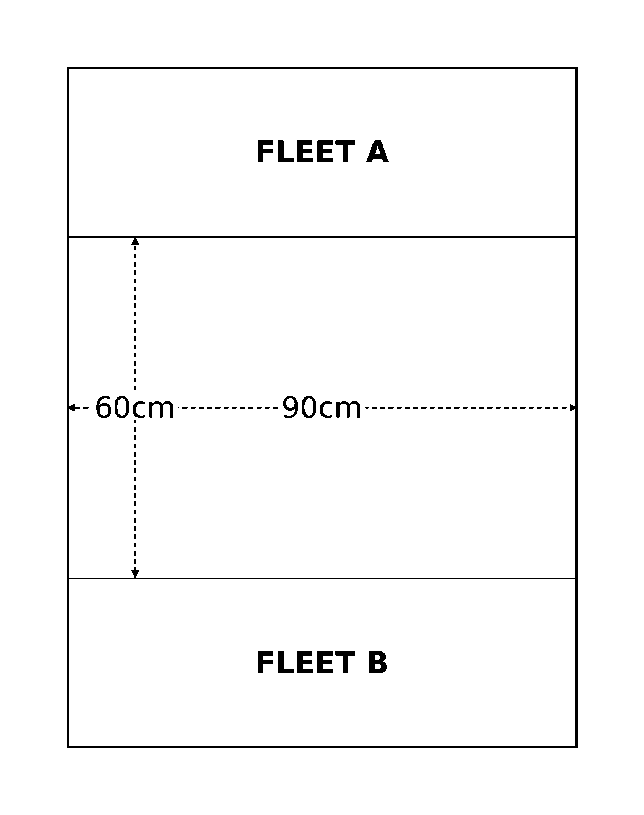
Deployment diagram
First Turn. Both players roll a dice. The player with the highest score may choose whether to have the first or second turn.
Game Length. The game lasts until the players have had eight complete turns each or until one fleet has all its ships destroyed.
Victory Conditions. Normal victory points are not used in this scenario. Instead, at the end of the game, each player scores 1 point for each point of damage they have inflicted on the enemy ships. A player scores an additional point for each crippled enemy ship, or 3 additional points for each destroyed enemy ship. For example, if an enemy ship suffers 5 points of damage this earns the opposing player 5 points and an additional point because the ship has been crippled. Note that you only receive 3 additional points for destroyed ships, you do not also get the single point for the ship having been crippled before it was destroyed. The player who scores the most victory points is the winner.
A Note on Introductory Games: For your first few games, you will probably want to avoid most of the content in the Advanced Rules section of the rulebook, at least until you feel comfortable commanding your fleet. Moreover, we recommend that you limit the amount of attack craft that both sides bring to the battle, as too much ordnance can be overwhelming for new players. Indeed, the ordnance phase can become a game unto itself when fleets' launch capacity gets large enough. Once you are ready for additional complexity, take a look at the Alternatives below or any of the other introductory scenarios in this book.

Cruiser Clash - Alternatives
Source: BFG:XR Rulebook, printed p.85.
After playing this scenario a few times, you can try any of the following to introduce some additional complexity to your games:
Forces. You may remove the restriction on the maximum points value of the cruisers, which means that players will be able to take cruisers with nova cannons and other fancy weapons. Alternatively, you could allow each player one cruiser with special weapons in their fleet, or some other similar restriction. Refer to players' fleet lists for the points values of different cruisers. Furthermore, you may allow any number of cruisers up to an agreed points limit using the players' normal fleet lists. A good size to start with is 750 points, or 1,000 points if you want to include fleet commanders in your game. Fleet commander options available to a player are given at the start of their fleet list.
Battlezone. Once you are used to moving and shooting with your ships over an open table, try placing celestial phenomena on the tabletop. Start with gas and dust clouds first, and after playing with those a couple of times, try adding a planet or some asteroid fields as well. If players feel ready to expand on this, you may use the full celestial phenomena rules. If you do, roll a D6, on a score of a 1, 2 or 3 the battle takes place in the outer reaches; on a score of 4, 5 or 6 the battle is fought in deep space. See the Celestial Phenomena section for more details.
Set-up. You may like to use the Set-up rules for the Fleet Engagement scenario instead of simply pointing your ships at each other.
Victory Conditions. Rather than adding up damage points, try using the victory points system in the introduction to the Scenarios section.
Advanced Rules. Once you are familiar with the basic Battlefleet Gothic rules, you should begin using some of the Advanced Rules (source: rulebook p.36). In particular you may like to try using the rules for ramming, disengaging, and boarding actions.

The Bait
Source: BFG:XR Rulebook, printed p.86.
A lone ship has been sent into a system to lure out the defending forces in an extended pursuit. Unknown to the pursuers, the fleeing vessel has some friends lying in wait up ahead. This is a good introductory scenario for learning about asymmetric starting forces.
Forces. This scenario works with forces worth up to 750 points. These are divided as shown below: Pursuing forces (Attacker): up to 500 points. Pursued forces (Defender): one ship or squadron worth up to 250 points initially, with up to 500 points of reinforcements.
Battlezone. The battle will take place in the outer reaches or deep space. Use any standard method to determine the battlezone, or roll a D6: on a score of 1-3, the battle takes place in the outer reaches; otherwise, it takes place in deep space.
Set-up. The pursued vessel is placed in the center of the table first, facing one of the short table edges. The pursuers are deployed more than 60cm away behind it. Reinforcements for the pursued ship enter from the table edge in front of it.
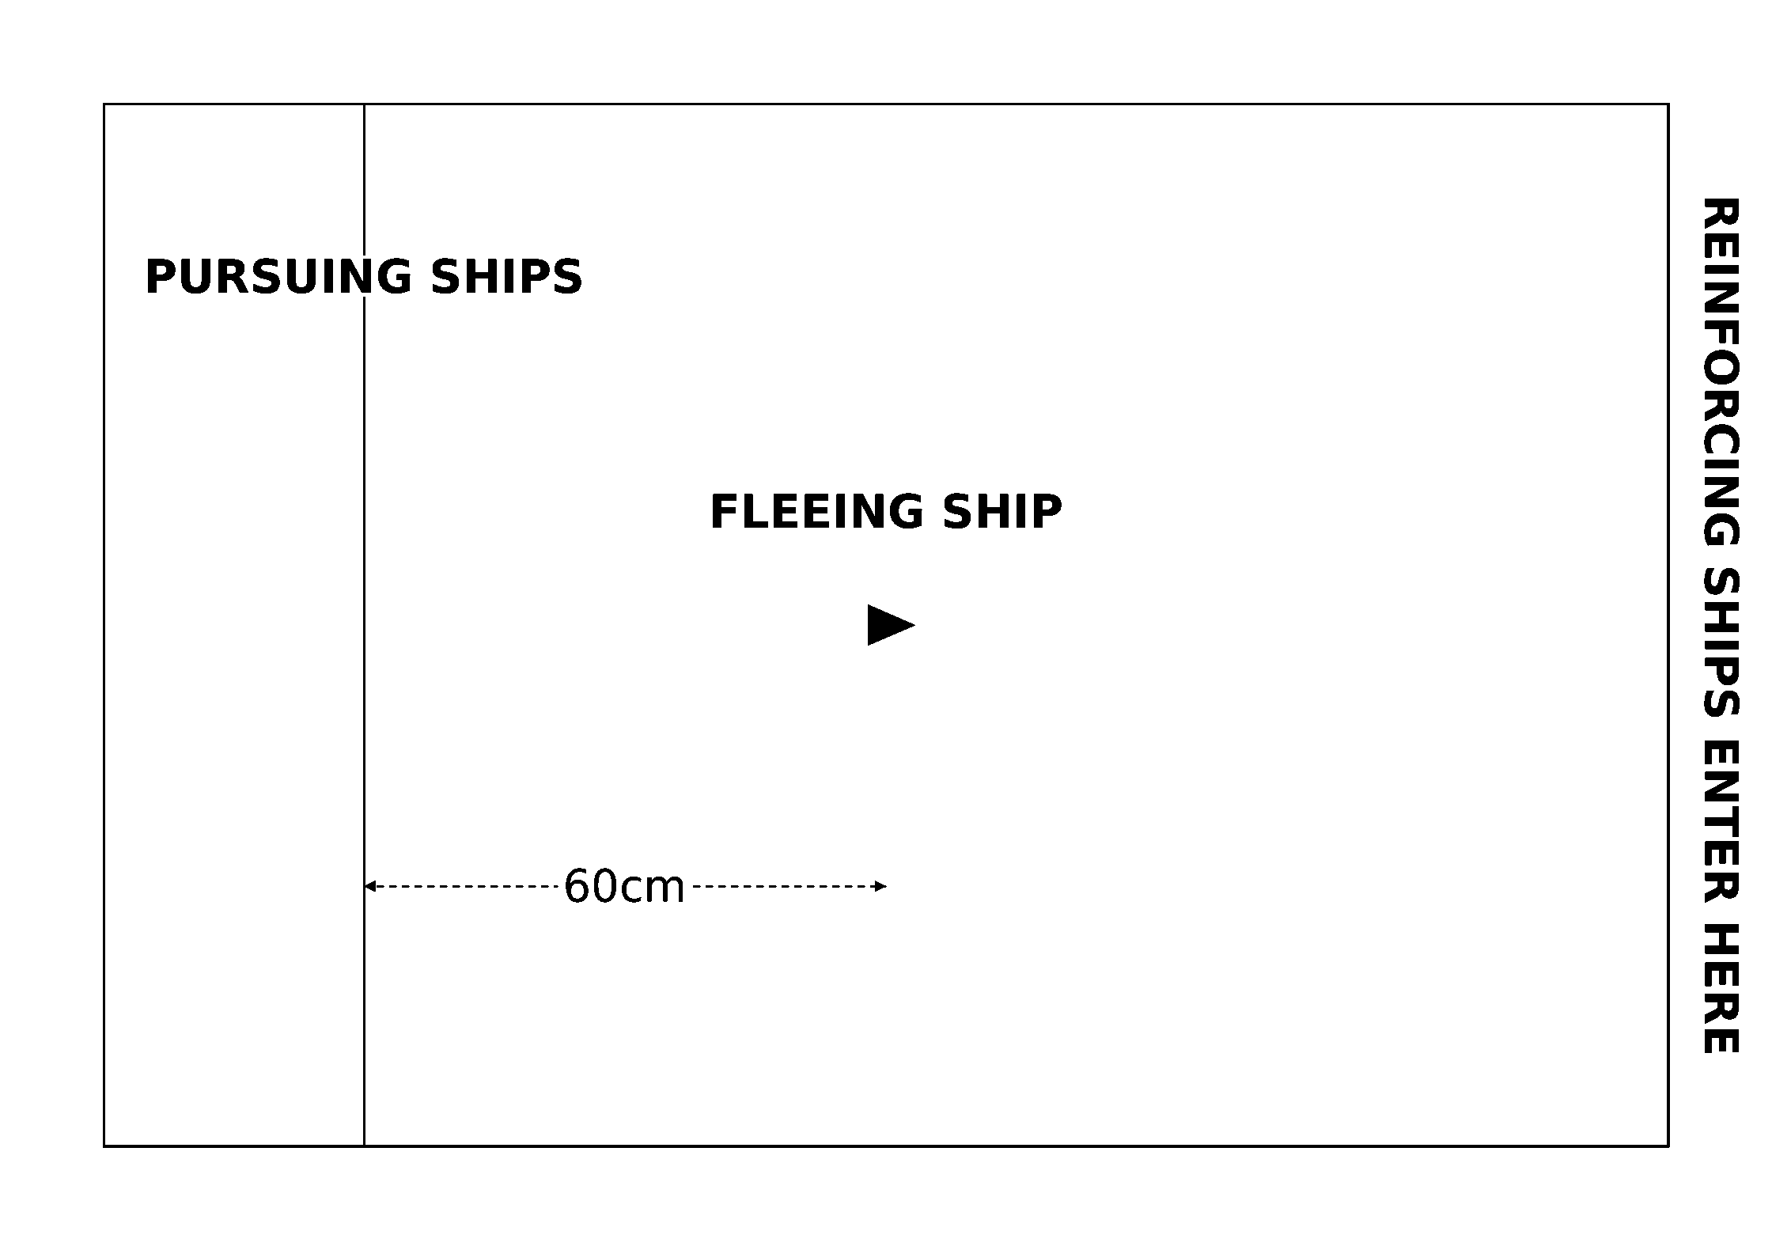
Deployment diagram
First Turn. The defender (who controls the fleeing ship or squadron) takes the first turn.
Special Rules. Any reinforcements for the fleeing ship(s) may enter the table on any turn, including Turn 1. If the reinforcing ships enter after Turn 1, they may be deployed up to 30cm along one of the long table edges for each turn after the first (as measured from their short table edge). For example, a Slaughter class cruiser enters as reinforcements on Turn 4, so it may be placed on the defender's short table edge or up to 90cm away from it, along one of the long edges.
Game Length. The game continues until one fleet disengages or is destroyed.
Victory Conditions. The fleet with the highest victory point total at the end of the game wins.
The Third Armageddon War: If you are playing in a Third Armageddon War Campaign, you may use the variant scenario below called Parol's Bait, which represents Admiral Parol's desperate attempt to break up the overwhelming number of Ork ships descending on the Armageddon system.

Parol's Bait (Variant Scenario)
Source: BFG:XR Rulebook, printed p.87. Campaign-specific variant of The Bait, for the Third Armageddon War Campaign.
As the massive tidal wave of Ork ships spread throughout the Armageddon system, Admiral Parol was forced to disengage his ships from front line combat or run the risk of having his fleet destroyed before he was able to mount any serious challenge. With direct battle out of the question, Parol dispersed his forces with orders to harry the Orks' flanks wherever possible. With most of the alien vessels only too willing to seek combat, Parol hoped that he could distract and possibly destroy enough of the enemy to delay their arrival around Armageddon itself. Many textbook naval stratagems were tested to their limits.
The Parol's Bait variant scenario uses all the same rules as Scenario Two (The Bait), with the following modifications:
Forces. In this scenario, a small group of Imperial Navy light cruisers and escorts have successfully drawn out a force of Ork ships from the main fleet and are leading them towards a trap. When playing the Parol's Bait scenario in a Third Armageddon War Campaign, the attacker plays as the Ork fleet, and the defender plays as the Imperial Navy. The pursued forces may only include light cruisers and escort squadrons, but more than one cruiser or squadron may start on the table (as fleeing ships). The Imperial Navy player may also purchase up to six orbital mines, which count against the 500 points of reinforcements (although they start on the table as normal, source: rulebook p.67).
Battlezone. Roll for the battlezone randomly. On a 1-4, this scenario takes place in the outer reaches. On a 5-6 it takes place in the primary biosphere. Generate celestial phenomena on the appropriate battlezone table.
Set-up. The scenario uses the same set-up rules as The Bait. Any orbital mines included by the Imperial Navy player must be placed between the fleeing ships and the short table edge in front of them.
Victory Conditions. Standard victory points are earned for ships crippled or destroyed. In addition, the Orks gain bonus victory points equal to half the value of any reinforcements brought on to help the pursued Imperial ships. If mines are taken, the victory points for these are automatically awarded to the attacker.
Flavour text: "Heroes of Armageddon! You have withstood the evil savagery of the Orks, and they have left nothing for you to fear. So raise high the black banners of vengeance, now is our time!", Commissar Yarrick, during the Third War for Armageddon

Chance Encounter
Source: BFG:XR Rulebook, printed p.88.
An invading fleet led by a powerful, singular flagship heads towards a vital system to join its allies for an impending attack. Patrolling forces detect the fleet and quickly change course. Their only option is to stop or at least stall this advancing menace before it can reach an allied battle-zone. Will the defenders succeed in buying some precious time, or will these brave souls join the long list of those crushed before the invaders' mighty warfleet? This is a good introductory scenario for learning about larger battles with asymmetric victory conditions.
Forces. This scenario works best with a points limit between 750 and 1,000 points. The attacking force then receives an additional 250 points beyond the agreed limit.
- Invading Forces (Attacker): The attacker must include one flagship and at least one cruiser. The flagship must have more than 12 starting hits or be worth at least 500 points. If the attacker's faction cannot meet this requirement, an Activated Blackstone Fortress may be used instead. The flagship must also embark a fleet commander (with Ld9 or better, if possible). Remaining forces may be chosen at the attacking player's discretion, but no battleships may be included (except the flagship, if it is one).
- Patrolling Forces (Defender): The defender must include a single battlecruiser, grand cruiser, or heavy cruiser (or faction equivalent) as a flagship, and at least two other regular cruisers. The flagship must embark a fleet commander (with Ld9 or better, if possible). Remaining forces may be chosen at the defending player's discretion, but no battleships may be included.
Battlezone. This battle will either take place in the outer reaches or in deep space. You may use any of the usual methods to determine the battlezone, or you may roll a D6: on a score of 1-3, the battle takes place in the outer reaches; otherwise, it takes place in deep space.
Set-up. The attacker begins by placing their chosen flagship on the center line of their long table edge, 10cm in from the edge itself. Players then alternate placing one capital ship or escort squadron within their respective deployment zones until all models have been placed.
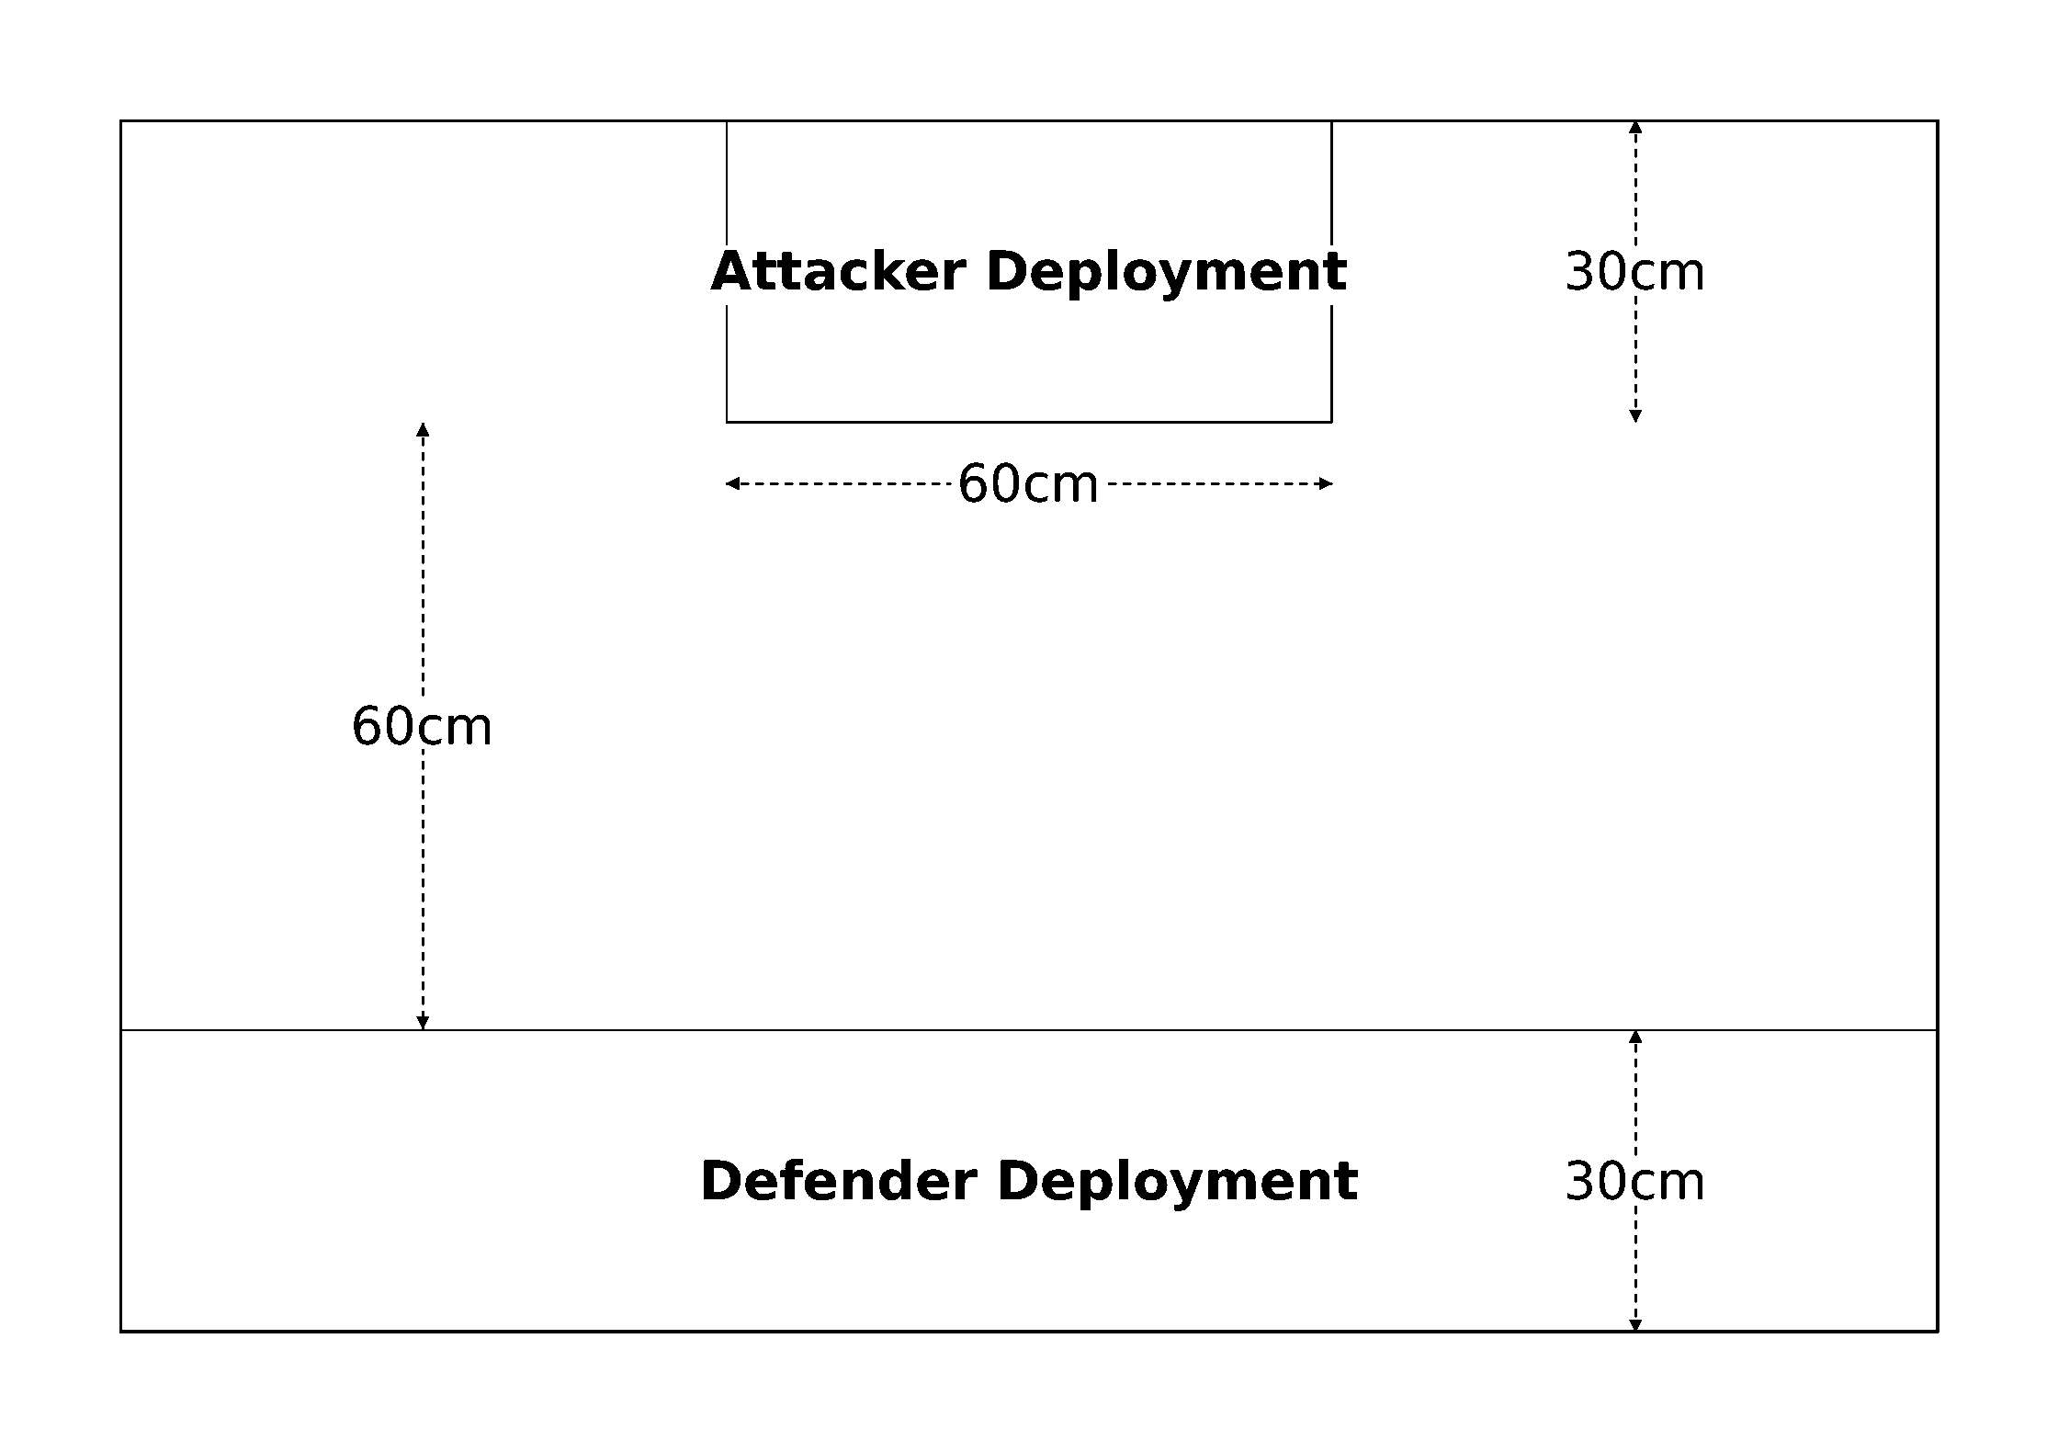
Deployment diagram
First Turn. The defender may choose whether to go first or second.
Game Length. The game lasts six turns, or until one fleet disengages or is destroyed.
Victory Conditions. All the defending forces can hope to do is slow the invading fleet and buy time for their allies to regroup. As a result, the defenders are considered victorious if the attacker's flagship is crippled before the end of the game. If the defenders manage to actually destroy the attacker's flagship, it is a heroic victory instead! If the attacking flagship and at least one other attacking capital ship disengage by moving off the defender's long table edge, the attacker is victorious (unless their flagship is crippled, of course).

Abaddon's 13th Black Crusade
Source: BFG:XR Rulebook, printed p.89. Campaign-specific scenario dressing, still grouped under Introductory Scenarios in the source.
If you are playing in a 13th Black Crusade Campaign, this scenario may be used to represent the Planet Killer's approach towards Cadia. To do so, use the following forces:
Chaos (Attacker): The Planet Killer, a Devastation class cruiser, a Slaughter class cruiser, and one squadron of three Iconoclast class destroyers. The Planet Killer is commanded by a Chaos Warmaster.
Imperial Navy (Defender): A Mars class battlecruiser, a Tyrant class cruiser, a Gothic class cruiser, and one squadron of four Cobra class destroyers. The Mars class battlecruiser is commanded by a Fleet Admiral.

Suggested Flagships
The following are some recommended flagship vessels for different factions to use with this scenario. This can be a good way to learn how to use some of the larger, centerpiece units in your chosen faction book.
Faction | Suggested Flagship
Chaos Fleets | The Planet Killer or a Chaos Space Hulk
Ork Fleets | Ork Space Hulk
Tyranid Fleets | Proteus Class Hive Ship
Necron Fleets | Cairn Class Tomb Ship
Tau Empire Fleets | Kroot Warsphere (w/ extra hits added)
Eldar Fleets | Void Stalker or Wyrm Battleship (w/ refits)
Space Marine Fleets | Battle Barge (w/ refits)
Other Fleets | Activated Blackstone Fortress

For an Imperial Navy or Space Marine fleet, you may also consider using the Ramilies Star Fort or Fortress-Monastery (respectively), replacing their rules for rotation with a 5cm move in any direction. Always make sure to check with your opponent before modifying the rules this way, however.

Overview
Source: BFG:XR Rulebook, printed p.90.
The six scenarios presented in this section are referred to as raids. All raids share the common theme of a weaker attacking force launching a lightning strike on a larger defending force, taking advantage of a momentary vulnerability or fortuitous circumstance to hopefully tip the odds in their favor. Due to the inherent asymmetry in raid scenarios, these can be good choices when not all players have a full collection of miniatures ready for the table. Several raids also reward objective-based gameplay over direct engagements, ideal for players looking for more than a straight-up ship brawl.
Flavour text: "In my high seat I gaze into the immaterium and see the shadow that our own universe casts into depthlessness. This eye... this eye sees gentle flows of soul-stuff where the becalmed mind might starve to death, and tides and churns of genius and hate. The warp mocks the power of words to describe. But what I can never turn my back on is the power and the beauty of the Emperor. I see His soul shine out from Earth and His presence fill every corner of the immaterium. I am scorned for what I talk of seeing, scorned by my family, so be it. Some say that every one of us sees a face of the warp meant only for him, a warp that none other shall ever see, but it makes no matter. I have known from the first time I beheld it that I could do nothing but follow that light with my life.", Peshto Vask Zemlya, Navigator

The Raiders
Source: BFG:XR Rulebook, printed p.91.
A small attacking force has been sent in to cripple or destroy as much of the enemy fleet as possible before they are destroyed themselves. If the attackers succeed, the defending fleet will be put out of operation for months, enabling the attacker's main fleet to roam the system unhindered.
Forces. Agree on a points limit for the battle. The defender may spend up to this points limit in total, while the attacker can spend up to half this amount.
Battlezone. The attack could take place anywhere from the flare region all the way to deep space. Use any of the methods on rulebook p.49 to determine the battlezone and any appropriate celestial phenomena.
Set-up. The defender deploys their whole fleet first. The defending fleet must be set up with all the ships facing the same table edge and at least 30cm from any table edge. Each defending ship or squadron must be set up at least 20cm apart. The attacker moves their fleet onto the table from any edge on their first turn.
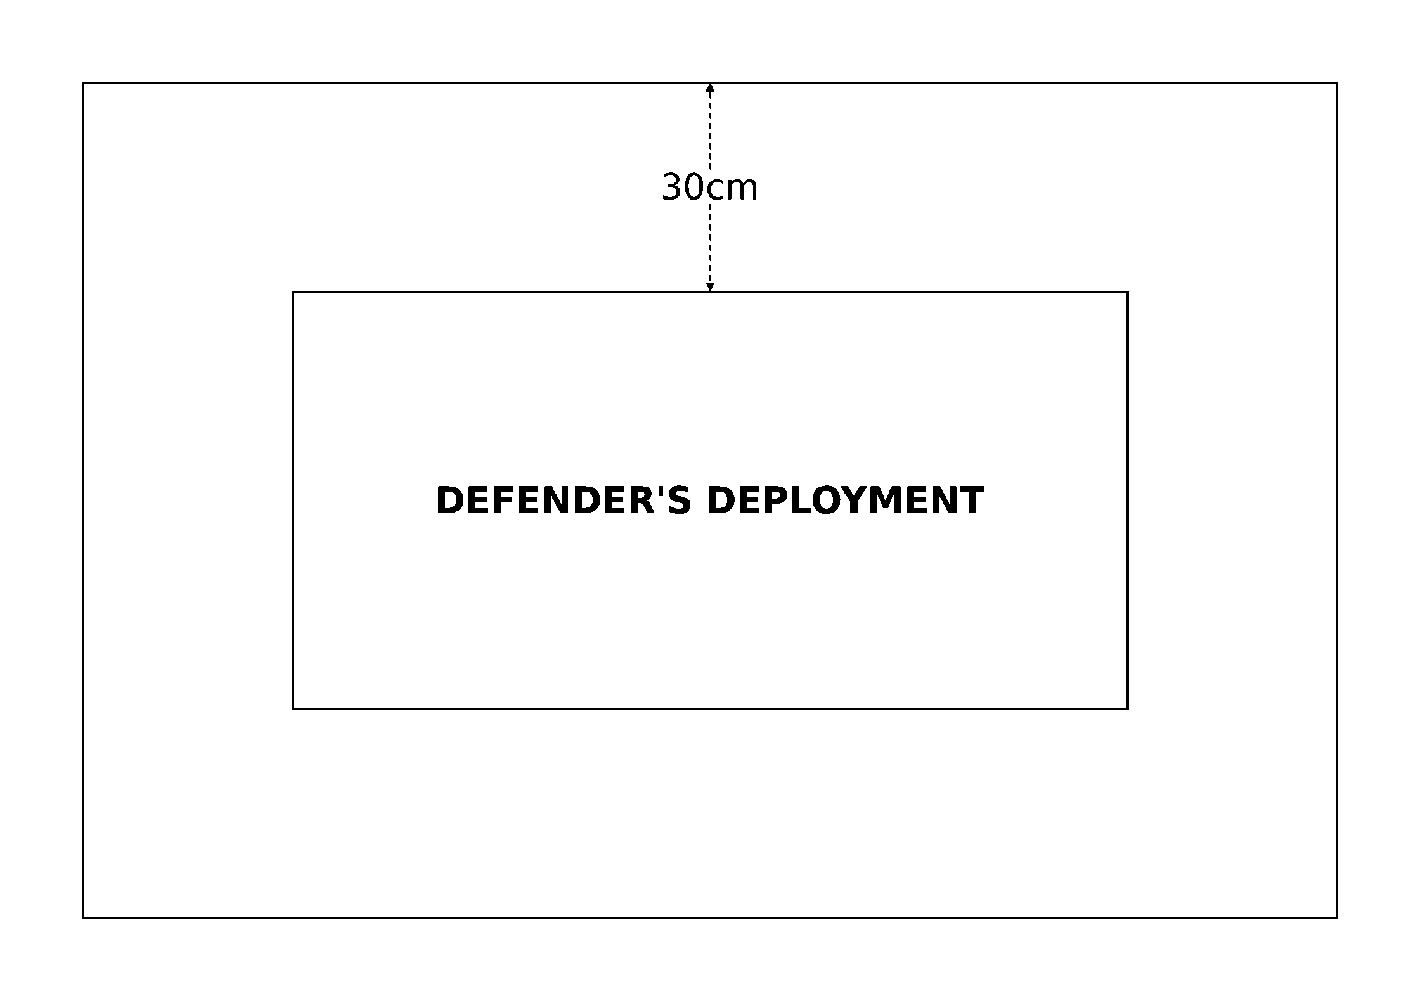
Deployment diagram
First Turn. The attacker takes the first turn and moves their fleet on from one table edge.
Special Rules. For the first D6 turns, all the defender's ships suffer a -1 Leadership penalty to represent their reduced state of alert.
Game Length. The game lasts eight turns, or until one fleet disengages or is destroyed.
Victory Conditions. Both fleets score victory points as normal, and the fleet with the highest victory points total at the end of the game wins. Note that this means it is possible for the attacker to be completely destroyed and still win the scenario!

Blockade Run
Source: BFG:XR Rulebook, printed p.92.
A fleet has been trapped in the system for several months, unable to fight past the enemy fleet blockading the jump point. A small attack force has been assembled to break through the blockade at its weakest point, to hopefully return with sufficient reinforcements to lift the blockade totally.
Forces. Agree on a points limit for the battle. The blockading player (the defender) may spend up to this many points on their fleet. The attacker (attempting to break the blockade) may spend up to half this total on their fleet.
Battlezone. The blockading force is stationed at the edge of the system, so the battle will take place in either the outer reaches or deep space. You may use any of the usual methods to determine the battlezone, or you may roll a D6: on a score of 1-3, the battle takes place in the outer reaches; otherwise, it takes place in deep space.
Set-up. Divide the table lengthwise into thirds as shown below. The blockading player then sets up their fleet. Roll a D6 for each blockading ship or squadron to determine the area in which it must be deployed. Blockading ships may start facing in any direction, but may not be placed within 60cm of the attacker's table edge. The attacker then sets up their force within 15cm of their table edge.
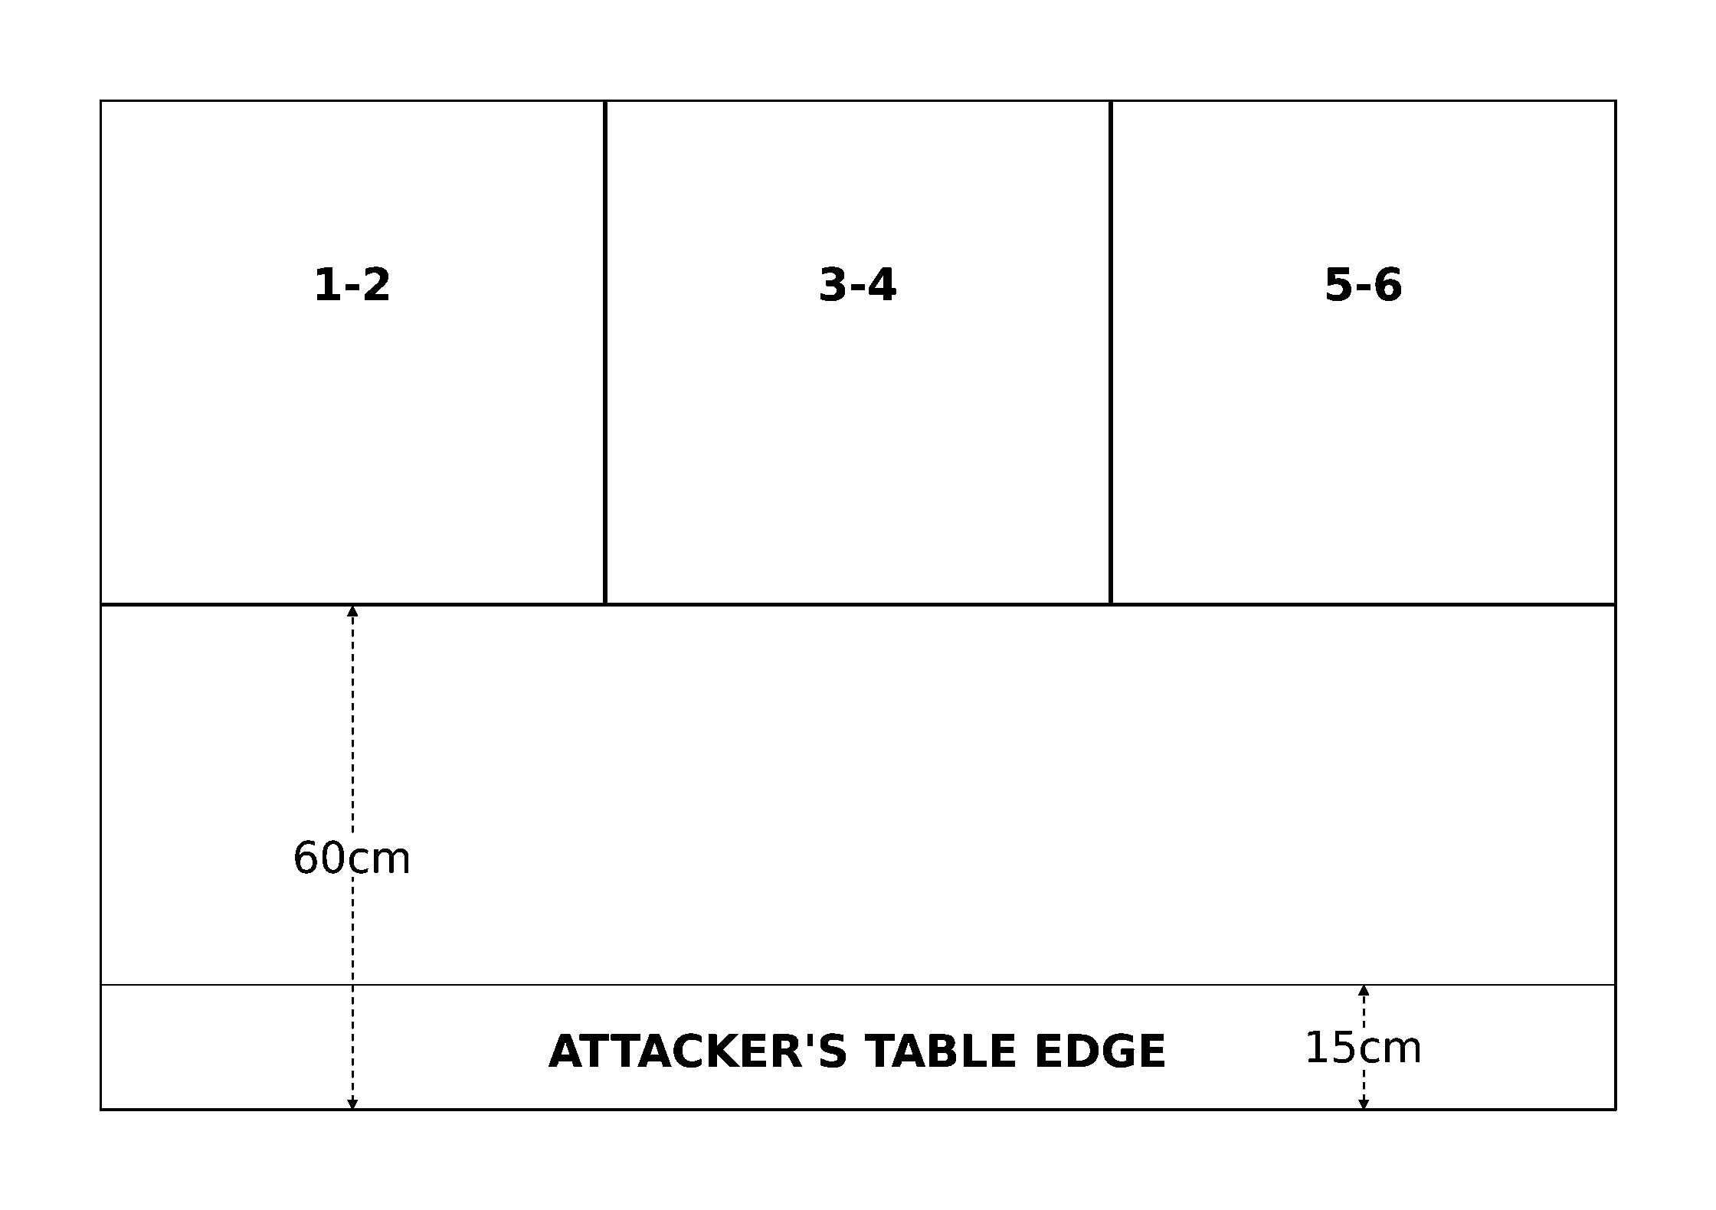
Deployment diagram
First Turn. Both players roll a D6. The player with the higher score may choose whether to go first or second. (Re-roll in the case of a tie).
Game Length. The game lasts six turns, or until one fleet disengages or is destroyed.
Victory Conditions. Both fleets score victory points as normal. In addition, the attacker scores bonus victory points for any vessels that he or she can move off the board (i.e. disengage) via the blockading player's table edge. Capital ships and escort squadrons that escape this way are worth 100% of their total points value if not crippled, otherwise they are only worth 25%. The side with the most victory points at the end of the game wins. Note that this means it is possible for the attacker to be completely destroyed and still win the scenario!
Abaddon's 13th Black Crusade: If you are playing in a 13th Black Crusade Campaign, you may use the variant scenario below called Daemon Blockade, which represents a fleet of Imperial Navy reinforcements attempting to reach the embattled Scelus and Belis Corona sectors before the region falls to Abaddon the Despoiler.

Daemon Blockade (Variant Scenario)
Source: BFG:XR Rulebook, printed p.93. Campaign-specific variant of Blockade Run, for the 13th Black Crusade Campaign.
Reinforcements en route to the Belis Corona and Scelus sectors find themselves having to penetrate widespread Chaos blockades. This is risky business indeed, and many Admirals are forced to lead their ships as fast as possible through treacherous minefields and withering barrages of hostile firepower. Surprise is the only thing on their side. To make matters worse, there are reports that the Ruinous Powers have infused the enemy's orbital mines with daemonic abilities. This can only be a bad thing.
The Daemon Blockade variant scenario uses all the same rules as Scenario Two (Blockade Run), with the following modifications:
Forces. When using the Daemon Blockade scenario in a 13th Black Crusade Campaign, the attacker plays as one of the "Forces of Order" (the Imperial Navy, Adeptus Mechanicus, Space Marines, Inquisition, or Eldar), and the defender plays as the blockading Chaos fleet. The Chaos player may spend up to the agreed points limit, minus 100 points, on their fleet. In addition to this, he or she receives ten daemon mines for free, which follow the special rules defined below. The attacking player may spend up to half the agreed points limit on their fleet, as normal.
Set-up. The scenario uses the same set-up rules as Blockade Run. In addition, the Chaos player must place his or her daemon mines one at a time, rolling for their deployment zone just like other blockading ships and squadrons.
Special Rules. Daemon mines use the normal rules for mines as described on rulebook p.27, with the following exceptions: they move 10+D6cm in each ordnance phase; they have a 4+ resilient save against enemy fighters (working just like it does for attack craft); and they automatically destroy any enemy ordnance they encounter (except fighters), without being removed themselves.
Victory Conditions. The scenario uses the same victory conditions as Blockade Run. In addition, each daemon mine destroyed by the attacker before it contacts one of his or her vessels adds +10 victory points to his or her final total.

Convoy
Source: BFG:XR Rulebook, printed p.94-95.
In this scenario, the defender must escort a convoy of vital transport vessels into a star system threatened by enemy forces. In order to catch the convoy, the attacking forces have seeded a wide area of space with ships lurking on minimal power to avoid detection, and clusters of "deadfall" torpedoes which will activate and launch as soon as an enemy ship registers on their sensors. But this convoy is desperately needed and must run the gauntlet of ships and missiles to deliver the supplies it carries.
Forces. Agree on a transport capacity requirement for the defender (minimum 2). The defending fleet's points limit is equal to half its transport capacity requirement (rounded down) × 100. Note that in this scenario, convoy ships must be arranged in squadrons of at least 2 vessels and/or 2 transport capacity. The attacker generates his or her forces randomly. Make two rolls on the table below, plus one additional roll for every 2 transport capacity in the defending fleet. Escort squadrons and capital ships are chosen from the attacker's fleet list. These are free from most restrictions (such as ratios of ships), but cannot exceed the fleet list's normal maximums for ship classes or sizes.
D6 Roll | Result
1 | One deadfall torpedo or attack craft cluster.
2 | Two deadfall torpedo or attack craft clusters (in any mix desired).
3 | Three deadfall torpedo or attack craft clusters (in any mix desired).
4 | One squadron of escort ships worth up to 100 points.
5 | One squadron of escort ships worth up to 150 points.
6 | One capital ship worth up to 200 points.

Battlezone. The attack could take place anywhere from the flare region all the way to deep space. Use any of the methods on rulebook p.49 to determine the battlezone and any appropriate celestial phenomena.
Set-up. The attacker sets up first, placing a face-down contact marker on the table for each capital ship, escort squadron, and deadfall torpedo or attack craft cluster in their fleet. Contact markers must be placed at least 30cm apart and may not be placed within 30cm of a table edge. If all of the counters cannot fit onto the table, start to double them up by placing an extra counter on top of each one already placed (and so on until all have been placed). The defender then rolls a D6 to determine the short table edge from which the convoy will move onto the board. He or she places one ship from the convoy at that edge of the table, at least 45cm from either long table edge, to mark the convoy's entry point.
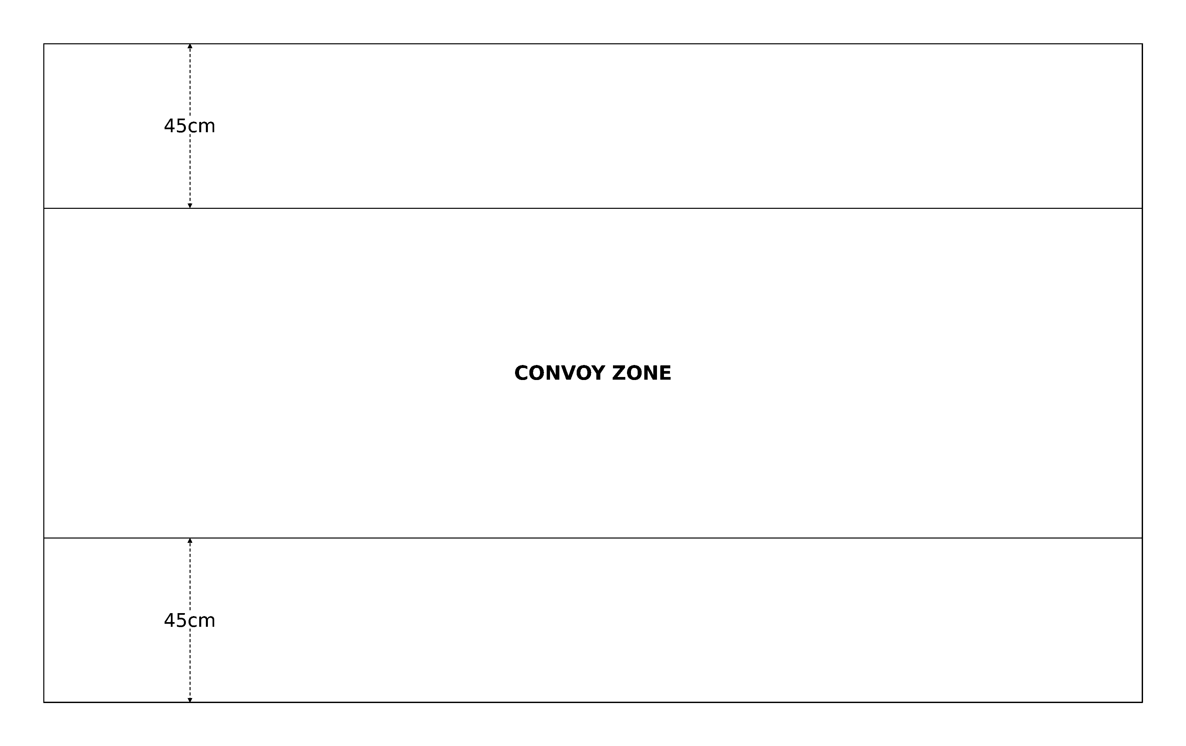
Deployment diagram
Contact markers represent the locations of the attacker's forces. Each must be unique to its corresponding ship, squadron, or torpedo/attack craft cluster, but should not be identifiable to the defender. Classically, Battlefleet Gothic uses triangular tokens (25×30mm) with numbers on one side.
A contact marker is activated as soon as a defending vessel moves within 30cm of it. Flip the marker face-up, then complete the defending ship's movement (if any). Once the defender's movement phase is finished, deploy the attacker's forces for each activated contact marker as described below:
Deadfall Torpedoes: Replace the contact marker with an ordinary torpedo salvo (Strength D6+2), oriented as desired by the attacking player. These have a speed of 30cm and begin moving in the next ordnance phase.
Attack Craft: Replace the contact marker with D3+1 squadrons of attack craft. These may be any mix of standard fighters, bombers, and/or assault boats, and may be combined into waves as desired by the attacking player. The attack craft begin moving in the next ordnance phase.
Ship Squadron: Place one ship from the squadron on top of the contact marker. The rest of the squadron is placed in formation with the first ship, no closer to the enemy than the first placed vessel. The squadron may be deployed facing any direction as desired by the attacking player, but all members must be oriented the same way.
Capital Ship: Place the capital ship on top of the contact marker, facing in any direction the attacking player chooses.
In addition, the attacking player may voluntarily activate one contact marker at the start of his or her movement phase, plus an additional marker if the defender has any ships on special orders, to represent the attacking fleet detecting the approaching convoy. Deploy the forces for these markers immediately, using the rules described above.
First Turn. The defender takes the first turn. Each ship in the convoy moves onto the table from the point indicated. If desired, the defender may hold back up to half of his or her fleet's ships, which must move onto the table from the same entry point on his or her second turn.
Game Length. The game continues until the defender has no convoy ships left on the board.
Victory Conditions. The success or failure of the convoy depends on the total transport capacity of the convoy ships that move off the short table edge opposite the defender's entry point (rounding down). Only convoy ships that disengage in this manner count for victory purposes.
Transport Capacity Escaped | Game Result
None | Attackers Win.
One | Attackers Marginal Win.
Two | Convoy Marginal Win.
Three or More | Convoy Win.

Note that if the attacking fleet disengages or is destroyed (with no remaining ships, deadfall torpedoes, or attack craft available), and at least one point of transport capacity has escaped or is still on the table, the game ends immediately and the defender is automatically victorious.
The Third Armageddon War: If you are playing in a Third Armageddon War Campaign, you may use the variant scenario below called The Gauntlet, which represents a fleet of Imperial transport ships making a desperate run through Ork-infested space, in order to deliver critical supplies to the besieged worlds of the Armageddon Sector.

The Gauntlet (Variant Scenario)
Source: BFG:XR Rulebook, printed p.96. Campaign-specific variant of Convoy, for the Third Armageddon War Campaign.
The ferocity and speed with which Ghazghkull's "Waaagh!" assailed the Armageddon sector left many worlds isolated, and left much of the Imperial Navy scattered. To ensure the sector did not become entirely strangled by the invading greenskins, many hundreds of daring convoy runs had to be made directly through Ork held space...
The Gauntlet variant scenario uses all the same rules as Scenario Three (Convoy), with the following modifications:
Forces. When using the Gauntlet scenario in a Third Armageddon War Campaign, the attacker plays as the Orks, and the defender plays as the Imperial Navy. The Imperial player chooses their fleet normally, except that he or she must take at least 3 transport capacity worth of convoy ships (rather than 2), and may only take escorts, light cruisers, and up to one standard cruiser. No battle-cruisers, grand cruisers, heavy cruisers, or battleships may be taken. The Ork player chooses any number of escorts (in valid squadrons), up to a points limit equal to half the defender's transport capacity (rounding up) × 100.
Set-up. The Imperial convoy and escorting fleet are placed within 45cm of one short table edge, facing the opposite edge. The Orks do not deploy, and will instead move onto the table during their first turn.
First Turn. The Ork player takes the first turn, moving all of his or her ships onto the table from any point(s) along either long table edge. A different entry point may be chosen for each attacking squadron as desired.
Victory Conditions. The scenario uses the same victory conditions as the Convoy scenario, except that the Imperial player must have at least 3 transport capacity escape in order to claim victory, rather than the usual 2.
Running Battle (Optional): As this is a running battle, representing an Imperial fleet desperately trying to get their convoy to safety, you might like to try the following special rule when playing this scenario:
- Set-Up: The Imperial convoy and escorting ships are all placed within 30cm of the center of the table at the start of the game, facing either short table edge. The Ork ships move on from any point along either long table edge in the first turn as normal.
- Special Rules: At the end of every Imperial turn, every ship and item of celestial phenomena is moved back 20cm, away from the table edge the Imperial ships were facing at the start of the game. Any ship that "drops" off the end of the table during this shift is considered to have disengaged from the battle. In addition, roll a die at the end of the Imperial player's turn. On a 6, a randomly generated item of celestial phenomena is placed by the Imperial player along the short table edge that his or her ships originally faced, representing the Imperial commander leading the convoy (and the battle) towards any celestial phenomena that will give them an advantage on their mission. Always ignore any rolls that would generate a planet, after all, Armageddon is still many thousands of kilometers away!
- Game Length: In this variation of The Gauntlet, the game lasts for ten turns.
- Victory Conditions: If the Imperial player still has at least 3 transport capacity on the table at the end of the game, they may claim victory.

Rearguard Attack
Source: BFG:XR Rulebook, printed p.97.
Forces sector wide have been split up into smaller patrols and sent in to cripple or destroy as much of an enemy's rearguard as possible before they are destroyed themselves. The targeted hostile forces are experiencing radar malfunctions due to the presence of jammer mines scattered in their way. The time to strike is now. If the attacker can cause enough damage, then these rearguard fleets will be rendered temporarily ineffective, buying the systems ahead some time to organize their defenses. The odds are stacked against them, but stealth may just triumph over numerical superiority.
Forces. Agree on a points limit for the battle. The defender may spend up to this limit on their fleet, but must split at least 25% of its point value off as reinforcements. The attacker may only spend up to half the agreed points limit on their fleet.
Battlezone. The attack could take place anywhere from the flare region all the way to deep space. Use any of the methods on rulebook p.49 to determine the battlezone and any appropriate celestial phenomena.
Set-up. Only the defender deploys their fleet. They must set up with all the ships facing the sunward table edge and at least 30cm from any long table edge and 60cm from the sunward table edge. Each defending ship or squadron must be set up at least 10cm away from all other defending ships or squadrons.
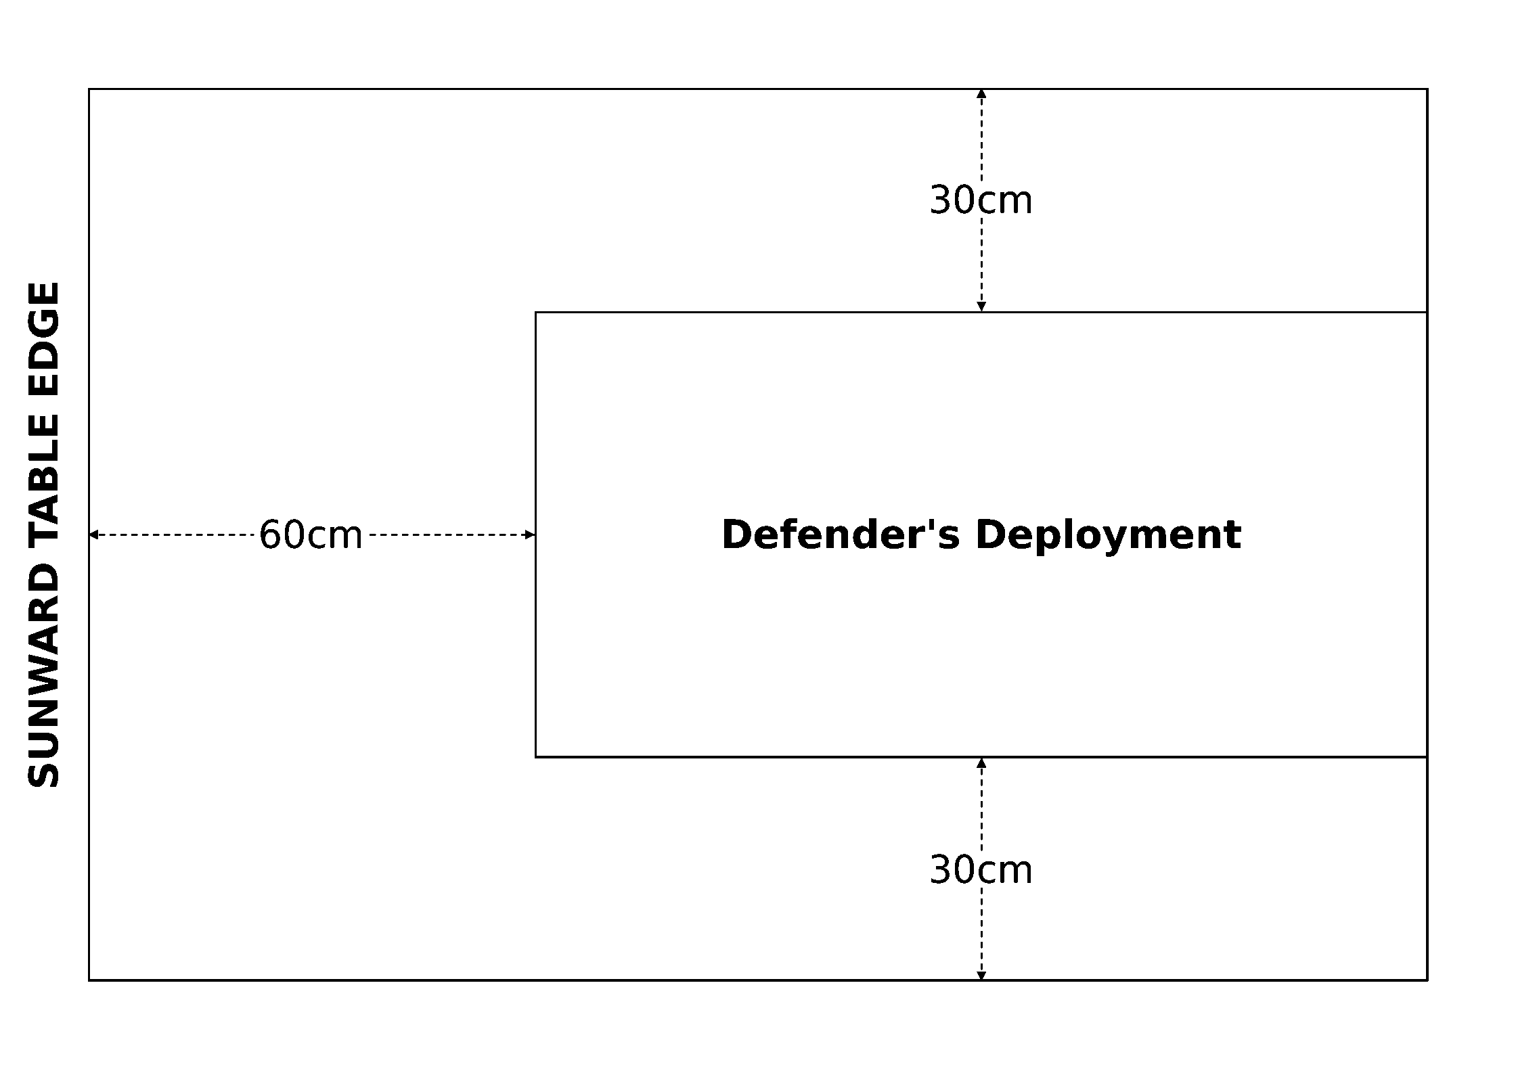
Deployment diagram
First Turn. The attacker takes the first turn, moving their fleet onto the table from any table edge(s) of their choice.
Special Rules. For the first D6 turns, all the defender's ships suffer a -1 Leadership penalty to represent their reduced state of alert. Any reinforcements for the defender may enter the table from the sunward table edge on any turn, including Turn 1. If the reinforcing ships enter after Turn 1, they may be deployed up to 30cm along one of the long table edges for each turn after the first (as measured from the sunward table edge). For example, a Slaughter class cruiser enters as reinforcements on Turn 4, so it may be placed on the sunward table edge or up to 90cm away from it, along one of the long edges.
Game Length. The game lasts eight turns, or until one fleet disengages or is destroyed.
Victory Conditions. Both fleets score victory points as normal, and the fleet with the highest victory points total at the end of the game wins.
Abaddon's 13th Black Crusade: If you are playing this scenario in a 13th Black Crusade Campaign, the Forces of Order will be the attackers, and the Forces of Disorder will be the defenders.

Navigate the Storm
Source: BFG:XR Rulebook, printed p.98.
Warp Storms have ravaged several sectors, making travel through them difficult at best, and in many cases impossible. Many warp rifts have opened up along transport channels as a result of these storms. These vital channels have been rendered doubly dangerous by the disturbing fact that the arriving enemy fleets have found a way to use the warp rifts to their advantage. The transports must continue to deliver their important cargo on time and so convoy escort fleets have doubled in size to repel any would-be attackers.
Forces. The attacking player may spend up to 750 points on their fleet. The defending player may spend up to 1000 points on their fleet, and must take 10 transport capacity worth of convoy ships to represent the convoy their fleet is escorting through the storm.
Battlezone. Instead of using the normal battlezone rules, players take turns placing 8 warp rifts each, starting with the attacking player. Each warp rift must be at least 10cm from any other warp rift. Do not place any other celestial phenomena.
Set-up. Both players secretly set up their fleets in their respective deployment zones. You may use any suitable method to accomplish this, such as dividing the board with a tall screen or having players first privately sketch their ships' positions then deploy to match.
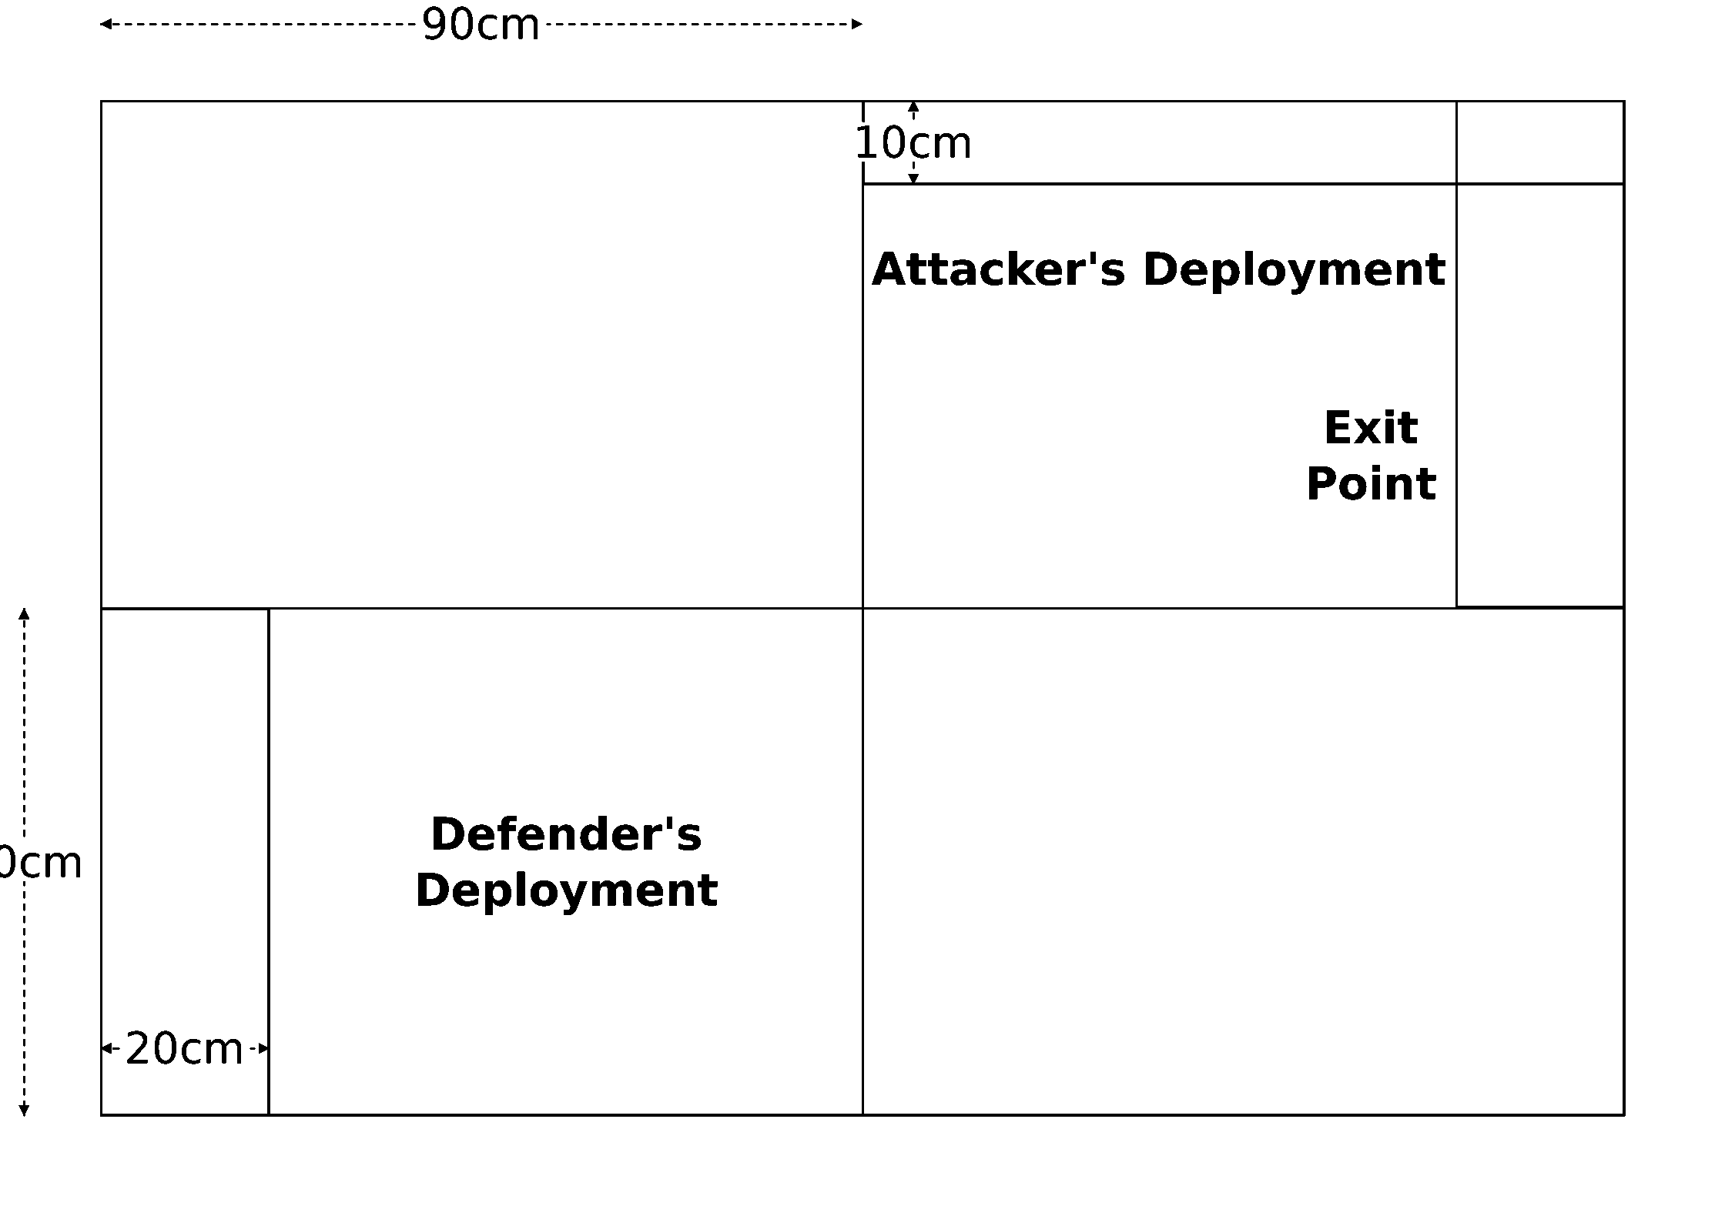
Deployment zones and the exit point
First Turn. The attacker chooses whether to go first or second.
Special Rules. If an attacking ship fails to navigate a warp rift, it is not lost forever. Instead, during the attacker's end phase, they must do the following for each of their ships lost in the warp: choose a friendly or enemy capital ship already on the table and roll a D6. On a result of 2+, place the "lost" ship anywhere within 20cm of the target, facing any direction. Otherwise, the "lost" ship remains in the warp for another turn. Ships that arrive this way are materializing, they take no damage, do not interact with anything on the table, and can do nothing except move and turn. At the end of the attacker's movement phase, each materializing ship that is not in base contact with an enemy vessel returns to normal and must take a leadership test. If the test is failed, the ship's armaments function at half-strength until the end of the turn.
Game Length. The game lasts until victory conditions are met, or no transport capacity remains in play.
Victory Conditions. The attacking player needs to destroy at least 8 transport capacity worth of enemy ships and score at least 50% of the defending fleet's point value in victory points. Ships lost in warp rifts count towards this total, but those that evacuate via the exit point do not. The defending player needs to move at least 5 transport capacity and 25% of their fleet (by point total, ignoring crippled ships and squadrons) off the table via the exit point (see the deployment diagram). Otherwise, the player that destroyed or evacuated the most transports is the winner. If the players' totals are equal, the attacker wins.
Flavour text: Every servant has his place, no matter how lowly or modest. To know it is his greatest comfort, to excel within it is his greatest solace, and his master's contentment is his greatest reward.
Abaddon's 13th Black Crusade: If you are playing this scenario in a 13th Black Crusade Campaign, Chaos is the attacker and the Imperium is the defender. In this case, any Chaos ships that are lost in the warp are permanently transformed into daemonships (for the rest of the campaign), and must arrive via Warp Translation in the Chaos player's end phase rather than use the special rules of the scenario.

Destroy the Docks
Source: BFG:XR Rulebook, printed p.99.
A massive influx of enemy reinforcements are making their way to the orbital docks of a strategically vital system. Although this regrouping effort cannot be stopped, it can be hindered. A raid on the shipyards and resupply stations around the planet could stall the enemy fleet's momentum if the attack goes well, as the infrastructure will need to be repaired by the foe before they can move on. A small fleet has been dispatched to strike at the vulnerable orbital satellites and cause as much havoc as possible before further hostile reinforcements arrive.
Forces. The attacking player may spend up to 1500 points on their fleet, then must divide it into two forces with points values as equal as possible. The defender may only spend up to 750 points on their fleet, and cannot include any battleships. In exchange, the defender gains one fleet commander re-roll for free, along with 2 Space Stations, 1 Orbital Dock, 8 Orbital Mines, 1 Defense Monitor, and 2 System Escorts at no additional cost (source: rulebook p.65-67). The defender also chooses (separately from their fleet) eight of the following satellites in any mix desired: Orbital Weapons Platform, Orbital Defense Laser Platform, or Orbital Torpedo Launcher. These must be divided into two groups of four, referred to as the inner platforms and outer platforms respectively.
Battlezone. Instead of using the normal battlezone rules, place a large planet in the center of the table. Both players (starting with the attacker) then place an asteroid field anywhere outside the planet's gravity well (30cm from the marker's edge).
Set-up. The defending player starts by placing the orbital dock and two space stations anywhere within the planet's gravity well. Then, the defender places the outer platforms anywhere on the table (they do not need to be within a gravity well). The attacker then deploys one of their two forces within 10cm of a short table edge and deploys the other force within 10cm of the opposite table edge. The defender now places the inner platforms, system escorts, defense monitor, and orbital mines anywhere within the planet's gravity well. The remainder of the defender's forces are held in reserve and will arrive later.
First Turn. The attacker rolls 2D6 and the defender rolls 1D6. The player with the highest result chooses whether to go first or second.
Special Rules. The defender's reinforcements arrive at random. Roll a D6 for each ship and squadron in reserve at the start of the defender's turn and consult the chart below. For every two turns that a particular ship or squadron fails this roll, add a cumulative +1 modifier to all subsequent arrival rolls it makes.

Slowest Speed | 20cm or less | 21-29cm | 30cm+
Arrives on a result of... | 5+ | 4+ | 3+

Arriving reinforcements enter play from the table edge shown in the diagram below.
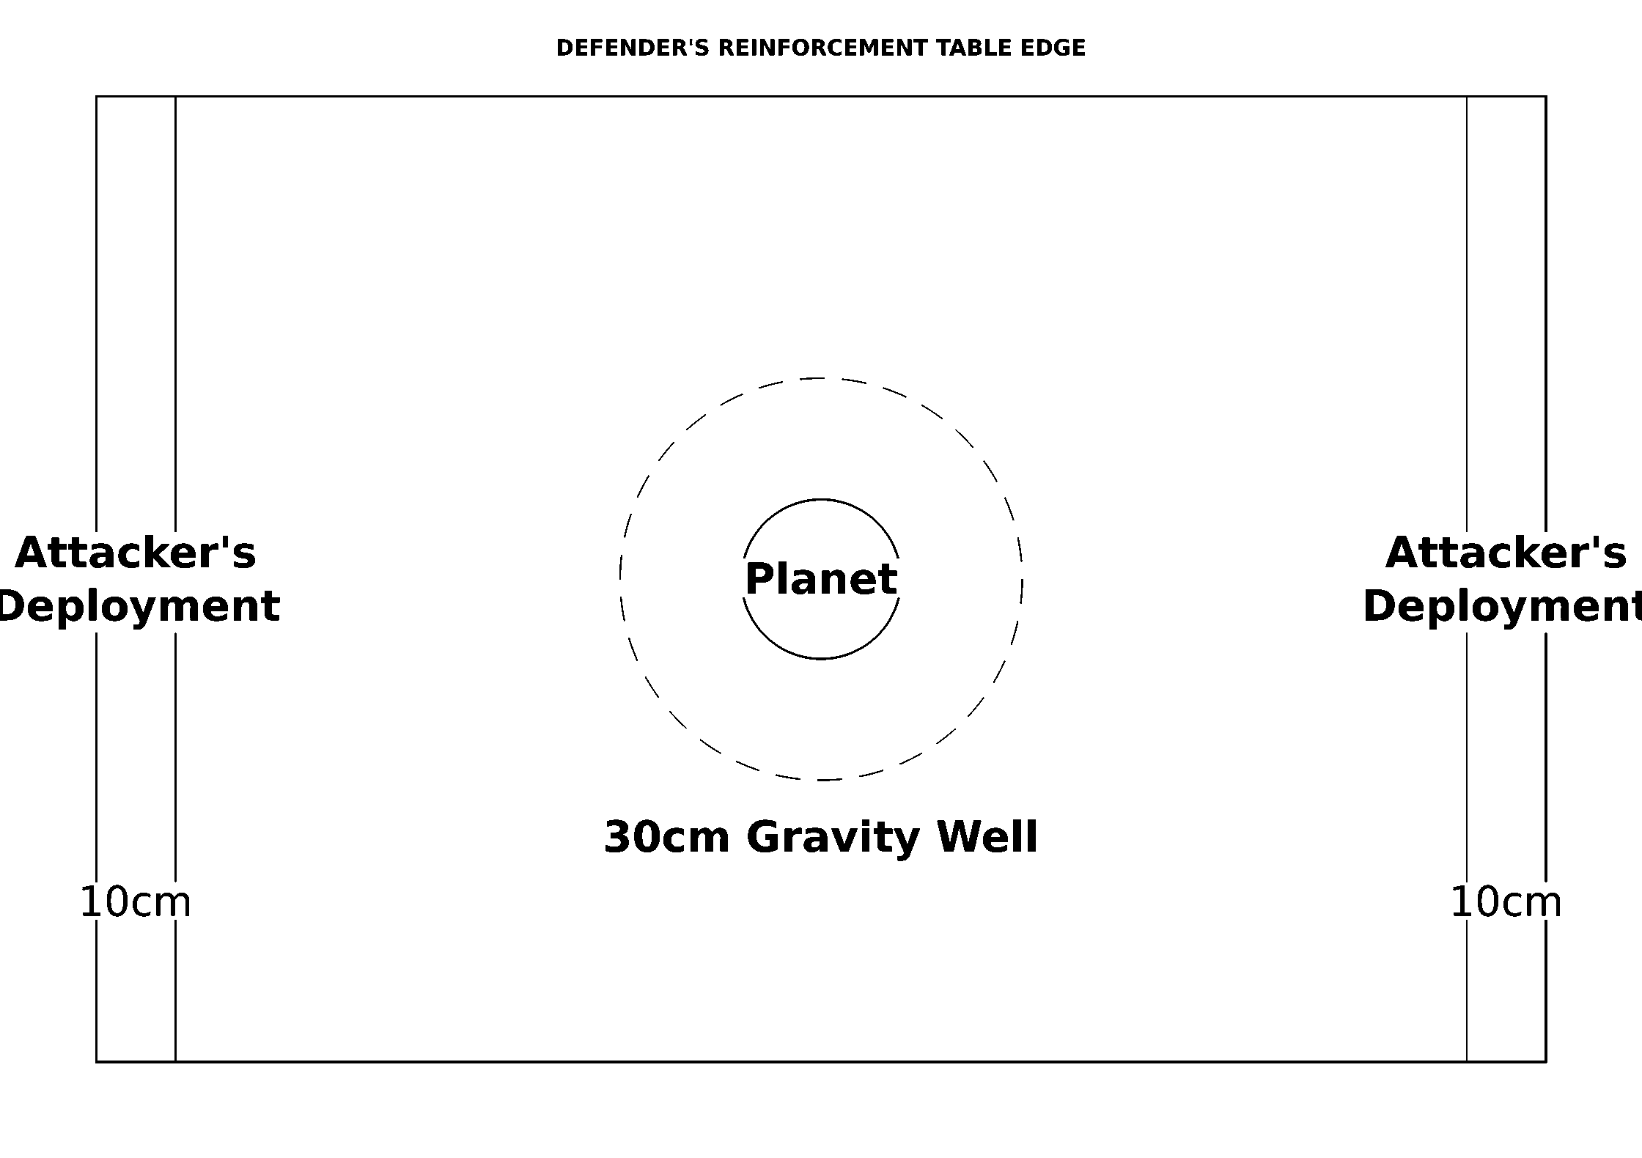
Reinforcement edge, gravity well and attacker's deployment
Game Length. The game lasts for eight turns or until the attacking fleet has completely disengaged or been destroyed.
Victory Conditions. In order to win, the attacker must destroy both space stations, the orbital dock, all of the inner platforms, and at least 25% of the defender's reinforcement fleet (by point value). Otherwise, the defender wins.
Abaddon's 13th Black Crusade: If you are playing in a 13th Black Crusade Campaign, this scenario may be used to represent the Chaos raid on Belis Corona (known as Above Belis Corona in previous editions of Battlefleet Gothic). In this case, the Forces of Disorder will be the attackers and the Forces of Order will be the defenders.

Overview
Source: BFG:XR Rulebook, printed p.100.
This next section presents six scenarios designed to represent more conventional fleet battles. While the introductory scenarios and raids can also be played at higher points limits, these battle scenarios are configured with larger fleets in mind. Many of these battles will take place near planets with ample defensive forces of their own, giving players an opportunity to field their collections of orbital satellites, deadly mine fields, and imposing space fortresses. Additionally, some battles may even involve descending into low orbit where ships must contend against the inexorable pull of gravity or be smashed upon the planet's surface!

Exterminatus!
Source: BFG:XR Rulebook, printed p.101-102.
Sometimes, an enemy poses a threat so grave and so immediate that there can be only one solution: the utter annihilation of a world, accomplished through an unparalleled act of destruction known in the Imperium as Exterminatus. In this scenario, the attacking fleet is escorting a group of Exterminators, ships capable of laying waste to entire planetary populations or even obliterating all life on a world in a matter of hours. The defenders must stop this Exterminator fleet at all costs, and will rush every ship in the vicinity to protect their threatened planet.
Forces. Agree on a points limit for the battle. Attacker: may spend up to the agreed limit on their fleet. For every 1,000 points (or portion thereof), the attacking player may nominate one of their capital ships to be an Exterminator, granting that ship an Armageddon weapon (replacing the ship's prow armament, if any). Alternatively, the attacking fleet may include a single Activated Blackstone Fortress as its Exterminator instead of refitting any capital ships (subject to the normal cost and restrictions in the General Fleet Support List; source: rulebook p.75). Defender: may spend up to the agreed limit on their fleet, plus an additional D6×10 points on planetary defenses for every 500 points (or portion thereof) in their fleet. Keep in mind that the defender may also spend up to one third of their fleet's points on planetary defenses (source: rulebook p.65).
Battlezone. The defender determines whether the battle is fought in the primary or inner biosphere. Place a planet (D6: 1 = small, 2-5 = medium, 6 = large) no more than 150cm from any short table edge, as shown below. Use any method on rulebook p.49 to place additional celestial phenomena.
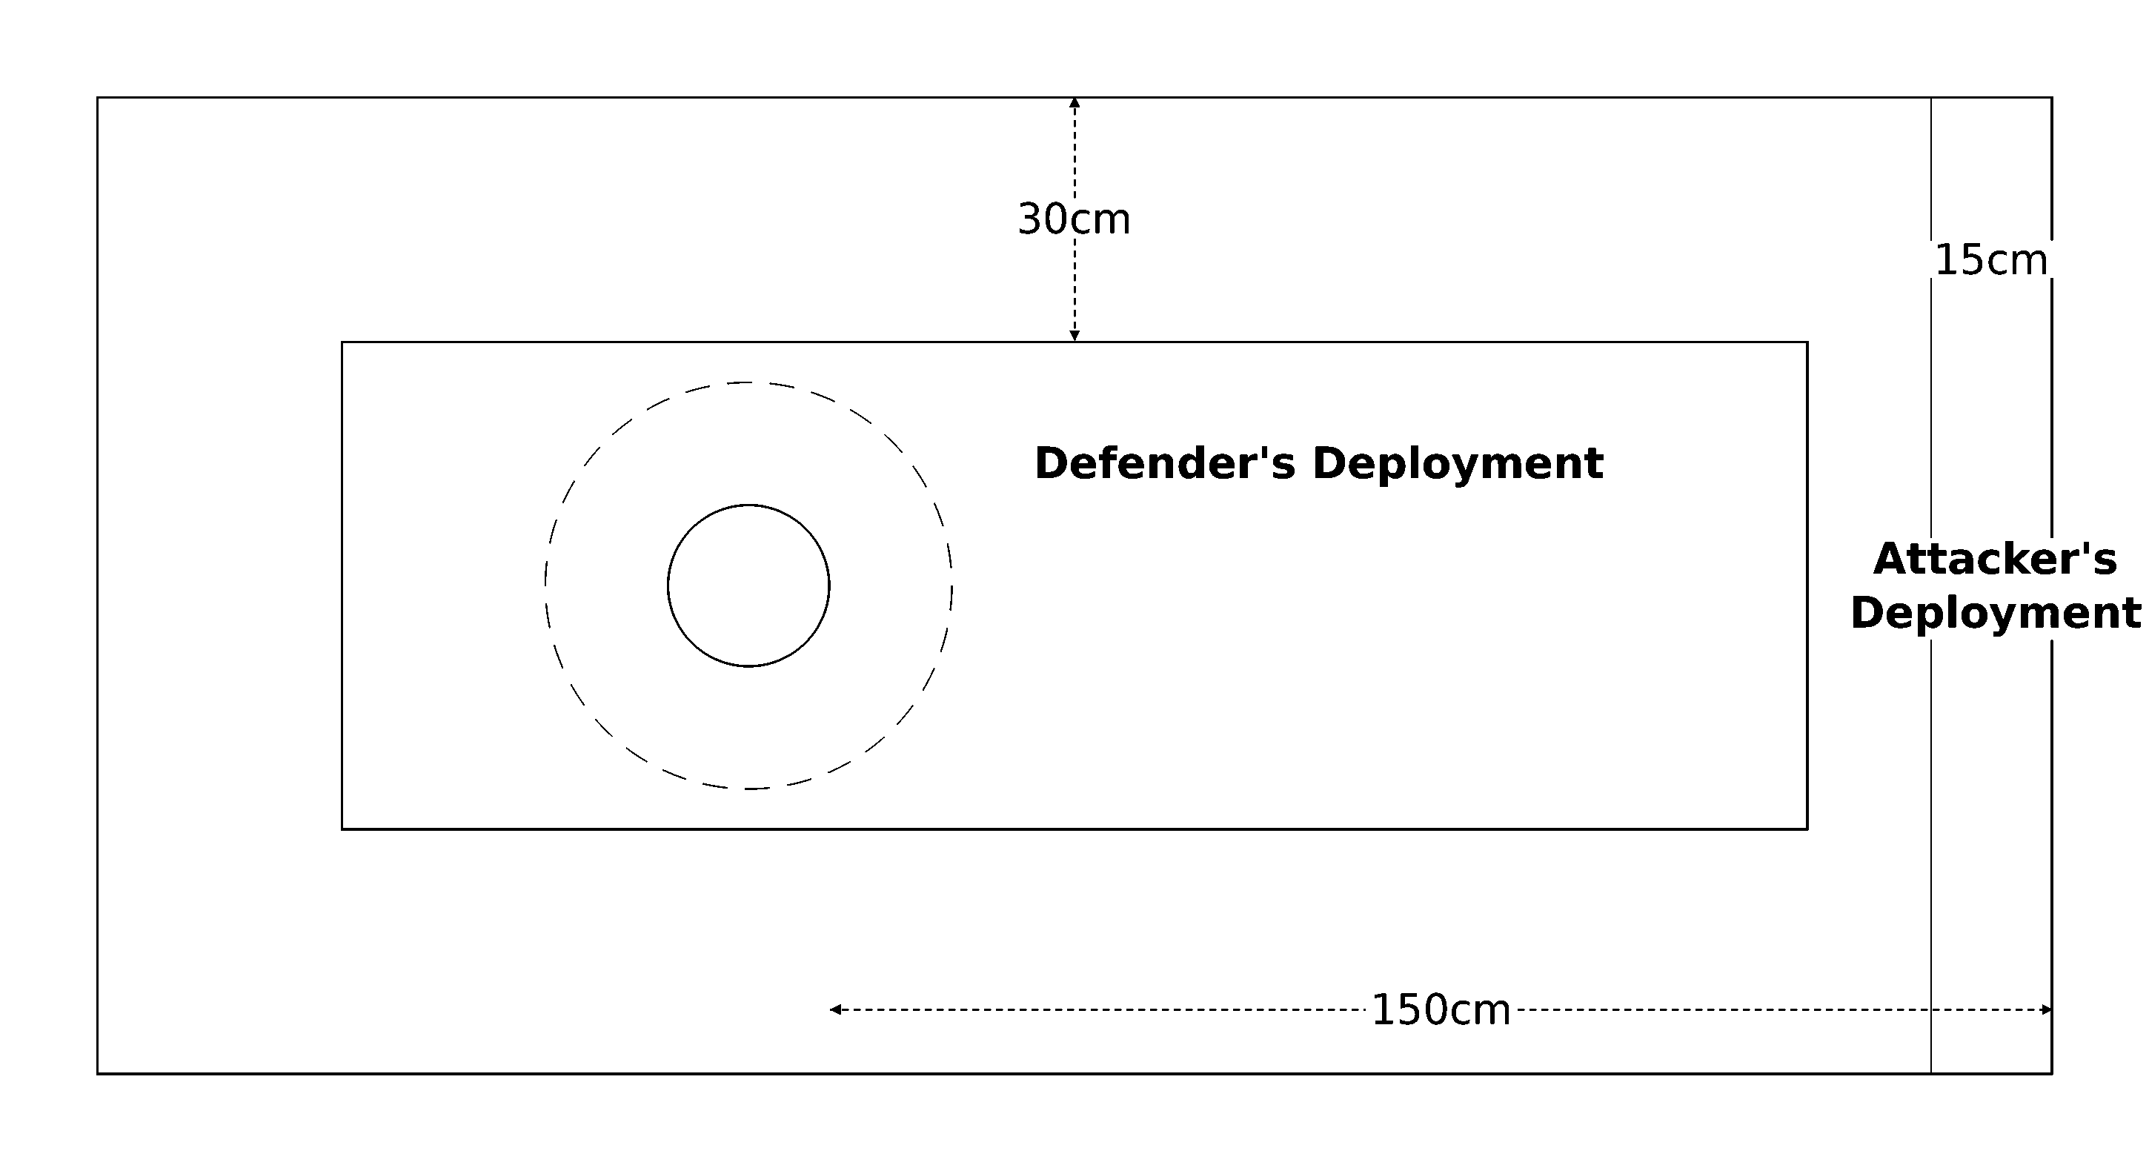
Planet placement and deployment zones
Set-up. The defender has most of their fleet stationed near the planet, but several ships or squadrons are out on patrol and will arrive later. The defender must choose one capital ship or escort squadron to be away on patrol for every 500 points (or portion thereof) in their fleet. Set the chosen ships aside. The remainder of the defender's fleet may then be deployed anywhere on the table further than 30cm from a table edge. The attacker then sets up their entire fleet within 15cm of the short table edge furthest from the planet. Note: a separate low-orbit table is needed for this scenario (source: rulebook p.54).
First Turn. Each player rolls a D6. The player with the higher score chooses whether to go first or second.
Special Rules. The Exterminator(s) must enter low orbit to attack the planet. At the start of each turn that an Exterminator is within 45cm of the planet table edge, roll a D6. On a result of 4+ the ship successfully deploys its Armageddon weapon, destroying the planet! As a result of this threat, defending ships may always treat Exterminators as the closest enemy for the purpose of target priority. The defender's patrols arrive at random. Roll a D6 for each ship and squadron away on patrol at the start of the defender's turn and consult the chart below. Arriving patrols move onto the board from a random table edge, determined as shown below.
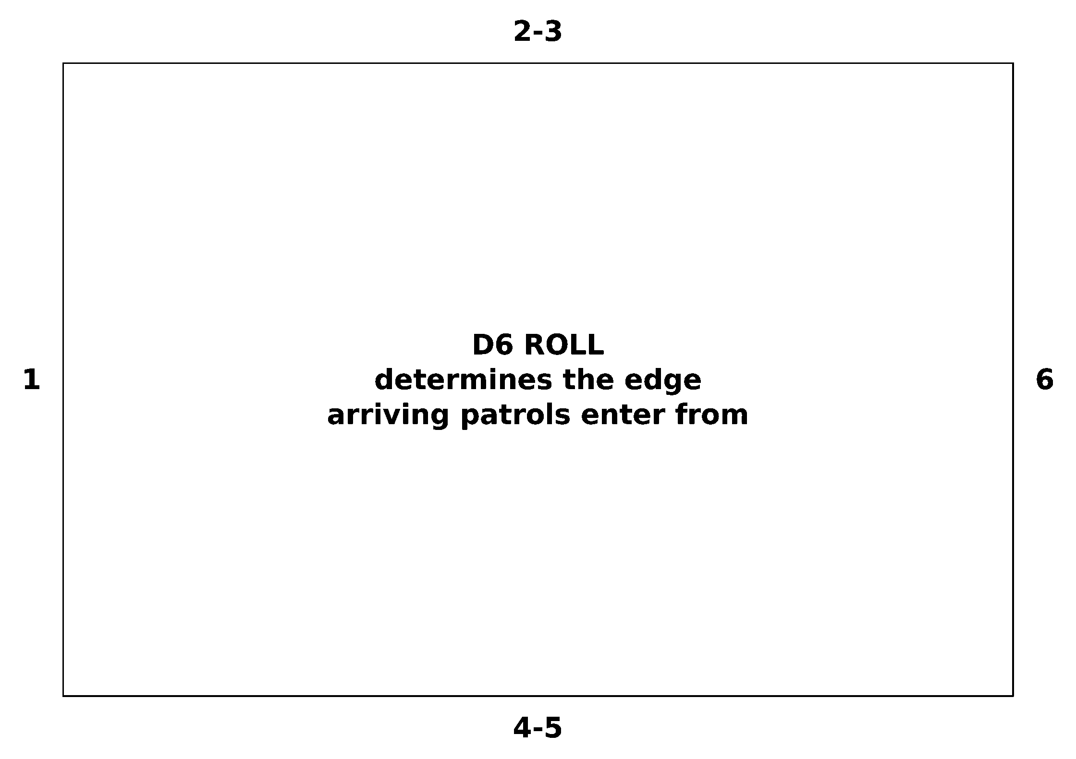
Random arrival edge by D6 roll

Slowest Speed | 20cm or less | 21-29cm | 30cm+
Arrives on a result of... | 5+ | 4+ | 3+

Game Length. The game lasts until the planet or all Exterminators are destroyed, or when one fleet disengages or is destroyed in its entirety.
Victory Conditions. If the planet is destroyed, the attacker wins. If all Exterminators are destroyed, the defender wins. Otherwise, whichever fleet holds the field at the end of the game is the winner. If you are playing in a campaign and the planet is destroyed, make a roll on the table below to determine the long-term consequences of the lost planet:
D6 Roll | Result
1-3 | The system becomes uninhabited. Mark it as such on the subsector map.
4-6 | The system's primary world is destroyed but one or more other planets still bear life. Roll a D6 to see what the system's new primary planet is: 1-3 = agri-world, 4-6 = mining planet.

Note: If you are interested in playing out the ground portion of a planetary assault through a game of Warhammer 40,000 and/or Epic 40,000, each assault point is worth 2000 and 400 points, respectively (see the Planetary Assault scenario below for assault points). This ratio will create some truly impressive battles, but feel free to use a smaller one where appropriate for the players' collections.
Flavour text: Heresy is like a tree, its roots lie in the darkness whilst its leaves wave in the sun and to those who suspect nought, it has an attractive and pleasing appearance. Truly, you can prune away its branches, or even cut the tree to the ground, but it will grow up again ever the stronger and ever more comely. Yet all awhile the root grows thick and black, gnawing at the bitter soil, drawing its nourishment from the darkness, and growing even greater and more deeply entrenched. Such is the nature of heresy, and this is why it is so hard to destroy, for it must be eradicated leaf, branch, trunk and root. It must be exorcised utterly or it will return all the stronger, time and time again, until it is too great to destroy. Then we are doomed., Prelude to The Abominatus
Flavour text: "We have arrived, and it is now that we perform our charge. In fealty to the God Emperor, our undying lord, and by the grace of the Golden Throne, I declare Exterminatus upon the Imperial world of Typhon Primaris. I hereby sign the death warrant of an entire world, and consign a million souls to oblivion. May Imperial justice account in all balance. The Emperor protects.", Last transmission before the destruction of Typhon Primaris

Alien Intervention
Source: BFG:XR Rulebook, printed p.103.
A hostile fleet thought to have abandoned the sector is instead found raiding a space hulk orbiting a nearby world. When this news reaches allied fleet command, a force is quickly gathered in an attempt to surprise the enemy and crush them. Unfortunately, the reconnaissance group was spotted by the enemy raiders. Now, allied forces have fallen into a trap and all seems to be in favor of the ruthless pillagers aligned against them. That is until sensors begin picking up traces of nearby alien warships...
Forces. Agree on a points limit for the battle. The attacker may spend up to this limit on their fleet. The defender may spend up to 75% of the agreed points limit on their fleet, and up to 25% of the agreed limit on a separate fleet of allies of convenience chosen from a different faction (this fleet is entirely separate, built using its own fleet list). This fleet can also be controlled by a third player, if desired.
Battlezone. The attack could take place anywhere from the flare region all the way to deep space. Use any of the methods on rulebook p.49 to determine the battlezone and any appropriate celestial phenomena. In addition, you must include one planet and one drifting hulk (source: rulebook p.24; you may use any capital ship to represent the hulk) anywhere within 30cm of the table's center.
Set-up. First, the defender deploys their entire fleet within 30cm of the table's center line, as shown below. Each defending ship or squadron must be set up at least 10cm apart and facing in the same direction. The attacker then deploys their fleet anywhere within 20cm of either short table edge (divided in any way the attacker chooses).
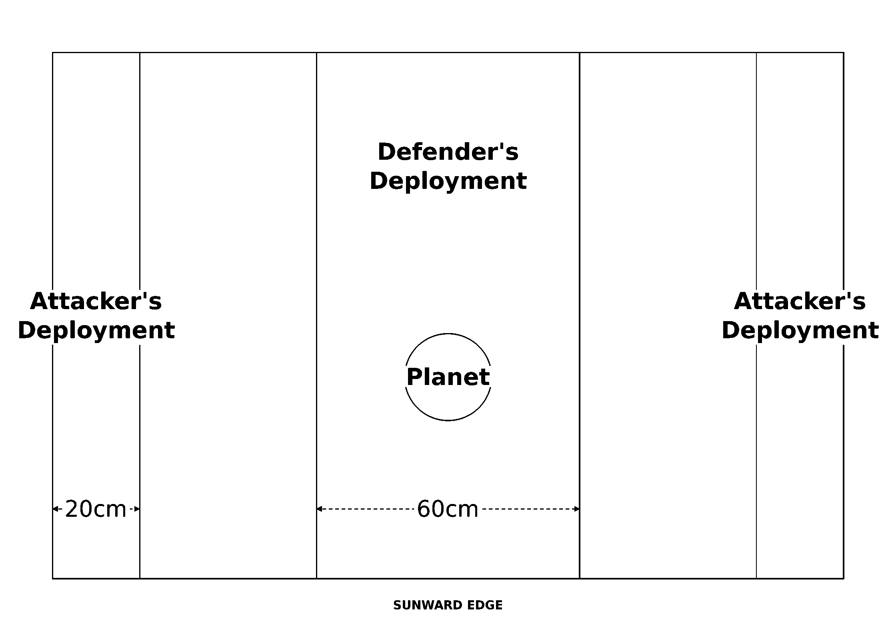
Deployment diagram
First Turn. The attacker rolls 2D6 and the defender rolls 1D6. The player with the highest total chooses whether to go first or second.
Special Rules. The defender's "alien reinforcements" are fickle, and will arrive randomly. Roll a D6 at the start of the defender's 2nd turn onward and consult the chart below. When the reinforcements arrive, the entire fleet enters from the long table edge of the controlling player's choice.
Turn Number | 2 | 3 | 4 | 5 | 6
Alien fleet arrives on... | 4+ | 3+ | 2+ | 2+ | Auto

Game Length. The game lasts eight turns, or until one side disengages or is destroyed.
Victory Conditions. Both fleets score victory points as normal, and the fleet with the highest victory points total at the end of the game wins. Note that all ships and squadrons from the "alien reinforcements" fleet are counted as part of the defender's forces for the purpose of scoring victory points.
Flavour text: Trust not in their appearance, for the Eldar are as alien to good, honest men as the vile Tyranids and savage Orks. There is no understanding them for there is nothing to understand, they are a random force in the universe.
Abaddon's 13th Black Crusade: If you are playing this scenario in a 13th Black Crusade Campaign, the Forces of Disorder are the attackers and the Forces of Order are the defenders, and the Eldar Corsairs represent the alien reinforcements.

Surprise Attack
Source: BFG:XR Rulebook, printed p.104.
The attacking fleet has launched a preemptive strike against their foe, catching the enemy unawares while its vessels are still taking on stores in dock over a nearby planet. The attacker's aim is simple: decimate the vulnerable opposing fleet before it can deploy and regroup. With most of their ships powered down on standby, the defenders must try to muster a response as quickly as possible before they are destroyed piecemeal by the approaching force.
Forces. Agree on a points limit for the battle. Both players may spend up to this limit on their fleets. In addition, the defender may spend an extra D6×10 points on planetary defenses for every 500 points (or portion thereof) in their fleet.
Battlezone. The attack takes place in the primary or inner biosphere (defender's choice). Set up a planet in the middle of the table. The planet's size depends on the size of the battle: up to 500pts = small, 501-1500pts = medium, 1501pts or more = large. Use any method on rulebook p.49 to place additional celestial phenomena as desired.
Set-up. First, the defender must choose D3 ships or squadrons in their fleet to be on full alert. These ships may be deployed anywhere on the table at least 30cm from a table edge. The rest of the defending fleet is on standby. Ships and squadrons on standby must be deployed within 15cm of the planet, with all ships abeam of the planet's surface, as shown below. The attacking fleet does not deploy; it will move onto the table during the first turn.
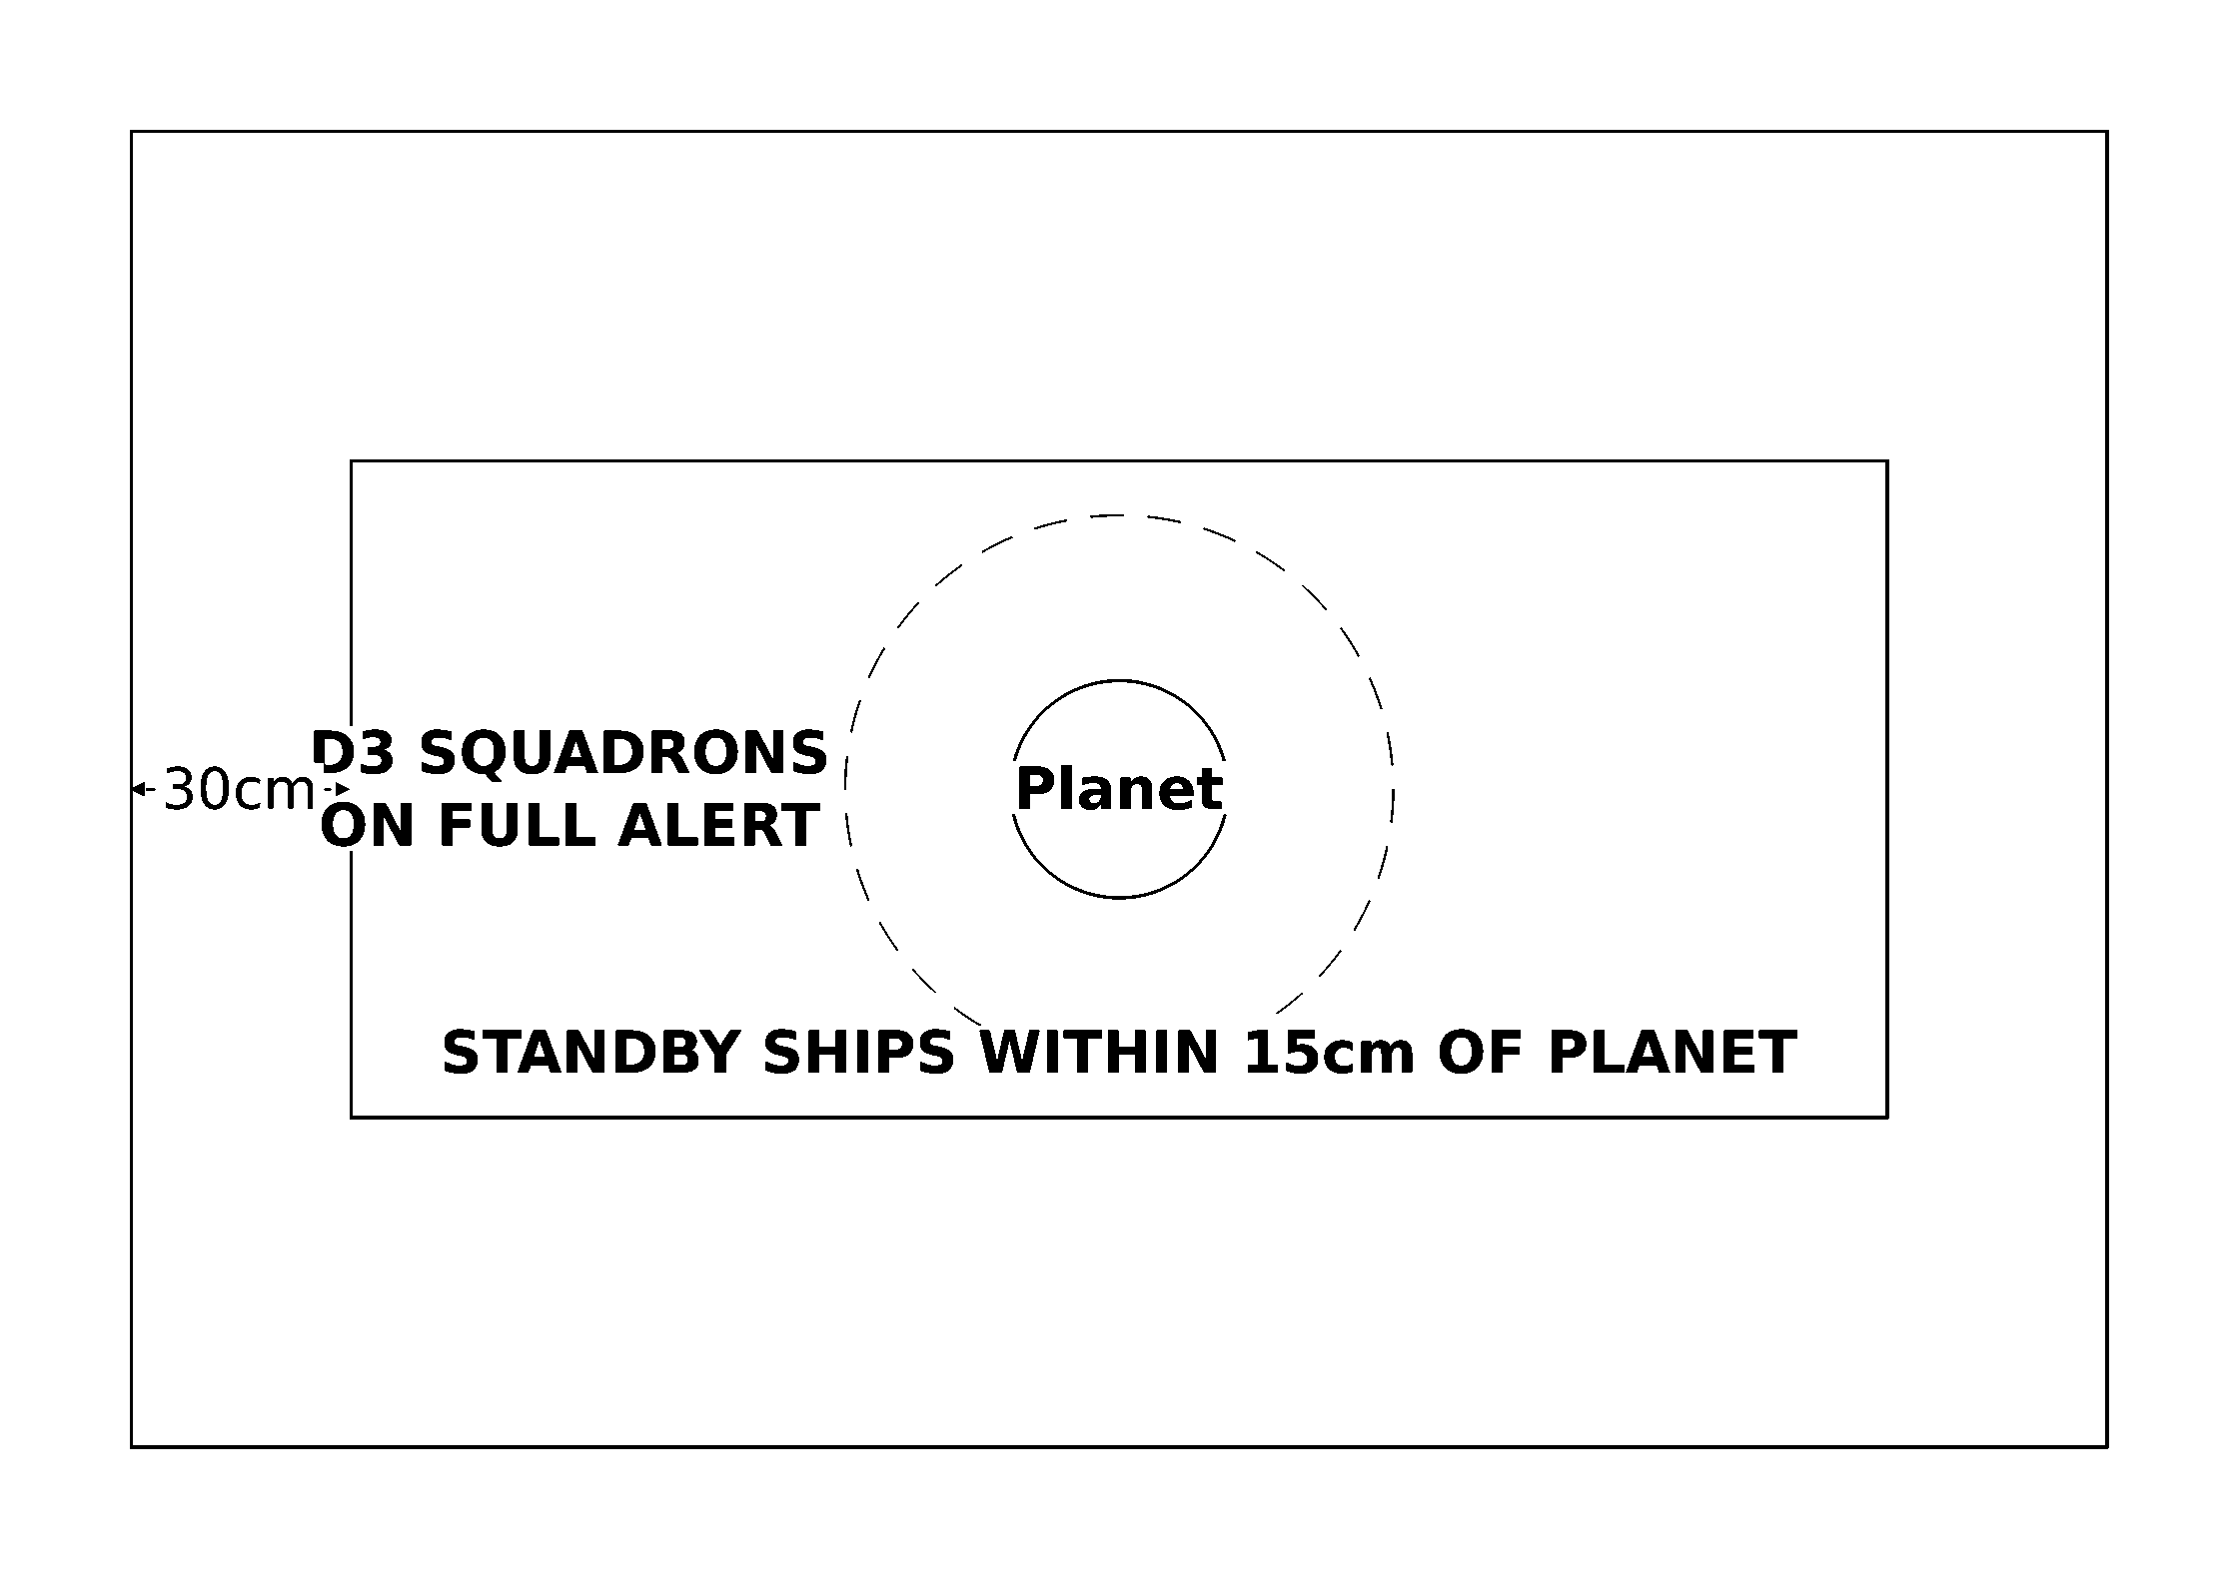
Full-alert and standby deployment
First Turn. The attacker goes first, choosing a table edge and moving their entire fleet onto the table from anywhere along that edge.
Special Rules. Ships and squadrons on standby may not move, shoot, launch ordnance, board, or make teleport attacks. However, they may attempt Brace for Impact orders, repair critical damage, and use their turrets against enemy ordnance. At the start of the defender's turn, each ship or squadron on standby may take a leadership test. Each ship or squadron that succeeds goes on full alert and may act normally, though it cannot use any special orders on that turn.
Game Length. The game lasts until one fleet disengages or is destroyed.
Victory Conditions. Both fleets score victory points as normal, and the fleet with the highest victory points total at the end of the game wins.

Planetary Assault
Source: BFG:XR Rulebook, printed p.105-106.
Although fleet engagements are vital to every war effort, the undeniable reality is that in the absence of an Exterminatus order, ground battles will ultimately determine who controls a system's resources and strategic position. To facilitate this, an attacking fleet will often be tasked with deploying troops onto the surface of a contested planet, either to spearhead an invasion or reinforce existing armies. Doing this will not be easy however; they must smash through enemy defenders and hold off any counterattack while the troop transports make their landing.
Forces. Agree on a points limit for the battle. Both players may spend up to this limit on their fleets. In addition, for every 500 points (or portion thereof) in the players' fleets, the attacker must take 2 transport capacity worth of convoy ships while the defender may spend an extra D6×10 points on planetary defenses.
Battlezone. The defender determines whether the battle is fought in the primary or inner biosphere. Place a planet (D6: 1 = small, 2-5 = medium, 6 = large) no more than 150cm from any short table edge, as shown below. Use any method on rulebook p.49 to place additional celestial phenomena.
Planet placement and deployment zones
Set-up. First, the defender must choose which ships and squadrons in their fleet are on patrol or on alert. Those on alert must be deployed within the planet's gravity well. For each ship or squadron on patrol, roll a D6. On a result of 1-3, that ship or squadron is placed by the attacker. Otherwise, it is placed by the defender. Ships on patrol must be deployed at least 30cm from a table edge, not within an area of celestial phenomena, and facing a direction of the defender's choice (regardless of who placed them). The attacker then sets up their entire fleet within 15cm of the short table edge furthest from the planet. Note: a separate low-orbit table is needed for this scenario (source: rulebook p.54).
First Turn. Each player rolls a D6. The player with the higher score chooses whether to go first or second.
Special Rules. At the start of the attacker's shooting phase, they may direct any of their capital ships and/or convoy vessels within 30cm of the planet table edge (excluding those that are in the process of boarding or being boarded) to assault the planet rather than fight normally. Ships attacking the planet must focus all their efforts on doing so and thus cannot shoot, launch ordnance, or make teleport attacks for the rest of the turn. For each ship that assaults the planet, the attacker scores a number of assault points equal to twice that ship's transport capacity. All capital ships are treated as having a point of transport capacity at a minimum for this purpose, unless otherwise specified.
Escort-sized convoy ships that land on the planet (source: rulebook p.54) may score on the same turn they do so (as if they were within 30cm of the planet table edge), but not on any subsequent turns. Furthermore, the defender will still score victory points for ships that disengage this way. Keep in mind that this scoring method is only for escort-sized vessels, capital ships cannot land!
Game Length. The game lasts until the attacker scores 10 or more assault points, or one fleet disengages or is destroyed.
Victory Conditions. Tally up the attacker's total assault points, adding +1 for every full 500 victory points they earned and deducting -1 for every 500 victory points (or portion thereof) earned by the defender. If the attacker holds the field, each attacking capital ship and convoy ship on the table (not counting crippled ships) scores one final time (as described above). Look up the total result below:
Total | Result
0-1 | Defender's Victory.
2-5 | Defender's Marginal Win.
6-9 | Attacker's Marginal Win.
10+ | Attacker's Victory.

Note: If you are interested in playing out the ground portion of a planetary assault through a game of Warhammer 40,000 and/or Epic 40,000, each assault point is worth 2000 and 400 points, respectively. (This ratio will create some truly impressive battles, but feel free to use a smaller one where appropriate for the players' collections.)
Flavour text: "When the people forget their duty they are no longer human and become something less than beasts. They have no place in the bosom of humanity nor in the heart of the Emperor. Let them die and be forgotten.", Leto Barbaden, Governor of Salinas

Escalating Engagement
Source: BFG:XR Rulebook, printed p.107.
Any tactician worth their salt knows that the only thing worse than disregarding battlefield intelligence is assuming that it is infallible. As such, it is wise for a fleet traversing contested space to proceed with caution, lest it find itself suddenly outmaneuvered and out-gunned. In this scenario, two opposing fleets are in the area, each unsure of the enemy's size and disposition. As they split to spread their search wider, two groups come into contact and signal the rest of their forces. Whose ships will arrive first? Will they be able to overcome the enemy? Only time will tell...
Forces. Agree on a points limit for the battle. Both players may spend up to this limit on their fleets. Each player then gathers five contact markers (25×30mm triangular tokens with numbers on one side work best) and divides their fleet into divisions, each corresponding to one of their contact markers. Note which forces are assigned to each marker. There are no restrictions as to what ships can be in a division, but each division must have at least one ship or squadron assigned to it. Once a division moves onto the table, its ships may move normally; they are not constrained to stay together like a squadron.
Battlezone. The attack could take place anywhere from the flare region all the way to deep space. Use any of the methods on rulebook p.49 to determine the battlezone and any appropriate celestial phenomena.
Set-up. Both players must randomly select one contact marker (without showing their opponent the division it represents). These will be the players' starting forces. Each player then rolls a D6. The player with the higher score chooses whether to place their marker first or second. Contact markers may be placed anywhere on the table at least 30cm from the table edge and at least 60cm from an enemy contact marker. Once both markers have been placed, reveal the divisions they represent. The players then deploy those divisions' forces anywhere within 10cm of their respective markers, starting with whoever placed their contact marker last.
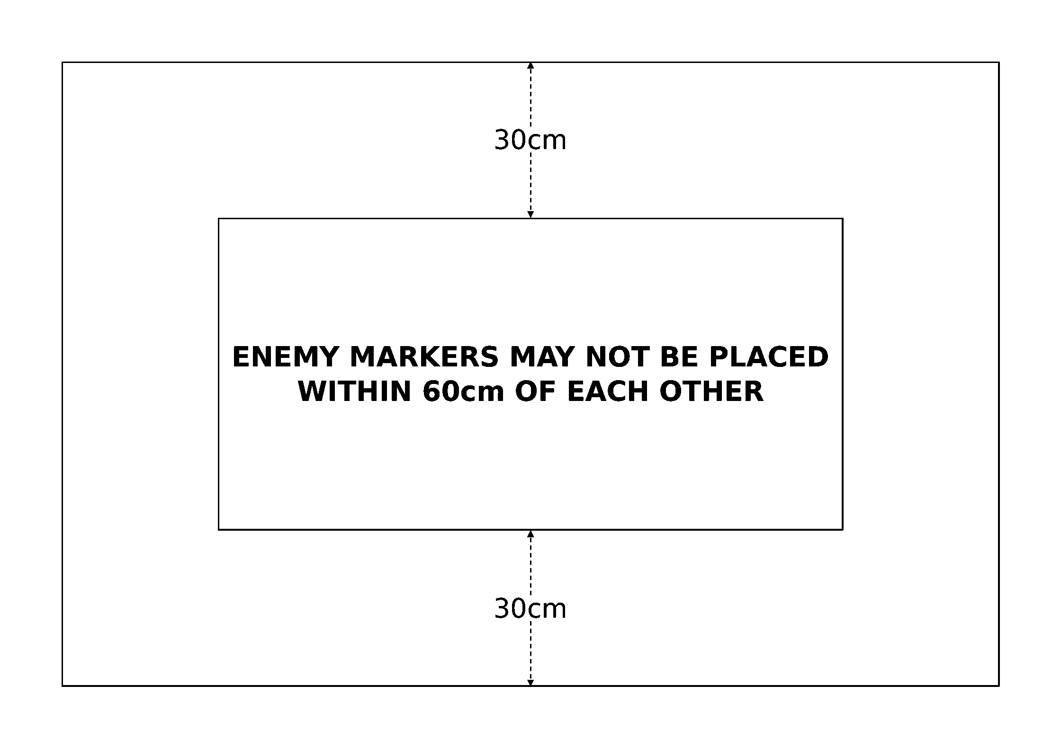
Deployment diagram
First Turn. Each player rolls a D6. The player with the higher score chooses whether to go first or second.
Special Rules. In the end phase of each player's turn, that player randomly selects another one of their contact markers (again without showing their opponent the division it represents) and places it along a randomly rolled table edge according to the following restrictions: the marker cannot be placed within 60cm of any enemy ships; if there are friendly ships within 30cm of that table edge, the marker must be placed within 30cm of at least one of those ships.
At the beginning of a player's turn, that player may try to bring additional ships into play by rolling a D6 for any of their contact markers already placed on a table edge and consulting the chart below:
Slowest Speed | Division arrives on*
20cm or less | 5+
21-29cm | 4+
30cm+ | 3+

If friendly ships are within 30cm of the contact marker, add +2 to the dice roll.
If the division arrives successfully, each of its ships and squadrons must move onto the table from anywhere along the marker's table edge that is within 10cm of the marker. Then remove that division's contact marker from the game. Otherwise, the player may move that contact marker in either direction along its table edge, up to a distance equal to the speed of the slowest ship in the division.
Game Length. The game lasts until one fleet disengages or is destroyed.
Victory Conditions. Both fleets score victory points as normal, and the fleet with the highest victory points total at the end of the game wins.

Fleet Engagement
Source: BFG:XR Rulebook, printed p.108-109.
While the majority of void-based conflicts in an interstellar war are fought by relatively small forces with specific objectives, it is inevitable that sometimes a direct engagement is the only means to protect a system, hold back a hostile advance, or simply crush all enemy resistance. These types of battles are often both tactically and strategically decisive; failure to defeat one's foe in such a large-scale showdown usually means extensive loss of territory, resources, or fighting strength, and may even spell the doom of the entire war effort.
Forces. Agree on a points limit for the battle. Both players may spend up to this limit on their fleets. For this scenario, ignore the usual rules for determining the attacker and defender, this will be decided by the set-up rules instead.
Battlezone. The attack could take place anywhere from the flare region all the way to deep space. Use any of the methods on rulebook p.49 to determine the battlezone and any appropriate celestial phenomena.
Set-up. Each player secretly chooses one of the following formations for their fleet and writes it down. Reveal the opposing fleet's formations simultaneously and then compare the two formations on the table below to determine the attacker and defender, as well as which battle set-up to use.
Sphere: This formation attempts to spread the fleet so that it envelops the enemy, surrounding it as the sphere closes in. It is vulnerable to the wedge formation however, which can break through the closing net.
Wedge: This formation keeps the fleet closely packed together for mutual support and allows it to storm through thinly-spread opponents. However, it offers no flexibility against the cross formation.
Cross: This formation spreads its ships out to run parallel with the enemy fleet, keeping them abeam for an extended engagement. The cross may be engulfed by the sphere formation, however.

Your Choice \ Opponent's Choice | Sphere | Wedge | Cross
Sphere | B | A (Atk) / C (Atk) | A (Atk) / D (Atk)
Wedge | A (Def) / C (Def) | D (Atk) / D (Def) | B
Cross | A (Def) / D (Def) | B | B

Where the table shows two possible results (e.g. "A (Atk) / C (Atk)"), each player must roll a D6 and apply the following modifiers:
The Fleet With the... | Adds
Fastest ship (by Speed characteristic) | +1
Best commander (by Ld characteristic) | +1
Most escorts | +1

The player with the higher score chooses which of the two set-up diagrams to use (A to D, below). Note that the choosing player always uses the formation comparison that applies to their own fleet. For example, if the choosing player is using the wedge formation and their opponent is using sphere formation, they will be the defender in their choice of either set-up A or set-up C. Alternatively, if both players are using the wedge formation, the choosing player decides whether they will be the attacker or the defender in set-up D.
Once the proper set-up configuration has been determined, both players roll a further D6. Starting with whoever rolled the lowest, players alternate placing one ship or squadron in their respective deployment zones until all forces have been placed. The players' deployments are also subject to the following rules:
Divisions: Some set-ups may split a fleet's deployment zone into several divisions. When this happens, the fleet must deploy at least one ship or squadron in each available division.
Approach Angle: Each set-up diagram has arrows indicating the approach angles for the opposing fleets. As ships are deployed, they must be oriented so that they are facing in the same direction as the arrow in their division.
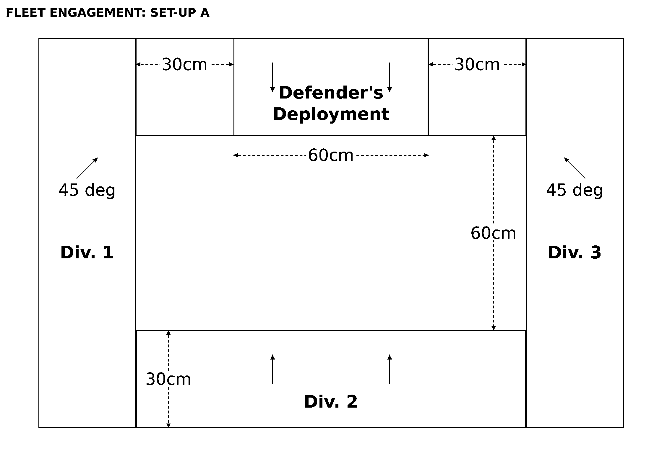
Set-up A
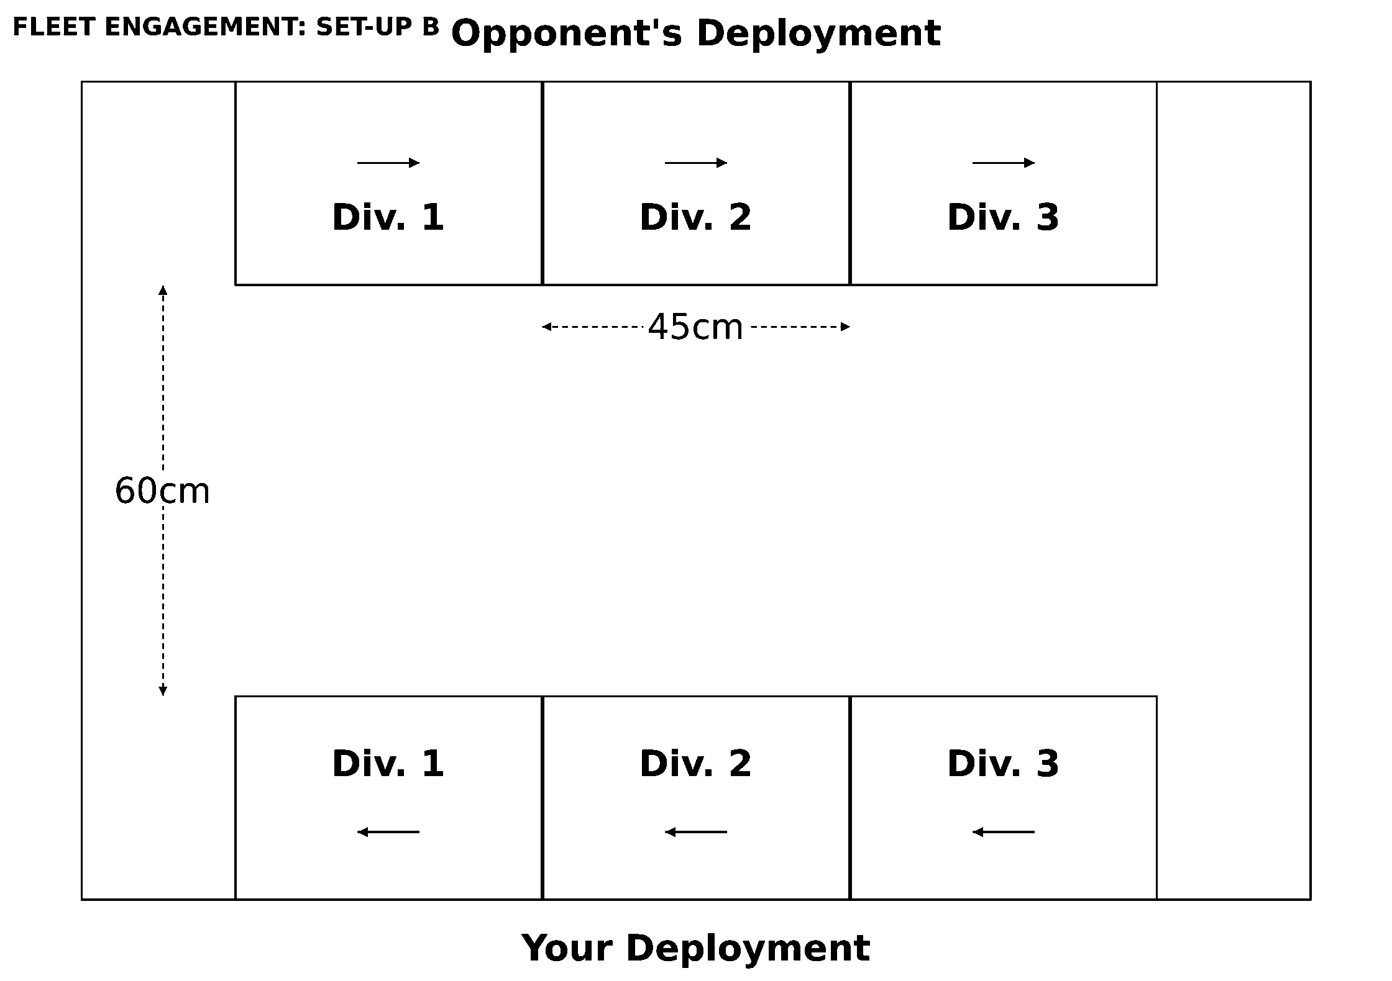
Set-up B
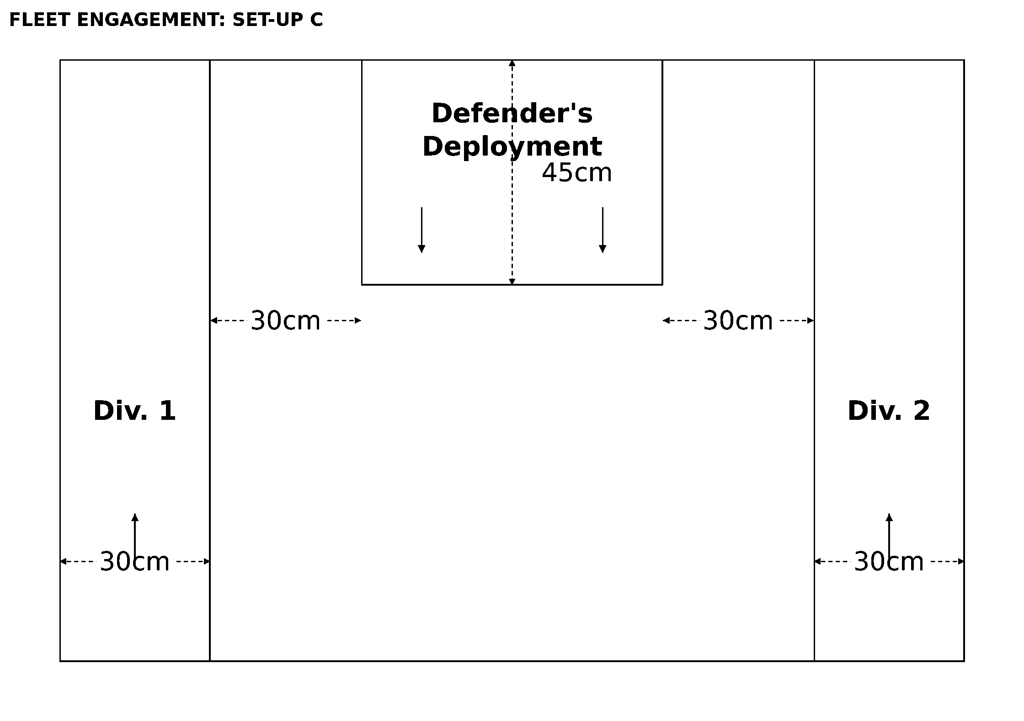
Set-up C
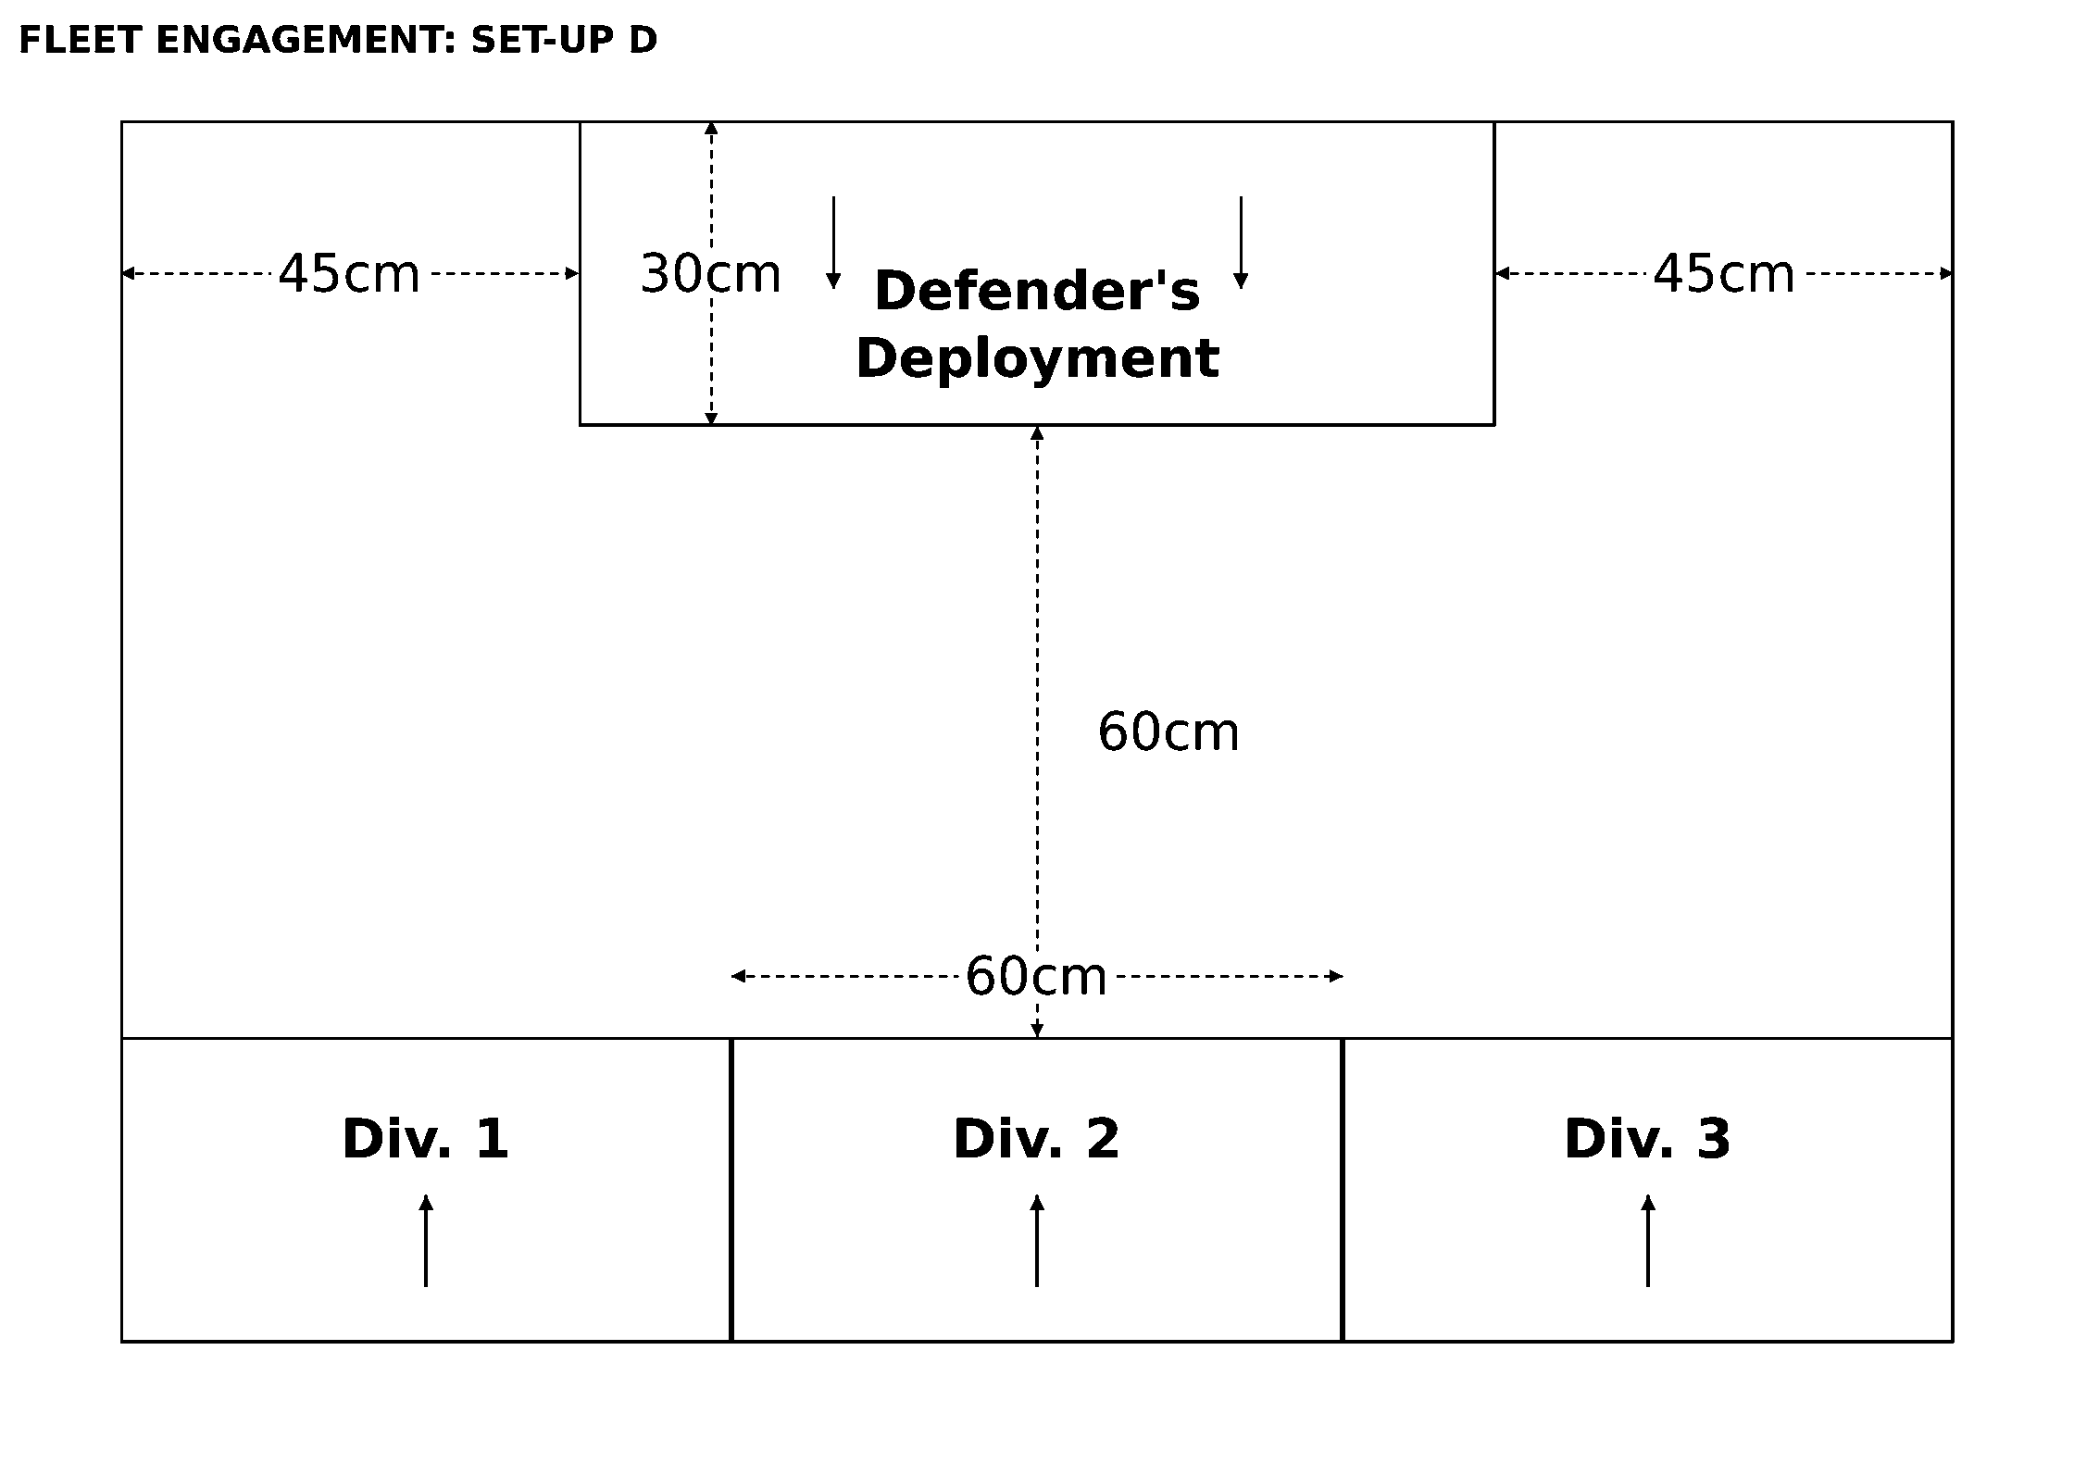
Set-up D
First Turn. Each player rolls a D6. The player with the higher score chooses whether to go first or second.
Game Length. The game lasts until one fleet disengages or is destroyed.
Victory Conditions. Both fleets score victory points as normal, and the fleet with the highest victory points total at the end of the game wins.
Flavour text: I have seen with mine own eyes many long and terrible wars. I have met brave men and good men whose deaths have weighed heavily upon my soul. On Anathasia I was witness to the Conquests of Zhar and the burning ruins of Ramnion haunt me still. On Badab I watched as the Tyrant's own fortress fell in dark ruin after so many years of unholy war. Even then I was not glad, for too many had fallen who were needed elsewhere. Too many lives extinguished whilst our enemies grew ever more powerful. Yet in all my many years I have never seen a sight as terrible as that great battle at the Gates of Athan. That horde of Chaos came on as a sea of blood that stretched from horizon to horizon without end. Over it hung a stink of death, a black cloud of evil which tainted the sky with its obscenity. I cannot think of it still without terror, and must endure a moment's panic to write even these few words. Even so, the Eldar did not flinch but stood their ground with a determination that exceeded human resolve as the strength of steel outmatches mortal flesh. And that was when I witnessed for the first and only time the strange secret of that race, seeing then what few humans have seen, the thing beyond human comprehension, the great daemon that is the Avatar of the Eldar., Historicus Ostalan Varus

Overview
Source: BFG:XR Rulebook, printed p.110.
This section of the book features three special scenarios, each representing a singularly climactic battle where the fate of an entire world hangs in the balance. The first two serve as the grand finales of the Third Armageddon War and Abaddon's 13th Black Crusade campaigns, respectively, while the third is a truly unique experience. These have been separated from the standard raids and battles due to requiring more elaborate set-ups and/or larger forces than normal. As a result, choosing to play any of these scenarios is something you should discuss with your opponent, in the same way as any of the introductory scenarios.
Flavour text: "We fight the long war, not through vain notions of duty and honour, but through a far purer purpose: hatred. At the height of our glory we were betrayed and cast out by our kin. Guilliman, Dorn, Sanguinius, these are names I curse. Horus, Perturabo, Angron, these are names I revere, names I would follow to the very end. It is this hatred that has sustained me through the long millennia. I tend it with bitterness. I nurture it with the deaths of my former brothers. For I know that when the end is upon us and Horus is returned, then the false emperor shall be cast down from his sepulchral Golden Throne, and we shall take our rightful place at the side of Horus, the true Emperor of Mankind.", Ferrous Ironclaw, Iron Warriors Warsmith, 2nd Grand Company

The Defense of Pelucidar
Source: BFG:XR Rulebook, printed p.111. Grand-finale scenario for the Third Armageddon War Campaign.
The initial elements of Ghazghkull's fleet entered the Armageddon system on the Day of the Feast of the Emperor's Ascension, a time when the Imperial Navy was building up to full alert status. Admiral Parol knew that time was of the essence as the forces of the Imperium marshaled their strength on Armageddon itself and that it would be the task of his fleet to buy this valuable time in the face of an immense Ork fleet. The Defence of Pelucidar was actually a huge engagement and so this scenario concentrates on only a small portion of the battle. The Imperial player, representing Admiral Parol, must cause as much damage as possible to the Ork fleet whilst trying to minimize his own losses. Initially, the Ork fleet will be poorly organized, but their strength will soon increase and threaten to overwhelm the Imperial force.
Forces. The battle takes place between the defending Imperial Navy and the attacking Orks, at the end of the Third Armageddon War. The Imperial player may spend up to 1500 points on their fleet, but may only include cruisers, battlecruisers, and battleships (no grand cruisers, light cruisers, or escorts), as well as up to four minefields at their normal cost. The Ork player starts with no ships or fleet, their forces will arrive at random throughout the battle (arriving ships always use their default profile; they do not get any refits).
Battlezone. The planet Pelucidar is located in the outer reaches of the Armageddon system. Generate any random celestial phenomena appropriate to the battlezone, then have the Imperial player place a medium planet (representing Pelucidar) anywhere on the table more than 5cm from a table edge.
Set-up. The defending Imperial fleet deploys first. Each defending ship and squadron must be set-up at least 30cm from any table edge, at least 20cm from another ship or squadron, and all facing directly towards the same table edge. The Ork player does not have any ships at this point and thus does not deploy anything.
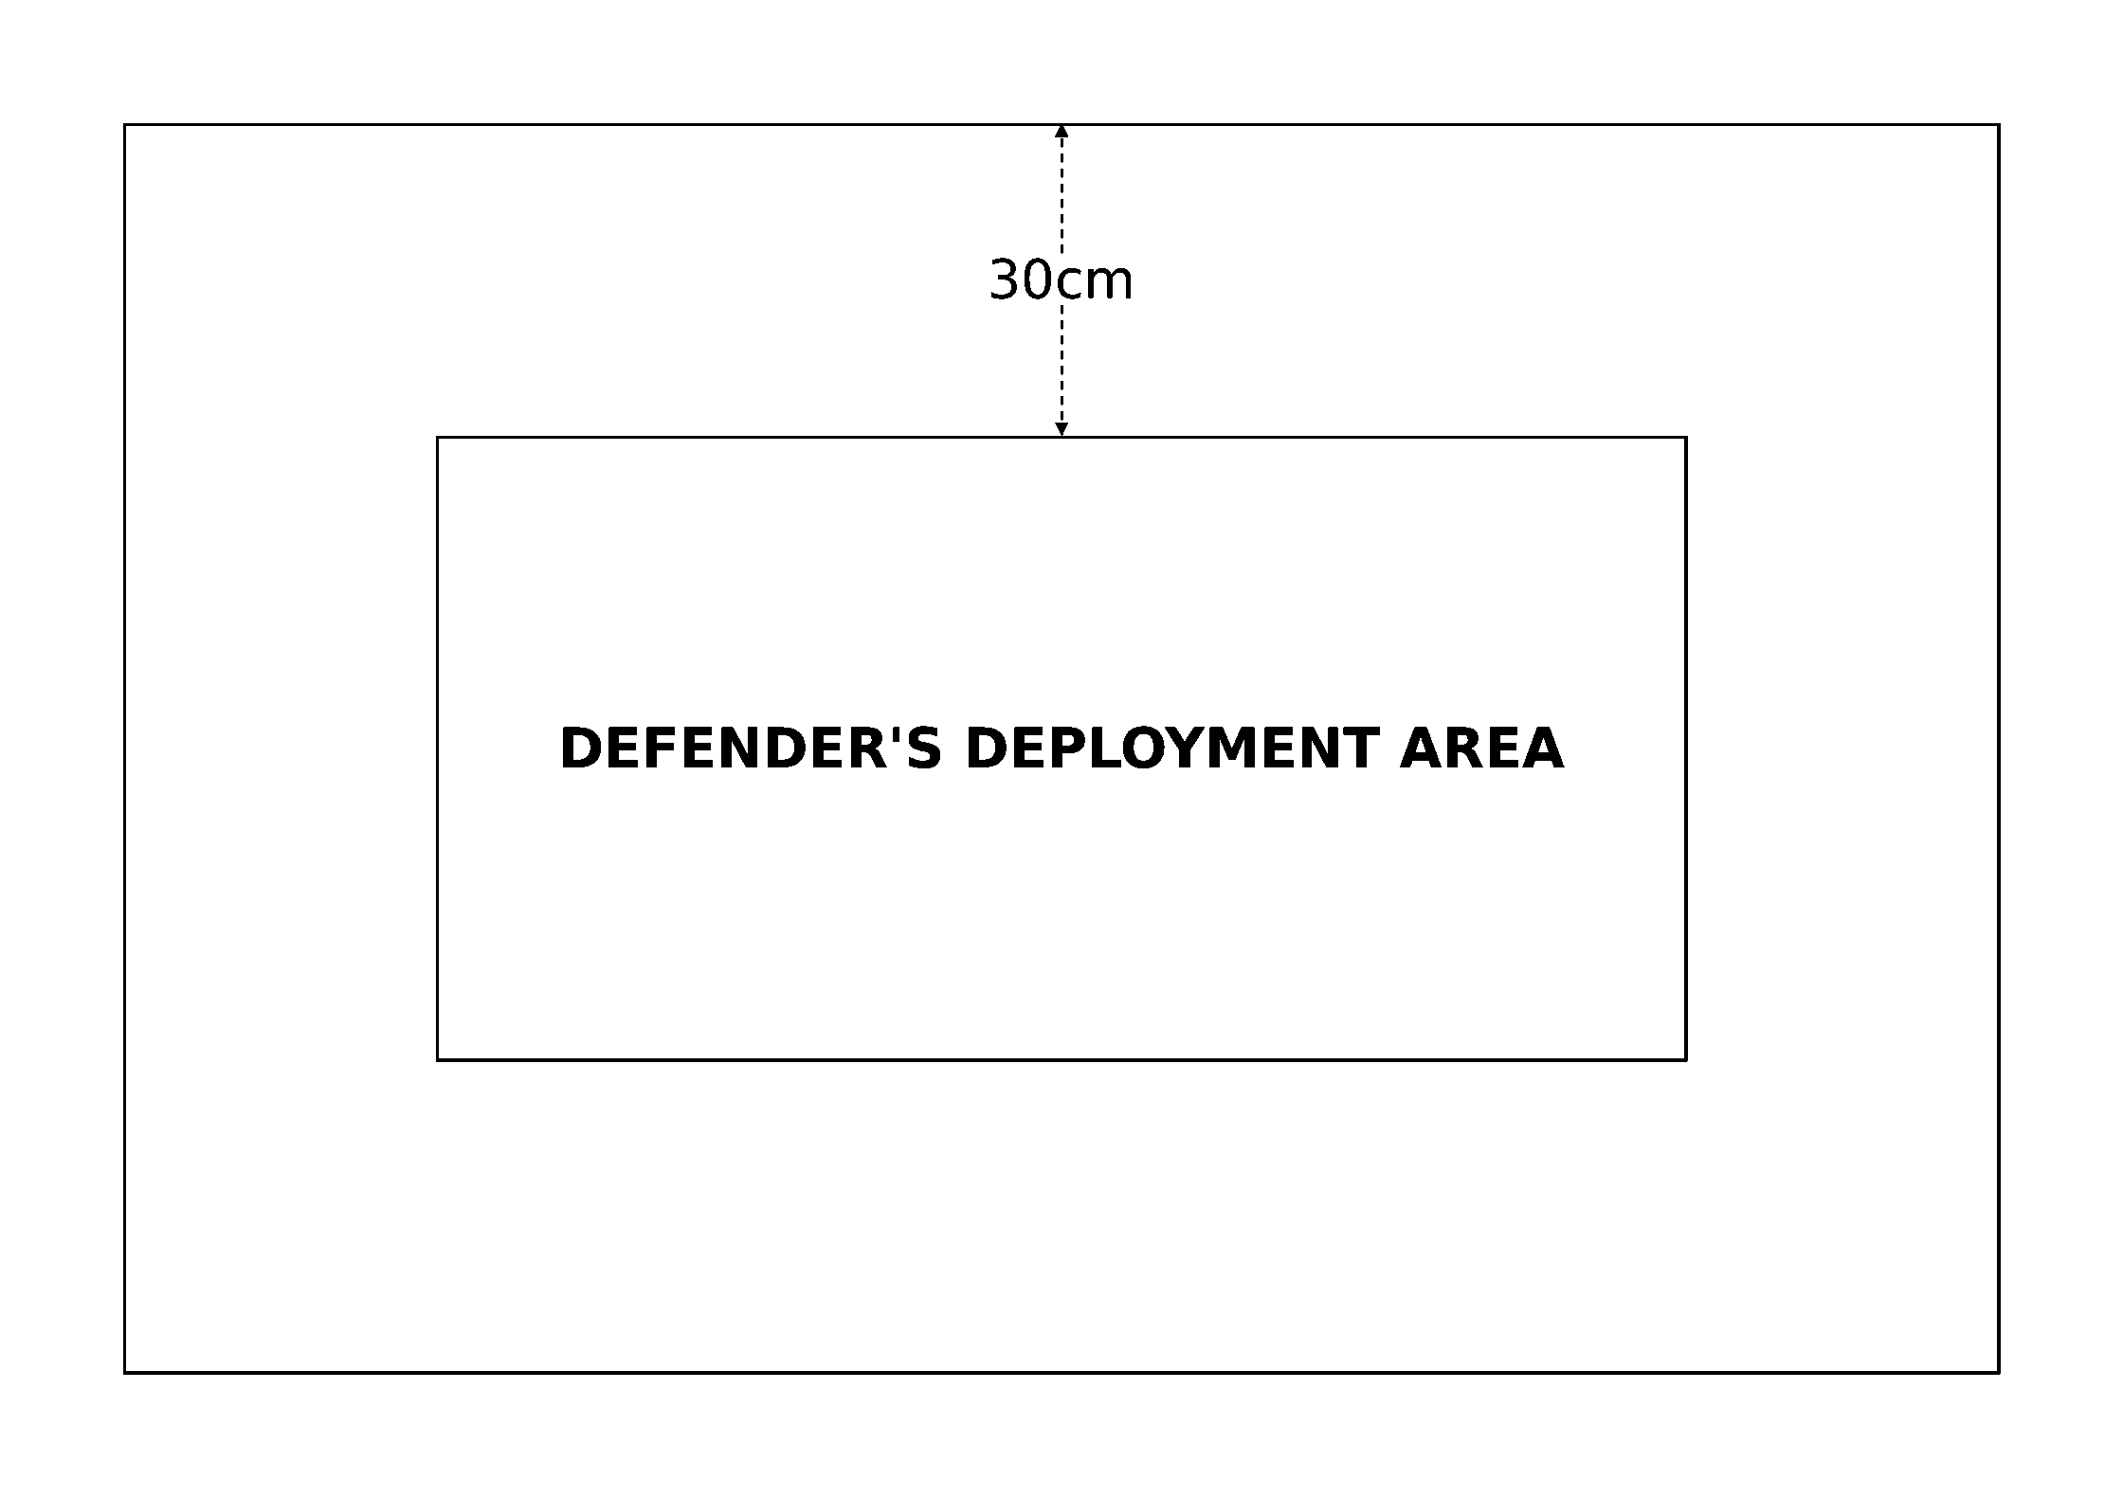
Deployment diagram
First Turn. The Orks always take the first turn.
Special Rules. At the start of each of their turns, the Ork player rolls on the chart below to determine what forces from Ghazghkull's fleet will arrive. The first few turns will go by quickly, but things will intensify rapidly as more and more Ork ships join the battle. If the Ork player rolls a result that they cannot field due to lack of models, use the next lowest result on the table instead. For example, if an 11 is rolled but the player has run out of capital ships, the Orks receive three squadrons of escorts instead.
D6 + Turn Number | Forces
2-4 | 1 Wave of 4 Squadrons of Fighta-Bommerz
5-6 | 1 Squadron of D6 Escorts (in any combination desired)
7-9 | 2 Squadrons of D6 Escorts each (in any combination desired)
10 | 3 Squadrons of D6 Escorts each (in any combination desired)
11 | 1 Kill-Kroozer, Terror Ship, or Basha Lite Kroozer
12 | 2 Kill-Kroozers, Terror Ships, or Basha Lite Kroozers
13-14 | 1 Hammer Class Battlekroozer or Ork Rok
15+ | 1 Ork Space Hulk

Game Length. The game lasts until the Imperial fleet disengages or is destroyed (it will continue even if there are no Ork ships on the board at the end of a turn).
Victory Conditions. Both fleets score victory points as normal, except that neither fleet counts as holding the field at the end of the game. If the Imperial fleet scores at least 2000 more victory points than the Orks, they win. Any other result is a triumph for the Orks.

Macharia's End
Source: BFG:XR Rulebook, printed p.112. Grand-finale scenario for Abaddon's 13th Black Crusade Campaign.
The dreaded Planet Killer has managed to battle its way to the planet Macharia with the help of a sizable Chaos armada. If action is not taken immediately, the unthinkable will happen. Data gathered from previous victims of the Planet Killer indicate that its Armageddon gun takes a considerable amount of time to charge up before it is capable of destroying a planet. This means that there may still be enough time to thwart the Chaos fleet and save Macharia if swift Imperial vengeance is brought upon Abaddon's infernal machine.
Forces. This battle is fought between the defending Imperial Navy and an attacking Chaos armada at the conclusion of Abaddon's 13th Black Crusade. The Chaos player may spend up to 1500 points on their fleet in addition to including the Planet Killer at no cost. The Imperial player may spend up to 2000 points on their fleet, of which 500 points may be split off as the fleet's vanguard.
Battlezone. The battle takes place over Macharia, located in the system's primary biosphere. Place Macharia itself (a medium planet) in the center of the Imperial player's short table edge, as shown below. Randomly generate any other celestial phenomena appropriate to the battlezone.
Set-up. First, the Imperial player deploys their main fleet (without the vanguard) within 20cm of their short table edge (the same side as the planet Macharia). The Chaos player then sets up their whole fleet except the Planet Killer within 10cm of their short table edge (on the other side of the board). The Imperial player may then deploy their vanguard forces anywhere within 5cm of the centerline dividing the Imperial and Chaos sides of the table.
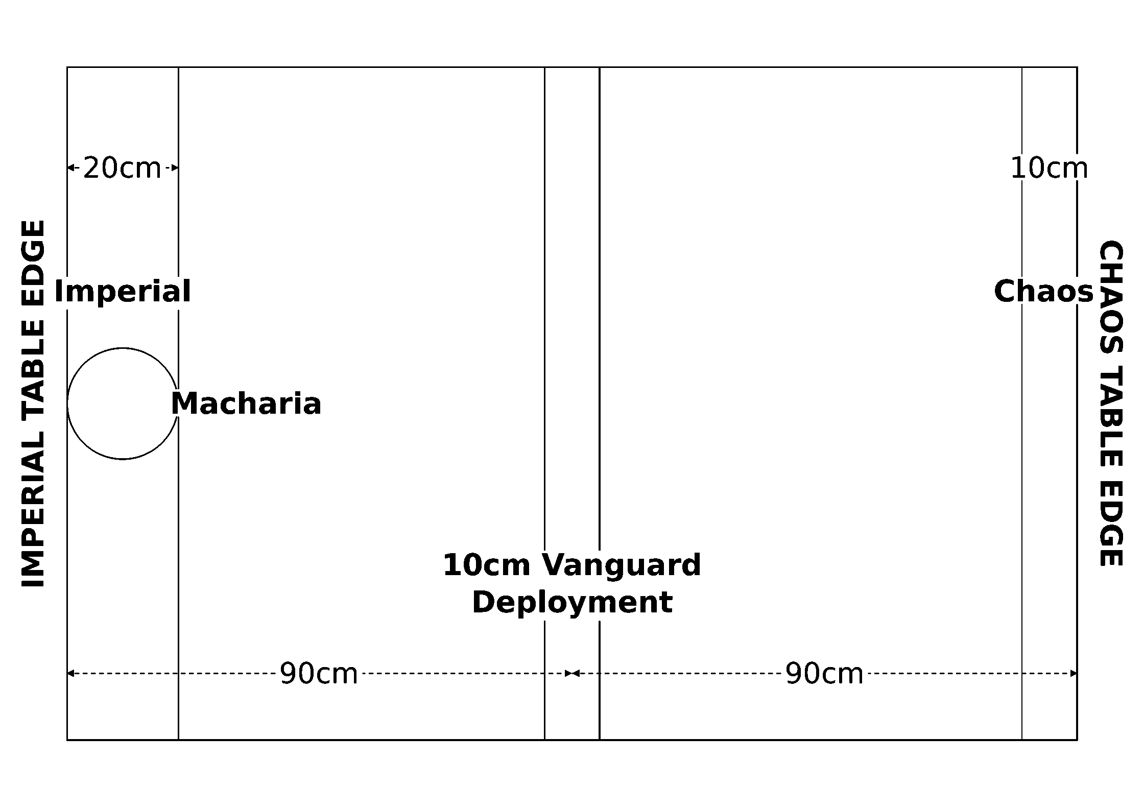
Deployment diagram
First Turn. The Imperial player takes the first turn. At the start of the first Chaos turn, the Planet Killer must move onto the board from the Chaos player's short table edge.
Special Rules. This scenario uses some additional special rules for the Planet Killer and its Armageddon Gun in conjunction with its rules found in the Chaos faction list.
No Retreat: Abaddon is committed to his course; if the Planet Killer would disengage, treat it as being destroyed instead.
Armageddon Overcharge: For this scenario, the Planet Killer needs to overcharge its main weapon in order to deal the deathblow to Macharia. While it can use this weapon normally if desired, it must overcharge the weapon in order to win the game. At the start of the Chaos player's turn, they may decide whether or not to begin the charge-up sequence for the Armageddon Gun. If they do, place a charge counter (such as a coin) next to the Planet Killer. Add another counter at the start of each subsequent Chaos turn. Once 3 counters have been accumulated the gun must fire during the Shooting Phase.
While Overcharging the Gun: The Planet Killer cannot turn, attempt special orders, or fire its lances while charging, but it gains an additional +2 shields. Once started, the charging process cannot be stopped.
Firing the Overcharged Gun: Place the Nova Cannon template so that it is touching the Planet Killer's stem, then move it directly ahead 60cm (just like firing it normally, but with shorter range). If any part of the template passes over any ship's base, that ship is completely destroyed. If the hole in the center of the template touches Macharia, the planet is obliterated and the game is over.
Recharging: If for some reason you manage to miss Macharia with the overcharged blast (how did you do that?!), the Planet Killer must pass two Reload Ordnance special orders across two consecutive turns to bring the weapon back online. During this time, it can do nothing except move (and attempt to Reload Ordnance).
Game Length & Victory Conditions. The game lasts until Chaos wins by destroying Macharia, or the Imperial Navy wins by crippling or destroying the Planet Killer.

Craftworld Assault
Source: BFG:XR Rulebook, printed p.113-115.
A direct attack against an Eldar craftworld is exceedingly rare for a multitude of reasons, not the least of which is that they are astoundingly elusive prey despite their impressive size. Indeed, few non-Eldar can claim to have ever seen one in person. Nevertheless, when the Tyranid swarms of Hivefleet Kraken descended upon the galaxy, they did so in such numbers that the famed Craftworld Iyanden was forced into the path of the vast swarm and suddenly found itself facing the greatest peril of its long history.
Forces. This battle is fought between the defending Craftworld Eldar of Iyanden and any attacking force (canonically Tyranids). Agree on a points limit for the battle. Both players may spend up to this limit on their fleets. In addition, for every 500 points (or portion thereof) in the players' fleets, the attacker must take 2 transport capacity worth of convoy ships.
Reserves: Any number of ships or squadrons in the Eldar fleet may be purchased at 50% of their base cost. However, all ships and squadrons taken this way must start off the table as special reserves. These vessels will deploy later in the battle, via the Gates (below).
Battlezone. The attack could take place anywhere from the primary biosphere all the way to deep space. Randomly determine the battlezone using a D3, then use any of the methods on rulebook p.49 to determine appropriate celestial phenomena (ignoring any outcome that results in a planet). Finally, place the craftworld marker no more than 150cm from one of the short table edges.

The Craftworld
In this scenario, a craftworld is the target of an attack in the same way a planet would be in the Planetary Assault scenario. The Tyranids of Hive Fleet Kraken targeted Iyanden, which is a fairly large craftworld (about 25cm in diameter). However, if you are playing this scenario with another craftworld as the target, or if you want to introduce some degree of randomness into the game, you can vary the size of the craftworld by rolling a D6:
D6 | Size | Diameter | Gravity Well
1 | Small | 10-15cm | 10cm
2-5 | Medium | 16-20cm | 15cm
6 | Large | 21-30cm | 20cm

Craftworld Iyanden: For the purpose of game rules, a craftworld is a planet (and is represented by a planet marker of the appropriate size). This means they have their own gravity wells (as shown above), may use the low-orbit table, and so on. However, craftworlds never have moons or rings. Also note that while craftworlds are technically interstellar vessels, they move so remarkably slow that during a scenario the marker is treated as stationary in the same way as any other planet.
Unlike planets however, craftworlds do not have independent defenses. Instead, certain areas of the vessel are constructed with built-in combat and support systems. These are represented by the Fortresses, the Forges, the Gates, and the Spear of Light. The rules for these are below, and may be used to represent the standard defense configuration of any craftworld. In the case of Iyanden, these use the names shown in the craftworld layout diagram below.
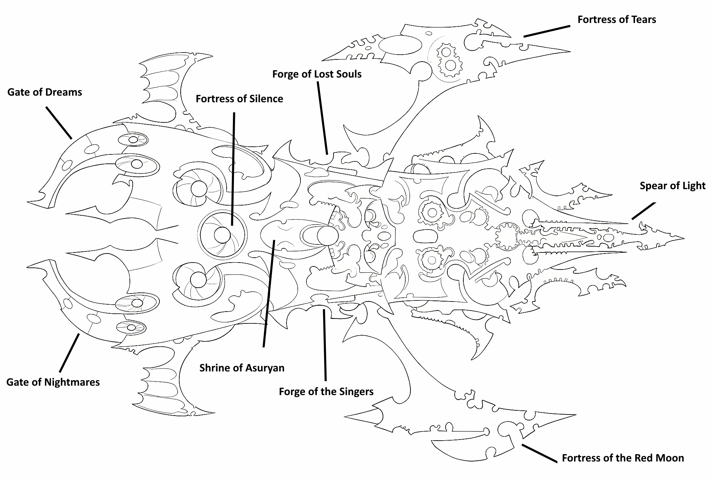
Craftworld Iyanden: named fortresses, forges, gates and the Spear of Light
Flavour text: They shall come, expecting the obvious, the simple, the artless. They shall stab at the shadows with confused minds and troubled hearts. Meanwhile, we shall appear unseen from ten directions, and from every one strike a fatal blow.

The Fortresses
The two fortresses that flank the main body of the craftworld are designed to repel invaders from Iyanden by utilizing powerful but indirect plasma barrages to disrupt and scatter any enemy that manages to evade the craftworld's patrols.
Each time an assault point would be scored against the craftworld, roll a D6. On a result of 4+, the assault point is negated, the landing force was destroyed by interception fire from one of the fortresses.
In addition, the fortresses will fire directly upon approaching vessels. During the Eldar player's shooting phase, the two fortresses each unleash a Strength 1 pulsar lance attack against every enemy capital ship and escort squadron on the low-orbit table that is within 45cm of the planet table edge. Roll separately for each attack against each target.
However, the fortresses are not invincible. During each player's end phase, roll 1D6 per assault point already scored. If at least one result is a "6" the fortresses are damaged, mark a hit on a piece of paper or use a token of some kind. Use the table below to determine the effect(s) of damage on the fortresses. Keep in mind that the fortresses may only suffer a maximum of one damage per turn, no matter how many 6s are rolled in the end phase.
Damage | Effect
1 | No effect
2-3 | Nullify assault points only on a result of 5+
4+ | Nullify assault points only on a result of 6+
5+ | One fortress is destroyed. It no longer makes attacks against targets on the low-orbit table.
6+ | Both fortresses are destroyed. All benefits of the fortresses are lost. Do not roll for any further damage to them.

The Spear of Light
While the Spear of Light is essentially just another heavily-armed redoubt built to defend the craftworld, it is most renowned for its eponymous Spear of Light, a titanic linear accelerator capable of hurling plasma charges at high relativistic speeds. The device's primary purpose is to eliminate dangerous objects in the craftworld's path, such as large comets and recalcitrant moonlets. However, if the survival of the craftworld is at stake, it can be re-purposed as a terribly destructive weapon despite its limited accuracy (by Eldar standards).
The Spear of Light functions as a single Nova Cannon in all respects. As with the fortresses, roll 1D6 in each player's end phase for each assault point already scored. If at least one result is a "6" the Spear of Light is damaged. Use the table below to determine the effect. As before, it can only suffer a maximum of one damage per turn, no matter how many 6s are rolled.
Damage | Effect
1 | After firing the Spear of Light, the craftworld must use the Reload Ordnance special order (counting as Ld8) before the weapon can be fired again.
2+ | The Spear of Light is destroyed and may no longer be used. Do not roll for any further damage to it.

Note that the Spear of Light is used against targets at range and has no effect against vessels on the low-orbit table.

The Forges
A craftworld's bonesingers have at their disposal the means to build and service an entire armada of Eldar vessels. Indeed, their fabrication techniques are so efficient, they can quite literally produce more starships than there are Eldar crews to man them. In an emergency, these forge docks may be outfitted to aid damaged vessels in the midst of battle.
Any Eldar capital ship in low orbit can dock with the craftworld by landing on the surface (in the same way that escorts and transports may land on a planet). To do so, simply move the ship into contact with the planet table edge, but do not remove it from the table. Instead, it remains docked in place until the end of the next Eldar turn. (Note that ships crashing into the surface due to the pull of gravity do not get to land, they are still destroyed as normal).
Docked Eldar capital ships add +4D6 to their roll to repair critical damage in the end phase (and ignore blast markers while repairing). Those without any repairable critical damage may also roll (including the preceding bonuses), and will recover 1 lost damage point for every result of 6. Additionally, docked Eldar ships automatically benefit from Reload Ordnance special orders and have the protection of the forges' netherfields and polarization fields (these are identical to those of the Haven Spire found in the Eldar faction list).
However, docked ships are unable to move, shoot, launch ordnance, board, or conduct teleport attacks, as this would obviously interfere with repair efforts.

The Gates
Virtually all craftworlds have a series of webway portals scattered throughout their structure. The two largest of these are capable of opening portals tall and wide enough for an Eldar titan. Together, they create a single portal at the rear of the craftworld that can even accommodate starships.
At the beginning of each of their turns after the first, the Eldar player may roll a D6. On a score of 5+, the Eldar player chooses D3 capital ships and/or escort squadrons they have held in reserve and deploy them touching the craftworld planet marker and facing the closest short table edge. Eldar ships arriving from reserve cannot move or shoot in the same turn they appear.

Set-up, First Turn, Special Rules, Game Length & Victory Conditions
Source: BFG:XR Rulebook, printed p.115.
Set-up. First, the Eldar player chooses which ships and squadrons in their fleet (besides those in reserve) are on patrol or on alert. Those on alert must be deployed within the craftworld's gravity well or on the low-orbit table. For each ship or squadron on patrol, roll a D6. On a result of 1-3, that ship or squadron is placed by the attacker. Otherwise, it is placed by the defender. Note that due to their nearly exclusive role as patrol ships, any escort squadron consisting entirely of Shadowhunter class destroyers must be set-up on patrol, but will always be deployed by the defender. Ships on patrol must be deployed at least 30cm from a table edge, not within an area of celestial phenomena, and facing a direction of the defender's choice (regardless of who placed them). The attacker then sets up their entire fleet within 15cm of the short table edge furthest from the planet.
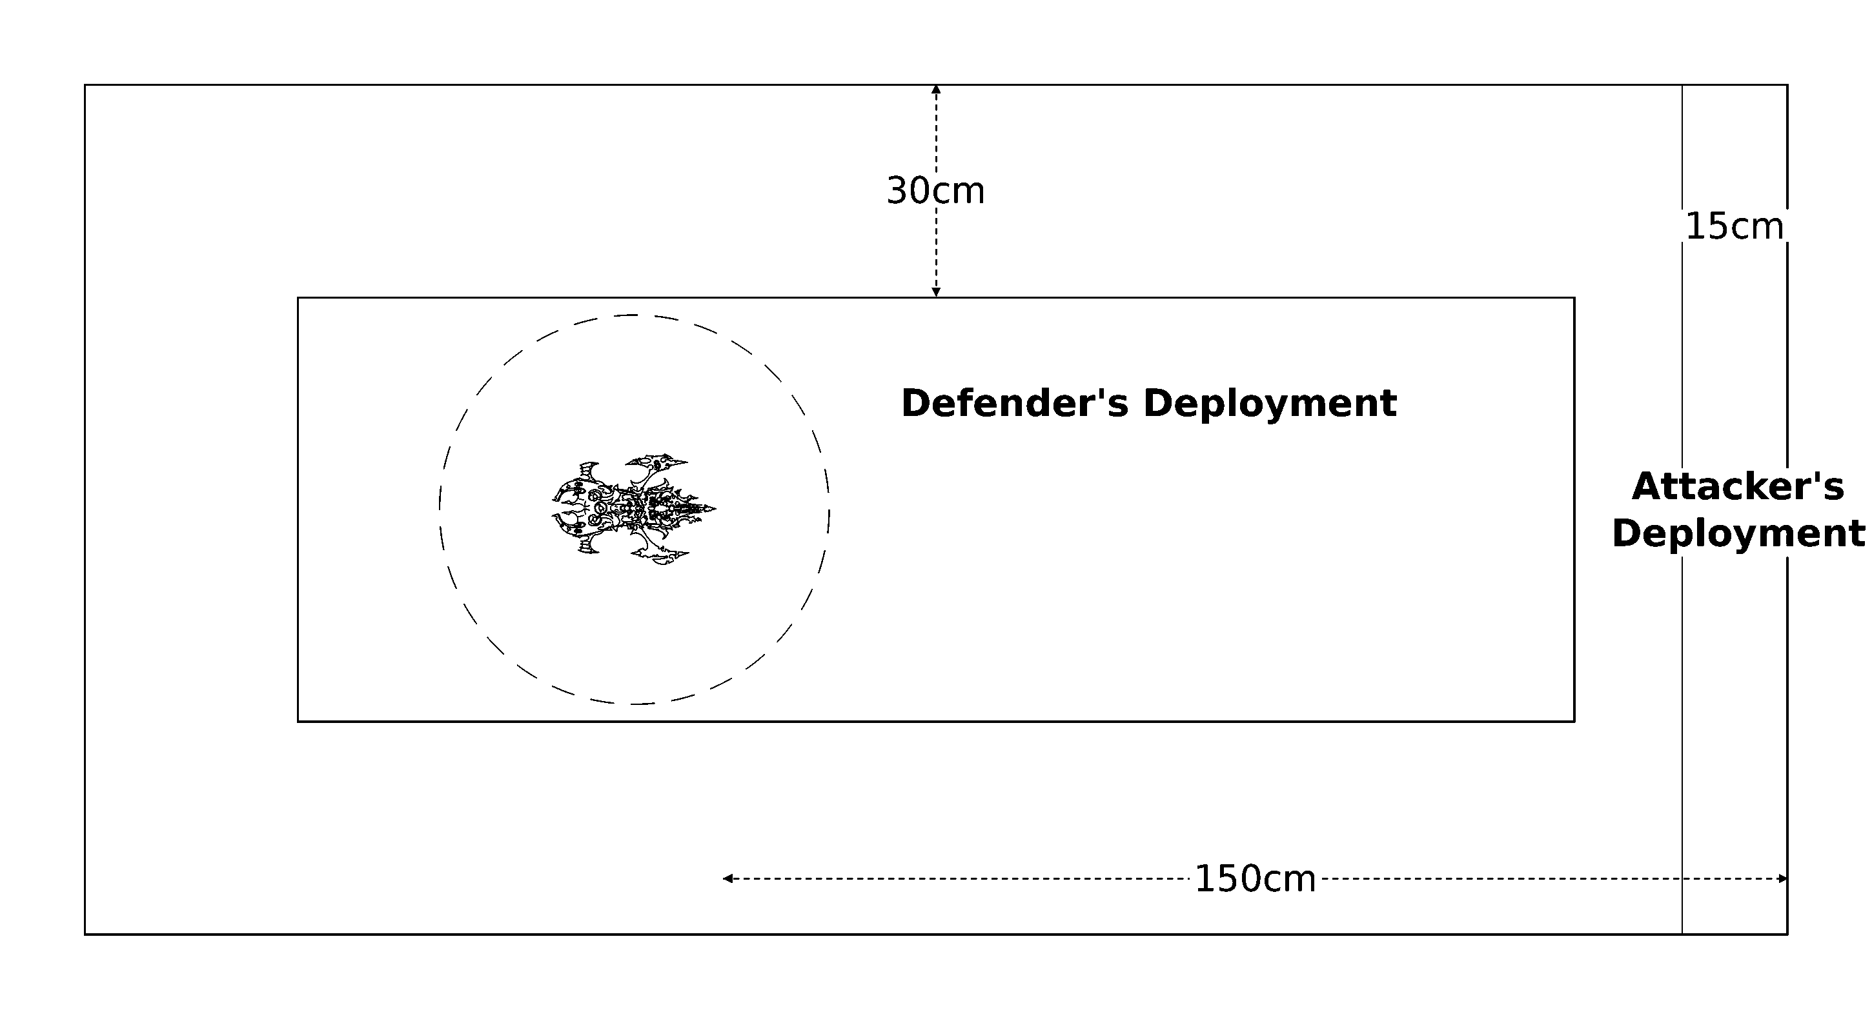
Deployment diagram
First Turn. Each player rolls a D6 and adds their fleet's attack rating to their result. The player with the higher total chooses whether to go first or second.
Special Rules. At the start of the attacker's shooting phase, they may direct any of their capital ships and/or transports within 30cm of the planet table edge (excluding those that are in the process of boarding or being boarded) to assault the craftworld rather than fight normally. Ships attacking the craftworld must focus all their efforts on doing so and thus cannot shoot, launch ordnance, or make teleport attacks for the rest of the turn. For each ship that assaults the craftworld, the attacker scores a number of assault points equal to twice that ship's transport capacity. All capital ships are treated as having a point of transport capacity at a minimum for this purpose, unless otherwise specified. Escort-sized convoy ships that land on the craftworld (source: rulebook p.54) may score on the same turn they do so (as if they were within 30cm of the planet table edge), but not on any subsequent turns. Furthermore, the defender will still score victory points for ships that disengage this way. Keep in mind that this scoring method is only for escort-sized vessels, capital ships cannot land!
Game Length. The game lasts until the attacker scores 10 or more assault points, or one fleet disengages or is destroyed.
Victory Conditions. Tally up the attacker's total assault points, adding +1 for every full 500 victory points they earned and deducting -1 for every 500 victory points (or portion thereof) earned by the defender. If the attacker holds the field, each attacking capital ship and convoy ship on the table (not counting crippled ships) scores one final time (as described above). Look up the total result below:
Total | Result
0-1 | Defender's Victory.
2-5 | Defender's Marginal Win.
6-9 | Attacker's Marginal Win.
10+ | Attacker's Victory.

Overview
Source: BFG:XR Rulebook, printed p.116.
The nine scenarios presented in this section are faster, simpler versions of the narrative scenarios presented in the Raids and Battles sections. They have been designed with "pick-up" and "matched" play in mind, for clubs and tournaments where players are looking for a more balanced, competitive style of game. In particular, the Domination scenario is perhaps the most ideal for this purpose. These scenarios may also be useful for players looking to setup a gaming league with their friends and family. Finally, you should always feel free to use these scenarios in place of any narrative missions if your group finds them more enjoyable!
Flavour text: "Some say that perfection is the enemy of the good. They speak nonsense. Such apathetic thinking is what turns that which is good into bad. We should never cease our striving for greatness, never halt our purpose of bettering ourselves. Anything else is nothing but stagnation, and I have seen enough of the galaxy to know that to stagnate is to wither and die in shameful ignominy.", Shas'o Arra'kon

Confrontation
Source: BFG:XR Rulebook, printed p.117.
The great ships of the Gothic Sector and beyond come together in a great clash among the stars. Each fleet brings the weight of their massive arsenals to bear in an all out conflict that will leave the void littered with the wreckage of once proud armadas. Thousands will perish and all that will remain is the laughter of thirsting gods.
Forces. Agree on a points limit for the battle. Both players may spend up to this limit on their fleets.
Battlezone. The attack could take place anywhere from the flare region all the way to deep space. Use any of the methods on rulebook p.49 to determine the battlezone and any appropriate celestial phenomena.
Set-up. The attacker chooses one of the long table edges and deploys their entire fleet anywhere within 30cm of it. The defender then deploys their fleet within 30cm of the opposite table edge.
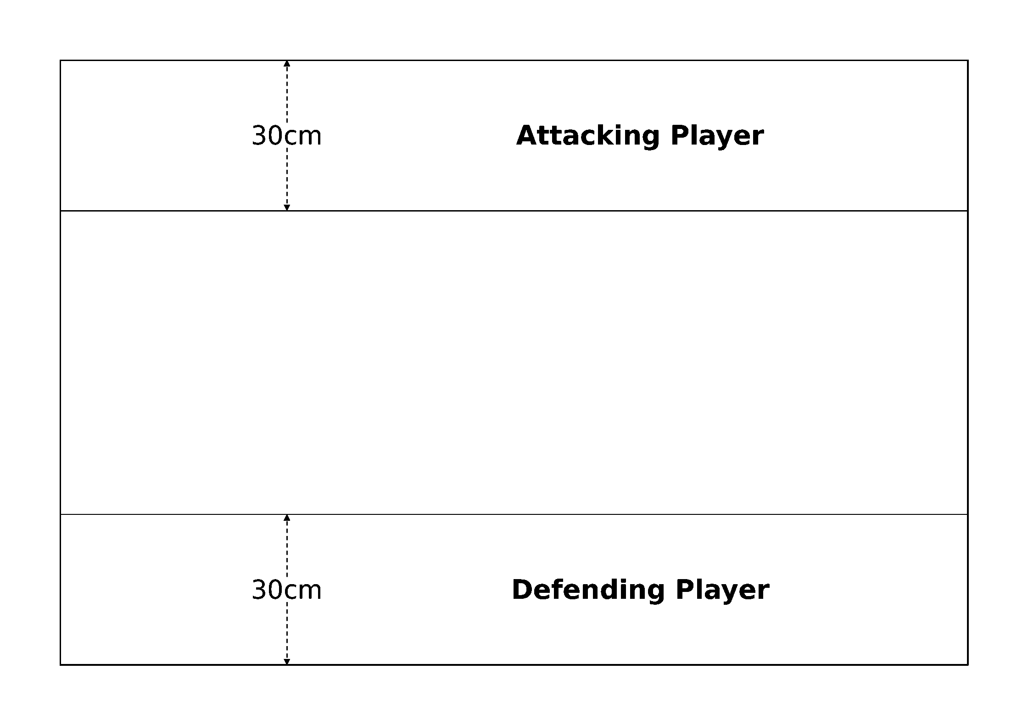
Deployment diagram
First Turn. The attacker takes the first turn.
Game Length. The game lasts until one fleet disengages or is destroyed.
Victory Conditions. Both fleets score victory points as normal, and the fleet with the highest victory point total at the end of the game wins.
Flavour text: "It was silent as the void, and to look upon it was to know terror. It drifted above us with slow, liquid grace, and its gaze caused madness and despair wherever it fell. Those it came near took their own lives rather than endure its hellish presence.", Morillia, Harlequin Shadowseer

Line Breaker
Source: BFG:XR Rulebook, printed p.118.
Long range defense platforms have been set up at the edge of the system. These are the first line of defense against raiders and invasion forces alike. The attacking fleet must smash a hole in this blockade before it can move on to the interior of the system and wreak terrible havoc on the enemy's strategic positions. The defender will not make it easy, however; they have dispatched their own fleet in response to the threat.
Forces. Agree on a points limit for the battle. Both players may spend up to this limit on their fleets. The defender must include one defense platform for every 200 points (or portion thereof) in their fleet, counting its cost against their points total as normal. Each defense platform is represented by an orbital weapons platform, orbital defense laser platform, or orbital torpedo launcher (source: rulebook p.65-66). They cannot be formed into squadrons.
Battlezone. The attack takes place in the outer reaches. Use the appropriate table on rulebook p.51 to place celestial phenomena.
Set-up. The defender chooses one of the long table edges and sets up their fleet within 60cm of it. Defense platforms must be placed more than 30cm from any table edge, more than 15cm from each other, and not within any celestial phenomena. Note that they do not need to be placed within a planet's gravity well. The attacker then sets up his or her fleet within 15cm of the opposite long table edge.
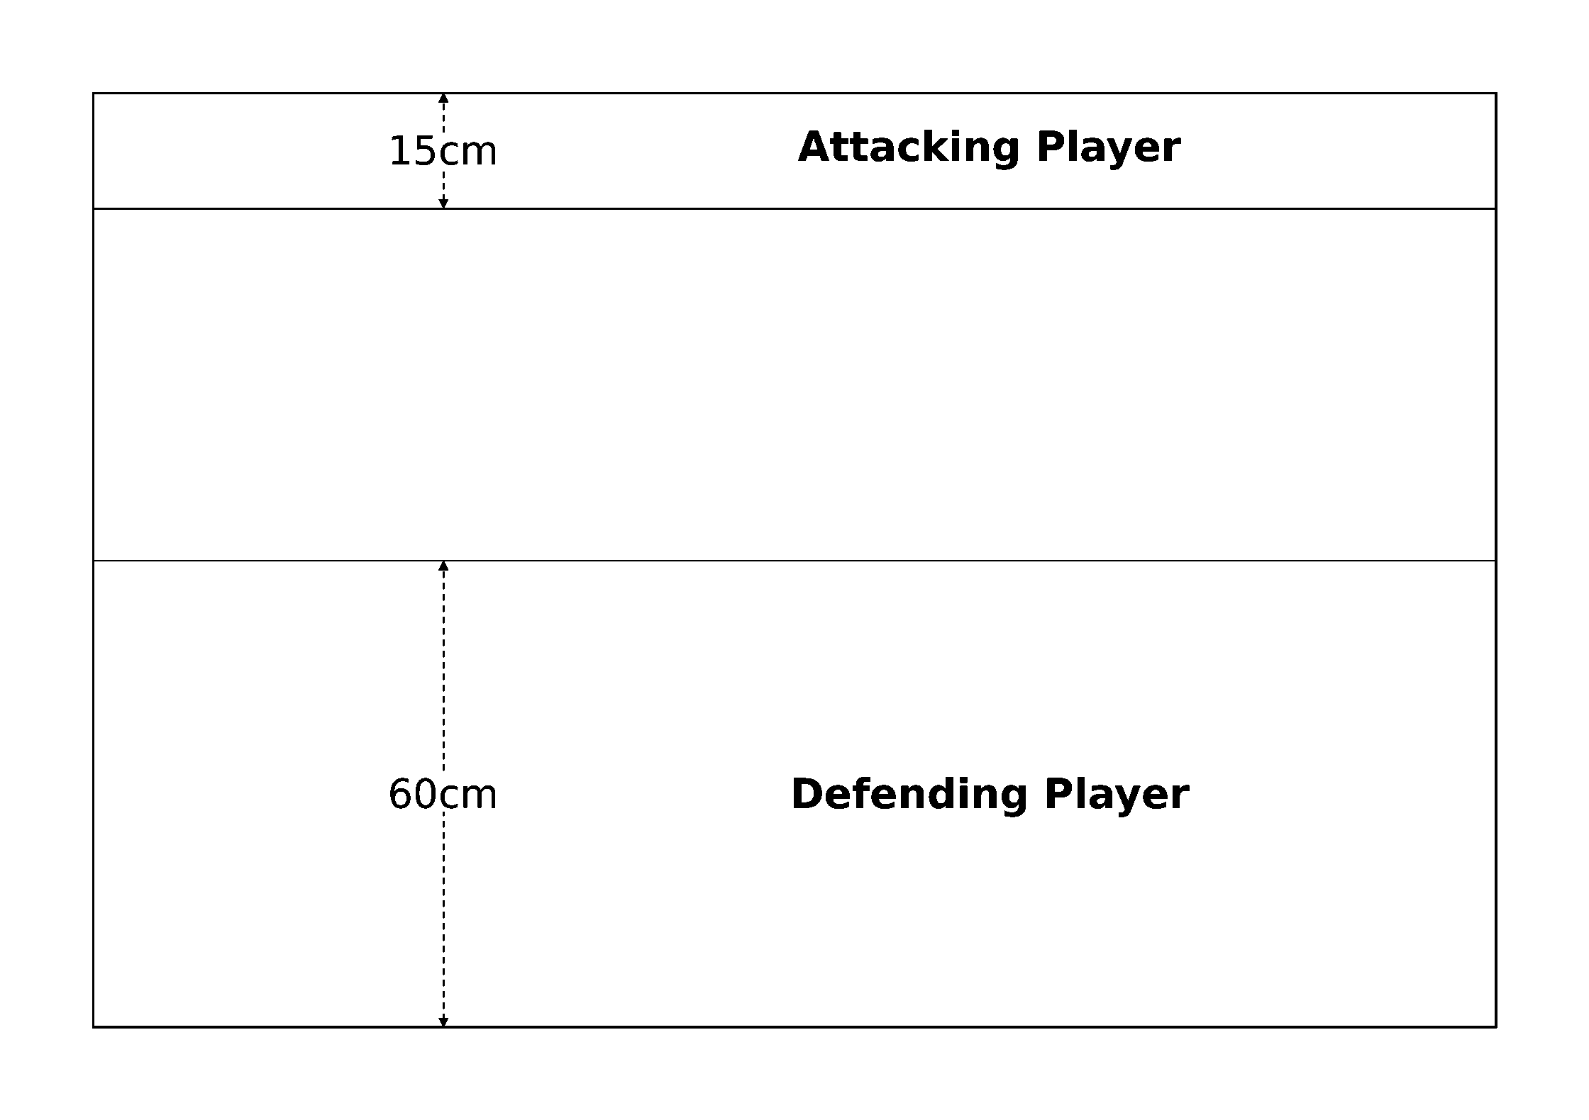
Deployment diagram
First Turn. The attacker takes the first turn.
Game Length. The game lasts until the attacker destroys all defense platforms and moves one capital ship off the defender's long table edge, or until one fleet disengages or is destroyed in its entirety.
Victory Conditions. The attacker must destroy all of the opposing defense platforms and move at least one of their capital ships off the defender's long table edge in order to win. Otherwise, victory is awarded to the defender.
Flavour text: "Beyond that opening are my enemies. Behind me are warriors who would happily turn their weapons on me if they thought they could get away with it. Do you really think I'm doing this to try and impress anyone? I know who I am, and I don't give a greenskin's fart what anyone thinks of me.", Honsou, Warsmith of the Iron Warriors

Ambush
Source: BFG:XR Rulebook, printed p.119.
Only the truly mad or desperate would attack a stronger force with a weaker one, but when the opportunity presents itself a carefully planned raid by a small number of vessels can devastate even a far more powerful opponent. In this scenario, the attacker's aim is to cause as much damage as possible before the enemy turns them to dust with their superior numbers and firepower.
Forces. Agree on a points limit for the battle. The defender may spend up to this limit on his or her fleet, while the attacker may only spend up to half this amount.
Battlezone. The attack could take place anywhere from the flare region all the way to deep space. Use any of the methods on rulebook p.49 to determine the battlezone and any appropriate celestial phenomena.
Set-up. The defender deploys their fleet anywhere on the board more than 30cm from a table edge. Each defending ship and squadron must be set up facing the same direction and at least 20cm from another ship or squadron (not including ships in their own squadron). The attacker then deploys their entire fleet anywhere within 30cm of any table edge.
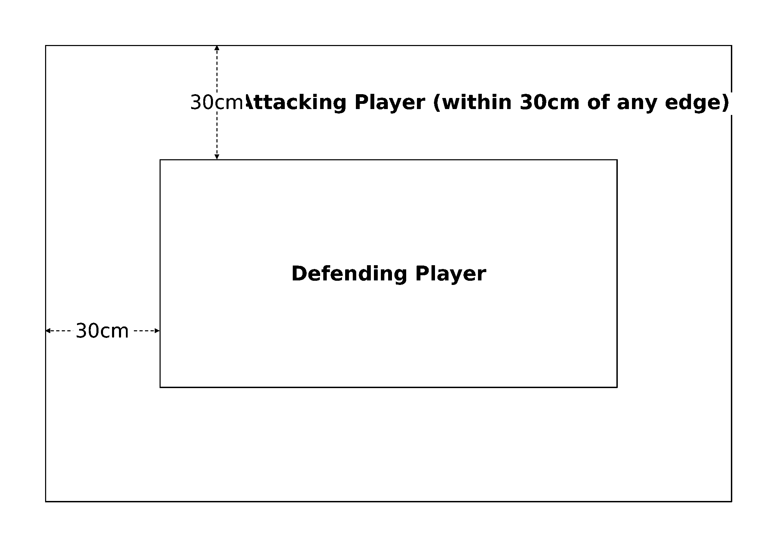
Deployment diagram
First Turn. The attacker takes the first turn.
Special Rules. The defender is caught unawares at the start of the battle. During the defender's first turn, none of their ships may go on special orders or attempt to disengage. Additionally, all defending ships start the game without any ordnance loaded (as if it had been expended), and will need to use the Reload Ordnance special order before they may launch or fire any ordnance.
Game Length. The game lasts until one fleet disengages or is destroyed.
Victory Conditions. Both fleets score victory points as normal, and the fleet with the highest victory point total at the end of the game wins.
Flavour text: "...and the Engines of Vaul will smite them, and bring fire upon them, and in agony they will depart this realm, their souls screaming into the black void that awaits their pitiful race. And with their banishment there will be peace in this place, and we will be one step further along the road we must tread...", Farseer Ulthos of Alaitoc

Convoy
Source: BFG:XR Rulebook, printed p.120. A distinct, simplified matched-play version, not the same as Raid Scenario Three (Convoy), above.
Transport ships are easy prey for fleets of hungry warships, yet are vital to the war efforts of the endless conflicts across the galaxy. The attacker has set up a blockade just outside of the system, ready to intercept convoys laden with precious resources as they make their escape. The defender must work to escort the supply ships out of the system by driving off the attacking fleet.
Forces. Agree on a points limit for the battle. Both players may spend up to this limit on their fleets. In addition, the defender must include exactly 1 transport capacity worth of convoy ships for every 100 points (or portion thereof) in their fleet.
Battlezone. The attack takes place in the outer reaches. Use the appropriate table on rulebook p.51 to place celestial phenomena.
Set-up. The defender chooses one of the long table edges and deploys their fleet (not including any convoy ships) within 30cm of it. The attacker then sets up their fleet anywhere between 15cm and 45cm of the opposite table edge. Lastly, the defender sets up their convoy ships anywhere in their deployment area.
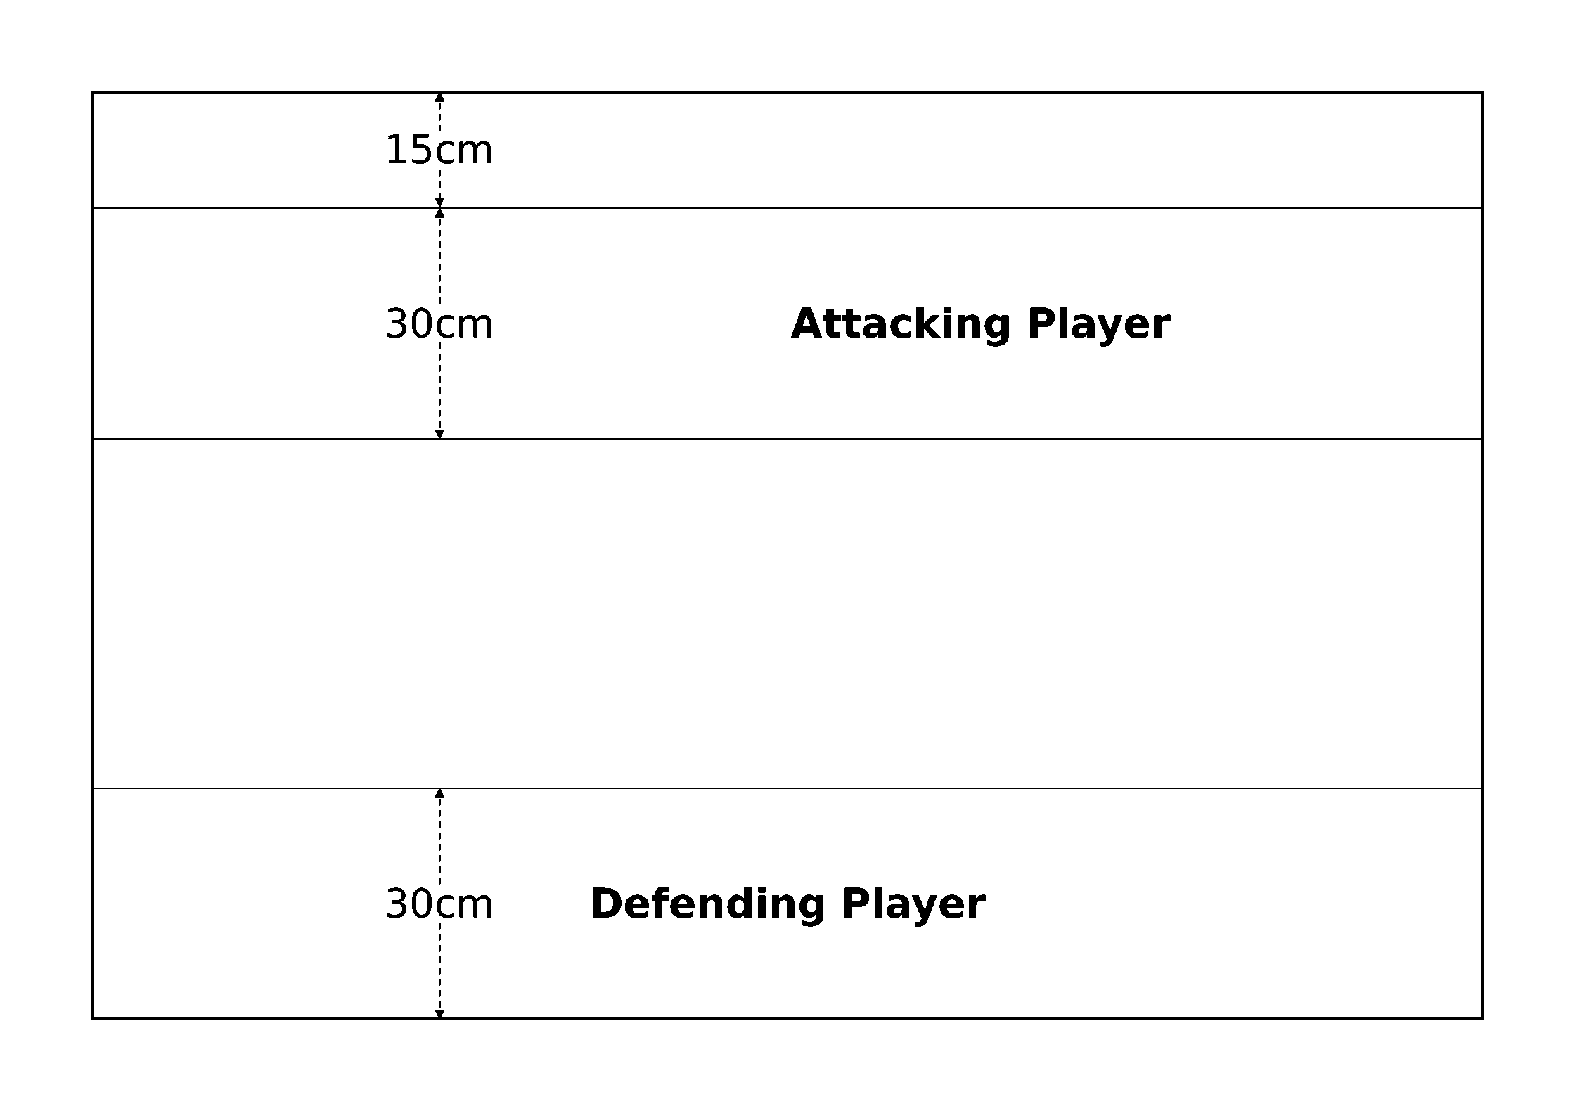
Deployment diagram
First Turn. The defender takes the first turn.
Game Length. The game lasts until the defender has no transport capacity left on the table.
Victory Conditions. Both fleets score victory points as normal, and the fleet with the highest victory point total at the end of the game wins. Each of the defender's convoy ships that disengages by moving off the attacker's long table edge awards the defender 100 victory points instead of counting towards the attacker's score. Otherwise, convoy ships that leave the board any other way are treated as destroyed and award the attacker an extra 50 victory points each (in addition to any victory point score based on their cost).
Flavour text: "Ours is to be an empire of worlds, not merely of castes or nations, or races or peoples. To simply control the worlds which we claim as our own will not be enough, we must control the paths between them also, or be divided, and so fail.", Air Caste Petition, Tau'n Campaign

Space Assault
Source: BFG:XR Rulebook, printed p.121.
Space stations and orbital shipyards are the lifeblood of any space fleet. They are a place to repair, rearm, and refuel for the many warships of the Gothic sector and beyond. An attack on a space station will always be hard fought, but victory here will leave the enemy fleet in ruins and without a place to lick their wounds.
Forces. Agree on a points limit for the battle. Both players may spend up to this limit on their fleets. The defender must include a single space station, and may also include any number of orbital weapons platforms, defense laser platforms, and torpedo launchers. The costs of these are counted towards the defender's points total as normal (source: rulebook p.65-66).
Battlezone. The attack takes place in the primary biosphere. Use the appropriate table on rulebook p.51 to place celestial phenomena.
Set-up. The defender chooses one of the long table edges and deploys their fleet within 30cm of it. The space station must be deployed exactly 30cm from the chosen edge and equidistant from either short table edge, as shown below. Move any celestial phenomena as necessary such that none is within 10cm of the space station. Other orbital platforms are placed anywhere in the defender's deployment zone (rather than in the gravity well of a planet). The attacker then deploys their fleet anywhere within 30cm of the opposite long table edge.
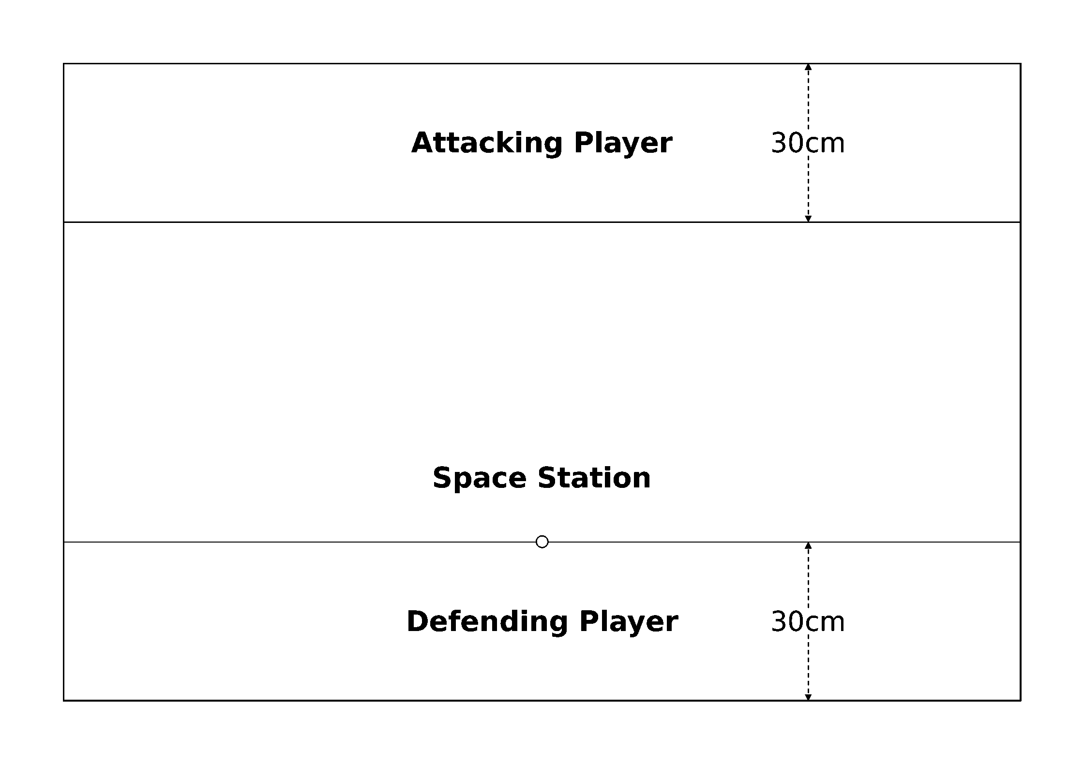
Space station placement and deployment zones
First Turn. The attacker takes the first turn.
Game Length. The game lasts until one fleet disengages or is destroyed.
Victory Conditions. Both fleets score victory points as normal, and the fleet with the highest victory point total at the end of the game wins. The attacker earns an additional 250 victory points if the space station is destroyed at the end of the game. Otherwise, the defender scores an additional 250 victory points if the station survives.

Rescue
Source: BFG:XR Rulebook, printed p.122.
The commander's flagship narrowly escapes an enemy ambush and sends out a desperate distress signal. By a stroke of good fortune it is heard and answered by a defending fleet that moves to intercept. However the gods are fickle and cruel. It may yet be too late to rescue the fleeing vessel and the ensuing battle may cause more harm than good.
Forces. Agree on a points limit for the battle. Both players may spend up to this limit on their fleets. The defender's fleet must include a fleet commander and at least one capital ship (to which the fleet commander must be assigned). This is the defender's flagship for the purpose of this scenario.
Battlezone. The attack takes place in the outer reaches. Use the appropriate table on rulebook p.51 to place celestial phenomena.
Set-up. The defender chooses one of the short table edges and deploys their fleet (other than their flagship) within 30cm of it. The defending flagship is then placed at the exact center of the board, pointing directly at the defender's table edge. The attacker then sets up their fleet within 30cm of the opposite short table edge.
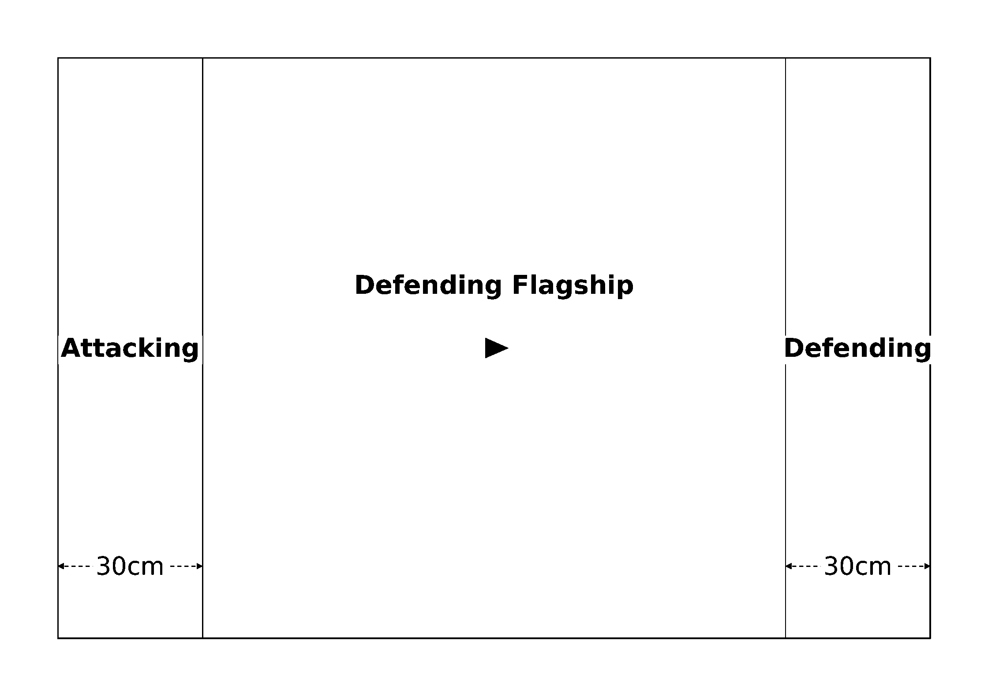
Deployment diagram
First Turn. The defender takes the first turn.
Special Rules. The defending flagship was sabotaged as part of the initial ambush. It may only disengage by moving off of the defender's short table edge. If it moves off any other table edge treat it as destroyed instead. Additionally, the defending flagship may not be issued special orders during the defender's first turn.
Game Length. The game lasts until one fleet disengages or is destroyed.
Victory Conditions. Both fleets score victory points as normal, and the fleet with the highest victory point total at the end of the game wins. The attacker earns an additional 100% of the defending flagship's cost in victory points if it is destroyed at the end of the game.

Warp Storm
Source: BFG:XR Rulebook, printed p.123.
In the chaos of the warp there is little room for organized maneuvers. Fleets who enter together are often split apart, arriving to the battle in different places or times. In the midst of a warp-storm this chaos only intensifies, often throwing opposing fleets together into a jumbled mess. Scattered and disoriented, the first fleet to recover its formation is likely to emerge the victor.
Forces. Agree on a points limit for the battle. Both players may spend up to this limit on their fleets.
Battlezone. The attack takes place in deep space. Use the appropriate table on rulebook p.51 to place celestial phenomena.
Set-up. The attacker must first divide their fleet into two divisions with as close to the same number of capital ships and escort squadrons as possible. The attacker then deploys these divisions in opposite corners of the table, each within 30cm of the table edges comprising the division's corresponding corner, as shown below. The defender must do the same with their fleet and deploy using the other pair of opposing corners.
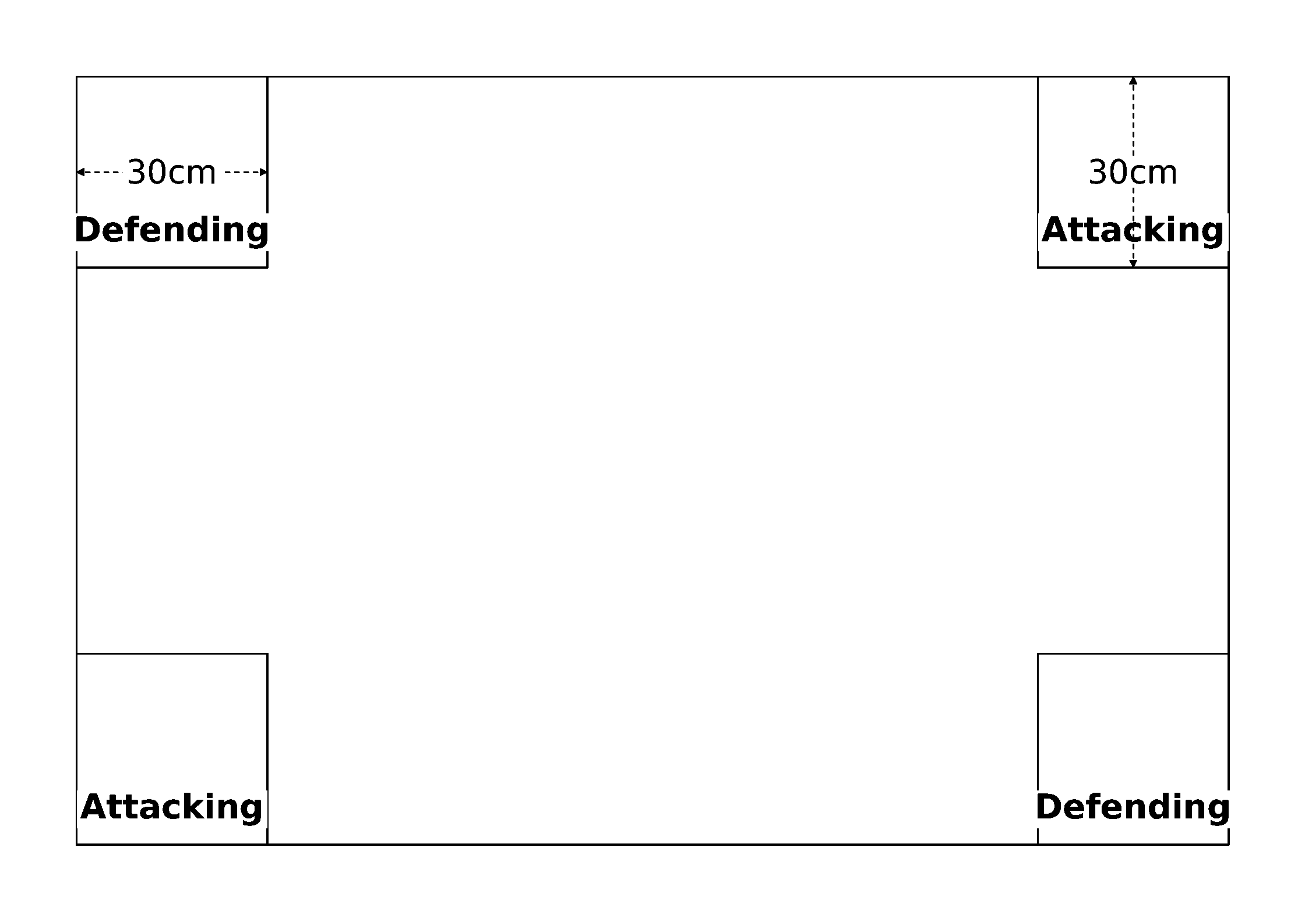
Four-corner divisional deployment
First Turn. The attacker takes the first turn.
Game Length. The game lasts until one fleet disengages or is destroyed.
Victory Conditions. Both fleets score victory points as normal, and the fleet with the highest victory point total at the end of the game wins. Each ship or squadron that disengaged during the battle must also take a leadership test at the end of the game; those that fail are lost in the warp and count as being destroyed instead.
Flavour text: "The Omnissiah directs our footsteps along the path of knowledge.", Techpriest Yaffel, Soylens Viridians for the Machine-Spirit

Planet Strike
Source: BFG:XR Rulebook, printed p.124.
After months of drawn out fighting, a local uprising has created a gap in a strategically valuable planet's defensive perimeter. With conflict already raging below as rebels and loyalists battle for supremacy, the time has come for the attacking fleet to strike against its foes on the surface, bombarding their strongholds and deploying drop-troops to crush the defenders once and for all.
Forces. Agree on a points limit for the battle. Both players may spend up to this limit on their fleets. The defender may also spend up to an extra 20% of the agreed points limit on planetary defenses (not including low orbit defenses, as the low orbit table is not used in this scenario). The defender may also purchase planetary defenses with points allocated to their fleet, as described on rulebook p.65. The attacker must take 1 transport capacity worth of convoy ships for every 100 points (or portion thereof) in their fleet.
Battlezone. The attack takes place in the primary biosphere. Start by placing a large planet centered between the long table edges with the far side of the marker exactly 45cm from one of the short table edges. Use the appropriate table on rulebook p.51 to place any remaining celestial phenomena (or have a neutral third party set up terrain ahead of time). Do not place any more planets.
Set-up. The attacker deploys first, setting up their fleet within 30cm of the short table edge opposite the planet. The defender then sets up their fleet within 45cm of the other short table edge. Any planetary defenses included must be deployed within the planet's gravity well (rather than the defender's deployment zone) as normal.
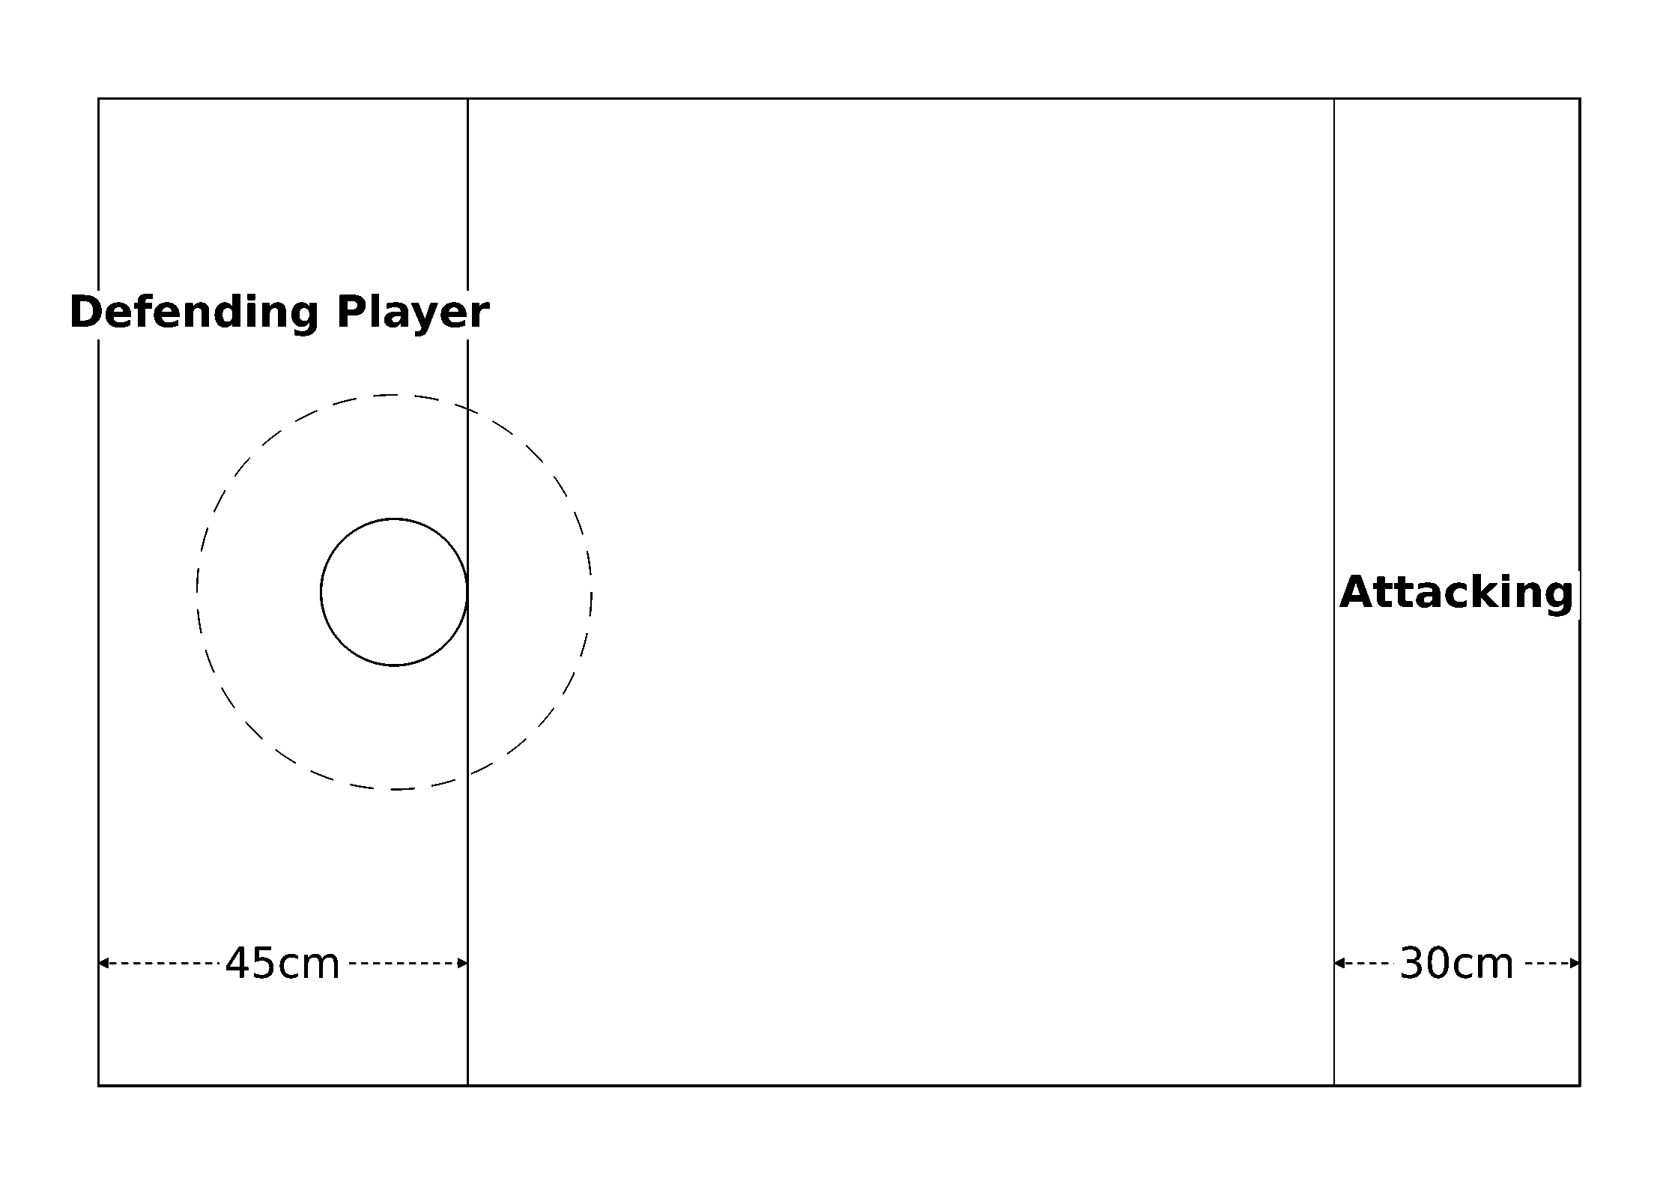
Deployment diagram
First Turn. The attacker takes the first turn.
Special Rules. The attacking player scores bombardment points by having ships hold position over the planet. For each attacking vessel that spends its entire turn stationary and in base contact with the planet marker, the attacker earns bombardment points equal to that ship's remaining hits plus its total transport capacity. Note that ships which can score extra assault points during a Planetary Assault may score extra bombardment points in the same way.
Game Length. The game lasts until one fleet disengages or is destroyed.
Victory Conditions. If the attacker holds the field at the end of the game, they win. Otherwise, look up the attacker's bombardment point total on the table below and roll a D6 to determine the result of the planetary invasion (if the attacker fails this roll, the defender wins).
Bombardment Points | D6 Result
0-5 | Defender Wins Automatically
6-10 | Attacker wins on 6+
11-15 | Attacker wins on 5+
16-20 | Attacker wins on 4+
21-25 | Attacker wins on 3+
26-30 | Attacker wins on 2+
31+ | Attacker Wins Automatically

Domination
Source: BFG:XR Rulebook, printed p.125-126.
Some fight to save what they hold dear, while others fight to destroy that which they hate. Whether for glory or for blood, these are but the feeble aspirations of the violent masses. For real masters of warfare, it is not enough simply to attack and kill one's enemies; instead, true victory lies in the total domination of the battlefield.
Forces. Agree on a points limit for the battle. Both players may spend up to this limit on their fleets.
Battlezone. Before placing celestial phenomena, roll a D6 and look up the matching result among the six deployment diagrams at the end of this scenario. The chosen diagram is the deployment configuration the scenario will use. Place objective markers at all the indicated positions. Coins or small ship bases work the best for this purpose. The attack takes place in the primary biosphere. Use the appropriate table on rulebook p.51 to place celestial phenomena, keeping each feature at least 15cm from the center of any objective marker.
Set-up. The attacker deploys their fleet in one of the deployment zones indicated on the chosen deployment diagram. The defender then deploys in the opposite zone.
First Turn. The attacker takes the first turn.
Game Length. The game lasts until one fleet disengages or is destroyed, or until one player scores 10 or more objective points.
Victory Conditions. The aim of this scenario is to control as many objective markers as possible for as long as possible. An objective marker is controlled by a player if they have at least one ship within 15cm of it (measured from the center of the marker to the stem of the vessel) and their opponent does not. Note that objectives may never be moved, attacked, or destroyed during the course of the game. At the end of each player's turn, that player scores 1 objective point for each objective marker they control. The player with the most objective points at the end of the game wins.
Flavour text: "Beyond that opening are my enemies. Behind me are warriors who would happily turn their weapons on me if they thought they could get away with it. Do you really think I'm doing this to try and impress anyone? I know who I am, and I don't give a greenskin's fart what anyone thinks of me.", Honsou, Warsmith of the Iron Warriors
Domination Deployments. Roll a D6 before the battle and use the matching configuration below. Each shows the two deployment zones and the objective marker positions for that configuration.
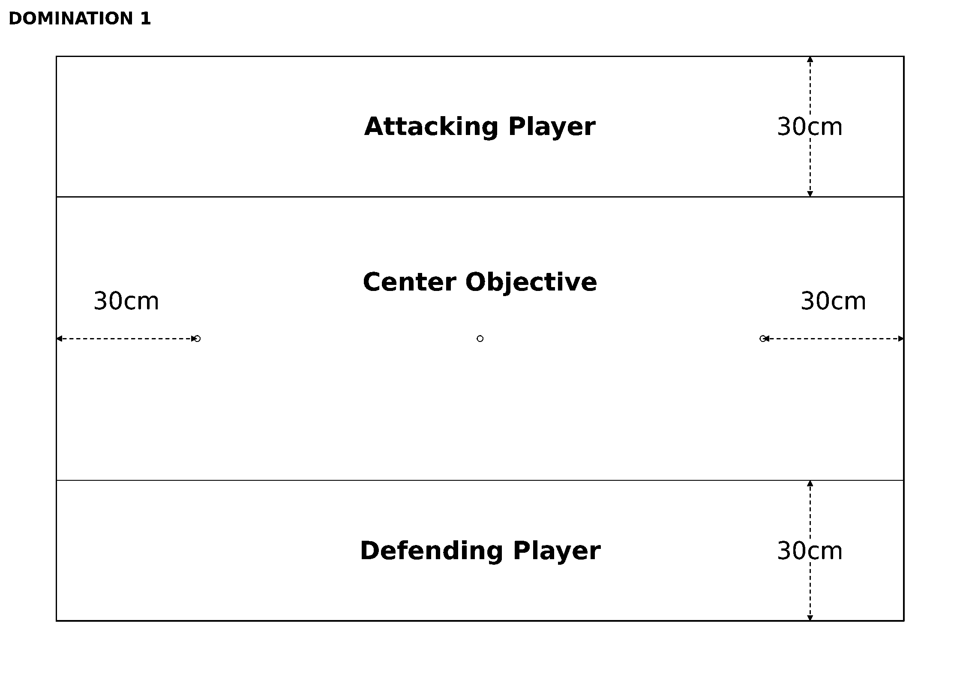
Deployment 1 (D6 result: 1)
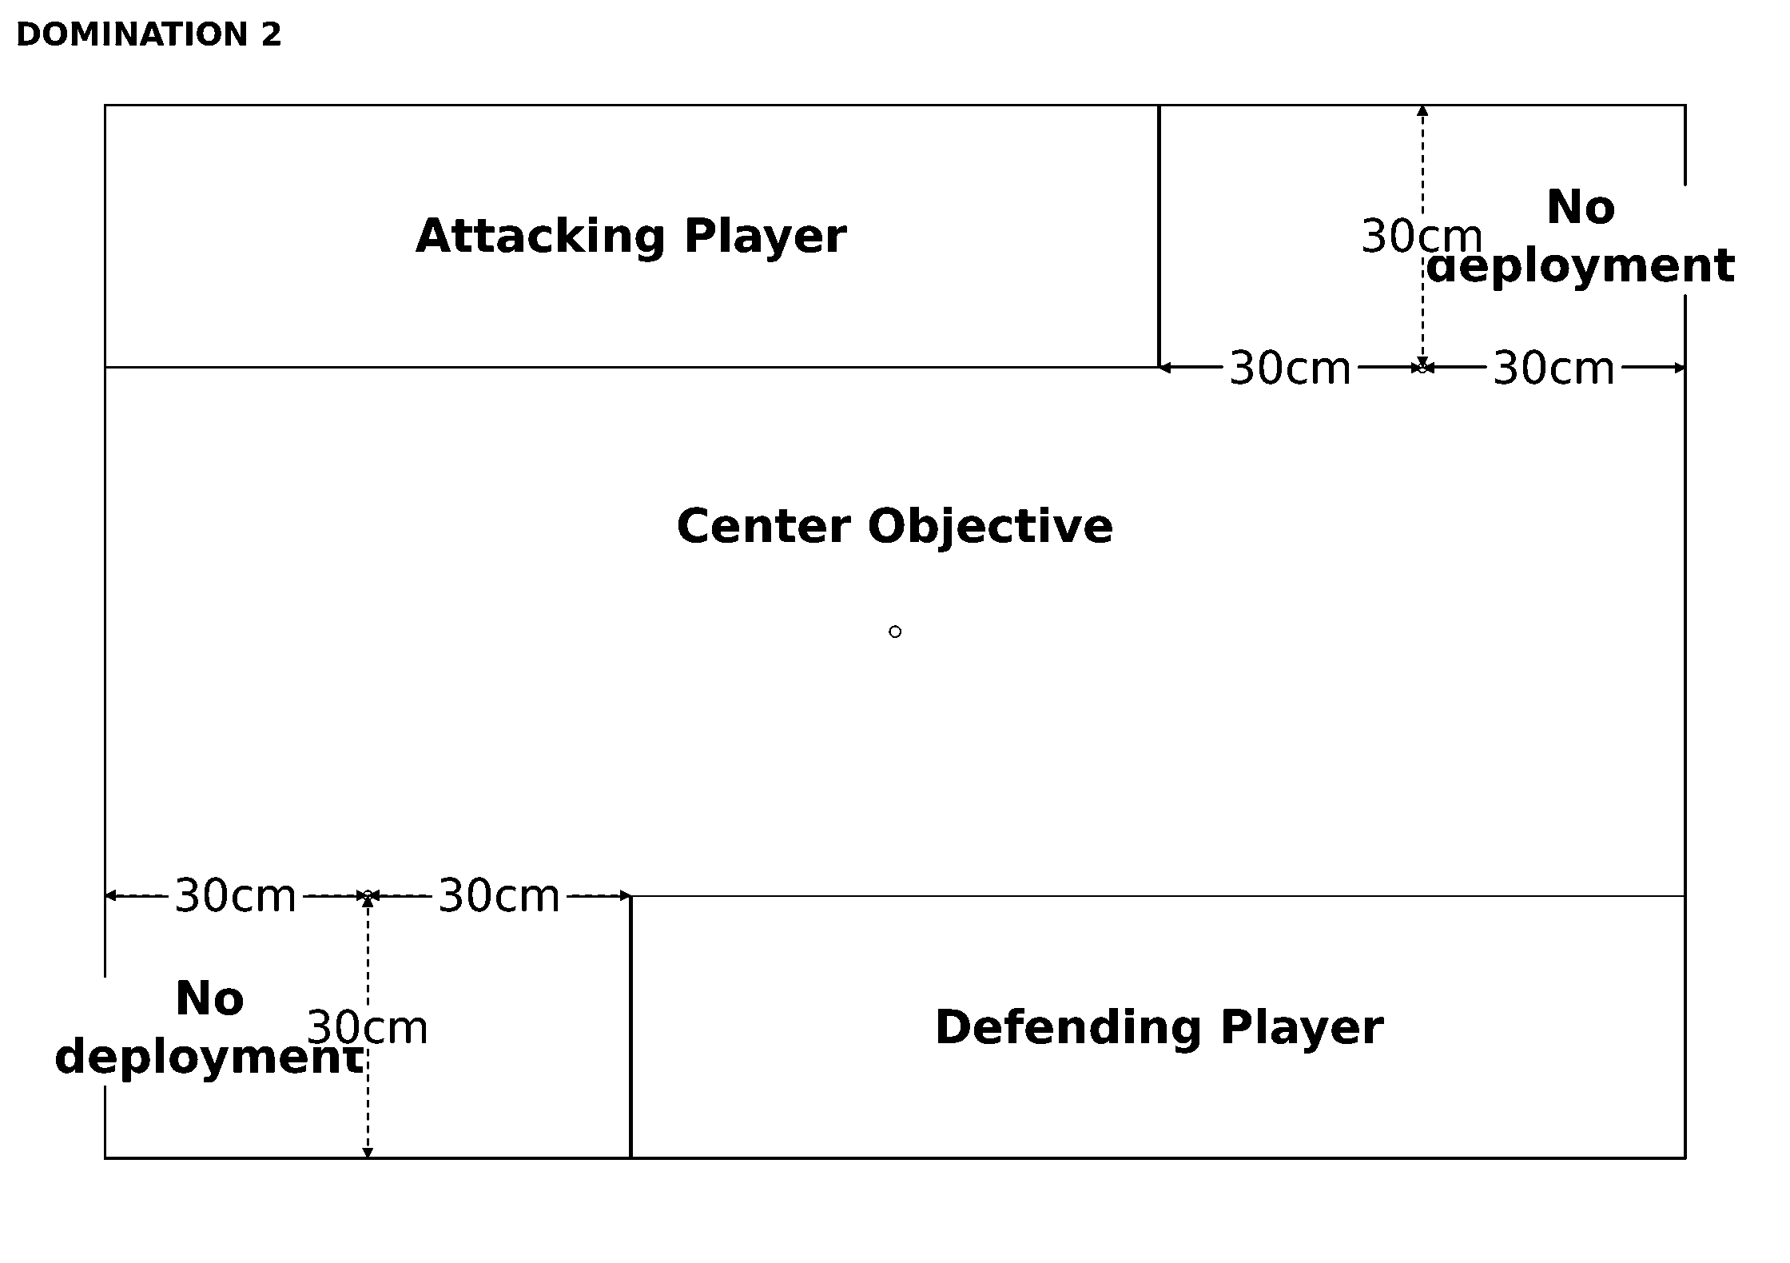
Deployment 2 (D6 result: 2)
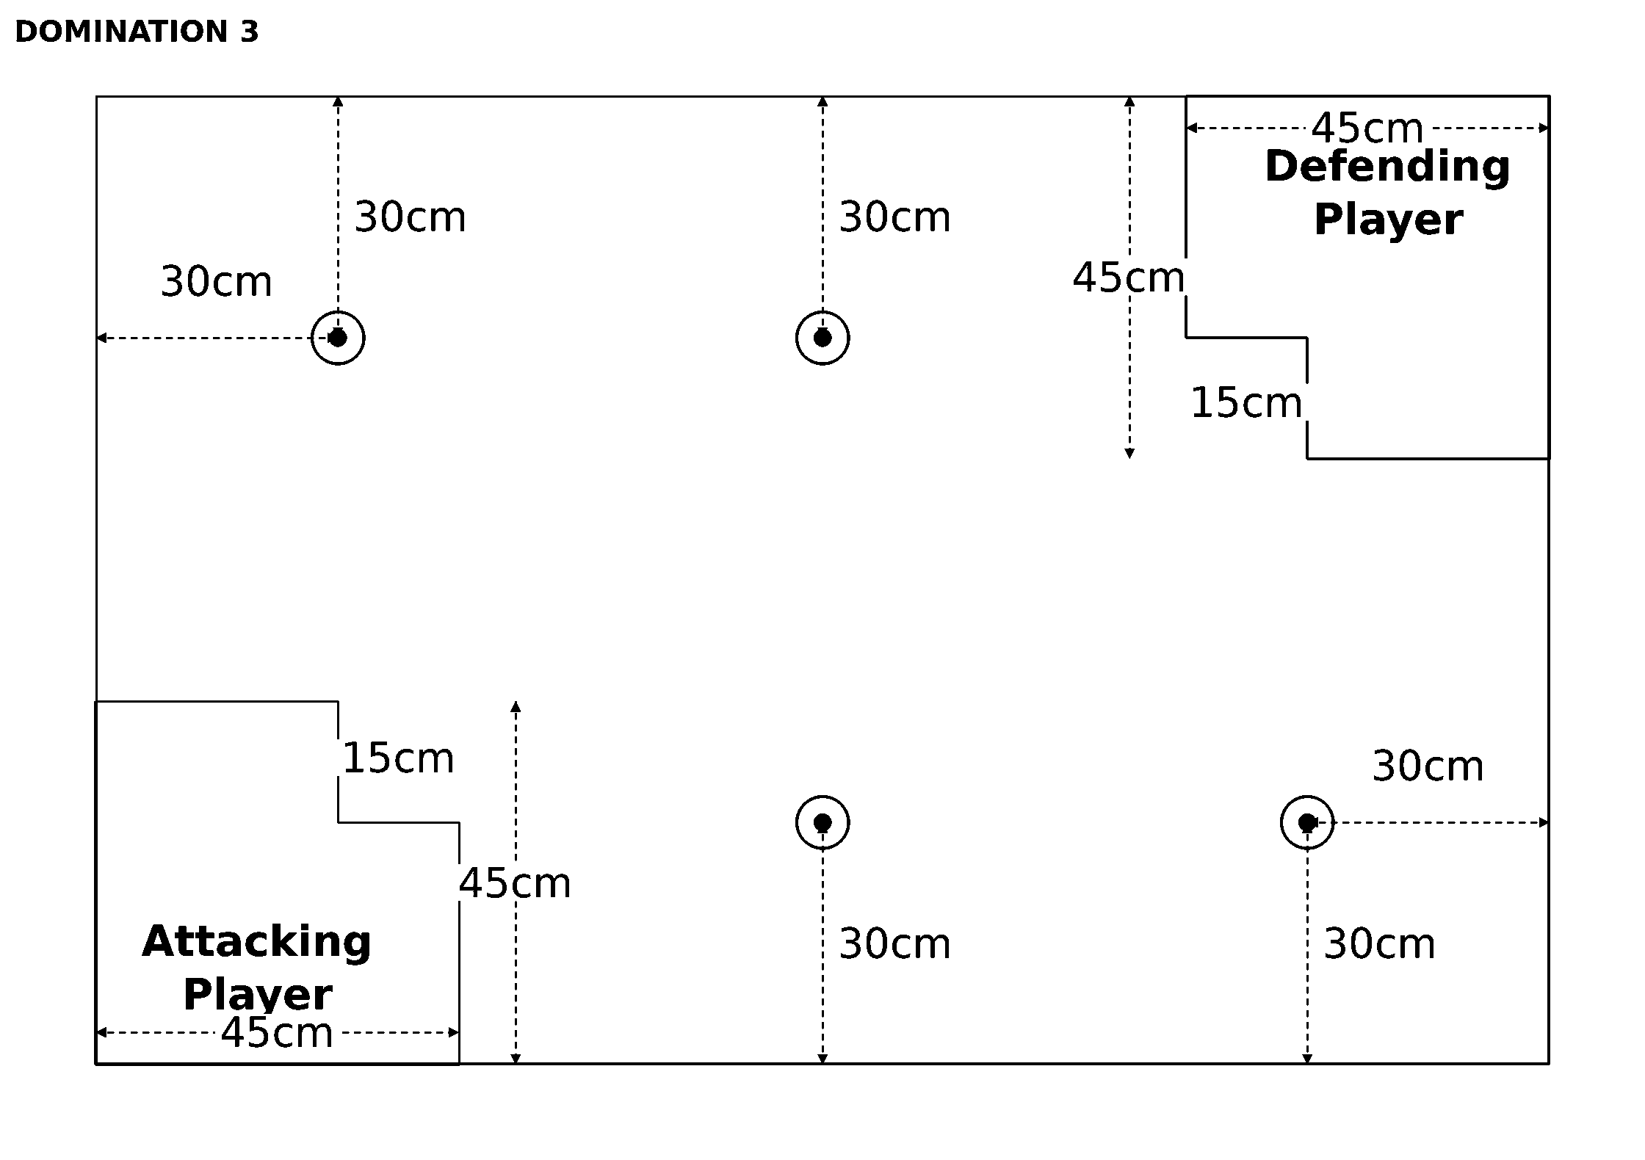
Deployment 3 (D6 result: 3)
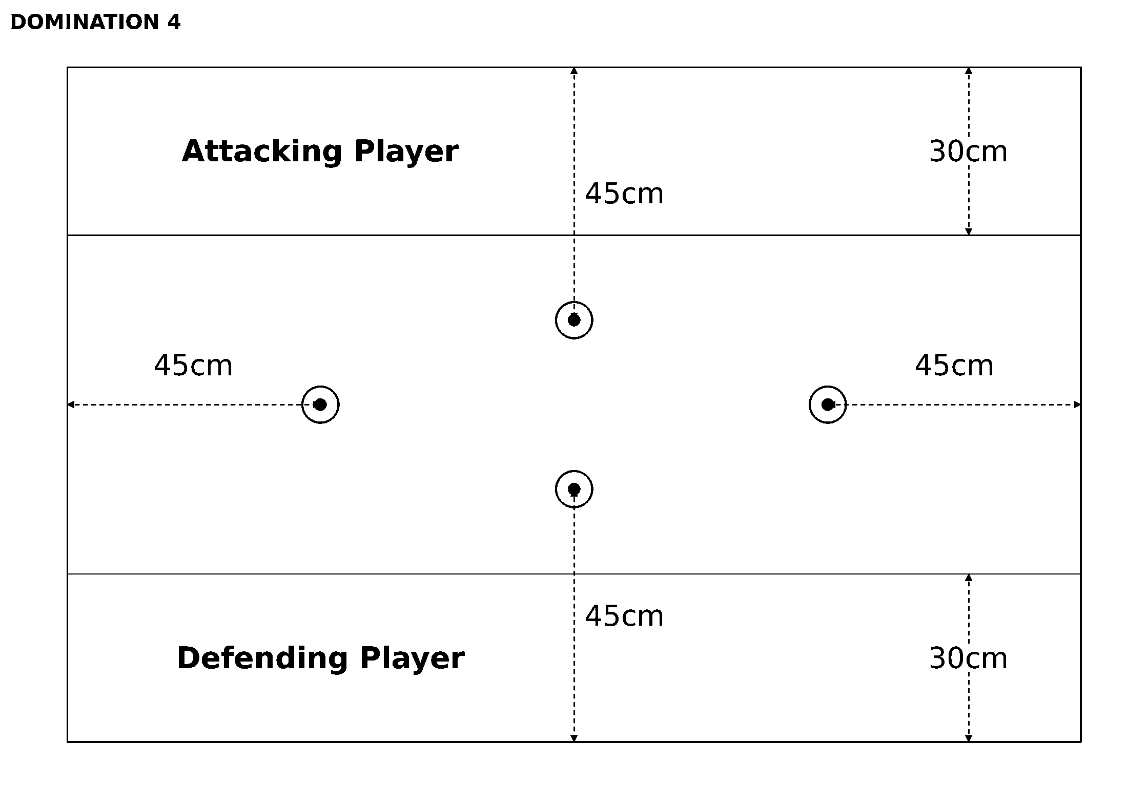
Deployment 4 (D6 result: 4)
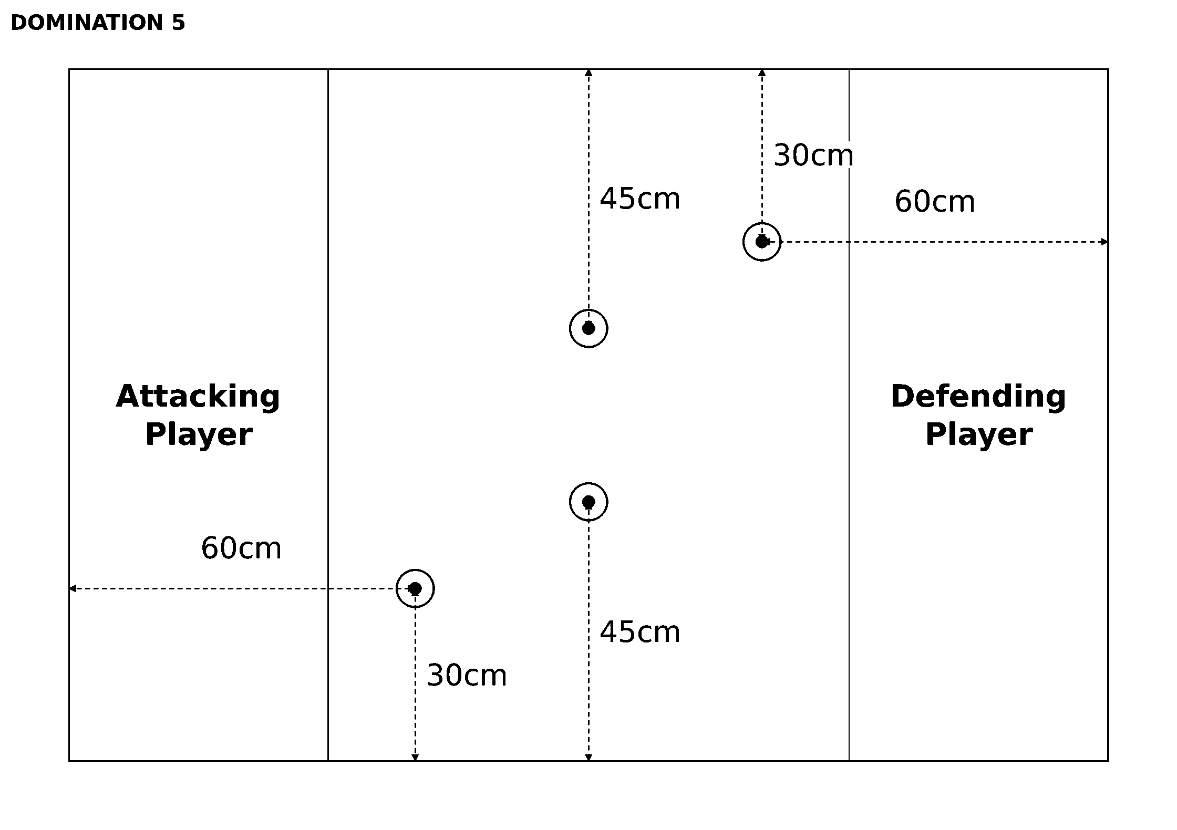
Deployment 5 (D6 result: 5)
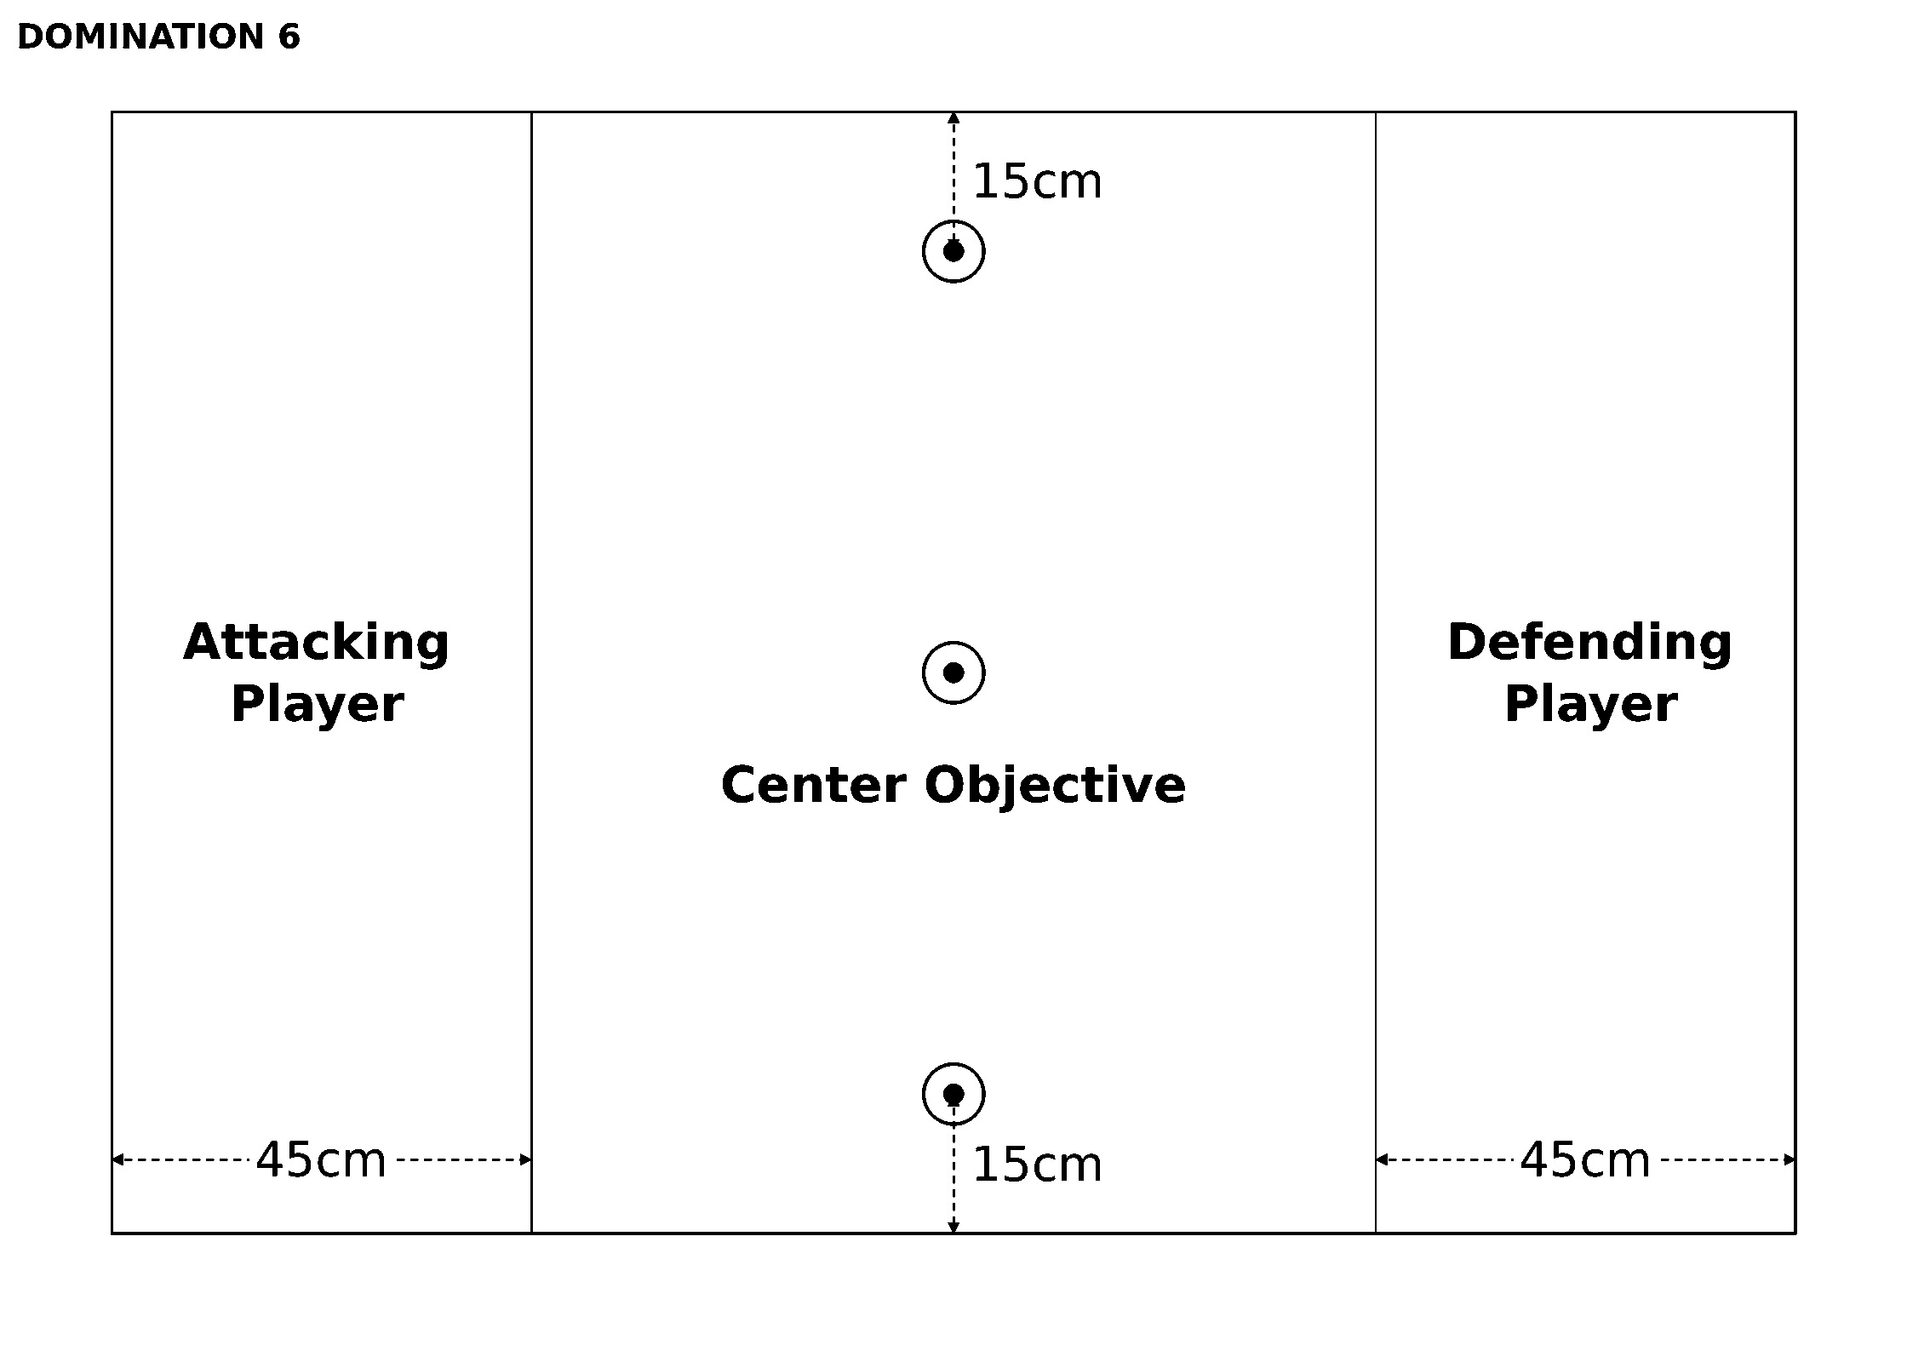
Deployment 6 (D6 result: 6)

Campaigns

Overview
Source: BFG:XR Rulebook, printed p.127.
At some stage all wargamers contemplate running a campaign. This is understandable, after all, battles don't take place in isolation; rather, they are part of an ongoing war. A campaign allows you to fight such a war by linking battles together, so that the results of one battle will have an effect on the future ones you fight. Over the course of the campaign, you will be able to develop cunning strategies to conquer whole sub-sectors and watch your fleet develop as ships' crews hone their skills in battle. Will your commander rise to new heights of glory or fall into the depths of ignominy? Embark on a campaign and find out!
Flavour text: I ask myself what it means to be one of the Dark Angels. Is it to hunt the Fallen, chasing shadows through the dark places of the galaxy? Is it to pursue our quest at any expense, forgoing all other oaths and duties? Is it to lie, to hide and to plot so that others will never know of our shame? Is it to keep our own brethren unacquainted with the truth of our past, the legacy we all share in? Or is it to be a Space Marine? Is it to follow the path laid down by the Emperor and Lion El'Johnson at the founding of this great Imperium of Man? To protect mankind, to purge the alien, cleanse the unclean?, Interrogator-Chaplain Boreas

Running a Campaign
Source: BFG:XR Rulebook, printed p.128.
As I hope you can tell, campaigns can be a lot of fun and they are not all that difficult to run either. To help you, we've developed a map-based campaign system based on our own experiences of running campaigns over the years, but you really should feel free to modify and change what's here to suit your own tastes. For example, playing a campaign offers great opportunities to try out new rules or new classes of ship that you've invented, or you could start thinking of adding rules for fighting land battles and boarding actions using the Warhammer 40,000 and Epic 40,000 rules. The possibilities really are endless.
Getting Started. In order to run a campaign you'll need at least two players to represent the main factions opposing one another in the campaign. You may also include any number of players whose factions will act as non-aligned raiders. Raiders will fight battles normally but do not capture systems, making them ideal for players that wish to participate but cannot commit to a fixed schedule.
Once you've got your players together you need to pick one of the sub-sectors on the sub-sector maps as the location for your campaign to take place. For your first campaign we recommend starting off with one of the smaller sub-sectors, unless you have a large number of players (i.e. more than eight) taking part in the campaign. You'll probably need to photocopy the sub-sector map you've decided to use (or draw it by hand) to keep track of which player controls each system.
Next you need to get all the players together for a "campaign briefing". The most important thing you'll need to go over at this point is the rules for the campaign, to make sure that everybody knows what's going on. You should then decide how long the campaign is to last. For your first campaign we recommend playing for one month of real time and on the whole it's best to keep campaigns short, after all, you can always start another one!
Once this has been decided, players can pick their starting systems and design their fleets using the rules described below, then you can start fighting battles. However, it is usually a good idea to set a regular time and place for campaign meetings, and also to elect a "campaign arbitrator" who is in charge of making sure that the campaign runs smoothly. You might also want to consider putting together a campaign newsletter, in which case you'll need to decide who will be its editor.
Starting Systems. At the start of the campaign, many of the systems in the sub-sector will be neutral. As the campaign progresses, this will change and players will gain control of systems that will pay them tithes and help repair their ships.
Designer's Note: In reality, every star system starts nominally under the control of the Imperium, but as planetary governors tend to go their own way until reminded of their obligations, they are for all intents and purposes neutral.
Each regular player starts with one of the systems in the sub-sector under their control. Roll off to decide the order in which players pick their starting system, and record who controls what. Raider players start with a hidden base instead, and should write down secretly in which system it is located (they can pick a system controlled by a regular player).
Starting Fleets & the Fleet Register. Regular fleets begin the campaign with 2,000 points and raider fleets start with 1,500 points. Important: you must have models to represent all of the ships in your fleet, in case they all end up in a big battle! If your fleet doesn't add up to 2,000 points, then just use what you've got available. (If players wish, the campaign may be played at lower points values in general, just remember to start raiders at 75% of the regular fleets' points values.)
A starting fleet is chosen from one of your faction's fleet lists as normal (except your fleet commander, see The Commander, below). As you add to your fleet during a campaign, you must obey the restrictions of your fleet list except where otherwise specified in the campaign rules. Record your starting fleet on your fleet registry, described below: each player has their own fleet registry, used to keep notes and dates of when each capital ship or escort squadron was commissioned (i.e. purchased from their fleet list) along with class of ship, when it takes its fleet trials (i.e. it's assembled, painted and its Leadership rating is rolled for), its campaign history, and its loss if and when these events occur.
If a vessel is used in battle before its fleet trials are complete (i.e. it's not fully assembled and painted) it will suffer a critical hit on a D6 roll of 1 every time it uses special orders. Ships which are added to the fleet register after the start of the campaign suffer a -1 modifier to their Leadership due to their hasty training and less experienced officers.
When players fight battles they must pick their forces according to the restrictions of their fleet list, but may only use forces which are actually shown on their fleet register.

The Commander
Source: BFG:XR Rulebook, printed p.129.
Each player's fleet begins with a commander (or an appropriately named leader for their faction) who will represent the player himself (or herself). Over the course of the campaign, your commander will collect renown points and gain in rank, and at the end of the campaign the commander with the highest renown is the winner.
Your campaign commander fills the role of a fleet commander in your fleet list, but does not cost any points and cannot purchase any of the usual options shown in the list's Fleet Commander section. (They will instead receive bonuses as they develop during the campaign, see the Promotion tables, below.)
Once you've filled in your fleet register, you need to fill in the details of your commander. He or she will need a name, and starts off with 1 point of renown and one re-roll. In addition, you must pick one ship in your fleet as their flagship. If this ship is involved in a battle then "you" are there, and you may use the commander's re-roll or any other special abilities he or she may have in the battle. If the flagship is not there then you may not use the commander's reroll or abilities.
If the flagship is destroyed, then it is assumed that your commander manages to escape somehow. He or she may not have any further effect in that game, but you may choose a new flagship for them once the game is over.
Fighting Battles. In order for things to happen during the campaign players must fight battles! At its simplest level all players have to do is challenge any other player that is in the campaign to a game and if they agree then the game uses the additional campaign rules below as well as the rules used for a normal game.
The only problem with this is that it can lead to some odd situations where fleets of the same faction attack each other to gain control of systems. Thus, it's best if players of the same faction are prohibited from attacking each other. If you have a lot of fleets from a specific faction in the campaign (or, indeed, only a single faction), then it is best to split them into loyalists and rebels, the latter being assumed to have committed some terrible act of betrayal!
Anyway, however you decide to do it, you need to challenge other players in the campaign to a game. The game is arranged in exactly the same manner as a one-off game; simply agree on a time and a place and go for it. You can play as many or as few campaign games as you like, all you need to do is find an opponent.
Note that opposing players do not have to agree to play just because you happened to have challenged them to a battle, but you may want to penalize players that refuse to play games with anybody for long periods of time and spoil the campaign for the other players. For example, if a player doesn't play any games for (say) a fortnight then they lose a point of renown, and if they don't play any games for a month then one of their systems (randomly selected) rebels and is turned over to another player.
The Campaign Turn. Campaign games include a number of extra steps which take place at the beginning and end of the game, as described below. Unless stated otherwise all of the normal Battlefleet Gothic rules apply in a campaign game.
Each time that two players have a game they both get what is known as a campaign turn. A campaign turn uses the following sequence of play:
1. Build Up: Determine Attacker & Defender; Roll for Incoming Orders; Select Target System; Pick Fleets
2. Fight Battle
3. Aftermath: Spoils of War; Adjust Renown; Promotions & Demotions; Ship Experience; Repairs & Withdrawals; Make Appeals

Build-Up
Source: BFG:XR Rulebook, printed p.130.
The build-up stage takes place at the start of the battle, before either player deploys or picks their fleet. In this stage you decide where the battle will be, what type of scenario to play, and what size of fleets to use. The stage has a number of steps that need to be carried out in the following order: 1. Determine Attacker & Defender; 2. Roll for Incoming Orders; 3. Pick Fleets.
1. Determine Attacker & Defender. Using the fleets' attack ratings as described on p.78 (above), determine who will be the attacker and who will be the defender. The player who controls less total systems does not need to spread their forces as thinly as their opponent, and thus adds +1 to the result(s) of their dice. Similarly, the player who controls more systems in total must spread their forces thinly, reducing their fleet size by 10 points for each additional system they hold over their opponent.
2. Roll for Incoming Orders. Although fleet commanders have a large measure of autonomy, higher command still sends down orders telling them what they must achieve next. In effect, the players get to decide what happens in the battles, but receive orders that direct the strategy they must follow, and the type of battles they will fight. To reflect this, the attacker must roll a D6 to determine what type and size of scenario is to be played.
D6 Roll | Orders
1-2 | Raid (500-750 points)
3-6 | Battle (750-1500 points)

If one player's commander has at least 21 Renown, that player may choose whether to fight a battle or a raid, even if they are the defender. If both players' commanders have at least 21 Renown, the attacker rolls for the scenario type normally.
After determining whether to fight a raid or battle, roll on the appropriate table below to determine the specific scenario to be played:
Raids
D6 Roll | Scenario
1 | The Raiders
2 | Blockade Run
3 | Convoy
4 | Rearguard Attack
5 | Navigate the Storm
6 | Destroy the Docks

Battles
D6 Roll | Scenario
1 | Exterminatus!
2 | Alien Intervention
3 | Surprise Attack
4 | Planetary Assault
5 | Escalating Engagement
6 | Fleet Engagement

Once the scenario has been determined, the attacker chooses the system where the game will take place. The system must be connected to one already under the attacker's control (via warp route on the sector diagram). If the attacker controls no systems, any may be chosen.
Having established the scenario and location, both players must agree on a points limit for the game. The chosen limit must abide by any restrictions in the scenario's rules (as well as the range shown in the Incoming Orders table above, if no value is specified). If the fight takes place in a system that is uninhabited, the defender reduces his or her fleet size by 100 points due to lack of supply lines.
Raiders: Note that raider fleets never engage in full battles. Instead, if one or both players are acting as raiders, treat results of 3-6 on the Incoming Orders table as a major raid rather than a battle. A major raid uses the Raids table to determine the scenario but will have a points limit of 750-1500 points like a standard battle.
3. Pick Fleets. Both players must now pick their fleets using ships from their fleet register. The total value of the ships you pick may not exceed the points total you and your opponent have decided for the scenario you are to play. Note that you can't change the details of ships on the register or adjust their points value at this stage, the ships you pick must come from your register and not be changed in any way. With the build-up completed all you need do now is roll for a sub-plot and then get fighting!
Hidden Bases: Raider fleets never get to capture systems, but instead have a secret base. If the opponent of a raider fleet is the attacker and has at least 21 renown points, that player may attempt to find and attack the secret base. To do this, they must roll a D6 and multiply the result by 10. If the result is less than the raider player's renown, the secret base is found and remains revealed until the raider player moves it. Otherwise, it stays hidden and the players choose a normal scenario to play.
A secret raider base cannot be attacked if it is in a system controlled by another regular player. If this prevents it from being attacked on the campaign turn it is discovered, play a normal game instead. Assuming it is found and is a valid target, the attacker chooses either the Planetary Assault or Exterminatus scenario to represent the attack on the base. If they win, the base is destroyed and may no longer be used.

Aftermath
Source: BFG:XR Rulebook, printed p.131.
Once you have fought a campaign game and know who has won, you come to probably the most important stage: the aftermath. This is where you find out what effect the game you have just played has on the campaign map, as well as the effect it has had on the ships and crew that took part. This stage has a number of steps, which need to be carried out in the following order: 1. Spoils of War; 2. Adjust Renown; 3. Promotions & Demotions; 4. Ship Experience; 5. Repairs & Withdrawals; 6. Appeals.
1. Spoils of War. Whenever an attacker wins a battle, he or she may claim control of the system if it is connected by a warp route to one he or she already controls. The system can only be taken over by the player that won the battle if it previously belonged to the player that was defeated, or if it was previously neutral. Whenever an attacker wins a raid, he or she may count the system where the raid took place as his or her own for the rest of this campaign turn (which is important, since the systems you control affect your ability to repair ships, etc). After the campaign turn ends, control of the system reverts to normal.
2. Adjust Renown. Renown is a measure of the total fame (or infamy) enjoyed by you, the fleet commander. Players start the campaign with 1 point of renown and can gain or lose renown as shown on the Renown table below. Renown is very important, at the end of the campaign, the player that has earned the most renown is the winner! Note that you can gain or lose renown even if your commander was not present during the scenario (i.e. their flagship did not take part).
Renown Table
Gained For | Amount
Winning a battle or major raid | +2
Winning a raid | +1
Victory points earned | +1 per 100 VPs (rounding up)
Sub-plots | Varies
Each hulk captured by holding the field | +1
Fought against a commander with higher renown | +1
Fought against a fleet worth more points and lost | +1
Fought against a fleet worth more points and won | +2

Lost For | Amount
Losing a battle | -1
Losing a raid | -1
Each capital ship lost | -1
Sub-plots | Varies

Note: A commander can never be reduced below 1 renown point (you may only be renowned as a poor commander, but you will be renowned nonetheless).
Flavour text: "There's not nearly enough. Whatever foul work the Arch-enemy does here must be stopped at all costs, but do not fool yourself Governor; this world will die. It just remains to be seen how many of us it takes with it.", Inquisitor Barzano

3. Promotions and Demotions
Source: BFG:XR Rulebook, printed p.132-133.
Your commander gains promotions according to their renown as shown on the tables that follow. It is possible to lose rank if you lose renown points. Your rank determines how many re-rolls and other upgrades your commander receives in the scenario you fight.
Note: Upgrades granted by a commander's renown rank are chosen when the rank is achieved and do not change during the campaign. They are free, but must still abide by any restrictions in the relevant fleet list, counting any limitations that refer to fleet commanders as applying to a player's commander in the campaign. For example, a Chaos Overlord has two Marks of Chaos (one chosen at 6 renown and the other at 21 renown). Each game where the Overlord is present, these Marks must be assigned to different capital ships, and if one is the Mark of Chaos Undivided, it must be assigned to the Overlord's vessel (since he counts as the fleet commander).
Adeptus Mechanicus Promotion Table
Renown | Title | Bonuses
1-5 | Explorator Techpriest | Ld7, 1 re-roll
6-10 | Magos Errant | Ld8, 1 re-roll, +1 Max Gifts
11-20 | Magos Explorator | Ld8, 2 re-rolls, +1 Max Gifts
21-30 | Aspiring Archmagos | Ld9, 2 re-rolls, +1 Max Gifts
31-50 | Archmagos Explorator | Ld9, 3 re-rolls, +1 Max Gifts
51+ | Archmagos Veneratus | Ld10, 3 re-rolls, +2 Max Gifts

Eldar Promotion Table (Corsair / Craftworld titles)
Renown | Title (Corsair/Craftworld) | Bonuses
1-5 | Captain | 1 re-roll
6-10 | Lord | +1Ld, 1 re-roll
11-20 | Shadow Lord / Mariner Lord | +1Ld, 2 re-rolls
21-30 | Prince / Admiral | +2Ld, 2 re-rolls
31-50 | Shadow Prince / High Admiral | +2Ld, 3 re-rolls
51+ | Dragon Prince / Autarch | +2Ld, 4 re-rolls

Chaos Promotion Table
Renown | Title | Bonuses
1-5 | Chaos Champion | Ld8, 1 re-roll
6-10 | Exalted Chaos Champion | Ld8, 1 re-roll, 1 Mark of Chaos
11-20 | Tyrant | Ld9, 1 re-roll, 1 Mark of Chaos
21-30 | Chaos Lord | Ld9, 1 re-roll, 2 Marks of Chaos
31-50 | Overlord | Ld10, 1 re-roll, 2 Marks of Chaos
51+ | Warmaster | Ld10, 1 re-roll, 3 Marks of Chaos

Imperial Navy Promotion Table
Renown | Title | Bonuses
1-5 | Commander | Ld8, 1 re-roll
6-10 | Battle Group Commander | Ld8, 2 re-rolls
11-20 | Subsector Commander | Ld9, 2 re-rolls
21-30 | Admiral | Ld9, 3 re-rolls
31-50 | Fleet Admiral | Ld10, 3 re-rolls
51+ | Solar Admiral | Ld10, 4 re-rolls

Dark Eldar Promotion Table
Renown | Title | Bonuses
1-5 | Kabal Captain | 1 re-roll
6-10 | Trueborn Captain | +1Ld, 1 re-roll
11-20 | Dracon | +1Ld, 2 re-rolls
21-30 | Hierarch | +2Ld, 2 re-rolls
31-50 | Archon | +2Ld, 2 re-rolls, 1 Dracon
51+ | Dread Archon | +2Ld, 2 re-rolls, 2 Dracons

Inquisition Promotion Table
Renown | Title | Bonuses
1-5 | Inquisitorial Acolyte | Ld8, 1 re-roll
6-10 | Inquisitor Ordinary | Ld9, 1 re-roll
11-20 | High Inquisitor | Ld9, 1 re-roll, 1 appeal re-roll
21-30 | Lord Inquisitor | Ld10, 1 re-roll, 1 appeal re-roll
31-50 | Master Inquisitor | Ld10, 2 re-rolls, 1 appeal re-roll
51+ | Grandmaster Inquisitor | Ld10, 3 re-rolls, 1 appeal re-roll

Necron Promotion Table
Renown | Title | Bonuses
1-5 | Immortal | Ld8, 1 re-roll
6-10 | Cryptek | Ld8, 2 re-rolls
11-20 | Necron Lord | Ld9, 2 re-rolls
21-30 | Nemesor | Ld9, 2 re-rolls, Nightmare Field
31-50 | Overlord | Ld10, 2 re-rolls, Nightmare Field
51+ | Phaeron | Ld10, 3 re-rolls, Nightmare Field

Note: The nightmare field is always equipped on the commander's flagship.
Space Marine Promotion Table
Renown | Title | Bonuses
1-5 | Company Champion | Ld8, 1 re-roll
6-10 | Veteran Sergeant | Ld8, 2 re-rolls
11-20 | Lieutenant | Ld9, 2 re-rolls
21-30 | Captain | Ld9, 2 re-rolls, Honor Guard
31-50 | Hero of the Chapter | Ld10, 2 re-rolls, Honor Guard
51+ | Master of the Fleet | Ld10, 3 re-rolls, Terminator Honor Guard

Note: The honor guard or Terminator honor guard is always assigned to the commander's flagship.
Ork Promotion Table
Renown | Title | Bonuses
1-5 | Nob | 1 re-roll
6-10 | Big Nob | 1 re-roll, 1 Kustom Upgrade
11-20 | Big Mek / Warboss / Freebooter | 2 re-rolls, 1 Kustom Upgrade
21-30 | Big Boss | 2 re-rolls, 2 Kustom Upgrades
31-50 | Mega Boss | 2 re-rolls, 3 Kustom Upgrades
51+ | Warlord | 3 re-rolls, 3 Kustom Upgrades

Note: The first time he reaches 11 renown, an Ork commander must choose whether to be a Big Mek, Warboss, or Freebooter, gaining the abilities of the matching commander type in the Ork faction list. The chosen abilities remain in effect as long as he has at least 11 renown points. In addition, Ork campaign commanders may purchase clan support before a game just like normal Ork fleet commanders. If they are a Big Boss or better, they have authority over vessels in their fleet in the same way as a fleet commander with the matching upgrade (treat Warlords as mega bosses for this purpose).
Rogue Trader Promotion Table
Renown | Title | Bonuses
1-5 | Bond-Captain | Ld8, 1 re-roll
6-10 | Veteran Captain | Ld8, 1 re-roll, +2 Fortune
11-20 | Lord Captain | Ld9, 1 re-roll, +2 Fortune
21-30 | Venerable Lord Captain | Ld9, 1 re-roll, +4 Fortune
31-50 | Commodore | Ld10, 1 re-roll, +4 Fortune
51+ | Legendary Commodore | Ld10, 1 re-roll, +6 Fortune

Tau Empire Promotion Table
Renown | Title | Bonuses
1-5 | Kor'el | Ld8, 1 re-roll
6-10 | Honored Kor'el | Ld8, 2 re-rolls
11-20 | Kor'O'saal | Ld9, 2 re-rolls
21-30 | Kor'O | Ld9, 2 re-rolls, 1 Crew Skill
31-50 | High Kor'O | Ld10, 2 re-rolls, 1 Crew Skill
51+ | Supreme Kor'O | Ld10, 2 re-rolls, 2 Crew Skills

Note: Crew skills earned via rank must be applied to the commander's flagship.
Tyranid Promotion Table
Renown | Title | Synapse Effect
1-5 | Minor Synapse Node | Ld7, 30cm Synapse
6-10 | Adult Synapse Node | Ld8, 30cm Synapse
11-20 | Major Synapse Node | Ld8, 45cm Synapse
21-30 | Evolved Synapse Node | Ld8, 45cm Synapse, 1 re-roll
31-50 | Alpha Synapse Node | Ld9, 45cm Synapse, 1 re-roll
51+ | Omega Synapse Node | Ld10, 60cm Synapse, 1 re-roll

Note: A Tyranid campaign commander may select any primary hive ship as its flagship, overwriting its synapse rules with those of the relevant rank. It cannot purchase any additional hive mind re-rolls or primary hive ship upgrades, in the same way that regular campaign commanders cannot purchase options in their list's Fleet Commander section.

4. Ship Experience
Source: BFG:XR Rulebook, printed p.134.
As the campaign progresses, ships (or rather, their crews) will gain experience. This is represented by increasing their Leadership characteristic, and by giving them special "crew skills". On the other hand a ship that is badly damaged is likely to have lost a sizable proportion of its experienced crewmen, which will reduce its effectiveness, while a ship that is destroyed will have to be replaced by a new or salvaged vessel with a very inexperienced crew.
Gaining Experience: Ships which fought in a battle and were not crippled or destroyed roll 2D6. If the roll is higher than their Leadership rating, then either their Leadership may be improved by +1 point (up to a maximum of 10) or the ship may roll on the Crew Skills table for their faction (Imperial or Xenos), in the Appendix. You may choose which option to take, unless the ship has a Leadership of 6 or 7, in which case you must choose to increase the ship's Leadership.
Crippled Ships: Vessels that become crippled in a battle lose -1 Leadership (to a minimum of 6). Note that crew skills aren't lost for being crippled, even if the ship's Leadership is reduced to 6 or 7.
Destroyed Ships: Vessels which are destroyed (i.e. reduced to 0 damage points) must be replaced with a new ship of the same class. Change their name on your fleet register. The new ship has a Leadership of 6, no crew skills, and any refits that have been taken are lost (the rules for refits follow later on).
Escort Squadrons: Escort squadrons gain and lose Leadership and skills in the same way as ships. Escort squadrons which suffer 50% or greater casualties are considered crippled for the purpose of experience, while those that are wiped out are considered destroyed.

5. Repairs & Withdrawals
Source: BFG:XR Rulebook, printed p.134.
In a campaign, vessels that have suffered damage must be repaired, and it is the number of systems a player controls that determines just how much damage can be fixed. Sometimes the systems under your control won't be able to repair all the damage your fleet has suffered, in which case you can either withdraw the ships and send them to be repaired outside the sub-sector, or you can let them limp on as they are until you have time to repair them.
Repairs: Each system a player controls may repair a number of damage points. This varies depending on the type of system and your renown. The number of damage points different systems can repair is shown below. Renown is important because it helps with recruiting or press-ganging extra crew, claiming resources and time in dock etc. Note that all critical hits are repaired automatically, including ones which may not be repaired during a battle (i.e. Bridge Smashed and Shields Collapse). Also remember that if the attacker won a raid he may count the enemy system where the raid took place as his own for this turn. You can use Repair points to bring escort squadrons back up to strength, in which case each member is worth its Hits value.
System Repair Table (damage points repairable, by system type and renown)

Renown | Agri | Penal (min. 1) | Mining | Forge, Hive, Hidden Base | Civilized | Uninhabited
1-5 | 1 | 1 | 2 | 3 | 1 | 1
6-10 | 1 | D6-4 | 2 | 3 | 2 | 1
11-20 | 1 | D6-3 | 2 | 4 | 3 | 1
21-30 | 2 | D6-2 | 2 | 5 | 4 | 1
31-50 | 2 | D6-1 | 3 | 6 | 5 | 1
51+ | 3 | D6 | 4 | 12 | 6 | 1

Withdrawing Ships: A player may also choose to withdraw ships to get them fully repaired at a major base. Mark the fact they have been withdrawn on the fleet register. Ships which are withdrawn are unavailable for the player's next game, after which they return to the fleet with their full number of hits. Escort squadrons which are withdrawn may return at full strength.
Note: Vessels that begin a campaign game crippled must be damaged at least once during the game to count as crippled for the purpose of victory points.
Flavour text: "Now the past must unveil one of its darkest secrets, the story of the Plague of Unbelief and its most heinous vector Bucharis the Apostate Cardinal of Gathalamor. Never has the Imperium endured such a crisis of faith, not since the dark days of the Horus Heresy itself.", Galan Noirgrim, Master of the Ordo Malleus

6. Appeals
Source: BFG:XR Rulebook, printed p.135.
After repairs have been completed, both players can appeal to higher authorities and/or the gods of Chaos for aid. The amount of help you can expect to receive depends on how well you've been doing, as measured by your renown. To reflect this, the number of appeals that may be made depend on the players' renown as shown on the table below.
Renown | No. of Appeals
1-10 | 1 Appeal
11-30 | 2 Appeals
31-50 | 3 Appeals
51+ | 4 Appeals

Appeals may normally only be made for refits and reinforcements. If you are allowed to make more than one appeal you can ask for the same thing up to two times (and may have each appeal granted), or you can appeal for different things, it's up to you! However, you must declare what you will appeal for this turn before determining whether the appeals have been granted. Having declared what you are going to appeal for, roll a D6 for each appeal to see if the appeal is granted.
Appeal Type | Score Needed
Reinforcements | 2+
Refits | 4+
Other | 5+

Note: Some campaigns may allow access to other types of appeals besides refits and reinforcements. These will naturally use the "Other" category of the table above. However, raider fleets may only ever appeal for refits and/or reinforcements, regardless of the campaign being played.
Reinforcements. If the appeal is granted, one new capital ship or a squadron of up to five escorts may be added to the player's fleet registry. Note that you must have the models to represent the ships, if you don't, then they can't be added to the fleet register.
Refits. A player who is granted a refit must choose one of his capital ships to undergo the refit, then roll a D6 to see what type of equipment system is upgraded. On a roll of 1 or 2 you receive a ship refit, on a roll of 3 or 4 an engine refit, and on a roll of 5 or 6 a weapon refit. If a ship already has every refit in the rolled category, roll again until you get a different category.
The ship, engine, and weapon refit tables are in the Appendix (Appendix 2, p.148). Always use the table that matches your faction list's source book: Imperial Refits for the Imperium, Chaos, the Inquisition, Rogue Traders, the Adeptus Mechanicus and the Space Marines; Xenos Refits for the xenos fleets. For example, Chaos ships that earn a weapon refit roll on the Weapon Refit section of the Imperial Refits table.
If you roll a result that the ship already has, roll again until you get a refit the ship does not have. The points value of the ship is increased by 10% for each refit it has and you'll need to update your ship register appropriately.
Other Appeals. Other appeals typically allow you to request the aid of other allies or beseech your gods for a miracle. As before, if you roll a result on the table that you already have, then roll again until you get a new result.
Flavour text: "The best way of improving a gun is to improve its ammunition."

Conclusion (Campaigns)
Source: BFG:XR Rulebook, printed p.135.
As noted in the introduction, players should set a deadline for the campaign. When the deadline is reached, the player that has built up the greatest renown is the winner. However, once you've got some experience running campaigns like this, you should feel free to change the criteria for victory.

Notable Campaigns
Source: BFG:XR Rulebook, printed p.135. This is the reference key for the many campaign-specific cross-references scattered through the scenarios above (Daemon Blockade, The Gauntlet, Parol's Bait, Chance Encounter's Third Armageddon War usage, Macharia's End, The Defense of Pelucidar, and others).
You may use the following guidelines to construct campaigns around specific major events in the history of the 41st Millennium. The required scenarios do not need to be played consecutively, but should be resolved in the order they are listed.
The Gothic War
- Main Factions: Imperial Navy & Chaos
- Raider Factions: Corsair Eldar & Orks
- Imperial Navy Appeals: Space Marine Support
- Chaos Appeals: Forces of Chaos
- Sub-Sector: Bhein Morr, the Cyclops Cluster, Gethsemane, Port Maw, the Quinrox Sound, Lysades, or Orar
- Special Rules: Some systems include the presence of one of the Blackstone Fortresses (indicated in brackets). In these systems, a defender may include a Blackstone Fortress as a planetary defense (paying its cost as normal). In addition, all planets in the Port Maw system (not the sub-sector) double the points limit of their planetary defenses.
The Third Armageddon War
- Main Factions: Imperial Navy & Orks
- Imperial Navy Appeals: Space Marine Support
- Ork Appeals: Power of the Waaagh!
- Required Scenarios: The Gauntlet, Parol's Bait, Defense of Pelucidar
- Sub-Sector: Armageddon, Desedna & Paleoth, Golgotha, Justicar, or Voss
- Special Rules: Infested worlds (indicated with an "I" on the sub-sector map) count as uninhabited to everyone except the Orks, to whom they count as civilized worlds. However, if an Ork player loses a battle in one of his or her own infested systems, all negative (-1, -2, etc) modifiers to their renown are doubled when adjusting renown after that game.
Abaddon's 13th Black Crusade
- Forces of Order: Imperial Navy (Main), Eldar (Raiders)
- Forces of Disorder: Chaos (Main), Dark Eldar (Raiders)
- Imperial Navy Appeals: Space Marine Support
- Chaos Appeals: Forces of Chaos
- Required Scenarios: Chance Encounter, Rearguard Attack, Alien Intervention, Destroy the Docks, Daemon Blockade, Navigate the Storm, Macharia's End
- Sub-Sector: Agripinaa, Belial IV, Cadia, Caliban, Corona, Chinchare, Eidolon, Medusa, the Nemesis Tessera, Scarus, Scelus, or the Sentinel Worlds
- Special Rules: Some of the sub-sectors for this campaign are especially small. To make things interesting, consider linking multiple sub-sector maps together to create a much larger overall map, one fitting the grand scale of Abaddon's 13th Black Crusade!
The three faction appeal tables (Forces of Chaos, Power of the Waaagh!, Space Marine Support) are in the Appendix: see Appendix 1, p.146.

Sub-Sector Maps
Source: BFG:XR Rulebook, printed p.138.
Number of Systems. A sub-sector contains many stars, but of these only a few will have any planets orbiting, the vast majority of which will be gas giants or planets locked in sub-zero ice ages. This means that any given sub-sector will have relatively few star systems actually worth fighting over. Of these, the majority will be mining worlds, agri-worlds and other worlds with a sizable population and contemporary level of technology (categorized as civilized worlds). A few systems may have a forge world, hive world or other such planet. Occasionally uninhabited systems also have strategic importance as jump points or gathering places for assembling war fleets. As a result of these factors, the sub-sector maps only show those systems of military or strategic importance to the forces fighting in the campaign.
Warpspace Channels. In theory it is possible to travel anywhere through warp space. However, the warp's shifting tides make it easier to travel from some systems to others, and short warp jumps are always more accurate than longer ones. This is particularly true when moving a large fleet, which may become spread out across several light years of space. For this reason, the systems on a sub-sector map are connected by a number of warpspace channels (also known as warp routes) to the other systems.
System Type. Each system will be one of the following types: uninhabited, agri-world, mining world, hive world, penal colony, forge world or civilized world, as shown in the map key. Note that a system may actually contain more than one world, but the political power and the bulk of the resources will be concentrated on the type of world shown. The system type will influence how much ship damage it can repair and level of its orbital defenses.
Flavour text: "Every planet, moon, and star in these cosmos belongs to the Emperor. Steal one if you dare."
Key to Sub-Sector Maps (printed p.141)

Symbol | Meaning |  | Symbol | Meaning |  | Symbol | Meaning
P | Penal |  | M | Mining |  | A | Agri-world
H | Hive |  | U | Uninhabited |  | ? | Unknown
F | Forge |  | C | Civilized |  | I | Infested

The sub-sector maps themselves are not yet reproduced in this Companion. Use the named maps in the BFG:XR Rulebook, printed p.138-141, which cover the sub-sectors listed under Notable Campaigns above.

Appendix 1 - Campaign Tables
Rolled in the Aftermath step of a campaign turn, when making an appeal. See the Appeals rules in the Campaigns section.
Forces of Chaos Table
Source: BFG:XR Rulebook, printed p.136. Chaos faction appeal table ("Other Appeals"). Roll 2D6.
2D6 | Result
2 | At the start of your next battle, roll once on the Critical Damage table and apply the result to your commander's ship.
3 | You may re-roll the dice when deciding who has the initiative in the next campaign turn. The second roll stands.
4 | Nominate one capital ship in the next battle. A single enemy ship within 15cm during your end phase is attacked: roll a D6, this is the number of dice you roll to hit against the target's Armour (shields have no effect).
5 | Add a Chaos Lord (with a Mark of Chaos if you wish) to your Fleet Registry.
6 | Your flagship is upgraded to be a Chaos Space Marine vessel.
7 | Your flagship and any ship with a Chaos Lord aboard has a +2 crew damage bonus instead of the normal +1 applied to Chaos ships.
8 | One ship in your fleet embarks a squad of Chaos Terminators. They gain the normal +1 bonus to hit-and-run results even aboard a ship that is not a Chaos Space Marine vessel.
9 | One ship in your fleet may be equipped with boarding torpedoes and/or Dreadclaw assault boats for no extra cost.
10 | Choose a single cruiser, heavy cruiser, grand cruiser, or battleship in your fleet roster. That vessel becomes a daemonship for the rest of the campaign, at no change in cost.
11 | Nominate one of your capital ships in the next game. Any enemy shooting at this ship suffers a right column shift on the Gunnery table (before any other shifts for range or Blast markers).
12 | Nominate one capital ship in your fleet. In the next battle, any enemy ship within 15cm of this vessel counts as having one Blast marker in contact with its base.

Power of the Waaagh! Table
Source: BFG:XR Rulebook, printed p.136. Ork faction appeal table ("Other Appeals"). Roll 2D6.
2D6 | Result
2 | Your flagship is changed into a different random vessel of the same type (cruiser, battleship, etc). Any refits are retained and the Meks add a new one from the Xenos Refits table. Your crew loses 1 Ld for the next battle only.
3 | You may add up to 1 cruiser or squadron of escorts to your roster for each system you control. Each unit added requires you to reduce the grade of 1 system: Forge to Mining, Civilized to Agri, or any other type to Uninhabited.
4 | If you held the field at the end of the last scenario, nominate one capital ship for each enemy hulk you captured. The indicated ships gain either Looted Torpedoes or Extra Power Fields (your choice for each).
5 | For each civilized system or hive world you control you may give one of your capital ships one Kustom Upgrade.
6 | You may add 1 Ork Boss to your registry.
7 | One of your ships gains a +2 crew damage bonus instead of the usual +1 applied to Ork vessels.
8 | Your flagship gains Mega Armored Boarding Parties.
9 | Assign extra boyz to two vessels, both of which increase their crew damage bonus to +2 instead of +1.
10 | You win any dice roll-offs which are drawn during your next campaign turn and battle.
11 | One uninhabited system you own becomes an agri-world system.
12 | The next time you are the attacker in a battle you may nominate two systems to be attacked. The battle will be 1,500 to 2,000 points. If you win, you claim both systems; if your opponent wins, they claim one neutral system.

Space Marine Support Table
Source: BFG:XR Rulebook, printed p.137. Imperial Navy faction appeal table ("Other Appeals"). Roll 2D6.
2D6 | Result
2 | You may include one Space Marine battle barge in your next game for free, provided you have a model for it (if not, roll again). No refits or upgrades.
3 | You may include two strike cruisers in your next game for free, provided you have models for them (if not, roll again). No refits or upgrades.
4 | You may include one strike cruiser in your next game for free, provided you have a model for it (if not, roll again). No refits or upgrades.
5 | Two companies of Space Marines are stationed aboard two ships of your choice. Treat those ships as Space Marine vessels for all boarding actions and hit-and-run raids.
6 | A company of Space Marines is stationed aboard one ship of your choice. Treat that ship as a Space Marine vessel for all boarding actions and hit-and-run raids.
7 | One ship of your choice (must be capable of launching attack craft) is supplied with Thunderhawk Gunships. It must halve the strength of its launch bays and may only launch Thunderhawks (see the Space Marine faction rules). These gain a +1 bonus to hit-and-run results, as if launched from a Space Marine vessel.
8 | One ship of your choice (must be capable of launching torpedoes) gains boarding torpedoes in addition to its normal torpedoes. These gain a +1 bonus to hit-and-run results, as if launched from a Space Marine vessel.
9 | Your flagship gains a Terminator Honor Guard and may conduct teleport attacks against targets with more remaining hits than itself.
10 | You may train one ship's crew after each game (mark it on your fleet registry). Trained ships may re-roll the dice in a boarding action.
11 | In your next game your opponent must reduce his points value by D6×30.
12 | In the next game where your opponent has planetary defenses, their value is reduced by D6×30 points.

Appendix 2 - Refits and Crew Skills
Refits and crew skills are shared across factions rather than belonging to any one of them, so they are printed here once. The Campaigns rules (Ship Experience, Appeals) and several faction and fleet-list rules point to these tables.

How refits work
Source: Imperium p.151 / Xenos p.122.
A ship can never have or benefit from more than one copy of any named refit, no matter how it was acquired. Refits sharing a name are the same refit even when they come from different tables or sources: a ship granted Extra Turrets from the Imperial Refits table cannot also buy Extra Turrets from the Xenos Refits table.
Each refit table is subdivided into three sub-tables: Engine, Ship, and Weapon Refits. The tables are not faction-restricted; use the table found in the same book as your faction list (so Chaos ships use the Imperial Refits table).
Standard games. Refits are not freely available. You may only buy them where your faction rules and fleet list direct, subject to any limits those impose.
Campaign games. You may also acquire a refit by making an appeal in the Aftermath step of a campaign turn. See the Appeals rules in the Campaigns section.
Roll or buy. Normally you buy the refit, adding its points cost to the ship's cost as usual. When a refit is acquired via a campaign appeal, or by certain fleet or faction special rules, you instead roll for it: the refit's points cost is waived, but other associated costs are not (such as the points increase the appeal itself imposes).
Rolling. Unless directed to a specific sub-table, roll a D3 for the category (1 Engine, 2 Ship, 3 Weapon), then a D6 on that sub-table. Re-roll any result the ship cannot take, whether because it already has that refit, is prohibited from equipping it, or already has every refit in the category.
Note: the Appeals rules in the Campaigns section reach the same result by a different roll, using a D6 for the category (1-2 Ship, 3-4 Engine, 5-6 Weapon). Both are as printed in their respective source books; the odds are identical.
Imperial Refits - Engine Refits
Source: Imperium p.152.
D6 | Cost | Engine Refit
1 | 5 pts | Arrester Engines. +1 Ld on Burn Retros and All Ahead Full command checks.
2 | 5 pts | Navigational Shields. No Speed reduction for moving through blast markers (including gas and dust clouds).
3 | 10 pts | Auxiliary Power Relays. +5cm Speed.
4 | 10 pts | Secondary Reactors. +2D6cm extra Speed on All Ahead Full.
5 | 20 pts | Maneuvering Thrusters. Reduce the distance moved before turning by 5cm.
6 | 20 pts | Evasive Jets. At the start of the enemy shooting phase, take a leadership test; if passed, turn 45° in the direction of your choice, but the ship cannot go on special orders during its next turn.

Imperial Refits - Ship Refits
Source: Imperium p.152.
D6 | Cost | Ship Refit
1 | 5 pts | Improved Logic Engines. No -1 Ld to command checks while in contact with blast markers.
2 | 5 pts | Improved Sensor Array. +2 Ld (instead of +1) on command checks when any enemy ships are on special orders.
3 | 10 pts | Superior Damage Control. Roll an additional D6 when repairing critical damage.
4 | 10 pts | Reinforced Hull. +25% maximum damage points (rounding up), -5cm Speed. Escorts cannot take this refit.
5 | 20 pts | Additional Shield Generator. +1 Shields.
6 | 20 pts | Overloaded Shield Capacitors. After an enemy rolls to hit, roll a D6 for each active shield; each 6 discards one hit. No effect against hits that bypass shields.

Imperial Refits - Weapon Refits
Source: Imperium p.152.
D6 | Cost | Weapon Refit
1 | 5 pts | Extra Turrets. +1 Turrets. Re-roll if the ship already has a Turrets value of 6 or higher.
2 | 5 pts | Auto-loaders. +1 Ld on Reload Ordnance command checks. Re-roll if the ship has no ordnance.
3 | 10 pts | Superior Fire Control. +1 Ld on Lock On command checks.
4 | 10 pts | Turbo Weapons. No right column-shift when firing gunnery at targets more than 30cm away.
5 | 20 pts | Targeting Matrix. An extra left column-shift on all gunnery, in addition to any other shifts that apply.
6 | 20 pts | Motion-Tracking Targeters. On All Ahead Full, Burn Retros, or Come to New Heading, gunnery effectiveness is reduced by only 25% (rounding up) rather than halved.

Imperial Crew Skills
Roll a D6. Re-roll duplicates or results that cannot apply; a ship with all six gains no more. Source: Imperium p.151.
D6 | Crew Skill
1 | Expert Gunnery. Lock On command checks: roll 3D6 and discard the highest.
2 | Skilled Engineers. All Ahead Full and Burn Retros command checks: roll 3D6 and discard the highest.
3 | Adept Trimsmen. Come to New Heading command checks: roll 3D6 and discard the highest.
4 | Excellent Pilots. Bomber squadrons re-roll the dice determining their number of attacks; fighters gain a 4+ resilient save if they do not already have one. No effect on multi-role attack craft.
5 | Disciplined Crew. Once per battle, re-roll a failed leadership test or command check.
6 | Elite Command Crew. Once per battle, before making a leadership test or command check, automatically pass it without rolling.

Xenos Refits - Engine Refits
The twin of the Imperial table; acquisition works identically. Entries marked (shared) are the same refit as the Imperial one of that name, so a ship cannot hold both. Source: Xenos p.123.
D6 | Cost | Engine Refit
1 | 5 pts | Silent Running. +2 Ld when attempting to disengage. If the leadership test is failed, the ship may instead move directly forward exactly 10cm, ignoring blast markers and celestial phenomena.
2 | 5 pts | Navigational Shields. No Speed reduction for moving through blast markers (including gas and dust clouds). (shared)
3 | 10 pts | Auxiliary Power Relays. +5cm Speed. (shared)
4 | 10 pts | Secondary Reactors. +2D6cm extra Speed on All Ahead Full. (shared)
5 | 20 pts | Gravity Anchor. Once per turn, make an extra 45° turn at the end of the move. No effect while the ship is in a gravity well.
6 | 20 pts | Jink Engines. At the start of the shooting phase, take a leadership test; if passed, gain a 6+ save against hits from enemy direct fire weapons until the end of the turn. Cannot be used while braced.

Xenos Refits - Ship Refits
Source: Xenos p.123.
D6 | Cost | Ship Refit
1 | 5 pts | Improved Logic Engines. No -1 Ld to command checks while in contact with blast markers. (shared)
2 | 5 pts | Signal Jamming Array. This ship and its squadron are ignored for the Enemy Contacts modifier on enemy command checks, even while on special orders.
3 | 10 pts | Magneto-Gravitic Deflector Field. Never suffers damage from passing through blast markers, and automatically passes all leadership tests to navigate asteroid fields.
4 | 10 pts | Reinforced Hull. +25% maximum damage points (rounding up), -5cm Speed. Escorts cannot take this refit. (shared)
5 | 20 pts | Refraction Shield. Enemies treat the ship as 10cm further away than it is when measuring range for direct fire weapons.
6 | 20 pts | Extraordinary Repair Systems. With no critical damage, the ship may still roll for damage control in the end phase, recovering one lost damage point if any dice score a 6. Maximum one point per turn.

Xenos Refits - Weapon Refits
Source: Xenos p.123.
D6 | Cost | Weapon Refit
1 | 5 pts | Extra Turrets. +1 Turrets. Re-roll if the ship already has a Turrets value of 6 or higher. (shared)
2 | 5 pts | Auto-loaders. +1 Ld on Reload Ordnance command checks. Re-roll if the ship has no ordnance. (shared)
3 | 10 pts | Rail-Accelerated Torpedoes. The ship's torpedoes have +10cm Speed on the turn they are launched.
4 | 10 pts | Piercing Ammunition. Never suffers a right column-shift for firing gunnery through blast markers.
5 | 20 pts | Xenos Weapon Emplacement. Gains a Dorsal Lance (Range 60cm, Strength 1, Left/Front/Right), always a basic lance. If the ship already has a standard lance of the same range and arcs, add +1 to that lance's strength instead.
6 | 20 pts | Motion-Tracking Targeters. On All Ahead Full, Burn Retros, or Come to New Heading, gunnery effectiveness is reduced by only 25% (rounding up) rather than halved. (shared)

Xenos Crew Skills
Roll a D6. Re-roll duplicates or results that cannot apply. Note that this table differs from the Imperial one at results 2, 3 and 4. Source: Xenos p.122.
D6 | Crew Skill
1 | Expert Gunnery. Lock On command checks: roll 3D6 and discard the highest.
2 | Warrior Host. The ship may re-roll its result when fighting a boarding action, but the second result stands even if it is worse.
3 | Strategic Analyst. The ship may always attempt to go on special orders, even if another ship or squadron in the fleet has already failed a command check that turn.
4 | Superior Pilots. The ship's fighters and bombers (and any multi-role attack craft that can act as at least one of those types) gain a 4+ resilient save if they do not already have one. Those that already have a resilient save instead reduce its difficulty by 1, to a minimum of 2+.
5 | Disciplined Crew. Once per battle, re-roll a failed leadership test or command check.
6 | Elite Command Crew. Once per battle, before making a leadership test or command check, automatically pass it without rolling.

Appendix 3 - Special Damage Tables
Critical hits and catastrophic damage for the Ramilies Star Fort, the Fortress-Monastery, and the Chaos and Ork Space Hulks. Everything else uses Appendix 5, p.156.

Imperial Navy

Star Fort / Fortress-Monastery Critical Hits Table
Used by the Ramilies Star Fort (Imperial Navy) and the Fortress-Monastery (Space Marines). Roll 2D6; results apply to the quadrant hit unless stated. Source: Imperium p.88 / p.147.
2D6 | Extra Damage | Result
2-3 | +0 | Lances damaged. The quadrant's lance array is offline until repaired.
4 | +0 | Macrobatteries damaged. The quadrant's batteries fire at half strength until repaired.
5 | +0 | Launch bays damaged. The quadrant cannot launch ordnance until repaired.
6 | +1 | Reactors damaged. The quadrant's shields and turrets are at half strength until repaired.
7 | +0 | Fire! Roll to extinguish in the end phase; if not put out it causes 1 extra damage and keeps burning.
8 | +D3 | Hull breach. A gash is torn in the quadrant's hull.
9 | +0 | Command tower destroyed. Leadership is reduced by 2 (cannot be repaired).
10 | +0 | Shields collapse. The quadrant's shield strength drops to zero (cannot be repaired).
11 | +D3 | Basilica breached. All quadrants suffer the +D3 damage and any Basilica weapons are lost (cannot be repaired).
12 | +D6 | Reactor struck. All quadrants suffer the +D6 damage. Roll again and apply the result to the appropriate quadrant.

Star Fort / Fortress-Monastery Catastrophic Damage Table
Roll D6 when all quadrants reach 0 hits. Source: Imperium p.88 / p.147.
D6 | Result
1-2 | Wrecked. The station stops functioning; venting gas and debris block line of sight across it, and moving through it counts as an asteroid field.
3 | Structural collapse. Replace the model with a 15cm diameter asteroid field.
4-5 | Hyper-plasma meltdown. Resolve 8 lance shots against all ships within 4D6cm and remove all ordnance in range; everything else on the table suffers a solar flare centred on the fort. Replace the fort with 2D6 blast markers.
6 | Warp field implosion. Resolve 4 lance shots against all ships and ordnance within 4D6cm, then replace the station with a warp rift. All remaining ships and ordnance markers are drawn 15cm toward the rift's centre and are affected as per the Celestial Phenomena rules if they enter it.

Space Marines
The Fortress-Monastery uses the shared Star Fort / Fortress-Monastery Critical Hits Table and Catastrophic Damage Table (p.153).

Chaos
Space Hulk Critical Hits Table
Used by the Chaos Space Hulk and the Ork Space Hulk. Roll D6 when a hit would be a critical (re-roll any result that cannot be applied). Source: Imperium p.45 / Xenos p.70.
D6 | Result
1-2 | Target high-energy systems. Roll again: 1-2 reduce Turrets by 1; 3-4 reduce Shields by 1; 5-6 reduce all lance strengths by 1.
3-4 | Target weapons clusters. Attacker picks one applicable option: -2 firepower to a gunnery weapon facing the attacker; -2 strength to a torpedo salvo (a launcha, for Orks) facing the attacker; or -2 launch capacity to a launch bay.
5+ | Target thruster assemblies. Note each time this is rolled. Thereafter, each time the hulk wants to turn it must roll higher on a D6 than its number of thruster-assembly hits (the free gravity-well turn is exempt). Maximum 6 such hits.

Orks
The Ork Space Hulk uses the shared Space Hulk Critical Hits Table (p.154).

Appendix 4 - Leadership Tables
Roll a D6 before the game for each ship and read across. Factions not listed use Default. The default ranks are Untried (6), Experienced (7), Veteran (8), Crack (9). Eldar use the Default table +1. Sources: BFG:XR Rulebook p.7; Mechanicus, Space Marine and Ork fleet lists; Eldar per XR and the MMS rulesheet.
D6 | Default | Mechanicus | Astartes | Orks | Eldar
1 | 6 | 7 | 8 | 5 | 7
2 | 7 | 8 | 8 | 6 | 8
3 | 7 | 8 | 9 | 6 | 8
4 | 8 | 9 | 9 | 7 | 9
5 | 8 | 9 | 10 | 7 | 9
6 | 9 | 9 | 10 | 8 | 10

Appendix 5 - Default Damage Tables
Critical Hits Table
Roll 2D6 when a hit causes critical damage (a 6 on the damage roll, not against shields). Source: BFG:XR Rulebook, p.20.
2D6 | Extra Damage | Result
2 | +0 | Dorsal armament damaged. The ship's dorsal armament may not fire until repaired.
3 | +0 | Starboard armament damaged. The ship's starboard armament may not fire until repaired.
4 | +0 | Port armament damaged. The ship's port armament may not fire until repaired.
5 | +0 | Prow armament damaged. The ship's prow armament may not fire until repaired.
6 | +1 | Engine room damaged. The ship may not make any turns until repaired.
7 | +0 | Fire! Each fire the ship fails to extinguish in the end phase inflicts 1 point of damage.
8 | +1 | Thrusters damaged. Reduce speed by 10cm until repaired (not cumulative; all thruster hits must be repaired to regain full speed).
9 | +0 | Bridge smashed. Leadership reduced by 3 (cannot be repaired).
10 | +0 | Shields collapse. Shield strength reduced to zero (cannot be repaired).
11 | +D3 | Hull breach. A huge gash is torn in the ship's hull.
12 | +D6 | Bulkhead collapse. Whole compartments crumple; pray some of the ship holds together.

Catastrophic Damage Table
Roll 2D6 when a ship loses its last hit. Source: BFG:XR Rulebook, p.23.
2D6 | Result
2-6 | Drifting hulk. The ship is a shattered hulk; it drifts 4D6cm forward each movement phase, leaving a blast marker in contact with its base after each move.
7-8 | Burning hulk. As a drifting hulk, but at the end of each movement phase roll again on this table (replacing this result if 2-6 is scored).
9-11 | Plasma drive overload. Remove the ship; leave blast markers equal to half its starting hits. Every ship within 3D6cm is struck by lance shots equal to half the ship's starting damage capacity; all ordnance in the blast radius is destroyed.
12 | Warp drive implosion. Remove the ship; leave blast markers equal to its starting hits. Every ship within 3D6cm is struck by lance shots equal to the ship's starting damage capacity; all ordnance in the blast radius is destroyed.

Appendix 6 - Special Orders
An at-a-glance summary of the six special orders. Full rules for each are in the Core Rules Special Orders section; the page reference under each order name points to its detailed entry. Source: BFG:XR Rulebook, p.9.

Order | Speed | Turns | Shooting | Ordnance | Notes
All Ahead Full (detail p.14)   | +4D6cm | None | Half | Full | Must move the maximum distance. Squadrons roll the bonus once, applied to every member.
Come to New Heading (detail p.14)   | Half-full | Up to 2 | Half | Full | Must still move the minimum distance before each turn.
Burn Retros (detail p.14)   | 0-half | Up to 1 | Half | Full | Does not need to move forward before turning.
Lock On (detail p.19)   | Half-full | None | Full | Full | Re-roll failed to-hit rolls with lance and gunnery weapons.
Reload Ordnance (detail p.28)   | Half-full | Up to 1 | Full | Full | All ordnance is reloaded.
Brace for Impact (detail p.21)   | Half-full | Up to 1 | Half | Half | Declared any time before a hit is rolled (ordnance phase or enemy turn). 4+ save vs hull hits and hit-and-run raids. Lasts to the end of your next turn.

Appendix 7 - Gunnery Table
The number of dice to roll for a gunnery attack, by firepower and target aspect. Cross-reference the firing weapon's firepower (left column) with the target's type and aspect. Source: BFG:XR Rulebook, p.18.
FIREPOWER | Capital-Closing | Capital-MovingAway/Escort-Closing | Capital-Abeam/Escort-MovingAway | Escort-Abeam/Defenses | Ordnance
1 | 1 | 1 | 1 | 0 | 0
2 | 2 | 1 | 1 | 1 | 0
3 | 3 | 2 | 2 | 1 | 1
4 | 4 | 3 | 2 | 1 | 1
5 | 5 | 4 | 3 | 2 | 1
6 | 5 | 4 | 3 | 2 | 1
7 | 6 | 5 | 4 | 2 | 1
8 | 7 | 6 | 4 | 3 | 2
9 | 8 | 6 | 5 | 3 | 2
10 | 9 | 7 | 5 | 4 | 2
11 | 10 | 8 | 6 | 4 | 2
12 | 11 | 8 | 6 | 4 | 2
13 | 12 | 9 | 7 | 5 | 3
14 | 13 | 10 | 7 | 5 | 3
15 | 14 | 11 | 8 | 5 | 3
16 | 14 | 11 | 8 | 6 | 3
17 | 15 | 12 | 9 | 6 | 3
18 | 16 | 13 | 9 | 6 | 4
19 | 17 | 13 | 10 | 7 | 4
20 | 18 | 14 | 10 | 7 | 4

