 | UNIQUE CENTRAL SCHOOL  KNOWLEDGE ★ CHARACTER ★ PROGRESS  ACADEMIC SESSION : 2026 – 2027  RESULT / MARKSHEET  (P.T.1 – 40 | P.T..2 – 40 | S.A.-1 – 80 | Total – 100) | 
Class : IV | Section : | Roll No. : 01
Student Information  Student Name : Akriti Goswami  Father’s Name : Mr. Kaushal Goswami  Mother’s Name : Mrs. Anisha Goswami | PHOTO  (Optional) | Result Summary
  Total Marks : | 673 / 800
  Percentage (%) : | 84.12 %
  Overall Grade : | A2
  Result : | PASS
  Rank : | 1
S.No. | Subject | Internal Assessment |  |  |  | Summative  Assessment I  (80 marks) | Total  (100 marks) | Grade
S.No. | Subject | P.T. I | P.T. II | Multiple Assessment | Subject Enrichment | Summative  Assessment I  (80 marks) | Total  (100 marks) | Grade
S.No. | Subject | (5 marks) | (5 marks) | (5 marks) | (5 marks) | Summative  Assessment I  (80 marks) | Total  (100 marks) | Grade
1 | Hindi | 0 | 4 | 4 | 4 | 73 | 85 | A2
2 | English | 0 | 5 | 5 | 5 | 80 | 95 | A1
3 | Maths | 3 | 4 | 4 | 5 | 70 | 86 | A2
4 | Science | 4 | 5 | 5 | 5 | 78 | 97 | A1
5 | S.St. | 2 | 3 | 4 | 4 | 50 | 63 | B2
6 | Sanskrit | 2 | 4 | 4 | 4 | 60 | 74 | B1
7 | G.K. | 0 | 4 | 4 | 4 | 79 | 91 | A1
8 | Computer | 0 | 4 | 4 | 4 | 70 | 82 | A2
CO-SCHOLASTIC AREAS |  |  |  |  |  |  | SCALE
Subject | Drawing | Music | Uniform | Sports | Discipline |  | GRADE | A1 | A2 | B1 | B2 | C1 | C2 | D | E
Grade | A | A | A | A | A |  | MARKS RANGE | 91-100 | 81-90 | 71-80 | 61-70 | 51-60 | 41-50 | 31-40 | Below 30
 |  |  |  |  |  |  | CO-SCH. AREAS | GRADE A  Outstanding |  | GRADE B  Very Good |  | GRADE C  Fair
Attendance  Working Days : 132  Present : 126  Absent : 6 | Teacher’s Remark  Excellent performance. Keep up the good work. |  | Performance Chart (Total /100 : Student vs Class Average)  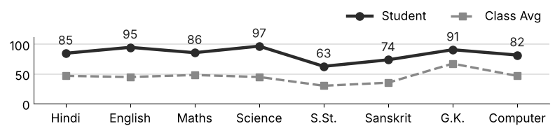
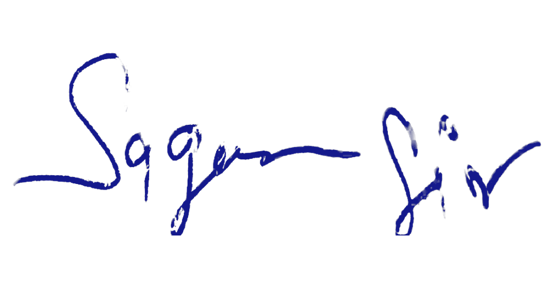  Class Teacher |  | —— Better Education ★ Brighter Future —— |  |   Principal

UNIQUE CENTRAL SCHOOL
KNOWLEDGE ★ CHARACTER ★ PROGRESS
ACADEMIC SESSION : 2026 – 2027
RESULT / MARKSHEET
(P.T.1 – 40 | P.T..2 – 40 | S.A.-1 – 80 | Total – 100)
Class : IV | Section : | Roll No. : 02
Student Information  Student Name : Pushpendar Yadav  Father’s Name : Mr. Sanjay Kumar  Mother’s Name : Mrs. Madhuri Sinha | PHOTO  (Optional) | Result Summary
  Total Marks : | 638 / 800
  Percentage (%) : | 79.75 %
  Overall Grade : | B1
  Result : | PASS
  Rank : | 4
S.No. | Subject | Internal Assessment |  |  |  | Summative  Assessment I  (80 marks) | Total  (100 marks) | Grade
S.No. | Subject | P.T. I | P.T. II | Multiple Assessment | Subject Enrichment | Summative  Assessment I  (80 marks) | Total  (100 marks) | Grade
S.No. | Subject | (5 marks) | (5 marks) | (5 marks) | (5 marks) | Summative  Assessment I  (80 marks) | Total  (100 marks) | Grade
1 | Hindi | 3 | 4 | 4 | 4 | 57 | 72 | B1
2 | English | 4 | 5 | 4 | 4 | 71 | 88 | A2
3 | Maths | 3 | 4 | 4 | 5 | 70 | 86 | A2
4 | Science | 2 | 4 | 5 | 5 | 78 | 94 | A1
5 | S.St. | 1 | 2 | 3 | 3 | 49 | 58 | C1
6 | Sanskrit | 3 | 3 | 3 | 4 | 42 | 55 | C1
7 | G.K. | 4 | 5 | 5 | 5 | 79 | 98 | A1
8 | Computer | 3 | 2 | 4 | 5 | 73 | 87 | A2
CO-SCHOLASTIC AREAS |  |  |  |  |  |  | SCALE
Subject | Drawing | Music | Uniform | Sports | Discipline |  | GRADE | A1 | A2 | B1 | B2 | C1 | C2 | D | E
Grade | A | A | A | A | A |  | MARKS RANGE | 91-100 | 81-90 | 71-80 | 61-70 | 51-60 | 41-50 | 31-40 | Below 30
 |  |  |  |  |  |  | CO-SCH. AREAS | GRADE A  Outstanding |  | GRADE B  Very Good |  | GRADE C  Fair
Attendance  Working Days : 132  Present : 126  Absent : 6 | Teacher’s Remark  Very good performance. Keep working hard. |  | Performance Chart (Total /100 : Student vs Class Average)  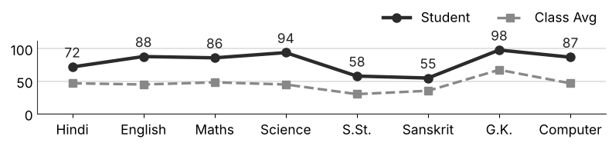
Class Teacher |  | —— Better Education ★ Brighter Future —— |  | Principal

UNIQUE CENTRAL SCHOOL
KNOWLEDGE ★ CHARACTER ★ PROGRESS
ACADEMIC SESSION : 2026 – 2027
RESULT / MARKSHEET
(P.T.1 – 40 | P.T..2 – 40 | S.A.-1 – 80 | Total – 100)
Class : IV | Section : | Roll No. : 03
Student Information  Student Name : Amit Kumar  Father’s Name : Mr. Vidyanand Kumar  Mother’s Name : Mrs. Manita Kumari | PHOTO  (Optional) | Result Summary
  Total Marks : | 637 / 800
  Percentage (%) : | 79.62 %
  Overall Grade : | B1
  Result : | PASS
  Rank : | 5
S.No. | Subject | Internal Assessment |  |  |  | Summative  Assessment I  (80 marks) | Total  (100 marks) | Grade
S.No. | Subject | P.T. I | P.T. II | Multiple Assessment | Subject Enrichment | Summative  Assessment I  (80 marks) | Total  (100 marks) | Grade
S.No. | Subject | (5 marks) | (5 marks) | (5 marks) | (5 marks) | Summative  Assessment I  (80 marks) | Total  (100 marks) | Grade
1 | Hindi | 3 | 4 | 4 | 4 | 71 | 86 | A2
2 | English | 4 | 5 | 5 | 5 | 69 | 88 | A2
3 | Maths | 4 | 3 | 4 | 4 | 68 | 83 | A2
4 | Science | 3 | 4 | 4 | 4 | 62 | 77 | B1
5 | S.St. | 2 | 3 | 4 | 3 | 43 | 55 | C1
6 | Sanskrit | 4 | 4 | 4 | 4 | 55 | 71 | B1
7 | G.K. | 4 | 5 | 5 | 5 | 76 | 95 | A1
8 | Computer | 3 | 2 | 5 | 4 | 68 | 82 | A2
CO-SCHOLASTIC AREAS |  |  |  |  |  |  | SCALE
Subject | Drawing | Music | Uniform | Sports | Discipline |  | GRADE | A1 | A2 | B1 | B2 | C1 | C2 | D | E
Grade | A | A | A | A | A |  | MARKS RANGE | 91-100 | 81-90 | 71-80 | 61-70 | 51-60 | 41-50 | 31-40 | Below 30
 |  |  |  |  |  |  | CO-SCH. AREAS | GRADE A  Outstanding |  | GRADE B  Very Good |  | GRADE C  Fair
Attendance  Working Days : 132  Present : 130  Absent : 2 | Teacher’s Remark  Very good performance. Keep working hard. |  | Performance Chart (Total /100 : Student vs Class Average)  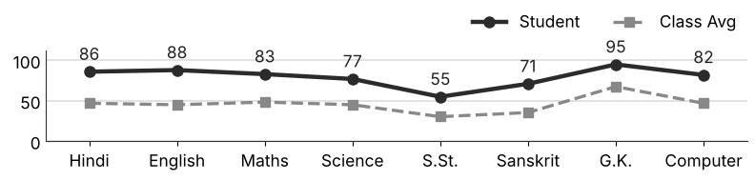
Class Teacher |  | —— Better Education ★ Brighter Future —— |  | Principal

UNIQUE CENTRAL SCHOOL
KNOWLEDGE ★ CHARACTER ★ PROGRESS
ACADEMIC SESSION : 2026 – 2027
RESULT / MARKSHEET
(P.T.1 – 40 | P.T..2 – 40 | S.A.-1 – 80 | Total – 100)
Class : IV | Section : | Roll No. : 04
Student Information  Student Name : Rudra Raj  Father’s Name : Mr. Ravi Prashad  Mother’s Name : Mrs. Dimpal Devi | PHOTO  (Optional) | Result Summary
  Total Marks : | 463 / 800
  Percentage (%) : | 57.88 %
  Overall Grade : | C1
  Result : | PASS
  Rank : | 20
S.No. | Subject | Internal Assessment |  |  |  | Summative  Assessment I  (80 marks) | Total  (100 marks) | Grade
S.No. | Subject | P.T. I | P.T. II | Multiple Assessment | Subject Enrichment | Summative  Assessment I  (80 marks) | Total  (100 marks) | Grade
S.No. | Subject | (5 marks) | (5 marks) | (5 marks) | (5 marks) | Summative  Assessment I  (80 marks) | Total  (100 marks) | Grade
1 | Hindi | 0 | 0 | 3 | 4 | 60 | 67 | B2
2 | English | 0 | 0 | 4 | 4 | 66 | 74 | B1
3 | Maths | 2 | 2 | 3 | 3 | 30 | 40 | D
4 | Science | 3 | 4 | 4 | 4 | 38 | 53 | C1
5 | S.St. | 0 | 2 | 2 | 3 | 20 | 27 | E
6 | Sanskrit | 3 | 3 | 4 | 4 | 46 | 60 | C1
7 | G.K. | 0 | 5 | 5 | 5 | 78 | 93 | A1
8 | Computer | 0 | 0 | 3 | 3 | 43 | 49 | C2
CO-SCHOLASTIC AREAS |  |  |  |  |  |  | SCALE
Subject | Drawing | Music | Uniform | Sports | Discipline |  | GRADE | A1 | A2 | B1 | B2 | C1 | C2 | D | E
Grade | B | B | A | B | A |  | MARKS RANGE | 91-100 | 81-90 | 71-80 | 61-70 | 51-60 | 41-50 | 31-40 | Below 30
 |  |  |  |  |  |  | CO-SCH. AREAS | GRADE A  Outstanding |  | GRADE B  Very Good |  | GRADE C  Fair
Attendance  Working Days : 132  Present : 120  Absent : 12 | Teacher’s Remark  Satisfactory performance. Needs to work harder. Give more time to S.St.. |  | Performance Chart (Total /100 : Student vs Class Average)  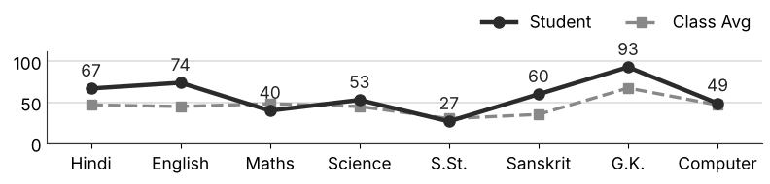
Class Teacher |  | —— Better Education ★ Brighter Future —— |  | Principal

UNIQUE CENTRAL SCHOOL
KNOWLEDGE ★ CHARACTER ★ PROGRESS
ACADEMIC SESSION : 2026 – 2027
RESULT / MARKSHEET
(P.T.1 – 40 | P.T..2 – 40 | S.A.-1 – 80 | Total – 100)
Class : IV | Section : | Roll No. : 05
Student Information  Student Name : Asad Ansari  Father’s Name : Md. Fahir  Mother’s Name : Mrs. Raveena Khan | PHOTO  (Optional) | Result Summary
  Total Marks : | 609 / 800
  Percentage (%) : | 76.12 %
  Overall Grade : | B1
  Result : | PASS
  Rank : | 6
S.No. | Subject | Internal Assessment |  |  |  | Summative  Assessment I  (80 marks) | Total  (100 marks) | Grade
S.No. | Subject | P.T. I | P.T. II | Multiple Assessment | Subject Enrichment | Summative  Assessment I  (80 marks) | Total  (100 marks) | Grade
S.No. | Subject | (5 marks) | (5 marks) | (5 marks) | (5 marks) | Summative  Assessment I  (80 marks) | Total  (100 marks) | Grade
1 | Hindi | 2 | 3 | 4 | 4 | 53 | 66 | B2
2 | English | 4 | 5 | 4 | 5 | 58 | 76 | B1
3 | Maths | 3 | 3 | 4 | 5 | 62 | 77 | B1
4 | Science | 3 | 0 | 4 | 4 | 59 | 70 | B2
5 | S.St. | 2 | 1 | 4 | 4 | 54 | 65 | B2
6 | Sanskrit | 4 | 0 | 4 | 5 | 74 | 87 | A2
7 | G.K. | 4 | 5 | 5 | 5 | 78 | 97 | A1
8 | Computer | 4 | 1 | 4 | 3 | 59 | 71 | B1
CO-SCHOLASTIC AREAS |  |  |  |  |  |  | SCALE
Subject | Drawing | Music | Uniform | Sports | Discipline |  | GRADE | A1 | A2 | B1 | B2 | C1 | C2 | D | E
Grade | A | A | A | A | A |  | MARKS RANGE | 91-100 | 81-90 | 71-80 | 61-70 | 51-60 | 41-50 | 31-40 | Below 30
 |  |  |  |  |  |  | CO-SCH. AREAS | GRADE A  Outstanding |  | GRADE B  Very Good |  | GRADE C  Fair
Attendance  Working Days : 132  Present : 117  Absent : 15 | Teacher’s Remark  Very good performance. Keep working hard. |  | Performance Chart (Total /100 : Student vs Class Average)  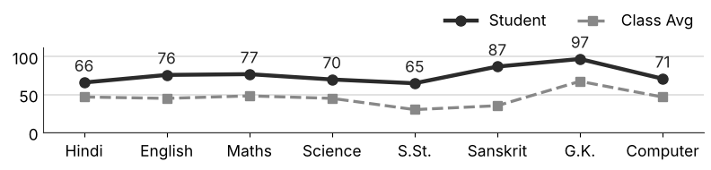
Class Teacher |  | —— Better Education ★ Brighter Future —— |  | Principal

UNIQUE CENTRAL SCHOOL
KNOWLEDGE ★ CHARACTER ★ PROGRESS
ACADEMIC SESSION : 2026 – 2027
RESULT / MARKSHEET
(P.T.1 – 40 | P.T..2 – 40 | S.A.-1 – 80 | Total – 100)
Class : IV | Section : | Roll No. : 06
Student Information  Student Name : Naksh Raj  Father’s Name : Mr. Ravi Ranjan Kumar  Mother’s Name : Mrs. Nitu Kumari | PHOTO  (Optional) | Result Summary
  Total Marks : | 669 / 800
  Percentage (%) : | 83.62 %
  Overall Grade : | A2
  Result : | PASS
  Rank : | 2
S.No. | Subject | Internal Assessment |  |  |  | Summative  Assessment I  (80 marks) | Total  (100 marks) | Grade
S.No. | Subject | P.T. I | P.T. II | Multiple Assessment | Subject Enrichment | Summative  Assessment I  (80 marks) | Total  (100 marks) | Grade
S.No. | Subject | (5 marks) | (5 marks) | (5 marks) | (5 marks) | Summative  Assessment I  (80 marks) | Total  (100 marks) | Grade
1 | Hindi | 3 | 3 | 4 | 4 | 62 | 76 | B1
2 | English | 4 | 5 | 4 | 5 | 71 | 89 | A2
3 | Maths | 2 | 4 | 4 | 4 | 78 | 92 | A1
4 | Science | 3 | 4 | 4 | 4 | 70 | 85 | A2
5 | S.St. | 1 | 2 | 4 | 4 | 66 | 77 | B1
6 | Sanskrit | 3 | 3 | 4 | 4 | 57 | 71 | B1
7 | G.K. | 3 | 5 | 5 | 4 | 76 | 93 | A1
8 | Computer | 5 | 3 | 4 | 5 | 69 | 86 | A2
CO-SCHOLASTIC AREAS |  |  |  |  |  |  | SCALE
Subject | Drawing | Music | Uniform | Sports | Discipline |  | GRADE | A1 | A2 | B1 | B2 | C1 | C2 | D | E
Grade | A | A | A | A | A |  | MARKS RANGE | 91-100 | 81-90 | 71-80 | 61-70 | 51-60 | 41-50 | 31-40 | Below 30
 |  |  |  |  |  |  | CO-SCH. AREAS | GRADE A  Outstanding |  | GRADE B  Very Good |  | GRADE C  Fair
Attendance  Working Days : 132  Present : 120  Absent : 12 | Teacher’s Remark  Excellent performance. Keep up the good work. |  | Performance Chart (Total /100 : Student vs Class Average)  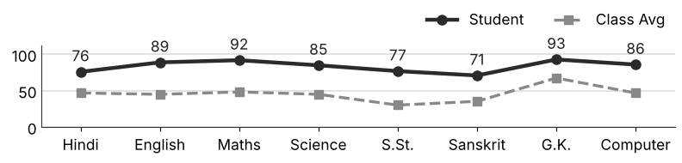
Class Teacher |  | —— Better Education ★ Brighter Future —— |  | Principal

UNIQUE CENTRAL SCHOOL
KNOWLEDGE ★ CHARACTER ★ PROGRESS
ACADEMIC SESSION : 2026 – 2027
RESULT / MARKSHEET
(P.T.1 – 40 | P.T..2 – 40 | S.A.-1 – 80 | Total – 100)
Class : IV | Section : | Roll No. : 07
Student Information  Student Name : Ayush Kumar  Father’s Name : Mr. Santosh Kumar  Mother’s Name : Mrs. Shobha Devi | PHOTO  (Optional) | Result Summary
  Total Marks : | 535 / 800
  Percentage (%) : | 66.88 %
  Overall Grade : | B2
  Result : | PASS
  Rank : | 10
S.No. | Subject | Internal Assessment |  |  |  | Summative  Assessment I  (80 marks) | Total  (100 marks) | Grade
S.No. | Subject | P.T. I | P.T. II | Multiple Assessment | Subject Enrichment | Summative  Assessment I  (80 marks) | Total  (100 marks) | Grade
S.No. | Subject | (5 marks) | (5 marks) | (5 marks) | (5 marks) | Summative  Assessment I  (80 marks) | Total  (100 marks) | Grade
1 | Hindi | 2 | 3 | 4 | 4 | 36 | 49 | C2
2 | English | 4 | 5 | 4 | 5 | 46 | 64 | B2
3 | Maths | 0 | 4 | 4 | 4 | 65 | 77 | B1
4 | Science | 3 | 3 | 4 | 5 | 65 | 80 | B1
5 | S.St. | 1 | 2 | 3 | 3 | 29 | 38 | D
6 | Sanskrit | 4 | 3 | 4 | 4 | 49 | 64 | B2
7 | G.K. | 4 | 5 | 5 | 4 | 76 | 94 | A1
8 | Computer | 4 | 2 | 4 | 4 | 55 | 69 | B2
CO-SCHOLASTIC AREAS |  |  |  |  |  |  | SCALE
Subject | Drawing | Music | Uniform | Sports | Discipline |  | GRADE | A1 | A2 | B1 | B2 | C1 | C2 | D | E
Grade | B | B | A | B | B |  | MARKS RANGE | 91-100 | 81-90 | 71-80 | 61-70 | 51-60 | 41-50 | 31-40 | Below 30
 |  |  |  |  |  |  | CO-SCH. AREAS | GRADE A  Outstanding |  | GRADE B  Very Good |  | GRADE C  Fair
Attendance  Working Days : 132  Present : 87  Absent : 45 | Teacher’s Remark  Good performance. More practice can make it better. Attendance must improve. |  | Performance Chart (Total /100 : Student vs Class Average)  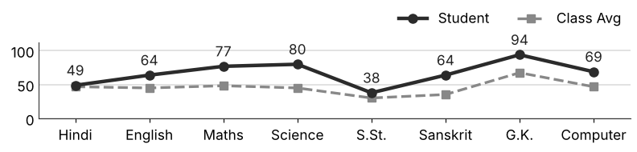
Class Teacher |  | —— Better Education ★ Brighter Future —— |  | Principal

UNIQUE CENTRAL SCHOOL
KNOWLEDGE ★ CHARACTER ★ PROGRESS
ACADEMIC SESSION : 2026 – 2027
RESULT / MARKSHEET
(P.T.1 – 40 | P.T..2 – 40 | S.A.-1 – 80 | Total – 100)
Class : IV | Section : | Roll No. : 08
Student Information  Student Name : Suraj Sharma  Father’s Name : Mr. Shivpujan Kumar  Mother’s Name : Mrs. Rajni Kumari | PHOTO  (Optional) | Result Summary
  Total Marks : | 668 / 800
  Percentage (%) : | 83.50 %
  Overall Grade : | A2
  Result : | PASS
  Rank : | 3
S.No. | Subject | Internal Assessment |  |  |  | Summative  Assessment I  (80 marks) | Total  (100 marks) | Grade
S.No. | Subject | P.T. I | P.T. II | Multiple Assessment | Subject Enrichment | Summative  Assessment I  (80 marks) | Total  (100 marks) | Grade
S.No. | Subject | (5 marks) | (5 marks) | (5 marks) | (5 marks) | Summative  Assessment I  (80 marks) | Total  (100 marks) | Grade
1 | Hindi | 4 | 4 | 5 | 5 | 70 | 88 | A2
2 | English | 4 | 5 | 5 | 5 | 78 | 97 | A1
3 | Maths | 3 | 3 | 5 | 4 | 68 | 83 | A2
4 | Science | 5 | 2 | 4 | 4 | 54 | 69 | B2
5 | S.St. | 2 | 3 | 4 | 4 | 58 | 71 | B1
6 | Sanskrit | 4 | 4 | 4 | 4 | 57 | 73 | B1
7 | G.K. | 5 | 4 | 4 | 5 | 79 | 97 | A1
8 | Computer | 4 | 4 | 4 | 4 | 74 | 90 | A2
CO-SCHOLASTIC AREAS |  |  |  |  |  |  | SCALE
Subject | Drawing | Music | Uniform | Sports | Discipline |  | GRADE | A1 | A2 | B1 | B2 | C1 | C2 | D | E
Grade | A | A | A | A | A |  | MARKS RANGE | 91-100 | 81-90 | 71-80 | 61-70 | 51-60 | 41-50 | 31-40 | Below 30
 |  |  |  |  |  |  | CO-SCH. AREAS | GRADE A  Outstanding |  | GRADE B  Very Good |  | GRADE C  Fair
Attendance  Working Days : 132  Present : 119  Absent : 13 | Teacher’s Remark  Excellent performance. Keep up the good work. |  | Performance Chart (Total /100 : Student vs Class Average)  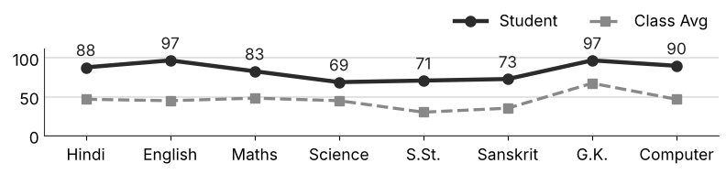
Class Teacher |  | —— Better Education ★ Brighter Future —— |  | Principal

UNIQUE CENTRAL SCHOOL
KNOWLEDGE ★ CHARACTER ★ PROGRESS
ACADEMIC SESSION : 2026 – 2027
RESULT / MARKSHEET
(P.T.1 – 40 | P.T..2 – 40 | S.A.-1 – 80 | Total – 100)
Class : IV | Section : | Roll No. : 09
Student Information  Student Name : Aditya Raj  Father’s Name : Mr. Harendra Kumar  Mother’s Name : Mrs. Khushaboo Kumari | PHOTO  (Optional) | Result Summary
  Total Marks : | 413 / 800
  Percentage (%) : | 51.62 %
  Overall Grade : | C1
  Result : | PASS
  Rank : | 31
S.No. | Subject | Internal Assessment |  |  |  | Summative  Assessment I  (80 marks) | Total  (100 marks) | Grade
S.No. | Subject | P.T. I | P.T. II | Multiple Assessment | Subject Enrichment | Summative  Assessment I  (80 marks) | Total  (100 marks) | Grade
S.No. | Subject | (5 marks) | (5 marks) | (5 marks) | (5 marks) | Summative  Assessment I  (80 marks) | Total  (100 marks) | Grade
1 | Hindi | 1 | 2 | 3 | 3 | 32 | 41 | C2
2 | English | 3 | 1 | 3 | 3 | 31 | 41 | C2
3 | Maths | 1 | 3 | 4 | 4 | 62 | 74 | B1
4 | Science | 2 | 3 | 4 | 4 | 46 | 59 | C1
5 | S.St. | 0 | 3 | 3 | 2 | 16 | 24 | E
6 | Sanskrit | 1 | 3 | 3 | 3 | 22 | 32 | D
7 | G.K. | 3 | 5 | 4 | 4 | 52 | 68 | B2
8 | Computer | 0 | 1 | 3 | 4 | 66 | 74 | B1
CO-SCHOLASTIC AREAS |  |  |  |  |  |  | SCALE
Subject | Drawing | Music | Uniform | Sports | Discipline |  | GRADE | A1 | A2 | B1 | B2 | C1 | C2 | D | E
Grade | B | B | B | B | B |  | MARKS RANGE | 91-100 | 81-90 | 71-80 | 61-70 | 51-60 | 41-50 | 31-40 | Below 30
 |  |  |  |  |  |  | CO-SCH. AREAS | GRADE A  Outstanding |  | GRADE B  Very Good |  | GRADE C  Fair
Attendance  Working Days : 132  Present : 125  Absent : 7 | Teacher’s Remark  Satisfactory performance. Needs to work harder. Give more time to S.St.. |  | Performance Chart (Total /100 : Student vs Class Average)  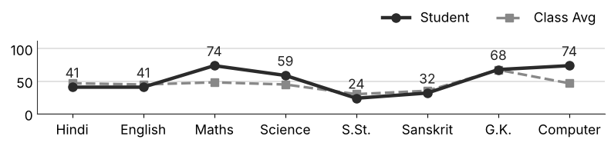
Class Teacher |  | —— Better Education ★ Brighter Future —— |  | Principal

UNIQUE CENTRAL SCHOOL
KNOWLEDGE ★ CHARACTER ★ PROGRESS
ACADEMIC SESSION : 2026 – 2027
RESULT / MARKSHEET
(P.T.1 – 40 | P.T..2 – 40 | S.A.-1 – 80 | Total – 100)
Class : IV | Section : | Roll No. : 10
Student Information  Student Name : Ali Nazir  Father’s Name : Md. Nazir Alam  Mother’s Name : Mrs. Gulishata Kumari | PHOTO  (Optional) | Result Summary
  Total Marks : | 591 / 800
  Percentage (%) : | 73.88 %
  Overall Grade : | B1
  Result : | PASS
  Rank : | 7
S.No. | Subject | Internal Assessment |  |  |  | Summative  Assessment I  (80 marks) | Total  (100 marks) | Grade
S.No. | Subject | P.T. I | P.T. II | Multiple Assessment | Subject Enrichment | Summative  Assessment I  (80 marks) | Total  (100 marks) | Grade
S.No. | Subject | (5 marks) | (5 marks) | (5 marks) | (5 marks) | Summative  Assessment I  (80 marks) | Total  (100 marks) | Grade
1 | Hindi | 2 | 3 | 4 | 4 | 58 | 71 | B1
2 | English | 4 | 4 | 4 | 4 | 70 | 86 | A2
3 | Maths | 3 | 0 | 4 | 3 | 65 | 75 | B1
4 | Science | 3 | 2 | 4 | 4 | 51 | 64 | B2
5 | S.St. | 1 | 1 | 3 | 3 | 29 | 37 | D
6 | Sanskrit | 4 | 0 | 4 | 4 | 71 | 83 | A2
7 | G.K. | 5 | 4 | 5 | 5 | 70 | 89 | A2
8 | Computer | 4 | 3 | 4 | 4 | 71 | 86 | A2
CO-SCHOLASTIC AREAS |  |  |  |  |  |  | SCALE
Subject | Drawing | Music | Uniform | Sports | Discipline |  | GRADE | A1 | A2 | B1 | B2 | C1 | C2 | D | E
Grade | A | A | A | A | A |  | MARKS RANGE | 91-100 | 81-90 | 71-80 | 61-70 | 51-60 | 41-50 | 31-40 | Below 30
 |  |  |  |  |  |  | CO-SCH. AREAS | GRADE A  Outstanding |  | GRADE B  Very Good |  | GRADE C  Fair
Attendance  Working Days : 132  Present : 112  Absent : 20 | Teacher’s Remark  Very good performance. Keep working hard. |  | Performance Chart (Total /100 : Student vs Class Average)  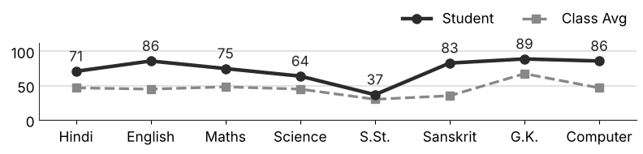
Class Teacher |  | —— Better Education ★ Brighter Future —— |  | Principal

UNIQUE CENTRAL SCHOOL
KNOWLEDGE ★ CHARACTER ★ PROGRESS
ACADEMIC SESSION : 2026 – 2027
RESULT / MARKSHEET
(P.T.1 – 40 | P.T..2 – 40 | S.A.-1 – 80 | Total – 100)
Class : IV | Section : | Roll No. : 11
Student Information  Student Name : Ayush Kumar  Father’s Name : Mr. Nagendra Kumar  Mother’s Name : Mrs. Pinki Devi | PHOTO  (Optional) | Result Summary
  Total Marks : | 415 / 800
  Percentage (%) : | 51.88 %
  Overall Grade : | C1
  Result : | PASS
  Rank : | 30
S.No. | Subject | Internal Assessment |  |  |  | Summative  Assessment I  (80 marks) | Total  (100 marks) | Grade
S.No. | Subject | P.T. I | P.T. II | Multiple Assessment | Subject Enrichment | Summative  Assessment I  (80 marks) | Total  (100 marks) | Grade
S.No. | Subject | (5 marks) | (5 marks) | (5 marks) | (5 marks) | Summative  Assessment I  (80 marks) | Total  (100 marks) | Grade
1 | Hindi | 2 | 4 | 3 | 3 | 30 | 42 | C2
2 | English | 4 | 1 | 3 | 3 | 36 | 47 | C2
3 | Maths | 2 | 3 | 4 | 4 | 58 | 71 | B1
4 | Science | 2 | 2 | 3 | 3 | 32 | 42 | C2
5 | S.St. | 1 | 1 | 3 | 2 | 16 | 23 | E
6 | Sanskrit | 1 | 4 | 3 | 3 | 26 | 37 | D
7 | G.K. | 4 | 4 | 5 | 4 | 72 | 89 | A2
8 | Computer | 2 | 0 | 3 | 3 | 56 | 64 | B2
CO-SCHOLASTIC AREAS |  |  |  |  |  |  | SCALE
Subject | Drawing | Music | Uniform | Sports | Discipline |  | GRADE | A1 | A2 | B1 | B2 | C1 | C2 | D | E
Grade | B | B | B | B | B |  | MARKS RANGE | 91-100 | 81-90 | 71-80 | 61-70 | 51-60 | 41-50 | 31-40 | Below 30
 |  |  |  |  |  |  | CO-SCH. AREAS | GRADE A  Outstanding |  | GRADE B  Very Good |  | GRADE C  Fair
Attendance  Working Days : 132  Present : 93  Absent : 39 | Teacher’s Remark  Satisfactory performance. Needs to work harder. Attendance must improve. |  | Performance Chart (Total /100 : Student vs Class Average)  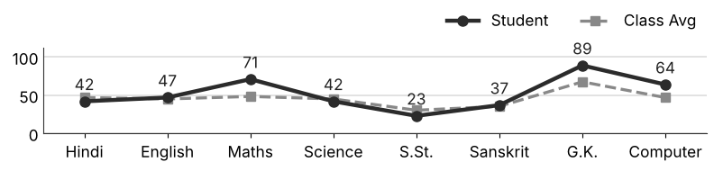
Class Teacher |  | —— Better Education ★ Brighter Future —— |  | Principal

UNIQUE CENTRAL SCHOOL
KNOWLEDGE ★ CHARACTER ★ PROGRESS
ACADEMIC SESSION : 2026 – 2027
RESULT / MARKSHEET
(P.T.1 – 40 | P.T..2 – 40 | S.A.-1 – 80 | Total – 100)
Class : IV | Section : | Roll No. : 12
Student Information  Student Name : Piyush Raj  Father’s Name : Mr. Dharmendra Kumar  Mother’s Name : Mrs. Archana Devi | PHOTO  (Optional) | Result Summary
  Total Marks : | 350 / 800
  Percentage (%) : | 43.75 %
  Overall Grade : | C2
  Result : | PASS
  Rank : | 37
S.No. | Subject | Internal Assessment |  |  |  | Summative  Assessment I  (80 marks) | Total  (100 marks) | Grade
S.No. | Subject | P.T. I | P.T. II | Multiple Assessment | Subject Enrichment | Summative  Assessment I  (80 marks) | Total  (100 marks) | Grade
S.No. | Subject | (5 marks) | (5 marks) | (5 marks) | (5 marks) | Summative  Assessment I  (80 marks) | Total  (100 marks) | Grade
1 | Hindi | 0 | 0 | 2 | 2 | 17 | 21 | E
2 | English | 0 | 0 | 2 | 2 | 25 | 29 | E
3 | Maths | 1 | 2 | 3 | 4 | 38 | 48 | C2
4 | Science | 1 | 2 | 3 | 3 | 30 | 39 | D
5 | S.St. | 1 | 1 | 2 | 3 | 21 | 28 | E
6 | Sanskrit | 1 | 2 | 3 | 4 | 29 | 39 | D
7 | G.K. | 0 | 0 | 4 | 4 | 66 | 74 | B1
8 | Computer | 0 | 0 | 4 | 4 | 64 | 72 | B1
CO-SCHOLASTIC AREAS |  |  |  |  |  |  | SCALE
Subject | Drawing | Music | Uniform | Sports | Discipline |  | GRADE | A1 | A2 | B1 | B2 | C1 | C2 | D | E
Grade | B | B | B | B | B |  | MARKS RANGE | 91-100 | 81-90 | 71-80 | 61-70 | 51-60 | 41-50 | 31-40 | Below 30
 |  |  |  |  |  |  | CO-SCH. AREAS | GRADE A  Outstanding |  | GRADE B  Very Good |  | GRADE C  Fair
Attendance  Working Days : 132  Present : 114  Absent : 18 | Teacher’s Remark  Fair performance. Needs regular practice and revision. Give more time to Hindi. |  | Performance Chart (Total /100 : Student vs Class Average)  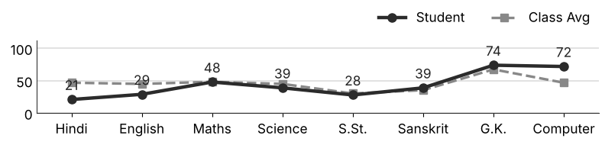
Class Teacher |  | —— Better Education ★ Brighter Future —— |  | Principal

UNIQUE CENTRAL SCHOOL
KNOWLEDGE ★ CHARACTER ★ PROGRESS
ACADEMIC SESSION : 2026 – 2027
RESULT / MARKSHEET
(P.T.1 – 40 | P.T..2 – 40 | S.A.-1 – 80 | Total – 100)
Class : IV | Section : | Roll No. : 13
Student Information  Student Name : Pinki Kumari  Father’s Name : Mr. Pawan Saw  Mother’s Name : Mrs. Sarita Devi | PHOTO  (Optional) | Result Summary
  Total Marks : | 448 / 800
  Percentage (%) : | 56.00 %
  Overall Grade : | C1
  Result : | PASS
  Rank : | 23
S.No. | Subject | Internal Assessment |  |  |  | Summative  Assessment I  (80 marks) | Total  (100 marks) | Grade
S.No. | Subject | P.T. I | P.T. II | Multiple Assessment | Subject Enrichment | Summative  Assessment I  (80 marks) | Total  (100 marks) | Grade
S.No. | Subject | (5 marks) | (5 marks) | (5 marks) | (5 marks) | Summative  Assessment I  (80 marks) | Total  (100 marks) | Grade
1 | Hindi | 2 | 4 | 4 | 4 | 33 | 47 | C2
2 | English | 3 | 5 | 4 | 4 | 51 | 67 | B2
3 | Maths | 3 | 1 | 4 | 4 | 44 | 56 | C1
4 | Science | 3 | 4 | 4 | 3 | 35 | 49 | C2
5 | S.St. | 1 | 1 | 3 | 2 | 17 | 24 | E
6 | Sanskrit | 0 | 2 | 3 | 3 | 47 | 55 | C1
7 | G.K. | 3 | 3 | 4 | 4 | 62 | 76 | B1
8 | Computer | 3 | 1 | 4 | 4 | 62 | 74 | B1
CO-SCHOLASTIC AREAS |  |  |  |  |  |  | SCALE
Subject | Drawing | Music | Uniform | Sports | Discipline |  | GRADE | A1 | A2 | B1 | B2 | C1 | C2 | D | E
Grade | B | B | B | B | B |  | MARKS RANGE | 91-100 | 81-90 | 71-80 | 61-70 | 51-60 | 41-50 | 31-40 | Below 30
 |  |  |  |  |  |  | CO-SCH. AREAS | GRADE A  Outstanding |  | GRADE B  Very Good |  | GRADE C  Fair
Attendance  Working Days : 132  Present : 103  Absent : 29 | Teacher’s Remark  Satisfactory performance. Needs to work harder. Give more time to S.St.. |  | Performance Chart (Total /100 : Student vs Class Average)  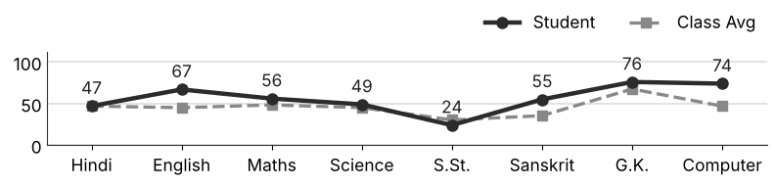
Class Teacher |  | —— Better Education ★ Brighter Future —— |  | Principal

UNIQUE CENTRAL SCHOOL
KNOWLEDGE ★ CHARACTER ★ PROGRESS
ACADEMIC SESSION : 2026 – 2027
RESULT / MARKSHEET
(P.T.1 – 40 | P.T..2 – 40 | S.A.-1 – 80 | Total – 100)
Class : IV | Section : | Roll No. : 14
Student Information  Student Name : Bittu Kumar  Father’s Name : Mr. Nagendra Prashad  Mother’s Name : Mrs. Punam Devi | PHOTO  (Optional) | Result Summary
  Total Marks : | 516 / 800
  Percentage (%) : | 64.50 %
  Overall Grade : | B2
  Result : | PASS
  Rank : | 13
S.No. | Subject | Internal Assessment |  |  |  | Summative  Assessment I  (80 marks) | Total  (100 marks) | Grade
S.No. | Subject | P.T. I | P.T. II | Multiple Assessment | Subject Enrichment | Summative  Assessment I  (80 marks) | Total  (100 marks) | Grade
S.No. | Subject | (5 marks) | (5 marks) | (5 marks) | (5 marks) | Summative  Assessment I  (80 marks) | Total  (100 marks) | Grade
1 | Hindi | 3 | 4 | 4 | 4 | 63 | 78 | B1
2 | English | 4 | 5 | 4 | 4 | 52 | 69 | B2
3 | Maths | 3 | 2 | 4 | 4 | 55 | 68 | B2
4 | Science | 3 | 4 | 4 | 4 | 50 | 65 | B2
5 | S.St. | 0 | 1 | 2 | 3 | 18 | 24 | E
6 | Sanskrit | 3 | 3 | 4 | 3 | 35 | 48 | C2
7 | G.K. | 4 | 4 | 5 | 5 | 68 | 86 | A2
8 | Computer | 3 | 4 | 4 | 4 | 63 | 78 | B1
CO-SCHOLASTIC AREAS |  |  |  |  |  |  | SCALE
Subject | Drawing | Music | Uniform | Sports | Discipline |  | GRADE | A1 | A2 | B1 | B2 | C1 | C2 | D | E
Grade | B | B | A | A | A |  | MARKS RANGE | 91-100 | 81-90 | 71-80 | 61-70 | 51-60 | 41-50 | 31-40 | Below 30
 |  |  |  |  |  |  | CO-SCH. AREAS | GRADE A  Outstanding |  | GRADE B  Very Good |  | GRADE C  Fair
Attendance  Working Days : 132  Present : 104  Absent : 28 | Teacher’s Remark  Good performance. More practice can make it better. Give more time to S.St.. |  | Performance Chart (Total /100 : Student vs Class Average)  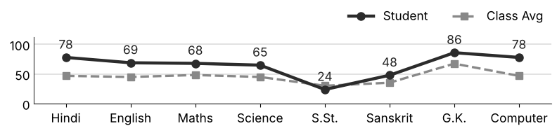
Class Teacher |  | —— Better Education ★ Brighter Future —— |  | Principal

UNIQUE CENTRAL SCHOOL
KNOWLEDGE ★ CHARACTER ★ PROGRESS
ACADEMIC SESSION : 2026 – 2027
RESULT / MARKSHEET
(P.T.1 – 40 | P.T..2 – 40 | S.A.-1 – 80 | Total – 100)
Class : IV | Section : | Roll No. : 15
Student Information  Student Name : Piyush Kumar  Father’s Name : Mr. Rahul Gupta  Mother’s Name : Mrs. Soni Devi | PHOTO  (Optional) | Result Summary
  Total Marks : | 217 / 800
  Percentage (%) : | 27.12 %
  Overall Grade : | E
  Result : | FAIL
  Rank : | 63
S.No. | Subject | Internal Assessment |  |  |  | Summative  Assessment I  (80 marks) | Total  (100 marks) | Grade
S.No. | Subject | P.T. I | P.T. II | Multiple Assessment | Subject Enrichment | Summative  Assessment I  (80 marks) | Total  (100 marks) | Grade
S.No. | Subject | (5 marks) | (5 marks) | (5 marks) | (5 marks) | Summative  Assessment I  (80 marks) | Total  (100 marks) | Grade
1 | Hindi | 1 | 4 | 2 | 3 | 10 | 20 | E
2 | English | 4 | 0 | 3 | 3 | 6 | 16 | E
3 | Maths | 0 | 0 | 3 | 3 | 38 | 44 | C2
4 | Science | 0 | 0 | 2 | 2 | 15 | 19 | E
5 | S.St. | 0 | 0 | 3 | 2 | 16 | 21 | E
6 | Sanskrit | 0 | 0 | 3 | 3 | 15 | 21 | E
7 | G.K. | 1 | 0 | 2 | 3 | 32 | 38 | D
8 | Computer | 0 | 2 | 3 | 3 | 30 | 38 | D
CO-SCHOLASTIC AREAS |  |  |  |  |  |  | SCALE
Subject | Drawing | Music | Uniform | Sports | Discipline |  | GRADE | A1 | A2 | B1 | B2 | C1 | C2 | D | E
Grade | C | C | C | C | C |  | MARKS RANGE | 91-100 | 81-90 | 71-80 | 61-70 | 51-60 | 41-50 | 31-40 | Below 30
 |  |  |  |  |  |  | CO-SCH. AREAS | GRADE A  Outstanding |  | GRADE B  Very Good |  | GRADE C  Fair
Attendance  Working Days : 132  Present : 107  Absent : 25 | Teacher’s Remark  Weak performance. Needs special attention and practice. Give more time to English. |  | Performance Chart (Total /100 : Student vs Class Average)  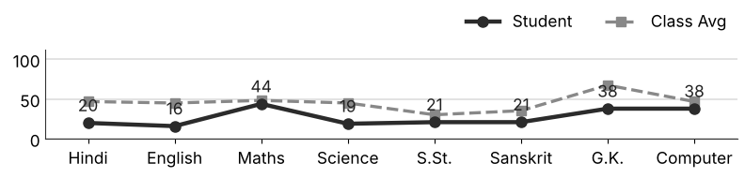
Class Teacher |  | —— Better Education ★ Brighter Future —— |  | Principal

UNIQUE CENTRAL SCHOOL
KNOWLEDGE ★ CHARACTER ★ PROGRESS
ACADEMIC SESSION : 2026 – 2027
RESULT / MARKSHEET
(P.T.1 – 40 | P.T..2 – 40 | S.A.-1 – 80 | Total – 100)
Class : IV | Section : | Roll No. : 16
Student Information  Student Name : Ankush Kumar  Father’s Name : Mr. Rajaram Giri  Mother’s Name : Mrs. Renu Devi | PHOTO  (Optional) | Result Summary
  Total Marks : | 25 / 800
  Percentage (%) : | 3.12 %
  Overall Grade : | E
  Result : | FAIL
  Rank : | 76
S.No. | Subject | Internal Assessment |  |  |  | Summative  Assessment I  (80 marks) | Total  (100 marks) | Grade
S.No. | Subject | P.T. I | P.T. II | Multiple Assessment | Subject Enrichment | Summative  Assessment I  (80 marks) | Total  (100 marks) | Grade
S.No. | Subject | (5 marks) | (5 marks) | (5 marks) | (5 marks) | Summative  Assessment I  (80 marks) | Total  (100 marks) | Grade
1 | Hindi | 2 | 0 | 2 | 2 | 0 | 6 | E
2 | English | 1 | 4 | 2 | 2 | 0 | 9 | E
3 | Maths | 0 | 0 | 0 | 0 | 0 | 0 | E
4 | Science | 0 | 0 | 0 | 0 | 0 | 0 | E
5 | S.St. | 0 | 0 | 0 | 0 | 0 | 0 | E
6 | Sanskrit | 0 | 0 | 0 | 0 | 0 | 0 | E
7 | G.K. | 4 | 2 | 2 | 2 | 0 | 10 | E
8 | Computer | 0 | 0 | 0 | 0 | 0 | 0 | E
CO-SCHOLASTIC AREAS |  |  |  |  |  |  | SCALE
Subject | Drawing | Music | Uniform | Sports | Discipline |  | GRADE | A1 | A2 | B1 | B2 | C1 | C2 | D | E
Grade | C | C | C | C | C |  | MARKS RANGE | 91-100 | 81-90 | 71-80 | 61-70 | 51-60 | 41-50 | 31-40 | Below 30
 |  |  |  |  |  |  | CO-SCH. AREAS | GRADE A  Outstanding |  | GRADE B  Very Good |  | GRADE C  Fair
Attendance  Working Days : 132  Present : 0  Absent : 132 | Teacher’s Remark  Weak performance. Needs special attention and practice. Attendance must improve. |  | Performance Chart (Total /100 : Student vs Class Average)  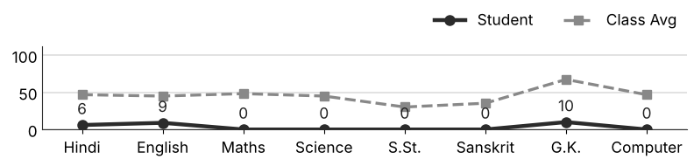
Class Teacher |  | —— Better Education ★ Brighter Future —— |  | Principal

UNIQUE CENTRAL SCHOOL
KNOWLEDGE ★ CHARACTER ★ PROGRESS
ACADEMIC SESSION : 2026 – 2027
RESULT / MARKSHEET
(P.T.1 – 40 | P.T..2 – 40 | S.A.-1 – 80 | Total – 100)
Class : IV | Section : | Roll No. : 17
Student Information  Student Name : Ayush Kumar  Father’s Name : Mr. Gautam Raj  Mother’s Name : Mrs. Shardha Devi | PHOTO  (Optional) | Result Summary
  Total Marks : | 483 / 800
  Percentage (%) : | 60.38 %
  Overall Grade : | C1
  Result : | PASS
  Rank : | 19
S.No. | Subject | Internal Assessment |  |  |  | Summative  Assessment I  (80 marks) | Total  (100 marks) | Grade
S.No. | Subject | P.T. I | P.T. II | Multiple Assessment | Subject Enrichment | Summative  Assessment I  (80 marks) | Total  (100 marks) | Grade
S.No. | Subject | (5 marks) | (5 marks) | (5 marks) | (5 marks) | Summative  Assessment I  (80 marks) | Total  (100 marks) | Grade
1 | Hindi | 2 | 0 | 3 | 4 | 53 | 62 | B2
2 | English | 3 | 0 | 4 | 3 | 66 | 76 | B1
3 | Maths | 3 | 0 | 4 | 4 | 68 | 79 | B1
4 | Science | 3 | 2 | 4 | 4 | 33 | 46 | C2
5 | S.St. | 1 | 1 | 3 | 3 | 32 | 40 | D
6 | Sanskrit | 2 | 3 | 3 | 4 | 30 | 42 | C2
7 | G.K. | 4 | 0 | 4 | 4 | 66 | 78 | B1
8 | Computer | 0 | 0 | 3 | 3 | 54 | 60 | C1
CO-SCHOLASTIC AREAS |  |  |  |  |  |  | SCALE
Subject | Drawing | Music | Uniform | Sports | Discipline |  | GRADE | A1 | A2 | B1 | B2 | C1 | C2 | D | E
Grade | B | B | A | A | A |  | MARKS RANGE | 91-100 | 81-90 | 71-80 | 61-70 | 51-60 | 41-50 | 31-40 | Below 30
 |  |  |  |  |  |  | CO-SCH. AREAS | GRADE A  Outstanding |  | GRADE B  Very Good |  | GRADE C  Fair
Attendance  Working Days : 132  Present : 121  Absent : 11 | Teacher’s Remark  Good performance. More practice can make it better. Give more time to S.St.. |  | Performance Chart (Total /100 : Student vs Class Average)  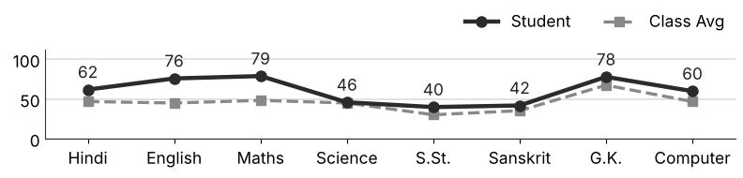
Class Teacher |  | —— Better Education ★ Brighter Future —— |  | Principal

UNIQUE CENTRAL SCHOOL
KNOWLEDGE ★ CHARACTER ★ PROGRESS
ACADEMIC SESSION : 2026 – 2027
RESULT / MARKSHEET
(P.T.1 – 40 | P.T..2 – 40 | S.A.-1 – 80 | Total – 100)
Class : IV | Section : | Roll No. : 18
Student Information  Student Name : Nibha Hansda  Father’s Name : Mr. Bhudhdew Hansda  Mother’s Name : Mrs. Nuniya Devi | PHOTO  (Optional) | Result Summary
  Total Marks : | 530 / 800
  Percentage (%) : | 66.25 %
  Overall Grade : | B2
  Result : | PASS
  Rank : | 12
S.No. | Subject | Internal Assessment |  |  |  | Summative  Assessment I  (80 marks) | Total  (100 marks) | Grade
S.No. | Subject | P.T. I | P.T. II | Multiple Assessment | Subject Enrichment | Summative  Assessment I  (80 marks) | Total  (100 marks) | Grade
S.No. | Subject | (5 marks) | (5 marks) | (5 marks) | (5 marks) | Summative  Assessment I  (80 marks) | Total  (100 marks) | Grade
1 | Hindi | 3 | 2 | 4 | 4 | 50 | 63 | B2
2 | English | 4 | 2 | 5 | 5 | 71 | 87 | A2
3 | Maths | 2 | 2 | 3 | 3 | 30 | 40 | D
4 | Science | 3 | 4 | 4 | 4 | 50 | 65 | B2
5 | S.St. | 2 | 2 | 3 | 3 | 29 | 39 | D
6 | Sanskrit | 3 | 4 | 4 | 5 | 70 | 86 | A2
7 | G.K. | 5 | 2 | 4 | 5 | 74 | 90 | A2
8 | Computer | 2 | 0 | 4 | 4 | 50 | 60 | C1
CO-SCHOLASTIC AREAS |  |  |  |  |  |  | SCALE
Subject | Drawing | Music | Uniform | Sports | Discipline |  | GRADE | A1 | A2 | B1 | B2 | C1 | C2 | D | E
Grade | A | B | A | A | A |  | MARKS RANGE | 91-100 | 81-90 | 71-80 | 61-70 | 51-60 | 41-50 | 31-40 | Below 30
 |  |  |  |  |  |  | CO-SCH. AREAS | GRADE A  Outstanding |  | GRADE B  Very Good |  | GRADE C  Fair
Attendance  Working Days : 132  Present : 132  Absent : 0 | Teacher’s Remark  Good performance. More practice can make it better. Give more time to S.St.. |  | Performance Chart (Total /100 : Student vs Class Average)  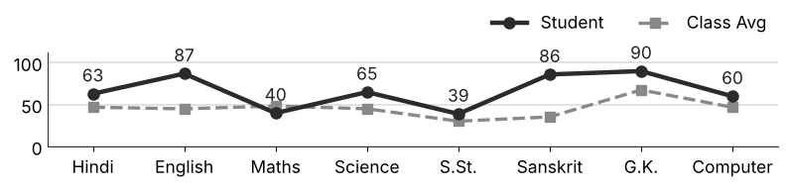
Class Teacher |  | —— Better Education ★ Brighter Future —— |  | Principal

UNIQUE CENTRAL SCHOOL
KNOWLEDGE ★ CHARACTER ★ PROGRESS
ACADEMIC SESSION : 2026 – 2027
RESULT / MARKSHEET
(P.T.1 – 40 | P.T..2 – 40 | S.A.-1 – 80 | Total – 100)
Class : IV | Section : | Roll No. : 19
Student Information  Student Name : Sunny Kumar  Father’s Name : Mr. Mahesh Prashad  Mother’s Name : Mrs. Pinki Devi | PHOTO  (Optional) | Result Summary
  Total Marks : | 533 / 800
  Percentage (%) : | 66.62 %
  Overall Grade : | B2
  Result : | PASS
  Rank : | 11
S.No. | Subject | Internal Assessment |  |  |  | Summative  Assessment I  (80 marks) | Total  (100 marks) | Grade
S.No. | Subject | P.T. I | P.T. II | Multiple Assessment | Subject Enrichment | Summative  Assessment I  (80 marks) | Total  (100 marks) | Grade
S.No. | Subject | (5 marks) | (5 marks) | (5 marks) | (5 marks) | Summative  Assessment I  (80 marks) | Total  (100 marks) | Grade
1 | Hindi | 1 | 3 | 3 | 3 | 56 | 66 | B2
2 | English | 4 | 5 | 5 | 4 | 64 | 82 | A2
3 | Maths | 2 | 2 | 4 | 4 | 38 | 50 | C2
4 | Science | 3 | 5 | 4 | 5 | 74 | 91 | A1
5 | S.St. | 0 | 1 | 3 | 3 | 57 | 64 | B2
6 | Sanskrit | 2 | 3 | 3 | 3 | 25 | 36 | D
7 | G.K. | 1 | 5 | 4 | 4 | 56 | 70 | B2
8 | Computer | 0 | 4 | 4 | 4 | 62 | 74 | B1
CO-SCHOLASTIC AREAS |  |  |  |  |  |  | SCALE
Subject | Drawing | Music | Uniform | Sports | Discipline |  | GRADE | A1 | A2 | B1 | B2 | C1 | C2 | D | E
Grade | A | B | A | A | A |  | MARKS RANGE | 91-100 | 81-90 | 71-80 | 61-70 | 51-60 | 41-50 | 31-40 | Below 30
 |  |  |  |  |  |  | CO-SCH. AREAS | GRADE A  Outstanding |  | GRADE B  Very Good |  | GRADE C  Fair
Attendance  Working Days : 132  Present : 117  Absent : 15 | Teacher’s Remark  Good performance. More practice can make it better. Give more time to Sanskrit. |  | Performance Chart (Total /100 : Student vs Class Average)  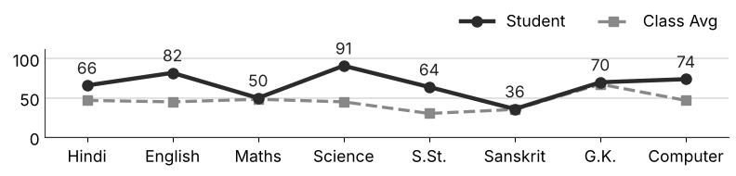
Class Teacher |  | —— Better Education ★ Brighter Future —— |  | Principal

UNIQUE CENTRAL SCHOOL
KNOWLEDGE ★ CHARACTER ★ PROGRESS
ACADEMIC SESSION : 2026 – 2027
RESULT / MARKSHEET
(P.T.1 – 40 | P.T..2 – 40 | S.A.-1 – 80 | Total – 100)
Class : IV | Section : | Roll No. : 20
Student Information  Student Name : Himanshu Kumar  Father’s Name : Mr. Bajrangi Prasad  Mother’s Name : Mrs. Ripu Devi | PHOTO  (Optional) | Result Summary
  Total Marks : | 506 / 800
  Percentage (%) : | 63.25 %
  Overall Grade : | B2
  Result : | PASS
  Rank : | 15
S.No. | Subject | Internal Assessment |  |  |  | Summative  Assessment I  (80 marks) | Total  (100 marks) | Grade
S.No. | Subject | P.T. I | P.T. II | Multiple Assessment | Subject Enrichment | Summative  Assessment I  (80 marks) | Total  (100 marks) | Grade
S.No. | Subject | (5 marks) | (5 marks) | (5 marks) | (5 marks) | Summative  Assessment I  (80 marks) | Total  (100 marks) | Grade
1 | Hindi | 2 | 4 | 3 | 4 | 43 | 56 | C1
2 | English | 4 | 5 | 4 | 4 | 53 | 70 | B2
3 | Maths | 3 | 0 | 3 | 3 | 33 | 42 | C2
4 | Science | 3 | 4 | 4 | 4 | 69 | 84 | A2
5 | S.St. | 1 | 3 | 4 | 4 | 55 | 67 | B2
6 | Sanskrit | 3 | 4 | 4 | 4 | 42 | 57 | C1
7 | G.K. | 4 | 4 | 4 | 5 | 62 | 79 | B1
8 | Computer | 2 | 1 | 3 | 3 | 42 | 51 | C1
CO-SCHOLASTIC AREAS |  |  |  |  |  |  | SCALE
Subject | Drawing | Music | Uniform | Sports | Discipline |  | GRADE | A1 | A2 | B1 | B2 | C1 | C2 | D | E
Grade | A | B | A | A | A |  | MARKS RANGE | 91-100 | 81-90 | 71-80 | 61-70 | 51-60 | 41-50 | 31-40 | Below 30
 |  |  |  |  |  |  | CO-SCH. AREAS | GRADE A  Outstanding |  | GRADE B  Very Good |  | GRADE C  Fair
Attendance  Working Days : 132  Present : 117  Absent : 15 | Teacher’s Remark  Good performance. More practice can make it better. Give more time to Maths. |  | Performance Chart (Total /100 : Student vs Class Average)  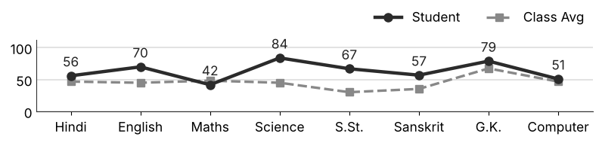
Class Teacher |  | —— Better Education ★ Brighter Future —— |  | Principal

UNIQUE CENTRAL SCHOOL
KNOWLEDGE ★ CHARACTER ★ PROGRESS
ACADEMIC SESSION : 2026 – 2027
RESULT / MARKSHEET
(P.T.1 – 40 | P.T..2 – 40 | S.A.-1 – 80 | Total – 100)
Class : IV | Section : | Roll No. : 21
Student Information  Student Name : Ganesh Kumar  Father’s Name : Mr. Satish Kumar  Mother’s Name : Mrs. Raj Kumari | PHOTO  (Optional) | Result Summary
  Total Marks : | 390 / 800
  Percentage (%) : | 48.75 %
  Overall Grade : | C2
  Result : | PASS
  Rank : | 33
S.No. | Subject | Internal Assessment |  |  |  | Summative  Assessment I  (80 marks) | Total  (100 marks) | Grade
S.No. | Subject | P.T. I | P.T. II | Multiple Assessment | Subject Enrichment | Summative  Assessment I  (80 marks) | Total  (100 marks) | Grade
S.No. | Subject | (5 marks) | (5 marks) | (5 marks) | (5 marks) | Summative  Assessment I  (80 marks) | Total  (100 marks) | Grade
1 | Hindi | 2 | 3 | 4 | 3 | 40 | 52 | C1
2 | English | 3 | 4 | 4 | 4 | 47 | 62 | B2
3 | Maths | 3 | 1 | 3 | 3 | 47 | 57 | C1
4 | Science | 3 | 0 | 3 | 3 | 28 | 37 | D
5 | S.St. | 1 | 1 | 3 | 3 | 24 | 32 | D
6 | Sanskrit | 2 | 3 | 3 | 3 | 14 | 25 | E
7 | G.K. | 3 | 3 | 5 | 4 | 72 | 87 | A2
8 | Computer | 0 | 0 | 3 | 2 | 33 | 38 | D
CO-SCHOLASTIC AREAS |  |  |  |  |  |  | SCALE
Subject | Drawing | Music | Uniform | Sports | Discipline |  | GRADE | A1 | A2 | B1 | B2 | C1 | C2 | D | E
Grade | B | B | B | B | B |  | MARKS RANGE | 91-100 | 81-90 | 71-80 | 61-70 | 51-60 | 41-50 | 31-40 | Below 30
 |  |  |  |  |  |  | CO-SCH. AREAS | GRADE A  Outstanding |  | GRADE B  Very Good |  | GRADE C  Fair
Attendance  Working Days : 132  Present : 126  Absent : 6 | Teacher’s Remark  Fair performance. Needs regular practice and revision. Give more time to Sanskrit. |  | Performance Chart (Total /100 : Student vs Class Average)  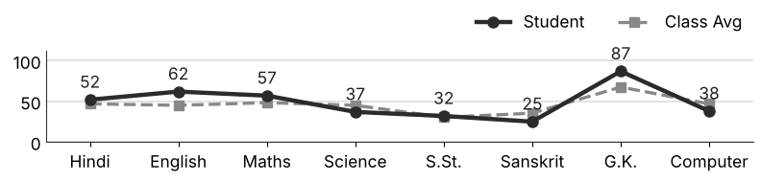
Class Teacher |  | —— Better Education ★ Brighter Future —— |  | Principal

UNIQUE CENTRAL SCHOOL
KNOWLEDGE ★ CHARACTER ★ PROGRESS
ACADEMIC SESSION : 2026 – 2027
RESULT / MARKSHEET
(P.T.1 – 40 | P.T..2 – 40 | S.A.-1 – 80 | Total – 100)
Class : IV | Section : | Roll No. : 22
Student Information  Student Name : Beauty Kumari  Father’s Name : Mr. Raj Kumar  Mother’s Name : Mrs. Abha Devi | PHOTO  (Optional) | Result Summary
  Total Marks : | 486 / 800
  Percentage (%) : | 60.75 %
  Overall Grade : | C1
  Result : | PASS
  Rank : | 18
S.No. | Subject | Internal Assessment |  |  |  | Summative  Assessment I  (80 marks) | Total  (100 marks) | Grade
S.No. | Subject | P.T. I | P.T. II | Multiple Assessment | Subject Enrichment | Summative  Assessment I  (80 marks) | Total  (100 marks) | Grade
S.No. | Subject | (5 marks) | (5 marks) | (5 marks) | (5 marks) | Summative  Assessment I  (80 marks) | Total  (100 marks) | Grade
1 | Hindi | 2 | 4 | 4 | 4 | 50 | 64 | B2
2 | English | 4 | 2 | 4 | 5 | 70 | 85 | A2
3 | Maths | 2 | 3 | 3 | 4 | 36 | 48 | C2
4 | Science | 2 | 1 | 4 | 4 | 61 | 72 | B1
5 | S.St. | 1 | 2 | 3 | 3 | 50 | 59 | C1
6 | Sanskrit | 3 | 3 | 3 | 4 | 44 | 57 | C1
7 | G.K. | 2 | 0 | 4 | 3 | 58 | 67 | B2
8 | Computer | 1 | 0 | 2 | 3 | 28 | 34 | D
CO-SCHOLASTIC AREAS |  |  |  |  |  |  | SCALE
Subject | Drawing | Music | Uniform | Sports | Discipline |  | GRADE | A1 | A2 | B1 | B2 | C1 | C2 | D | E
Grade | B | B | A | A | A |  | MARKS RANGE | 91-100 | 81-90 | 71-80 | 61-70 | 51-60 | 41-50 | 31-40 | Below 30
 |  |  |  |  |  |  | CO-SCH. AREAS | GRADE A  Outstanding |  | GRADE B  Very Good |  | GRADE C  Fair
Attendance  Working Days : 132  Present : 108  Absent : 24 | Teacher’s Remark  Good performance. More practice can make it better. Give more time to Computer. |  | Performance Chart (Total /100 : Student vs Class Average)  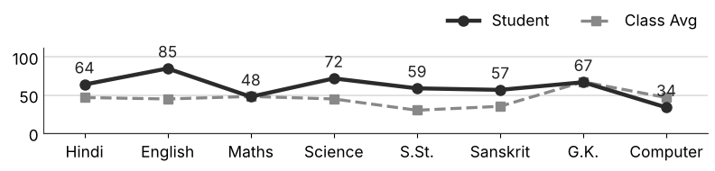
Class Teacher |  | —— Better Education ★ Brighter Future —— |  | Principal

UNIQUE CENTRAL SCHOOL
KNOWLEDGE ★ CHARACTER ★ PROGRESS
ACADEMIC SESSION : 2026 – 2027
RESULT / MARKSHEET
(P.T.1 – 40 | P.T..2 – 40 | S.A.-1 – 80 | Total – 100)
Class : IV | Section : | Roll No. : 23
Student Information  Student Name : Dipu Kumar  Father’s Name : Mr. Suraj Kumar  Mother’s Name : Mrs. Anrita Kumari | PHOTO  (Optional) | Result Summary
  Total Marks : | 318 / 800
  Percentage (%) : | 39.75 %
  Overall Grade : | D
  Result : | PASS
  Rank : | 46
S.No. | Subject | Internal Assessment |  |  |  | Summative  Assessment I  (80 marks) | Total  (100 marks) | Grade
S.No. | Subject | P.T. I | P.T. II | Multiple Assessment | Subject Enrichment | Summative  Assessment I  (80 marks) | Total  (100 marks) | Grade
S.No. | Subject | (5 marks) | (5 marks) | (5 marks) | (5 marks) | Summative  Assessment I  (80 marks) | Total  (100 marks) | Grade
1 | Hindi | 1 | 2 | 3 | 3 | 20 | 29 | E
2 | English | 2 | 0 | 3 | 3 | 26 | 34 | D
3 | Maths | 3 | 0 | 3 | 4 | 37 | 47 | C2
4 | Science | 2 | 1 | 3 | 3 | 16 | 25 | E
5 | S.St. | 1 | 1 | 3 | 3 | 31 | 39 | D
6 | Sanskrit | 1 | 2 | 2 | 3 | 18 | 26 | E
7 | G.K. | 3 | 4 | 4 | 5 | 74 | 90 | A2
8 | Computer | 1 | 0 | 3 | 3 | 21 | 28 | E
CO-SCHOLASTIC AREAS |  |  |  |  |  |  | SCALE
Subject | Drawing | Music | Uniform | Sports | Discipline |  | GRADE | A1 | A2 | B1 | B2 | C1 | C2 | D | E
Grade | B | C | B | B | B |  | MARKS RANGE | 91-100 | 81-90 | 71-80 | 61-70 | 51-60 | 41-50 | 31-40 | Below 30
 |  |  |  |  |  |  | CO-SCH. AREAS | GRADE A  Outstanding |  | GRADE B  Very Good |  | GRADE C  Fair
Attendance  Working Days : 132  Present : 122  Absent : 10 | Teacher’s Remark  Needs improvement. Should study regularly at home. Give more time to Science. |  | Performance Chart (Total /100 : Student vs Class Average)  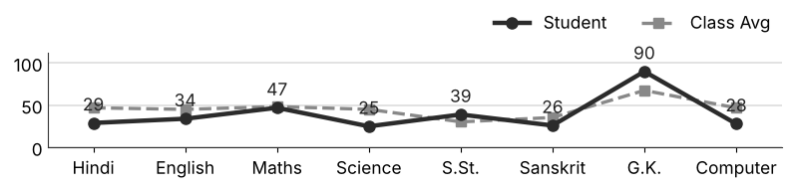
Class Teacher |  | —— Better Education ★ Brighter Future —— |  | Principal

UNIQUE CENTRAL SCHOOL
KNOWLEDGE ★ CHARACTER ★ PROGRESS
ACADEMIC SESSION : 2026 – 2027
RESULT / MARKSHEET
(P.T.1 – 40 | P.T..2 – 40 | S.A.-1 – 80 | Total – 100)
Class : IV | Section : | Roll No. : 24
Student Information  Student Name : Shiva Kumar  Father’s Name : Mr. Ranji Kumar  Mother’s Name : Mrs. Guriya Devi | PHOTO  (Optional) | Result Summary
  Total Marks : | 499 / 800
  Percentage (%) : | 62.38 %
  Overall Grade : | B2
  Result : | PASS
  Rank : | 17
S.No. | Subject | Internal Assessment |  |  |  | Summative  Assessment I  (80 marks) | Total  (100 marks) | Grade
S.No. | Subject | P.T. I | P.T. II | Multiple Assessment | Subject Enrichment | Summative  Assessment I  (80 marks) | Total  (100 marks) | Grade
S.No. | Subject | (5 marks) | (5 marks) | (5 marks) | (5 marks) | Summative  Assessment I  (80 marks) | Total  (100 marks) | Grade
1 | Hindi | 1 | 3 | 4 | 4 | 50 | 62 | B2
2 | English | 3 | 4 | 4 | 4 | 48 | 63 | B2
3 | Maths | 4 | 3 | 4 | 4 | 55 | 70 | B2
4 | Science | 2 | 2 | 4 | 4 | 48 | 60 | C1
5 | S.St. | 1 | 2 | 3 | 3 | 37 | 46 | C2
6 | Sanskrit | 3 | 3 | 4 | 4 | 42 | 56 | C1
7 | G.K. | 5 | 3 | 5 | 5 | 76 | 94 | A1
8 | Computer | 1 | 2 | 4 | 3 | 38 | 48 | C2
CO-SCHOLASTIC AREAS |  |  |  |  |  |  | SCALE
Subject | Drawing | Music | Uniform | Sports | Discipline |  | GRADE | A1 | A2 | B1 | B2 | C1 | C2 | D | E
Grade | A | B | A | A | A |  | MARKS RANGE | 91-100 | 81-90 | 71-80 | 61-70 | 51-60 | 41-50 | 31-40 | Below 30
 |  |  |  |  |  |  | CO-SCH. AREAS | GRADE A  Outstanding |  | GRADE B  Very Good |  | GRADE C  Fair
Attendance  Working Days : 132  Present : 123  Absent : 9 | Teacher’s Remark  Good performance. More practice can make it better. Give more time to S.St.. |  | Performance Chart (Total /100 : Student vs Class Average)  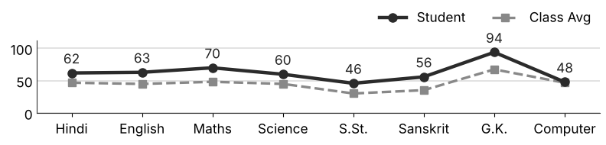
Class Teacher |  | —— Better Education ★ Brighter Future —— |  | Principal

UNIQUE CENTRAL SCHOOL
KNOWLEDGE ★ CHARACTER ★ PROGRESS
ACADEMIC SESSION : 2026 – 2027
RESULT / MARKSHEET
(P.T.1 – 40 | P.T..2 – 40 | S.A.-1 – 80 | Total – 100)
Class : IV | Section : | Roll No. : 25
Student Information  Student Name : Amit Kumar  Father’s Name : Mr. Subhodh Sah  Mother’s Name : Mrs. Kanti Devi | PHOTO  (Optional) | Result Summary
  Total Marks : | 330 / 800
  Percentage (%) : | 41.25 %
  Overall Grade : | C2
  Result : | PASS
  Rank : | 42
S.No. | Subject | Internal Assessment |  |  |  | Summative  Assessment I  (80 marks) | Total  (100 marks) | Grade
S.No. | Subject | P.T. I | P.T. II | Multiple Assessment | Subject Enrichment | Summative  Assessment I  (80 marks) | Total  (100 marks) | Grade
S.No. | Subject | (5 marks) | (5 marks) | (5 marks) | (5 marks) | Summative  Assessment I  (80 marks) | Total  (100 marks) | Grade
1 | Hindi | 1 | 2 | 3 | 2 | 30 | 38 | D
2 | English | 2 | 4 | 3 | 3 | 15 | 27 | E
3 | Maths | 1 | 0 | 4 | 3 | 56 | 64 | B2
4 | Science | 1 | 0 | 3 | 4 | 38 | 46 | C2
5 | S.St. | 0 | 0 | 2 | 3 | 32 | 37 | D
6 | Sanskrit | 1 | 1 | 2 | 2 | 7 | 13 | E
7 | G.K. | 2 | 3 | 4 | 3 | 38 | 50 | C2
8 | Computer | 0 | 1 | 3 | 3 | 48 | 55 | C1
CO-SCHOLASTIC AREAS |  |  |  |  |  |  | SCALE
Subject | Drawing | Music | Uniform | Sports | Discipline |  | GRADE | A1 | A2 | B1 | B2 | C1 | C2 | D | E
Grade | B | C | B | B | B |  | MARKS RANGE | 91-100 | 81-90 | 71-80 | 61-70 | 51-60 | 41-50 | 31-40 | Below 30
 |  |  |  |  |  |  | CO-SCH. AREAS | GRADE A  Outstanding |  | GRADE B  Very Good |  | GRADE C  Fair
Attendance  Working Days : 132  Present : 124  Absent : 8 | Teacher’s Remark  Fair performance. Needs regular practice and revision. Give more time to Sanskrit. |  | Performance Chart (Total /100 : Student vs Class Average)  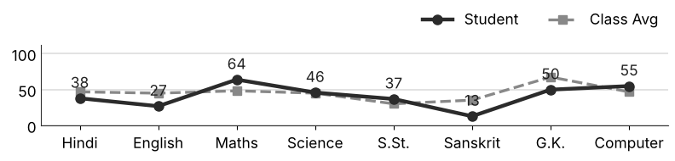
Class Teacher |  | —— Better Education ★ Brighter Future —— |  | Principal

UNIQUE CENTRAL SCHOOL
KNOWLEDGE ★ CHARACTER ★ PROGRESS
ACADEMIC SESSION : 2026 – 2027
RESULT / MARKSHEET
(P.T.1 – 40 | P.T..2 – 40 | S.A.-1 – 80 | Total – 100)
Class : IV | Section : | Roll No. : 26
Student Information  Student Name : Aradhya Keshri  Father’s Name : Mr. Manoj Keshri  Mother’s Name : Mrs. Soni Devi | PHOTO  (Optional) | Result Summary
  Total Marks : | 546 / 800
  Percentage (%) : | 68.25 %
  Overall Grade : | B2
  Result : | PASS
  Rank : | 8
S.No. | Subject | Internal Assessment |  |  |  | Summative  Assessment I  (80 marks) | Total  (100 marks) | Grade
S.No. | Subject | P.T. I | P.T. II | Multiple Assessment | Subject Enrichment | Summative  Assessment I  (80 marks) | Total  (100 marks) | Grade
S.No. | Subject | (5 marks) | (5 marks) | (5 marks) | (5 marks) | Summative  Assessment I  (80 marks) | Total  (100 marks) | Grade
1 | Hindi | 2 | 3 | 4 | 4 | 69 | 82 | A2
2 | English | 3 | 3 | 4 | 4 | 50 | 64 | B2
3 | Maths | 3 | 3 | 4 | 4 | 48 | 62 | B2
4 | Science | 1 | 2 | 4 | 4 | 70 | 81 | A2
5 | S.St. | 1 | 1 | 3 | 3 | 40 | 48 | C2
6 | Sanskrit | 3 | 3 | 3 | 4 | 39 | 52 | C1
7 | G.K. | 4 | 2 | 4 | 5 | 76 | 91 | A1
8 | Computer | 4 | 3 | 4 | 4 | 51 | 66 | B2
CO-SCHOLASTIC AREAS |  |  |  |  |  |  | SCALE
Subject | Drawing | Music | Uniform | Sports | Discipline |  | GRADE | A1 | A2 | B1 | B2 | C1 | C2 | D | E
Grade | A | B | A | A | A |  | MARKS RANGE | 91-100 | 81-90 | 71-80 | 61-70 | 51-60 | 41-50 | 31-40 | Below 30
 |  |  |  |  |  |  | CO-SCH. AREAS | GRADE A  Outstanding |  | GRADE B  Very Good |  | GRADE C  Fair
Attendance  Working Days : 132  Present : 128  Absent : 4 | Teacher’s Remark  Good performance. More practice can make it better. Give more time to S.St.. |  | Performance Chart (Total /100 : Student vs Class Average)  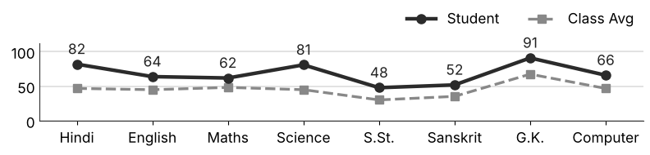
Class Teacher |  | —— Better Education ★ Brighter Future —— |  | Principal

UNIQUE CENTRAL SCHOOL
KNOWLEDGE ★ CHARACTER ★ PROGRESS
ACADEMIC SESSION : 2026 – 2027
RESULT / MARKSHEET
(P.T.1 – 40 | P.T..2 – 40 | S.A.-1 – 80 | Total – 100)
Class : IV | Section : | Roll No. : 27
Student Information  Student Name : Shristi Kumari  Father’s Name : Mr. Santosh Kumar  Mother’s Name : Mrs. Jyoti Gupta | PHOTO  (Optional) | Result Summary
  Total Marks : | 441 / 800
  Percentage (%) : | 55.12 %
  Overall Grade : | C1
  Result : | PASS
  Rank : | 24
S.No. | Subject | Internal Assessment |  |  |  | Summative  Assessment I  (80 marks) | Total  (100 marks) | Grade
S.No. | Subject | P.T. I | P.T. II | Multiple Assessment | Subject Enrichment | Summative  Assessment I  (80 marks) | Total  (100 marks) | Grade
S.No. | Subject | (5 marks) | (5 marks) | (5 marks) | (5 marks) | Summative  Assessment I  (80 marks) | Total  (100 marks) | Grade
1 | Hindi | 2 | 3 | 3 | 4 | 38 | 50 | C2
2 | English | 0 | 3 | 3 | 4 | 47 | 57 | C1
3 | Maths | 2 | 2 | 4 | 3 | 40 | 51 | C1
4 | Science | 1 | 1 | 3 | 4 | 62 | 71 | B1
5 | S.St. | 1 | 0 | 3 | 4 | 40 | 48 | C2
6 | Sanskrit | 1 | 1 | 3 | 2 | 15 | 22 | E
7 | G.K. | 4 | 2 | 5 | 4 | 78 | 93 | A1
8 | Computer | 1 | 2 | 3 | 3 | 40 | 49 | C2
CO-SCHOLASTIC AREAS |  |  |  |  |  |  | SCALE
Subject | Drawing | Music | Uniform | Sports | Discipline |  | GRADE | A1 | A2 | B1 | B2 | C1 | C2 | D | E
Grade | B | B | A | B | A |  | MARKS RANGE | 91-100 | 81-90 | 71-80 | 61-70 | 51-60 | 41-50 | 31-40 | Below 30
 |  |  |  |  |  |  | CO-SCH. AREAS | GRADE A  Outstanding |  | GRADE B  Very Good |  | GRADE C  Fair
Attendance  Working Days : 132  Present : 125  Absent : 7 | Teacher’s Remark  Satisfactory performance. Needs to work harder. Give more time to Sanskrit. |  | Performance Chart (Total /100 : Student vs Class Average)  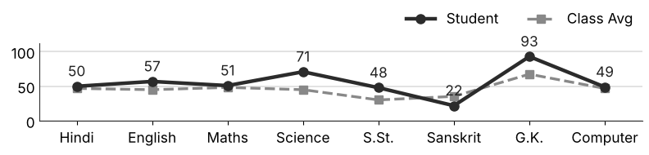
Class Teacher |  | —— Better Education ★ Brighter Future —— |  | Principal

UNIQUE CENTRAL SCHOOL
KNOWLEDGE ★ CHARACTER ★ PROGRESS
ACADEMIC SESSION : 2026 – 2027
RESULT / MARKSHEET
(P.T.1 – 40 | P.T..2 – 40 | S.A.-1 – 80 | Total – 100)
Class : IV | Section : | Roll No. : 28
Student Information  Student Name : Aryan Soni  Father’s Name : Mr. Raj Soni  Mother’s Name : Mrs. Puja Soni | PHOTO  (Optional) | Result Summary
  Total Marks : | 539 / 800
  Percentage (%) : | 67.38 %
  Overall Grade : | B2
  Result : | PASS
  Rank : | 9
S.No. | Subject | Internal Assessment |  |  |  | Summative  Assessment I  (80 marks) | Total  (100 marks) | Grade
S.No. | Subject | P.T. I | P.T. II | Multiple Assessment | Subject Enrichment | Summative  Assessment I  (80 marks) | Total  (100 marks) | Grade
S.No. | Subject | (5 marks) | (5 marks) | (5 marks) | (5 marks) | Summative  Assessment I  (80 marks) | Total  (100 marks) | Grade
1 | Hindi | 3 | 4 | 4 | 4 | 39 | 54 | C1
2 | English | 4 | 5 | 5 | 4 | 75 | 93 | A1
3 | Maths | 2 | 2 | 4 | 4 | 48 | 60 | C1
4 | Science | 1 | 4 | 3 | 4 | 35 | 47 | C2
5 | S.St. | 1 | 3 | 3 | 3 | 45 | 55 | C1
6 | Sanskrit | 3 | 3 | 4 | 4 | 32 | 46 | C2
7 | G.K. | 4 | 4 | 5 | 5 | 76 | 94 | A1
8 | Computer | 4 | 3 | 5 | 5 | 73 | 90 | A2
CO-SCHOLASTIC AREAS |  |  |  |  |  |  | SCALE
Subject | Drawing | Music | Uniform | Sports | Discipline |  | GRADE | A1 | A2 | B1 | B2 | C1 | C2 | D | E
Grade | A | A | A | A | A |  | MARKS RANGE | 91-100 | 81-90 | 71-80 | 61-70 | 51-60 | 41-50 | 31-40 | Below 30
 |  |  |  |  |  |  | CO-SCH. AREAS | GRADE A  Outstanding |  | GRADE B  Very Good |  | GRADE C  Fair
Attendance  Working Days : 132  Present : 110  Absent : 22 | Teacher’s Remark  Good performance. More practice can make it better. Give more time to Sanskrit. |  | Performance Chart (Total /100 : Student vs Class Average)  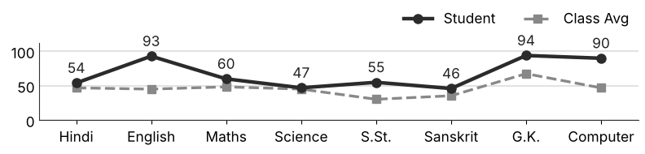
Class Teacher |  | —— Better Education ★ Brighter Future —— |  | Principal

UNIQUE CENTRAL SCHOOL
KNOWLEDGE ★ CHARACTER ★ PROGRESS
ACADEMIC SESSION : 2026 – 2027
RESULT / MARKSHEET
(P.T.1 – 40 | P.T..2 – 40 | S.A.-1 – 80 | Total – 100)
Class : IV | Section : | Roll No. : 29
Student Information  Student Name : Kavya Kumari  Father’s Name : Mr. Papu Kumar  Mother’s Name : Mrs. Puja Kumari | PHOTO  (Optional) | Result Summary
  Total Marks : | 403 / 800
  Percentage (%) : | 50.38 %
  Overall Grade : | C2
  Result : | PASS
  Rank : | 32
S.No. | Subject | Internal Assessment |  |  |  | Summative  Assessment I  (80 marks) | Total  (100 marks) | Grade
S.No. | Subject | P.T. I | P.T. II | Multiple Assessment | Subject Enrichment | Summative  Assessment I  (80 marks) | Total  (100 marks) | Grade
S.No. | Subject | (5 marks) | (5 marks) | (5 marks) | (5 marks) | Summative  Assessment I  (80 marks) | Total  (100 marks) | Grade
1 | Hindi | 2 | 3 | 4 | 4 | 46 | 59 | C1
2 | English | 4 | 3 | 3 | 3 | 14 | 27 | E
3 | Maths | 1 | 3 | 3 | 4 | 40 | 51 | C1
4 | Science | 1 | 0 | 4 | 4 | 54 | 63 | B2
5 | S.St. | 0 | 0 | 3 | 3 | 41 | 47 | C2
6 | Sanskrit | 2 | 2 | 3 | 4 | 31 | 42 | C2
7 | G.K. | 4 | 2 | 4 | 4 | 58 | 72 | B1
8 | Computer | 2 | 0 | 3 | 3 | 34 | 42 | C2
CO-SCHOLASTIC AREAS |  |  |  |  |  |  | SCALE
Subject | Drawing | Music | Uniform | Sports | Discipline |  | GRADE | A1 | A2 | B1 | B2 | C1 | C2 | D | E
Grade | B | B | B | B | B |  | MARKS RANGE | 91-100 | 81-90 | 71-80 | 61-70 | 51-60 | 41-50 | 31-40 | Below 30
 |  |  |  |  |  |  | CO-SCH. AREAS | GRADE A  Outstanding |  | GRADE B  Very Good |  | GRADE C  Fair
Attendance  Working Days : 132  Present : 100  Absent : 32 | Teacher’s Remark  Satisfactory performance. Needs to work harder. Attendance must improve. |  | Performance Chart (Total /100 : Student vs Class Average)  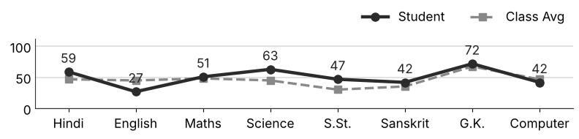
Class Teacher |  | —— Better Education ★ Brighter Future —— |  | Principal

UNIQUE CENTRAL SCHOOL
KNOWLEDGE ★ CHARACTER ★ PROGRESS
ACADEMIC SESSION : 2026 – 2027
RESULT / MARKSHEET
(P.T.1 – 40 | P.T..2 – 40 | S.A.-1 – 80 | Total – 100)
Class : IV | Section : | Roll No. : 30
Student Information  Student Name : Piyush Kumar  Father’s Name : Mr. Bhotu Prashad  Mother’s Name : Mrs. Puja Kumari | PHOTO  (Optional) | Result Summary
  Total Marks : | 331 / 800
  Percentage (%) : | 41.38 %
  Overall Grade : | C2
  Result : | PASS
  Rank : | 41
S.No. | Subject | Internal Assessment |  |  |  | Summative  Assessment I  (80 marks) | Total  (100 marks) | Grade
S.No. | Subject | P.T. I | P.T. II | Multiple Assessment | Subject Enrichment | Summative  Assessment I  (80 marks) | Total  (100 marks) | Grade
S.No. | Subject | (5 marks) | (5 marks) | (5 marks) | (5 marks) | Summative  Assessment I  (80 marks) | Total  (100 marks) | Grade
1 | Hindi | 2 | 3 | 4 | 3 | 24 | 36 | D
2 | English | 3 | 4 | 3 | 3 | 21 | 34 | D
3 | Maths | 3 | 3 | 3 | 4 | 36 | 49 | C2
4 | Science | 0 | 1 | 4 | 3 | 55 | 63 | B2
5 | S.St. | 1 | 0 | 3 | 3 | 33 | 40 | D
6 | Sanskrit | 1 | 1 | 2 | 2 | 12 | 18 | E
7 | G.K. | 3 | 4 | 3 | 4 | 42 | 56 | C1
8 | Computer | 0 | 0 | 2 | 2 | 31 | 35 | D
CO-SCHOLASTIC AREAS |  |  |  |  |  |  | SCALE
Subject | Drawing | Music | Uniform | Sports | Discipline |  | GRADE | A1 | A2 | B1 | B2 | C1 | C2 | D | E
Grade | C | B | B | B | B |  | MARKS RANGE | 91-100 | 81-90 | 71-80 | 61-70 | 51-60 | 41-50 | 31-40 | Below 30
 |  |  |  |  |  |  | CO-SCH. AREAS | GRADE A  Outstanding |  | GRADE B  Very Good |  | GRADE C  Fair
Attendance  Working Days : 132  Present : 128  Absent : 4 | Teacher’s Remark  Fair performance. Needs regular practice and revision. Give more time to Sanskrit. |  | Performance Chart (Total /100 : Student vs Class Average)  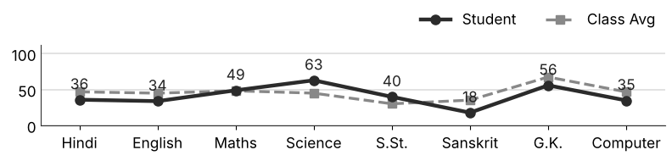
Class Teacher |  | —— Better Education ★ Brighter Future —— |  | Principal

UNIQUE CENTRAL SCHOOL
KNOWLEDGE ★ CHARACTER ★ PROGRESS
ACADEMIC SESSION : 2026 – 2027
RESULT / MARKSHEET
(P.T.1 – 40 | P.T..2 – 40 | S.A.-1 – 80 | Total – 100)
Class : IV | Section : | Roll No. : 31
Student Information  Student Name : Manish Kumar  Father’s Name : Mr. Anil Yadav  Mother’s Name : Mrs. Sabita Devi | PHOTO  (Optional) | Result Summary
  Total Marks : | 204 / 800
  Percentage (%) : | 25.50 %
  Overall Grade : | E
  Result : | FAIL
  Rank : | 68
S.No. | Subject | Internal Assessment |  |  |  | Summative  Assessment I  (80 marks) | Total  (100 marks) | Grade
S.No. | Subject | P.T. I | P.T. II | Multiple Assessment | Subject Enrichment | Summative  Assessment I  (80 marks) | Total  (100 marks) | Grade
S.No. | Subject | (5 marks) | (5 marks) | (5 marks) | (5 marks) | Summative  Assessment I  (80 marks) | Total  (100 marks) | Grade
1 | Hindi | 0 | 0 | 3 | 3 | 20 | 26 | E
2 | English | 3 | 0 | 3 | 3 | 10 | 19 | E
3 | Maths | 0 | 2 | 3 | 2 | 33 | 40 | D
4 | Science | 0 | 0 | 3 | 3 | 30 | 36 | D
5 | S.St. | 0 | 0 | 2 | 2 | 7 | 11 | E
6 | Sanskrit | 0 | 2 | 3 | 2 | 7 | 14 | E
7 | G.K. | 4 | 0 | 3 | 2 | 18 | 27 | E
8 | Computer | 2 | 0 | 3 | 2 | 24 | 31 | D
CO-SCHOLASTIC AREAS |  |  |  |  |  |  | SCALE
Subject | Drawing | Music | Uniform | Sports | Discipline |  | GRADE | A1 | A2 | B1 | B2 | C1 | C2 | D | E
Grade | C | C | C | C | C |  | MARKS RANGE | 91-100 | 81-90 | 71-80 | 61-70 | 51-60 | 41-50 | 31-40 | Below 30
 |  |  |  |  |  |  | CO-SCH. AREAS | GRADE A  Outstanding |  | GRADE B  Very Good |  | GRADE C  Fair
Attendance  Working Days : 132  Present : 127  Absent : 5 | Teacher’s Remark  Weak performance. Needs special attention and practice. Give more time to S.St.. |  | Performance Chart (Total /100 : Student vs Class Average)  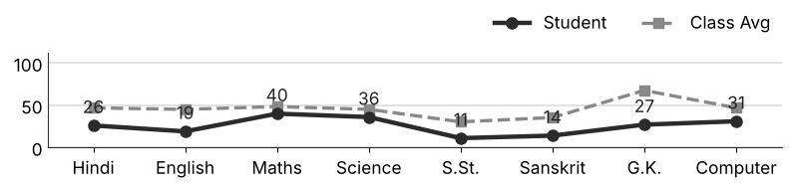
Class Teacher |  | —— Better Education ★ Brighter Future —— |  | Principal

UNIQUE CENTRAL SCHOOL
KNOWLEDGE ★ CHARACTER ★ PROGRESS
ACADEMIC SESSION : 2026 – 2027
RESULT / MARKSHEET
(P.T.1 – 40 | P.T..2 – 40 | S.A.-1 – 80 | Total – 100)
Class : IV | Section : | Roll No. : 32
Student Information  Student Name : Anan Kumar  Father’s Name : Mr. Manoj Kumar  Mother’s Name : Mrs. Seema Devi | PHOTO  (Optional) | Result Summary
  Total Marks : | 315 / 800
  Percentage (%) : | 39.38 %
  Overall Grade : | D
  Result : | PASS
  Rank : | 48
S.No. | Subject | Internal Assessment |  |  |  | Summative  Assessment I  (80 marks) | Total  (100 marks) | Grade
S.No. | Subject | P.T. I | P.T. II | Multiple Assessment | Subject Enrichment | Summative  Assessment I  (80 marks) | Total  (100 marks) | Grade
S.No. | Subject | (5 marks) | (5 marks) | (5 marks) | (5 marks) | Summative  Assessment I  (80 marks) | Total  (100 marks) | Grade
1 | Hindi | 0 | 2 | 3 | 3 | 33 | 41 | C2
2 | English | 1 | 4 | 4 | 3 | 37 | 49 | C2
3 | Maths | 3 | 3 | 4 | 4 | 46 | 60 | C1
4 | Science | 0 | 2 | 2 | 2 | 15 | 21 | E
5 | S.St. | 0 | 0 | 2 | 2 | 12 | 16 | E
6 | Sanskrit | 1 | 1 | 2 | 2 | 14 | 20 | E
7 | G.K. | 2 | 0 | 4 | 3 | 46 | 55 | C1
8 | Computer | 0 | 0 | 3 | 3 | 47 | 53 | C1
CO-SCHOLASTIC AREAS |  |  |  |  |  |  | SCALE
Subject | Drawing | Music | Uniform | Sports | Discipline |  | GRADE | A1 | A2 | B1 | B2 | C1 | C2 | D | E
Grade | C | C | B | B | B |  | MARKS RANGE | 91-100 | 81-90 | 71-80 | 61-70 | 51-60 | 41-50 | 31-40 | Below 30
 |  |  |  |  |  |  | CO-SCH. AREAS | GRADE A  Outstanding |  | GRADE B  Very Good |  | GRADE C  Fair
Attendance  Working Days : 132  Present : 109  Absent : 23 | Teacher’s Remark  Needs improvement. Should study regularly at home. Give more time to S.St.. |  | Performance Chart (Total /100 : Student vs Class Average)  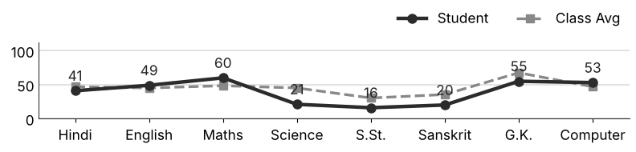
Class Teacher |  | —— Better Education ★ Brighter Future —— |  | Principal

UNIQUE CENTRAL SCHOOL
KNOWLEDGE ★ CHARACTER ★ PROGRESS
ACADEMIC SESSION : 2026 – 2027
RESULT / MARKSHEET
(P.T.1 – 40 | P.T..2 – 40 | S.A.-1 – 80 | Total – 100)
Class : IV | Section : | Roll No. : 33
Student Information  Student Name : Md. Atif Alam  Father’s Name : Md. Rafik Alam  Mother’s Name : Mrs. Sahnaaz Bano | PHOTO  (Optional) | Result Summary
  Total Marks : | 421 / 800
  Percentage (%) : | 52.62 %
  Overall Grade : | C1
  Result : | PASS
  Rank : | 27
S.No. | Subject | Internal Assessment |  |  |  | Summative  Assessment I  (80 marks) | Total  (100 marks) | Grade
S.No. | Subject | P.T. I | P.T. II | Multiple Assessment | Subject Enrichment | Summative  Assessment I  (80 marks) | Total  (100 marks) | Grade
S.No. | Subject | (5 marks) | (5 marks) | (5 marks) | (5 marks) | Summative  Assessment I  (80 marks) | Total  (100 marks) | Grade
1 | Hindi | 2 | 2 | 4 | 3 | 33 | 44 | C2
2 | English | 3 | 5 | 4 | 5 | 60 | 77 | B1
3 | Maths | 0 | 0 | 3 | 3 | 45 | 51 | C1
4 | Science | 0 | 0 | 3 | 3 | 38 | 44 | C2
5 | S.St. | 0 | 0 | 2 | 2 | 24 | 28 | E
6 | Sanskrit | 0 | 0 | 3 | 2 | 37 | 42 | C2
7 | G.K. | 3 | 5 | 4 | 4 | 50 | 66 | B2
8 | Computer | 1 | 1 | 3 | 4 | 60 | 69 | B2
CO-SCHOLASTIC AREAS |  |  |  |  |  |  | SCALE
Subject | Drawing | Music | Uniform | Sports | Discipline |  | GRADE | A1 | A2 | B1 | B2 | C1 | C2 | D | E
Grade | B | B | B | B | B |  | MARKS RANGE | 91-100 | 81-90 | 71-80 | 61-70 | 51-60 | 41-50 | 31-40 | Below 30
 |  |  |  |  |  |  | CO-SCH. AREAS | GRADE A  Outstanding |  | GRADE B  Very Good |  | GRADE C  Fair
Attendance  Working Days : 132  Present : 96  Absent : 36 | Teacher’s Remark  Satisfactory performance. Needs to work harder. Attendance must improve. |  | Performance Chart (Total /100 : Student vs Class Average)  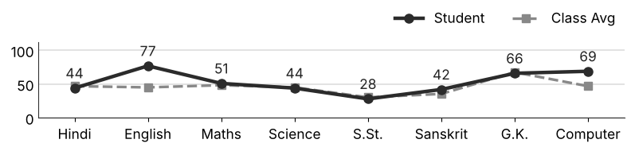
Class Teacher |  | —— Better Education ★ Brighter Future —— |  | Principal

UNIQUE CENTRAL SCHOOL
KNOWLEDGE ★ CHARACTER ★ PROGRESS
ACADEMIC SESSION : 2026 – 2027
RESULT / MARKSHEET
(P.T.1 – 40 | P.T..2 – 40 | S.A.-1 – 80 | Total – 100)
Class : IV | Section : | Roll No. : 34
Student Information  Student Name : Md. Adil Alam  Father’s Name : Md. Tipu Sultan  Mother’s Name : Mrs. Sabnam Khatun | PHOTO  (Optional) | Result Summary
  Total Marks : | 270 / 800
  Percentage (%) : | 33.75 %
  Overall Grade : | D
  Result : | PASS
  Rank : | 58
S.No. | Subject | Internal Assessment |  |  |  | Summative  Assessment I  (80 marks) | Total  (100 marks) | Grade
S.No. | Subject | P.T. I | P.T. II | Multiple Assessment | Subject Enrichment | Summative  Assessment I  (80 marks) | Total  (100 marks) | Grade
S.No. | Subject | (5 marks) | (5 marks) | (5 marks) | (5 marks) | Summative  Assessment I  (80 marks) | Total  (100 marks) | Grade
1 | Hindi | 0 | 2 | 3 | 3 | 25 | 33 | D
2 | English | 4 | 2 | 3 | 3 | 12 | 24 | E
3 | Maths | 0 | 3 | 2 | 2 | 12 | 19 | E
4 | Science | 0 | 3 | 3 | 2 | 23 | 31 | D
5 | S.St. | 0 | 0 | 2 | 2 | 14 | 18 | E
6 | Sanskrit | 0 | 0 | 3 | 3 | 50 | 56 | C1
7 | G.K. | 1 | 3 | 4 | 4 | 72 | 84 | A2
8 | Computer | 0 | 1 | 2 | 2 | 0 | 5 | E
CO-SCHOLASTIC AREAS |  |  |  |  |  |  | SCALE
Subject | Drawing | Music | Uniform | Sports | Discipline |  | GRADE | A1 | A2 | B1 | B2 | C1 | C2 | D | E
Grade | C | C | C | C | C |  | MARKS RANGE | 91-100 | 81-90 | 71-80 | 61-70 | 51-60 | 41-50 | 31-40 | Below 30
 |  |  |  |  |  |  | CO-SCH. AREAS | GRADE A  Outstanding |  | GRADE B  Very Good |  | GRADE C  Fair
Attendance  Working Days : 132  Present : 93  Absent : 39 | Teacher’s Remark  Needs improvement. Should study regularly at home. Attendance must improve. |  | Performance Chart (Total /100 : Student vs Class Average)  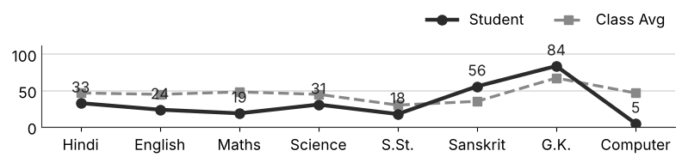
Class Teacher |  | —— Better Education ★ Brighter Future —— |  | Principal

UNIQUE CENTRAL SCHOOL
KNOWLEDGE ★ CHARACTER ★ PROGRESS
ACADEMIC SESSION : 2026 – 2027
RESULT / MARKSHEET
(P.T.1 – 40 | P.T..2 – 40 | S.A.-1 – 80 | Total – 100)
Class : IV | Section : | Roll No. : 35
Student Information  Student Name : Md. Adil Alam  Father’s Name : Md. Rijwan  Mother’s Name : Mrs. Rakhbar Khatun | PHOTO  (Optional) | Result Summary
  Total Marks : | 300 / 800
  Percentage (%) : | 37.50 %
  Overall Grade : | D
  Result : | PASS
  Rank : | 52
S.No. | Subject | Internal Assessment |  |  |  | Summative  Assessment I  (80 marks) | Total  (100 marks) | Grade
S.No. | Subject | P.T. I | P.T. II | Multiple Assessment | Subject Enrichment | Summative  Assessment I  (80 marks) | Total  (100 marks) | Grade
S.No. | Subject | (5 marks) | (5 marks) | (5 marks) | (5 marks) | Summative  Assessment I  (80 marks) | Total  (100 marks) | Grade
1 | Hindi | 2 | 0 | 3 | 3 | 32 | 40 | D
2 | English | 3 | 0 | 3 | 2 | 18 | 26 | E
3 | Maths | 0 | 3 | 2 | 3 | 16 | 24 | E
4 | Science | 0 | 0 | 3 | 2 | 20 | 25 | E
5 | S.St. | 1 | 1 | 2 | 2 | 13 | 19 | E
6 | Sanskrit | 2 | 0 | 4 | 4 | 63 | 73 | B1
7 | G.K. | 3 | 0 | 4 | 4 | 70 | 81 | A2
8 | Computer | 1 | 0 | 3 | 2 | 6 | 12 | E
CO-SCHOLASTIC AREAS |  |  |  |  |  |  | SCALE
Subject | Drawing | Music | Uniform | Sports | Discipline |  | GRADE | A1 | A2 | B1 | B2 | C1 | C2 | D | E
Grade | C | C | B | C | C |  | MARKS RANGE | 91-100 | 81-90 | 71-80 | 61-70 | 51-60 | 41-50 | 31-40 | Below 30
 |  |  |  |  |  |  | CO-SCH. AREAS | GRADE A  Outstanding |  | GRADE B  Very Good |  | GRADE C  Fair
Attendance  Working Days : 132  Present : 105  Absent : 27 | Teacher’s Remark  Needs improvement. Should study regularly at home. Give more time to Computer. |  | Performance Chart (Total /100 : Student vs Class Average)  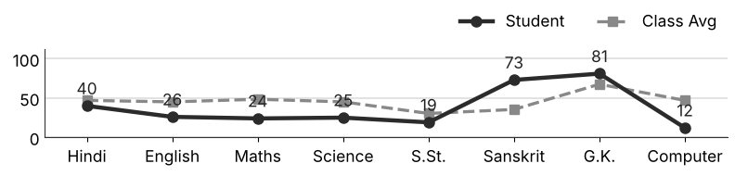
Class Teacher |  | —— Better Education ★ Brighter Future —— |  | Principal

UNIQUE CENTRAL SCHOOL
KNOWLEDGE ★ CHARACTER ★ PROGRESS
ACADEMIC SESSION : 2026 – 2027
RESULT / MARKSHEET
(P.T.1 – 40 | P.T..2 – 40 | S.A.-1 – 80 | Total – 100)
Class : IV | Section : | Roll No. : 36
Student Information  Student Name : Anuradha Kumari  Father’s Name : Mr. Sakhi Gopal  Mother’s Name : Mrs. Virinda Devi | PHOTO  (Optional) | Result Summary
  Total Marks : | 39 / 800
  Percentage (%) : | 4.88 %
  Overall Grade : | E
  Result : | FAIL
  Rank : | 74
S.No. | Subject | Internal Assessment |  |  |  | Summative  Assessment I  (80 marks) | Total  (100 marks) | Grade
S.No. | Subject | P.T. I | P.T. II | Multiple Assessment | Subject Enrichment | Summative  Assessment I  (80 marks) | Total  (100 marks) | Grade
S.No. | Subject | (5 marks) | (5 marks) | (5 marks) | (5 marks) | Summative  Assessment I  (80 marks) | Total  (100 marks) | Grade
1 | Hindi | 1 | 2 | 2 | 2 | 0 | 7 | E
2 | English | 2 | 2 | 2 | 2 | 0 | 8 | E
3 | Maths | 1 | 0 | 2 | 2 | 0 | 5 | E
4 | Science | 0 | 2 | 2 | 2 | 0 | 6 | E
5 | S.St. | 0 | 0 | 0 | 0 | 0 | 0 | E
6 | Sanskrit | 1 | 1 | 2 | 2 | 0 | 6 | E
7 | G.K. | 1 | 2 | 2 | 2 | 0 | 7 | E
8 | Computer | 0 | 0 | 0 | 0 | 0 | 0 | E
CO-SCHOLASTIC AREAS |  |  |  |  |  |  | SCALE
Subject | Drawing | Music | Uniform | Sports | Discipline |  | GRADE | A1 | A2 | B1 | B2 | C1 | C2 | D | E
Grade | C | C | C | C | C |  | MARKS RANGE | 91-100 | 81-90 | 71-80 | 61-70 | 51-60 | 41-50 | 31-40 | Below 30
 |  |  |  |  |  |  | CO-SCH. AREAS | GRADE A  Outstanding |  | GRADE B  Very Good |  | GRADE C  Fair
Attendance  Working Days : 132  Present : 0  Absent : 132 | Teacher’s Remark  Weak performance. Needs special attention and practice. Attendance must improve. |  | Performance Chart (Total /100 : Student vs Class Average)  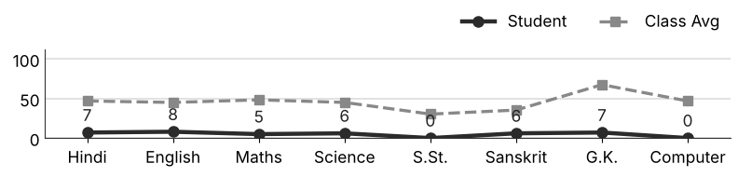
Class Teacher |  | —— Better Education ★ Brighter Future —— |  | Principal

UNIQUE CENTRAL SCHOOL
KNOWLEDGE ★ CHARACTER ★ PROGRESS
ACADEMIC SESSION : 2026 – 2027
RESULT / MARKSHEET
(P.T.1 – 40 | P.T..2 – 40 | S.A.-1 – 80 | Total – 100)
Class : IV | Section : | Roll No. : 37
Student Information  Student Name : Anmol Kumar  Father’s Name : Mr. Suman Kumar  Mother’s Name : Mrs. Anita Kumari | PHOTO  (Optional) | Result Summary
  Total Marks : | 353 / 800
  Percentage (%) : | 44.12 %
  Overall Grade : | C2
  Result : | PASS
  Rank : | 35
S.No. | Subject | Internal Assessment |  |  |  | Summative  Assessment I  (80 marks) | Total  (100 marks) | Grade
S.No. | Subject | P.T. I | P.T. II | Multiple Assessment | Subject Enrichment | Summative  Assessment I  (80 marks) | Total  (100 marks) | Grade
S.No. | Subject | (5 marks) | (5 marks) | (5 marks) | (5 marks) | Summative  Assessment I  (80 marks) | Total  (100 marks) | Grade
1 | Hindi | 1 | 3 | 3 | 4 | 40 | 51 | C1
2 | English | 0 | 5 | 4 | 3 | 43 | 55 | C1
3 | Maths | 2 | 2 | 3 | 3 | 30 | 40 | D
4 | Science | 3 | 5 | 3 | 3 | 20 | 34 | D
5 | S.St. | 2 | 2 | 3 | 2 | 15 | 24 | E
6 | Sanskrit | 1 | 1 | 2 | 2 | 9 | 15 | E
7 | G.K. | 2 | 3 | 4 | 4 | 54 | 67 | B2
8 | Computer | 0 | 2 | 4 | 4 | 57 | 67 | B2
CO-SCHOLASTIC AREAS |  |  |  |  |  |  | SCALE
Subject | Drawing | Music | Uniform | Sports | Discipline |  | GRADE | A1 | A2 | B1 | B2 | C1 | C2 | D | E
Grade | C | C | B | B | B |  | MARKS RANGE | 91-100 | 81-90 | 71-80 | 61-70 | 51-60 | 41-50 | 31-40 | Below 30
 |  |  |  |  |  |  | CO-SCH. AREAS | GRADE A  Outstanding |  | GRADE B  Very Good |  | GRADE C  Fair
Attendance  Working Days : 132  Present : 102  Absent : 30 | Teacher’s Remark  Fair performance. Needs regular practice and revision. Give more time to Sanskrit. |  | Performance Chart (Total /100 : Student vs Class Average)  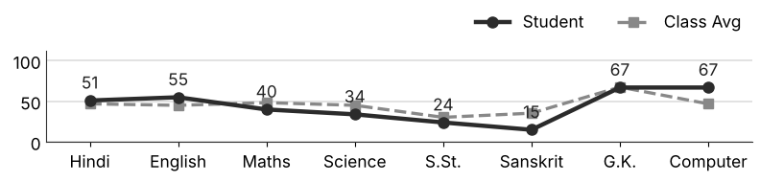
Class Teacher |  | —— Better Education ★ Brighter Future —— |  | Principal

UNIQUE CENTRAL SCHOOL
KNOWLEDGE ★ CHARACTER ★ PROGRESS
ACADEMIC SESSION : 2026 – 2027
RESULT / MARKSHEET
(P.T.1 – 40 | P.T..2 – 40 | S.A.-1 – 80 | Total – 100)
Class : IV | Section : | Roll No. : 38
Student Information  Student Name : Harsh Kumar  Father’s Name : Mr. Mandal Yadav  Mother’s Name : Mrs. Arti Devi | PHOTO  (Optional) | Result Summary
  Total Marks : | 418 / 800
  Percentage (%) : | 52.25 %
  Overall Grade : | C1
  Result : | PASS
  Rank : | 29
S.No. | Subject | Internal Assessment |  |  |  | Summative  Assessment I  (80 marks) | Total  (100 marks) | Grade
S.No. | Subject | P.T. I | P.T. II | Multiple Assessment | Subject Enrichment | Summative  Assessment I  (80 marks) | Total  (100 marks) | Grade
S.No. | Subject | (5 marks) | (5 marks) | (5 marks) | (5 marks) | Summative  Assessment I  (80 marks) | Total  (100 marks) | Grade
1 | Hindi | 1 | 2 | 3 | 3 | 45 | 54 | C1
2 | English | 3 | 4 | 4 | 4 | 57 | 72 | B1
3 | Maths | 1 | 2 | 4 | 4 | 55 | 66 | B2
4 | Science | 3 | 4 | 3 | 3 | 16 | 29 | E
5 | S.St. | 0 | 1 | 3 | 2 | 16 | 22 | E
6 | Sanskrit | 1 | 5 | 3 | 3 | 14 | 26 | E
7 | G.K. | 3 | 4 | 4 | 4 | 60 | 75 | B1
8 | Computer | 3 | 0 | 4 | 4 | 63 | 74 | B1
CO-SCHOLASTIC AREAS |  |  |  |  |  |  | SCALE
Subject | Drawing | Music | Uniform | Sports | Discipline |  | GRADE | A1 | A2 | B1 | B2 | C1 | C2 | D | E
Grade | B | B | A | B | B |  | MARKS RANGE | 91-100 | 81-90 | 71-80 | 61-70 | 51-60 | 41-50 | 31-40 | Below 30
 |  |  |  |  |  |  | CO-SCH. AREAS | GRADE A  Outstanding |  | GRADE B  Very Good |  | GRADE C  Fair
Attendance  Working Days : 132  Present : 122  Absent : 10 | Teacher’s Remark  Satisfactory performance. Needs to work harder. Give more time to S.St.. |  | Performance Chart (Total /100 : Student vs Class Average)  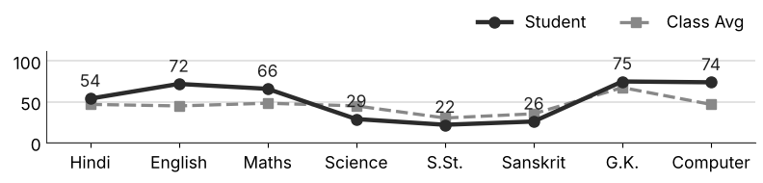
Class Teacher |  | —— Better Education ★ Brighter Future —— |  | Principal

UNIQUE CENTRAL SCHOOL
KNOWLEDGE ★ CHARACTER ★ PROGRESS
ACADEMIC SESSION : 2026 – 2027
RESULT / MARKSHEET
(P.T.1 – 40 | P.T..2 – 40 | S.A.-1 – 80 | Total – 100)
Class : IV | Section : | Roll No. : 39
Student Information  Student Name : Harsh Kumar  Father’s Name : Mr. Gudan Saw  Mother’s Name : Mrs. Rina Devi | PHOTO  (Optional) | Result Summary
  Total Marks : | 435 / 800
  Percentage (%) : | 54.38 %
  Overall Grade : | C1
  Result : | PASS
  Rank : | 25
S.No. | Subject | Internal Assessment |  |  |  | Summative  Assessment I  (80 marks) | Total  (100 marks) | Grade
S.No. | Subject | P.T. I | P.T. II | Multiple Assessment | Subject Enrichment | Summative  Assessment I  (80 marks) | Total  (100 marks) | Grade
S.No. | Subject | (5 marks) | (5 marks) | (5 marks) | (5 marks) | Summative  Assessment I  (80 marks) | Total  (100 marks) | Grade
1 | Hindi | 1 | 2 | 4 | 3 | 46 | 56 | C1
2 | English | 3 | 2 | 4 | 3 | 49 | 61 | B2
3 | Maths | 2 | 3 | 4 | 4 | 48 | 61 | B2
4 | Science | 2 | 1 | 3 | 3 | 28 | 37 | D
5 | S.St. | 0 | 1 | 2 | 2 | 24 | 29 | E
6 | Sanskrit | 0 | 2 | 2 | 2 | 18 | 24 | E
7 | G.K. | 4 | 5 | 4 | 5 | 78 | 96 | A1
8 | Computer | 2 | 0 | 4 | 3 | 62 | 71 | B1
CO-SCHOLASTIC AREAS |  |  |  |  |  |  | SCALE
Subject | Drawing | Music | Uniform | Sports | Discipline |  | GRADE | A1 | A2 | B1 | B2 | C1 | C2 | D | E
Grade | B | B | B | B | A |  | MARKS RANGE | 91-100 | 81-90 | 71-80 | 61-70 | 51-60 | 41-50 | 31-40 | Below 30
 |  |  |  |  |  |  | CO-SCH. AREAS | GRADE A  Outstanding |  | GRADE B  Very Good |  | GRADE C  Fair
Attendance  Working Days : 132  Present : 113  Absent : 19 | Teacher’s Remark  Satisfactory performance. Needs to work harder. Give more time to Sanskrit. |  | Performance Chart (Total /100 : Student vs Class Average)  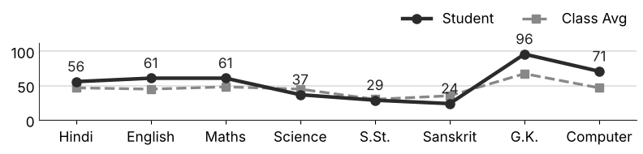
Class Teacher |  | —— Better Education ★ Brighter Future —— |  | Principal

UNIQUE CENTRAL SCHOOL
KNOWLEDGE ★ CHARACTER ★ PROGRESS
ACADEMIC SESSION : 2026 – 2027
RESULT / MARKSHEET
(P.T.1 – 40 | P.T..2 – 40 | S.A.-1 – 80 | Total – 100)
Class : IV | Section : | Roll No. : 40
Student Information  Student Name : Harsh Raj Patel  Father’s Name : Mr. Ranjan Kumar  Mother’s Name : Mrs. Khusboo Kumari | PHOTO  (Optional) | Result Summary
  Total Marks : | 460 / 800
  Percentage (%) : | 57.50 %
  Overall Grade : | C1
  Result : | PASS
  Rank : | 21
S.No. | Subject | Internal Assessment |  |  |  | Summative  Assessment I  (80 marks) | Total  (100 marks) | Grade
S.No. | Subject | P.T. I | P.T. II | Multiple Assessment | Subject Enrichment | Summative  Assessment I  (80 marks) | Total  (100 marks) | Grade
S.No. | Subject | (5 marks) | (5 marks) | (5 marks) | (5 marks) | Summative  Assessment I  (80 marks) | Total  (100 marks) | Grade
1 | Hindi | 3 | 3 | 4 | 4 | 47 | 61 | B2
2 | English | 3 | 5 | 3 | 3 | 27 | 41 | C2
3 | Maths | 4 | 2 | 4 | 4 | 53 | 67 | B2
4 | Science | 3 | 4 | 3 | 3 | 20 | 33 | D
5 | S.St. | 1 | 3 | 4 | 4 | 52 | 64 | B2
6 | Sanskrit | 1 | 3 | 4 | 4 | 41 | 53 | C1
7 | G.K. | 4 | 4 | 5 | 4 | 62 | 79 | B1
8 | Computer | 3 | 4 | 4 | 4 | 47 | 62 | B2
CO-SCHOLASTIC AREAS |  |  |  |  |  |  | SCALE
Subject | Drawing | Music | Uniform | Sports | Discipline |  | GRADE | A1 | A2 | B1 | B2 | C1 | C2 | D | E
Grade | B | B | B | B | B |  | MARKS RANGE | 91-100 | 81-90 | 71-80 | 61-70 | 51-60 | 41-50 | 31-40 | Below 30
 |  |  |  |  |  |  | CO-SCH. AREAS | GRADE A  Outstanding |  | GRADE B  Very Good |  | GRADE C  Fair
Attendance  Working Days : 132  Present : 99  Absent : 33 | Teacher’s Remark  Satisfactory performance. Needs to work harder. Attendance must improve. |  | Performance Chart (Total /100 : Student vs Class Average)  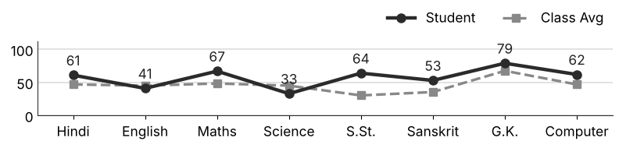
Class Teacher |  | —— Better Education ★ Brighter Future —— |  | Principal

UNIQUE CENTRAL SCHOOL
KNOWLEDGE ★ CHARACTER ★ PROGRESS
ACADEMIC SESSION : 2026 – 2027
RESULT / MARKSHEET
(P.T.1 – 40 | P.T..2 – 40 | S.A.-1 – 80 | Total – 100)
Class : IV | Section : | Roll No. : 41
Student Information  Student Name : Mahi Kumari  Father’s Name : Mr. Dhanedar Thakur  Mother’s Name : Mrs. Rekha Devi | PHOTO  (Optional) | Result Summary
  Total Marks : | 425 / 800
  Percentage (%) : | 53.12 %
  Overall Grade : | C1
  Result : | PASS
  Rank : | 26
S.No. | Subject | Internal Assessment |  |  |  | Summative  Assessment I  (80 marks) | Total  (100 marks) | Grade
S.No. | Subject | P.T. I | P.T. II | Multiple Assessment | Subject Enrichment | Summative  Assessment I  (80 marks) | Total  (100 marks) | Grade
S.No. | Subject | (5 marks) | (5 marks) | (5 marks) | (5 marks) | Summative  Assessment I  (80 marks) | Total  (100 marks) | Grade
1 | Hindi | 2 | 0 | 3 | 3 | 54 | 62 | B2
2 | English | 3 | 0 | 3 | 4 | 38 | 48 | C2
3 | Maths | 2 | 3 | 4 | 3 | 52 | 64 | B2
4 | Science | 0 | 0 | 2 | 3 | 22 | 27 | E
5 | S.St. | 1 | 0 | 3 | 3 | 38 | 45 | C2
6 | Sanskrit | 2 | 0 | 3 | 3 | 33 | 41 | C2
7 | G.K. | 3 | 0 | 4 | 3 | 60 | 70 | B2
8 | Computer | 1 | 0 | 4 | 4 | 59 | 68 | B2
CO-SCHOLASTIC AREAS |  |  |  |  |  |  | SCALE
Subject | Drawing | Music | Uniform | Sports | Discipline |  | GRADE | A1 | A2 | B1 | B2 | C1 | C2 | D | E
Grade | B | B | B | B | B |  | MARKS RANGE | 91-100 | 81-90 | 71-80 | 61-70 | 51-60 | 41-50 | 31-40 | Below 30
 |  |  |  |  |  |  | CO-SCH. AREAS | GRADE A  Outstanding |  | GRADE B  Very Good |  | GRADE C  Fair
Attendance  Working Days : 132  Present : 123  Absent : 9 | Teacher’s Remark  Satisfactory performance. Needs to work harder. Give more time to Science. |  | Performance Chart (Total /100 : Student vs Class Average)  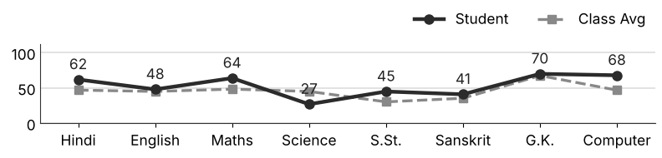
Class Teacher |  | —— Better Education ★ Brighter Future —— |  | Principal

UNIQUE CENTRAL SCHOOL
KNOWLEDGE ★ CHARACTER ★ PROGRESS
ACADEMIC SESSION : 2026 – 2027
RESULT / MARKSHEET
(P.T.1 – 40 | P.T..2 – 40 | S.A.-1 – 80 | Total – 100)
Class : IV | Section : | Roll No. : 42
Student Information  Student Name : Divya Bharti  Father’s Name : Mr. Prabhu Kumar  Mother’s Name : Mrs. Pushpa Bharti | PHOTO  (Optional) | Result Summary
  Total Marks : | 516 / 800
  Percentage (%) : | 64.50 %
  Overall Grade : | B2
  Result : | PASS
  Rank : | 13
S.No. | Subject | Internal Assessment |  |  |  | Summative  Assessment I  (80 marks) | Total  (100 marks) | Grade
S.No. | Subject | P.T. I | P.T. II | Multiple Assessment | Subject Enrichment | Summative  Assessment I  (80 marks) | Total  (100 marks) | Grade
S.No. | Subject | (5 marks) | (5 marks) | (5 marks) | (5 marks) | Summative  Assessment I  (80 marks) | Total  (100 marks) | Grade
1 | Hindi | 3 | 3 | 4 | 4 | 59 | 73 | B1
2 | English | 4 | 2 | 4 | 4 | 52 | 66 | B2
3 | Maths | 3 | 2 | 4 | 5 | 60 | 74 | B1
4 | Science | 0 | 2 | 3 | 3 | 39 | 47 | C2
5 | S.St. | 1 | 1 | 3 | 3 | 41 | 49 | C2
6 | Sanskrit | 3 | 2 | 4 | 4 | 35 | 48 | C2
7 | G.K. | 4 | 2 | 4 | 5 | 68 | 83 | A2
8 | Computer | 0 | 3 | 4 | 4 | 65 | 76 | B1
CO-SCHOLASTIC AREAS |  |  |  |  |  |  | SCALE
Subject | Drawing | Music | Uniform | Sports | Discipline |  | GRADE | A1 | A2 | B1 | B2 | C1 | C2 | D | E
Grade | A | A | A | A | A |  | MARKS RANGE | 91-100 | 81-90 | 71-80 | 61-70 | 51-60 | 41-50 | 31-40 | Below 30
 |  |  |  |  |  |  | CO-SCH. AREAS | GRADE A  Outstanding |  | GRADE B  Very Good |  | GRADE C  Fair
Attendance  Working Days : 132  Present : 125  Absent : 7 | Teacher’s Remark  Good performance. More practice can make it better. Give more time to Science. |  | Performance Chart (Total /100 : Student vs Class Average)  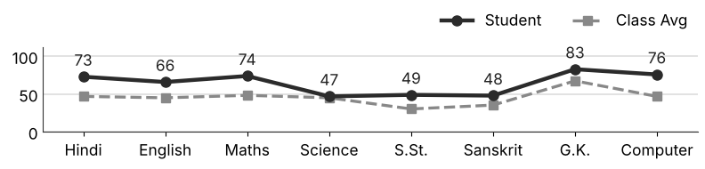
Class Teacher |  | —— Better Education ★ Brighter Future —— |  | Principal

UNIQUE CENTRAL SCHOOL
KNOWLEDGE ★ CHARACTER ★ PROGRESS
ACADEMIC SESSION : 2026 – 2027
RESULT / MARKSHEET
(P.T.1 – 40 | P.T..2 – 40 | S.A.-1 – 80 | Total – 100)
Class : IV | Section : | Roll No. : 43
Student Information  Student Name : Tansif Zaid  Father’s Name : Md. Ishak Alam  Mother’s Name : Mrs. Farzana Praveen | PHOTO  (Optional) | Result Summary
  Total Marks : | 322 / 800
  Percentage (%) : | 40.25 %
  Overall Grade : | D
  Result : | PASS
  Rank : | 45
S.No. | Subject | Internal Assessment |  |  |  | Summative  Assessment I  (80 marks) | Total  (100 marks) | Grade
S.No. | Subject | P.T. I | P.T. II | Multiple Assessment | Subject Enrichment | Summative  Assessment I  (80 marks) | Total  (100 marks) | Grade
S.No. | Subject | (5 marks) | (5 marks) | (5 marks) | (5 marks) | Summative  Assessment I  (80 marks) | Total  (100 marks) | Grade
1 | Hindi | 1 | 3 | 3 | 3 | 15 | 25 | E
2 | English | 1 | 5 | 3 | 3 | 6 | 18 | E
3 | Maths | 3 | 3 | 4 | 3 | 37 | 50 | C2
4 | Science | 3 | 3 | 4 | 4 | 29 | 43 | C2
5 | S.St. | 2 | 0 | 3 | 3 | 28 | 36 | D
6 | Sanskrit | 4 | 0 | 3 | 3 | 15 | 25 | E
7 | G.K. | 1 | 5 | 3 | 4 | 50 | 63 | B2
8 | Computer | 0 | 1 | 3 | 3 | 55 | 62 | B2
CO-SCHOLASTIC AREAS |  |  |  |  |  |  | SCALE
Subject | Drawing | Music | Uniform | Sports | Discipline |  | GRADE | A1 | A2 | B1 | B2 | C1 | C2 | D | E
Grade | C | C | C | C | B |  | MARKS RANGE | 91-100 | 81-90 | 71-80 | 61-70 | 51-60 | 41-50 | 31-40 | Below 30
 |  |  |  |  |  |  | CO-SCH. AREAS | GRADE A  Outstanding |  | GRADE B  Very Good |  | GRADE C  Fair
Attendance  Working Days : 132  Present : 105  Absent : 27 | Teacher’s Remark  Fair performance. Needs regular practice and revision. Give more time to English. |  | Performance Chart (Total /100 : Student vs Class Average)  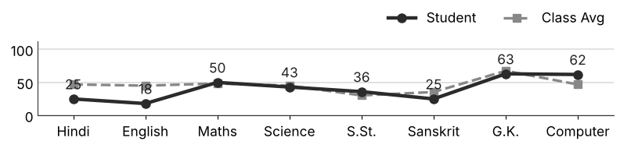
Class Teacher |  | —— Better Education ★ Brighter Future —— |  | Principal

UNIQUE CENTRAL SCHOOL
KNOWLEDGE ★ CHARACTER ★ PROGRESS
ACADEMIC SESSION : 2026 – 2027
RESULT / MARKSHEET
(P.T.1 – 40 | P.T..2 – 40 | S.A.-1 – 80 | Total – 100)
Class : IV | Section : | Roll No. : 44
Student Information  Student Name : Pallavi Kumari  Father’s Name : Mr. Salender Kumar  Mother’s Name : Mrs. Ranju Kumari | PHOTO  (Optional) | Result Summary
  Total Marks : | 343 / 800
  Percentage (%) : | 42.88 %
  Overall Grade : | C2
  Result : | PASS
  Rank : | 40
S.No. | Subject | Internal Assessment |  |  |  | Summative  Assessment I  (80 marks) | Total  (100 marks) | Grade
S.No. | Subject | P.T. I | P.T. II | Multiple Assessment | Subject Enrichment | Summative  Assessment I  (80 marks) | Total  (100 marks) | Grade
S.No. | Subject | (5 marks) | (5 marks) | (5 marks) | (5 marks) | Summative  Assessment I  (80 marks) | Total  (100 marks) | Grade
1 | Hindi | 2 | 3 | 4 | 4 | 55 | 68 | B2
2 | English | 3 | 4 | 4 | 4 | 38 | 53 | C1
3 | Maths | 2 | 3 | 4 | 4 | 32 | 45 | C2
4 | Science | 3 | 3 | 4 | 4 | 36 | 50 | C2
5 | S.St. | 1 | 2 | 3 | 3 | 10 | 19 | E
6 | Sanskrit | 3 | 2 | 3 | 2 | 14 | 24 | E
7 | G.K. | 4 | 2 | 4 | 3 | 44 | 57 | C1
8 | Computer | 1 | 2 | 2 | 2 | 20 | 27 | E
CO-SCHOLASTIC AREAS |  |  |  |  |  |  | SCALE
Subject | Drawing | Music | Uniform | Sports | Discipline |  | GRADE | A1 | A2 | B1 | B2 | C1 | C2 | D | E
Grade | B | B | B | B | B |  | MARKS RANGE | 91-100 | 81-90 | 71-80 | 61-70 | 51-60 | 41-50 | 31-40 | Below 30
 |  |  |  |  |  |  | CO-SCH. AREAS | GRADE A  Outstanding |  | GRADE B  Very Good |  | GRADE C  Fair
Attendance  Working Days : 132  Present : 126  Absent : 6 | Teacher’s Remark  Fair performance. Needs regular practice and revision. Give more time to S.St.. |  | Performance Chart (Total /100 : Student vs Class Average)  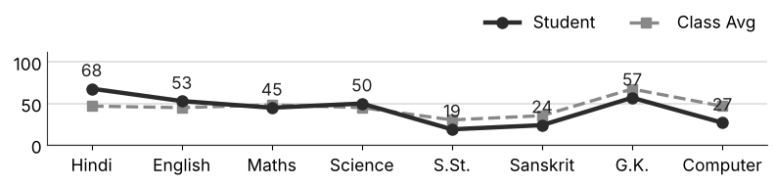
Class Teacher |  | —— Better Education ★ Brighter Future —— |  | Principal

UNIQUE CENTRAL SCHOOL
KNOWLEDGE ★ CHARACTER ★ PROGRESS
ACADEMIC SESSION : 2026 – 2027
RESULT / MARKSHEET
(P.T.1 – 40 | P.T..2 – 40 | S.A.-1 – 80 | Total – 100)
Class : IV | Section : | Roll No. : 45
Student Information  Student Name : Akash Kumar  Father’s Name : Mr. Chandan Kumar  Mother’s Name : Mrs. Poonam Devi | PHOTO  (Optional) | Result Summary
  Total Marks : | 386 / 800
  Percentage (%) : | 48.25 %
  Overall Grade : | C2
  Result : | PASS
  Rank : | 34
S.No. | Subject | Internal Assessment |  |  |  | Summative  Assessment I  (80 marks) | Total  (100 marks) | Grade
S.No. | Subject | P.T. I | P.T. II | Multiple Assessment | Subject Enrichment | Summative  Assessment I  (80 marks) | Total  (100 marks) | Grade
S.No. | Subject | (5 marks) | (5 marks) | (5 marks) | (5 marks) | Summative  Assessment I  (80 marks) | Total  (100 marks) | Grade
1 | Hindi | 1 | 2 | 4 | 3 | 37 | 47 | C2
2 | English | 3 | 4 | 4 | 4 | 40 | 55 | C1
3 | Maths | 3 | 2 | 4 | 4 | 40 | 53 | C1
4 | Science | 3 | 0 | 3 | 3 | 25 | 34 | D
5 | S.St. | 0 | 1 | 3 | 4 | 58 | 66 | B2
6 | Sanskrit | 1 | 2 | 3 | 2 | 13 | 21 | E
7 | G.K. | 2 | 3 | 4 | 4 | 58 | 71 | B1
8 | Computer | 0 | 0 | 3 | 3 | 33 | 39 | D
CO-SCHOLASTIC AREAS |  |  |  |  |  |  | SCALE
Subject | Drawing | Music | Uniform | Sports | Discipline |  | GRADE | A1 | A2 | B1 | B2 | C1 | C2 | D | E
Grade | B | B | B | B | B |  | MARKS RANGE | 91-100 | 81-90 | 71-80 | 61-70 | 51-60 | 41-50 | 31-40 | Below 30
 |  |  |  |  |  |  | CO-SCH. AREAS | GRADE A  Outstanding |  | GRADE B  Very Good |  | GRADE C  Fair
Attendance  Working Days : 132  Present : 124  Absent : 8 | Teacher’s Remark  Fair performance. Needs regular practice and revision. Give more time to Sanskrit. |  | Performance Chart (Total /100 : Student vs Class Average)  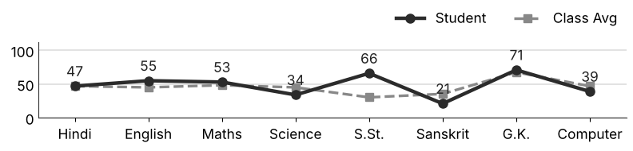
Class Teacher |  | —— Better Education ★ Brighter Future —— |  | Principal

UNIQUE CENTRAL SCHOOL
KNOWLEDGE ★ CHARACTER ★ PROGRESS
ACADEMIC SESSION : 2026 – 2027
RESULT / MARKSHEET
(P.T.1 – 40 | P.T..2 – 40 | S.A.-1 – 80 | Total – 100)
Class : IV | Section : | Roll No. : 46
Student Information  Student Name : Bishnu Kumar  Father’s Name : Mr. Pawan Saw  Mother’s Name : Mrs. Kavita Devi | PHOTO  (Optional) | Result Summary
  Total Marks : | 421 / 800
  Percentage (%) : | 52.62 %
  Overall Grade : | C1
  Result : | PASS
  Rank : | 27
S.No. | Subject | Internal Assessment |  |  |  | Summative  Assessment I  (80 marks) | Total  (100 marks) | Grade
S.No. | Subject | P.T. I | P.T. II | Multiple Assessment | Subject Enrichment | Summative  Assessment I  (80 marks) | Total  (100 marks) | Grade
S.No. | Subject | (5 marks) | (5 marks) | (5 marks) | (5 marks) | Summative  Assessment I  (80 marks) | Total  (100 marks) | Grade
1 | Hindi | 1 | 2 | 3 | 3 | 30 | 39 | D
2 | English | 2 | 4 | 3 | 3 | 42 | 54 | C1
3 | Maths | 4 | 3 | 3 | 4 | 40 | 54 | C1
4 | Science | 2 | 0 | 3 | 3 | 34 | 42 | C2
5 | S.St. | 1 | 0 | 4 | 3 | 52 | 60 | C1
6 | Sanskrit | 3 | 1 | 3 | 3 | 19 | 29 | E
7 | G.K. | 3 | 3 | 4 | 4 | 66 | 80 | B1
8 | Computer | 1 | 1 | 4 | 3 | 54 | 63 | B2
CO-SCHOLASTIC AREAS |  |  |  |  |  |  | SCALE
Subject | Drawing | Music | Uniform | Sports | Discipline |  | GRADE | A1 | A2 | B1 | B2 | C1 | C2 | D | E
Grade | B | B | A | B | B |  | MARKS RANGE | 91-100 | 81-90 | 71-80 | 61-70 | 51-60 | 41-50 | 31-40 | Below 30
 |  |  |  |  |  |  | CO-SCH. AREAS | GRADE A  Outstanding |  | GRADE B  Very Good |  | GRADE C  Fair
Attendance  Working Days : 132  Present : 129  Absent : 3 | Teacher’s Remark  Satisfactory performance. Needs to work harder. Give more time to Sanskrit. |  | Performance Chart (Total /100 : Student vs Class Average)  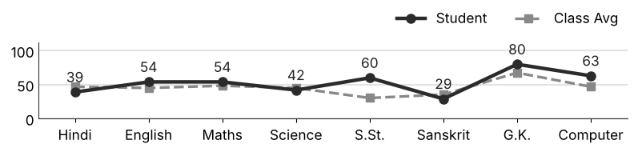
Class Teacher |  | —— Better Education ★ Brighter Future —— |  | Principal

UNIQUE CENTRAL SCHOOL
KNOWLEDGE ★ CHARACTER ★ PROGRESS
ACADEMIC SESSION : 2026 – 2027
RESULT / MARKSHEET
(P.T.1 – 40 | P.T..2 – 40 | S.A.-1 – 80 | Total – 100)
Class : IV | Section : | Roll No. : 47
Student Information  Student Name : Lucky Raj  Father’s Name : Mr. Raj Kishwar Prashad  Mother’s Name : Mrs. Nikki Devi | PHOTO  (Optional) | Result Summary
  Total Marks : | 272 / 800
  Percentage (%) : | 34.00 %
  Overall Grade : | D
  Result : | PASS
  Rank : | 57
S.No. | Subject | Internal Assessment |  |  |  | Summative  Assessment I  (80 marks) | Total  (100 marks) | Grade
S.No. | Subject | P.T. I | P.T. II | Multiple Assessment | Subject Enrichment | Summative  Assessment I  (80 marks) | Total  (100 marks) | Grade
S.No. | Subject | (5 marks) | (5 marks) | (5 marks) | (5 marks) | Summative  Assessment I  (80 marks) | Total  (100 marks) | Grade
1 | Hindi | 1 | 3 | 3 | 3 | 28 | 38 | D
2 | English | 2 | 1 | 3 | 3 | 12 | 21 | E
3 | Maths | 2 | 2 | 3 | 3 | 26 | 36 | D
4 | Science | 1 | 0 | 4 | 3 | 59 | 67 | B2
5 | S.St. | 0 | 0 | 2 | 2 | 17 | 21 | E
6 | Sanskrit | 1 | 0 | 2 | 2 | 7 | 12 | E
7 | G.K. | 2 | 3 | 4 | 3 | 36 | 48 | C2
8 | Computer | 1 | 0 | 3 | 2 | 23 | 29 | E
CO-SCHOLASTIC AREAS |  |  |  |  |  |  | SCALE
Subject | Drawing | Music | Uniform | Sports | Discipline |  | GRADE | A1 | A2 | B1 | B2 | C1 | C2 | D | E
Grade | C | C | C | C | C |  | MARKS RANGE | 91-100 | 81-90 | 71-80 | 61-70 | 51-60 | 41-50 | 31-40 | Below 30
 |  |  |  |  |  |  | CO-SCH. AREAS | GRADE A  Outstanding |  | GRADE B  Very Good |  | GRADE C  Fair
Attendance  Working Days : 132  Present : 66  Absent : 66 | Teacher’s Remark  Needs improvement. Should study regularly at home. Attendance must improve. |  | Performance Chart (Total /100 : Student vs Class Average)  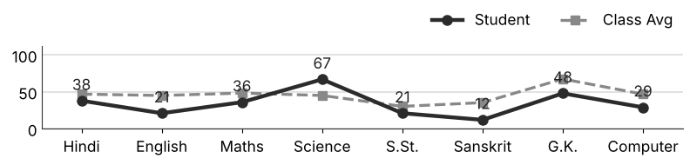
Class Teacher |  | —— Better Education ★ Brighter Future —— |  | Principal

UNIQUE CENTRAL SCHOOL
KNOWLEDGE ★ CHARACTER ★ PROGRESS
ACADEMIC SESSION : 2026 – 2027
RESULT / MARKSHEET
(P.T.1 – 40 | P.T..2 – 40 | S.A.-1 – 80 | Total – 100)
Class : IV | Section : | Roll No. : 48
Student Information  Student Name : Riya Raj  Father’s Name : Mr. Ganesh Kumar  Mother’s Name : Mrs. Vibha Kumari | PHOTO  (Optional) | Result Summary
  Total Marks : | 456 / 800
  Percentage (%) : | 57.00 %
  Overall Grade : | C1
  Result : | PASS
  Rank : | 22
S.No. | Subject | Internal Assessment |  |  |  | Summative  Assessment I  (80 marks) | Total  (100 marks) | Grade
S.No. | Subject | P.T. I | P.T. II | Multiple Assessment | Subject Enrichment | Summative  Assessment I  (80 marks) | Total  (100 marks) | Grade
S.No. | Subject | (5 marks) | (5 marks) | (5 marks) | (5 marks) | Summative  Assessment I  (80 marks) | Total  (100 marks) | Grade
1 | Hindi | 3 | 3 | 4 | 4 | 54 | 68 | B2
2 | English | 0 | 4 | 4 | 4 | 57 | 69 | B2
3 | Maths | 3 | 3 | 3 | 3 | 32 | 44 | C2
4 | Science | 2 | 4 | 3 | 4 | 49 | 62 | B2
5 | S.St. | 1 | 1 | 2 | 2 | 17 | 23 | E
6 | Sanskrit | 2 | 3 | 3 | 4 | 41 | 53 | C1
7 | G.K. | 0 | 0 | 4 | 4 | 70 | 78 | B1
8 | Computer | 2 | 0 | 3 | 4 | 50 | 59 | C1
CO-SCHOLASTIC AREAS |  |  |  |  |  |  | SCALE
Subject | Drawing | Music | Uniform | Sports | Discipline |  | GRADE | A1 | A2 | B1 | B2 | C1 | C2 | D | E
Grade | B | B | B | B | B |  | MARKS RANGE | 91-100 | 81-90 | 71-80 | 61-70 | 51-60 | 41-50 | 31-40 | Below 30
 |  |  |  |  |  |  | CO-SCH. AREAS | GRADE A  Outstanding |  | GRADE B  Very Good |  | GRADE C  Fair
Attendance  Working Days : 132  Present : 85  Absent : 47 | Teacher’s Remark  Satisfactory performance. Needs to work harder. Attendance must improve. |  | Performance Chart (Total /100 : Student vs Class Average)  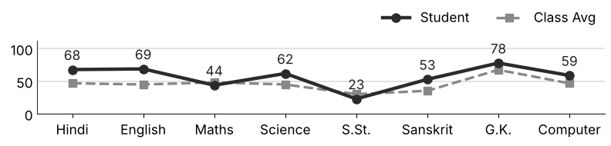
Class Teacher |  | —— Better Education ★ Brighter Future —— |  | Principal

UNIQUE CENTRAL SCHOOL
KNOWLEDGE ★ CHARACTER ★ PROGRESS
ACADEMIC SESSION : 2026 – 2027
RESULT / MARKSHEET
(P.T.1 – 40 | P.T..2 – 40 | S.A.-1 – 80 | Total – 100)
Class : IV | Section : | Roll No. : 49
Student Information  Student Name : Chohat Praveen  Father’s Name : Md. Saddam  Mother’s Name : Mrs. Sakila Khatun | PHOTO  (Optional) | Result Summary
  Total Marks : | 292 / 800
  Percentage (%) : | 36.50 %
  Overall Grade : | D
  Result : | PASS
  Rank : | 53
S.No. | Subject | Internal Assessment |  |  |  | Summative  Assessment I  (80 marks) | Total  (100 marks) | Grade
S.No. | Subject | P.T. I | P.T. II | Multiple Assessment | Subject Enrichment | Summative  Assessment I  (80 marks) | Total  (100 marks) | Grade
S.No. | Subject | (5 marks) | (5 marks) | (5 marks) | (5 marks) | Summative  Assessment I  (80 marks) | Total  (100 marks) | Grade
1 | Hindi | 0 | 3 | 4 | 3 | 38 | 48 | C2
2 | English | 3 | 0 | 3 | 3 | 11 | 20 | E
3 | Maths | 0 | 2 | 2 | 3 | 25 | 32 | D
4 | Science | 0 | 2 | 3 | 3 | 38 | 46 | C2
5 | S.St. | 0 | 0 | 2 | 2 | 13 | 17 | E
6 | Sanskrit | 0 | 0 | 3 | 3 | 47 | 53 | C1
7 | G.K. | 1 | 2 | 3 | 3 | 44 | 53 | C1
8 | Computer | 0 | 1 | 2 | 3 | 17 | 23 | E
CO-SCHOLASTIC AREAS |  |  |  |  |  |  | SCALE
Subject | Drawing | Music | Uniform | Sports | Discipline |  | GRADE | A1 | A2 | B1 | B2 | C1 | C2 | D | E
Grade | C | C | B | C | B |  | MARKS RANGE | 91-100 | 81-90 | 71-80 | 61-70 | 51-60 | 41-50 | 31-40 | Below 30
 |  |  |  |  |  |  | CO-SCH. AREAS | GRADE A  Outstanding |  | GRADE B  Very Good |  | GRADE C  Fair
Attendance  Working Days : 132  Present : 126  Absent : 6 | Teacher’s Remark  Needs improvement. Should study regularly at home. Give more time to S.St.. |  | Performance Chart (Total /100 : Student vs Class Average)  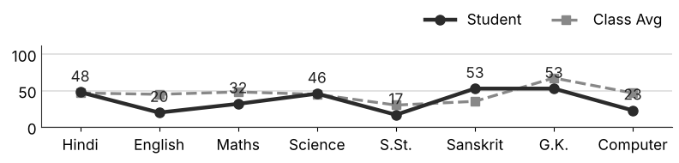
Class Teacher |  | —— Better Education ★ Brighter Future —— |  | Principal

UNIQUE CENTRAL SCHOOL
KNOWLEDGE ★ CHARACTER ★ PROGRESS
ACADEMIC SESSION : 2026 – 2027
RESULT / MARKSHEET
(P.T.1 – 40 | P.T..2 – 40 | S.A.-1 – 80 | Total – 100)
Class : IV | Section : | Roll No. : 50
Student Information  Student Name : Ansh Kumar  Father’s Name : Mr. Bishnath Kumar  Mother’s Name : Mrs. Renu Devi | PHOTO  (Optional) | Result Summary
  Total Marks : | 344 / 800
  Percentage (%) : | 43.00 %
  Overall Grade : | C2
  Result : | PASS
  Rank : | 38
S.No. | Subject | Internal Assessment |  |  |  | Summative  Assessment I  (80 marks) | Total  (100 marks) | Grade
S.No. | Subject | P.T. I | P.T. II | Multiple Assessment | Subject Enrichment | Summative  Assessment I  (80 marks) | Total  (100 marks) | Grade
S.No. | Subject | (5 marks) | (5 marks) | (5 marks) | (5 marks) | Summative  Assessment I  (80 marks) | Total  (100 marks) | Grade
1 | Hindi | 1 | 2 | 3 | 3 | 28 | 37 | D
2 | English | 4 | 4 | 3 | 3 | 24 | 38 | D
3 | Maths | 2 | 2 | 4 | 4 | 38 | 50 | C2
4 | Science | 1 | 1 | 3 | 4 | 50 | 59 | C1
5 | S.St. | 0 | 1 | 3 | 2 | 14 | 20 | E
6 | Sanskrit | 1 | 1 | 3 | 3 | 17 | 25 | E
7 | G.K. | 2 | 4 | 4 | 4 | 60 | 74 | B1
8 | Computer | 3 | 4 | 4 | 3 | 27 | 41 | C2
CO-SCHOLASTIC AREAS |  |  |  |  |  |  | SCALE
Subject | Drawing | Music | Uniform | Sports | Discipline |  | GRADE | A1 | A2 | B1 | B2 | C1 | C2 | D | E
Grade | C | C | B | B | B |  | MARKS RANGE | 91-100 | 81-90 | 71-80 | 61-70 | 51-60 | 41-50 | 31-40 | Below 30
 |  |  |  |  |  |  | CO-SCH. AREAS | GRADE A  Outstanding |  | GRADE B  Very Good |  | GRADE C  Fair
Attendance  Working Days : 132  Present : 106  Absent : 26 | Teacher’s Remark  Fair performance. Needs regular practice and revision. Give more time to S.St.. |  | Performance Chart (Total /100 : Student vs Class Average)  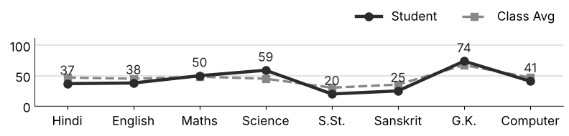
Class Teacher |  | —— Better Education ★ Brighter Future —— |  | Principal

UNIQUE CENTRAL SCHOOL
KNOWLEDGE ★ CHARACTER ★ PROGRESS
ACADEMIC SESSION : 2026 – 2027
RESULT / MARKSHEET
(P.T.1 – 40 | P.T..2 – 40 | S.A.-1 – 80 | Total – 100)
Class : IV | Section : | Roll No. : 51
Student Information  Student Name : Ritik Raushan  Father’s Name : Mr. Mukesh Kumar  Mother’s Name : Mrs. Mamta Devi | PHOTO  (Optional) | Result Summary
  Total Marks : | 279 / 800
  Percentage (%) : | 34.88 %
  Overall Grade : | D
  Result : | PASS
  Rank : | 55
S.No. | Subject | Internal Assessment |  |  |  | Summative  Assessment I  (80 marks) | Total  (100 marks) | Grade
S.No. | Subject | P.T. I | P.T. II | Multiple Assessment | Subject Enrichment | Summative  Assessment I  (80 marks) | Total  (100 marks) | Grade
S.No. | Subject | (5 marks) | (5 marks) | (5 marks) | (5 marks) | Summative  Assessment I  (80 marks) | Total  (100 marks) | Grade
1 | Hindi | 0 | 0 | 2 | 2 | 24 | 28 | E
2 | English | 0 | 0 | 3 | 3 | 23 | 29 | E
3 | Maths | 2 | 1 | 3 | 3 | 20 | 29 | E
4 | Science | 2 | 2 | 3 | 4 | 40 | 51 | C1
5 | S.St. | 0 | 0 | 3 | 3 | 43 | 49 | C2
6 | Sanskrit | 2 | 3 | 3 | 2 | 5 | 15 | E
7 | G.K. | 0 | 0 | 3 | 3 | 56 | 62 | B2
8 | Computer | 0 | 0 | 2 | 2 | 12 | 16 | E
CO-SCHOLASTIC AREAS |  |  |  |  |  |  | SCALE
Subject | Drawing | Music | Uniform | Sports | Discipline |  | GRADE | A1 | A2 | B1 | B2 | C1 | C2 | D | E
Grade | C | C | B | C | C |  | MARKS RANGE | 91-100 | 81-90 | 71-80 | 61-70 | 51-60 | 41-50 | 31-40 | Below 30
 |  |  |  |  |  |  | CO-SCH. AREAS | GRADE A  Outstanding |  | GRADE B  Very Good |  | GRADE C  Fair
Attendance  Working Days : 132  Present : 107  Absent : 25 | Teacher’s Remark  Needs improvement. Should study regularly at home. Give more time to Sanskrit. |  | Performance Chart (Total /100 : Student vs Class Average)  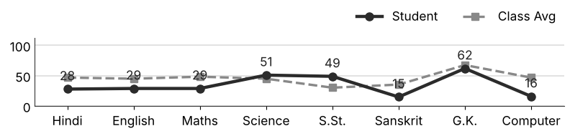
Class Teacher |  | —— Better Education ★ Brighter Future —— |  | Principal

UNIQUE CENTRAL SCHOOL
KNOWLEDGE ★ CHARACTER ★ PROGRESS
ACADEMIC SESSION : 2026 – 2027
RESULT / MARKSHEET
(P.T.1 – 40 | P.T..2 – 40 | S.A.-1 – 80 | Total – 100)
Class : IV | Section : | Roll No. : 52
Student Information  Student Name : Aryan Kumar  Father’s Name : Mr. Santosh Kumar  Mother’s Name : Mrs. Soni Kumari | PHOTO  (Optional) | Result Summary
  Total Marks : | 278 / 800
  Percentage (%) : | 34.75 %
  Overall Grade : | D
  Result : | PASS
  Rank : | 56
S.No. | Subject | Internal Assessment |  |  |  | Summative  Assessment I  (80 marks) | Total  (100 marks) | Grade
S.No. | Subject | P.T. I | P.T. II | Multiple Assessment | Subject Enrichment | Summative  Assessment I  (80 marks) | Total  (100 marks) | Grade
S.No. | Subject | (5 marks) | (5 marks) | (5 marks) | (5 marks) | Summative  Assessment I  (80 marks) | Total  (100 marks) | Grade
1 | Hindi | 0 | 3 | 3 | 3 | 24 | 33 | D
2 | English | 0 | 3 | 2 | 2 | 18 | 25 | E
3 | Maths | 2 | 2 | 3 | 3 | 30 | 40 | D
4 | Science | 0 | 4 | 3 | 3 | 34 | 44 | C2
5 | S.St. | 1 | 0 | 2 | 3 | 8 | 14 | E
6 | Sanskrit | 1 | 2 | 3 | 3 | 24 | 33 | D
7 | G.K. | 0 | 1 | 3 | 3 | 54 | 61 | B2
8 | Computer | 0 | 1 | 3 | 3 | 21 | 28 | E
CO-SCHOLASTIC AREAS |  |  |  |  |  |  | SCALE
Subject | Drawing | Music | Uniform | Sports | Discipline |  | GRADE | A1 | A2 | B1 | B2 | C1 | C2 | D | E
Grade | C | C | B | B | B |  | MARKS RANGE | 91-100 | 81-90 | 71-80 | 61-70 | 51-60 | 41-50 | 31-40 | Below 30
 |  |  |  |  |  |  | CO-SCH. AREAS | GRADE A  Outstanding |  | GRADE B  Very Good |  | GRADE C  Fair
Attendance  Working Days : 132  Present : 110  Absent : 22 | Teacher’s Remark  Needs improvement. Should study regularly at home. Give more time to S.St.. |  | Performance Chart (Total /100 : Student vs Class Average)  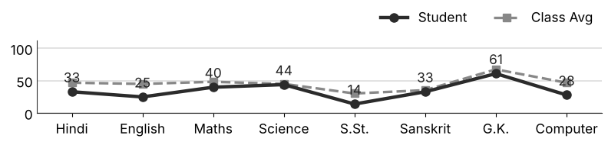
Class Teacher |  | —— Better Education ★ Brighter Future —— |  | Principal

UNIQUE CENTRAL SCHOOL
KNOWLEDGE ★ CHARACTER ★ PROGRESS
ACADEMIC SESSION : 2026 – 2027
RESULT / MARKSHEET
(P.T.1 – 40 | P.T..2 – 40 | S.A.-1 – 80 | Total – 100)
Class : IV | Section : | Roll No. : 53
Student Information  Student Name : Ankita Kumari  Father’s Name : Mr. Ravishankar Saw  Mother’s Name : Mrs. Kriti Kumari | PHOTO  (Optional) | Result Summary
  Total Marks : | 216 / 800
  Percentage (%) : | 27.00 %
  Overall Grade : | E
  Result : | FAIL
  Rank : | 64
S.No. | Subject | Internal Assessment |  |  |  | Summative  Assessment I  (80 marks) | Total  (100 marks) | Grade
S.No. | Subject | P.T. I | P.T. II | Multiple Assessment | Subject Enrichment | Summative  Assessment I  (80 marks) | Total  (100 marks) | Grade
S.No. | Subject | (5 marks) | (5 marks) | (5 marks) | (5 marks) | Summative  Assessment I  (80 marks) | Total  (100 marks) | Grade
1 | Hindi | 1 | 2 | 3 | 3 | 33 | 42 | C2
2 | English | 0 | 5 | 3 | 2 | 1 | 11 | E
3 | Maths | 2 | 2 | 3 | 3 | 26 | 36 | D
4 | Science | 0 | 0 | 3 | 2 | 26 | 31 | D
5 | S.St. | 1 | 0 | 2 | 2 | 4 | 9 | E
6 | Sanskrit | 1 | 1 | 3 | 2 | 15 | 22 | E
7 | G.K. | 0 | 3 | 3 | 3 | 30 | 39 | D
8 | Computer | 0 | 1 | 2 | 3 | 20 | 26 | E
CO-SCHOLASTIC AREAS |  |  |  |  |  |  | SCALE
Subject | Drawing | Music | Uniform | Sports | Discipline |  | GRADE | A1 | A2 | B1 | B2 | C1 | C2 | D | E
Grade | C | C | C | C | C |  | MARKS RANGE | 91-100 | 81-90 | 71-80 | 61-70 | 51-60 | 41-50 | 31-40 | Below 30
 |  |  |  |  |  |  | CO-SCH. AREAS | GRADE A  Outstanding |  | GRADE B  Very Good |  | GRADE C  Fair
Attendance  Working Days : 132  Present : 102  Absent : 30 | Teacher’s Remark  Weak performance. Needs special attention and practice. Give more time to S.St.. |  | Performance Chart (Total /100 : Student vs Class Average)  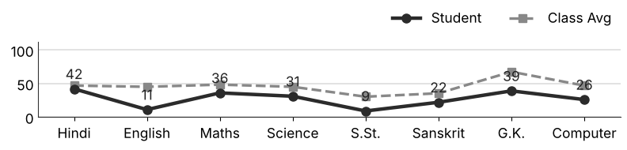
Class Teacher |  | —— Better Education ★ Brighter Future —— |  | Principal

UNIQUE CENTRAL SCHOOL
KNOWLEDGE ★ CHARACTER ★ PROGRESS
ACADEMIC SESSION : 2026 – 2027
RESULT / MARKSHEET
(P.T.1 – 40 | P.T..2 – 40 | S.A.-1 – 80 | Total – 100)
Class : IV | Section : | Roll No. : 54
Student Information  Student Name : Lucky Raj  Father’s Name : Mr. Rajesh Raj  Mother’s Name : Mrs. Rekha Kumari | PHOTO  (Optional) | Result Summary
  Total Marks : | 344 / 800
  Percentage (%) : | 43.00 %
  Overall Grade : | C2
  Result : | PASS
  Rank : | 38
S.No. | Subject | Internal Assessment |  |  |  | Summative  Assessment I  (80 marks) | Total  (100 marks) | Grade
S.No. | Subject | P.T. I | P.T. II | Multiple Assessment | Subject Enrichment | Summative  Assessment I  (80 marks) | Total  (100 marks) | Grade
S.No. | Subject | (5 marks) | (5 marks) | (5 marks) | (5 marks) | Summative  Assessment I  (80 marks) | Total  (100 marks) | Grade
1 | Hindi | 2 | 4 | 3 | 4 | 25 | 38 | D
2 | English | 4 | 5 | 3 | 4 | 28 | 44 | C2
3 | Maths | 3 | 3 | 4 | 3 | 45 | 58 | C1
4 | Science | 2 | 1 | 4 | 4 | 52 | 63 | B2
5 | S.St. | 1 | 2 | 3 | 2 | 5 | 13 | E
6 | Sanskrit | 3 | 3 | 3 | 4 | 23 | 36 | D
7 | G.K. | 2 | 4 | 3 | 4 | 44 | 57 | C1
8 | Computer | 4 | 2 | 3 | 3 | 23 | 35 | D
CO-SCHOLASTIC AREAS |  |  |  |  |  |  | SCALE
Subject | Drawing | Music | Uniform | Sports | Discipline |  | GRADE | A1 | A2 | B1 | B2 | C1 | C2 | D | E
Grade | B | C | B | B | B |  | MARKS RANGE | 91-100 | 81-90 | 71-80 | 61-70 | 51-60 | 41-50 | 31-40 | Below 30
 |  |  |  |  |  |  | CO-SCH. AREAS | GRADE A  Outstanding |  | GRADE B  Very Good |  | GRADE C  Fair
Attendance  Working Days : 132  Present : 123  Absent : 9 | Teacher’s Remark  Fair performance. Needs regular practice and revision. Give more time to S.St.. |  | Performance Chart (Total /100 : Student vs Class Average)  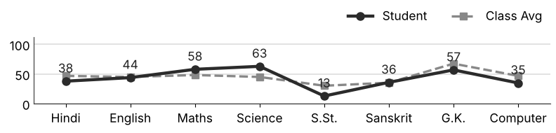
Class Teacher |  | —— Better Education ★ Brighter Future —— |  | Principal

UNIQUE CENTRAL SCHOOL
KNOWLEDGE ★ CHARACTER ★ PROGRESS
ACADEMIC SESSION : 2026 – 2027
RESULT / MARKSHEET
(P.T.1 – 40 | P.T..2 – 40 | S.A.-1 – 80 | Total – 100)
Class : IV | Section : | Roll No. : 55
Student Information  Student Name : Aditya Raj  Father’s Name : Mr. Arun Kumar  Mother’s Name : Mrs. Priyanka Kumari | PHOTO  (Optional) | Result Summary
  Total Marks : | 264 / 800
  Percentage (%) : | 33.00 %
  Overall Grade : | D
  Result : | PASS
  Rank : | 59
S.No. | Subject | Internal Assessment |  |  |  | Summative  Assessment I  (80 marks) | Total  (100 marks) | Grade
S.No. | Subject | P.T. I | P.T. II | Multiple Assessment | Subject Enrichment | Summative  Assessment I  (80 marks) | Total  (100 marks) | Grade
S.No. | Subject | (5 marks) | (5 marks) | (5 marks) | (5 marks) | Summative  Assessment I  (80 marks) | Total  (100 marks) | Grade
1 | Hindi | 1 | 2 | 3 | 3 | 43 | 52 | C1
2 | English | 0 | 0 | 2 | 2 | 6 | 10 | E
3 | Maths | 1 | 2 | 3 | 3 | 20 | 29 | E
4 | Science | 1 | 1 | 3 | 3 | 22 | 30 | E
5 | S.St. | 0 | 1 | 2 | 2 | 8 | 13 | E
6 | Sanskrit | 1 | 0 | 3 | 3 | 14 | 21 | E
7 | G.K. | 0 | 0 | 3 | 3 | 52 | 58 | C1
8 | Computer | 0 | 0 | 3 | 3 | 45 | 51 | C1
CO-SCHOLASTIC AREAS |  |  |  |  |  |  | SCALE
Subject | Drawing | Music | Uniform | Sports | Discipline |  | GRADE | A1 | A2 | B1 | B2 | C1 | C2 | D | E
Grade | C | C | B | C | B |  | MARKS RANGE | 91-100 | 81-90 | 71-80 | 61-70 | 51-60 | 41-50 | 31-40 | Below 30
 |  |  |  |  |  |  | CO-SCH. AREAS | GRADE A  Outstanding |  | GRADE B  Very Good |  | GRADE C  Fair
Attendance  Working Days : 132  Present : 112  Absent : 20 | Teacher’s Remark  Needs improvement. Should study regularly at home. Give more time to English. |  | Performance Chart (Total /100 : Student vs Class Average)  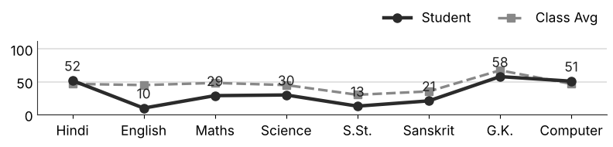
Class Teacher |  | —— Better Education ★ Brighter Future —— |  | Principal

UNIQUE CENTRAL SCHOOL
KNOWLEDGE ★ CHARACTER ★ PROGRESS
ACADEMIC SESSION : 2026 – 2027
RESULT / MARKSHEET
(P.T.1 – 40 | P.T..2 – 40 | S.A.-1 – 80 | Total – 100)
Class : IV | Section : | Roll No. : 56
Student Information  Student Name : Aman Kumar  Father’s Name : Mr. Dilip Kumar  Mother’s Name : Mrs. Rinku Devi | PHOTO  (Optional) | Result Summary
  Total Marks : | 187 / 800
  Percentage (%) : | 23.38 %
  Overall Grade : | E
  Result : | FAIL
  Rank : | 70
S.No. | Subject | Internal Assessment |  |  |  | Summative  Assessment I  (80 marks) | Total  (100 marks) | Grade
S.No. | Subject | P.T. I | P.T. II | Multiple Assessment | Subject Enrichment | Summative  Assessment I  (80 marks) | Total  (100 marks) | Grade
S.No. | Subject | (5 marks) | (5 marks) | (5 marks) | (5 marks) | Summative  Assessment I  (80 marks) | Total  (100 marks) | Grade
1 | Hindi | 1 | 2 | 2 | 3 | 15 | 23 | E
2 | English | 3 | 1 | 3 | 3 | 2 | 12 | E
3 | Maths | 2 | 2 | 3 | 4 | 25 | 36 | D
4 | Science | 2 | 2 | 3 | 3 | 23 | 33 | D
5 | S.St. | 1 | 0 | 2 | 3 | 3 | 9 | E
6 | Sanskrit | 1 | 0 | 2 | 3 | 15 | 21 | E
7 | G.K. | 3 | 2 | 3 | 4 | 32 | 44 | C2
8 | Computer | 0 | 0 | 2 | 2 | 5 | 9 | E
CO-SCHOLASTIC AREAS |  |  |  |  |  |  | SCALE
Subject | Drawing | Music | Uniform | Sports | Discipline |  | GRADE | A1 | A2 | B1 | B2 | C1 | C2 | D | E
Grade | C | C | C | C | C |  | MARKS RANGE | 91-100 | 81-90 | 71-80 | 61-70 | 51-60 | 41-50 | 31-40 | Below 30
 |  |  |  |  |  |  | CO-SCH. AREAS | GRADE A  Outstanding |  | GRADE B  Very Good |  | GRADE C  Fair
Attendance  Working Days : 132  Present : 125  Absent : 7 | Teacher’s Remark  Weak performance. Needs special attention and practice. Give more time to S.St.. |  | Performance Chart (Total /100 : Student vs Class Average)  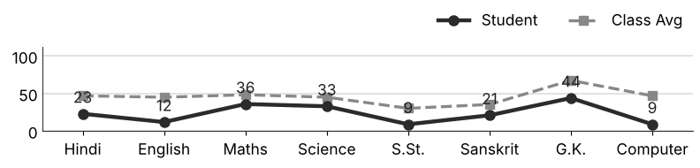
Class Teacher |  | —— Better Education ★ Brighter Future —— |  | Principal

UNIQUE CENTRAL SCHOOL
KNOWLEDGE ★ CHARACTER ★ PROGRESS
ACADEMIC SESSION : 2026 – 2027
RESULT / MARKSHEET
(P.T.1 – 40 | P.T..2 – 40 | S.A.-1 – 80 | Total – 100)
Class : IV | Section : | Roll No. : 57
Student Information  Student Name : Tannu Kumari  Father’s Name : Mr. Kalu Mistri  Mother’s Name : Mrs. Kanchan Devi | PHOTO  (Optional) | Result Summary
  Total Marks : | 180 / 800
  Percentage (%) : | 22.50 %
  Overall Grade : | E
  Result : | FAIL
  Rank : | 71
S.No. | Subject | Internal Assessment |  |  |  | Summative  Assessment I  (80 marks) | Total  (100 marks) | Grade
S.No. | Subject | P.T. I | P.T. II | Multiple Assessment | Subject Enrichment | Summative  Assessment I  (80 marks) | Total  (100 marks) | Grade
S.No. | Subject | (5 marks) | (5 marks) | (5 marks) | (5 marks) | Summative  Assessment I  (80 marks) | Total  (100 marks) | Grade
1 | Hindi | 0 | 2 | 3 | 3 | 30 | 38 | D
2 | English | 0 | 1 | 2 | 2 | 3 | 8 | E
3 | Maths | 2 | 1 | 3 | 3 | 20 | 29 | E
4 | Science | 0 | 1 | 2 | 2 | 18 | 23 | E
5 | S.St. | 1 | 0 | 2 | 2 | 11 | 16 | E
6 | Sanskrit | 2 | 0 | 2 | 3 | 5 | 12 | E
7 | G.K. | 0 | 0 | 3 | 2 | 24 | 29 | E
8 | Computer | 0 | 0 | 2 | 2 | 21 | 25 | E
CO-SCHOLASTIC AREAS |  |  |  |  |  |  | SCALE
Subject | Drawing | Music | Uniform | Sports | Discipline |  | GRADE | A1 | A2 | B1 | B2 | C1 | C2 | D | E
Grade | C | C | C | C | C |  | MARKS RANGE | 91-100 | 81-90 | 71-80 | 61-70 | 51-60 | 41-50 | 31-40 | Below 30
 |  |  |  |  |  |  | CO-SCH. AREAS | GRADE A  Outstanding |  | GRADE B  Very Good |  | GRADE C  Fair
Attendance  Working Days : 132  Present : 102  Absent : 30 | Teacher’s Remark  Weak performance. Needs special attention and practice. Give more time to English. |  | Performance Chart (Total /100 : Student vs Class Average)  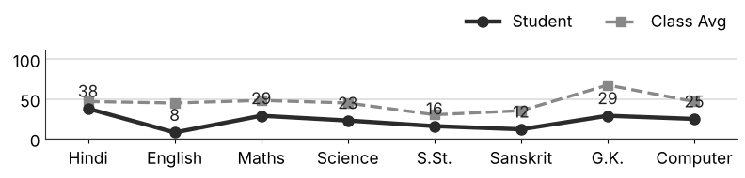
Class Teacher |  | —— Better Education ★ Brighter Future —— |  | Principal

UNIQUE CENTRAL SCHOOL
KNOWLEDGE ★ CHARACTER ★ PROGRESS
ACADEMIC SESSION : 2026 – 2027
RESULT / MARKSHEET
(P.T.1 – 40 | P.T..2 – 40 | S.A.-1 – 80 | Total – 100)
Class : IV | Section : | Roll No. : 58
Student Information  Student Name : Priyansh Kumar  Father’s Name : Mr. Banti Mahto  Mother’s Name : Mrs. Sarita Devi | PHOTO  (Optional) | Result Summary
  Total Marks : | 223 / 800
  Percentage (%) : | 27.88 %
  Overall Grade : | E
  Result : | FAIL
  Rank : | 62
S.No. | Subject | Internal Assessment |  |  |  | Summative  Assessment I  (80 marks) | Total  (100 marks) | Grade
S.No. | Subject | P.T. I | P.T. II | Multiple Assessment | Subject Enrichment | Summative  Assessment I  (80 marks) | Total  (100 marks) | Grade
S.No. | Subject | (5 marks) | (5 marks) | (5 marks) | (5 marks) | Summative  Assessment I  (80 marks) | Total  (100 marks) | Grade
1 | Hindi | 2 | 0 | 3 | 3 | 37 | 45 | C2
2 | English | 0 | 4 | 3 | 3 | 8 | 18 | E
3 | Maths | 2 | 2 | 3 | 3 | 31 | 41 | C2
4 | Science | 0 | 0 | 2 | 2 | 35 | 39 | D
5 | S.St. | 0 | 0 | 3 | 2 | 7 | 12 | E
6 | Sanskrit | 2 | 2 | 3 | 3 | 6 | 16 | E
7 | G.K. | 0 | 2 | 3 | 3 | 34 | 42 | C2
8 | Computer | 0 | 0 | 2 | 2 | 6 | 10 | E
CO-SCHOLASTIC AREAS |  |  |  |  |  |  | SCALE
Subject | Drawing | Music | Uniform | Sports | Discipline |  | GRADE | A1 | A2 | B1 | B2 | C1 | C2 | D | E
Grade | C | C | C | C | C |  | MARKS RANGE | 91-100 | 81-90 | 71-80 | 61-70 | 51-60 | 41-50 | 31-40 | Below 30
 |  |  |  |  |  |  | CO-SCH. AREAS | GRADE A  Outstanding |  | GRADE B  Very Good |  | GRADE C  Fair
Attendance  Working Days : 132  Present : 100  Absent : 32 | Teacher’s Remark  Weak performance. Needs special attention and practice. Attendance must improve. |  | Performance Chart (Total /100 : Student vs Class Average)  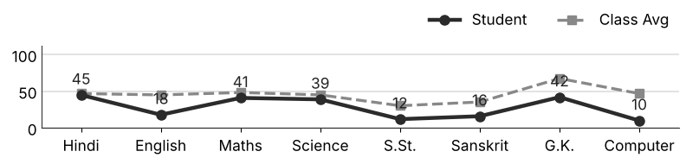
Class Teacher |  | —— Better Education ★ Brighter Future —— |  | Principal

UNIQUE CENTRAL SCHOOL
KNOWLEDGE ★ CHARACTER ★ PROGRESS
ACADEMIC SESSION : 2026 – 2027
RESULT / MARKSHEET
(P.T.1 – 40 | P.T..2 – 40 | S.A.-1 – 80 | Total – 100)
Class : IV | Section : | Roll No. : 59
Student Information  Student Name : Sadif Khan  Father’s Name : Mr. Jamal Khan  Mother’s Name : Mrs. Sagupta Naz | PHOTO  (Optional) | Result Summary
  Total Marks : | 214 / 800
  Percentage (%) : | 26.75 %
  Overall Grade : | E
  Result : | FAIL
  Rank : | 66
S.No. | Subject | Internal Assessment |  |  |  | Summative  Assessment I  (80 marks) | Total  (100 marks) | Grade
S.No. | Subject | P.T. I | P.T. II | Multiple Assessment | Subject Enrichment | Summative  Assessment I  (80 marks) | Total  (100 marks) | Grade
S.No. | Subject | (5 marks) | (5 marks) | (5 marks) | (5 marks) | Summative  Assessment I  (80 marks) | Total  (100 marks) | Grade
1 | Hindi | 1 | 2 | 2 | 3 | 20 | 28 | E
2 | English | 0 | 4 | 2 | 3 | 1 | 10 | E
3 | Maths | 4 | 3 | 3 | 4 | 30 | 44 | C2
4 | Science | 3 | 0 | 3 | 3 | 30 | 39 | D
5 | S.St. | 1 | 0 | 2 | 2 | 3 | 8 | E
6 | Sanskrit | 2 | 0 | 3 | 4 | 36 | 45 | C2
7 | G.K. | 0 | 4 | 2 | 2 | 0 | 8 | E
8 | Computer | 0 | 2 | 3 | 3 | 24 | 32 | D
CO-SCHOLASTIC AREAS |  |  |  |  |  |  | SCALE
Subject | Drawing | Music | Uniform | Sports | Discipline |  | GRADE | A1 | A2 | B1 | B2 | C1 | C2 | D | E
Grade | C | C | C | C | C |  | MARKS RANGE | 91-100 | 81-90 | 71-80 | 61-70 | 51-60 | 41-50 | 31-40 | Below 30
 |  |  |  |  |  |  | CO-SCH. AREAS | GRADE A  Outstanding |  | GRADE B  Very Good |  | GRADE C  Fair
Attendance  Working Days : 132  Present : 107  Absent : 25 | Teacher’s Remark  Weak performance. Needs special attention and practice. Give more time to S.St.. |  | Performance Chart (Total /100 : Student vs Class Average)  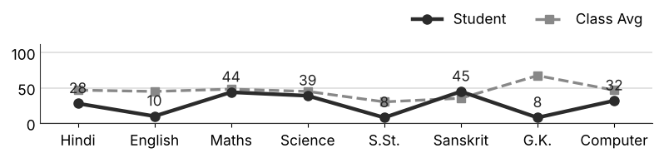
Class Teacher |  | —— Better Education ★ Brighter Future —— |  | Principal

UNIQUE CENTRAL SCHOOL
KNOWLEDGE ★ CHARACTER ★ PROGRESS
ACADEMIC SESSION : 2026 – 2027
RESULT / MARKSHEET
(P.T.1 – 40 | P.T..2 – 40 | S.A.-1 – 80 | Total – 100)
Class : IV | Section : | Roll No. : 60
Student Information  Student Name : Anand Raj  Father’s Name : Mr. Jitendra Prasad  Mother’s Name : Mrs. Milan Devi | PHOTO  (Optional) | Result Summary
  Total Marks : | 89 / 800
  Percentage (%) : | 11.12 %
  Overall Grade : | E
  Result : | FAIL
  Rank : | 73
S.No. | Subject | Internal Assessment |  |  |  | Summative  Assessment I  (80 marks) | Total  (100 marks) | Grade
S.No. | Subject | P.T. I | P.T. II | Multiple Assessment | Subject Enrichment | Summative  Assessment I  (80 marks) | Total  (100 marks) | Grade
S.No. | Subject | (5 marks) | (5 marks) | (5 marks) | (5 marks) | Summative  Assessment I  (80 marks) | Total  (100 marks) | Grade
1 | Hindi | 0 | 0 | 2 | 2 | 18 | 22 | E
2 | English | 0 | 0 | 0 | 0 | 0 | 0 | E
3 | Maths | 0 | 2 | 2 | 2 | 6 | 12 | E
4 | Science | 0 | 0 | 3 | 3 | 17 | 23 | E
5 | S.St. | 0 | 0 | 0 | 0 | 0 | 0 | E
6 | Sanskrit | 0 | 1 | 2 | 2 | 0 | 5 | E
7 | G.K. | 1 | 0 | 2 | 3 | 14 | 20 | E
8 | Computer | 0 | 0 | 2 | 2 | 3 | 7 | E
CO-SCHOLASTIC AREAS |  |  |  |  |  |  | SCALE
Subject | Drawing | Music | Uniform | Sports | Discipline |  | GRADE | A1 | A2 | B1 | B2 | C1 | C2 | D | E
Grade | C | C | C | C | C |  | MARKS RANGE | 91-100 | 81-90 | 71-80 | 61-70 | 51-60 | 41-50 | 31-40 | Below 30
 |  |  |  |  |  |  | CO-SCH. AREAS | GRADE A  Outstanding |  | GRADE B  Very Good |  | GRADE C  Fair
Attendance  Working Days : 132  Present : 87  Absent : 45 | Teacher’s Remark  Weak performance. Needs special attention and practice. Attendance must improve. |  | Performance Chart (Total /100 : Student vs Class Average)  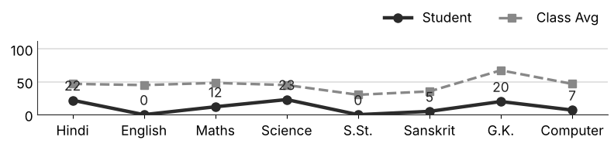
Class Teacher |  | —— Better Education ★ Brighter Future —— |  | Principal

UNIQUE CENTRAL SCHOOL
KNOWLEDGE ★ CHARACTER ★ PROGRESS
ACADEMIC SESSION : 2026 – 2027
RESULT / MARKSHEET
(P.T.1 – 40 | P.T..2 – 40 | S.A.-1 – 80 | Total – 100)
Class : IV | Section : | Roll No. : 61
Student Information  Student Name : Riya Kumari  Father’s Name : Mr. Lalan Prasad  Mother’s Name : Mrs. Sangita Devi | PHOTO  (Optional) | Result Summary
  Total Marks : | 352 / 800
  Percentage (%) : | 44.00 %
  Overall Grade : | C2
  Result : | PASS
  Rank : | 36
S.No. | Subject | Internal Assessment |  |  |  | Summative  Assessment I  (80 marks) | Total  (100 marks) | Grade
S.No. | Subject | P.T. I | P.T. II | Multiple Assessment | Subject Enrichment | Summative  Assessment I  (80 marks) | Total  (100 marks) | Grade
S.No. | Subject | (5 marks) | (5 marks) | (5 marks) | (5 marks) | Summative  Assessment I  (80 marks) | Total  (100 marks) | Grade
1 | Hindi | 1 | 3 | 4 | 3 | 49 | 60 | C1
2 | English | 0 | 2 | 4 | 3 | 49 | 58 | C1
3 | Maths | 1 | 2 | 2 | 3 | 21 | 29 | E
4 | Science | 0 | 0 | 2 | 3 | 30 | 35 | D
5 | S.St. | 3 | 0 | 3 | 3 | 8 | 17 | E
6 | Sanskrit | 3 | 1 | 3 | 3 | 10 | 20 | E
7 | G.K. | 0 | 1 | 3 | 4 | 62 | 70 | B2
8 | Computer | 3 | 3 | 4 | 4 | 49 | 63 | B2
CO-SCHOLASTIC AREAS |  |  |  |  |  |  | SCALE
Subject | Drawing | Music | Uniform | Sports | Discipline |  | GRADE | A1 | A2 | B1 | B2 | C1 | C2 | D | E
Grade | C | C | B | B | B |  | MARKS RANGE | 91-100 | 81-90 | 71-80 | 61-70 | 51-60 | 41-50 | 31-40 | Below 30
 |  |  |  |  |  |  | CO-SCH. AREAS | GRADE A  Outstanding |  | GRADE B  Very Good |  | GRADE C  Fair
Attendance  Working Days : 132  Present : 98  Absent : 34 | Teacher’s Remark  Fair performance. Needs regular practice and revision. Attendance must improve. |  | Performance Chart (Total /100 : Student vs Class Average)  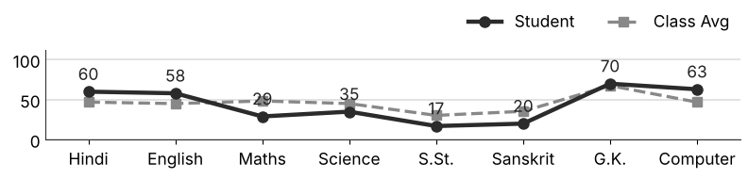
Class Teacher |  | —— Better Education ★ Brighter Future —— |  | Principal

UNIQUE CENTRAL SCHOOL
KNOWLEDGE ★ CHARACTER ★ PROGRESS
ACADEMIC SESSION : 2026 – 2027
RESULT / MARKSHEET
(P.T.1 – 40 | P.T..2 – 40 | S.A.-1 – 80 | Total – 100)
Class : IV | Section : | Roll No. : 62
Student Information  Student Name : Shivam Prakash  Father’s Name : Mr. Chandan Gupta  Mother’s Name : Mrs. Reena Kumari | PHOTO  (Optional) | Result Summary
  Total Marks : | 328 / 800
  Percentage (%) : | 41.00 %
  Overall Grade : | C2
  Result : | PASS
  Rank : | 44
S.No. | Subject | Internal Assessment |  |  |  | Summative  Assessment I  (80 marks) | Total  (100 marks) | Grade
S.No. | Subject | P.T. I | P.T. II | Multiple Assessment | Subject Enrichment | Summative  Assessment I  (80 marks) | Total  (100 marks) | Grade
S.No. | Subject | (5 marks) | (5 marks) | (5 marks) | (5 marks) | Summative  Assessment I  (80 marks) | Total  (100 marks) | Grade
1 | Hindi | 1 | 3 | 3 | 3 | 25 | 35 | D
2 | English | 3 | 4 | 3 | 4 | 22 | 36 | D
3 | Maths | 2 | 2 | 3 | 3 | 46 | 56 | C1
4 | Science | 0 | 3 | 3 | 3 | 26 | 35 | D
5 | S.St. | 0 | 0 | 2 | 2 | 8 | 12 | E
6 | Sanskrit | 1 | 1 | 3 | 3 | 20 | 28 | E
7 | G.K. | 1 | 3 | 4 | 4 | 66 | 78 | B1
8 | Computer | 3 | 1 | 3 | 4 | 37 | 48 | C2
CO-SCHOLASTIC AREAS |  |  |  |  |  |  | SCALE
Subject | Drawing | Music | Uniform | Sports | Discipline |  | GRADE | A1 | A2 | B1 | B2 | C1 | C2 | D | E
Grade | C | C | C | C | C |  | MARKS RANGE | 91-100 | 81-90 | 71-80 | 61-70 | 51-60 | 41-50 | 31-40 | Below 30
 |  |  |  |  |  |  | CO-SCH. AREAS | GRADE A  Outstanding |  | GRADE B  Very Good |  | GRADE C  Fair
Attendance  Working Days : 132  Present : 86  Absent : 46 | Teacher’s Remark  Fair performance. Needs regular practice and revision. Attendance must improve. |  | Performance Chart (Total /100 : Student vs Class Average)  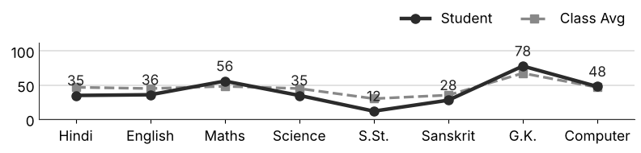
Class Teacher |  | —— Better Education ★ Brighter Future —— |  | Principal

UNIQUE CENTRAL SCHOOL
KNOWLEDGE ★ CHARACTER ★ PROGRESS
ACADEMIC SESSION : 2026 – 2027
RESULT / MARKSHEET
(P.T.1 – 40 | P.T..2 – 40 | S.A.-1 – 80 | Total – 100)
Class : IV | Section : | Roll No. : 63
Student Information  Student Name : Rubal Kumar  Father’s Name : Mr. Sunil Prasad  Mother’s Name : Mrs. Kavita Devi | PHOTO  (Optional) | Result Summary
  Total Marks : | 284 / 800
  Percentage (%) : | 35.50 %
  Overall Grade : | D
  Result : | PASS
  Rank : | 54
S.No. | Subject | Internal Assessment |  |  |  | Summative  Assessment I  (80 marks) | Total  (100 marks) | Grade
S.No. | Subject | P.T. I | P.T. II | Multiple Assessment | Subject Enrichment | Summative  Assessment I  (80 marks) | Total  (100 marks) | Grade
S.No. | Subject | (5 marks) | (5 marks) | (5 marks) | (5 marks) | Summative  Assessment I  (80 marks) | Total  (100 marks) | Grade
1 | Hindi | 1 | 3 | 3 | 4 | 23 | 34 | D
2 | English | 0 | 3 | 3 | 3 | 19 | 28 | E
3 | Maths | 1 | 2 | 4 | 4 | 42 | 53 | C1
4 | Science | 2 | 2 | 3 | 3 | 19 | 29 | E
5 | S.St. | 0 | 0 | 2 | 2 | 17 | 21 | E
6 | Sanskrit | 1 | 1 | 2 | 3 | 7 | 14 | E
7 | G.K. | 0 | 2 | 4 | 3 | 58 | 67 | B2
8 | Computer | 1 | 0 | 3 | 3 | 31 | 38 | D
CO-SCHOLASTIC AREAS |  |  |  |  |  |  | SCALE
Subject | Drawing | Music | Uniform | Sports | Discipline |  | GRADE | A1 | A2 | B1 | B2 | C1 | C2 | D | E
Grade | C | C | B | C | B |  | MARKS RANGE | 91-100 | 81-90 | 71-80 | 61-70 | 51-60 | 41-50 | 31-40 | Below 30
 |  |  |  |  |  |  | CO-SCH. AREAS | GRADE A  Outstanding |  | GRADE B  Very Good |  | GRADE C  Fair
Attendance  Working Days : 132  Present : 123  Absent : 9 | Teacher’s Remark  Needs improvement. Should study regularly at home. Give more time to Sanskrit. |  | Performance Chart (Total /100 : Student vs Class Average)  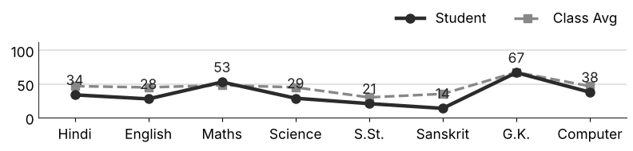
Class Teacher |  | —— Better Education ★ Brighter Future —— |  | Principal

UNIQUE CENTRAL SCHOOL
KNOWLEDGE ★ CHARACTER ★ PROGRESS
ACADEMIC SESSION : 2026 – 2027
RESULT / MARKSHEET
(P.T.1 – 40 | P.T..2 – 40 | S.A.-1 – 80 | Total – 100)
Class : IV | Section : | Roll No. : 64
Student Information  Student Name : Hanika Shreya  Father’s Name : Mr. Krishan Kant Ram  Mother’s Name : Mrs. Manilata Kumari | PHOTO  (Optional) | Result Summary
  Total Marks : | 305 / 800
  Percentage (%) : | 38.12 %
  Overall Grade : | D
  Result : | PASS
  Rank : | 51
S.No. | Subject | Internal Assessment |  |  |  | Summative  Assessment I  (80 marks) | Total  (100 marks) | Grade
S.No. | Subject | P.T. I | P.T. II | Multiple Assessment | Subject Enrichment | Summative  Assessment I  (80 marks) | Total  (100 marks) | Grade
S.No. | Subject | (5 marks) | (5 marks) | (5 marks) | (5 marks) | Summative  Assessment I  (80 marks) | Total  (100 marks) | Grade
1 | Hindi | 1 | 0 | 3 | 2 | 28 | 34 | D
2 | English | 3 | 0 | 4 | 4 | 57 | 68 | B2
3 | Maths | 0 | 0 | 3 | 2 | 35 | 40 | D
4 | Science | 0 | 0 | 3 | 3 | 27 | 33 | D
5 | S.St. | 0 | 0 | 2 | 2 | 8 | 12 | E
6 | Sanskrit | 0 | 0 | 2 | 3 | 12 | 17 | E
7 | G.K. | 1 | 0 | 3 | 4 | 56 | 64 | B2
8 | Computer | 0 | 0 | 3 | 3 | 31 | 37 | D
CO-SCHOLASTIC AREAS |  |  |  |  |  |  | SCALE
Subject | Drawing | Music | Uniform | Sports | Discipline |  | GRADE | A1 | A2 | B1 | B2 | C1 | C2 | D | E
Grade | B | C | B | B | B |  | MARKS RANGE | 91-100 | 81-90 | 71-80 | 61-70 | 51-60 | 41-50 | 31-40 | Below 30
 |  |  |  |  |  |  | CO-SCH. AREAS | GRADE A  Outstanding |  | GRADE B  Very Good |  | GRADE C  Fair
Attendance  Working Days : 132  Present : 132  Absent : 0 | Teacher’s Remark  Needs improvement. Should study regularly at home. Give more time to S.St.. |  | Performance Chart (Total /100 : Student vs Class Average)  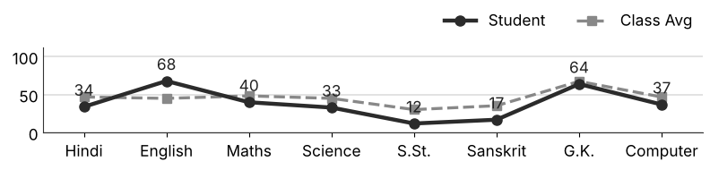
Class Teacher |  | —— Better Education ★ Brighter Future —— |  | Principal

UNIQUE CENTRAL SCHOOL
KNOWLEDGE ★ CHARACTER ★ PROGRESS
ACADEMIC SESSION : 2026 – 2027
RESULT / MARKSHEET
(P.T.1 – 40 | P.T..2 – 40 | S.A.-1 – 80 | Total – 100)
Class : IV | Section : | Roll No. : 65
Student Information  Student Name : Komal Kriti  Father’s Name : Mr. Krishan Kant Ram  Mother’s Name : Mrs. Manilata Kumari | PHOTO  (Optional) | Result Summary
  Total Marks : | 317 / 800
  Percentage (%) : | 39.62 %
  Overall Grade : | D
  Result : | PASS
  Rank : | 47
S.No. | Subject | Internal Assessment |  |  |  | Summative  Assessment I  (80 marks) | Total  (100 marks) | Grade
S.No. | Subject | P.T. I | P.T. II | Multiple Assessment | Subject Enrichment | Summative  Assessment I  (80 marks) | Total  (100 marks) | Grade
S.No. | Subject | (5 marks) | (5 marks) | (5 marks) | (5 marks) | Summative  Assessment I  (80 marks) | Total  (100 marks) | Grade
1 | Hindi | 1 | 2 | 3 | 3 | 31 | 40 | D
2 | English | 3 | 1 | 4 | 3 | 44 | 55 | C1
3 | Maths | 0 | 0 | 3 | 2 | 35 | 40 | D
4 | Science | 0 | 0 | 3 | 3 | 32 | 38 | D
5 | S.St. | 0 | 0 | 3 | 2 | 10 | 15 | E
6 | Sanskrit | 3 | 0 | 2 | 3 | 13 | 21 | E
7 | G.K. | 2 | 4 | 4 | 4 | 64 | 78 | B1
8 | Computer | 0 | 1 | 2 | 2 | 25 | 30 | E
CO-SCHOLASTIC AREAS |  |  |  |  |  |  | SCALE
Subject | Drawing | Music | Uniform | Sports | Discipline |  | GRADE | A1 | A2 | B1 | B2 | C1 | C2 | D | E
Grade | C | C | B | B | B |  | MARKS RANGE | 91-100 | 81-90 | 71-80 | 61-70 | 51-60 | 41-50 | 31-40 | Below 30
 |  |  |  |  |  |  | CO-SCH. AREAS | GRADE A  Outstanding |  | GRADE B  Very Good |  | GRADE C  Fair
Attendance  Working Days : 132  Present : 131  Absent : 1 | Teacher’s Remark  Needs improvement. Should study regularly at home. Give more time to S.St.. |  | Performance Chart (Total /100 : Student vs Class Average)  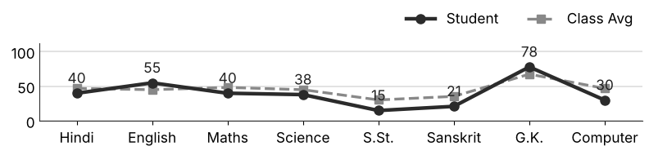
Class Teacher |  | —— Better Education ★ Brighter Future —— |  | Principal

UNIQUE CENTRAL SCHOOL
KNOWLEDGE ★ CHARACTER ★ PROGRESS
ACADEMIC SESSION : 2026 – 2027
RESULT / MARKSHEET
(P.T.1 – 40 | P.T..2 – 40 | S.A.-1 – 80 | Total – 100)
Class : IV | Section : | Roll No. : 66
Student Information  Student Name : Harinarayan Kumar  Father’s Name : Mr. Anunanjan Yadav  Mother’s Name : Mrs. Guriya Devi | PHOTO  (Optional) | Result Summary
  Total Marks : | 161 / 800
  Percentage (%) : | 20.12 %
  Overall Grade : | E
  Result : | FAIL
  Rank : | 72
S.No. | Subject | Internal Assessment |  |  |  | Summative  Assessment I  (80 marks) | Total  (100 marks) | Grade
S.No. | Subject | P.T. I | P.T. II | Multiple Assessment | Subject Enrichment | Summative  Assessment I  (80 marks) | Total  (100 marks) | Grade
S.No. | Subject | (5 marks) | (5 marks) | (5 marks) | (5 marks) | Summative  Assessment I  (80 marks) | Total  (100 marks) | Grade
1 | Hindi | 1 | 2 | 3 | 3 | 15 | 24 | E
2 | English | 1 | 3 | 2 | 2 | 3 | 11 | E
3 | Maths | 2 | 2 | 3 | 3 | 8 | 18 | E
4 | Science | 1 | 4 | 3 | 3 | 20 | 31 | D
5 | S.St. | 0 | 1 | 3 | 2 | 6 | 12 | E
6 | Sanskrit | 1 | 3 | 2 | 2 | 0 | 8 | E
7 | G.K. | 1 | 3 | 3 | 3 | 16 | 26 | E
8 | Computer | 0 | 0 | 3 | 3 | 25 | 31 | D
CO-SCHOLASTIC AREAS |  |  |  |  |  |  | SCALE
Subject | Drawing | Music | Uniform | Sports | Discipline |  | GRADE | A1 | A2 | B1 | B2 | C1 | C2 | D | E
Grade | C | C | C | C | C |  | MARKS RANGE | 91-100 | 81-90 | 71-80 | 61-70 | 51-60 | 41-50 | 31-40 | Below 30
 |  |  |  |  |  |  | CO-SCH. AREAS | GRADE A  Outstanding |  | GRADE B  Very Good |  | GRADE C  Fair
Attendance  Working Days : 132  Present : 81  Absent : 51 | Teacher’s Remark  Weak performance. Needs special attention and practice. Attendance must improve. |  | Performance Chart (Total /100 : Student vs Class Average)  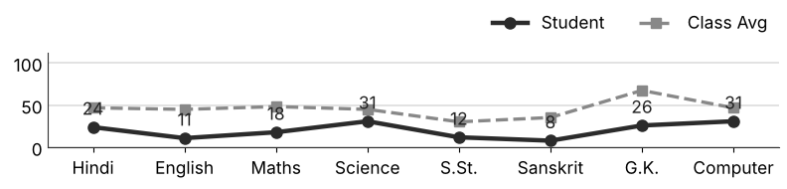
Class Teacher |  | —— Better Education ★ Brighter Future —— |  | Principal

UNIQUE CENTRAL SCHOOL
KNOWLEDGE ★ CHARACTER ★ PROGRESS
ACADEMIC SESSION : 2026 – 2027
RESULT / MARKSHEET
(P.T.1 – 40 | P.T..2 – 40 | S.A.-1 – 80 | Total – 100)
Class : IV | Section : | Roll No. : 67
Student Information  Student Name : Himanshu Kumar  Father’s Name : Mr. Raj Kumar Thakur  Mother’s Name : Mrs. Umi Kumari | PHOTO  (Optional) | Result Summary
  Total Marks : | 506 / 800
  Percentage (%) : | 63.25 %
  Overall Grade : | B2
  Result : | PASS
  Rank : | 15
S.No. | Subject | Internal Assessment |  |  |  | Summative  Assessment I  (80 marks) | Total  (100 marks) | Grade
S.No. | Subject | P.T. I | P.T. II | Multiple Assessment | Subject Enrichment | Summative  Assessment I  (80 marks) | Total  (100 marks) | Grade
S.No. | Subject | (5 marks) | (5 marks) | (5 marks) | (5 marks) | Summative  Assessment I  (80 marks) | Total  (100 marks) | Grade
1 | Hindi | 2 | 3 | 3 | 4 | 56 | 68 | B2
2 | English | 3 | 2 | 4 | 4 | 64 | 77 | B1
3 | Maths | 0 | 3 | 4 | 4 | 57 | 68 | B2
4 | Science | 2 | 2 | 3 | 3 | 45 | 55 | C1
5 | S.St. | 1 | 1 | 3 | 3 | 26 | 34 | D
6 | Sanskrit | 2 | 2 | 3 | 3 | 36 | 46 | C2
7 | G.K. | 4 | 4 | 5 | 5 | 76 | 94 | A1
8 | Computer | 2 | 0 | 4 | 3 | 55 | 64 | B2
CO-SCHOLASTIC AREAS |  |  |  |  |  |  | SCALE
Subject | Drawing | Music | Uniform | Sports | Discipline |  | GRADE | A1 | A2 | B1 | B2 | C1 | C2 | D | E
Grade | B | B | A | B | A |  | MARKS RANGE | 91-100 | 81-90 | 71-80 | 61-70 | 51-60 | 41-50 | 31-40 | Below 30
 |  |  |  |  |  |  | CO-SCH. AREAS | GRADE A  Outstanding |  | GRADE B  Very Good |  | GRADE C  Fair
Attendance  Working Days : 132  Present : 105  Absent : 27 | Teacher’s Remark  Good performance. More practice can make it better. Give more time to S.St.. |  | Performance Chart (Total /100 : Student vs Class Average)  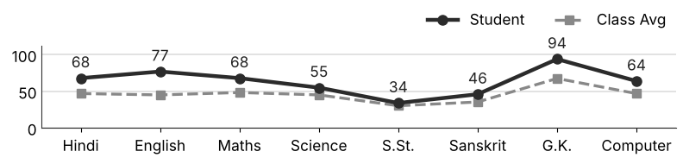
Class Teacher |  | —— Better Education ★ Brighter Future —— |  | Principal

UNIQUE CENTRAL SCHOOL
KNOWLEDGE ★ CHARACTER ★ PROGRESS
ACADEMIC SESSION : 2026 – 2027
RESULT / MARKSHEET
(P.T.1 – 40 | P.T..2 – 40 | S.A.-1 – 80 | Total – 100)
Class : IV | Section : | Roll No. : 68
Student Information  Student Name : Dilkush Kumar  Father’s Name : Mr. Ranjan Yadav  Mother’s Name : Mrs. Priti Kumari | PHOTO  (Optional) | Result Summary
  Total Marks : | 32 / 800
  Percentage (%) : | 4.00 %
  Overall Grade : | E
  Result : | FAIL
  Rank : | 75
S.No. | Subject | Internal Assessment |  |  |  | Summative  Assessment I  (80 marks) | Total  (100 marks) | Grade
S.No. | Subject | P.T. I | P.T. II | Multiple Assessment | Subject Enrichment | Summative  Assessment I  (80 marks) | Total  (100 marks) | Grade
S.No. | Subject | (5 marks) | (5 marks) | (5 marks) | (5 marks) | Summative  Assessment I  (80 marks) | Total  (100 marks) | Grade
1 | Hindi | 1 | 0 | 2 | 2 | 0 | 5 | E
2 | English | 0 | 0 | 0 | 0 | 0 | 0 | E
3 | Maths | 1 | 0 | 2 | 2 | 0 | 5 | E
4 | Science | 1 | 0 | 2 | 2 | 0 | 5 | E
5 | S.St. | 0 | 0 | 0 | 0 | 0 | 0 | E
6 | Sanskrit | 1 | 0 | 2 | 2 | 0 | 5 | E
7 | G.K. | 2 | 0 | 2 | 2 | 0 | 6 | E
8 | Computer | 2 | 0 | 2 | 2 | 0 | 6 | E
CO-SCHOLASTIC AREAS |  |  |  |  |  |  | SCALE
Subject | Drawing | Music | Uniform | Sports | Discipline |  | GRADE | A1 | A2 | B1 | B2 | C1 | C2 | D | E
Grade | C | C | C | C | C |  | MARKS RANGE | 91-100 | 81-90 | 71-80 | 61-70 | 51-60 | 41-50 | 31-40 | Below 30
 |  |  |  |  |  |  | CO-SCH. AREAS | GRADE A  Outstanding |  | GRADE B  Very Good |  | GRADE C  Fair
Attendance  Working Days : 132  Present : 0  Absent : 132 | Teacher’s Remark  Weak performance. Needs special attention and practice. Attendance must improve. |  | Performance Chart (Total /100 : Student vs Class Average)  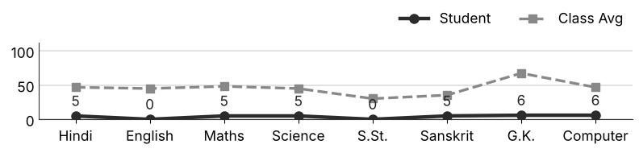
Class Teacher |  | —— Better Education ★ Brighter Future —— |  | Principal

UNIQUE CENTRAL SCHOOL
KNOWLEDGE ★ CHARACTER ★ PROGRESS
ACADEMIC SESSION : 2026 – 2027
RESULT / MARKSHEET
(P.T.1 – 40 | P.T..2 – 40 | S.A.-1 – 80 | Total – 100)
Class : IV | Section : | Roll No. : 69
Student Information  Student Name : Shristi Kumari  Father’s Name : Mr. Dhanjay Kumar  Mother’s Name : Mrs. Sati Devi | PHOTO  (Optional) | Result Summary
  Total Marks : | 192 / 800
  Percentage (%) : | 24.00 %
  Overall Grade : | E
  Result : | FAIL
  Rank : | 69
S.No. | Subject | Internal Assessment |  |  |  | Summative  Assessment I  (80 marks) | Total  (100 marks) | Grade
S.No. | Subject | P.T. I | P.T. II | Multiple Assessment | Subject Enrichment | Summative  Assessment I  (80 marks) | Total  (100 marks) | Grade
S.No. | Subject | (5 marks) | (5 marks) | (5 marks) | (5 marks) | Summative  Assessment I  (80 marks) | Total  (100 marks) | Grade
1 | Hindi | 1 | 2 | 4 | 3 | 33 | 43 | C2
2 | English | 3 | 1 | 3 | 3 | 4 | 14 | E
3 | Maths | 2 | 0 | 3 | 2 | 30 | 37 | D
4 | Science | 0 | 2 | 2 | 3 | 11 | 18 | E
5 | S.St. | 1 | 0 | 2 | 2 | 5 | 10 | E
6 | Sanskrit | 1 | 1 | 3 | 2 | 15 | 22 | E
7 | G.K. | 0 | 4 | 3 | 3 | 28 | 38 | D
8 | Computer | 1 | 0 | 2 | 2 | 5 | 10 | E
CO-SCHOLASTIC AREAS |  |  |  |  |  |  | SCALE
Subject | Drawing | Music | Uniform | Sports | Discipline |  | GRADE | A1 | A2 | B1 | B2 | C1 | C2 | D | E
Grade | C | C | C | C | C |  | MARKS RANGE | 91-100 | 81-90 | 71-80 | 61-70 | 51-60 | 41-50 | 31-40 | Below 30
 |  |  |  |  |  |  | CO-SCH. AREAS | GRADE A  Outstanding |  | GRADE B  Very Good |  | GRADE C  Fair
Attendance  Working Days : 132  Present : 120  Absent : 12 | Teacher’s Remark  Weak performance. Needs special attention and practice. Give more time to S.St.. |  | Performance Chart (Total /100 : Student vs Class Average)  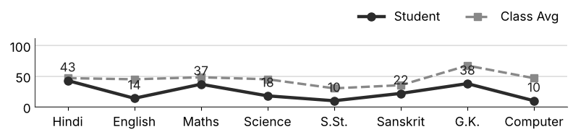
Class Teacher |  | —— Better Education ★ Brighter Future —— |  | Principal

UNIQUE CENTRAL SCHOOL
KNOWLEDGE ★ CHARACTER ★ PROGRESS
ACADEMIC SESSION : 2026 – 2027
RESULT / MARKSHEET
(P.T.1 – 40 | P.T..2 – 40 | S.A.-1 – 80 | Total – 100)
Class : IV | Section : | Roll No. : 70
Student Information  Student Name : Md. Shanad Alam  Father’s Name : Mr. Amjad Alam  Mother’s Name : Mrs. Sannanaz | PHOTO  (Optional) | Result Summary
  Total Marks : | 233 / 800
  Percentage (%) : | 29.12 %
  Overall Grade : | E
  Result : | FAIL
  Rank : | 60
S.No. | Subject | Internal Assessment |  |  |  | Summative  Assessment I  (80 marks) | Total  (100 marks) | Grade
S.No. | Subject | P.T. I | P.T. II | Multiple Assessment | Subject Enrichment | Summative  Assessment I  (80 marks) | Total  (100 marks) | Grade
S.No. | Subject | (5 marks) | (5 marks) | (5 marks) | (5 marks) | Summative  Assessment I  (80 marks) | Total  (100 marks) | Grade
1 | Hindi | 1 | 2 | 3 | 3 | 30 | 39 | D
2 | English | 4 | 1 | 2 | 3 | 7 | 17 | E
3 | Maths | 2 | 0 | 2 | 2 | 0 | 6 | E
4 | Science | 3 | 0 | 2 | 3 | 21 | 29 | E
5 | S.St. | 0 | 0 | 2 | 2 | 16 | 20 | E
6 | Sanskrit | 2 | 0 | 3 | 2 | 8 | 15 | E
7 | G.K. | 2 | 5 | 4 | 4 | 68 | 83 | A2
8 | Computer | 0 | 0 | 3 | 3 | 18 | 24 | E
CO-SCHOLASTIC AREAS |  |  |  |  |  |  | SCALE
Subject | Drawing | Music | Uniform | Sports | Discipline |  | GRADE | A1 | A2 | B1 | B2 | C1 | C2 | D | E
Grade | C | C | C | C | C |  | MARKS RANGE | 91-100 | 81-90 | 71-80 | 61-70 | 51-60 | 41-50 | 31-40 | Below 30
 |  |  |  |  |  |  | CO-SCH. AREAS | GRADE A  Outstanding |  | GRADE B  Very Good |  | GRADE C  Fair
Attendance  Working Days : 132  Present : 86  Absent : 46 | Teacher’s Remark  Weak performance. Needs special attention and practice. Attendance must improve. |  | Performance Chart (Total /100 : Student vs Class Average)  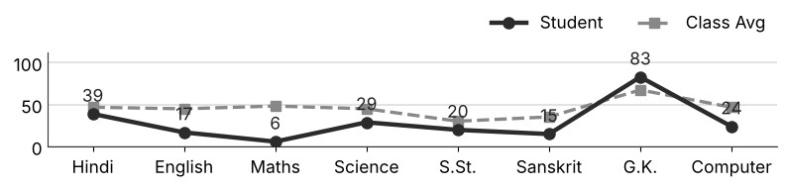
Class Teacher |  | —— Better Education ★ Brighter Future —— |  | Principal

UNIQUE CENTRAL SCHOOL
KNOWLEDGE ★ CHARACTER ★ PROGRESS
ACADEMIC SESSION : 2026 – 2027
RESULT / MARKSHEET
(P.T.1 – 40 | P.T..2 – 40 | S.A.-1 – 80 | Total – 100)
Class : IV | Section : | Roll No. : 71
Student Information  Student Name : Abutalib Alam  Father’s Name : Mr. Shaukat Alam  Mother’s Name : Mrs. Akhtari Bano | PHOTO  (Optional) | Result Summary
  Total Marks : | 311 / 800
  Percentage (%) : | 38.88 %
  Overall Grade : | D
  Result : | PASS
  Rank : | 50
S.No. | Subject | Internal Assessment |  |  |  | Summative  Assessment I  (80 marks) | Total  (100 marks) | Grade
S.No. | Subject | P.T. I | P.T. II | Multiple Assessment | Subject Enrichment | Summative  Assessment I  (80 marks) | Total  (100 marks) | Grade
S.No. | Subject | (5 marks) | (5 marks) | (5 marks) | (5 marks) | Summative  Assessment I  (80 marks) | Total  (100 marks) | Grade
1 | Hindi | 1 | 3 | 3 | 3 | 25 | 35 | D
2 | English | 1 | 3 | 4 | 3 | 42 | 53 | C1
3 | Maths | 1 | 0 | 3 | 2 | 25 | 31 | D
4 | Science | 1 | 1 | 2 | 3 | 20 | 27 | E
5 | S.St. | 0 | 0 | 2 | 2 | 9 | 13 | E
6 | Sanskrit | 1 | 0 | 3 | 2 | 19 | 25 | E
7 | G.K. | 1 | 3 | 4 | 4 | 74 | 86 | A2
8 | Computer | 0 | 0 | 2 | 3 | 36 | 41 | C2
CO-SCHOLASTIC AREAS |  |  |  |  |  |  | SCALE
Subject | Drawing | Music | Uniform | Sports | Discipline |  | GRADE | A1 | A2 | B1 | B2 | C1 | C2 | D | E
Grade | C | C | B | B | B |  | MARKS RANGE | 91-100 | 81-90 | 71-80 | 61-70 | 51-60 | 41-50 | 31-40 | Below 30
 |  |  |  |  |  |  | CO-SCH. AREAS | GRADE A  Outstanding |  | GRADE B  Very Good |  | GRADE C  Fair
Attendance  Working Days : 132  Present : 117  Absent : 15 | Teacher’s Remark  Needs improvement. Should study regularly at home. Give more time to S.St.. |  | Performance Chart (Total /100 : Student vs Class Average)  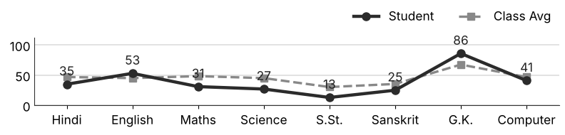
Class Teacher |  | —— Better Education ★ Brighter Future —— |  | Principal

UNIQUE CENTRAL SCHOOL
KNOWLEDGE ★ CHARACTER ★ PROGRESS
ACADEMIC SESSION : 2026 – 2027
RESULT / MARKSHEET
(P.T.1 – 40 | P.T..2 – 40 | S.A.-1 – 80 | Total – 100)
Class : IV | Section : | Roll No. : 72
Student Information  Student Name : Akshay Kumar  Father’s Name : Mr. Bijendra Kumar  Mother’s Name : Mrs. Kusum Devi | PHOTO  (Optional) | Result Summary
  Total Marks : | 233 / 800
  Percentage (%) : | 29.12 %
  Overall Grade : | E
  Result : | FAIL
  Rank : | 60
S.No. | Subject | Internal Assessment |  |  |  | Summative  Assessment I  (80 marks) | Total  (100 marks) | Grade
S.No. | Subject | P.T. I | P.T. II | Multiple Assessment | Subject Enrichment | Summative  Assessment I  (80 marks) | Total  (100 marks) | Grade
S.No. | Subject | (5 marks) | (5 marks) | (5 marks) | (5 marks) | Summative  Assessment I  (80 marks) | Total  (100 marks) | Grade
1 | Hindi | 0 | 3 | 3 | 3 | 30 | 39 | D
2 | English | 0 | 0 | 2 | 2 | 15 | 19 | E
3 | Maths | 2 | 0 | 3 | 2 | 25 | 32 | D
4 | Science | 0 | 0 | 2 | 2 | 12 | 16 | E
5 | S.St. | 0 | 0 | 2 | 2 | 17 | 21 | E
6 | Sanskrit | 1 | 0 | 3 | 3 | 15 | 22 | E
7 | G.K. | 0 | 0 | 3 | 4 | 48 | 55 | C1
8 | Computer | 0 | 0 | 2 | 2 | 25 | 29 | E
CO-SCHOLASTIC AREAS |  |  |  |  |  |  | SCALE
Subject | Drawing | Music | Uniform | Sports | Discipline |  | GRADE | A1 | A2 | B1 | B2 | C1 | C2 | D | E
Grade | C | C | C | C | B |  | MARKS RANGE | 91-100 | 81-90 | 71-80 | 61-70 | 51-60 | 41-50 | 31-40 | Below 30
 |  |  |  |  |  |  | CO-SCH. AREAS | GRADE A  Outstanding |  | GRADE B  Very Good |  | GRADE C  Fair
Attendance  Working Days : 132  Present : 123  Absent : 9 | Teacher’s Remark  Weak performance. Needs special attention and practice. Give more time to Science. |  | Performance Chart (Total /100 : Student vs Class Average)  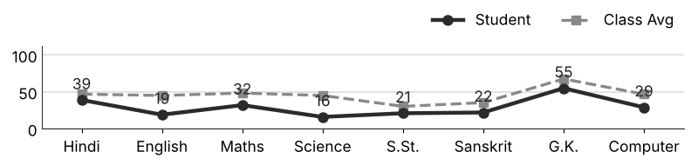
Class Teacher |  | —— Better Education ★ Brighter Future —— |  | Principal

UNIQUE CENTRAL SCHOOL
KNOWLEDGE ★ CHARACTER ★ PROGRESS
ACADEMIC SESSION : 2026 – 2027
RESULT / MARKSHEET
(P.T.1 – 40 | P.T..2 – 40 | S.A.-1 – 80 | Total – 100)
Class : IV | Section : | Roll No. : 73
Student Information  Student Name : Shivam Kumar  Father’s Name : Mr. Satya Prakesh  Mother’s Name : Mrs. Sarita Devi | PHOTO  (Optional) | Result Summary
  Total Marks : | 216 / 800
  Percentage (%) : | 27.00 %
  Overall Grade : | E
  Result : | FAIL
  Rank : | 64
S.No. | Subject | Internal Assessment |  |  |  | Summative  Assessment I  (80 marks) | Total  (100 marks) | Grade
S.No. | Subject | P.T. I | P.T. II | Multiple Assessment | Subject Enrichment | Summative  Assessment I  (80 marks) | Total  (100 marks) | Grade
S.No. | Subject | (5 marks) | (5 marks) | (5 marks) | (5 marks) | Summative  Assessment I  (80 marks) | Total  (100 marks) | Grade
1 | Hindi | 0 | 0 | 3 | 2 | 36 | 41 | C2
2 | English | 0 | 0 | 2 | 2 | 3 | 7 | E
3 | Maths | 0 | 0 | 3 | 3 | 28 | 34 | D
4 | Science | 0 | 3 | 3 | 3 | 18 | 27 | E
5 | S.St. | 0 | 0 | 3 | 2 | 18 | 23 | E
6 | Sanskrit | 0 | 1 | 3 | 2 | 24 | 30 | E
7 | G.K. | 0 | 0 | 3 | 2 | 36 | 41 | C2
8 | Computer | 0 | 0 | 2 | 2 | 9 | 13 | E
CO-SCHOLASTIC AREAS |  |  |  |  |  |  | SCALE
Subject | Drawing | Music | Uniform | Sports | Discipline |  | GRADE | A1 | A2 | B1 | B2 | C1 | C2 | D | E
Grade | C | C | C | C | C |  | MARKS RANGE | 91-100 | 81-90 | 71-80 | 61-70 | 51-60 | 41-50 | 31-40 | Below 30
 |  |  |  |  |  |  | CO-SCH. AREAS | GRADE A  Outstanding |  | GRADE B  Very Good |  | GRADE C  Fair
Attendance  Working Days : 132  Present : 125  Absent : 7 | Teacher’s Remark  Weak performance. Needs special attention and practice. Give more time to English. |  | Performance Chart (Total /100 : Student vs Class Average)  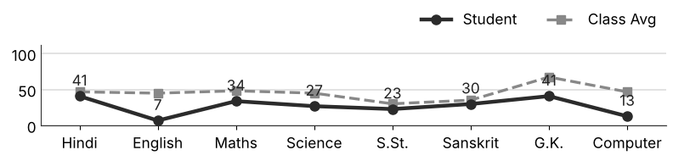
Class Teacher |  | —— Better Education ★ Brighter Future —— |  | Principal

UNIQUE CENTRAL SCHOOL
KNOWLEDGE ★ CHARACTER ★ PROGRESS
ACADEMIC SESSION : 2026 – 2027
RESULT / MARKSHEET
(P.T.1 – 40 | P.T..2 – 40 | S.A.-1 – 80 | Total – 100)
Class : IV | Section : | Roll No. : 74
Student Information  Student Name : Anan Kumar  Father’s Name : Mr. Sunny Kumar  Mother’s Name : Mrs. Sarita Devi | PHOTO  (Optional) | Result Summary
  Total Marks : | 211 / 800
  Percentage (%) : | 26.38 %
  Overall Grade : | E
  Result : | FAIL
  Rank : | 67
S.No. | Subject | Internal Assessment |  |  |  | Summative  Assessment I  (80 marks) | Total  (100 marks) | Grade
S.No. | Subject | P.T. I | P.T. II | Multiple Assessment | Subject Enrichment | Summative  Assessment I  (80 marks) | Total  (100 marks) | Grade
S.No. | Subject | (5 marks) | (5 marks) | (5 marks) | (5 marks) | Summative  Assessment I  (80 marks) | Total  (100 marks) | Grade
1 | Hindi | 0 | 0 | 3 | 2 | 25 | 30 | E
2 | English | 0 | 0 | 2 | 2 | 15 | 19 | E
3 | Maths | 0 | 0 | 3 | 2 | 15 | 20 | E
4 | Science | 0 | 0 | 2 | 3 | 20 | 25 | E
5 | S.St. | 0 | 0 | 2 | 2 | 7 | 11 | E
6 | Sanskrit | 0 | 0 | 2 | 3 | 10 | 15 | E
7 | G.K. | 0 | 0 | 3 | 4 | 52 | 59 | C1
8 | Computer | 0 | 0 | 3 | 3 | 26 | 32 | D
CO-SCHOLASTIC AREAS |  |  |  |  |  |  | SCALE
Subject | Drawing | Music | Uniform | Sports | Discipline |  | GRADE | A1 | A2 | B1 | B2 | C1 | C2 | D | E
Grade | C | C | C | C | C |  | MARKS RANGE | 91-100 | 81-90 | 71-80 | 61-70 | 51-60 | 41-50 | 31-40 | Below 30
 |  |  |  |  |  |  | CO-SCH. AREAS | GRADE A  Outstanding |  | GRADE B  Very Good |  | GRADE C  Fair
Attendance  Working Days : 132  Present : 119  Absent : 13 | Teacher’s Remark  Weak performance. Needs special attention and practice. Give more time to S.St.. |  | Performance Chart (Total /100 : Student vs Class Average)  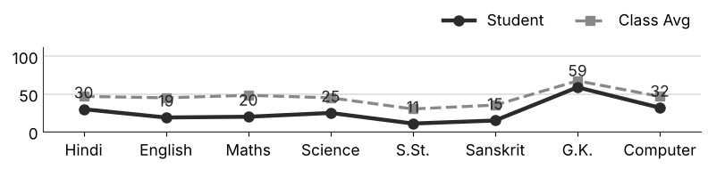
Class Teacher |  | —— Better Education ★ Brighter Future —— |  | Principal

UNIQUE CENTRAL SCHOOL
KNOWLEDGE ★ CHARACTER ★ PROGRESS
ACADEMIC SESSION : 2026 – 2027
RESULT / MARKSHEET
(P.T.1 – 40 | P.T..2 – 40 | S.A.-1 – 80 | Total – 100)
Class : IV | Section : | Roll No. : 75
Student Information  Student Name : Priyanshu Kumar  Father’s Name : Mr. Shailendra Kumar  Mother’s Name : Mrs. Anita Devi | PHOTO  (Optional) | Result Summary
  Total Marks : | 314 / 800
  Percentage (%) : | 39.25 %
  Overall Grade : | D
  Result : | PASS
  Rank : | 49
S.No. | Subject | Internal Assessment |  |  |  | Summative  Assessment I  (80 marks) | Total  (100 marks) | Grade
S.No. | Subject | P.T. I | P.T. II | Multiple Assessment | Subject Enrichment | Summative  Assessment I  (80 marks) | Total  (100 marks) | Grade
S.No. | Subject | (5 marks) | (5 marks) | (5 marks) | (5 marks) | Summative  Assessment I  (80 marks) | Total  (100 marks) | Grade
1 | Hindi | 0 | 0 | 3 | 3 | 31 | 37 | D
2 | English | 0 | 0 | 2 | 2 | 9 | 13 | E
3 | Maths | 0 | 0 | 3 | 3 | 35 | 41 | C2
4 | Science | 0 | 0 | 2 | 3 | 24 | 29 | E
5 | S.St. | 0 | 0 | 3 | 2 | 28 | 33 | D
6 | Sanskrit | 0 | 0 | 2 | 3 | 31 | 36 | D
7 | G.K. | 0 | 0 | 4 | 3 | 68 | 75 | B1
8 | Computer | 0 | 0 | 3 | 3 | 44 | 50 | C2
CO-SCHOLASTIC AREAS |  |  |  |  |  |  | SCALE
Subject | Drawing | Music | Uniform | Sports | Discipline |  | GRADE | A1 | A2 | B1 | B2 | C1 | C2 | D | E
Grade | B | C | B | B | B |  | MARKS RANGE | 91-100 | 81-90 | 71-80 | 61-70 | 51-60 | 41-50 | 31-40 | Below 30
 |  |  |  |  |  |  | CO-SCH. AREAS | GRADE A  Outstanding |  | GRADE B  Very Good |  | GRADE C  Fair
Attendance  Working Days : 132  Present : 124  Absent : 8 | Teacher’s Remark  Needs improvement. Should study regularly at home. Give more time to English. |  | Performance Chart (Total /100 : Student vs Class Average)  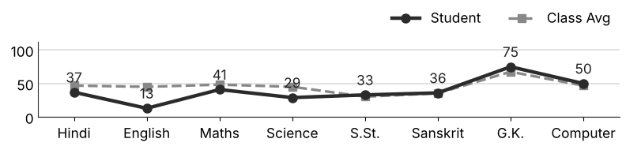
Class Teacher |  | —— Better Education ★ Brighter Future —— |  | Principal

UNIQUE CENTRAL SCHOOL
KNOWLEDGE ★ CHARACTER ★ PROGRESS
ACADEMIC SESSION : 2026 – 2027
RESULT / MARKSHEET
(P.T.1 – 40 | P.T..2 – 40 | S.A.-1 – 80 | Total – 100)
Class : IV | Section : | Roll No. : 76
Student Information  Student Name : Mohit Kumar  Father’s Name : Mr. Nandlal Gupta  Mother’s Name : Mrs. Meena Devi | PHOTO  (Optional) | Result Summary
  Total Marks : | 329 / 800
  Percentage (%) : | 41.12 %
  Overall Grade : | C2
  Result : | PASS
  Rank : | 43
S.No. | Subject | Internal Assessment |  |  |  | Summative  Assessment I  (80 marks) | Total  (100 marks) | Grade
S.No. | Subject | P.T. I | P.T. II | Multiple Assessment | Subject Enrichment | Summative  Assessment I  (80 marks) | Total  (100 marks) | Grade
S.No. | Subject | (5 marks) | (5 marks) | (5 marks) | (5 marks) | Summative  Assessment I  (80 marks) | Total  (100 marks) | Grade
1 | Hindi | 0 | 0 | 3 | 2 | 43 | 48 | C2
2 | English | 0 | 0 | 2 | 3 | 10 | 15 | E
3 | Maths | 0 | 0 | 3 | 3 | 40 | 46 | C2
4 | Science | 0 | 0 | 3 | 3 | 29 | 35 | D
5 | S.St. | 0 | 0 | 3 | 3 | 17 | 23 | E
6 | Sanskrit | 0 | 0 | 3 | 3 | 29 | 35 | D
7 | G.K. | 0 | 0 | 3 | 4 | 74 | 81 | A2
8 | Computer | 0 | 0 | 3 | 2 | 41 | 46 | C2
CO-SCHOLASTIC AREAS |  |  |  |  |  |  | SCALE
Subject | Drawing | Music | Uniform | Sports | Discipline |  | GRADE | A1 | A2 | B1 | B2 | C1 | C2 | D | E
Grade | C | C | B | B | B |  | MARKS RANGE | 91-100 | 81-90 | 71-80 | 61-70 | 51-60 | 41-50 | 31-40 | Below 30
 |  |  |  |  |  |  | CO-SCH. AREAS | GRADE A  Outstanding |  | GRADE B  Very Good |  | GRADE C  Fair
Attendance  Working Days : 132  Present : 128  Absent : 4 | Teacher’s Remark  Fair performance. Needs regular practice and revision. Give more time to English. |  | Performance Chart (Total /100 : Student vs Class Average)  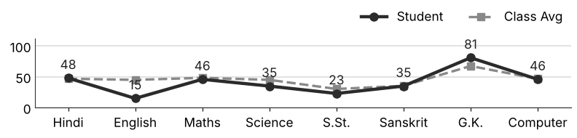
Class Teacher |  | —— Better Education ★ Brighter Future —— |  | Principal

