Principles for Object-Oriented Software Design

The Goals for Software
- Does what the customer wants or what it is expected to do.
- Software is maintainable.
- The software can evolve over time.
- Software is correct, that is, free of defects.
- It is secure.

Choose a Modular Architecture
This is a core recommendation of the UP.

Low Coupling
Coupling means that one thing depends on or uses another. There are several ways coupling can occur. The common kinds are ranked from worst to least bad:
- content coupling - one module or object uses or can modify the data of another object
- common coupling - different kinds of objects depend on the same global data. A change to the data can propagate to other modules and may cause errors.
- external coupling - an object depends on code external to the software. This dependency includes external data formats and external protocols.
- control coupling - one module controls the flow of another such as by passing a flag telling it what to do
- stamp coupling - an object uses another kind of object (module) in its code. It can be a parameter, local variable, or return value.
- data coupling - different objects share data, such as parameter values
All software involves some coupling. The goal of good software design is to avoid unnecessary coupling and coupling to (possibly) unstable code. Coupling between classes that are part of the same component or package is better than coupling to different components.

High Cohesion
All the "responsibilities" or methods of a class should be related to the class's main purpose.

Single Responsibility Principle

https://www.toptal.com/software/single-responsibility-principle

SOLID Principles for Class Design
Robert Martin collected five principles for class design, known as the SOLID Principles. The principles are guidelines to help design software that is modular, reusable, and able to accommodate change.

SRP | Single Responsibility Principle | A class should have only one reason to change.
OCP | Open Closed Principle | A class should be open for extension but closed for modification. You should be able to extend a class's behavior without modifying it.
LSP | Liskov Substitution Principle | Derived classes must be substitutable for their base classes.
ISP | Interface Segregation Principle | Make fine grained interfaces that are client specific.
DIP | Dependency Inversion Principle | Depend on abstractions, not on concretions.

Single Responsibility Principle
A class should have only one reason to change
Many developers say this is the most important principle for the design of good software.
There many articles describing the SRP, and many of them are incorrect.
Please see the articles by Robert Martin for this one. (Links on class web site.) One of them is:
https://blog.cleancoder.com/uncle-bob/2014/05/08/SingleReponsibilityPrinciple.html

Open-Closed Principle
Classes (or modules) should be open for extension,
but closed for modification.
We should be able to modify the behavior of a software entity without modifying the source code. But be realistic: don't over-design for things that are not likely to happen.
How to do it? "The key is abstraction", states Robert Martin.
Consider drawing shapes on a Canvas in the lab on Graphics 2D. The Canvas (drawing area) doesn't depend on a particular shape, like a Ball. Instead we define an interface for drawable shapes (an abstraction). The Canvas depends only on this interface, so we can use it to draw any object that implements the interface (open for extension).
The AWT and Swing graphics use this principle, too. Containers draw Components. Component is an abstract class. You can add new Components as subclasses of Component. You can even change how an existing component works by subclassing it and overriding some methods, like paint and repaint.
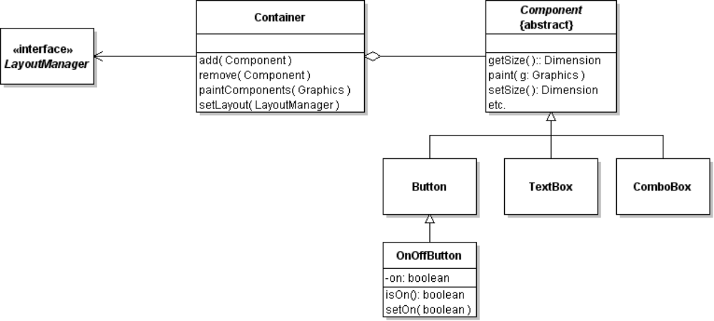
1. Attributes should be private. This prevents unauthorized access (class is closed).
2. The behavior that is open for modification or extension should be defined as an interface or abstract class.
3. For behavior that should not be modified, declare the method as final. Some methods are used by other methods to fulfill a "contract". If a subclass overrides these, it may violate the contract.
A strategy for achieving OCP is "separate what varies from that which stays the same".
Consider the Container in AWT graphics. A Container is responsible for containing a collection of components. How the components are laid out can change -- clearly different applications will want different layouts of components.
AWT handles this by separating the responsibility of arranging and sizing components from the responsibility of managing and painting components (SRP). Then, it encapsulates the layout responsbility in an interface (LayoutManager) and delegates the layout job to a LayoutManager object (the Strategy Pattern).

Liskov Substitution Principle
The LSP is a guideline for when inheritance is valid. OO languages let us use a subclass object anyplace where the application is expecting an object of the parent type. Its up to us to make sure the subclass works correctly. That is, the subclass fulfills the same "contract" as its parent class.
To check the LSP, look at the behavior (methods) of a class and their "contracts":
- the preconditions for using a subclass method should be no stronger than preconditions of the parent class method,
- the postconditions (what is true after a method is called) of subclass method should be at least as strong as the parent class method.
Consider a Stack. A stack has push(), pop(), and peak() methods. After we call push(object) the Stack should contain one more object than before. If the Stack is full, push(object) throws an exception.
Managing a stack is a nuisance because it can overflow. So we write a LeakyStack subclass that looks like a Stack, but is never full. If LeakyStack runs out of space, it just discards the element at the bottom of the stack. Logically, LeakyStack looks like a subclass of Stack but is it a valid Stack subclass according to LSP?
LeakyStack's push() doesn't fulfill the post-conditions of Stack's push(). An application that assumes push() always adds a new element without losing old elements would fail if we used LeakyStack in place of Stack.

Other Principles

Encapsulate what varies
Identify the part of an object that might change and encapsulate it. This is often done by creating a separate class (or interface) for the part that varies, and delegating some behavior to that object.
Purse Strategy Example: the withdraw algorithm may need to change, so we encapsulate the withdraw method in a WithdrawStrategy object. The Purse delegates the withdraw task to this object. We can change the way Purse performs withdraw. Write a new WithdrawStrategy and set the Purse's withdraw strategy to the new one.
Clock Example: How the clock handles a button press depends on what state it is in. So we encapsulate the button actions into a state object. The clock invokes the state object to handle button presses.
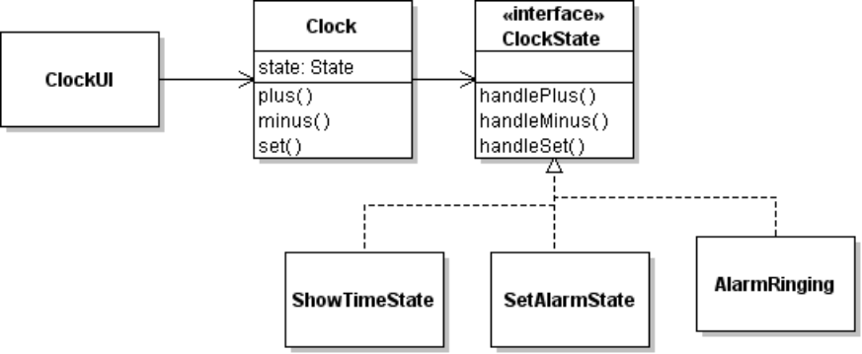

Strive for loosely coupled objects
Objects that are tightly "bound" together are difficult to change. Try to minimize the dependencies between different types of objects. The Program to an interface principle can help.

Program to an interface, not to an implementation
This means program to a specification not an implementation. "Interface" can be an abstract class.
List Example: When our Purse uses a list or returns a list, we declare the parameter or return type to be "List" (the interface), not "ArrayList" (a List class).
Related to this principle is:

Depend on abstraction rather than concrete classes
The Purse depends only on the Valuable interface, not on the type of Valuables. In the Graphics drawing lab, the Canvas depends only on a Drawable Shape, not on a concrete type of shape like Ball.

Concretions should depend on abstractions, Abstractions should not depend on Concretions
The ThaiMoneyFactory in Purse lab is a subclass of MoneyFactory (so it depends on it), but MoneyFactory does not depend on ThaiMoneyFactory or any other concrete subclass. The getInstance() method in MoneyFactory should use properties for the actual MoneyFactory class, or use dependency injection ("set" method).

Information Expert
When you need to decide which class to assign a responsibility to, assign it to the class that has the most information needed to fulfill the responsibility.
Example: In a sales application, which class should compute the total price of a sale?
Since the sale knows all the items in the sale, and each item knows its own price, the Sale should compute the total price.

Command/Query Separation
Command methods ("do something") and query methods ("ask something") should be independent. A query should not change the state of an object.
Example: when you call the Purse getBalance() method, it returns the balance. It doesn't sort the Purse contents or change the Purse in any way.

Favor composition over inheritance
(Here, "composition" means association.)
Example: we could design the Coin Purse to extend the ArrayList class. But it is more flexible (and better encapsulation) to design Purse to encapsulate a List of Coins. The Purse has an attribute that references a List of coins.
We get 3 benefits from this:
(a) we restrict access to the list of coins since it is encapsulated inside the Purse. If Purse extended ArrayList, the user could directly call any methods of ArrayList.
(b) The Purse can extend some other class if we choose (like Observable).
(c) We can change the implementation to something other than ArrayList without any change to the public interface of Purse.

Talk only to your friends
Avoid traversing chains of object references, such as this common way of using JDBC:
ResultSet rs = DriverConnection.getConnection(url).createStatement()
.executeQuery("SELECT * FROM USERS");
Long chains mean more dependencies and more opportunities for failure. A way to avoid this is to provide accessor methods for "distant" objects in intermediates. Long call chains can also be a sign that a "responsibility" has been assigned to the wrong class.

Principles for Class Interface Design
The book Object-Oriented Design and Patterns by Cay Horstmann has 5 principles for class interface design, the "5 C's" for interface design (see Chapter 3). Don't confuse these with the principles of class design listed above.
Cohesion | All methods should be related to a single responsibility or purpose. Horstmann defines cohesion in terms of "methods related to a single abstraction".
Completeness | The class should have enough methods to completely perform its responsibilities.  Example: a List has enough methods to let us insert, remove, or look at any element of the list. It also has a size() method so we know how many elements are in the list..
Clarity | The method names should be easy to understand.  Example: the List method names clearly describe what they do. isEmpty() is much clearer than empty() which could imply a command to "empty" the list.
Consistency | Names should be used consistently. The List has an isEmpty() method, but the same behavior for a Stack is named empty(). That's not consistent.
Convenience | The interface should be convenient for the programmer to use. The Collections have a clear() method that removes all elements. This isn't necessary but makes the collection easier to use. Similarly, instead of  if ( list.isEmpty() ) ...  we could use:  if ( list.size() == 0 ) ...  but isEmpty() is more convenient and easier to understand.

Larman's GRASP Principles
Author Craig Larman describes 9 principles for class design in his book Applied UML and Patterns. Most of these are mentioned above.
1. Low Coupling - try to avoid unnecessary dependency between objects
2. High Cohesion - an object's responsibilities should be closely related
3. Information Expert - assign a responsibility to the class that has the most information needed to perform the responsibility.
4. Creator - this principle helps answer the question "Which class should create objects of type A?" It guides that B should create instances of A if:
- B contains or aggregates the instances of A
- B closely uses A
- B has the values needed to construct A
5. Controller - a controller is the first class that receives an input from the user. A controller's job is to translate and dispatch user input, not handle everything itself.
6. Protected Variations - how to "protect" code from changes in different classes or components. There are many mechanisms, including Indirection, Polymorphism, and Dependency Injection.
7. Indirection. A mechanism of Protected Variations. To reduce coupling between two classes, create an intermediary component with a stable interface. The Adapter Pattern is an example of this.
8. Polymorphism - use polymorphism as a way to reduce coupling and add ability to add new components or new implementations.
9. Pure Fabrication - a class that you invent (out of nothing) to perform a responsibility when no suitable class is found using the other principles. Factory classes are an example.

References
Robert Martin, "The Principles of OOD". Article describes the five SOLID principles. http://butunclebob.com/ArticleS.UncleBob.PrinciplesOfOod. This article has hyperlinks to articles describing each of the 5 SOLID principles.
ObjectMentor.com (web site). Web site of Robert Martin has several articles and book chapters available for download. http://www.objectmentor.com.
Freeman, et al. Head First Design Patterns. O'Reilly (2004). Introduces these principles (sometimes with different names) using entertaining examples.

Famous Books with Design and Coding Principles
Gamma, et al. Design Patterns: Elements of Reusable Object-Oriented Software. (1994) Original design patterns book introduces many of these principles.
Hunt and Thomas, The Pragmatic Programmer (1999). Books contains advice for professional development, important skills, design and code advice. Written as short sections you can read in any order.

