Vision Document Template v1.3

Author: David Ordal

Date: 9/19/06

Vision Document Template

This is a document template which you can use if you’re writing a Vision Document for a software project. Copy the contents of this document into your own, and then work through each section to fill in the necessary information.

The goal of this document is to make sure all the stakeholders in a project are on the same high-level page. For you, the author, that means keeping the document simple and using lots of bullet points, tables and pretty pictures. Otherwise, people won’t read it. If it ends up being more than 2-3 pages, you’ve probably written too much.

We’ve based the contents of the document on a fictional piece of software called FlightView Pro, designed for the airline industry. While the nature and scope of the document are realistic, it is important to note that FightView Pro does not represent an actual piece of software.

Legal
Copyright © 2006 StartupCTO. You are welcome to share and/or redistribute this document as you see fit, provided you comply with the following two restrictions:
- You may not remove the StartupCTO branding or copyright notices from the template. You may remove them from your finished software-specific document.
- You may not charge for this document, or include it in any compilation or product which you do charge for.

All other rights are reserved.

The latest version of this template is available from www.startupcto.com.

<Project> Vision Document

Introduction
In this section, you introduce the product or project. Keep this very clean and simple, one or two sentences at most.

FlightView Pro is a web based application that will let customers monitor real-time status information on aircraft in United States airspace. It is intended to be used by transportation industry professionals who need to know where aircraft are located in flight, how soon they will arrive, etc.

Business Needs / Requirements
In this section, you discuss the reason you are planning to build your product. You’ll want to talk about the problem people are facing, the requirements you need to meet to solve that problem, and the market itself. Essentially, you’re making a case that the product needs to be built.

Currently, people involved in the transportation industry have no good way to monitor the progress of airplanes carrying their goods. In today’s outsourced world, companies such as Ocean Beauty Seafood and American Rainbow Floral Company ship highly perishable goods (seafood and flowers, respectively) on commercial air carriers such as Alaska Airlines and United Airlines.

In order to most effectively use their ground fleet, these organizations need to know when a plane with goods is going to show up so they can send a vehicle to meet it just as it lands. If they’re too early, they pay for driver and truck to sit doing nothing. If they’re too late, their goods spoil.

These organizations need a way to monitor accurate, up-to-the-minute information about their flights so that they can proactively make decisions.

Overview of the Solution
Now, we talk about the product itself. Give a high level overview of the solution and how it meets the needs outlined above. Optionally, you can talk about plans for both this version and future versions, as long as you don’t get too carried away.

FlightView Pro will be a web-based application that provides direct access to real-time FAA radar monitoring and data feeds about airborne aircraft. It will display both geographic location information as well as status info (airspeed, estimated arrival time, etc.)

The product will be designed specifically for customers who need to monitor a set of flights, and will allow them to enter information on flights that contain their shipments, and then see data on those flights in a variety of different ways (by arrival city, by delayed flights, etc. )

In a later version, we plan to have FlightView Pro issue email and text alerts about flight status changes. We will also open up an XML API so that customers can integrate flight tracking data into their own in-house applications.

Major Features (Optional)
This is the section where you outline the features at a high level (a detailed feature outline belongs in the requirements document.) Some people prefer to outline features in the above Product/Solution Overview section, which is also a fine approach. Whatever you do, keep it to bullet points, not paragraphs.

If you can use pictures, so much the better. You might want to use the StartupCTO Interface Design Tool to help you create your mockups – that’s what these were made with.
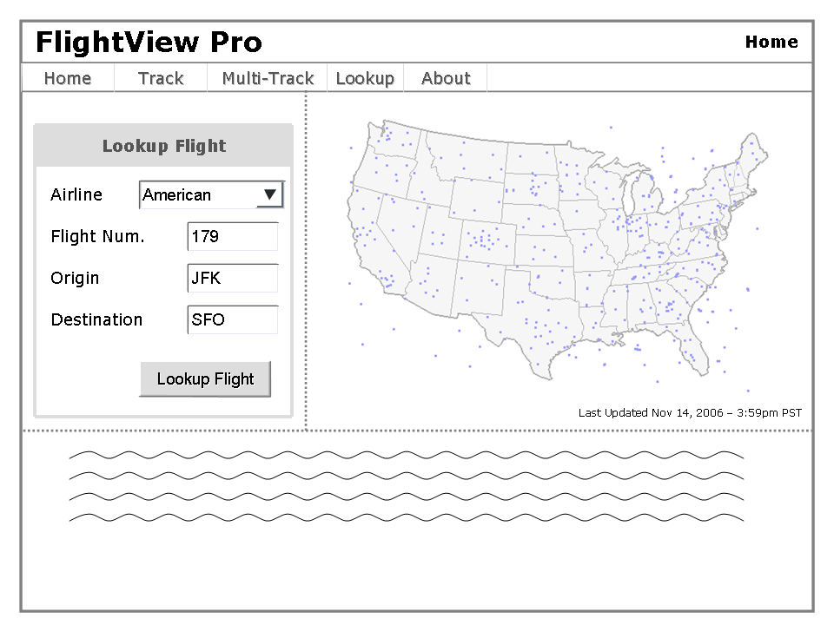
- Home Screen: When users login to the system, they will be presented with a picture showing all aircraft currently airborne in U.S. airspace, as well as controls to access various parts of the software.
- Flight Data Entry Screen: FlightView Pro will need to allow users to enter data (airline & flight number, etc.) about flights which they need to track. Capability should be allowed to enter one flight or multiple flights.
- Flight Display Screen: The software will need to provide a screen for viewing flight status for a particular flight. This should include a map position display, a distance to destination meter, a time to destination meter, and a speed and altitude indicator.
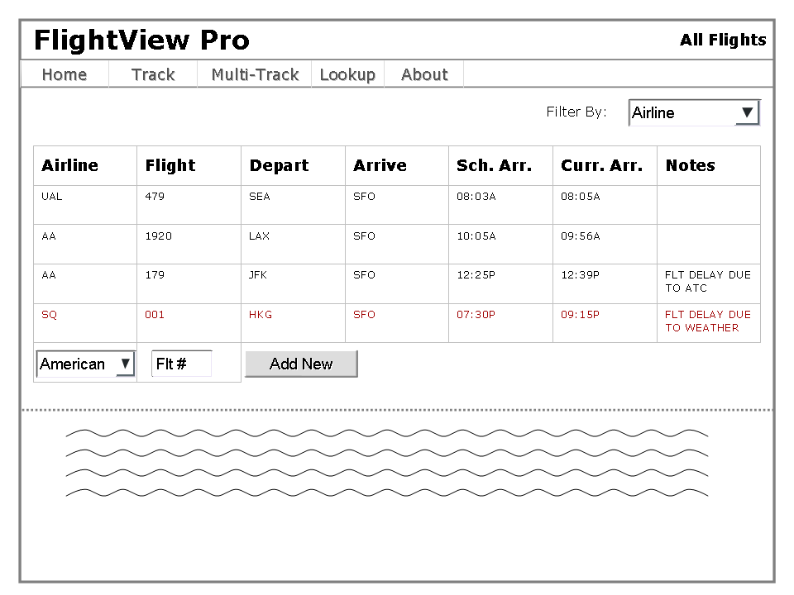
- View All Flight Status: View the status of all flights that the customer is tracking in a spreadsheet like format.
- Filter All Flight Status: Give customers the ability to filter the all flight status screens, so that they can see (for example) just delayed flights, or all flights originating or terminating in a specific city. Exact details of how the filters should work will be determined during the requirements phase.
- (V2) In a later version, the software will automatically interface to airline flight databases and vehicle dispatch systems to get package and flight information automatically, and suggest routing and delays for vehicles to coincide with flight delays.

Scope & Limitations
The Scope & Limitations section is where you talk about what is, and in particular, what isn’t included. This is where you tactfully tell your boss that his pet feature is not going to be included. Yes, this section may generate some arguments, but that’s what its there for. Better to argue now than argue later, after you’ve spent a bunch of money.

The initial version of FlightView Pro will focus on providing services to transportation customers, and will have a set of features designed to appeal to that industry, but not to others. In particular, this means that the software will not have features for the general consumer, such as:
- The ability to see all flights originating or departing from a given airport. Only flights that have been entered into the system can be requested.
- Information on aircraft type, registration number, owner, etc.

Other Needs
Other needs is sort of the ‘miscellaneous’ section. Anything else that you think is important should go here.

Accessibility
FlightView Pro will be designed to be as widely accessible as possible. Therefore, it will not use any modern browser technologies, and should be compatible with FireFox 1.0+ and IE 5+.

Backend
The FlightView Pro backend system will need to interface with FAA air traffic control computers, using its SONUS datafeed. More information on this requirement will be detailed in the construction phase.

