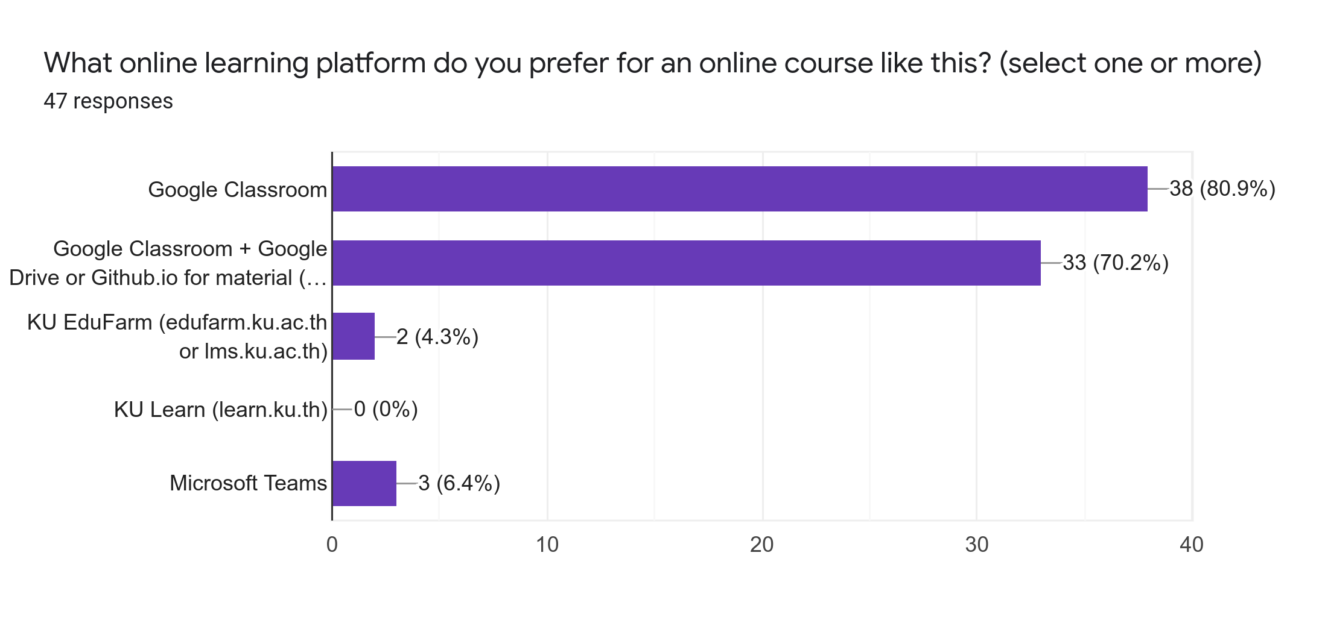

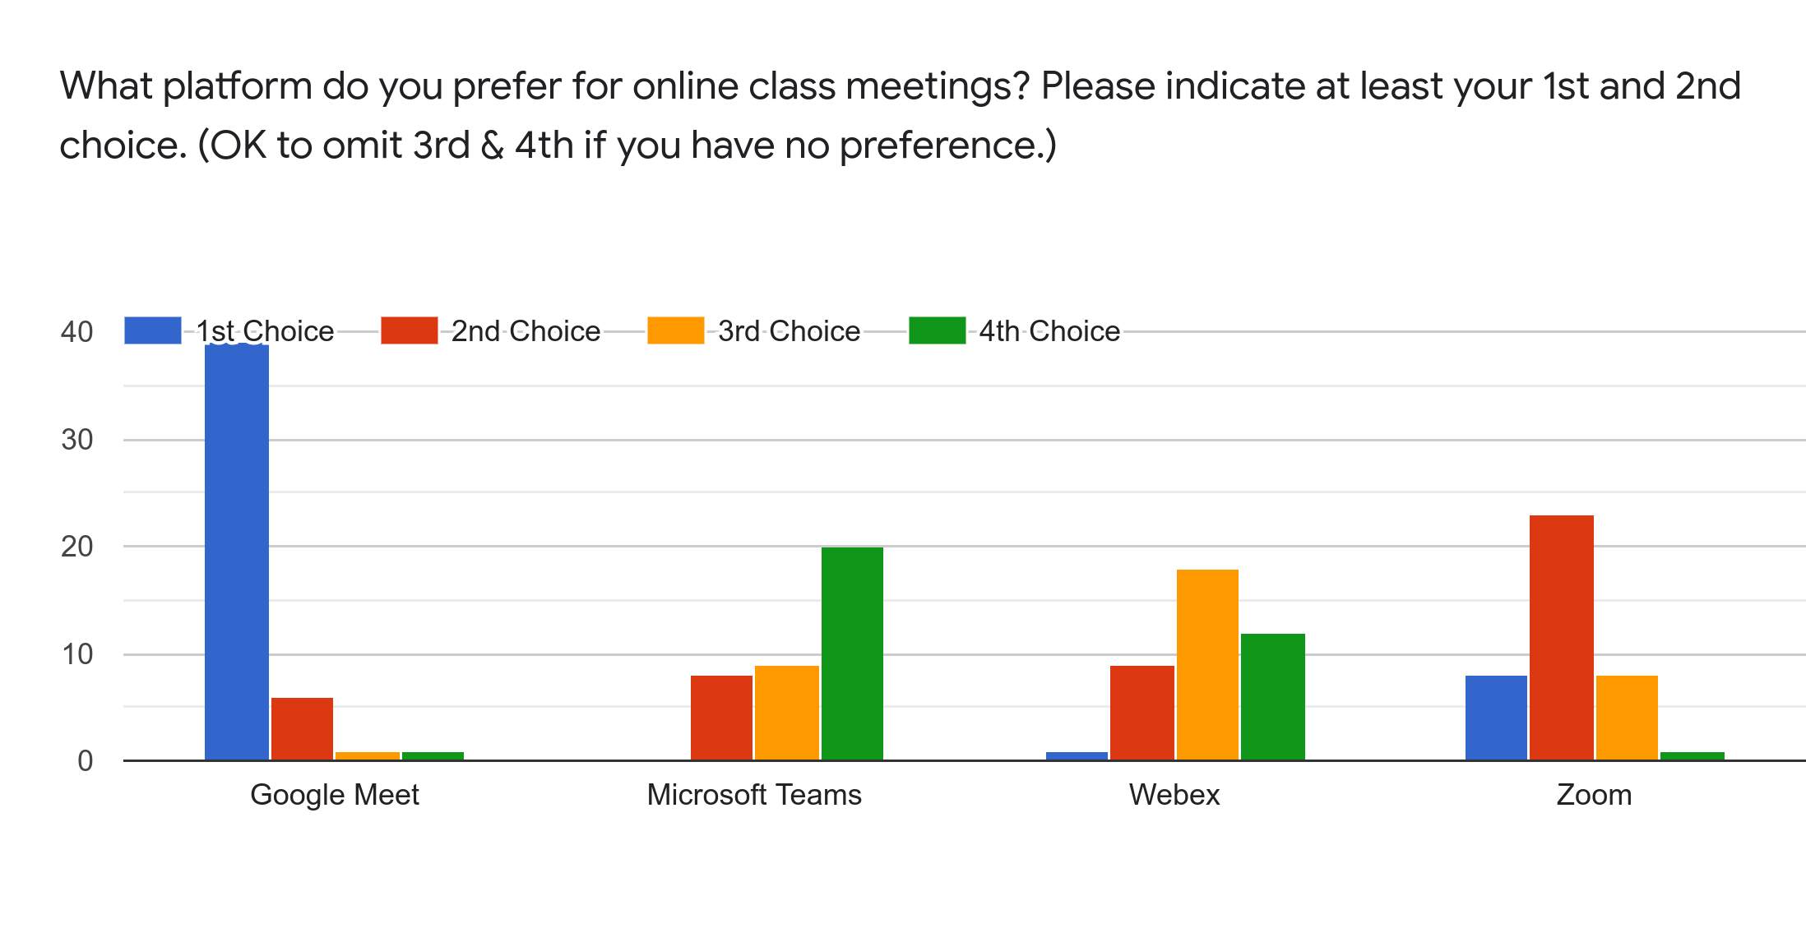
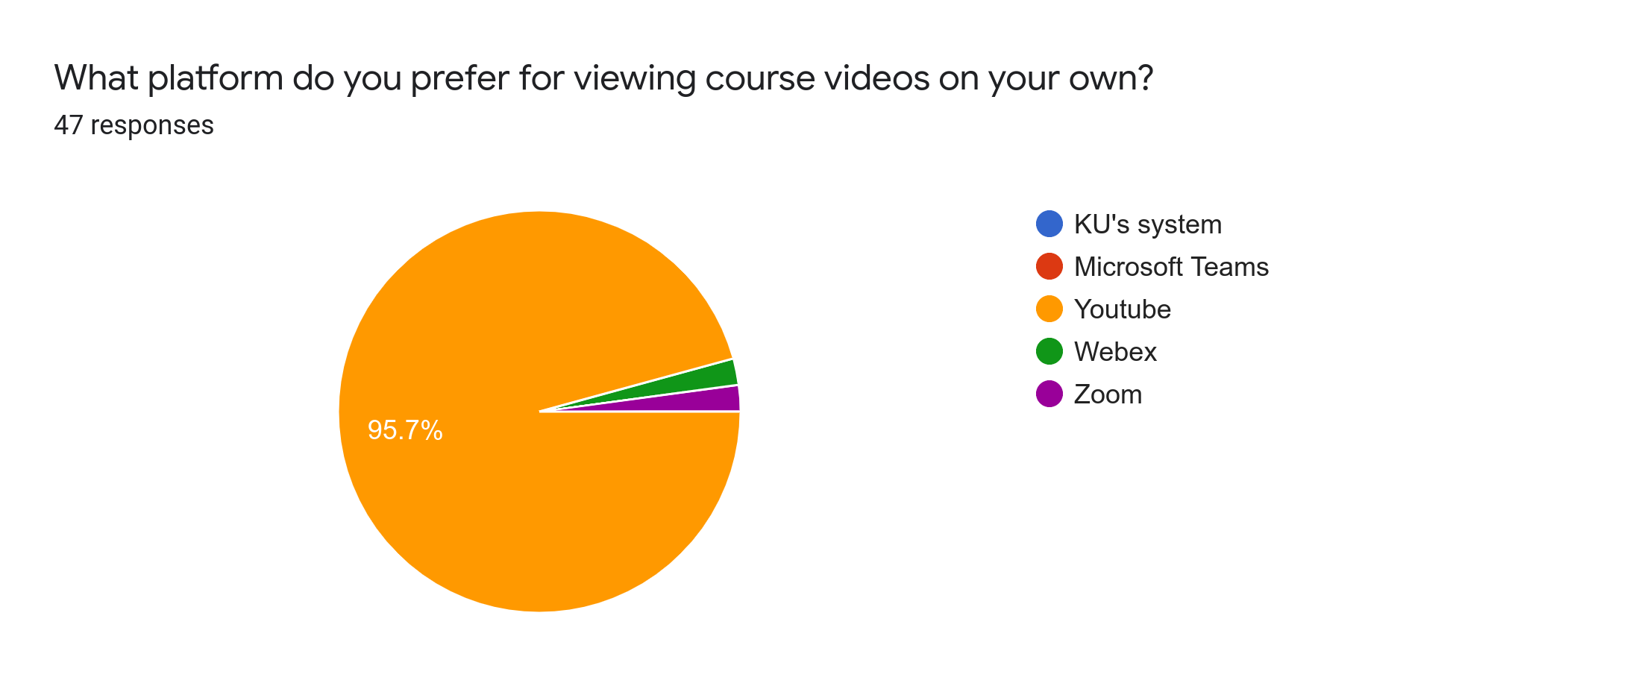

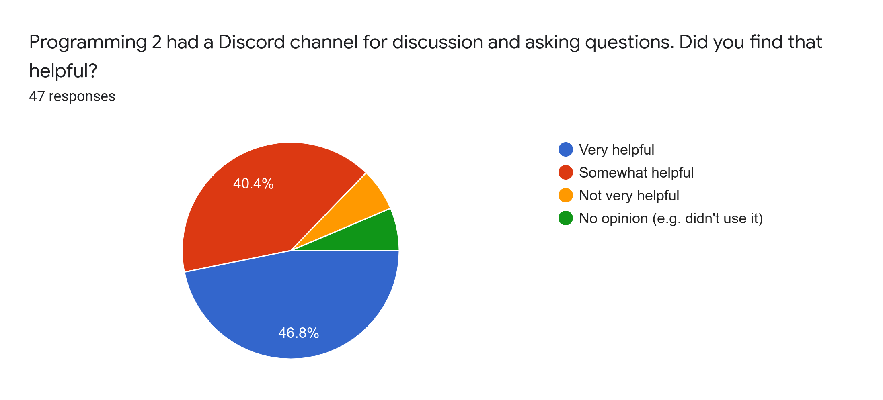

Do you have any comments or suggestions about online courses at KU?

- In my opinion the online courses did not make me understand the whole subject include the participate and more. If it can make it offline for those who have vaccinated it would be great.

- WebEx froze my computer multiple times. I would like to avoid it if possible.

- Can watch backwards

