Lab 6: Unit Converter

Write a Unit Converter for Length units. In a programming assignment you will expand on this to create a general unit converter.

Use an OO-style design with separate classes for each part of the converter
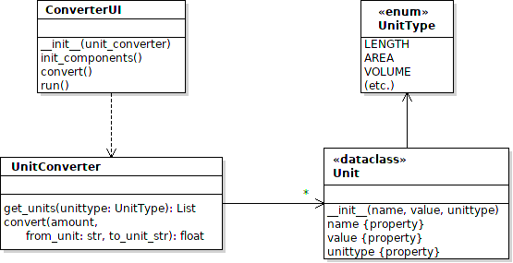

Unit is a class that contains info about one unit: name, value, and unit type. It is implemented as a Python dataclass to reduce coding. (Dataclass requires Python 3.7 or newer.)
UnitType is an Enum, which is a collection of named constants. Using an Enum instead of strings reduces many programming errors. The only type you need for this lab is UnitType.LENGTH

Assignment

1. Write the ConverterUI code. The UI should look something like this:

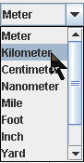
2. Populate the Comboboxes with units obtained from the UnitConverter class.
UnitConverter provides a method to get all the units of a particular type. For the lab, you want unit type UnitType.Length (a named constant).

3. In the UnitConverter class, complete the convert method to convert one unit value to another. Its easy. Just one line of code.

Combobox
See: https://www.pythontutorial.net/tkinter/tkinter-combobox/

You need to use a Control Variable (tk.StringVar or tk.IntVar) in order to get the selected value from the Combobox. For better control over styling, use ttk.Combobox instead of tk.Combobox.

