Exercise: Write a 'grep' function

1. Accept this Github assignment: https://classroom.github.com/a/wgni7xhE

2. Create a file grep.py in this repository. Write this function

grep( string, filename)
"""Print each line in a file that contains the string.

:param string: is the string to search for
:param filename: name of a file
"""

3. Commit & push your code
git add grep.py
git commit -m "add grep utility"
git push

Hints:
1. To open a file use:
file = open("filename", "r") # or open("filename")

2. To check if a line (string) contains a substring anywhere in the string, use this:
import re
if re.search(string, line):
# the line contains the string
You can also use string.index(substring) but that will raise exception if the substring is not found.

Try it: for one of your Python files containing some code, do:

>>> grep("def", "somefile.py")

Example:

>>> grep("def", "wallet.py")
def __init__(self):
def deposit(self, *items):
def balance(self, currency: str) -> Money:
def is_empty(self) -> bool:
def get_items(self):
def withdraw(self, amount: Money):
def withdraw_from(amount, items:):

Solution

import re

def grep(string, filename, linenum=False):
with open(filename, "r") as file:
all_lines = file.readlines()

# iterate over lines in the file
for line in all_lines:
if re.search(string, line):
print(line)

with open(filename, "r") as file:

# iterate over each line in the file
for line in file:
if re.search(string, line):
print(line)

Example: check if the word "fatalaijon" is in the dictionary (a really big dictionary).

What about Capital Letters?
Answer: "re.search" searches for a regular expression, so if you want so search for capital letters do this:

grep("[Ww]allet", "wallet.py")

UML Essentials

Class Diagram - need to know how to express relationships, and what the notation means

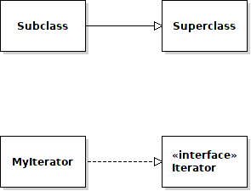
Inheritance

Implements

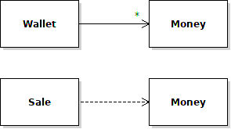
Association

Dependency

