Lab 7: Stopwatch with States, using Event Loop

There are two parts to this lab:
1. Apply the State Pattern to the Stopwatch you did in a previous lab.
2. Create a UI for the Stopwatch that updates itself every 100 milliseconds.

Part 1. State Pattern
The behavior of some objects depends strongly on what "state" the object is in. Parsers (programs that try to interpret files according to some grammar) are an example of this.

The object whose behavior depends on state is called the context. It can greatly simplify programming if you create one class for each state of the the context, and have the context delegate that behavior to the state object.

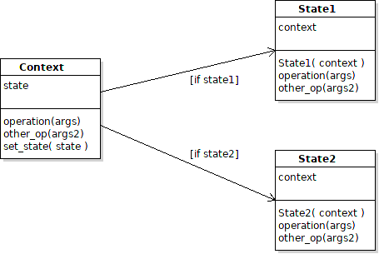

For example, in Context the code for operation would look like:

def operation(self, *args):
# delegate the operation to the current state
# self.state is the current state (could be state1 or state2)
return self.state.operation(*args)

The State Pattern is quite similar to the Strategy Pattern. The states are strategies. A distinct feature of the State Pattern is the context delegates entire methods to states, and the states usually have a way to change the current state of the context (context.set_state or enter_state).

References
Wikipedia State Pattern https://en.wikipedia.org/wiki/State_pattern

In the Stopwatch:
- what are the states of a stopwatch?
- what behavior depends on the state?
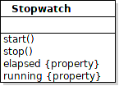

The states are: running and stopped

All the behavior depends on the current state. You can see this in the code; almost every method contains:
if self.running:
...
else:
...
that means the behavior depends on state.

You will apply the State Pattern to the Stopwatch and when you are finished there won't be any "if" statements in the code at all.

To do this, you need to write a RunningState and StoppedState class, and create one instance of those objects in the Stopwatch.

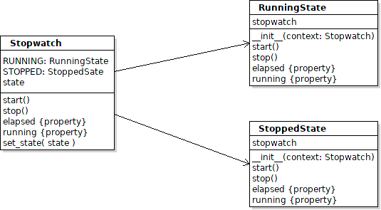

1.1 Define RunningState and StoppedState classes. Each of these classes contains all the methods of the Stopwatch. The code should handle only the case where the stopwatch is running (RunningState) or stopped (StoppedState).

class RunningState:
"""Behavior of the stopwatch when it is in the running state.
The only attribute is a reference to the stopwatch (context),
which the state uses to get attributes of the stopwatch.
Do not define any other attributes here.
"""

def __init__(self, stopwatch: Stopwatch):
# the state needs a reference to the context
self.stopwatch = stopwatch

def start(self):
# in the running state, what to do when start is invoked?
???

def stop(self):
# in the running state, what to do when stop is invoked?
#TODO write the code
# finally, change Stopwatch state to "stopped"
self.stopwatch.set_state(self.stopwatch.STOPPED)

@property
def elapsed(self):
# what is the elapsed time when stopwatch is in the running state?
return ???

@property
def running(self):
# what is the value of running when the stopwatch is running?
return True # obviously

Write the code for StoppedState. It is very similar.
1.2 Add States to Stopwatch.
In the Stopwatch you need to make 3 changes:
- create an attribute for each state (RunningState, StoppedState)
- add a state attribute that always refers to the current state
- modify all the state-dependent methods to delegate their behavior to the current state

class Stopwatch:
def __init__(self):
# a constant for each possible state of the Stopwatch
self.RUNNING = RunningState(self)
self.STOPPED = StoppedState(self)
# set the initial state of the stopwatch
self.set_state(self.STOPPED)
# your original code (may be different from this)
self._elapsed = 0.0

def set_state(self, state):
# change state of the stopwatch
self.state = state

1.3 Modify Stopwatch methods to delegate to the current state.

class Stopwatch:

def start(self):
self.state.start()

@property
def elapsed(self):
return self.state.elapsed

Revise the other methods similarly.

1.4 Test it!

When you are done:
- there should not be any "if" statements in any of the classes
- you don't need the self._running attribute (boolean).

Part 2. Graphical UI for Stopwatch
Write a graphical UI for the Stopwatch that updates every 50-100 milliseconds. The two things you will learn from this part are:
- how to schedule a future event (method call) using after
- use dependency injection to inject a Stopwatch reference into the StopwatchUI. You did this in the UnitConverterUI, too.
Your Graphical UI should look something like this:
