Tax Privileges of Private Clubs
Christian Strommen, 17 Sept 2026

Overview
The US gives nonprofit tax exemptions to clubs organized for their members’ recreation, and to entities that own property for other exempt organizations. While neither is organized with the intent to profit, neither is comparable to a charity. The central question is whether their legal advantages continue to be defensible, who captures the benefits, and potential changes if the advantages were removed.
The evidence generally supports ending the assumption that a separate holding corporation deserves its own exemption simply because its parent organization is exempt. It also supports a serious reconsideration of the broad definitions qualifying for social club tax exemption. It does not support treating every dollar of club assets as untaxed income, describe every club as an enclave of the wealthy, or promise a large federal revenue windfall if exemptions were removed.
Data was aggregated from the IRS’s September 8, 2026 registry which lists 4,075 domestic organizations coded under section 501(c)(2), reporting $17.10 billion in assets, and 46,465 under section 501(c)(7), reporting $44.99 billion. (IRS, 2026) The latest IRS statistical tables were analyzed, with the most recent available dated to 2022. Their estimates for social clubs filing Form 990 and Form 990-EZ together are 16,248 returns, $40.08 billion in assets, $18.97 billion in revenue, and $18.15 billion in expenses. There is not a direct means to derive national membership totals from these data sources. Title-holder entity asset asset value per capita by state is shown in Figure 1. (IRS, 2025b) (IRS, 2025c)
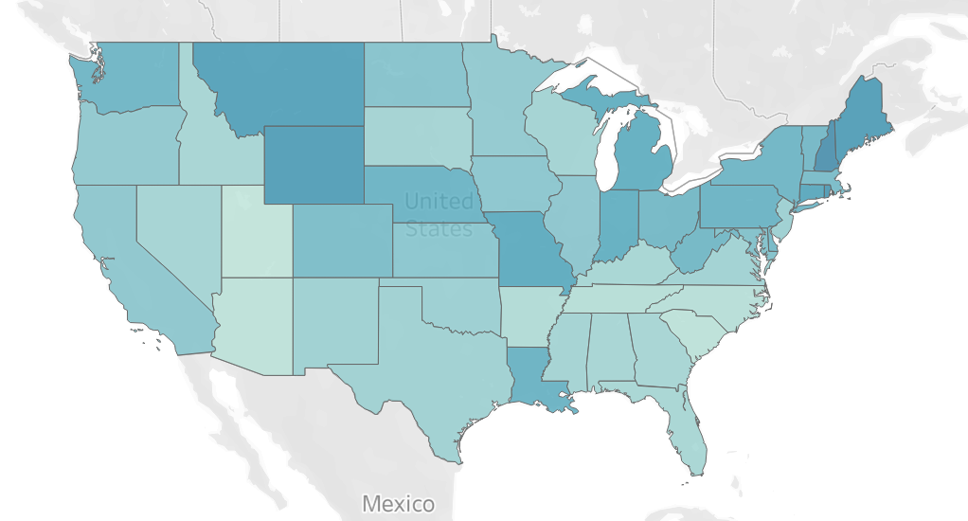
Figure 1: 501(c)(2) Assets per Capita by State
Minnesota’s registry includes 67 title holders with $164.51 million in reported assets, and 573 social clubs with $433.64 million. In addition, the state’s tax expenditure budget estimates that preferential valuation of recreational open-space property (e.g. golf course) shifts $16.8 million of tax burden in FY2026. This only accounts for the state property-tax program, not federal social-club exemptions. (IRS, 2026) (Minnesota Department of Revenue, 2025)
The largest unanswered fiscal question is the national revenue that would actually result from a potential repeal or restriction of these exemptions. Reasonable estimates can be made to quantify the sector and show measurable costs, with the remaining uncertainty strengthening the case for expanded disclosures.

Non-Profit Social Club Holding Corporations
A corporation can have no golf course members, no patients, no students, and no charitable program of its own, yet still be exempt from federal income tax. Section 501(c)(2) provides an exemption for a corporation organized exclusively to hold title to property, collect income from that property, and remit the income after expenses to an exempt organization. Any useful purpose associated with the property comes through the organization it serves. (26 U.S.C. § 501)
A holding corporation structure can be sensible. A hospital may want a separate entity to own buildings. A union may want its meeting hall legally separated from other activities. A fraternity may maintain a housing corporation so ownership can survive generations of students. Keeping an asset in a separate legal entity can organize governance, financing, and risk, but none of those functions by itself proves that a second federal exemption is necessary.
This purely structural middle layer forms a common argument for repeal of exempt status. Proponents argue to make the tax treatment follow the underlying activity and beneficiary, rather than grant a freestanding status to the ownership container. If the underlying organization performs an activity Congress has decided to exempt, a structured replacement entity could maintain the same tax treatment while requiring the property’s ownership and use to be visible. If the underlying activity does not deserve favorable treatment, its associated assets’ tax treatment will be brought into alignment with the activities of the organization.
While I have used golf courses as an example multiple times already, this is not meant to serve as a direct accusation of wrongdoing on the part of these organizations. A 501(c)(2) is not inherently an tax shelter, and it is not exclusively used by country clubs. Its parent can be a charity or any other kind of exempt organization. The governing rules broadly confine it to passive property holding and restrict unrelated business activities. The title holder’s net income must flow to its exempt, end beneficiary, it cannot accumulate profits for private shareholders. (IRS, 2025e)
Separate ownership also does not mean that money becomes tax free merely by crossing an organizational boundary. Ordinary rental exclusions have exceptions, including debt-financed income rules. Social clubs face special ‘unrelated income’ rules, and when a title holder and its exempt beneficiary meet the requirements for consolidated filing, the tax provisions can treat them as one organization. Claim that the pairing automatically tax washes club investments or income from non-members free of tax is too broad. (26 U.S.C. § 512) (IRS, 2021)
My overall objections concern accountability. A corporation whose justification is entirely derivative should have to show clearly what it owns, who is the beneficial owner, and why its treatment should differ from other structures of owning the same property.

National Asset Figures
The usual research obscures the scale of the title-holding sector. The IRS publishes convenient statistical tables for several exempt categories, but its table covering sections 501(c)(3) through 501(c)(9) does not cover section 501(c)(2). The absence of aggregated data is an administrative limitation but does not limit access to the underlying filings. Our strategy was to aggregate the available records but disclose their limitations. (IRS, 2025b) (IRS, 2023)
In this data, all four regional files of the IRS business master file were combined. The analysis selects entities coded under subsection 02 or 07, with a filing address in the 50 states or District of Columbia and an exemption status of 01 or 02. Filtering for the relevant data produces the following national totals. (IRS, 2026)
Table 1: Organization Asset Totals
Measure | Title holders | Social clubs
Organizations in the domestic registry scope | 4,075 | 46,465
Sum of reported book assets | $17.101 billion | $44.990 billion
Records reporting positive assets | 2,504 | 16,973
Records reporting zero assets | 1,448 | 24,991
Records with missing assets | 123 | 4,501
Share of reported assets in largest 100 records | 58.2% | 19.5%
Source: Original calculations from the IRS 8 Sept 2026 business master file, combined financial periods. (IRS, 2026)
The $17.1 billion in assets for title holder organizations is substantial, but it does not account for the market value of all property held by all such structures. An old building may be carried at historical cost less depreciation. Appreciated land may be worth more than its carrying value. A holding entity may instead report an interest in a subsidiary, and a combined return can complicate attempts to count the underlying economic asset only once.
Concentration is nevertheless revealing within the reported data. The largest 100 title holder records account for about 58% of the category’s reported assets. That suggests a relatively small number of large entities deserve close examination. One of the largest records leads away from the country-club narrative. Knickerbocker Edens LLC reported approximately $1.72 billion in assets in its 2024 return and described a property-holding purpose connected to NYSTRS, the New York State Teachers’ Retirement System. We cannot attribute the entirety of the $17.1bn as a golf subsidy, as evidenced by my 33 handicap. This example illustrates why parent organization identity matters as much as entity size. (Knickerbocker Edens LLC, 2025)

Balance Sheets to Brick and Mortar
Accounting categories only give a loose definition of the underlying assets. “Land, buildings, and equipment” can mean a hospital building, fraternity bedrooms, a union meeting hall, a golf course, or a clubhouse kitchen. “Investments” can include a financial interest in an entity that itself owns real estate. The first category is concrete but broad, while the second can hide the same physical property one organizational layer below.
To examine composition, we used the IRS annual extract for returns processed in calendar year 2024. It matches filings to the current domestic registry by employer identification number and subsection, keeps the latest financial period per organization, and separates full Form 990 returns from the shorter Form 990-EZ. This produces a matched title-holder cohort of 2,239 organizations with $15.17 billion in assets. Of these, 1,811 full form filers provide the detailed balance-sheet categories needed for the following calculation. (IRS, n.d.-e)
Table 2: Title-Holder Organization Asset Breakdown
Asset category | Title-holder full-form cohort | Share
Land, buildings, and equipment, net | $10.262 billion | 68.0%
Program-related investments | $1.501 billion | 9.9%
Other assets | $1.205 billion | 8.0%
Publicly traded securities | $0.632 billion | 4.2%
Other securities | $0.434 billion | 2.9%
Cash without interest | $0.394 billion | 2.6%
Savings and temporary investments | $0.309 billion | 2.0%
Receivables, inventories, and prepayments | $0.283 billion | 1.9%
Intangible assets | $0.069 billion | 0.5%
Source: Original calculations from the calendar-2024 processing extract, matched to the September 2026 registry. (IRS, n.d.-e)
The data supports the claim that directly reported property and equipment dominate this cohort. They do not support the earlier suggestion that “90% or more” of all title-holder assets are real estate.
Specific examples make the range easier to understand. Minnesota’s Sigma Chi Building Association describes housing for a collegiate fraternity and interaction between students and alumni, with its return for the year ending August 2025 reporting about $2.29 million in assets. Laborers 563 Building Corporation describes ownership of headquarters for the local union. Hospital Properties Inc. describes property support for OhioHealth. These are housing and institutional infrastructure, not really examples of private luxury. (Sigma Chi Building Association, 2026) (Laborers 563 Building Corporation, 2025) (Hospital Properties Inc., 2026)
Other permitted property can include office buildings, shopping centers, apartments, securities, and passive property rights. IRS guidance distinguishes passive holding from operating a business, and its rules address real, personal, and intangible property. (IRS, 2025e) (IRS, 1981)
The most useful concrete inventory is organized by who uses the asset, for example a hospital’s buildings, a union’s offices and meeting rooms, a fraternity’s bedrooms and common areas, a club’s golf course, docks, courts, locker rooms, and dining rooms, and income-producing commercial property held for another exempt beneficiary.

Beneficial Ownership
We need to be careful when using the phrase “beneficial owner”. In an ordinary investment company it often means a person with an ownership claim. In an exempt organization, the people who enjoy the services, the people who control the board, and the people entitled to residual property can be different. Combining those roles into a single imagined owner makes the distributional analysis less accurate.
A hospital property holder may ultimately benefit patients, staff, and the institution that provides care. A union building serves an organization whose members are workers. A fraternity house serves students and its alumni network. A country club serves its admitted members and their guests. Employees and suppliers can benefit economically from each of these arrangements without having governance rights or any claim to the assets.
An exempt title holder can even have natural-person shareholders. IRS instructions contemplate capital stock, and a revenue ruling accepted a fraternity housing corporation with stock held by individuals under conditions that denied them dividend or liquidation-profit rights. The underlying question is what those shares entitle a person to receive, not whether they hold shares in the holding entity. (IRS, n.d.-a) (IRS, 1968)
Social clubs add another complication. A longstanding IRS ruling holds that distributing property to members on a club’s liquidation does not by itself defeat the club’s exemption. That does not mean the distribution or asset sale is free of every tax, and the ruling predates the modern unrelated-business-income regime. Bylaws, state laws, membership contracts, and tax consequences govern this transfer/transaction. (IRS, 1958) (26 U.S.C. § 512)
For distribution purposes, four separate questions should replace the search for a single underlying owner.
- Who gets access?
- Who decides admission and spending?
- Who pays for the organization?
- Who can receive money or property if it dissolves?
The federal information return provides some financial and governance evidence. It does not provide a standardized national membership roster with members’ incomes, wealth, race, sex, age, or household relationships. The data in this dossier cannot establish a typical member’s income or a national demographic profile, despite how interesting the data would be. (IRS, n.d.-b)
That limitation does not make membership unknowable in every case. Published (or rumored) entrance prices show an economic barrier. Family eligibility rules show a mechanism by which access can continue across generations. Governance provisions show whose preferences determine the use of capital. This gives a general picture of membership on a club-by-club basis, although it would be much more interesting to know the answer to “who is really in these clubs?” Unfortunately, I don’t have a good answer for you here.

Retiring the Title Holding Exemption
The case for a narrow repeal administrative and structural. Congress would require proponents of section 501(c)(2) to identify the functions that cannot reasonably be supplied through direct ownership or a transparent subsidiary whose tax treatment follows its owner. Form 990 instructions generally require an exempt owner to include a disregarded entity’s activities in its own return. Those rules provide an existing model for integrating financial accountability directly. (IRS, n.d.-c) (IRS, n.d.-b)
Likely not every existing title holder entity can convert immediately without cost. Lender covenants, state transfer taxes, property-tax classifications, pension structures, title restrictions, and the entity’s specific tax position may complicate conversion. Congress would need to close the category prospectively, provide a transition, and prevent the transition itself from generating an unintended tax penalty. The preservation of legitimate liability separation should be an explicit design requirement.
The advantage of such reform would be clearer attribution of ownership of these assets. The financial results of a property vehicle would be tied more directly to the beneficiary whose exemption supplies the justification. Related entities would disclose their relationships and avoid implying that the same economic asset represents separate public benefits at each organizational level. Policymakers could then evaluate the underlying activity that receives favorable treatment rather than the sprawl of entities surrounding it.
The likely revenue effect is much less certain. If an exempt hospital can hold the property directly or through a disregarded entity with substantially the same tax result, repealing a separate title-holder category may raise little revenue from that arrangement. That would not make simplification worthless, it would mean that the simplification should be defended primarily as simplification, not sold as a large untapped source of tax revenue.
The objection becomes sharper when the recipient is a social club. Once the property-holder wrapper is stripped away, the investigative public may ask further questions. Why does the activity of the club itself deserve an exemption?

The Social Club Exemption
IRS section 501(c)(7) covers clubs organized for pleasure, recreation, and other nonprofitable purposes, subject to statutory conditions. It is a separate category from charitable organizations. Its members do not need to provide services to the general public in order to benefit from the club’s shared activities and assets. Contributions to such a club generally do not qualify as charitable deductions. Calling the club “nonprofit” only refers to its legal and financial organization, not that its central purpose is philanthropy. (26 U.S.C. § 501) (IRS, 2025d)
The historical rationale was mutuality. If a group of people pools money they have already earned to pay for their own recreation, a second tax at the association level may be hard to justify. Friends sharing the cost of a rented room do not ordinarily regard the unspent balance in the envelope as commercial profit. Organizing a modest club can be understood as a more durable version of that arrangement. IRS historical guidance describes the exemption in terms of members collectively providing recreational facilities with their own funds. (Langley & Rosenberg, 1996)
Weak repeal arguments assume that all favorable treatment is a subsidy for charitable work, then condemns social clubs for failing a test their category was not designed to meet. Stronger arguments asks how far the pooling rationale should extend when organizations accumulate substantial property, operate elaborate hospitality businesses, and control access to scarce recreational land.
Existing law already draws a distinction between member activity and revenues from non-members. Social clubs generally owe unrelated-business income tax on investment and nonmember income, subject to the detailed rules and deductions. The familiar 35% outside-receipts guideline, including a limit of 15% for public use of facilities or services, concerns continued qualification for exemption. It is not permission to receive that income tax free. Exceeding the guidelines requires further facts-and-circumstances analysis. (IRS, n.d.-d) (IRS, n.d.-l)
In the IRS’s published 2018 table, 3,361 social-club unrelated-business returns reported about $562.8 million in gross unrelated income, and 1,998 returns reported a total of $16.35 million in tax. The same table records $821,000 of tax for title-holding corporations. (IRS, n.d.-f)
The problem is the boundary of member mutuality. Does the same argument apply equally to a volunteer group pooling hundreds of dollars, a fraternity maintaining a house, and a club with a nine-figure balance sheet? If the answer is yes, it needs a principle more specific than tradition. If the answer is no, Congress needs a rule that separates them without making ordinary association needlessly difficult.

Clubs and Activities
For tax year 2022, the IRS estimates 9,877 full Form 990 returns and 6,371 Form 990-EZ returns. Together, they account for about $40.08 billion in assets and $18.97 billion in annual revenue. The shorter 990-EZ returns contribute approximately $760 million of assets and $529 million of revenue. Large, full-form reporting organizations dominate the financial totals even though a much broader population appears in the registry. Exempt social club registrations by state is shown in Figure 2. (IRS, 2025b) (IRS, 2025c)
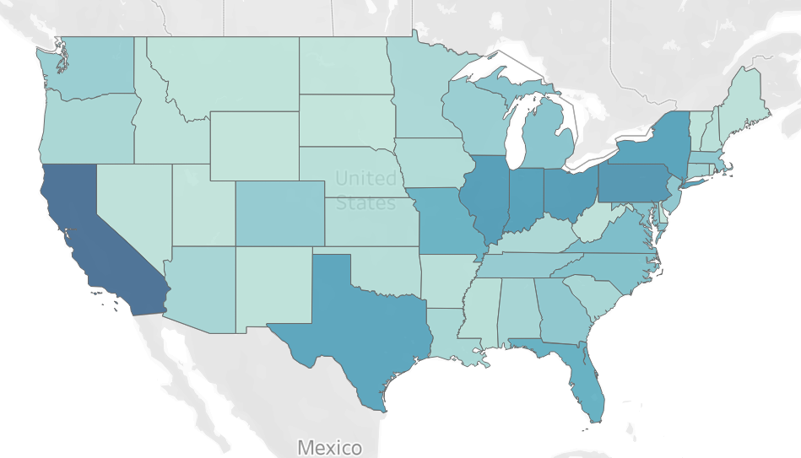
Figure 2: Registered 501(c)(7) Organizations by State

Table 3: Social Club Assets, Revenue, and Expenses by Year
Tax year | Estimated full Form 990 returns | Assets | Revenue | Expenses
2015 | 9,322 | $27.411bn | $13.573bn | $13.186bn
2018 | 9,042 | $29.672bn | $14.935bn | $14.113bn
2019 | 9,257 | $31.297bn | $14.589bn | $14.179bn
2020 | 8,362 | $33.222bn | $14.052bn | $13.154bn
2021 | 9,268 | $36.565bn | $17.169bn | $15.624bn
2022 | 9,877 | $39.317bn | $18.439bn | $17.643bn
Source: IRS Table 3 for each year, full Form 990 only, missing 2016 and 2017 observations. (IRS, n.d.-g) (IRS, n.d.-h) (IRS, n.d.-i) (IRS, n.d.-j) (IRS, n.d.-k) (IRS, 2025b)
The trends support the finding of a financially substantial sector, but does not show that every club’s wealth increased by the same percentage. Inflation, changes in the filing population, accounting differences, and pandemic disruption affect the comparison.
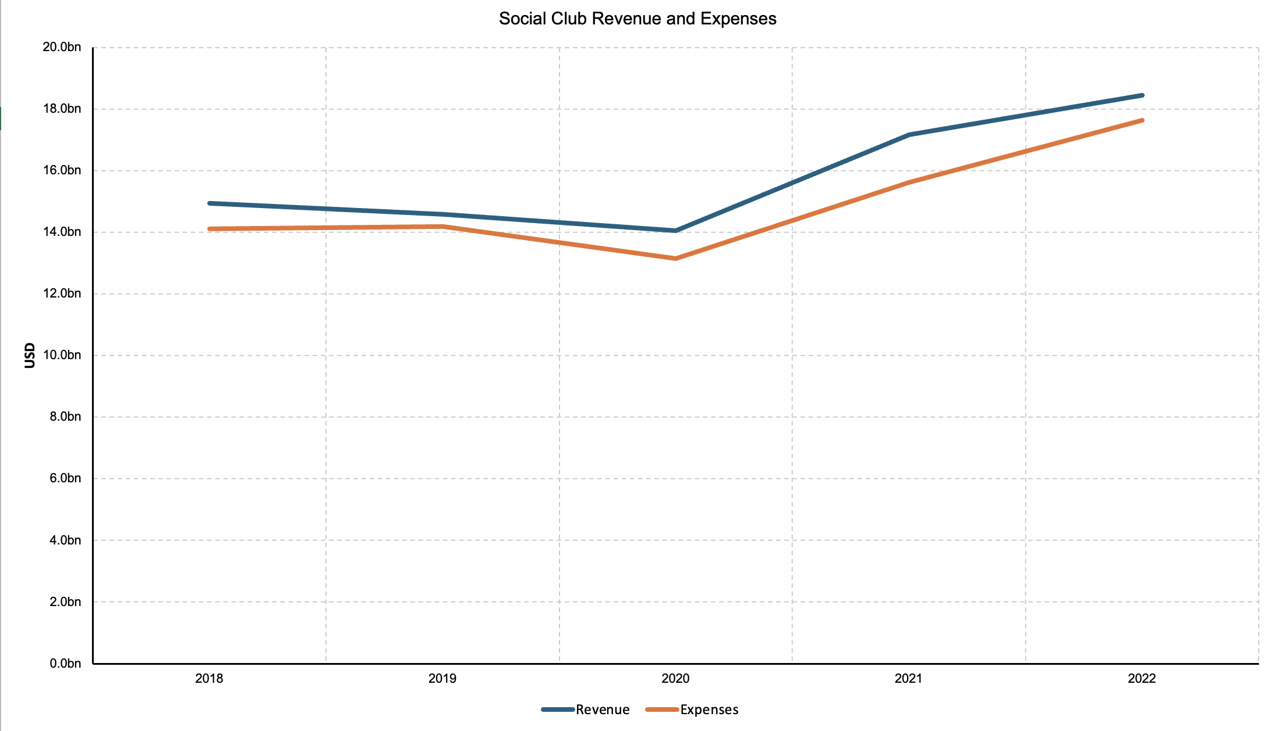
Figure 3: Social Club Revenue and Expenses, selected IRS tax-year estimates

The matched administrative filing data provides a different view of scale. Among 14,867 social clubs with a latest return in the 2024 processing dataset and a current matching registry classification, median revenue is $183,541 and median assets are $268,777. This shows that a nine-figure country club is a consequential extreme rather than a typical description of the median filer. (IRS, n.d.-e)
The registry’s revenue distribution reinforces the distinction. Only 586 records report revenue of at least $10 million, while 2,358 report between $1 million and $10 million. Together these 2,944 records account for about 86.4% of the reported revenue total. (IRS, 2026)
Determining membership is much harder. A count of returns cannot be simply multiplied by an assumed average club size to produce a total membership number. Membership may be individual, household, seasonal, junior, nonresident, or social-only. A person may belong to several clubs, and a fraternity’s alumni may overlap with another organization’s participants. A membership estimate would need to report both membership units and unique individuals. Our data sources do not provide enough information for us to make that estimate.

Membership Revenues
The IRS’s 2022 full-form social-club totals show $13.09 billion in program-service revenue, about 71% of all revenue shown in Table 3. Net inventory sales contribute another $2.48 billion. The $1.93 billion in contributions includes a separately reported noncharitable membership-dues component, not to be mistaken for public charitable generosity. Clubs can report transactional dues and fees in program-service revenue, so the membership-dues line does not represent a national dues total. (IRS, 2025b)
In plain English, these organizations sell or jointly finance access to activities that require use of large, shared assets, think golf, tennis, swimming, sailing, flying, meals, rooms for events, recreational equipment, student housing, and gatherings around shared interests. The IRS’s recognized examples extend beyond country clubs to hobby organizations and college fraternities and sororities. A nationwide story that illustrates only manicured golf courses leaves out much of the legal category. (IRS, 2016)
Full-form filers reported $17.64 billion in 2022 expenses. Categories that can be seen as compensation, officer and other reported wages, benefits, pensions, and payroll taxes, sum to about $7.77 billion. Occupancy costs totaled about $2.20 billion and depreciation about $1.77 billion. These organizations employ people and maintain expensive physical facilities necessitating real activity even when access is private. (IRS, 2025a)
Consider an example local to myself which is far from luxury golf. Twin City Radio Controllers publishes a 2026 regular or family annual membership price of $105, with an early-payment price of $90. Its schedule also offers junior membership. Separate Academy of Model Aeronautics membership is required, and online payment carries a fee, so $105 is not a universal all-in cost of participation. It is a textbook example of people pooling funds around a shared recreational interest. (Twin City Radio Controllers, 2026)
At the other end of the spectrum, a club-issued 2026 Desert Mountain schedule lists a $250,000 golf initiation fee and $2,472 in monthly golf dues. Twelve months of dues total to $29,664, before a $2,500 annual food and beverage minimum and other charges. This is a far cry from a local radio control aircraft club pooling $100 each per year to maintain a flying field. (Desert Mountain Club, 2026)
The contrast illustrates breadth of the category, largely independent of the price of admission/membership or the activities it serves. The two organizations offer different facilities and services. Yet Congress assigns both to a legal category justified in part by members pooling resources for recreation.

Minnesota and Private or Public Benefit
I’d like to use some local examples, as this article was mainly inspired by watching a Rolls Royce pull into the private country club across from my apartment in an area where land values continue to notch record highs.
Not at all related, The Minikahda Club’s return for the year ended March 2025 provides a detailed local example. It reports $27.27 million in assets, $18.04 million in revenue, and $14.90 million in expenses, leaving a $3.13 million accounting surplus. Its calendar-year employee count is 363, which is a headcount rather than a full-time-equivalent measure. Compensation, benefits, and payroll taxes reported in the return’s summary total approximately $9.88 million. (The Minikahda Club, 2026)
The revenue detail makes the activity tangible. Membership dues of about $8.08 million, capital dues of $1.80 million, initiation fees of $1.47 million, and golf operations of $1.62 million appear as specific program-service categories. This is an institution whose members support both current recreation and the continued financing of facilities. The return also reports about $1.09 million in unrelated-business revenue and $35,000 in net unrelated-business taxable income, showing that revenues are overwhelmingly generated from internal membership activities. (The Minikahda Club, 2026)
The club’s Schedule O describes several membership classes and associate eligibility for certain children and spouses under stated conditions. Such provisions supply a concrete basis for discussing family continuity in access. We cannot establish the wealth or demographic composition of the entire membership, prove unlawful discrimination, or show that every child has an unconditional right to join. The discussion that should be focused in as to whether publicly favored organizational treatment should require a clearer account of the people and access rights it supports. (The Minikahda Club, 2026)
Convenient to my analysis, Minnesota allows for more visibility that other states with regards to land use. Under the Open Space Property Tax Law, qualifying recreational property is valued according to its recreational use rather than its potential conversion to other uses. Eligibility includes specified recreational activities and conditions concerning acreage, operation, membership, and access. The statute also addresses sex and marital-status discrimination and generally provides for additional taxes when property ceases to qualify, subject to limits and exceptions. This can act as a window to enforce public control over membership and activities. (Minn. Stat. § 273.112, 2025)
This program is not restricted to 501(c)(7) clubs. Publicly accessible facilities and other qualifying operators can benefit from the same arrangement. This is not a blanket exemption from property tax, it is a valuation preference meant to encourage recreational and open space uses. Now, is a private golf course really a recreational and open space by the spirit of the law? That is not for me to interpret.
The state’s 2024 tax expenditure budget (revised in January 2025) reports approximately 290 benefiting parcels in 2024 and estimates the following shifts in tax burden. (Minnesota Department of Revenue, 2025)
Fiscal year | Estimated shift in tax burden
2024 | $15.9 million
2025 | $15.9 million
2026 | $16.8 million
2027 | $17.5 million

The distinction between a burden shift and lost revenue is very important here. Where taxing jurisdictions raise a set levy, reducing one property’s taxable value can increase the share borne elsewhere rather than reduce the amount collected. If a parking lot is able to reduce its tax valuation and in turn reduce total tax paid, that forces tax rates to be raised in other places, possibly the houses down the street. The state labels this estimate a shift in tax burden. (Minnesota Department of Revenue, 2025)
Households do not need to lose access to a public program for a preferential assessment elsewhere to affect its tax bill. The public may be helping sustain privately enjoyed land through how the levy is divided. To justify that decision, the state should be able to explain what recreational access, ecological benefit, or other public value it receives in exchange, and who those benefits should be made accessible to.

National Extremes
Desert Mountain’s 2024 filing reports $203.31 million in assets, $108.29 million in revenue, and $95.45 million in expenses. Its $12.84 million accounting surplus demonstrates that a member-oriented exempt organization can operate on a scale that would look substantial in many commercial sectors. It is important to not that I am not alleging tax evasion on the part of the organization, they actually operating within the limits of the law as written here. This is purely a reason to ask whether the mutual-pooling rationale alone adequately justifies the breadth of the exemption. (Desert Mountain Club Inc., 2025)
The well-known Los Angeles Country Club illustrates the limits of using book figures as a measure of either wealth or tax cost. Its return for the year ending September 2024 reports $98.17 million in assets, $29.16 million in revenue, and $35.02 million in expenses. Despite the resulting $5.85 million accounting deficit, the summary reports $361,994 in net unrelated-business taxable income. (The Los Angeles Country Club, 2025)
The USGA describes the Los Angeles club as occupying roughly 320 acres. A large private recreational site in an expensive metropolitan setting raises an obvious opportunity-cost question from a land use perspective. The relevant alternatives could remain recreation-oriented, favoring more public access, conservation, housing, or other uses. Of course, feasibility depends on zoning, infrastructure, environmental constraints, ownership rights, and political decisions, but the location of the acreage alone would likely prompt significant capital investments towards these alternative uses. (United States Golf Association, n.d.)
California’s constitution separately provides a current-use assessment rule for qualifying nonprofit golf courses of at least 10 acres that have been used for that purpose for at least two years. The state assessor guidance explains the interaction of golf-course valuation rules and the wider assessment system. Similar to Minnesota, these are state property-tax rules not created by federal section 501(c)(7). (Cal. Const. art. XIII, § 10) (California State Board of Equalization, n.d.)
This seems to be a common trend nationally, large privately controlled recreational land, costly access, substantial club finances, and a state policy that can privilege the existing use. These examples are extreme in scale and access cost. Again, these organizations are operating well within the definitions of state and federal laws, but I wanted to use each to highlight a real-world use case of the social-club exemption and the associated land-policy questions.

Federal Tax Cost
It really is tempting to try to convert an asset total into a tax estimate. In reality, corporate income tax applies to taxable income, not to every dollar of assets each year nor any unrealized gains on those assets. Taxing a $17.1 billion balance sheet at 21% would be an invented wealth tax, not a realistic revenue figure hypothetical for repealing an income-tax exemption. The current federal corporate income-tax rate is 21%, but the rate alone tells us nothing about the applicable tax base. (26 U.S.C. § 11)
A more realistic estimate would be to multiply each organization’s accounting surplus by 21%. In the IRS’s 2022 full Form 990 social-club table, revenue exceeds expenses by $795.34 million. Multiplying that number by 21% produces $167.02 million. Including Form 990-EZ produces a combined surplus of $817.224 million and an arithmetic product of $171.62 million. (IRS, 2025b) (IRS, 2025c)
There are a few inaccuracies in this estimation, both relating to the supposed income figure that would be taxed. Firstly, some income from exempt organizations is already taxable, an example being revenue derived from non-members over the prescribed threshold. Secondly, accounting income and taxable income differ, and organizations may choose different methods of realizing income if tax circumstances were different. Capital expenditures, depreciation, contributions, gains, and the treatment of member receipts do not necessarily move through the two systems identically. Thirdly, one entity’s loss does not ordinarily cancel another independent entity’s taxable profit. A sector’s net surplus conceals the distribution of positive and negative results. Fourth, repeal would change accounting choices, legal form, and possibly the way charges are structured.
The matched filing cohort demonstrates the third problem directly. Its 14,867 social clubs have a combined accounting surplus of $896.89 million, but the sum of each organization’s positive surplus is $1.563 billion. The negative results at other organizations explain the difference. Applying 21% produces approximately $188.35 million in the first calculation and $328.17 million in the second. (IRS, n.d.-e)
Separate title holder organizations create additional difficulties. Payments to an exempt parent are central to their qualification, but an obligation to remit money does not make every such payment deductible in a hypothetical taxable corporation. Conversely, direct ownership or a different entity structure may preserve some existing tax exclusions. A more accurate estimate for a hypothetical repeal scenario must model both the deductions that would actually be allowed and the reorganization options that would actually be used. (IRS, n.d.-a) (IRS, 2025e)
Taxable membership organizations also have their own additional rules. Section 277 restricts deductions attributable to providing services to members when they exceed member income, with a carryforward mechanism. An IRS ruling discussing nonexempt clubs shows why “treat it like an ordinary business” is not an actionable path forward. The proposed replacement statute and the existing membership-organization rules must be analyzed together. (IRS, 2003)
A more holistic national estimate would require tax-return microdata, including Form 990-T information, ownership links, book-to-tax adjustments, and a precisely defined repeal proposal. Public inspection requirements do not make all social-club Form 990-T returns available in the same way that charitable organizations’ returns are available. Form 990 alone cannot supply the missing calculations. (IRS, 2021)
Unfortunately, we cannot propose a reasonably defensible single national “total opportunity cost of tax revenue” here. The known asset stock, the existing taxable outside income, and Minnesota’s quantified property-tax burden shift are separate facts. Combining them into one total would create an appearance of precision while destroying the meaning of each component, and possible changes made by organizations in the event tax policy changes were put into effect.

Economic Activity and Public Benefit
Clubs can point to employment, purchases, and local spending to justify their favorable tax treatment, and each are legitimate parts of their economic footprint. An industry-funded study of larger private clubs estimated about $32.6 billion in direct revenue, $17.4 billion in payroll, and 573,000 employees for 2023. With multiplier effects, it reported about $156.5 billion in economic output and 1.5 million jobs. (Lee et al., 2024)
The distinction between a footprint and a benefit important here. A dollar spent on a club employee may have been spent on a restaurant employee, public recreation, another service, or a different investment in the absence of the club or its preference. If a member takes a client out for a steak dinner at the clubhouse, they likely would have gone to the local non-exempt steakhouse in the club’s absence.
The same caution applies to jobs. Workers gain from worthwhile employment, but their labor is also a resource that could add value elsewhere. The model does not establish that repealing a tax exemption would erase every job associated with the institution, or that all associated wages should count as a return on the public’s tax preference. The caddie at the country club would likely still work at a high-quality public course if the club were not to exist, assuming that club members would continue to participate in the sport outside of their existing walled garden fairways.
This distinction does not dismiss clubs’ value. Members may obtain enjoyment far above the price they pay. Staff may build stable careers. Social ties may provide support that a commercial transaction cannot replace. The Surgeon General’s advisory on social connection describes the importance of community and relationships for well-being. It does not specifically prescribe the federal club exemption, or a preference for high-value recreational land, is the most efficient way to feel those benefits. (Office of the Surgeon General, 2023)
An important comparison is the benefit induced by member preference. A club that would continue operating with somewhat higher dues after repeal may provide substantial value while needing little public assistance to do so. A modest association that would disappear under a burdensome compliance regime may present the opposite case. Equal statutory treatment does not imply equal sensitivity to reform, such that the ‘bottom of the market’ in relation to private member’s clubs may experience significant member churn due to their price elasticity. To be clear, I am not a member of a private club, which makes me below the ‘bottom of the market’ referenced above.
The benefits also have a larger social context, both positive and negative. A network can provide companionship while limiting who shares information and reaps opportunity. A green space can provide ecological services while excluding neighbors from recreation. A substantial wage bill can coexist with a tax preference captured mainly by members. These possibilities should be measured separately rather than combined into a single moral label, as there are truly positives and negatives to each of these organizations.

Land Use Opportunity Costs
Land makes the problem especially visible because it can only be occupied by one use at a single time. A course, marina, or private recreational campus may produce real benefits despite being unevenly distributed. The public question is not whether the land looks pleasant from outside the gate, it is whether the chosen tax treatment improves the allocation of a finite resource when very realistic and actionable alternatives are considered.
A true comparison begins with what is legally and practically feasible. Some land may face natural disaster risks or environmental restrictions that make housing unrealistic. Some sites may offer valuable habitat or water-management services in parallel with their primary recreational purpose. We cannot uniformly assume that every acre could become dense housing just as the assumption that every private green space provides the same benefit as a public park.
Access deserves its own measure. Acreage says little about who can use it, at what price, or at what times. Useful data would include public recreation hours, the number of nonmembers served, youth access, ADA accessibility, and the price of participation relative to local incomes. A private club may provide some public access, but a handful of expensive events is not equivalent to year-round public free use.
Property-tax policy can make these tradeoffs explicit. If the purpose is conservation, the public can ask for enforceable conservation terms. If the purpose is recreation, it can ask for meaningful public access. If the purpose is preserving an institution with social value, it can demand evidence of that value and compare the property tax opportunity costs with other institutions serving a similar need.
Minnesota’s program provides a practical place to start because it already recognizes that recreational land is a policy choice and already estimates a burden shift. This in effect acknowledges that the taxpayer is paying a price, however intangible, for this land to serve its current purpose. The next step would be parcel-level disclosure of the preference and the public benefits associated with it. This would turn an abstract dispute about nonprofit status into a reviewable account of who receives what and on what conditions.

Repeal
Realistic reforms would require three connected tracks. First, retire the separate title-holding exemption prospectively and create a transition that ties tax treatment and disclosure to the underlying exempt owner or beneficiary. Require related-entity identification, clear property descriptions, and reporting that avoids counting the same asset as multiple independent contributions to the public good. Assets owned by exempt social clubs whether directly or by holding entity should be visible and traceable to the public. In this process ordinary legal separation should be able to be preserved where it serves a legitimate purpose.
Second, replace the broad social-club exemption with a narrower member-pooling rule. The rule should protect genuine sharing of costs amongst individuals, including reasonable reserves for repairs and replacement, while treating substantial commercial and investment activity under straightforward income-tax rules. The design should address member charges, capital assessments, accumulated reserves, related entities, and distributions on exit or dissolution. Exact thresholds should be based on revenue, assets, and membership, not an arbitrary number enumerated in the policy directly.
This is a proposal to repeal and replace the current exempt social club category, not to tax every unspent dollar in a small association’s account. A pure repeal without a replacement could create complexity and burdens disproportionate to the revenue raised. Preserving a narrow rule for members jointly paying their costs maintains cases exemplary of the strongest defense of the existing law while requiring a better explanation for its broadest applications.
Any replacement policy should avoid punishing long-term maintenance. A club collecting funds to replace a roof is not necessarily accumulating an unjustified surplus. A rule focused only on a single year’s accounting profit could encourage wasteful year-end spending or penalize organizations that save responsibly. Multi-year reserve policies, documented capital needs, and consistent treatment of member contributions would better address these needs than a crude annual surplus cap or specific maximum values of accrued surplus.
Third, state and local governments should review recreational property preferences separately. Federal reform will not automatically change a state constitution or a property-assessment statute. States should publish recipients, the value of the preference, the intended public benefit, and whether that benefit occurred. Where the justification is access or conservation, eligibility should be tied to enforceable conditions rather than the prestige or longevity of the institution.
We acknowledge that these proposals impose burdens on organizations, and those burdens should be kept proportional. The smallest clubs should have simple forms and safe harbors. Larger organizations with professional staff and substantial assets can reasonably supply more information. Reporting obligations should focus on institutional access and aggregate membership characteristics, while continuing to protect sensitive member information, although it would be fun to compare one’s golf partners’ income with their handicap.
The strongest objection is that reform could consume administrative effort while raising little money and weakening useful associations. I will be the first to admit that this is likely the case. It argues for careful design, a transition, and evaluation of existing and future exemptions given to organizations that are not explicitly public-benefit nonprofits. An exemption that cannot be defended with evidence should not be insulated by the difficulty of measuring it.

Reasonable Exemption
Defenders of the current system could make a strong case by showing that the tax treatment directly causes public benefit that would not exist otherwise. As described above, I don’t find “but the grass is green and nice to look at from the sidewalk” a compelling enough argument. It would require evidence about additional participation, access for people who would otherwise lack it, conservation benefits secured over time, and an objective comparison to the cost of producing those outcomes through other means.
Any evaluation should distinguish four quantities:
- The institution’s total value to participants.
- Benefits and costs imposed on nonparticipants.
- The distribution of those effects.
- The change caused by the tax preference.
The first may be large even when the fourth is small. Muddling the weights of these criteria allows almost any successful private activity to claim public support on the ground that the members like it and it employs workers.
For a modest recreational association, the decisive evidence might be that a simple member-pooling rule allows volunteers to maintain a meeting place and shared equipment at low cost. For a large private club, the evidence might be a binding arrangement that supplies substantial public access or conservation value at a lower cost than an alternative policy proposal. For a title holder entity serving a hospital or pension system, the case might be continuity of the parent’s treatment with transparent reporting. These are different arguments and should be assessed separately based on the activities conducted by the organization.

The Larger Question
You may have noticed that my investigation begins with addressing the narrow 501(c)(2) provision for corporations that hold deeds associated with a qualifying exempt organization. In the discussion, the broader question about the relationship between private association and public obligation emerged. Neither a separate corporation nor the word “nonprofit” supplies an answer about social value.
The available data show a title-holding sector with billions in reported assets and a social-club category spanning modest associations and exceptionally wealthy institutions. They show real economic activity and real limits on what public filings reveal. They also show a measurable Minnesota property-tax preference whose cost is distributed across the tax base.
Favorable tax treatment must have a reason connected to the activity and the people who benefit, and its scope should be proportionate to that reason. A narrow rule for sharing recreation costs can meet that standard. A large private recreational institution should have to explain why the same rationale continues to justify its treatment at its scale, and opaque ownership structures further complicate accountability.
Do these organizations provide a net benefit to society at large? Some almost certainly create substantial value, while the opportunity costs of some likely result in negative societal value. At a higher level, even a net positive societal value does not settle the tax question. Society needs to know whether the preference produces additional public benefit worth its cost, and whether the gains and burdens are fairly distributed.
I find this a perfectly appropriate test for a system that asks the public to recognize private institutions as deserving special treatment. We should retire a redundant title-holding category where transparent alternatives can preserve legitimate functions, reconsider the breadth of the social-club exemption, and require the evidence that would allow the public to judge the result.

References
26 U.S.C. § 11 (2026). Tax imposed. https://www.law.cornell.edu/uscode/text/26/11
26 U.S.C. § 501 (2026). Exemption from tax on corporations, certain trusts, etc. https://www.law.cornell.edu/uscode/text/26/501
26 U.S.C. § 512 (2026). Unrelated business taxable income. https://www.law.cornell.edu/uscode/text/26/512
Cal. Const. art. XIII, § 10. https://leginfo.legislature.ca.gov/faces/codes_displaySection.xhtml?lawCode=CONS&sectionNum=SEC.%2010.&article=XIII
California State Board of Equalization. (n.d.). Assessment of golf courses (Assessors’ Handbook Section 515). https://www.boe.ca.gov/proptaxes/pdf/ah515.pdf
Desert Mountain Club Inc. (2025). Form 990 and accompanying schedules for 2024 [Tax return, EIN 27-3966137; reproduced by ProPublica]. https://projects.propublica.org/nonprofits/organizations/273966137/202531199349301048/full
Desert Mountain Club. (2026). 2026 schedule of dues and charges [Fee schedule; copy hosted by Desert Mountain Homes Online]. https://www.desertmountainhomesonline.com/images/pdfs/Desert_Mountain_Membership_Dues_and_Fees_2026.pdf
Hospital Properties Inc. (2026). Form 990 and accompanying schedules for year ended June 2025 [Tax return, EIN 31-1206071; reproduced by ProPublica]. https://projects.propublica.org/nonprofits/organizations/311206071/202601339349307145/full
Internal Revenue Service. (1958). Revenue Ruling 58-501, 1958-2 C.B. 262. https://www.irs.gov/pub/irs-tege/rr58-501.pdf
Internal Revenue Service. (1968). Revenue Ruling 68-222, 1968-1 C.B. 243. https://www.irs.gov/pub/irs-tege/rr68-222.pdf
Internal Revenue Service. (1981). Revenue Ruling 81-108, 1981-1 C.B. 327. https://www.irs.gov/pub/irs-tege/rr81-108.pdf
Internal Revenue Service. (2003). Revenue Ruling 2003-73. https://www.irs.gov/pub/irs-drop/rr-03-73.pdf
Internal Revenue Service. (2016). Social clubs—IRC 501(c)(7) [Audit technique guide]. https://www.irs.gov/pub/irs-tege/atg_social_rec_clubs.pdf
Internal Revenue Service. (2021, March). Tax on unrelated business income of exempt organizations (Publication 598). https://www.irs.gov/publications/p598
Internal Revenue Service. (2023, November). Exempt organizations business master file extract [Data dictionary]. https://www.irs.gov/pub/irs-soi/eo-info.pdf
Internal Revenue Service. (2025a). Table 2. Form 990 returns of 501(c)(3)–(9) organizations: Total expenses, by Internal Revenue Code section, tax year 2022 [Data set]. https://www.irs.gov/pub/irs-soi/22eo02.xlsx
Internal Revenue Service. (2025b). Table 3. Form 990 returns of 501(c)(3)–(9) organizations: Balance sheet and income statement items, by Internal Revenue Code section, tax year 2022 [Data set]. https://www.irs.gov/pub/irs-soi/22eo03.xlsx
Internal Revenue Service. (2025c). Table 4. Form 990-EZ returns of 501(c)(3)–(9) organizations: Balance sheet and income statement items, by Internal Revenue Code section, tax year 2022 [Data set]. https://www.irs.gov/pub/irs-soi/22eo04.xlsx
Internal Revenue Service. (2025d). Tax-exempt status for your organization (Publication 557). https://www.irs.gov/publications/p557
Internal Revenue Service. (2025e, February). Technical guide 2: Single parent title-holding corporations—IRC section 501(c)(2) (Publication 6055). https://www.irs.gov/pub/irs-pdf/p6055.pdf
Internal Revenue Service. (2026, September 8). Exempt organizations business master file extract [Data set]. https://www.irs.gov/charities-non-profits/exempt-organizations-business-master-file-extract-eo-bmf
Internal Revenue Service. (n.d.-a). Instructions for Form 1024. Retrieved September 17, 2026, from https://www.irs.gov/instructions/i1024
Internal Revenue Service. (n.d.-b). Instructions for Form 990. Retrieved September 17, 2026, from https://www.irs.gov/instructions/i990
Internal Revenue Service. (n.d.-c). Single member limited liability companies. Retrieved September 17, 2026, from https://www.irs.gov/businesses/small-businesses-self-employed/single-member-limited-liability-companies
Internal Revenue Service. (n.d.-d). Social clubs. Retrieved September 17, 2026, from https://www.irs.gov/charities-non-profits/other-non-profits/social-clubs
Internal Revenue Service. (n.d.-e). SOI tax stats: Annual extract of tax-exempt organization financial data [Calendar-year 2024 processing files and documentation]. Retrieved September 17, 2026, from https://www.irs.gov/statistics/soi-tax-stats-annual-extract-of-tax-exempt-organization-financial-data
Internal Revenue Service. (n.d.-f). Table 1. Unrelated business income tax returns, by type of tax-exempt organization, tax year 2018 [Data set]. https://www.irs.gov/pub/irs-soi/18eo01ub.xlsx
Internal Revenue Service. (n.d.-g). Table 3. Form 990 returns of 501(c)(3)–(9) organizations: Balance sheet and income statement items, by Internal Revenue Code section, tax year 2015 [Data set]. https://www.irs.gov/pub/irs-soi/15eo03.xlsx
Internal Revenue Service. (n.d.-h). Table 3. Form 990 returns of 501(c)(3)–(9) organizations: Balance sheet and income statement items, by Internal Revenue Code section, tax year 2018 [Data set]. https://www.irs.gov/pub/irs-soi/18eo03.xlsx
Internal Revenue Service. (n.d.-i). Table 3. Form 990 returns of 501(c)(3)–(9) organizations: Balance sheet and income statement items, by Internal Revenue Code section, tax year 2019 [Data set]. https://www.irs.gov/pub/irs-soi/19eo03.xlsx
Internal Revenue Service. (n.d.-j). Table 3. Form 990 returns of 501(c)(3)–(9) organizations: Balance sheet and income statement items, by Internal Revenue Code section, tax year 2020 [Data set]. https://www.irs.gov/pub/irs-soi/20eo03.xlsx
Internal Revenue Service. (n.d.-k). Table 3. Form 990 returns of 501(c)(3)–(9) organizations: Balance sheet and income statement items, by Internal Revenue Code section, tax year 2021 [Data set]. https://www.irs.gov/pub/irs-soi/21eo03.xlsx
Internal Revenue Service. (n.d.-l). Unrelated business taxable income: Social clubs. Retrieved September 17, 2026, from https://www.irs.gov/charities-non-profits/other-non-profits/unrelated-business-taxable-income-social-clubs
Knickerbocker Edens LLC. (2025). Form 990 and accompanying schedules for 2024 [Tax return, EIN 46-4299865; reproduced by ProPublica]. https://projects.propublica.org/nonprofits/organizations/464299865/202513189349300441/full
Laborers 563 Building Corporation. (2025). Form 990 and accompanying schedules for year ended June 2024 [Tax return, EIN 23-7161548; reproduced by ProPublica]. https://projects.propublica.org/nonprofits/organizations/237161548/202502939349300765/full
Langley, J., & Rosenberg, C. (1996). Social clubs: IRC 501(c)(7). Internal Revenue Service. https://www.irs.gov/pub/irs-tege/eotopicc96.pdf
Lee, S., Park, S., Kim, J., Butler, J., Cronin, R., LaBlue, B., Choi, N., & Shin, L. (2024). 2023 economic impact report: Private clubs. Club Management Association of America, National Club Association, and Club Benchmarking. https://www.cmaa.org/media/pnbkmnmv/2023-economic-impact-report-111524_rs.pdf
Minn. Stat. § 273.112 (2025). Private outdoor recreational, open space and park land tax. https://www.revisor.mn.gov/statutes/cite/273.112
Minnesota Department of Revenue. (2025, January). 2024 tax expenditure budget (Rev. ed., p. 236, item 13.2.03). https://www.revenue.state.mn.us/sites/default/files/2025-01/2024-tax-expenditure-budget-162024-revision.pdf
Office of the Surgeon General. (2023). Our epidemic of loneliness and isolation: The U.S. Surgeon General’s advisory on the healing effects of social connection and community. U.S. Department of Health and Human Services. https://www.hhs.gov/sites/default/files/surgeon-general-social-connection-advisory.pdf
Sigma Chi Building Association. (2026). Form 990 and accompanying schedules for year ended August 2025 [Tax return, EIN 41-1365083; reproduced by ProPublica]. https://projects.propublica.org/nonprofits/organizations/411365083/202621909349300727/full
The Los Angeles Country Club. (2025). Form 990 and accompanying schedules for year ended September 2024 [Tax return, EIN 95-0948160; reproduced by ProPublica]. https://projects.propublica.org/nonprofits/organizations/950948160/202511799349300201/full
The Minikahda Club. (2026). Form 990 and accompanying schedules for year ended March 2025 [Tax return, EIN 41-0414040; reproduced by ProPublica]. https://projects.propublica.org/nonprofits/organizations/410414040/202620449349300242/full
Twin City Radio Controllers. (2026). 2026 annual dues [Membership schedule]. Retrieved September 17, 2026, from https://tcrconline.com/annual%20dues_paypal.php
U.S. Census Bureau. (2026). Annual estimates of the resident population for the United States, regions, states, District of Columbia, and Puerto Rico: April 1, 2020 to July 1, 2025 (NST-EST2025-ALLDATA) [Data set]. https://www2.census.gov/programs-surveys/popest/datasets/2020-2025/state/totals/NST-EST2025-ALLDATA.csv
United States Golf Association. (n.d.). USGA to return to The Los Angeles Country Club for 2032 U.S. Women’s Open and 2039 U.S. Open [Press release]. https://mediacenter.usga.org/press-releases?item=122979

