City Latitude vs. Max Temperature Plot:

Cities near equator on both sides (-20 to 20) having almost same max temperature. But cities located around (-20 to -40) are having higher temperature compared to cities located around (20 to 40) on this time of the year. Even though they are located same distance from the equator. I think that this is due earth’s position of the earth around the sun during this month.

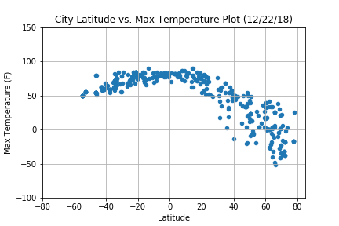

City Latitude vs. Humidity Plot:

Humidity of cities around the equator on both sides are almost same during this time of the year and equator doesn’t make much impact on cities near equator (-40 to 40).

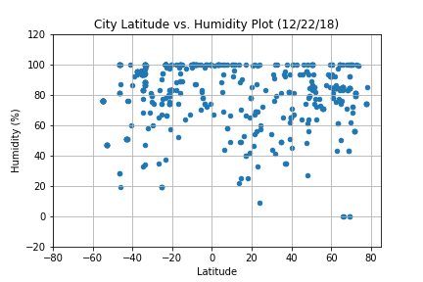

City Latitude vs. Cloudiness Plot:

Cloudiness is independent of the location of the cities from equator.

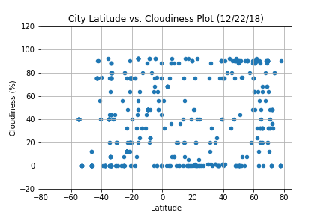

City Latitude vs. Wind Speed Plot:

The wind speed of cities ranges from (-40 to 40) are having 0 – 15 mph.

