**Team Profile**

**Andrew Bonney** - s3529361

<https://s3529361.github.io/IT-Profile/>

Ideal Job: Senior Systems Administrator

Andrew Bonney is a part-time student at RMIT both on-campus and online study, his Student Number being s352936.His nationality is Australian however his background is English, Scottish, German, Irish, Dutch, Italian and Spanish so he comes from a varied background (despite only know a bit of Italian).His hobbies include but are not limited to video games, history, computers (especially tinkering with computer hardware), sports (AFL, SANFL, NFL & NBA), listening to music and watching videos/TV shows. Andrew is quite interested in IT to the point that all of his careers in his adult working life has been in the IT industry and hoping to keep that way since he has early two years in IT experience. This current experience having worked a traineeship in 2014 at his former High School and his current position of employment as an ICT Support Officer for an Aftermarket Automotive/Airconditioning Company.

Test Outcomes:

Myer-Briggs Test: Architect INTJ-T - Analyst - Constant Improvement

It can be lonely at the top. Being one of the rarest personality types and being among the most capable people, Architects know this all too well. They make up just two percent of the population, and women with this personality type are especially rare, forming only 0.8%. It can be difficult for Architects to find people who can keep up with their non-stop analysis of things. People with this personality type are imaginative yet decisive... ambitious yet like their privacy... curious about everything but remain focused.

Learning Style Test:

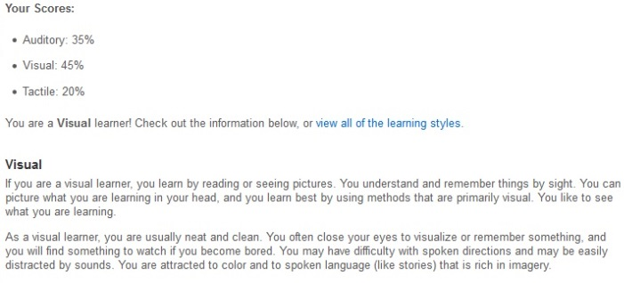

The Big Five Personality Test (Ranked in Openness, Conscientiousness, Extraversion, Agreeableness, and Neuroticism)

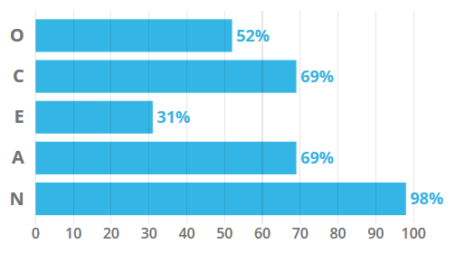

Ideal Jobs & Burning Glass Data Analysis

##### **Andrew B:**

Upon reviewing the Burning Glass Data for the position, the Senior Systems Administrator is still a more than appealing job for future employment, given pre existing experience, training and education in key parts being Microsoft Windows, Microsoft Office, Linux and Server is comforting to know that it aligns with requirements of that career role. Despite specific server knowledge not necessarily being in rather high demand, given the knowledge needed for Windows Server and similar server knowledge for Systems Administration will be quite useful and Andrew feels he is on the right path towards achieving his ideal goal and for the large part, the Burning Glass Data seems to mostly align with the ideal job requirements and he is still quite enthused at the idea of being a Senior Systems Administrator.

**I.T Technologies**

## **Cloud/Server Services**

***What does it do? (600 words)*** *What is the state of the art of this new technology? What can be done now? What is likely to be able to do be done soon (say in the next 3 years)? What technological or other developments make this possible?*

The state of the art newest technologies in the Server side the rapid improvement with in regards to Virtualisation & utilizing the Cloud. With traditional physical servers & typical server setups, physical servers require space, power and cooling, requires extensive lifecycle management, some servers may have older operating systems no longer supported or reaching EOL (end of life) which means a big hassle with migrating to a new server and time consuming, enter virtualisation. What can be done with virtualization in regards to servers is that with tools such as Microsoft Hyper-V, Oracle VM Server or VMware Workstation we can have multiple server instances on the same hardware, taking better advantage of resources and reducing the amount of cooling and power needed with less physical hardware, so as physical hardware shrinks, this allows for a more efficient usage of energy saving costs in energy and better for the environment. Now with better refined Virtual Software, instead of paying for costly servers to provision, virtual servers can be deployed thus saving on time, money and physical space as well as minimised downtime, faster deployment of applications and resources and better disaster recovery (you can create “snapshots” of servers where if a virus corrupted a server, you can revert back in time to an earlier version on the spot and continue running).

The state of the art with newest technologies with Cloud services is the introduction of products such as Microsoft Azure and alternatives to Microsoft Office with the introduction of Office 365. The “Cloud” can now be divided up into three different categories with different services offered depending on the type of cloud allowing for many flexible types of Cloud: Public, Private and Hybrid Cloud. Public clouds are owned and operated by a third-party cloud service provider, which delivers hardware, software and other supporting infrastructure such as servers and storage over the Internet with said services managed and accessed using a web browser. A private cloud is where computing resources are used exclusively by a single business or organisation. Typically located physically located on the company’s on-site data centre and maintained on a private network, otherwise companies may pay third-party service providers to host their private cloud. Hybrid clouds combine public and private clouds, bound together by technology that allows data and applications to be shared between them, giving businesses greater flexibility and more deployment options. Many businesses are migrating over to Office 365 as it allows users to access Outlook, Excel, Word and other services on the internet without having to install it onto your computer (that is an option however), with everything stored in the Cloud and most administration managed by Microsoft. Finally, Microsoft Azure is one of the big drivers of the newest developments in Cloud Technology, offering services to businesses such as AI & Machine learning, file storage, virtual servers, SQL databases and more, so now businesses will not only have to physically manage less hardware, but are able to expand their business through the use of tools provided by Cloud services like Azure.  
  
What is likely to be done and developments made possible in the next few years is the way we see typical business network layouts and the way employees would interact with a radically different infrastructure. Through the use of desktop virtualisation ,deploying desktops as a service (Virtual Desktop Infrastructure or VDI) will enable IT organizations to deploy virtualized desktops and applications faster and easily delivered to branch offices, outsourced and offshore employees as well as mobile workers using iPad and Android tablets, we could see business allow the use of BYOD (Bring Your Own Device) where they login through an online portal with a login where all their applications needed are ready to go, it would eliminate the need of relying on physical hardware at a business. To elaborate further, with more and more businesses storing their server needs in a datacenter or the cloud, such as storing files on Microsoft Azure, we will likely see entire businesses without a physical server located on-site that doesn’t need to be managed by an IT company and the company hosting a company’s data/server setup in the cloud is responsible for maintenance, support and management with the main factor determining everything being costs.

***What is the likely impact? (300 words)*** *What is the potential impact of this development? What is likely to change? Which people will be most affected and how? Will this create, replace or make redundant any current jobs or technologies?*

There’s a lot of potential for the current progress in the fields of the Cloud and how they relate to servers. The standard method of having on-site, physical storage with physical backups stored off-site in the event of hardware failure/natural disaster is now seen as an archaic way of backups in contrast to storing your information on the cloud and backing up data there. You can pay for a set amount of storage, no need to worry about hardware failure or lost data (since it’s another company’s problem and not yours). Greater strides have been made in Virtual Computing, RMIT have myDesktop where it allows students to access free software and save files to the school’s network where you can deploy virtual computers in seconds. We may see the day where companies use BYO (Bring Your Own) devices and use services similar to myDesktop for staff to do their work on, saving the need for purchasing and maintaining computers. As listed above, the changes in the Cloud doesn't just affect IT Staff, it affects the day to day of general users and impacts everyone.

With new strides in Cloud Computing & Servers it won’t necessarily make jobs redundant but instead create new jobs and make pre-existing jobs easier. For example, why host your Mail server on-site when you can just migrate over to the Cloud on Office 365, saving the need for untimely manual setups of Outlook, or if you’re facing licensing problems just use Office 365 to manage who gets Microsoft Office and who doesn’t? With more companies going towards the cloud, or using applications such as ESXI or vSphere it means that there are more jobs out there but more things for future IT Systems Administrators to learn. There will always be a need for on-site storage needs and servers, but if your company has the budget (and internet speeds!) they can benefit from the Cloud.

***How will this affect you? (300 words)*** *In your daily life, how will this affect you? What will be different for you? How might this affect members of your family or your friends?*

The way of the Cloud affects me quite radically from my day to day life in terms of my employment though I very much doubt my family or friends will notice unless they are more intertwined with what the cloud is and what actually uses cloud services. My first job at my former high school five years ago all our e-mail setups were done locally on the Exchange, with storage backed up locally on backup drives and the idea of utilizing the “Cloud” was largely non-existent beyond the odd Dropbox or Google Drive for personal use and my university courses in 2015 had very little focus on clouds & servers being all on-site. Now in 2019 I’m seeing workplaces and university embrace the cloud with services such as Microsoft Azure, Office 365 and off-site storage in the Cloud, with my workplace intending to have all our servers stored in a datacenter in a virtual server with all our storage in the cloud/virtual datacenter server. With all these changes, I have to learn about new technologies and consider that the days of on-site servers & storage may become a thing of the past and if I really want to work with them, considering working at a company that have data centers on-site. Family and friends more often than not where unless they are intending to directly participate in the management and maintenance of the day to day Cloud usage, are more often than not may find themselves using applications through a web portal more and more instead of the traditional method of installing a program on their computer or require a piece of hardware like a laptop or computer to be given to them by an IT Department.

Individual Team Reflections

Andrew B:

Upon reflecting on the overall conduct of the group, I found that the group worked really well with keeping in regular contact with each other, delegating tasks among each other and constructing deadlines for our individual tasks as well as how everyone was participating fully with no people slacking off. What surprised me the most was that despite the fact the group members were all over the place in terms of geographical locations, different work schedules and time commitments, we were always able to meet up for regular meetings and complete our tasks on time. I don’t really have any constructive criticism in regards to improving the group because I honestly have no complaints and having worked in groups for schooling life, this was probably the best group I’ve worked in so far, everything was well organised, flowed, we all knew what we were doing with our assigned tasks and kept in constant communication through Discord, which in my perspective made everything flow easily despite the various circumstances people were in with their personal strengths, weaknesses and time availability.