Andrew Kirkland

Feb 14, 2021

Foundations of Programing, Python

Assignment 06

Inventory Management Python Script pt.3

**Introduction**

In this assignment we started to include a lot of python concepts together to create a menu system which can do multiple things. With the introductions to functions in this script, we are now able to create a more streamlined script, and it is much more organized.

**Crafting the Script**

**Research**

This week we were given a lot of the script completed, which was nice, however we needed to add in some organization. Having to do a bit more digging into classes and functions this was a fun task to learn such a critical aspect of coding. I needed to watch a few videos to grasp what io needed to do with functions. In the videos I learned the power of functions and how to implement them in your code with classes!

**Writing the Script**

With all the research completed if let like I had a good handle on how to complete this assignment. Looking a the script we had a few todo’s we needed to complete. The first few were about adding the code into the class areas(figure 1.1). We want to keep the same type of functions together so you can call the class and then the function.

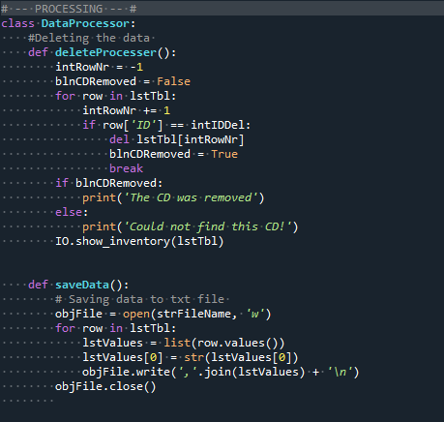

*Figure 1.1 Data processing class with the functions inside it.*

Next, we added other IO functions to that class so we can call them when needed. Having the organization really make coding much easier as it flows more logically. I then want to add and call the function in my code, which is easy as pie! We want to call the class it is under followed by the function(Figure 1.2).

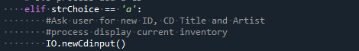

*Figure 1.2 Calling in the function for new cd input*

Finally, I went to add in the data processing for deleting the data. We would call in the class to function name as well (figure1.3)

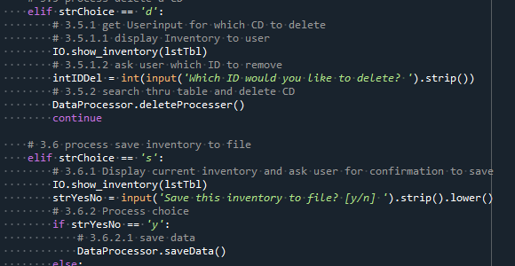

*Figure 1.3 Deleting and saving functions added into script*

**Final Steps**

The final steps were to make sure this ran in both the terminal window and in Spyder. You will see in the below figures 1.4, 1.5 and 1.6 that the code runs correctly.

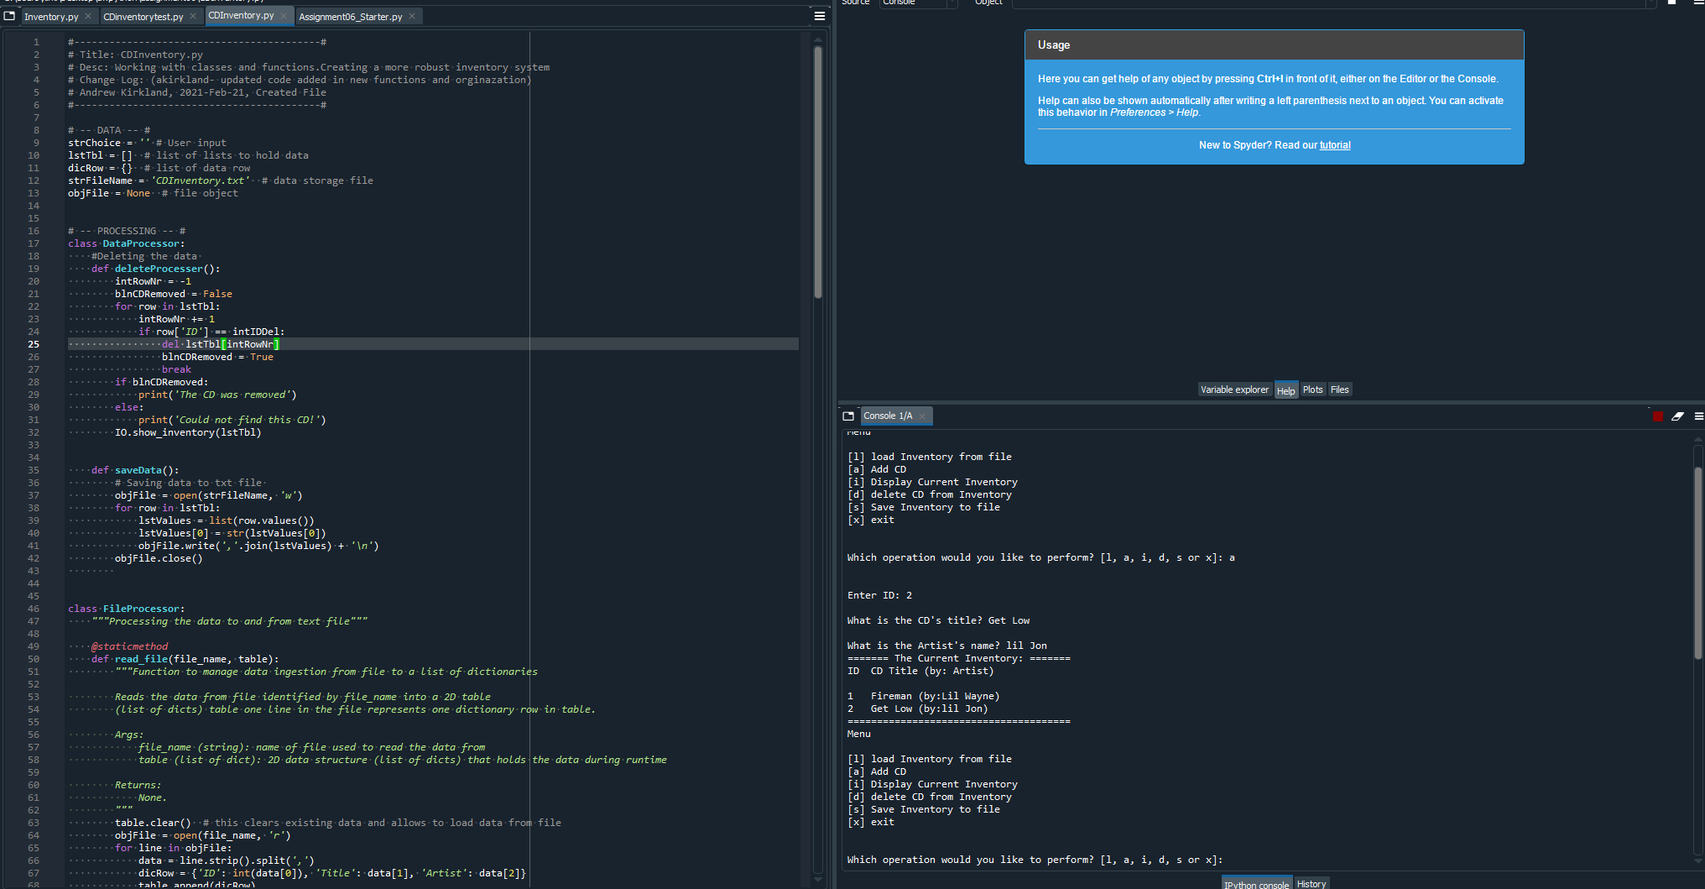

*Figure 1.4 Script running correctly in Spyder*

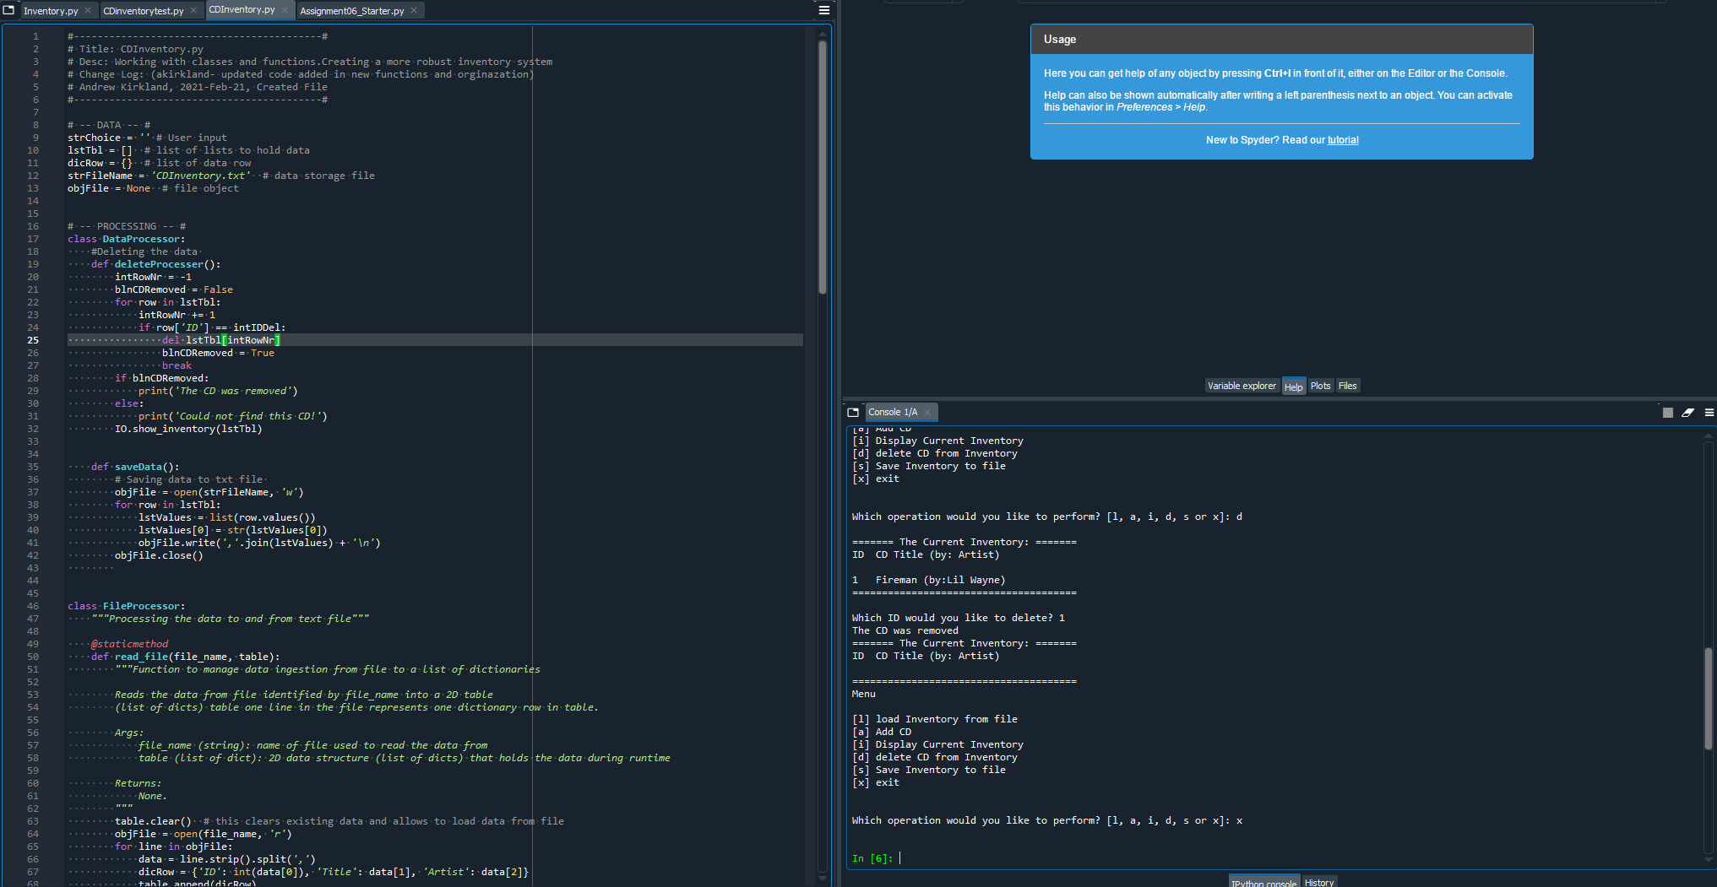

*Figure 1.5 Script running correctly in Spyder*

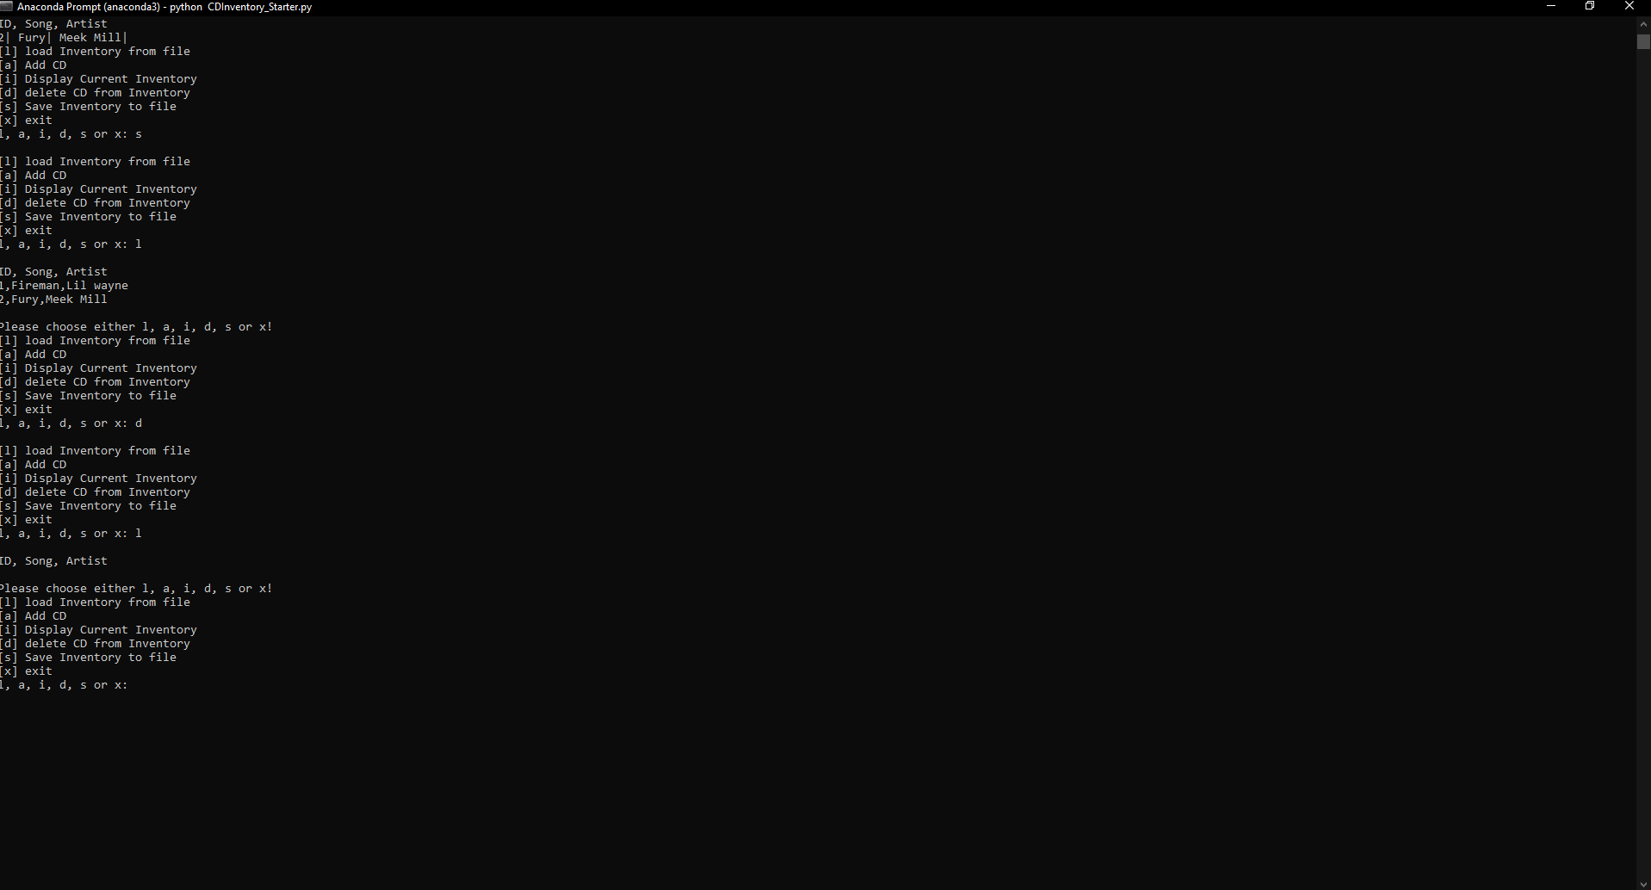

*Figure 1.6 Script running correctly in Terminal window.*

**Summary**

This project was a lot of fun to complete. I enjoyed being able to see my user input work and being able to select different options. This is a major step in developing my skills in python, and I can’t wait to keep adding to this. Please see the Git link below: https://github.com/cptkirk73/assignment06

**Citations:**

Dawson, Michael. *Python Programming for the Absolute Beginner, 3rd Edition*. 3rd ed., Course Technology, 2010.

Corey Schafer. “Python Tutorial for Beginners 8: Functions.” *YouTube*, 17 May 2017, www.youtube.com/watch?v=9Os0o3wzS_I.