Andrew Kirkland

Feb 28, 2021

Foundations of Programing, Python

Assignment 07

Inventory Management Python Script pt.4

**Introduction**

In this assignment we started to include a lot of python concepts together to create a menu system which can do multiple things. This week we were tasked with learning more about error handling and about pickling. This set the stage for us to be able to handle more data and make sure our programs do not crash due to incorrect user input.

**Crafting the Script**

**Research**

This week we had a lot more research we needed to do. We had to read up on exception handling as well as pickling. Exception handling is a great way for you to make sure a user can input data incorrectly and the program still runs. The way we use this is through try/except statements. We ask the computer to try and run lines and if there is an error, we use the except statement to catch and recognize the error and we will tell the user that there is an error without crashing the program. Pickling is the storing of data into a binary file. The benefits of this are we can load data a lot faster and it takes up less space. “The [pickle](https://docs.python.org/3/library/pickle.html#module-pickle) module implements binary protocols for serializing and de-serializing a Python object structure. *“Pickling”* is the process whereby a Python object hierarchy is converted into a byte stream, and *“unpickling”* is the inverse operation, whereby a byte stream (from a [binary file](https://docs.python.org/3/glossary.html#term-binary-file) or [bytes-like object](https://docs.python.org/3/glossary.html#term-bytes-like-object)) is converted back into an object hierarchy”(Python documentation).

**Writing the Script**

With all the research completed it is time to modify the script. We first want to import the pickle module (figure 1.1) this way we have access to the materials we need.

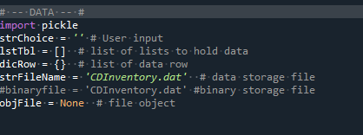

*Figure 1.1 Importing pickle*

Next, we want to go into out read and write functions and change up the script to work with the pickle option. We are going to want to open the file and make sure we are writing or reading into a binary file, by adding a b on the end of your read or write function(Figure 1.2).

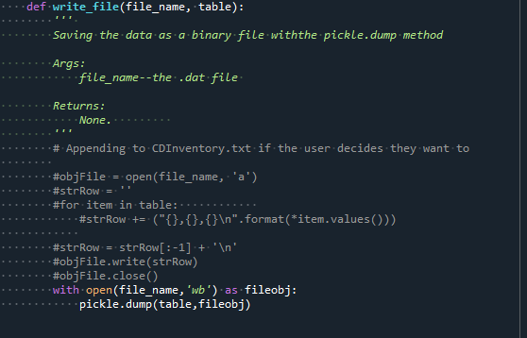

*Figure 1.2 Saving the data to a binary file through pickling*

Next, we want to go around and check to see where a user will input data and add in some exception handling, we see here I added this in because a user can accidently input a str value and not an integer (figure1.3)

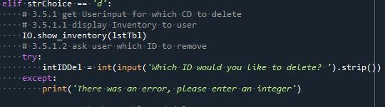

*Figure 1.3 Adding in functionality to make sure program doesn’t crash with try and except*

**Final Steps**

The final steps were to make sure this ran in both the terminal window and in Spyder. You will see in the below figures 1.4, 1.5 and 1.6 that the code runs correctly.

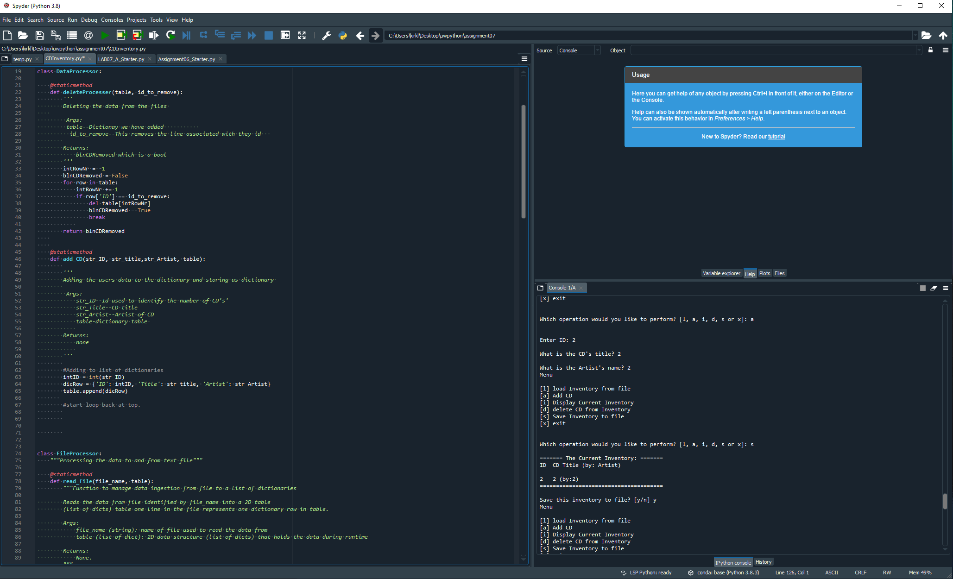

*Figure 1.4 Script running correctly in Spyder*

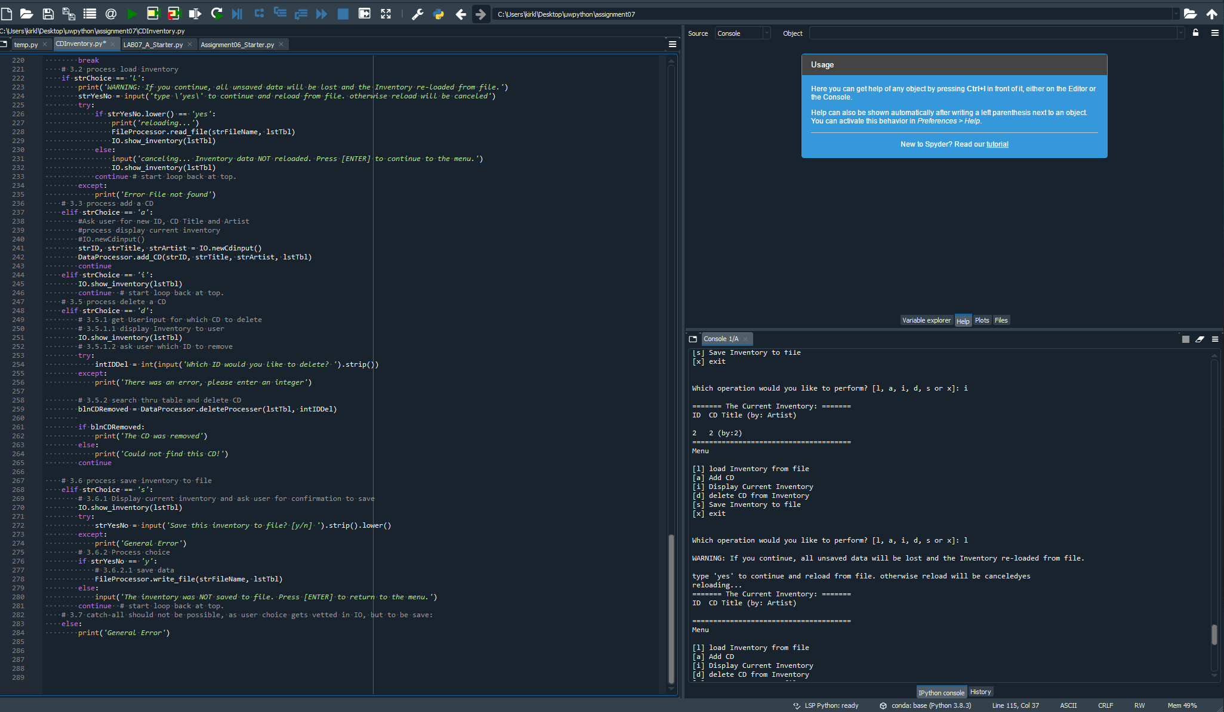

*Figure 1.5 Script running correctly in Spyder*

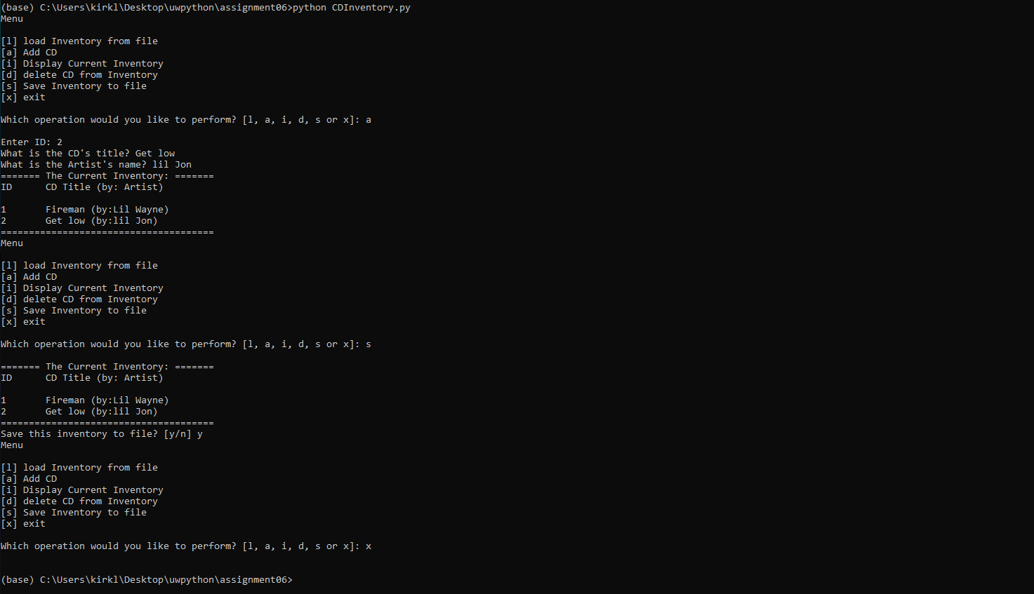

*Figure 1.6 Script running correctly in Terminal window.*

**Summary**

This project was a lot of fun to complete. I enjoyed being able to see my user input work and being able to select different options. This is a major step in developing my skills in python, and I can’t wait to keep adding to this. Please see the Git link below: https://github.com/cptkirk73/assignment07

**Citations:**

Dawson, Michael. *Python Programming for the Absolute Beginner, 3rd Edition*. 3rd ed., Course Technology, 2010.

Corey Schafer. “Python Tutorial for Beginners 8: Functions.” *YouTube*, 17 May 2017, [www.youtube.com/watch?v=9Os0o3wzS_I](http://www.youtube.com/watch?v=9Os0o3wzS_I).

“Pickle — Python Object Serialization — Python 3.7.3 Documentation.” *Python.org*, 2019, docs.python.org/3/library/pickle.html.