Andrew Kirkland
March 9, 2021
Foundations of Programing, Python
Assignment 08

Inventory Management Python Script OOP pt.1
Introduction
In this assignment we started to include more complex concepts in the code such as object-oriented programing OOP for short. The goal remains the same as create a menu system which can do multiple things.
Crafting the Script
Research
This week we had a lot more research we needed to do. OOP is a very efficient way to organize and make code more flexible in different areas. According to Real python OOP is a method of structuring a program by bundling related properties and behaviors into individual objects. It all starts with a class, that way we can organize and arrange the rest of the code in a manner that is efficient. I watched a few videos explaining the topic in depth. I felt like I had a grasp on it until it was actually time to write code…RealPython gave a wonderful example “For instance, an object could represent a person with properties like a name, age, and address and behaviors such as walking, talking, breathing, and running. Or it could represent an email with properties like a recipient list, subject, and body and behaviors like adding attachments and sending.” With this information I felt ready to try and attempt my hand at OOP!!
Writing the Script
With all the research completed it is time to modify the script. We need to create a class for out methods and functions to sit inside(figure 1.1). Below there is a main init function and then then the function of which we refer to the init function.
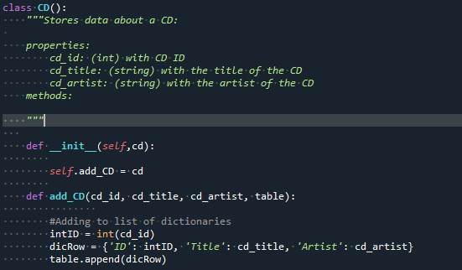
Figure 1.1 Creating a class and assigning method to that class

Next we work down the list and we come across some methods. We want to indicate these by @property before the function starts. This way our code is organized, and the machine reads and recognizes it faster. I then look at the function I’m going to use. This is easy since I have already created a load and save function. We are able to input that into the code and it works!(figure 1.2)
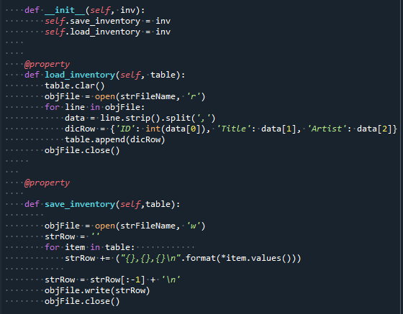
Figure 1.2 Identifying methods and code that comes with

Next, we want to go around and check to see where a user will input data and add in some exception handling, we see here I added this in just in case a user inputted an incorrect letter.
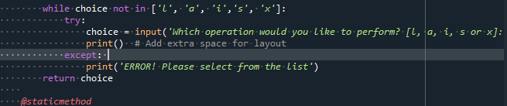
Figure 1.3 Adding in functionality to make sure program doesn’t crash with try and except

Final Steps
The final steps were to make sure this ran in both the terminal window and in Spyder. You will see in the below figures 1.4, 1.5 and 1.6 that the code runs correctly.
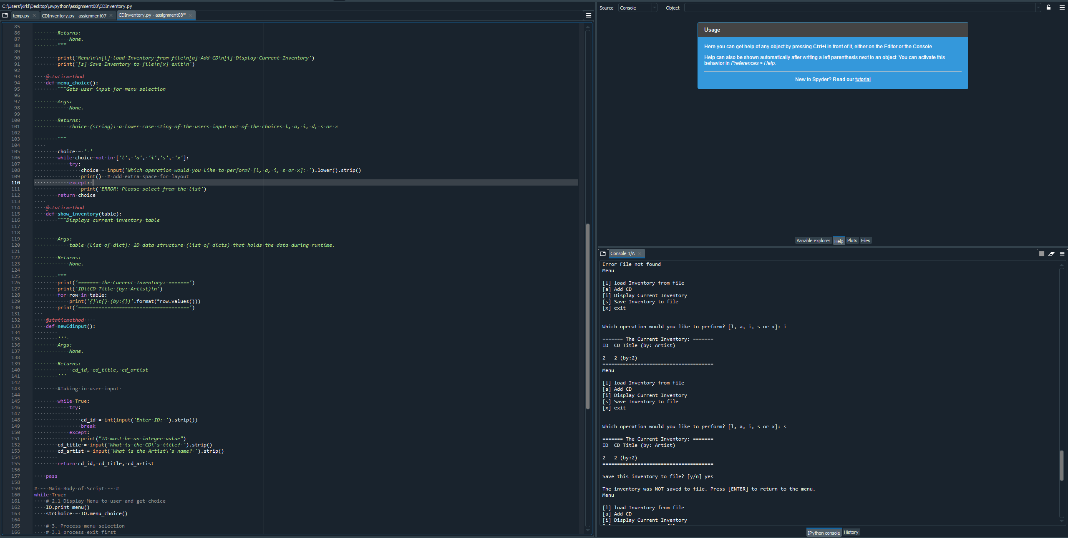
Figure 1.4 Script running correctly in Spyder
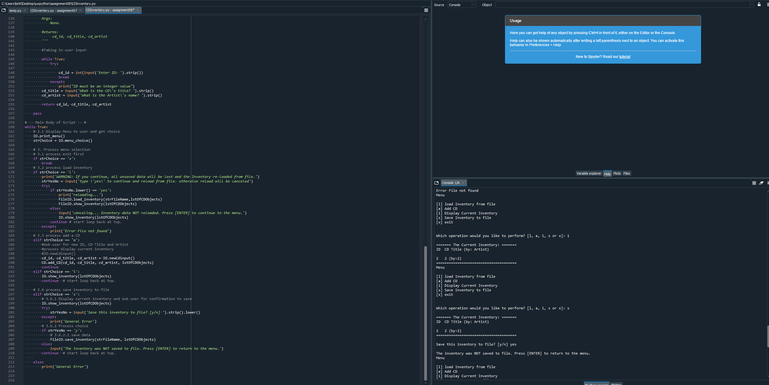
Figure 1.5 Script running correctly in Spyder
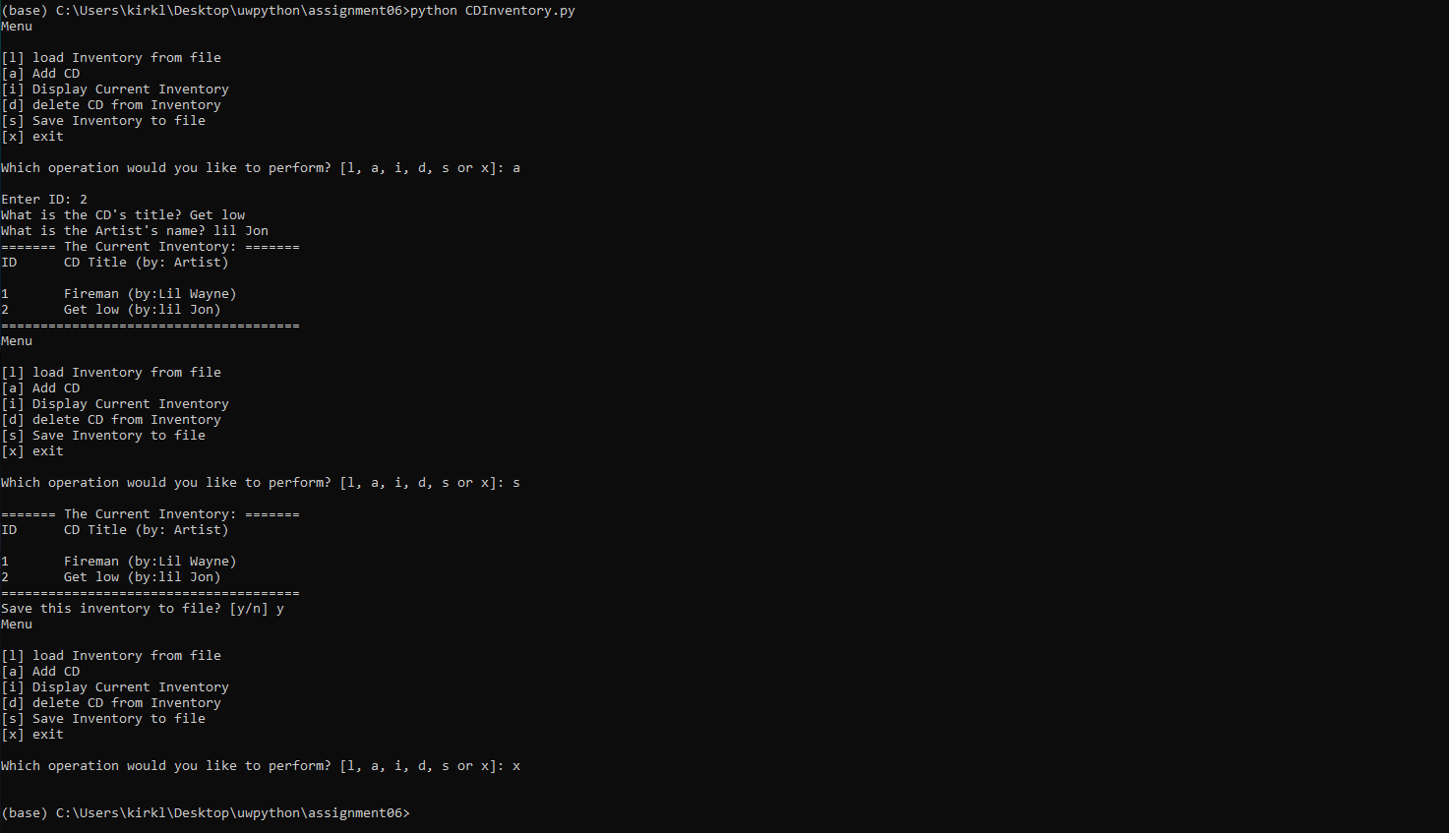
Figure 1.6 Script running correctly in Terminal window.

Summary
This project was a lot of fun to complete. I enjoyed being able to see my user input work and learning more about OOP and being able to select different options. This is a major step in developing my skills in python, and I cannot wait to keep adding to this. Please see the Git link below: https://github.com/cptkirk73/assignment08

Citations:
Dawson, Michael. Python Programming for the Absolute Beginner, 3rd Edition. 3rd ed., Course Technology, 2010.
Corey Schafer. “Python Tutorial for Beginners 8: Functions.” YouTube, 17 May 2017, www.youtube.com/watch?v=9Os0o3wzS_I.

“Pickle — Python Object Serialization — Python 3.7.3 Documentation.” Python.org, 2019, docs.python.org/3/library/pickle.html.

Corey Schafer. “Python OOP Tutorial 1: Classes and Instances” YouTube, 17 May 2017,
https://www.youtube.com/watch?v=ZDa-Z5JzLYM&list=PL-osiE80TeTsqhIuOqKhwlXsIBIdSeYtc&ab_channel=CoreySchafer

https://realpython.com/python3-object-oriented-programming/

