Andrew Kirkland

Feb 14, 2021

Foundations of Programing, Python

Assignment 05

Inventory Management Python Script pt.2

**Introduction**

In this assignment we started to include a lot of python concepts together to create a menu system which can do multiple things. This project added on a lot more features such as a way to read the current txt file inventory and also delete lines in the txt file. We have now built out a more robust management system.

**Crafting the Script**

**Research**

Having the task to create a basic menu system it was a bit difficult to put it together logically, so I went to the book and modules we have been assigned. We had a lot of resources at our disposal, my first thing I needed to check was the book (Dawson) on how to read and delete in txt files. I then proceeded to test the scrip a lot…This way I could try and navigate errors or other issues when running my code.

**Writing the Script**

With all the research completed if let like I had a good handle on how to complete this assignment. This first thing I wanted to do was to make sure my title section was completed. I started off the script with some already filled in lists to give the user an example on how the data is structured if they choose that option. The next order of business was to update a list of lists into a list of into dictionaries. Once that was accomplished, I was able to create a proper input to align items in their key value pair.

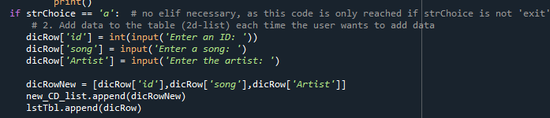

*Figure 1.1 Basic input key value diction pair*

I then went on to add in the functionality into the rest of the script. As we can see by (figure 1.2)

I really wanted to make the loading in the data clean, so I was able to pull the info from the dictionary list fairly easily by saving it all on as the values. With the values already saved it makes this line much simpler to write.

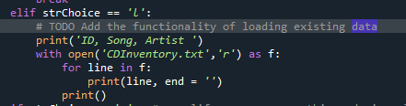

*Figure 1.2 Retrieving data from txt file*

Finally, for the new information I added in a way to delete data from the text file. I did this by opening a file and then resaving it as the same name and in the process of that it removes the last line of data. (figure 1.3)

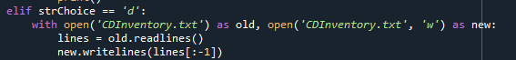

*Figure 1.3 Deleting last line of data*

**Final Steps**

The final steps were to make sure this ran in both the terminal window and in Spyder. You will see in the below figures 1.4, 1.5 and 1.6 that the code runs correctly.

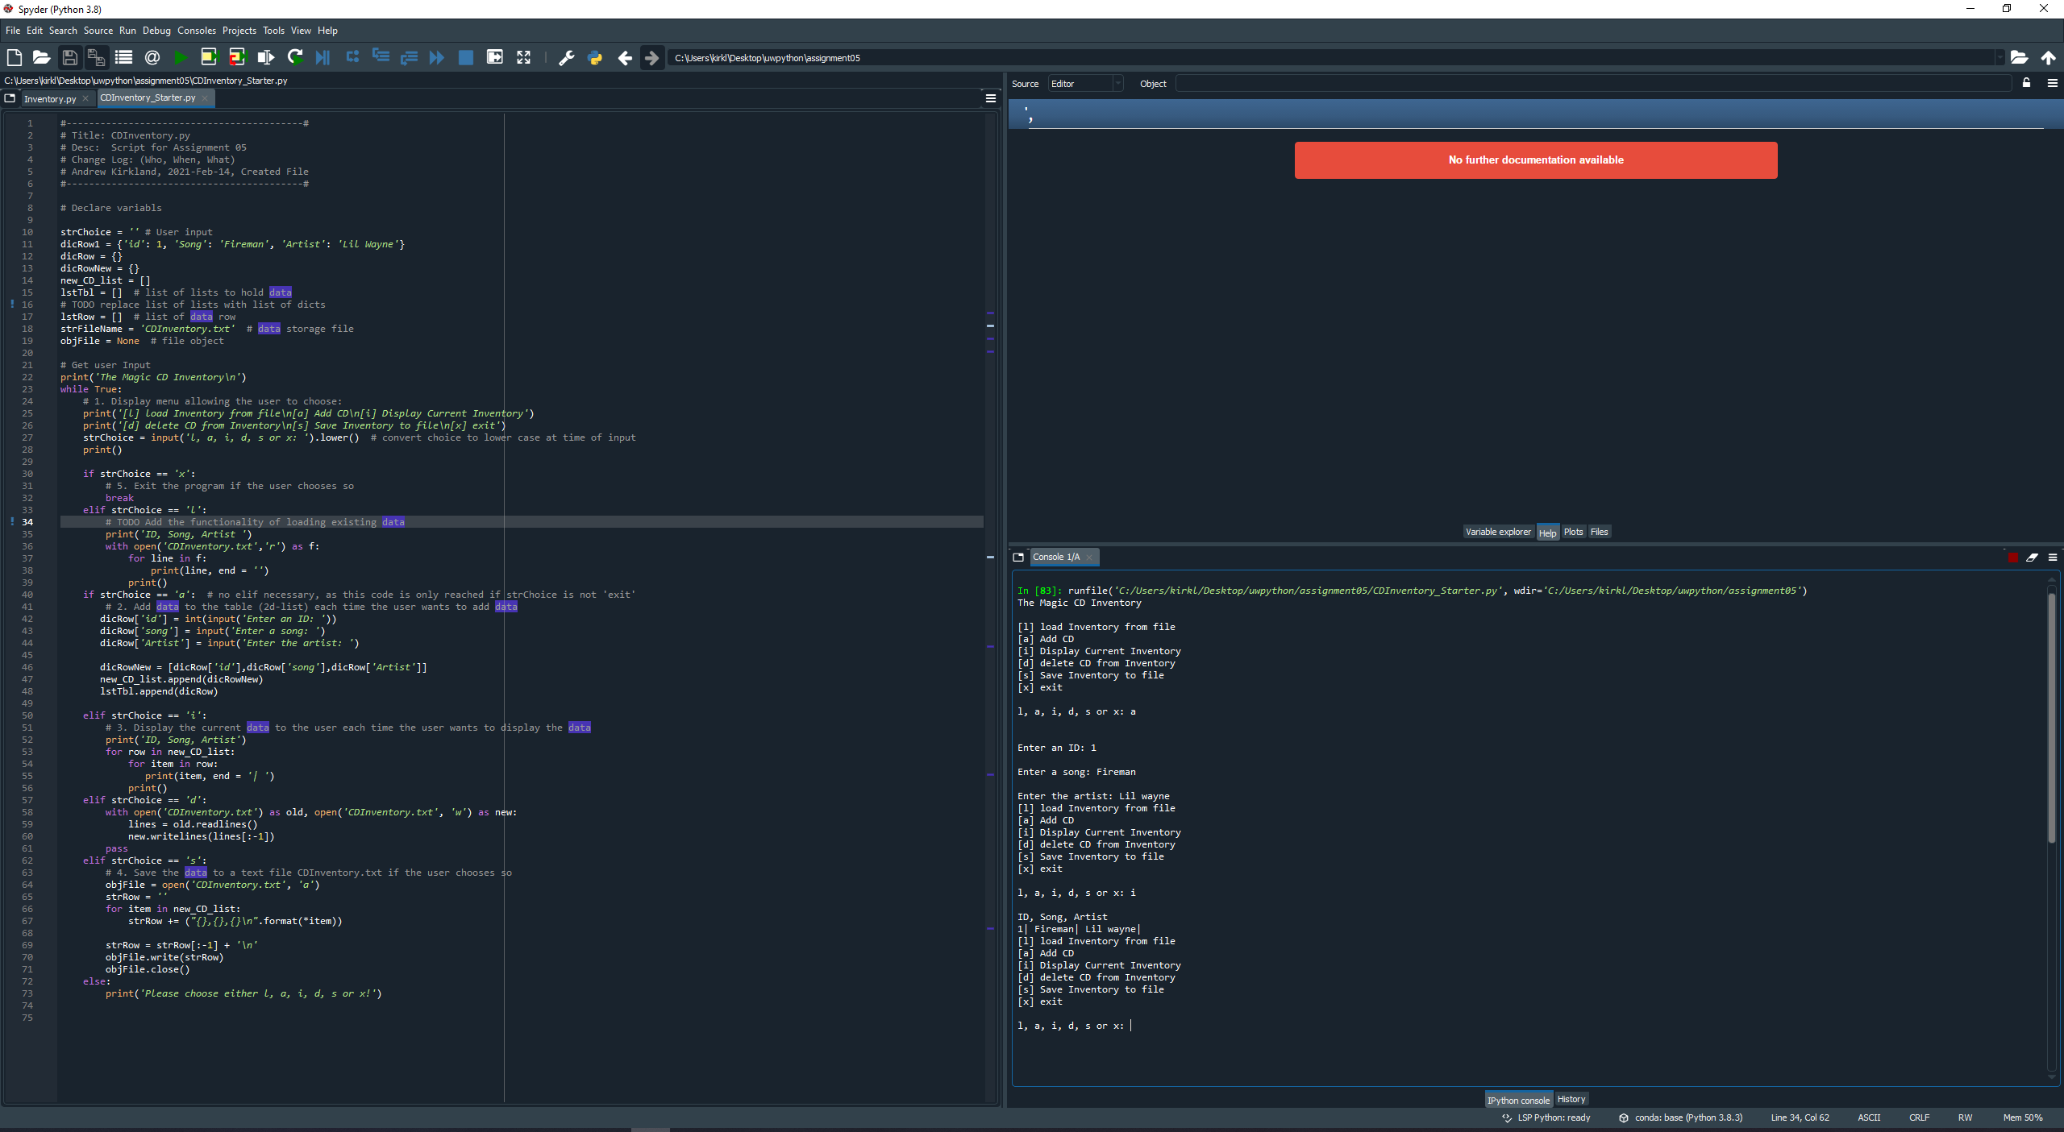

*Figure 1.4 Script running correctly in Spyder*

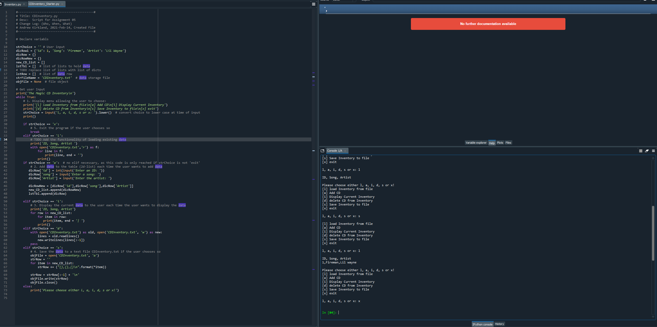

*Figure 1.5 Script running correctly in Spyder*

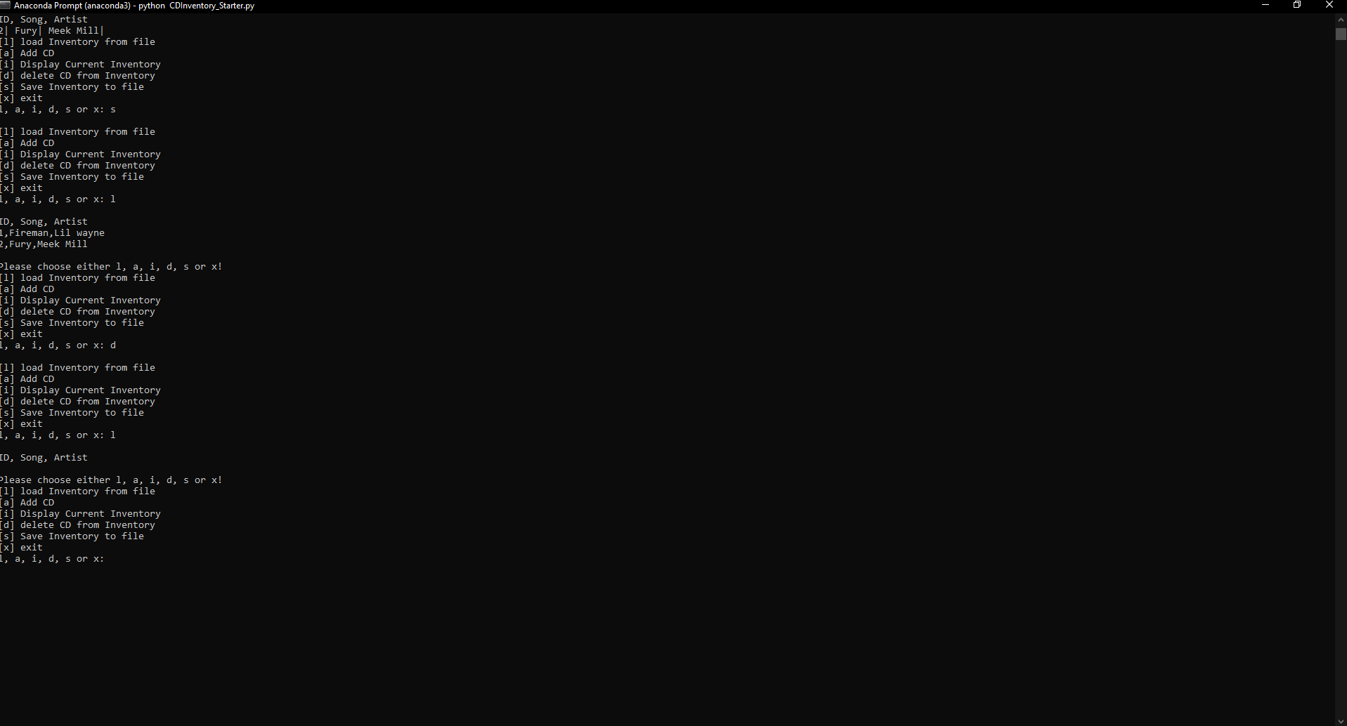

*Figure 1.6 Script running correctly in Terminal window.*

**Summary**

This project was a lot of fun to complete. I enjoyed being able to see my user input work and being able to select different options. This is a major building block and I can’t wait to keep adding to this.

**Citations:**

Dawson, Michael. *Python Programming for the Absolute Beginner, 3rd Edition*. 3rd ed., Course Technology, 2010.