JobCore Style Sheet
v0.2 DRAFT, for Jeff to mark up with Word comments and tracked changes
How to read this sheet
SET means Jeff already ruled; the source is cited under the word. PROPOSED means read from the code as it is today, with no ruling yet. OPEN is a known loose end.
Mark up by adding a Word comment (or tracked change) on any row. Every PROPOSED row and each open question already carries a comment to reply to.
Pictures are drawn at true proportion and printed at 100%: 1 app pixel = 1 point. Callouts show padding, alignment and how a part resizes. Values come from app/packages/ui/src/tokens.ts.
Spacing scale: xs 4, sm 8, md 16, lg 24, xl 32, xxl 48. Radius: sm 6, md 10, lg 16.

1. Global
Rule | Status | Measures: padding, alignment, resizing
No bottom tab bar | SET | Tabs sit along the top only (see section 4).
No NEW on-screen Back buttons; existing ones Jeff asked for stay | SET  feedback-android-back-not-buttons | Navigation back is the Android < button.
Android < follows actual visit history, never a fixed parent | SET  same as above | History order, not the screen hierarchy.
Every screen shows its screen-number badge | SET  jobcore-screen-number-working-rules | Badge is part of the screen chrome.
Tight vertical padding | SET | Row padding 8 max (see section 2).
Never inline-style a one-off; use the shared component | SET | Change the shared component so every screen follows.

2. Spacing
Scale: xs 4, sm 8, md 16, lg 24, xl 32, xxl 48.
Rule | Status | Measures: padding, alignment, resizing
Gap between related items (label/value, icon/text) | PROPOSED | xs to sm (4 to 8). Items align on their text baseline vertically; left-aligned horizontally.
Gap between rows / cards | PROPOSED | sm (8).
Screen side gutter | PROPOSED | md (16) left and right of the body.
Section gap | PROPOSED | md to lg (16 to 24) between sections.
Vertical padding inside rows | SET  tight vertical | sm (8) maximum, top and bottom.
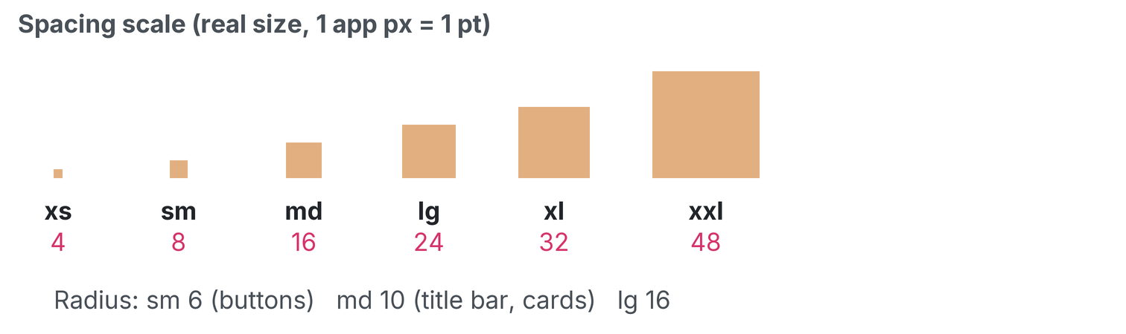
The spacing scale at true size. Printed at 100%: 1 app px = 1 pt.

3. Headers / title bar
Rule | Status | Measures: padding, alignment, resizing
Every screen uses the Admin & Finance header (AppChrome) | SET | Hamburger at left, options menu at right, title bar between.
Blue title bar fills the row between the hamburger and the options menu | SET | Resizing: the bar stretches to the space between the two menus; the menus never move.
Equal 14 px blue above and below the title text (balanced vertically) | SET | Padding: 14 above, 14 below. Vertical alignment: centred. Title text is centred horizontally.
Title names the screen it is on ("Field Tech-Assigned Jobs") | SET | Long titles wrap inside the bar; the 14 px bands stay equal.
JOB screens only: title bar inset 5 px each side so the menus are visible | SET  Round 5 | Padding: 5 left, 5 right, on JOB screens only. Other screens use the full row.
Job title bar = left "Job #N"+date, centre customer block, right schedule link | SET | Left block left-aligned, centre block centred, right link right-aligned.
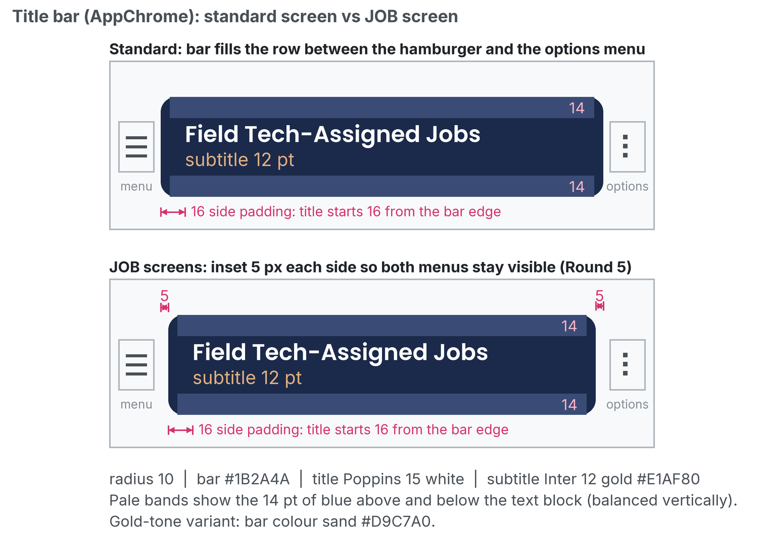
Blue title bar: 14 px bands, 16 px side padding and the 5 px job inset. Printed at 100%: 1 app px = 1 pt.

4. Tabs
Rule | Status | Measures: padding, alignment, resizing
Use DefaultTabBar, never inline a tab bar | SET | One shared component for every tab strip.
Anchored directly under the header, full width, outside the scrolling body | SET | Resizing: tabs share the full width; the bar does not scroll with the page.
Active tab: bold + sand background + 2 px #2563eb underline | SET | Label bold, centred both axes. Underline 2 px along the bottom edge.
Inactive tab: weight 400, sandInactive background | SET | Label weight 400, same padding as active so tabs do not shift.
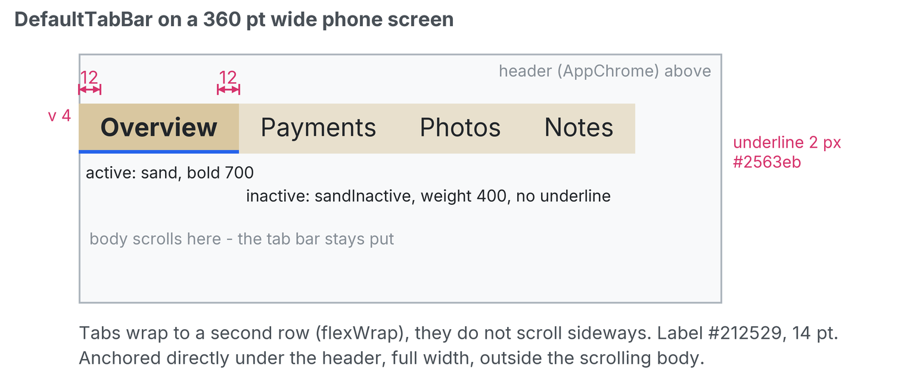
Active versus inactive tab with padding callouts. Printed at 100%: 1 app px = 1 pt.

5. Buttons
Rule | Status | Measures: padding, alignment, resizing
PayrollButton is THE button; Button/SandButton are legacy | SET | Use PayrollButton for every new button.
32 pt tall, 14 px side padding, radius 6, label 14/700 black centred both axes | SET | Height 32. Padding 14 left and right. Radius 6. Label centred horizontally and vertically.
Width = label + padding only; never stretch, never pass width/flex | SET  2026-10-20 | Resizing: width grows with the label, never stretches to fill.
Default tone sand; danger tone only when Jeff asks | SET | Sand fill by default; danger red is opt-in.
Selected state = 2 px blue bottom border | SET | Border 2 px along the bottom edge, #2563eb.
~50 files still use legacy Button; convert when touched | OPEN | Convert on touch; no sweep planned.
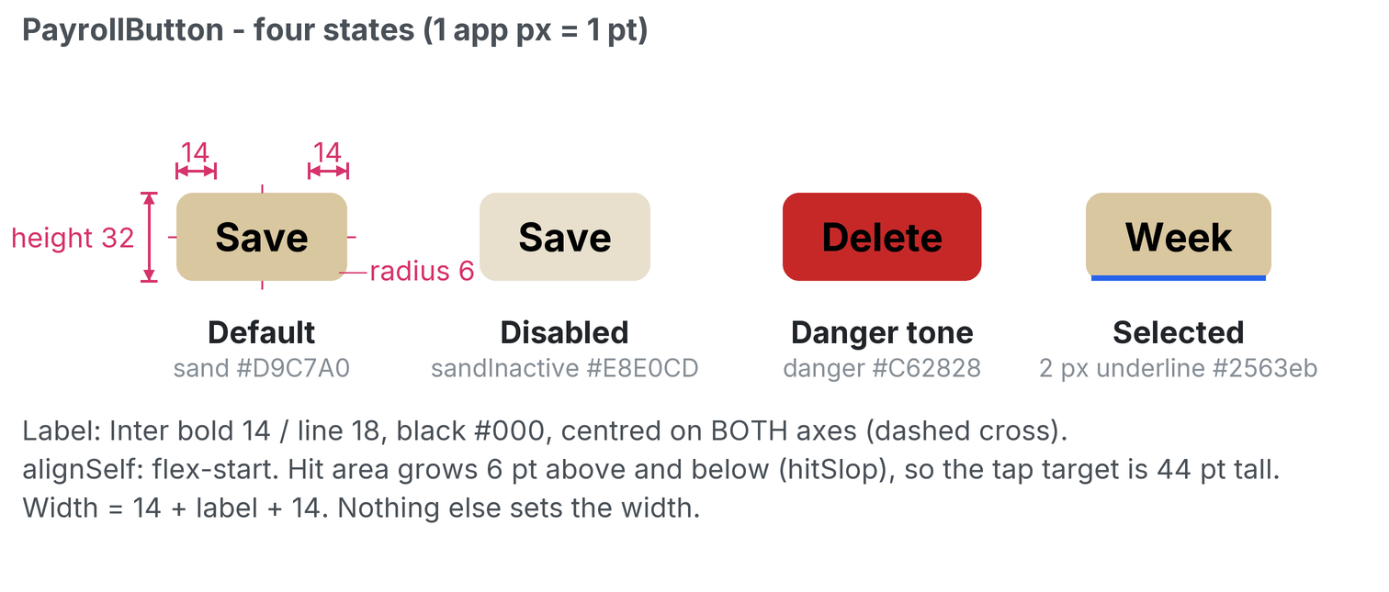
PayrollButton default, disabled, danger and selected. Printed at 100%: 1 app px = 1 pt.
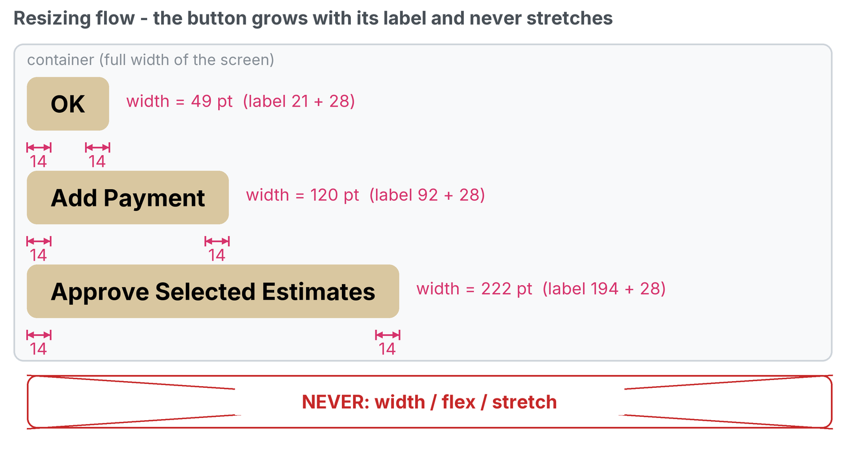
Resize flow: width grows with the label, never stretches. Printed at 100%: 1 app px = 1 pt.

6. Pickers
Rule | Status | Measures: padding, alignment, resizing
Every field-tech picker is TechSelect: heading "Choose a Field Tech", sheet 80% wide max 320, centred larger text, grey #CED4DA dividers | SET | Sheet width 80% of the screen, capped at 320, centred horizontally. Row text centred.
Non-tech selects keep plain Select | SET | Plain Select is unchanged.
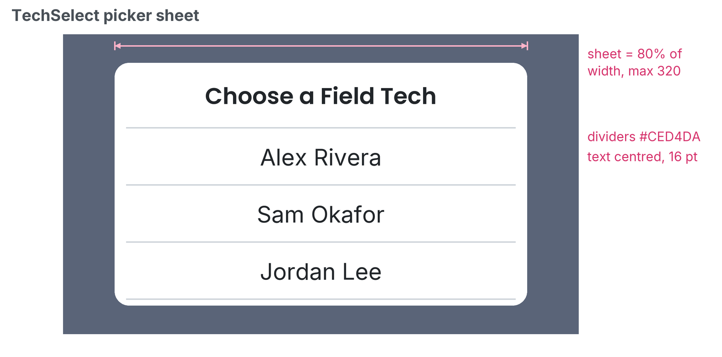
The TechSelect sheet. Printed at 100%: 1 app px = 1 pt.

7. Lists (rows)
Rule | Status | Measures: padding, alignment, resizing
Row min height 48 for tappable rows; thin divider line between rows | PROPOSED  matches picker | Min height 48. Divider 1 px #CED4DA. Row grows taller if the text wraps.
Never show raw UUIDs; show "Job #N" and drill into the job | SET  Payments | The "Job #N" text is the tap target.
Primary text 16 body; secondary 13 to 14 in textLight/textMuted | PROPOSED | Primary above secondary, both left-aligned, gap xs (4).

8. Empty states
Rule | Status | Measures: padding, alignment, resizing
Use EmptyState: centred, bold 20 title (text colour), 16 muted message, 24 padding | PROPOSED  component as built | Padding 24 all round. Centred horizontally; centred vertically in the list area.
Message says what to do next, in plain words | PROPOSED | One or two short sentences.
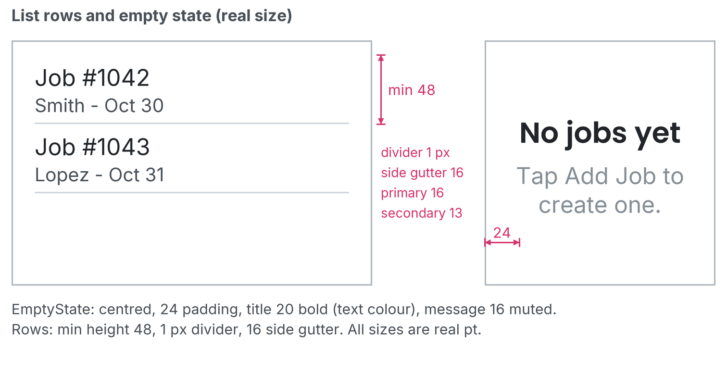
List rows (section 7) and the empty state (section 8). Printed at 100%: 1 app px = 1 pt.

9. Color and type
Rule | Status | Measures: padding, alignment, resizing
Brand navy #1B2A4A, gold/accent #E1AF80, sand #D9C7A0 | SET  tokens | See the swatches below.
Status: success #2E7D32, danger #C62828, warning #FACC15, info #1976D2 | SET  tokens | See the swatches below.
Headings Poppins, body Inter; sizes h4 20, body 16, label 14, small 13 | SET  tokens | This document uses the same families.
No raw hex in new code (use tokens); known exception: #2563eb tab/selected blue | SET | The blue is the only allowed raw value.

Swatch | Token | Hex | Where it is used
 | primary | #1B2A4A | Brand navy: header, text on sand
 | accent | #E1AF80 | Gold accent
 | sand | #D9C7A0 | Buttons and the active tab
 | sandInactive | #E8E0CD | Inactive tab
 | success | #2E7D32 | Status: success
 | danger | #C62828 | Status: danger
 | warning | #FACC15 | Status: warning
 | info | #1976D2 | Status: info
 | blue | #2563EB | Tab underline and selected state (known exception)
 | divider | #CED4DA | Picker and list dividers

Open questions for Jeff
1. Are the PROPOSED rows right, or should I tighten any (especially list rows and empty states)?
2. Should the 5 px job-header inset become the default for all screens?
3. Anything missing: forms/inputs, cards, dialogs, badges, toasts?

