JobCore Style Sheet
v0.3, Jeff rulings of 2026-10-31 applied; mark up with Word comments and tracked changes
How to read this sheet
SET means Jeff already ruled; the source is cited under the word. PROPOSED means read from the code as it is today, with no ruling yet. OPEN is a known loose end.
Mark up by adding a Word comment (or tracked change) on any row. Every PROPOSED row and each open question already carries a comment to reply to.
Pictures are drawn at true proportion and printed at 100%: 1 app pixel = 1 point. Callouts show padding, alignment and how a part resizes. Values come from app/packages/ui/src/tokens.ts.
Spacing scale: xs 4, sm 6, md 10, lg 15, xl 20, xxl 28. Radius: sm 6, md 10, lg 16.

1. Global
Rule | Status | Measures: padding, alignment, resizing
No bottom tab bar | SET | Tabs sit along the top only (see section 4).
No NEW on-screen Back buttons; existing ones Jeff asked for stay | SET  feedback-android-back-not-buttons | Navigation back is the Android < button.
Android < follows actual visit history, never a fixed parent | SET  same as above | History order, not the screen hierarchy.
Every screen shows its screen-number badge | SET  jobcore-screen-number-working-rules | Badge is part of the screen chrome.
Tight vertical padding | SET | Row padding 6 max (see section 2).
Never inline-style a one-off; use the shared component | SET | Change the shared component so every screen follows.

2. Spacing
Scale: xs 4, sm 6, md 10, lg 15, xl 20, xxl 28.
Rule | Status | Measures: padding, alignment, resizing
Gap between related items (label/value, icon/text) | SET  Jeff 2026-10-31 | xs to sm (4 to 6), keep. Items align on their text baseline vertically; left-aligned horizontally.
Gap between rows / cards | SET  Jeff 2026-10-31 | sm (6).
Screen side gutter | SET  Jeff 2026-10-31 | md (10) left and right of the body.
Section gap | SET  Jeff 2026-10-31 | md to lg (10 to 15) between sections.
Vertical padding inside rows | SET  Jeff 2026-10-31 | sm (6) maximum, top and bottom.
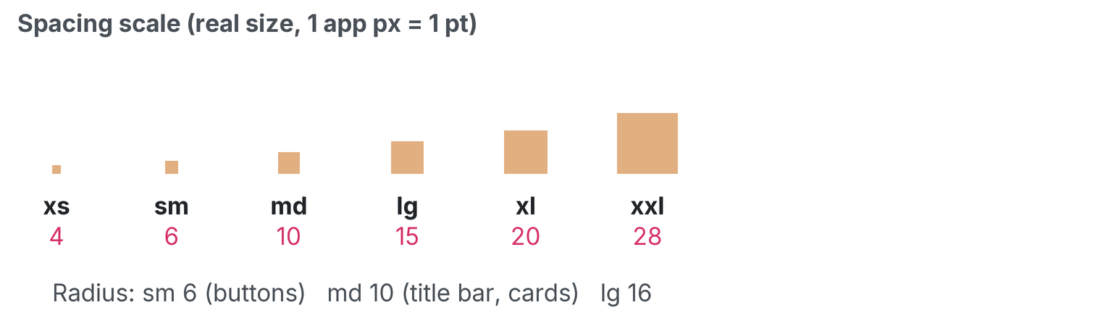
The spacing scale at true size. Printed at 100%: 1 app px = 1 pt.

3. Headers / title bar
Rule | Status | Measures: padding, alignment, resizing
Every screen uses the Admin & Finance header (AppChrome) | SET | Hamburger at left, options menu at right, title bar between.
Blue title bar fills the row between the hamburger and the options menu | SET | Resizing: the bar stretches to the space between the two menus; the menus never move.
Equal 10 px blue above and below the title text (was 14); side padding 20; both screens match sizing with the menu/options | SET  Jeff 2026-10-31 | Padding: 10 above, 10 below, 20 left and right. Vertical alignment: centred. Title text is centred horizontally.
Title names the screen it is on ("Field Tech-Assigned Jobs") | SET | Long titles wrap inside the bar; the 10 px bands stay equal.
JOB screens only: title bar inset 10 px each side (was 5), the gap between title box and menus | SET  Jeff 2026-10-31 | Inset: 10 left, 10 right, on JOB screens only. Other screens use the full row.
BUG: tech login title bar clips text at the bottom | OPEN | To fix.
Job title bar = left "Job #N"+date, centre customer block, right schedule link | SET | Left block left-aligned, centre block centred, right link right-aligned.
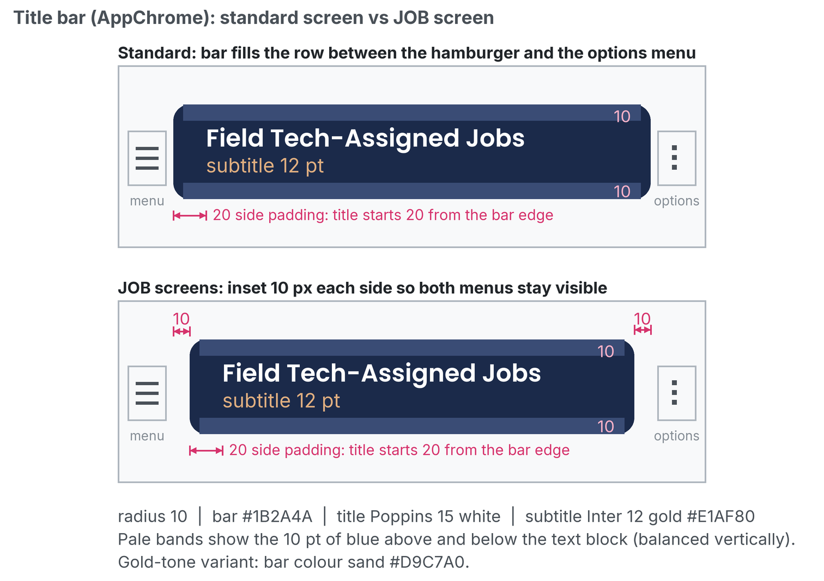
Blue title bar: 10 px bands, 20 px side padding and the 10 px job inset. Printed at 100%: 1 app px = 1 pt.

4. Tabs
Rule | Status | Measures: padding, alignment, resizing
Use DefaultTabBar, never inline a tab bar | SET | One shared component for every tab strip.
Anchored directly under the header, full width, outside the scrolling body | SET | Resizing: tabs share the full width; the bar does not scroll with the page.
Tab font 13, padding top/bottom reduced by 3 px. Active tab: bold + sand background + 2 px #2563eb underline | SET  Jeff 2026-10-31 | Label 13 bold, centred both axes. Underline 2 px along the bottom edge.
Inactive tab: weight 400, sandInactive background | SET | Label weight 400, same padding as active so tabs do not shift.
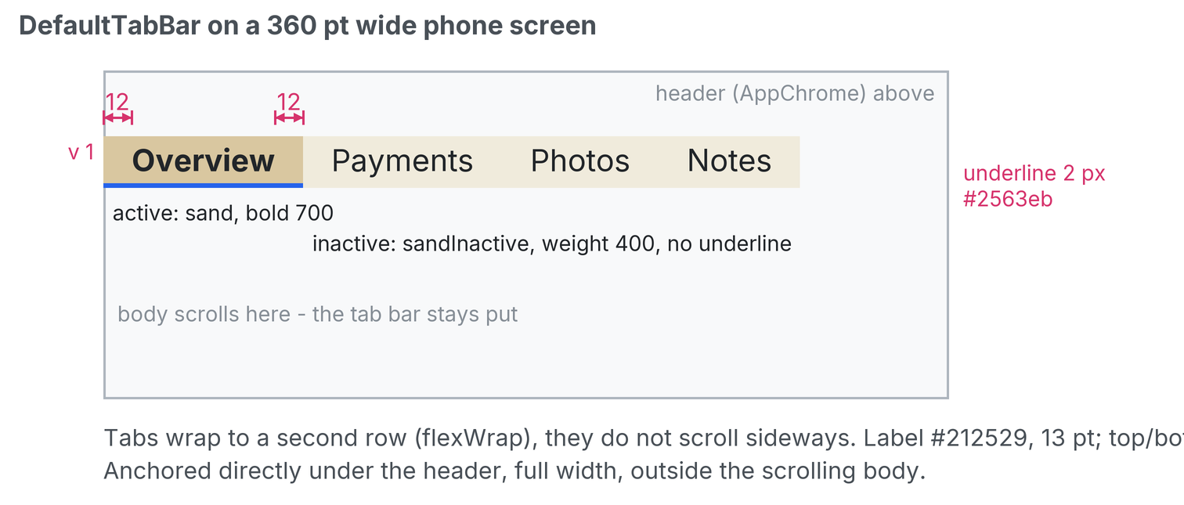
Active versus inactive tab with padding callouts. Printed at 100%: 1 app px = 1 pt.

5. Buttons
Rule | Status | Measures: padding, alignment, resizing
PayrollButton is THE button; Button/SandButton are legacy | SET | Use PayrollButton for every new button.
28 pt tall, 10 px side padding, radius 6, label 13/700 black centred both axes | SET  Jeff 2026-10-31 | Height 28. Padding 10 left and right. Radius 6. Label centred horizontally and vertically.
Width = label + padding only; never stretch, never pass width/flex | SET  2026-10-20 | Resizing: width grows with the label, never stretches to fill.
Default tone sand; disabled = one shade lighter than sandInactive (#F7F4EB); danger tone has white text, used only when Jeff asks | SET  Jeff 2026-10-31 | Sand fill by default; danger red is opt-in.
Selected state = 2 px blue bottom border | SET | Border 2 px along the bottom edge, #2563eb.
~50 files still use legacy Button; converted FIRST as part of this effort | SET  Jeff 2026-10-31 | Conversion sweep comes first.
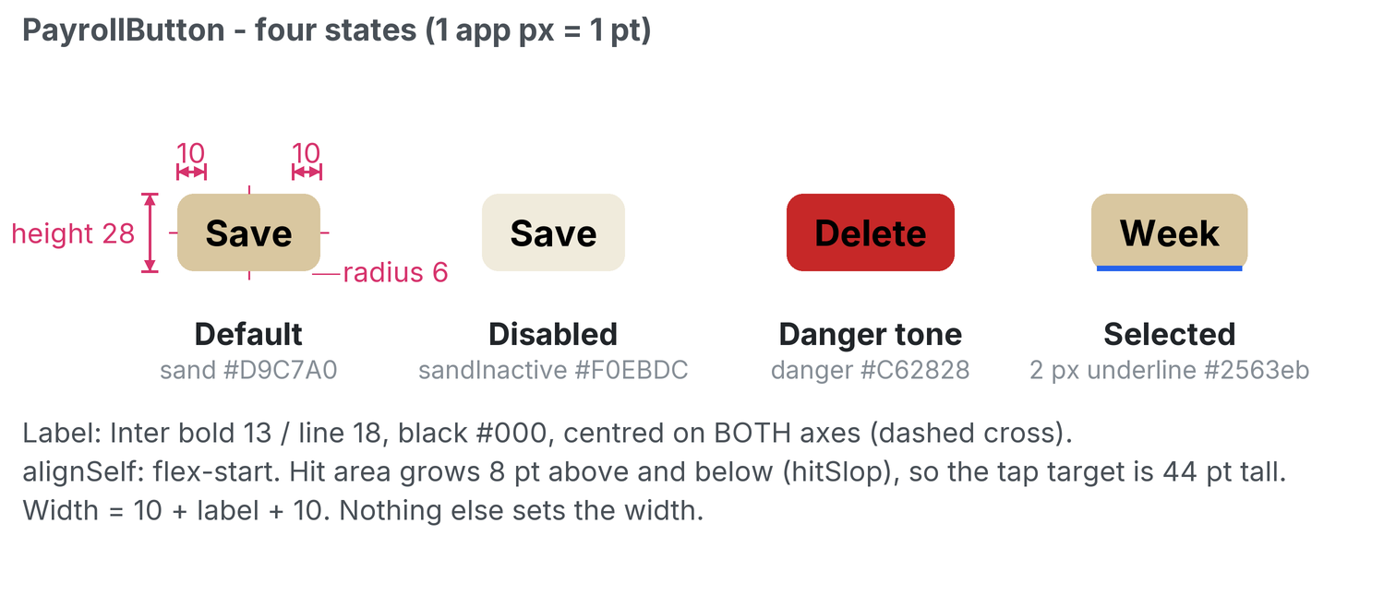
PayrollButton default, disabled, danger and selected. Printed at 100%: 1 app px = 1 pt.
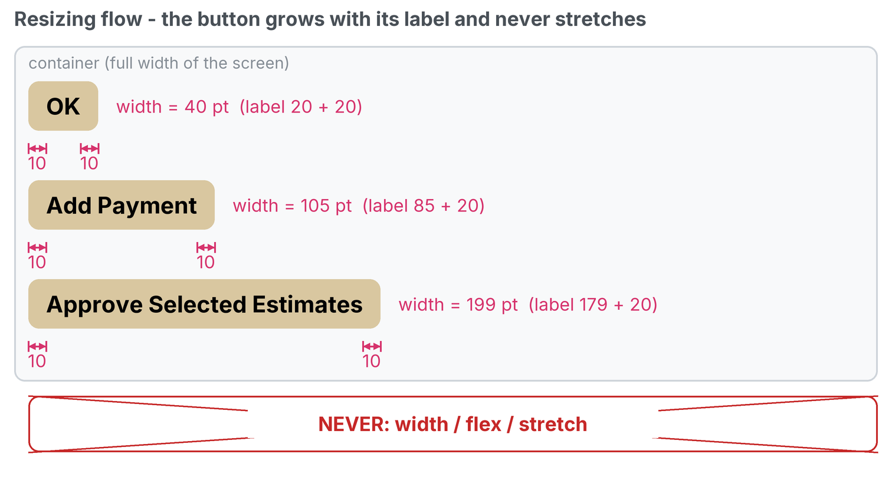
Resize flow: width grows with the label, never stretches. Printed at 100%: 1 app px = 1 pt.

6. Pickers
Rule | Status | Measures: padding, alignment, resizing
Every field-tech picker is TechSelect: heading "Choose a Field Tech", sheet 80% wide max 320, centred larger text, grey #CED4DA dividers | SET | Sheet width 80% of the screen, capped at 320, centred horizontally. Row text centred.
Non-tech selects keep plain Select | SET | Plain Select is unchanged.
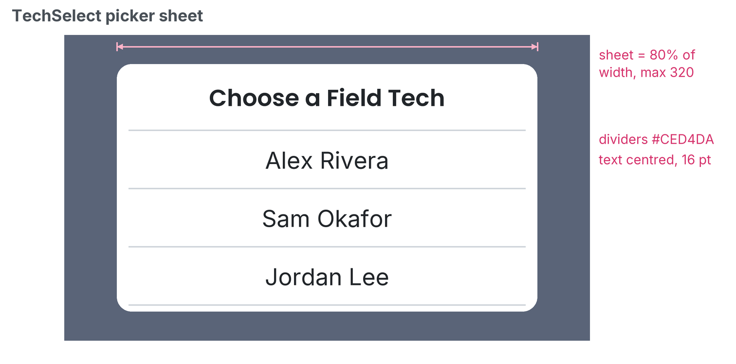
The TechSelect sheet. Printed at 100%: 1 app px = 1 pt.

7. Lists (rows)
Rule | Status | Measures: padding, alignment, resizing
Row min height 32 for tappable rows; thin divider line between rows | SET  Jeff 2026-10-31 | Min height 32. Divider 1 px #CED4DA. Row grows taller if the text wraps.
Never show raw UUIDs; show "Job #N" and drill into the job | SET  Payments | The "Job #N" text is the tap target.
Primary text 14; secondary 13 (unchanged) in textLight/textMuted | SET  Jeff 2026-10-31 | Primary above secondary, both left-aligned, gap xs (4).

8. Empty states
Rule | Status | Measures: padding, alignment, resizing
Use EmptyState: centred, bold 16 title (text colour), 16 muted message, 12 padding | SET  Jeff 2026-10-31 | Padding 12 all round. Centred horizontally; centred vertically in the list area.
Message says what to do next, in plain words | SET  Jeff 2026-10-31 | One or two short sentences.
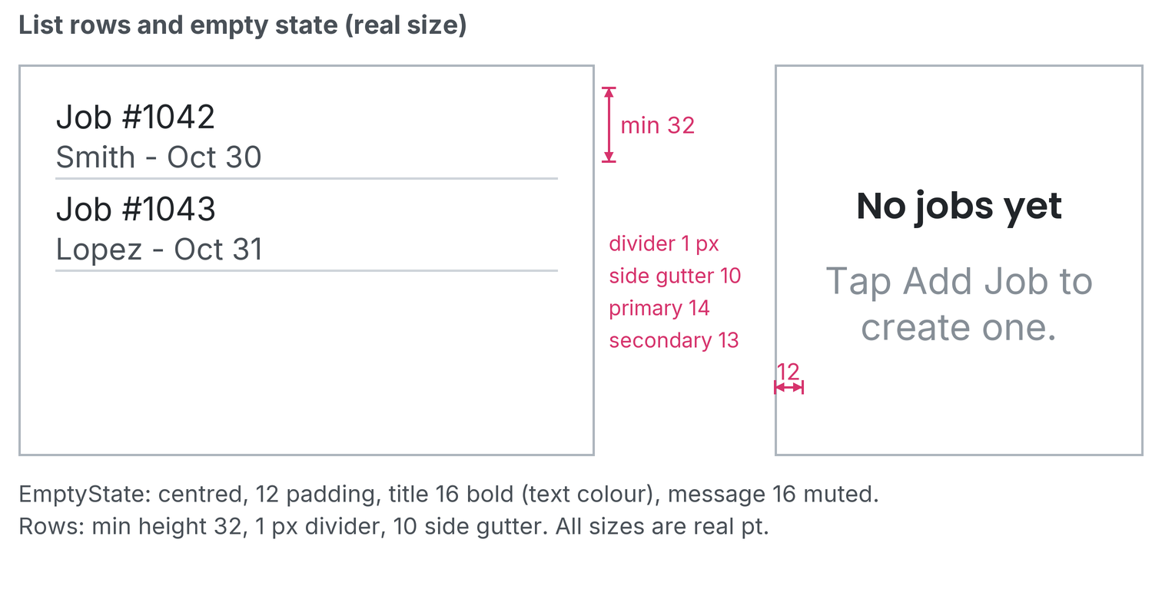
List rows (section 7) and the empty state (section 8). Printed at 100%: 1 app px = 1 pt.

9. Color and type
Rule | Status | Measures: padding, alignment, resizing
Brand navy #1B2A4A; sand #D9C7A0 replaces accent #E1AF80 in app screens only (accent token stays for website match); sandInactive becomes #F0EBDC | SET  Jeff 2026-10-31 | See the swatches below.
Status: success #2E7D32, danger #C62828, warning #FACC15, info #1976D2 | SET  tokens | See the swatches below.
Headings Poppins, body Inter; sizes h4 20, body 16, label 14, small 13 | SET  tokens | This document uses the same families.
No raw hex in new code (use tokens); known exception: #2563eb tab/selected blue | SET | The blue is the only allowed raw value.

Swatch | Token | Hex | Where it is used
 | primary | #1B2A4A | Brand navy: header, text on sand
 | accent | #E1AF80 | Gold accent (website match only; not used in app screens)
 | sand | #D9C7A0 | Buttons and the active tab
 | sandInactive | #F0EBDC | Inactive tab
 | disabled | #F7F4EB | Disabled button (one shade lighter than sandInactive)
 | success | #2E7D32 | Status: success
 | danger | #C62828 | Status: danger
 | warning | #FACC15 | Status: warning
 | info | #1976D2 | Status: info
 | blue | #2563EB | Tab underline and selected state (known exception)
 | divider | #CED4DA | Picker and list dividers

Rulings
Tighten top/bottom spacing and remove unneeded text wraps everywhere.
Question 3 is still open: forms, inputs, cards, dialogs, badges and toasts.

