JobCore Style Sheet
v0.4, Jeff decisions of 2026-10-31 codified; mark up with Word comments and tracked changes
How to read this sheet
SET means Jeff already ruled; the source is cited under the word. PROPOSED means read from the code as it is today, with no ruling yet. OPEN is a known loose end.
Mark up by adding a Word comment (or tracked change) on any row. Every PROPOSED row and each open question already carries a comment to reply to.
Pictures are drawn at true proportion and printed at 100%: 1 app pixel = 1 point. Callouts show padding, alignment and how a part resizes. Values come from app/packages/ui/src/tokens.ts.
Spacing scale: xs 4, sm 6, md 10, lg 15, xl 20, xxl 28. Radius: sm 6, md 10, lg 16.

1. Global
Rule | Status | Measures: padding, alignment, resizing
No bottom tab bar | SET | Tabs sit along the top only (see section 4).
No NEW on-screen Back buttons; existing ones Jeff asked for stay | SET  feedback-android-back-not-buttons | Navigation back is the Android < button.
Android < follows actual visit history, never a fixed parent | SET  same as above | History order, not the screen hierarchy.
Every screen shows its screen-number badge | SET  jobcore-screen-number-working-rules | Badge is part of the screen chrome.
Tight vertical padding | SET | Row padding 6 max (see section 2).
Never inline-style a one-off; use the shared component | SET | Change the shared component so every screen follows.

2. Spacing
Scale: xs 4, sm 6, md 10, lg 15, xl 20, xxl 28.
Rule | Status | Measures: padding, alignment, resizing
Gap between related items (label/value, icon/text) | SET  Jeff 2026-10-31 | xs to sm (4 to 6), keep. Items align on their text baseline vertically; left-aligned horizontally.
Gap between rows / cards | SET  Jeff 2026-10-31 | sm (6).
Screen side gutter | SET  Jeff 2026-10-31 | md (10) left and right of the body.
Section gap | SET  Jeff 2026-10-31 | md to lg (10 to 15) between sections.
Vertical padding inside rows | SET  Jeff 2026-10-31 | sm (6) maximum, top and bottom.
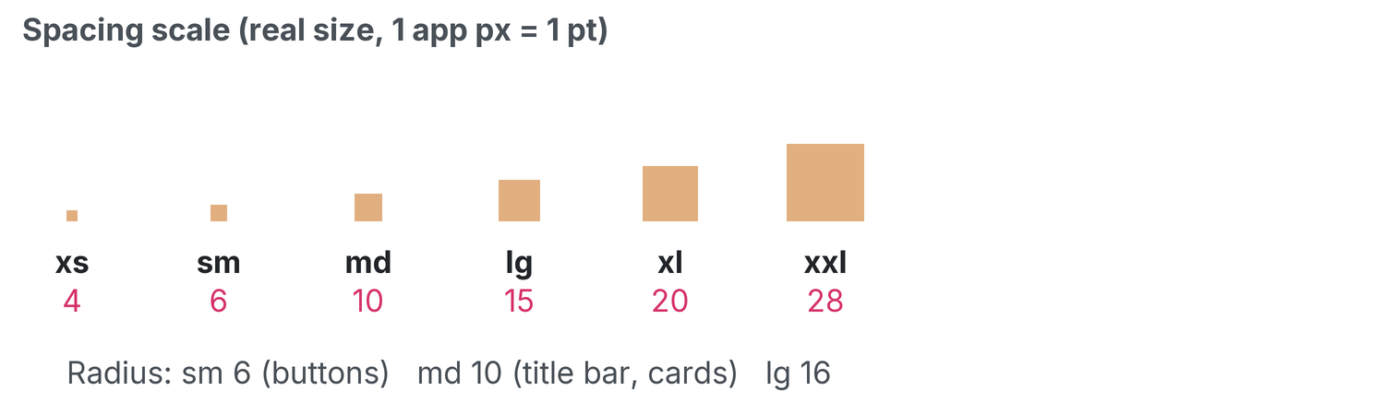
The spacing scale at true size. Printed at 100%: 1 app px = 1 pt.

3. Headers / title bar
Rule | Status | Measures: padding, alignment, resizing
Every screen uses the Admin & Finance header (AppChrome) | SET | Hamburger at left, options menu at right, title bar between.
Blue title bar fills the row between the hamburger and the options menu | SET | Resizing: the bar stretches to the space between the two menus; the menus never move.
Equal 10 px blue above and below the title text (was 14); side padding 20; both screens match sizing with the menu/options | SET  Jeff 2026-10-31 | Padding: 10 above, 10 below, 20 left and right. Vertical alignment: centred. Title text is centred horizontally.
Title-bar text is 2 pt smaller than before | SET  Jeff 2026-10-31 | Applies to AppChrome title text.
Title names the screen it is on ("Field Tech-Assigned Jobs") | SET | Long titles wrap inside the bar; the 10 px bands stay equal.
JOB screens only: title bar inset 10 px each side (was 5), the gap between title box and menus | SET  Jeff 2026-10-31 | Inset: 10 left, 10 right, on JOB screens only. Other screens use the full row.
BUG: tech login title bar clips text at the bottom | OPEN | To fix.
Job title bar = left "Job #N"+date, centre customer block, right schedule link | SET | Left block left-aligned, centre block centred, right link right-aligned.
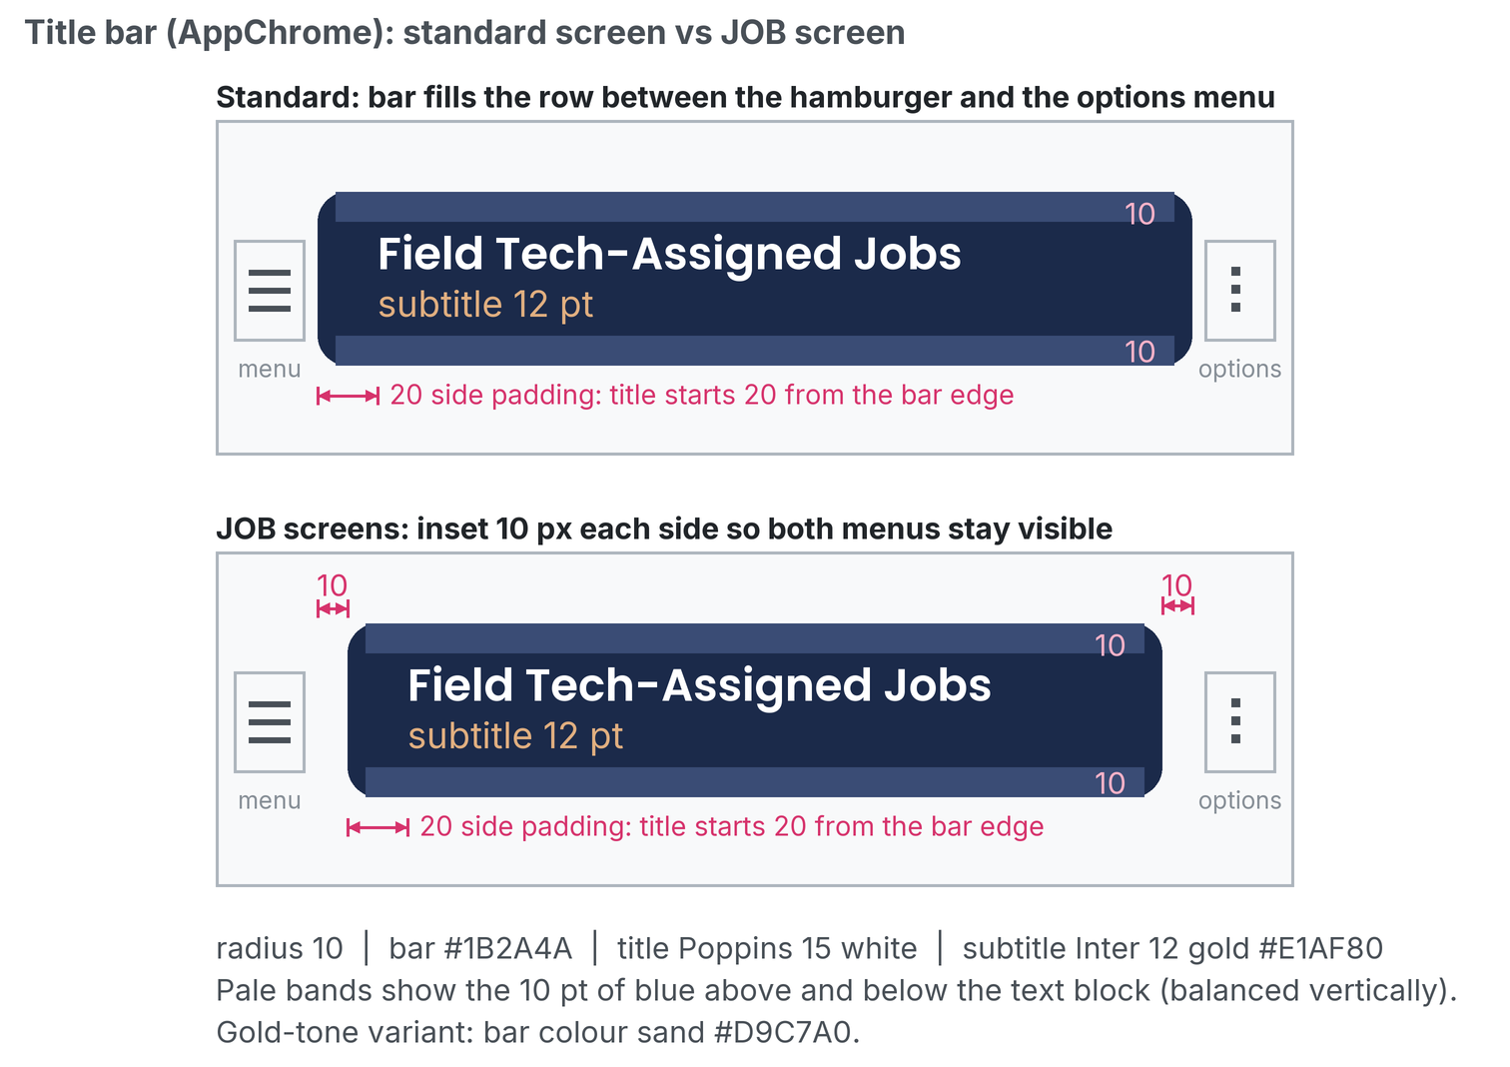
Blue title bar: 10 px bands, 20 px side padding and the 10 px job inset. Printed at 100%: 1 app px = 1 pt.

4. Tabs
Rule | Status | Measures: padding, alignment, resizing
Use DefaultTabBar, never inline a tab bar | SET | One shared component for every tab strip.
Anchored directly under the header, full width, outside the scrolling body | SET | Resizing: tabs share the full width; the bar does not scroll with the page.
Tab font 13, padding top/bottom reduced by 3 px. Active tab: bold + sand background + 2 px #2563eb underline | SET  Jeff 2026-10-31 | Label 13 bold, centred both axes. Underline 2 px along the bottom edge.
Inactive tab: weight 400, sandInactive background | SET | Label weight 400, same padding as active so tabs do not shift.
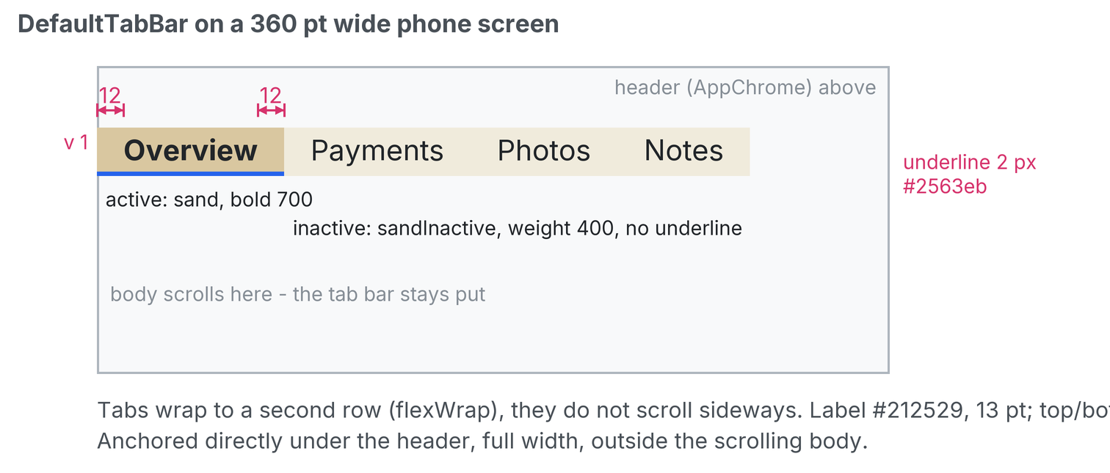
Active versus inactive tab with padding callouts. Printed at 100%: 1 app px = 1 pt.

5. Buttons
Rule | Status | Measures: padding, alignment, resizing
PayrollButton is THE button; Button/SandButton are legacy | SET | Use PayrollButton for every new button.
28 pt tall, 10 px side padding, radius 6, label 13/700 black centred both axes | SET  Jeff 2026-10-31 | Height 28. Padding 10 left and right. Radius 6. Label centred horizontally and vertically.
Width = label + padding only; never stretch, never pass width/flex | SET  2026-10-20 | Resizing: width grows with the label, never stretches to fill.
Default tone sand; disabled = one shade lighter than sandInactive (#F7F4EB); danger tone has white text, used only when Jeff asks | SET  Jeff 2026-10-31 | Sand fill by default; danger red is opt-in.
Primary look = bold text on sand fill (Add, Confirm Paid, PaymentSimulationNotice Cancel and Acknowledge) | SET  Jeff 2026-10-31 | Bold label on the sand fill.
13 button labels were shortened to stay on one line; the account dialog title is "Switch user" | SET  Jeff 2026-10-31 | Labels stay one line.
Selected state = 2 px blue (#2563eb) bottom border, for tabs, buttons and any selected item | SET | Border 2 px along the bottom edge, #2563eb.
~50 files still use legacy Button; converted FIRST as part of this effort | SET  Jeff 2026-10-31 | Conversion sweep comes first.
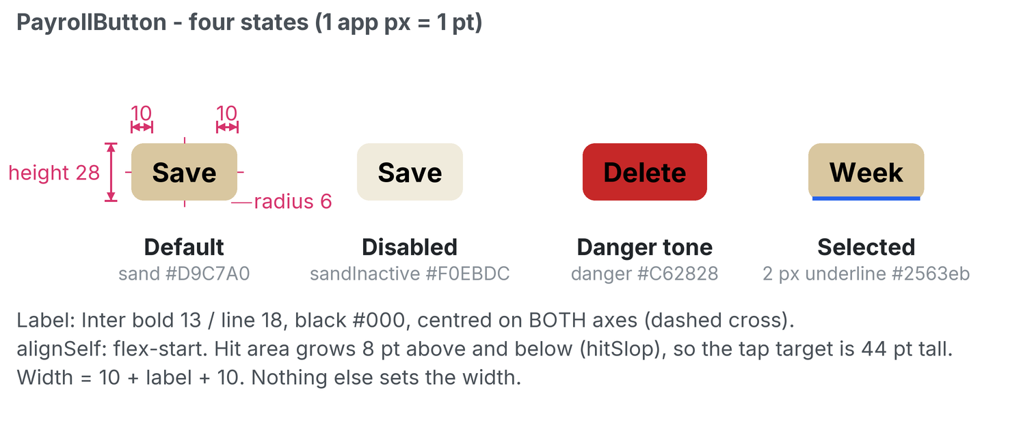
PayrollButton default, disabled, danger and selected. Printed at 100%: 1 app px = 1 pt.
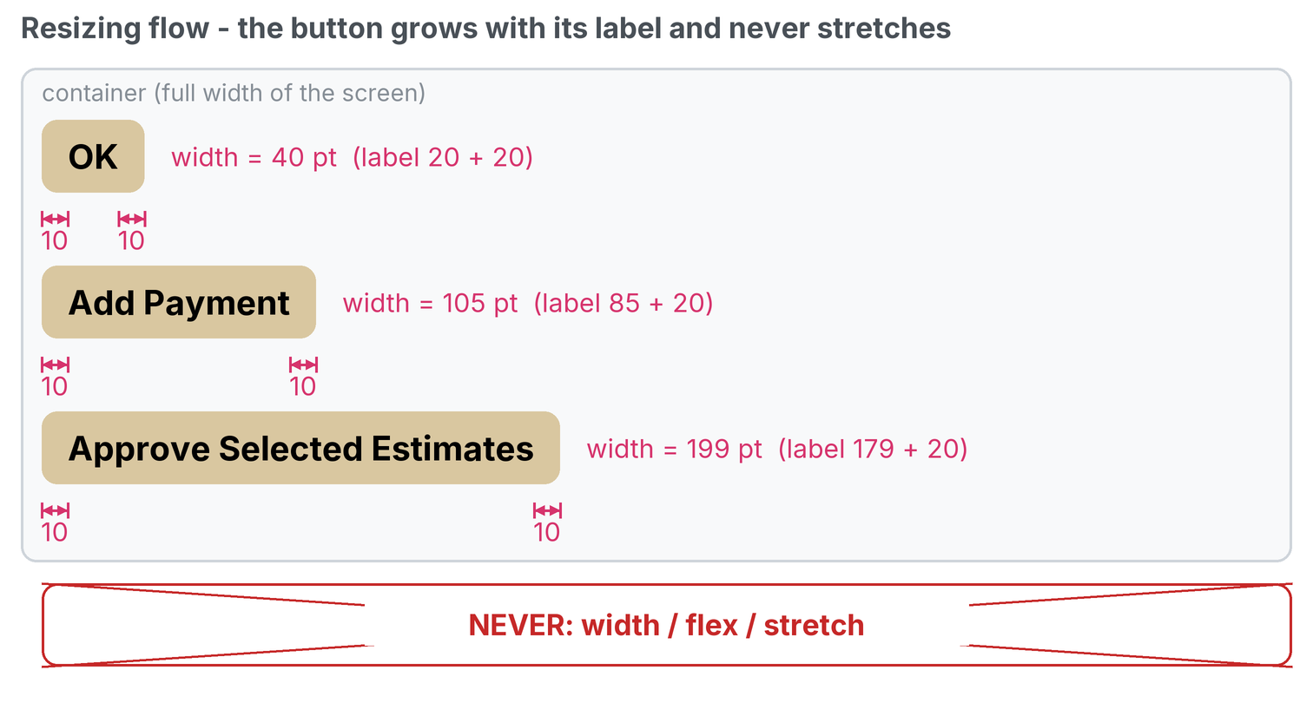
Resize flow: width grows with the label, never stretches. Printed at 100%: 1 app px = 1 pt.

6. Pickers
Rule | Status | Measures: padding, alignment, resizing
Every field-tech picker is TechSelect: heading "Choose a Field Tech", sheet 80% wide max 320, centred larger text, grey #CED4DA dividers | SET | Sheet width 80% of the screen, capped at 320, centred horizontally. Row text centred.
Non-tech selects keep plain Select | SET | Plain Select is unchanged.
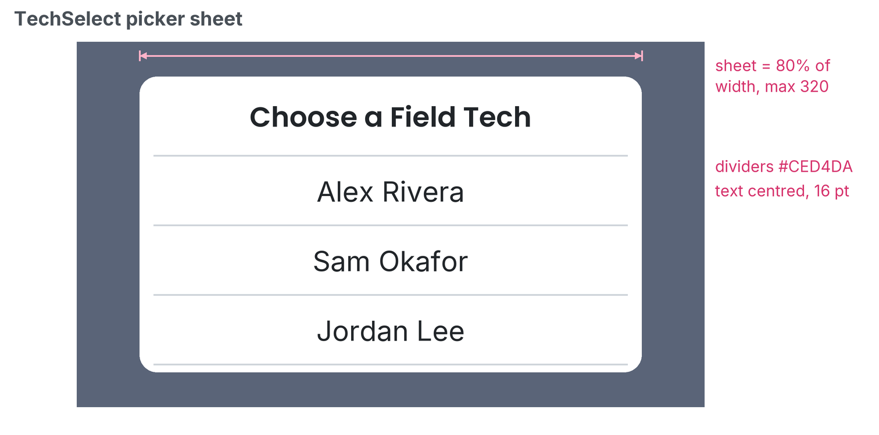
The TechSelect sheet. Printed at 100%: 1 app px = 1 pt.

7. Lists (rows)
Rule | Status | Measures: padding, alignment, resizing
Row min height 32 for tappable rows; thin divider line between rows | SET  Jeff 2026-10-31 | Min height 32. Divider 1 px #CED4DA. Row grows taller if the text wraps.
Min height 32 and primary text 14 apply to ListItem, overview cards, DayList and CallbackTasks. Select options, Checkbox, Toggle and settings rows are NOT raised, to avoid wasted vertical space | SET  Jeff 2026-10-31 | Scope of the 32 / 14 rule.
Never show raw UUIDs; show "Job #N" and drill into the job | SET  Payments | The "Job #N" text is the tap target.
Primary text 14; secondary 13 (unchanged) in textLight/textMuted | SET  Jeff 2026-10-31 | Primary above secondary, both left-aligned, gap xs (4).

7b. Text: minimize wrapping and ellipsis popup
Rule | Status | Measures: padding, alignment, resizing
Minimize wrapping: labels, buttons, tabs, titles and list-row primary text stay on one line | SET  Jeff 2026-10-31 | Shorten the text rather than wrap.
Ellipsis => popup: TruncatedText opens a popup with the full text only when the text is cut off | SET  Jeff 2026-10-31 | Used in ListItem, ScreenTitle, Breadcrumb current segment, AppChrome title/subtitle/sectionHeader/gearTitle, JobTitleBarHeader name/jobLine/dateLine. Source: app/packages/ui/src/TruncatedText.tsx.

8. Empty states
Rule | Status | Measures: padding, alignment, resizing
Use EmptyState: centred, bold 16 title (text colour), 16 muted message, 12 padding | SET  Jeff 2026-10-31 | Padding 12 all round. Centred horizontally; centred vertically in the list area.
Message says what to do next, in plain words | SET  Jeff 2026-10-31 | One or two short sentences.
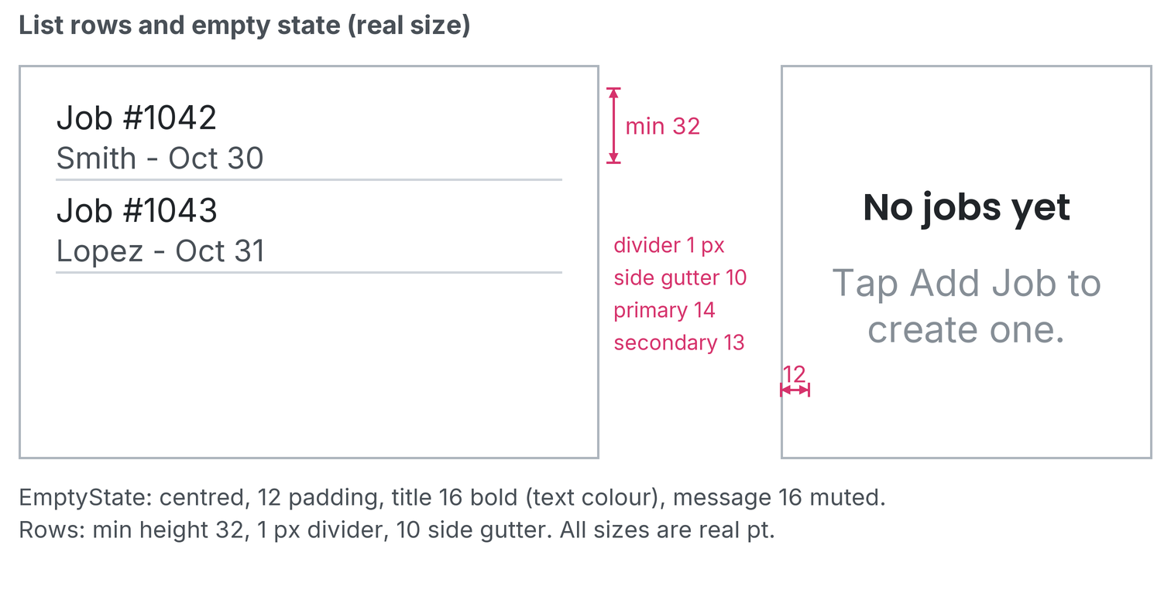
List rows (section 7) and the empty state (section 8). Printed at 100%: 1 app px = 1 pt.

9. Color and type
Rule | Status | Measures: padding, alignment, resizing
Brand navy #1B2A4A; sand #D9C7A0 (one shade lighter than the old accent) replaces accent #E1AF80 in app screens (accent token stays for website match); sandInactive #F0EBDC | SET  Jeff 2026-10-31 | See the swatches below.
Status: success #2E7D32, danger #C62828, warning #FACC15, info #4A9BE8 (lightened blue; navy primary unchanged) | SET  tokens | See the swatches below.
Headings Poppins, body Inter; sizes h4 20, body 16, label 14, small 13 | SET  tokens | This document uses the same families.
No raw hex in new code (use tokens); known exception: #2563eb tab/selected blue | SET | The blue is the only allowed raw value.

Swatch | Token | Hex | Where it is used
 | primary | #1B2A4A | Brand navy: header, text on sand
 | accent | #E1AF80 | Gold accent (website match only; not used in app screens)
 | sand | #D9C7A0 | Buttons and the active tab
 | sandInactive | #F0EBDC | Inactive tab
 | disabled | #F7F4EB | Disabled button (one shade lighter than sandInactive)
 | success | #2E7D32 | Status: success
 | danger | #C62828 | Status: danger
 | warning | #FACC15 | Status: warning
 | info | #4A9BE8 | Status: info (lightened blue, distinct from navy primary)
 | blue | #2563EB | Tab underline and selected state (known exception)
 | divider | #CED4DA | Picker and list dividers

Rulings
Tighten top/bottom spacing and remove unneeded text wraps everywhere.
Question 3 is still open: forms, inputs, cards, dialogs, badges and toasts.

