Child’s Play Touring Theatre

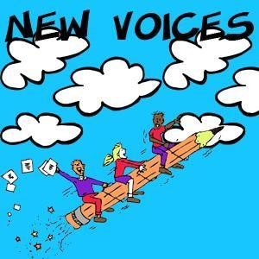

Story Coordinator Packet

For New Voices

New Voices

**You’ve booked a New Voices Performance, now what happens?**

For the New Voices Performance, students focus on writing and submitting their stories and poems to Child’s Play Touring Theatre for consideration to be adapted into a play, song or dance that will be included in a full-length repertory show. After the stories are received, the Child’s Play actors will then select some of these writings to be performed. In addition to the recognition of the pieces being performed, a handful of students will also receive Certificates of Creativity for Excellence in writing. In this packet you will also find a Certificate of Participation. This can be used by yourself or the teachers to give each child who submits a story or poem a certificate.

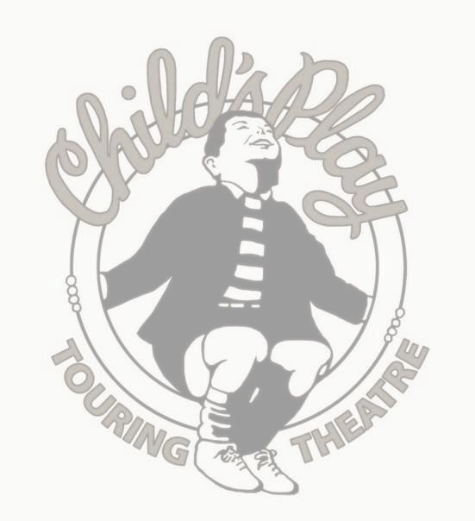

# Story Coordinator’s Guidelines

**Here’s what you do Story Coordinator!**

As mentioned before, you have chosen a Child’s Play Touring Theatre program that will feature material written by children in your school or community. As the Story Coordinator, you have some very important responsibilities. They are as follows:

1) Write your name, phone number and story deadline on the Teacher Guidelines section you will copy and distribute to the participating teacher. Encourage teachers to read through the teacher materials. This section includes:

a. Teacher Guidelines, Story Selection Process and Writing Guidelines b. Manuscript Identification Form c. Evaluation d. Certificate of Participation* * Please note that the teacher may make one copy for each student that submits a manuscript to Child’s Play. Each teacher/school/Story Coordinator may use discretion.

1. Ensure that the children’s manuscripts have Manuscript Identification Forms attached and are sent to Child’s Play by the submission deadline (in contract). It is very important for our records and in-office processing that each child has a completed Manuscript Identification Form attached to his/her manuscript. This form also contains an important no-plagiarism promise that must be signed by each young author.
2. Send Child’s Play a minimum of 25 stories and a maximum of 100. Encourage teachers to submit the best of his/her classroom’s written work. If you are worried about sending the originals, please either send copies or keep copies for your records. Please note though that Child’s Play will return the manuscripts on the performance day. Send stories in a mailing envelope or box, with your name, the school name and return address.

We recommend sending your manuscripts via First Class Mail or even Certified Mail to ensure we receive them. Also, include the Story Submission Form you received with your contract. Send stories to Child’s Play Touring Theatre, Attn: Story Coordinator, 5097 N. Elston Ave Suite 203 Chicago, IL 60630

1. Notify the school and parents of any student’s work that is chosen for performance or chosen for an Honorable Mention (this information will be sent to at least 7 days before performance if stories are submitted by your Story Due Date).
2. For the day of performance, please make copies of the Evaluation Form and distribute it to all adults attending the performance. Encourage teachers, parents and the principal to fill them out and return them to you. The evaluations should then be mailed to Child’s Play at your earliest convenience.

Thank you for your time and help assuring the success of this program. Please call our office if you have any questions, 773-235-8911.

## Evaluation Form for Child’s Play Touring Theatre

Child’s Play Touring Theatre endeavors not only to entertain, but also to motivate children to become more effective writers, enrich students’ environment, trigger effective learning experiences, and develop an appreciation of live theatre. Your answers to the following questions are an enormous help to us in determining how well we are meeting those objectives. Your direct input is an essential part of improving our programs and services.

I AM: (please check/expand if necessary)

Principal ______ Parent ______ Other __________________ Teacher/Grade Level___________________

Name of School______________________________________________

City_______________________ Date of show___________________

Time of Show______________

On a scale of 1 to 5, with 1 being the least favorable and 5 being the most favorable, please circle the number which best describes the level of your response

______________________________________________________________________________

1. Did the performers capture the attention of the audience? 1....2....3....4....5

______________________________________________________________________________

1. Did the artists control student response? 1....2....3....4....5

______________________________________________________________________________

1. Was the performance appropriate to students’ interests/age levels? 1....2....3....4....5

______________________________________________________________________________

1. Was this program useful as a stimulus to curriculum? 1....2....3....4....5
2. Do you see this program motivating writing? 1....2....3....4....5

______________________________________________________________________________

1. Did your students submit writings? Yes____ No____
2. Did you find teacher guidelines helpful? 1....2....3....4....5

_____________________________________________________________________________________________ Do you have any additional comments or suggestions about improving our programs? * May we use your name in our reports/publications?

If yes, please sign here________________________________________ *Please add me to your mailing list.*

My address is:___________________________________________________

My e-mail address is:_______________________________________________

Theatre

Teacher Guidelines

# For New Voices

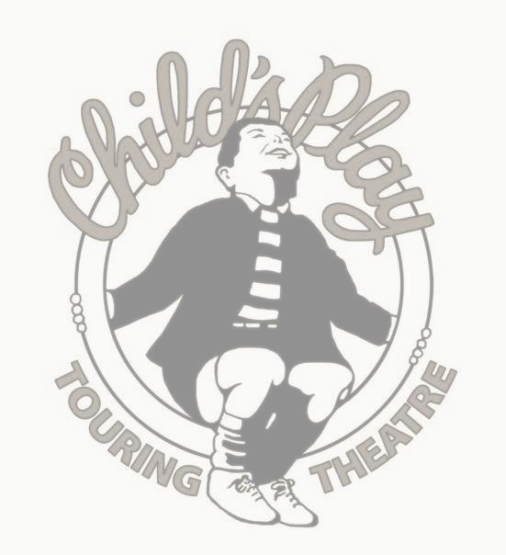

# Teacher Guidelines

Local sponsors have scheduled Child’s Play Touring Theatre to perform for your students in a few months and have arranged for material written by your students to be included in the performance.

What is Child’s Play Touring Theatre? Child’s Play Touring Theatre is recognized as the premiere professional children’s theatre dedicated exclusively to performing stories and poems written by children. Since 1978 Child’s Play has reached an audience of over 4 million children and adults across 40 states from Alaska to Florida. Child’s Play has performed at many prestigious venues including: the Goodman Theatre, the Smithsonian Institute, and the Brooklyn Academy of Music.

What does Child’s Play actually do? Child’s Play combines the imagination of children and the craftsmanship of professional theatre artists. Using characters, narration and dialogue created by young authors, the four actors of Child’s Play add songs, mime, music, sound effects, props and costumes to fashion a complete show. A lively pace, energetic performances and lots of audience participation keep the children involved throughout the performance.

We see ourselves as partners with you in the teaching and sharing of children’s manuscripts. We believe that providing an audience and a purpose for children to write and use their imaginations will enhance your writing curriculum. It also encourages young people to value writing as a way to communicate and express creativity.

Preparing for the Child’s Play performance can spark the writing program in your classroom, as well as open doors to other writing and drama activities. As children watch our actors performing literature written by other children - often by children they know, children they are sitting next to in the audience, they become very excited about their own possibilities as writers. They say, “I can do that too!”

Tell me about the show... Child’s Play will perform a 45-55 minute show that will include anywhere from 1 to 4 “World Premiere” pieces written by your school. They will be bookended by a few Child’s Play repertory pieces we have adapted throughout the years. There will also be a special awards presentation in the middle of the show. Certificates of Creativity will be awarded to all of the “World Premiere” authors. To encourage as many young writers as possible, additional students will be honored with certificates to recognize stories and poems showing exceptional effort or creativity. We will get a round of applause for anyone who submitted a manuscript to Child’s Play, though you may want to distribute the Certificate of Participation included in this packet to your participating students.

What do I need to do? After you have read through all of the materials, introduce this writing project to your students using the Writing Guidelines for Young Authors/Manuscript

Identification Form. We encourage you and your students to select the best of their work to send to us for consideration. The submission may be a new assignment, a selection from a child’s writing portfolio, from a journal kept during the school year, or writings from your own “Young Authors” program.

# Teacher Guidelines

About the Writing Guidelines Please make a copy of the Writing Guidelines for Young Authors/Manuscript Identification Form, and give one to each student. We encourage you to read aloud, discuss, and post a copy of this sheet. When going over the Writing Guidelines, please make note of the following points:

* Please do not require students to write a play. Many times, stories, poems and essays are better suited for our performance needs. On the other hand, playwriting can create new challenges for outstanding students.
* We encourage the submission of collaborative pieces, written by a cooperative learning group in your class, or even a piece written by your entire class! This can be really helpful for younger students.
* Poems can be as short as a few lines to several pages long. One to three pages is best for stories, three to five for plays. These are just suggestions, we don’t want to stifle any child’s creativity.
* While good handwriting, grammar and spelling do make stories easier to read, we think creative ideas are more important. We are quite adept at interpreting children’s unique variations on the English language.
* Keep in mind the season in which the performance is scheduled. Remind students that though they may be writing in December, the show is actually in February.
* Caution your students to avoid using excessive violence in their stories. We do not perform stories with violent themes or scenes.
* Please make sure each story has a Manuscript Identification Form attached to it and is completely filled out. For co-authored stories, each author should fill one out. Class stories need one form attached and signed by you.

**We’ve finished writing, now what?**

* A total of at least twenty-five and no more than one hundred students’ manuscripts may be submitted for each performance. We encourage you to select the best of your students’ work to be submitted for consideration. We cannot guarantee the performance of a specific child’s piece.
* Child’s Play will return all manuscripts to your Story Coordinator on the day of your performance. If you are concerned about illegibility, loss or damage to the original manuscripts, you or your Story Coordinator may opt to make copies and send those.
* At least one week prior to the performance, the Story Coordinator will be contacted with the names of the students whose work will be performed and honored.

NOTE: Your Story Coordinator is: ________________

Your School’s Submission Deadline is: _____________

# Teacher Guidelines

**Story Selection Process**

**How does Child’s Play Choose stories to perform?**

Child’s Play receives approximately 15,000 stories a year. Finding pieces to perform is a treasure hunt: difficult and time consuming, but with great rewards!

We look for strong story lines: a well defined beginning, middle and end. We often like to adapt stories that contain moral or thematic statements as our goal is to educate as well as to entertain. We appreciate stories where we can communicate such a point that the young author feels so strongly about. We are delighted to also find stories that include children’s thoughts on current world and national problems or events. They often provide unique solutions and perspectives on so-called adult matters.

Technically, we need to be able to stage the work. We consider how many characters are in the story, how many settings there are, what kinds of costumes, props and sets we will need to make this a successful adaptation.

**Do we change student’s stories?**

In adapting student writings for performance, it is entirely possible that changes will be made to the children’s original text. Factors involved in making these decisions include the size and gender of our acting company, the quality of the original text, logical inconsistencies in the story line, and staging limitations of touring theatre.

We may change the gender of a character if it is not essential to the story, i.e. Timmy changed to Tammy. Due to the small size of the acting company, non-essential characters may be deleted:

“my two best friends” becomes “my best friend”.

The most common change we make is the addition of dialogue. Young writers will often create space within the narration where additional dialogue is implied, such as “The king explained what happened.” Other times we will shift narrative text into dialogue between actors.

Because of the nature of live theatre some pieces of narrative work are better as stage action as opposed to verbal storytelling. In these cases, we might see the action instead of telling about it. Additionally, young authors will often write the action of a story to take place over an extended period of time or in a variety of locations. We may simplify it to one time or one place.

**A note on plagiarism...**

Our theatre is based on the idea that children can write well. Please stress your students the importance of using only their own ideas when writing stories. This includes characters as well as story lines. So, no Harry Potter, etc...

If you suspect a story is plagiarized, please either make note of it or do not send it.

## Manuscript Identification Form

**Writing Guidelines for Young Authors**

*You can write about anything. It can be serious or funny or silly or sad or... you get the picture!

*You can write a story, a poem, an essay, a play, or a song and you make it as long as you want or as short as you want.

*We love drawings and artwork. Please send them with your story or poem.

*Help us out, write as clearly and neatly as you can. Have your classmates read your writing and check for good handwriting and spelling. Of course, that’s on your final draft. At first, just write—let your ideas out onto the paper.

*Remember, you are the writer. That means no copying from a book, story you’re studying in class, your neighbor, a television show, or a movie you’ve just seen. So, no Harry Potter. Write with a friend, but please check with your teacher first.

———————————————————————————————————————

**CHILD’S PLAY TOURING THEATRE MANUSCRIPT IDENTIFICATION FORM**

**Title:_________________________________________________________________________**

**Author:_______________________________________________________________________**

**Home Address:________________________________________________________________**

**City:___________________________State:_______________________ZipCode:__________**

**Home Phone Number:_______________Email:_________________Age:_________________**

**School:_________________________________________________________**

**Grade:________________**

**Teacher:______________________________________________________________________**

**I promise that this story, poem or drawing is my own work and I did not copy it from a book, television show, movie or anything else.**

**Signature ___________________________________________Date___________________**