Problem 377

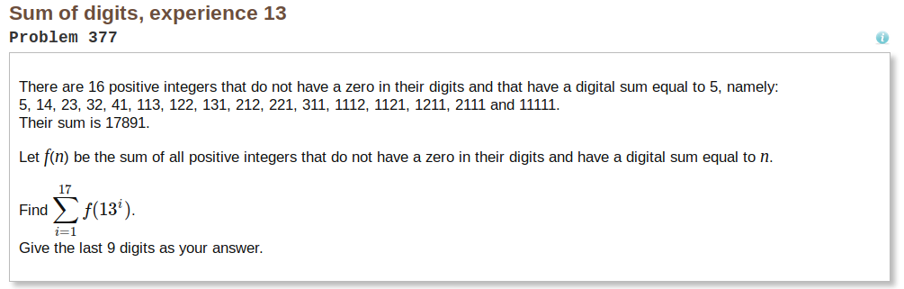
Approach
Starting out on this problem I knew that finding a pattern was important. The goal was to find every number with a matching digital sum without brute force and 0 comparisons (Ex. Checking if digital sum of 1112 = 5). Eventually I found a pattern by recursing with number length n, n-1, n -2, … ,1.

Solution
The solution was to start with the first digit as a 1 and recursing with digSum = digSum-1 and digLen = digLen-1.
Ex.
Searching for digit sum = 5 and digit len = 4
-start with 1xxx
-Recurse with digLen = remaining digits = 3
and digSum = digitSum – already known digits = 5 – 1 = 4
-Then recurse with digLen = 2, etc.
-Base case is when digLen = 1
Then you take all previous know digits (in this case it 111x) for the first set of iterations and combine them with whatever is the last digSum (digLen = 1, digSum = 2 for last digit).
-For digSum = 7 and digLen = 4 the pattern looks like:
1114 1123 1132 1141 1213 1222 1231 … 1411
2113 2122 2131 2212 2221 … 2311
3112 3121 3211
4111

