Graph Isomorphic Final Project Rough Draft

COSC 320

Kevin Koch
In 1972, Richard Karp used the Cook-Levin theorem to show that there is a polynomial time many-one reduction reduction to each of 21 graph theory and combinatorial problems, showing that they are NP-Complete. [Karp] This paper inspired a spur in research related to other NP-Complete problems, one of which came to be known as the graph isomorphism problem (GI). That is, if we can determine that there is an isomorphism between two graphs in polynomial time. It was once referred to as a “disease” since it was such a popular problem among computer scientists with an interest in algorithms. [Read, Cornell] In the near five decades of research since, there have been numerous attempts to prove that GI is NP-Complete, but all have been been false by some oversight. In 2015 Laszlo Babai of the University of Chicago published “Graph Isomorphism in Quasipolynomial time”, a paper showing that it was possible to achieve an algorithm that solved the GI problem in (exp((log n)^O(1))) time. The previous best bound for GI was (exp(O(sqrt(n log n))).[Babai]

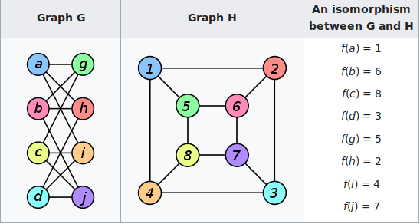
[graph isomorphism wiki]

So what is a Graph Isomorphism? A graph isomorphism has a few traits and six properties. Above is an example of two isomorphic graphs. You’ll note that the two look very dissimilar, however when you analyze what the nodes are actually connected to, you see that they are two different graphical representations of the same graph. From this you can draw a few things about graph isomorphism. For one, even if graphs look the same what matters is the number of vertexes and edges. If one graph has six vertexes but the other only has five, there is no possible way that the two are isomorphic of each other. For a graph to be isomorphic there must be a bijection between the vertices. Finally if the following are all true, then the graphs are said to be isomorphic, otherwise they are not.The six of graph isomorphism are as follows,
- The number of vertices should be equal for each graph
- The number of edges should be equal for each graph
- The indegree and outdegree of each vertex should be equal
- The number of connected components should be the same
- The number of loops should be the same
- The number of parallel edges should be the same

Graph isomorphism is a very interesting and important topic for many assets of our daily life. Some examples of why we care about graph isomorphism are for example tool assisted drafting programs like CAD. It’s used frequently in Social Networks to graph user’s inter-connectivity and our relationships with others. This information is also of interest to psychologists to help figure out more about human relationships on the whole, and could also be used to find out more information on the individual. Most interestingly it is also used to identify different chemical structures. You could feed in a new atomic structure to a program, and attempt to have it break down and analyze the atomic makeup to identify the compounds when compared to a list.[Somkunwar, Vaze]

Most research these days into Graph Isomorphism are purely academic as most of the heuristic evidence we have found so far strongly points to GI not being NP-Complete. If we ever did prove that GI was NP-Complete however, the entire polynomial hierarchy would collapse, and we would have to reanalyze how we approach many problems such as encryption. This said however, GI is polynomial time for some graphs such as, bounded treewidth, bounded genus, and bounded degree. The interesting problem of analyzing the number of isomorphisms between two graphs is Turing reducible (the Cook problem), to the graph inversion of itself. Also for most real world applications of GI, there are applications that are “practical in practice.” Which basically means that while there are a few worst case input run times that take a jaw dropping amount of time to complete, for most input they run fine.[Hartke Radcliffe]

