Problem 377

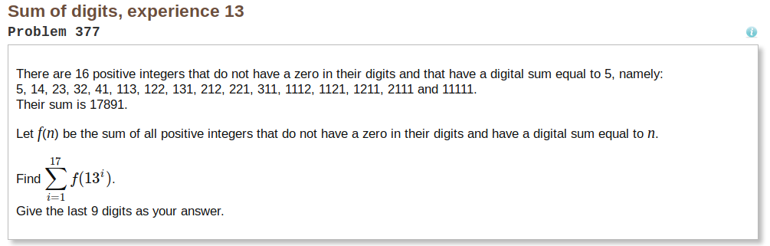
Approach
Starting out on this problem we knew that finding a pattern was important. The goal was to find every number with a matching digital sum without brute force and 0 comparisons (Ex. Checking if digital sum of 1112 = 5). Eventually we found a pattern by recursing with number length n, n-1, n -2, … ,1.

Solution
The solution was to start with the first digit as a 1 and recursing with digSum = digSum-1 and digLen = digLen-1.
Ex.
Searching for digit sum = 5 and digit len = 4
-start with 1xxx
-Recurse with digLen = remaining digits = 3
and digSum = digitSum – already known digits = 5 – 1 = 4
-Then recurse with digLen = 2, etc.
-Base case is when digLen = 1
Then you take all previous know digits (in this case it 111x) for the first set of iterations and combine them with whatever is the last digSum (digLen = 1, digSum = 2 for last digit).
-For digSum = 7 and digLen = 4 the pattern looks like:
1114 1123 1132 1141 1213 1222 1231 … 1411
2113 2122 2131 2212 2221 … 2311
3112 3121 3211
4111

To implement MPI, each starting number (0-9) was spread across the nodes. Meaning with 9 nodes, each node was responsible for a single starting number with the case that there are 9 possible starting numbers. This worked good for scattering since no mpi was needed considering the array being separated was always 1, 2, …, n and each node always had access to the array. There was no need to send anything. Then once each node calculated their sum, it was sent to the root node for it to be added to all other node’s sums. Each number was represented in integer arrays with each element being between 1-9. Therefore the final gather was not as simple as using MPI_Allreduce. This had the biggest impact on performance.

Results
Digital Sum | 1 Nodes | 3 Nodes | 5 Nodes | 7 Nodes | 9 Nodes | #Operations
5 | .250 | .272 | .278 | .285 | .298 | 235
10 | .291 | .291 | .312 | .283 | .290 | 11572
15 | .272 | .284 | .314 | .288 | .304 | 491783
20 | .367 | .420 | .401 | .384 | .385 | 19592945
25 | 4.144 | 5.102 | 4.965 | 1.087 | 1.681 | 750562749
30 | 3m20.787s | 2m54.787s | 2m22.744s | 1m21.886s | 1m7.107s | 2122506046
35 | 66m5.516 | 63m3.134 | 59m54.786s | 51m23.532 | 46m24.595 | >100 trillion

Issues/Road Bumps
Evenly splitting work: There was a big issue with with finding a way to effectively partition the work across processes. We ended up going with a strategy where different nodes check number with a different starting number. Therefore processes checking numbers starting with 9 will have much less work to do than processes that are checking numbers starting with 1. Thus, certain processes finish within seconds while others may take an hour. The best solution do this would be give processes a large and a small starting number. Normally a processor would get starting numbers such as 1 and 2 when the better solution would be it gets 1 and 9 and the next gets 2 and 7, etc.

Cap on number of processors: Since the max possible starting numbers is 9, using any more than 9 processors will not improve performance.

Large numbers: Since checking any number bigger than 20 will result in sums at lease size 20, using integers was not an options. Therefore, we used single int arrays (1-9) arrays to allow for larger numbers and had to implemented functions for addition, etc. Also we found that this solution lost the optimization that came from operations on regular c ints. Lastly, there was a noticeable performance loss when sending and receiving these large integer array. Without the final reduction of all processors sum, the program ran much faster. Meaning the benefits of MPI was only present on larger numbers.

